UML Diagrams
Class, sequence and state-machine diagrams of the chaos emulator
Field | Detail
Project | chaos: Network Latency & Packet-Loss Chaos Emulator
Student name | [YOUR NAME]
Roll no. / ID | [YOUR ROLL NO]
Course | [COURSE NAME / CODE]
Instructor | [INSTRUCTOR NAME]
Version / date | 1.0, October 2026
Repository | [GITHUB REPOSITORY URL]

1. Overview
All diagrams are derived from the source code. Their text sources are stored in the repository under docs/uml/ (Mermaid .mmd and Graphviz .dot), so they can be edited and re-rendered; GitHub also renders the .mmd files directly.
Figure | Diagram | Shows
1 | Class diagram: core model | Profile, Step, Impairment engine, Out, Counters, SimResult
2 | Class diagram: backends | CLI, UdpProxy, Event, Client, NetemBackend, ProbeModule and their options/results
3 | Sequence: proxy round trip | probe -> proxy -> impairment -> echo -> back
4 | Sequence: kernel netem apply | chaos -> tc -> kernel qdisc -> driver, including the dead-man revert
5 | State machine: netem lifecycle | Idle, Preflight, Applying, Active, Reverting, Failed
6 | State machine: Gilbert-Elliott loss | Good/Bad Markov chain used for burst loss

Modelling note: the code is C++17 with free functions in modules (profile.cpp, netem.cpp, ...). In the class diagrams such a module is drawn as a class with the stereotype of its file, so that responsibilities and dependencies are visible.

2. Class diagrams

2.1 Core model
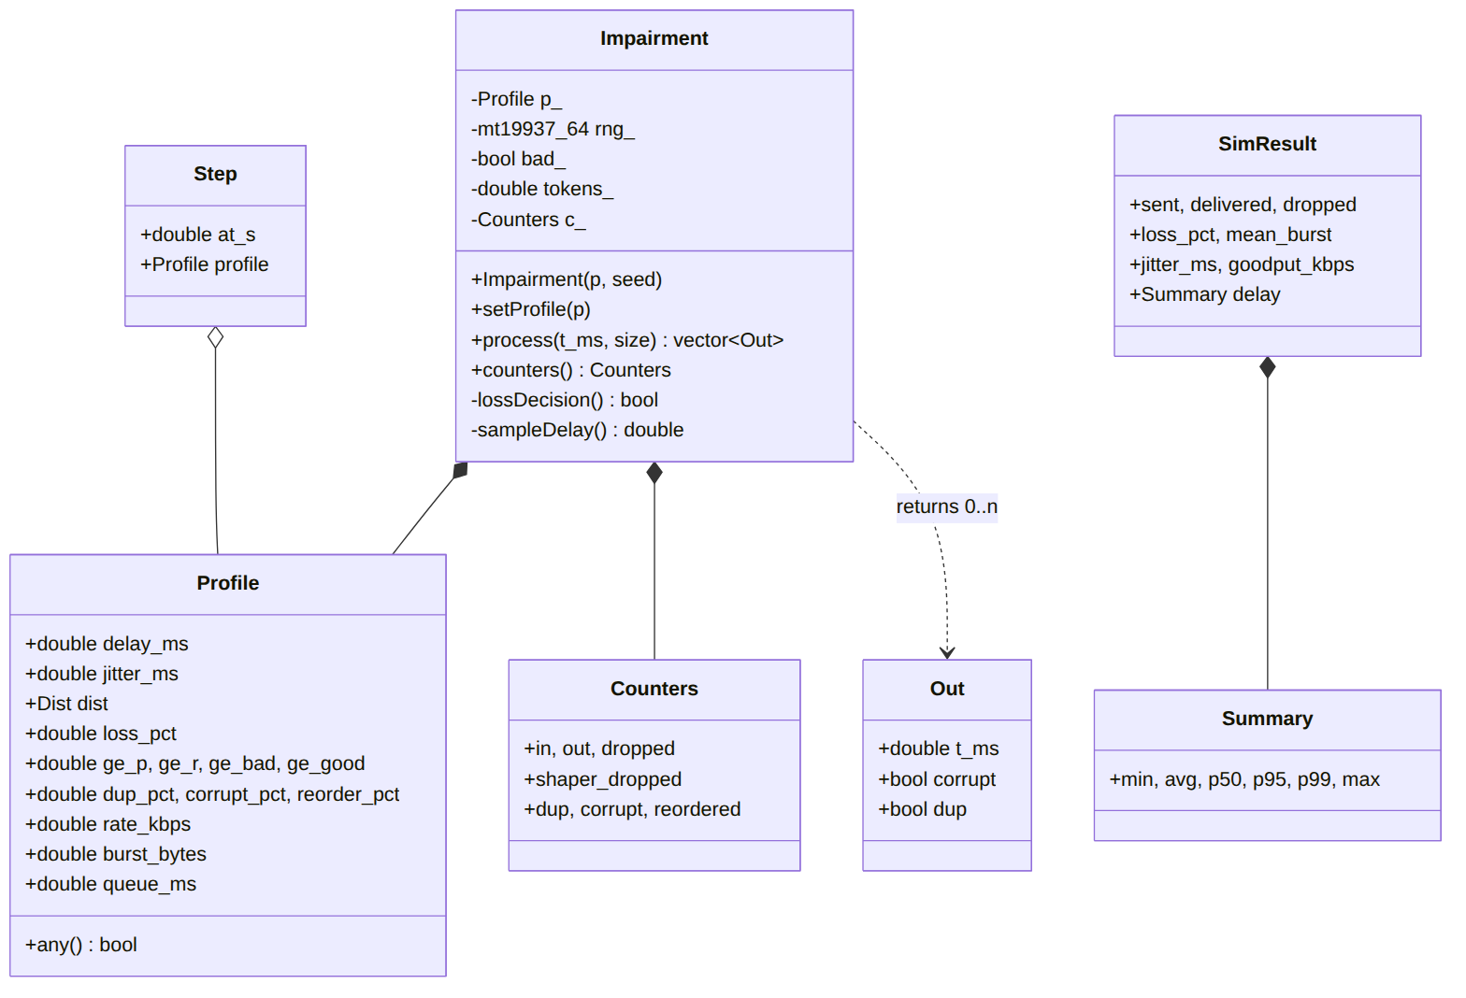
Figure 1: Core model. Impairment owns a Profile and Counters and returns a list of Out events per packet.
Profile holds every impairment parameter and is the single configuration type for all backends. A Step pairs a Profile with a start time to form a scenario. Impairment is the engine: it composes a Profile, a seeded random generator, the Gilbert-Elliott state (bad_), the token-bucket state (tokens_) and Counters. process() returns zero events for a lost packet, one event normally, and two when the packet is duplicated; each Out carries the departure time and corrupt/dup flags.

2.2 Backends and command-line layer
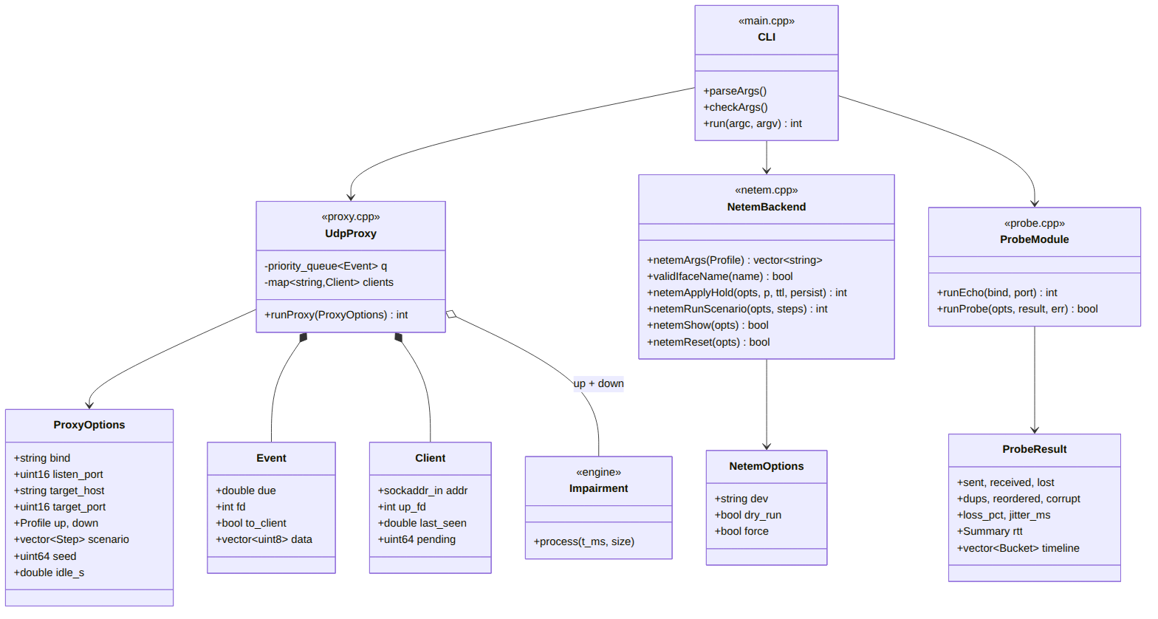
Figure 2: Runtime modules. The CLI creates option objects and calls one backend.
UdpProxy keeps a priority queue of Event objects (packets waiting for their due time) and a map of Client entries (client address, upstream socket, last-seen time, number of packets pending). It owns two Impairment objects, one per direction. NetemBackend translates a Profile into tc arguments and runs them with NetemOptions (device, dry-run, force). ProbeModule produces a ProbeResult with counters, RTT summary and the per-second timeline.

3. Sequence diagrams

3.1 Proxy round trip
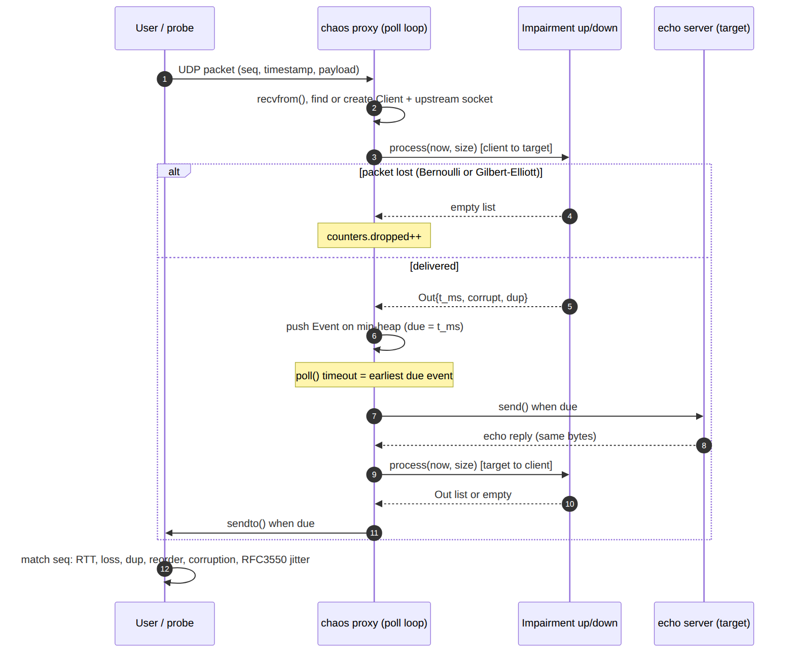
Figure 3: One probe packet through the userspace proxy and back.
The proxy decides the fate of the packet in the impairment engine twice: once client-to-target (profile "up") and once target-to-client ("down"). Delayed packets wait on the event heap until due; poll() is given the time to the earliest due event as its timeout. The probe finally matches sequence numbers to compute RTT, loss, duplicates, reordering and corruption.

3.2 Kernel netem apply with dead-man switch
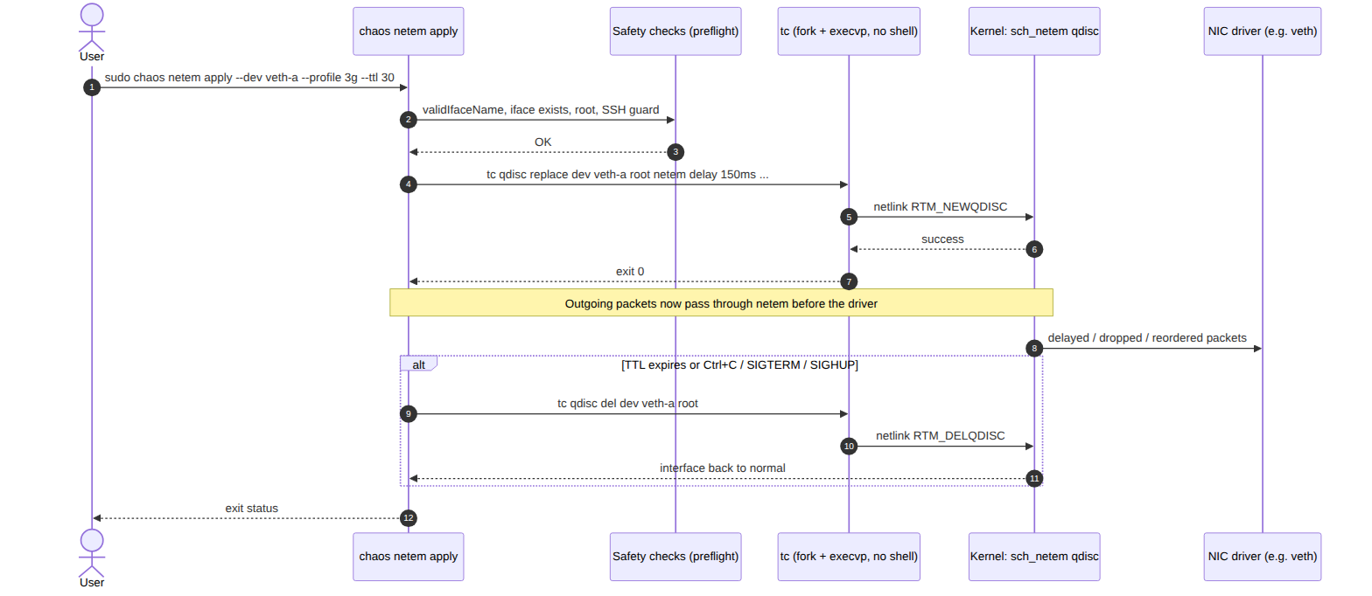
Figure 4: Applying a profile to a network interface through tc.
Preflight checks run before anything is changed. tc is started with fork/execvp and configures the sch_netem qdisc over netlink; the qdisc then manipulates outgoing packets before they reach the NIC driver (for example the virtual veth driver in the lab). When the TTL expires or a termination signal arrives, the qdisc is deleted and the interface returns to normal.

4. State-machine diagrams

4.1 Lifecycle of a kernel impairment
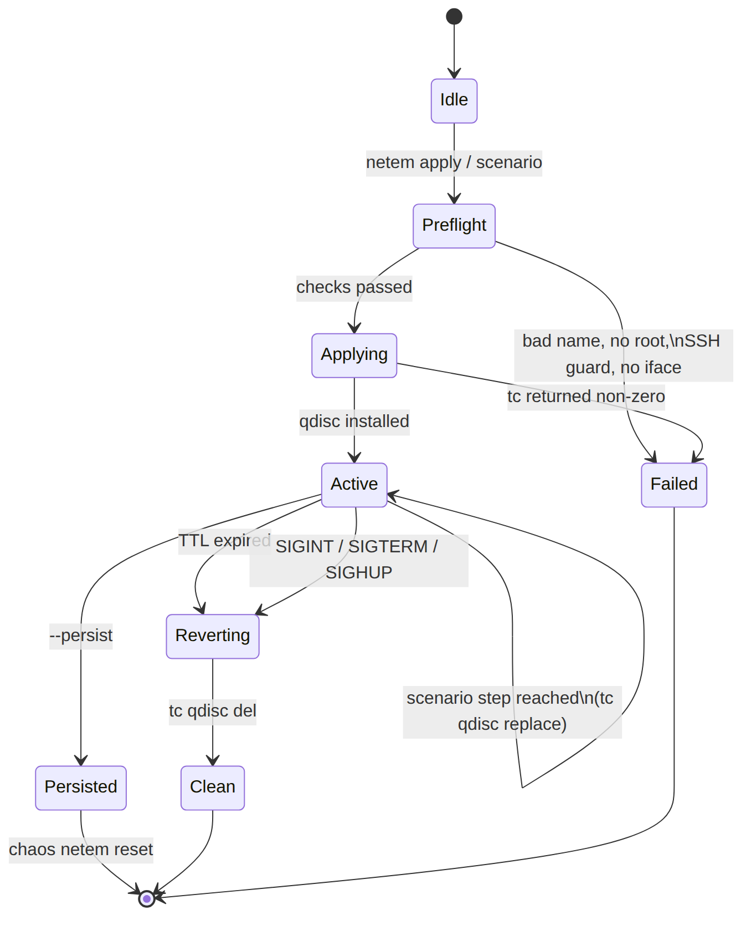
Figure 5: States of `chaos netem apply` / `scenario`.
Active can loop on itself when a scenario reaches the next step (tc qdisc replace). Every path that reaches Active ends in Reverting (TTL or signal) or in the explicit --persist state, which is cleared only by chaos netem reset. Any failure goes to Failed and, if something was already applied, the qdisc is removed before exit.

4.2 Gilbert-Elliott burst-loss model
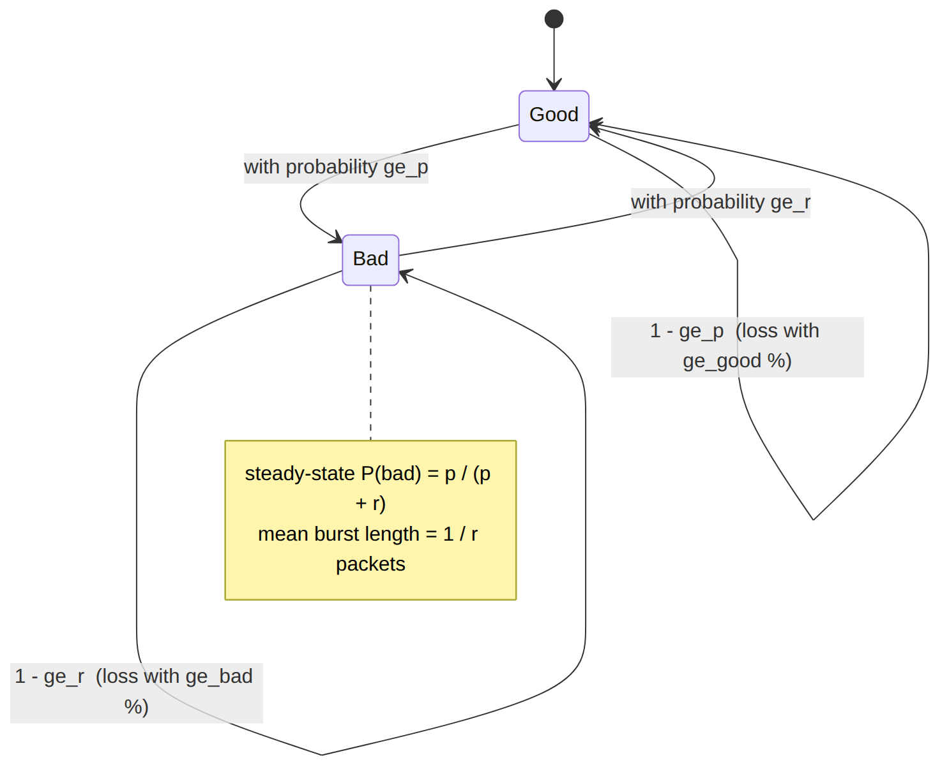
Figure 6: Two-state Markov chain implemented in `Impairment::lossDecision()`.
At each packet the chain may switch state (ge_p: Good to Bad, ge_r: Bad to Good) and the packet is then lost with the loss probability of the current state (ge_good, ge_bad). Steady-state probability of the Bad state is p/(p+r) and the mean burst length is 1/r; the unit tests verify the simulation against exactly these values. Example: the lossy-wifi preset uses p = 3%, r = 30%, bad = 60%.

