01 Dashboard ready — all system indicators green
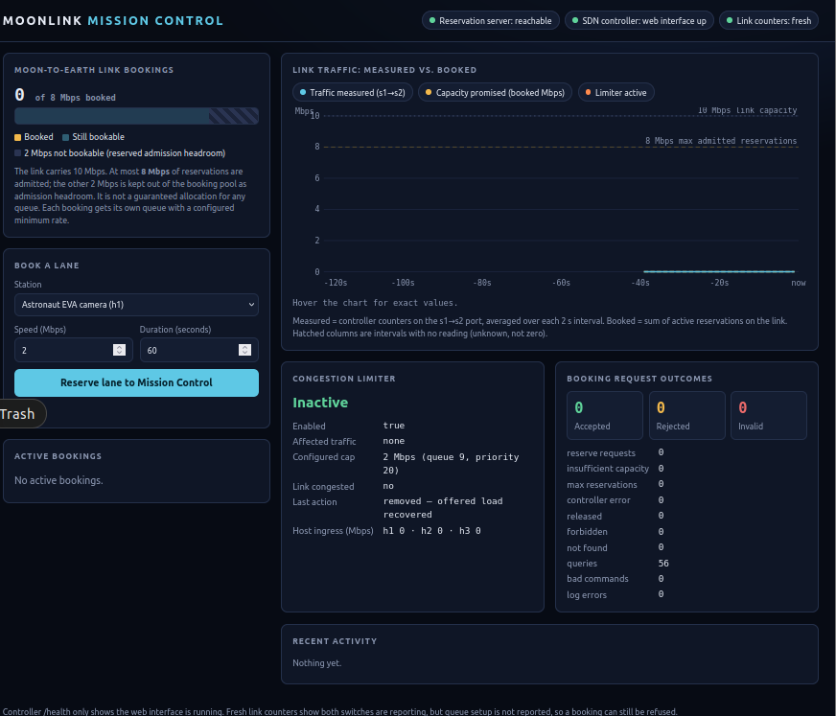

02 Accepted 5 Mbps booking from h1
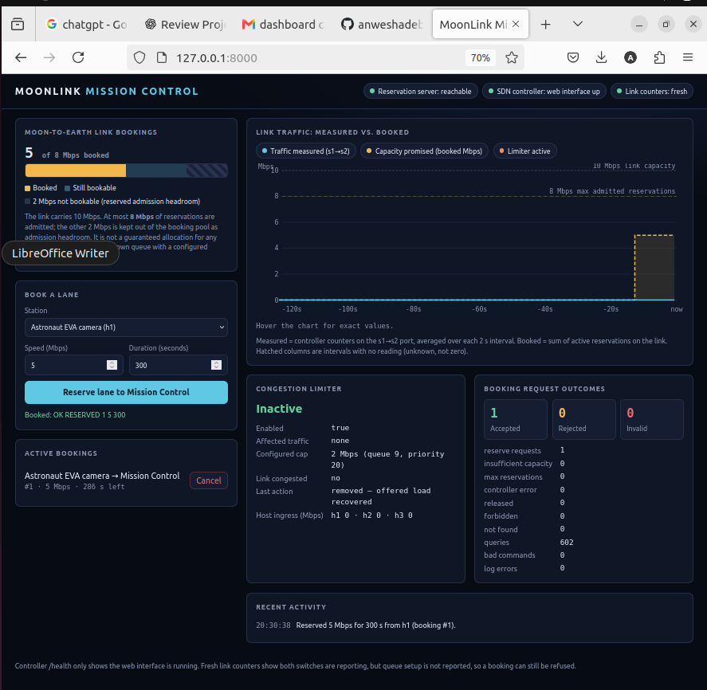

03 Reservation list and priority-100 flow / HTB queue
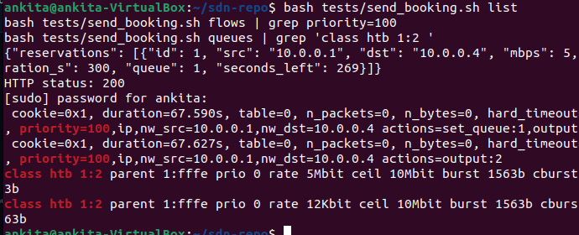

04 Capacity rejection for another 4 Mbps request
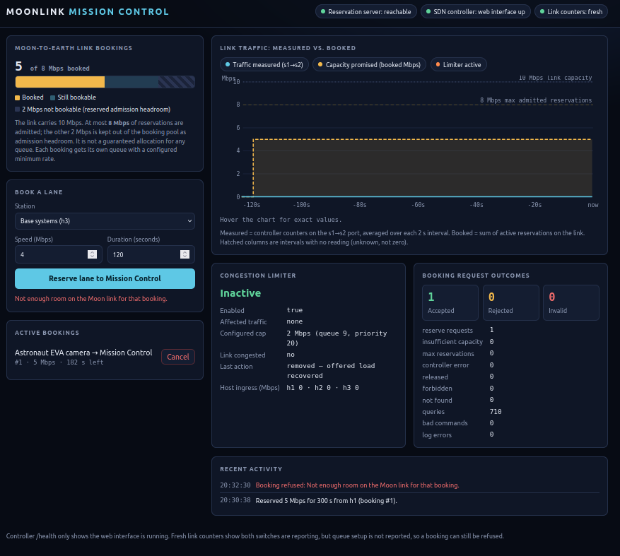

05 Invalid 9 Mbps reservation request
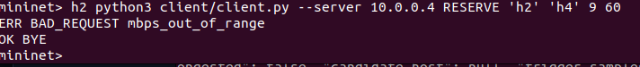

06 Outcome counters: accepted, rejected and invalid
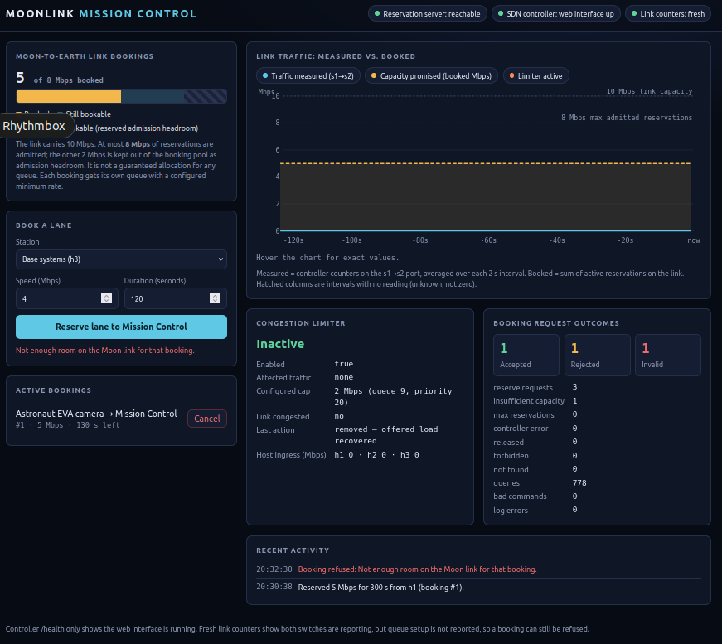

07 Live traffic compared with booked bandwidth
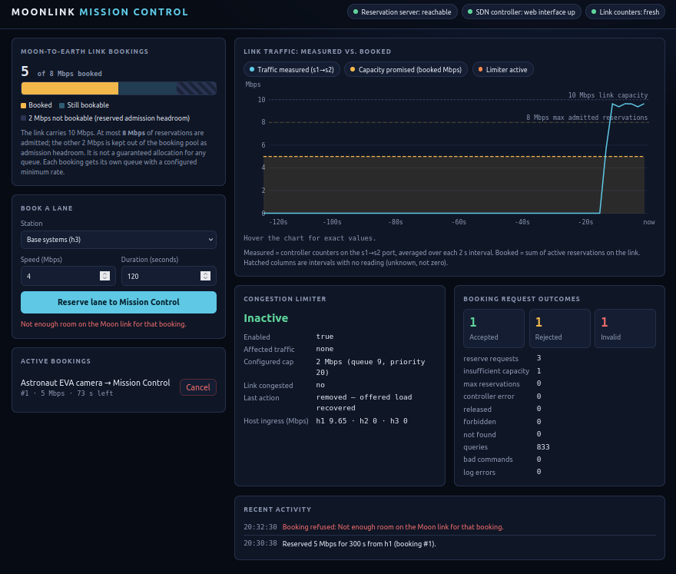

08 Live controller link-usage statistics
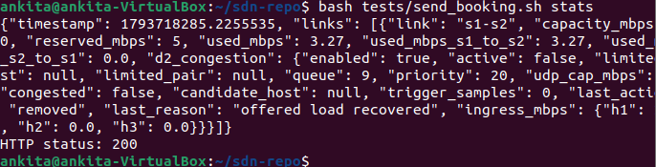

09 Congestion limiter ACTIVATED
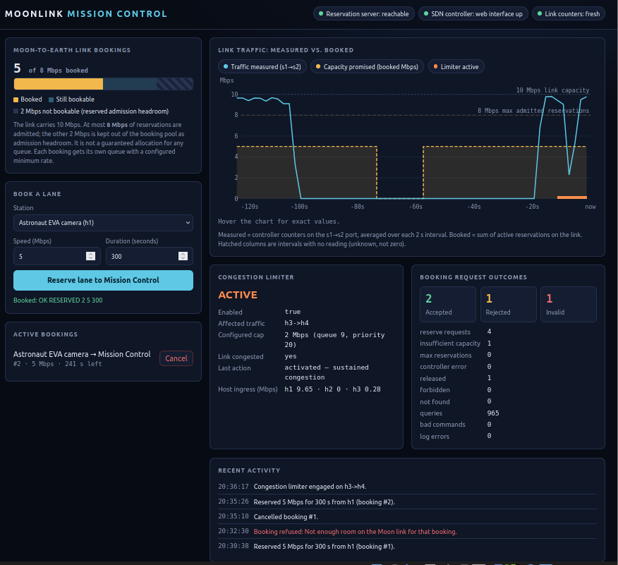

10 Congestion active with h3 offered traffic
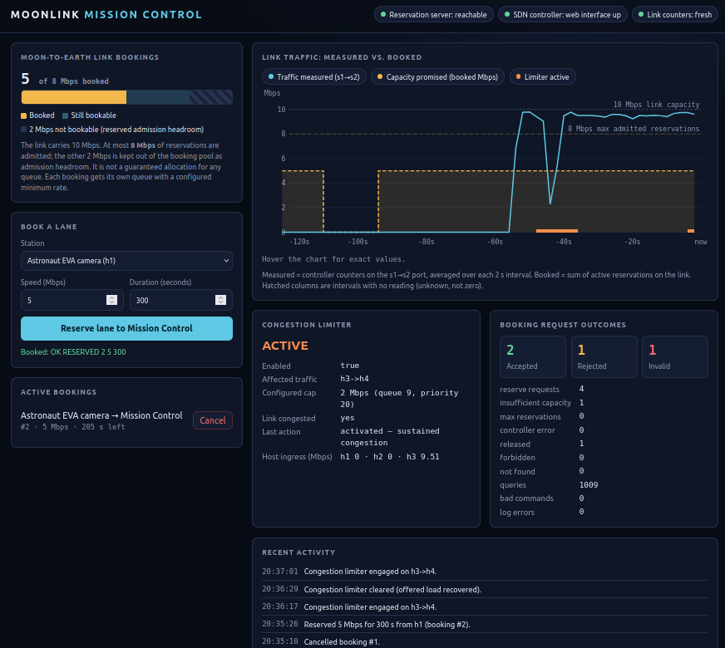

11 Controller ACTIVE and real priority-20 switch rule
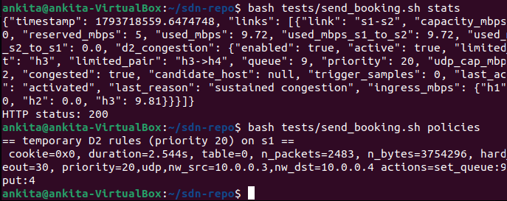

12 Controller INACTIVE and policy cleared
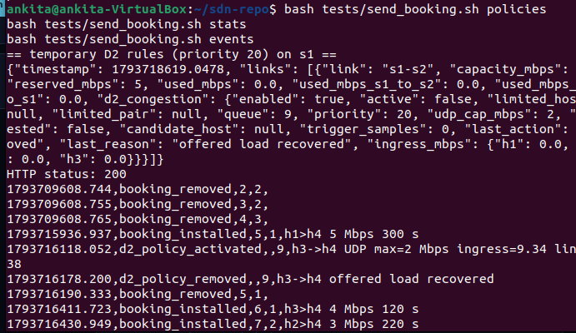

13 Policy activation and removal event log
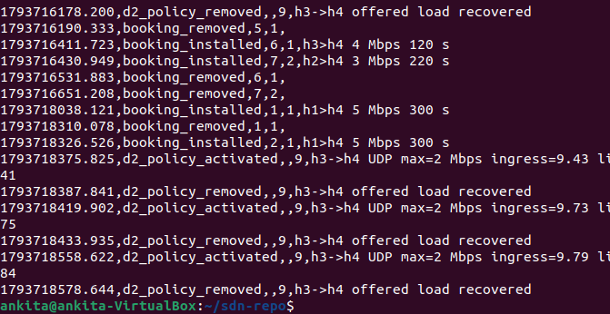

14 Final STATUS, LIST and server STATS
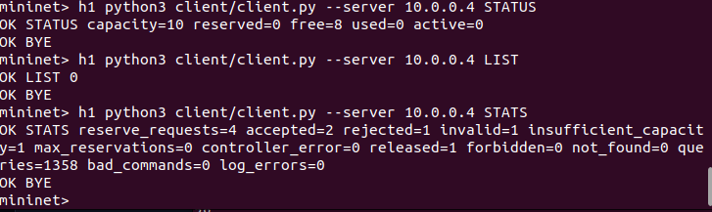

15 Final idle controller statistics


