MoonLink | Actual Test Screenshots
S03–S09 • Captured in Ubuntu VirtualBox / Mininet • 3 November 2026
This document contains only the actual screenshots supplied during testing. It is separate from Anirudh’s checklist and dashboard screenshot document. Images are preserved without altering test results. Some images show separate pieces of one long terminal output.

Evidence at a glance
S03: Two genuine successful one-line TCP bookings: h1→h4 5 Mbps and h2→h4 3 Mbps, each for 600 seconds.
S04: Live controller reservation list and /stats/links showing 8 Mbps reserved. An earlier saved E2 reservation snapshot is shown separately and is not the same live booking IDs.
S05: Live OpenFlow rules for h1 and h2, followed by the original saved E2 flow-rule snapshots. Packet counters and queue actions are visible in the screenshots.
S06: Original terminal captures showing OVS QoS/HTB configuration, 10 Mbps parent, 5 Mbps and 3 Mbps guaranteed classes, and queue 9 with a 2 Mbps maximum. These are consecutive pieces of one long command output.
S07: Saved h3 baseline receiver log shows 9.22 Mbps. Screenshots from the additional live trial show a h3 receiver result around 8.95 Mbps. The new h1 TCP baseline throughput was not captured as a completed measurement in these images, so it is not claimed.
S08: Saved E1 results show h1 TCP throughput of 9.41 Mbps and h3 UDP receiver average of 3.08 Mbps. Also included is the new h1 reservation and traffic-launch terminal screenshot; it does not contain finished client results.
S09: Saved E2 logs: h1 5.94 Mbps, h2 4.19 Mbps, h3 receiver 2.34 Mbps. New live run: reserved=8 Mbps; h1 4.99 Mbps, h2 4.67 Mbps, h3 receiver 1.62 Mbps. These measurements come from different run durations; do not sum as synchronous link usage.

S03 — Two live TCP reservations
Two genuine successful one-line TCP bookings: h1→h4 5 Mbps and h2→h4 3 Mbps, each for 600 seconds.
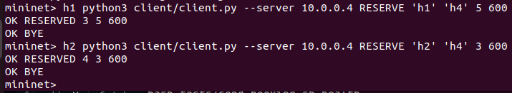
Original screenshot 1 of 1 — image(20261103-163027).png

S04 — Both reservations / 8 Mbps link allocation
Live controller reservation list and /stats/links showing 8 Mbps reserved. An earlier saved E2 reservation snapshot is shown separately and is not the same live booking IDs.
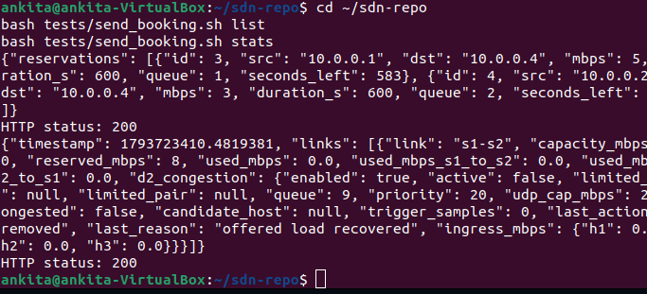
Original screenshot 1 of 2 — image(20261103-163040).png

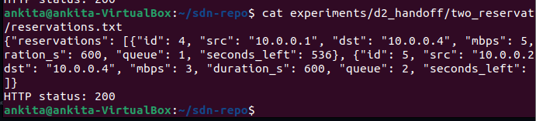
Original screenshot 2 of 2 — image(20261103-163101).png

S05 — Priority-100 OpenFlow enforcement
Live OpenFlow rules for h1 and h2, followed by the original saved E2 flow-rule snapshots. Packet counters and queue actions are visible in the screenshots.
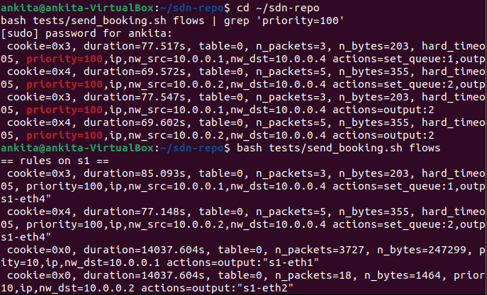
Original screenshot 1 of 4 — image(20261103-163222).png

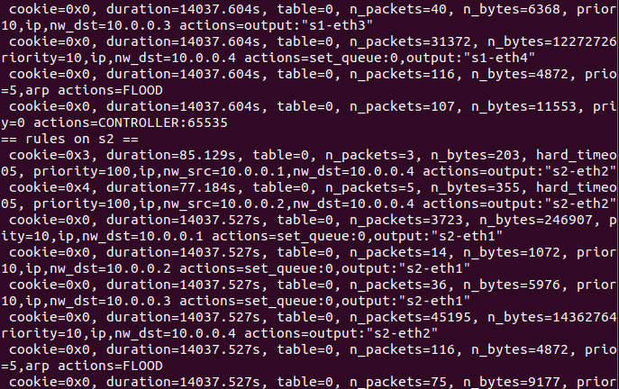
Original screenshot 2 of 4 — image(20261103-163318).png

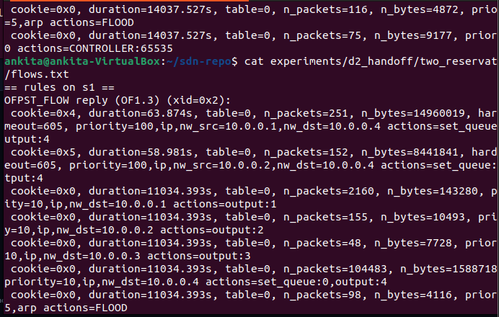
Original screenshot 3 of 4 — image(20261103-163346).png

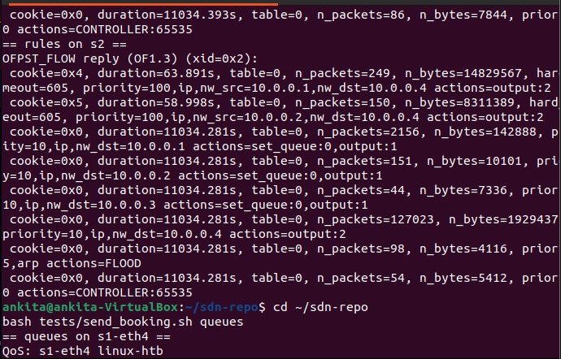
Original screenshot 4 of 4 — image(20261103-163410).png

S06 — Actual OVS HTB queues
Original terminal captures showing OVS QoS/HTB configuration, 10 Mbps parent, 5 Mbps and 3 Mbps guaranteed classes, and queue 9 with a 2 Mbps maximum. These are consecutive pieces of one long command output.
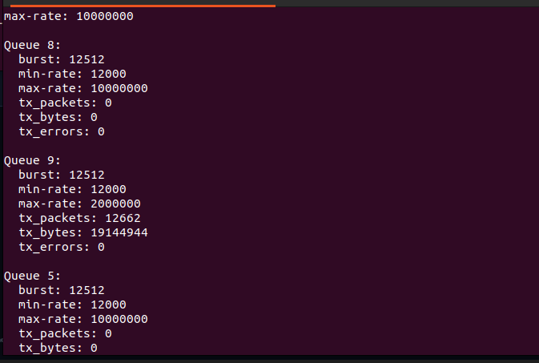
Original screenshot 1 of 9 — image(20261103-163425).png

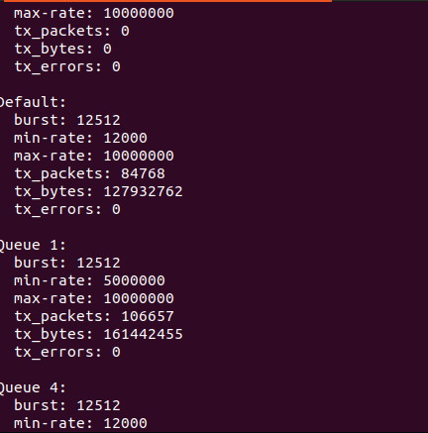
Original screenshot 2 of 9 — image(20261103-163449).png

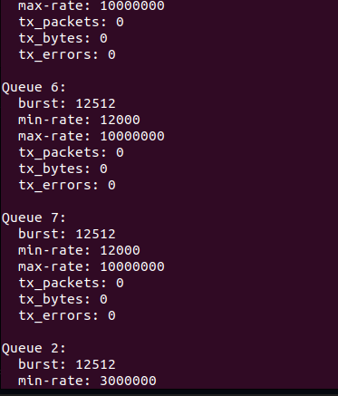
Original screenshot 3 of 9 — image(20261103-163509).png

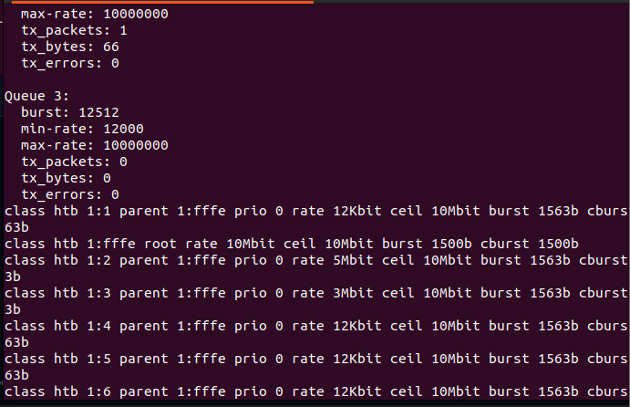
Original screenshot 4 of 9 — image(20261103-163526).png

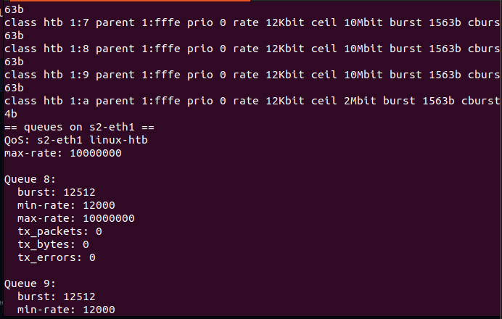
Original screenshot 5 of 9 — image(20261103-163603).png

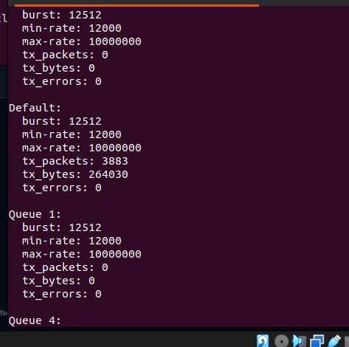
Original screenshot 6 of 9 — image(20261103-163625).png

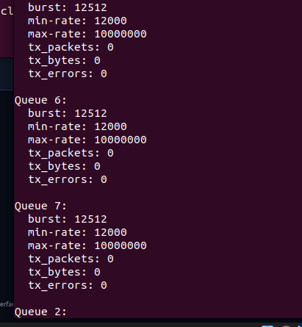
Original screenshot 7 of 9 — image(20261103-163643).png

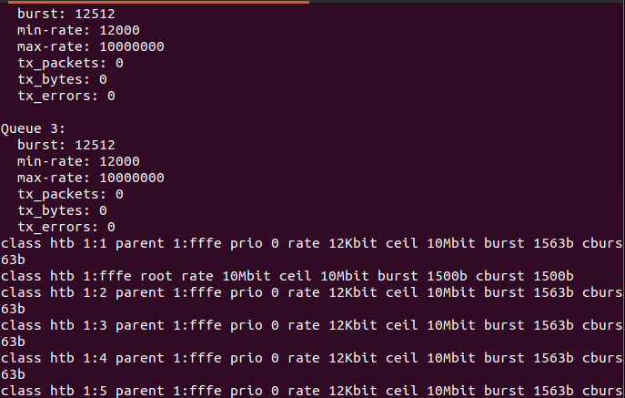
Original screenshot 8 of 9 — image(20261103-163700).png

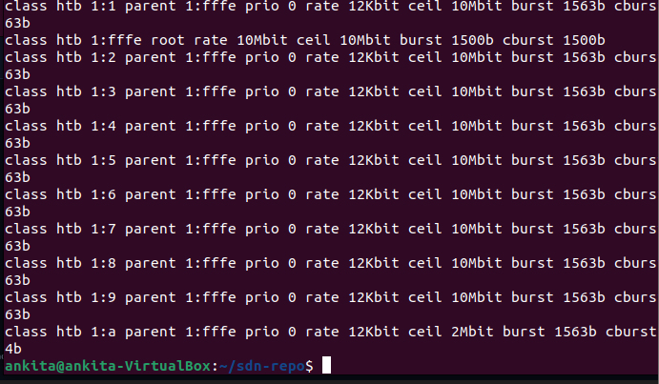
Original screenshot 9 of 9 — image(20261103-163716).png

S07 — No-booking baseline and live attempt
Saved h3 baseline receiver log shows 9.22 Mbps. Screenshots from the additional live trial show a h3 receiver result around 8.95 Mbps. The new h1 TCP baseline throughput was not captured as a completed measurement in these images, so it is not claimed.
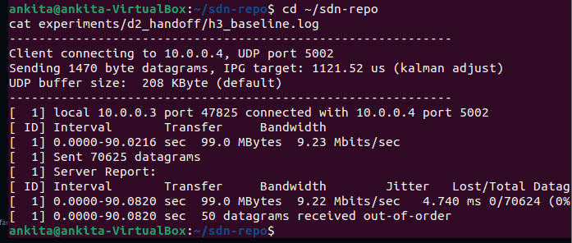
Original screenshot 1 of 4 — image(20261103-163804).png

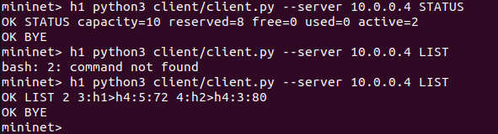
Original screenshot 2 of 4 — image(20261103-163904).png

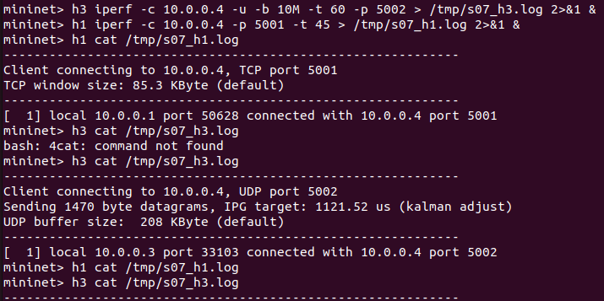
Original screenshot 3 of 4 — image(20261103-164156).png

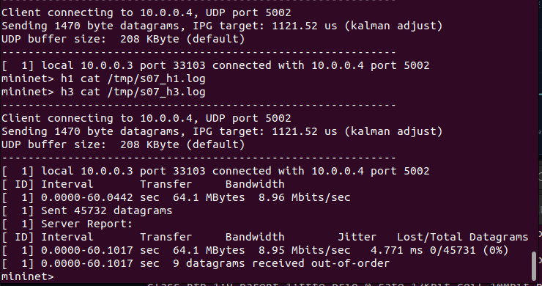
Original screenshot 4 of 4 — image(20261103-164211).png

S08 — Single booking under competing traffic
Saved E1 results show h1 TCP throughput of 9.41 Mbps and h3 UDP receiver average of 3.08 Mbps. Also included is the new h1 reservation and traffic-launch terminal screenshot; it does not contain finished client results.
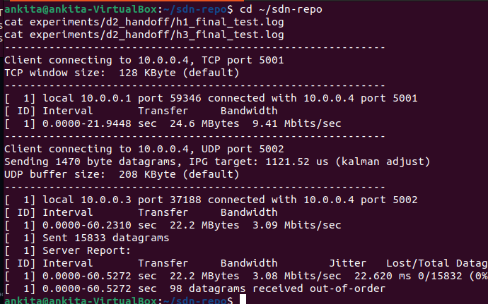
Original screenshot 1 of 2 — image(20261103-164245).png

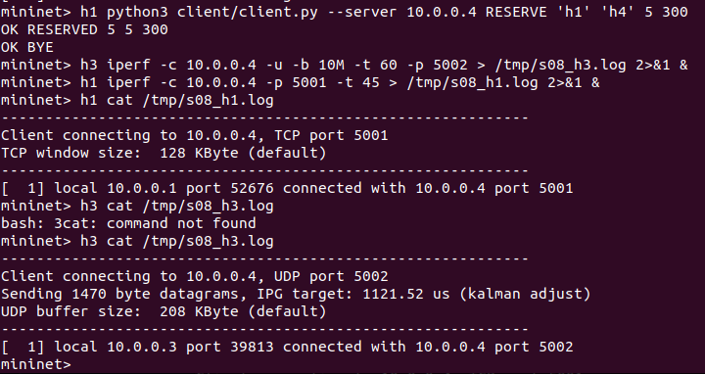
Original screenshot 2 of 2 — image(20261103-164459).png

S09 — Two booked hosts under UDP competition
Saved E2 logs: h1 5.94 Mbps, h2 4.19 Mbps, h3 receiver 2.34 Mbps. New live run: reserved=8 Mbps; h1 4.99 Mbps, h2 4.67 Mbps, h3 receiver 1.62 Mbps. These measurements come from different run durations; do not sum as synchronous link usage.
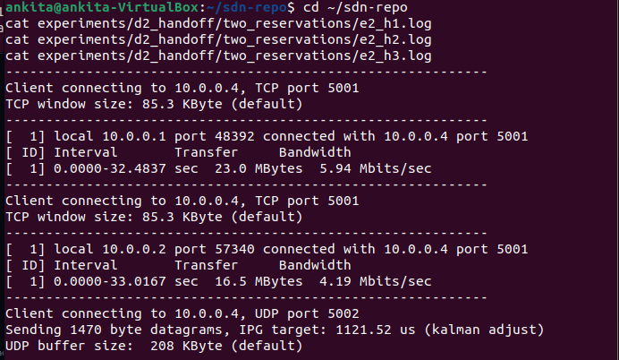
Original screenshot 1 of 5 — image(20261103-164546).png

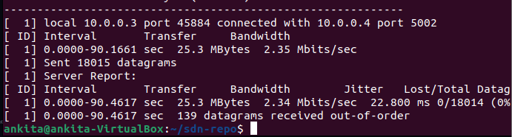
Original screenshot 2 of 5 — image(20261103-164612).png

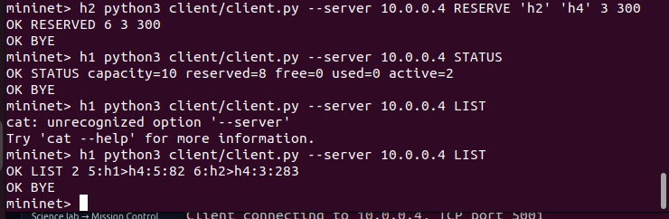
Original screenshot 3 of 5 — image(20261103-164705).png

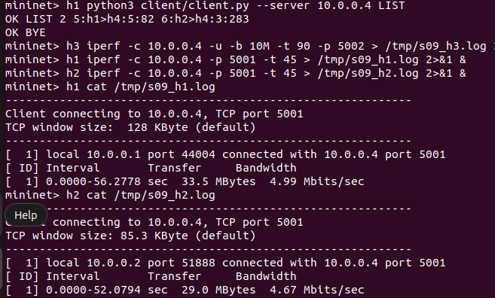
Original screenshot 4 of 5 — image(20261103-164920).png

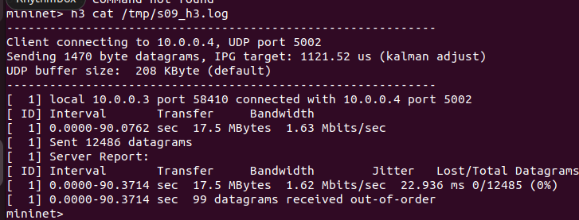
Original screenshot 5 of 5 — image(20261103-164938).png

