There are 4 Categories

1. **Status**
   1. Shelf
   2. Slot
   3. Card
   4. Port, Subports
      1. shelf = 1, slot = 1, port 1, line type
      2. Line Type
         1. OLT
         2. ONU
         3. ETHERNET
         4. IPOBRIDGE
         5. LINKAGG
         6. PTP
         7. T1
2. **Alarms**
   1. Alarms from (Shelf, Slot, Card, Port, Subport)
3. **Statistics**
   1. Card Level (CPU, Memory)
   2. OLT (Hierarchy – Shelf, Slot, port / line type)
      1. Statistics
   3. ONU
4. **Inventory**
   1. Hardware and Software Inventory

UI Design

* We can have 4 tabs corresponding to the above.
* We can use the timestamp of the log
* We can use IP address to refer to the origin node
* Hierarchy
  + Shelf, slot, port , subport or line type as applicable.
* 1-1-1-0 = line card 1, port 1, logical port 1-0
* We should be able to combine stats from multiple nodes
  + Rollup logic – ports, card , node

Reference:

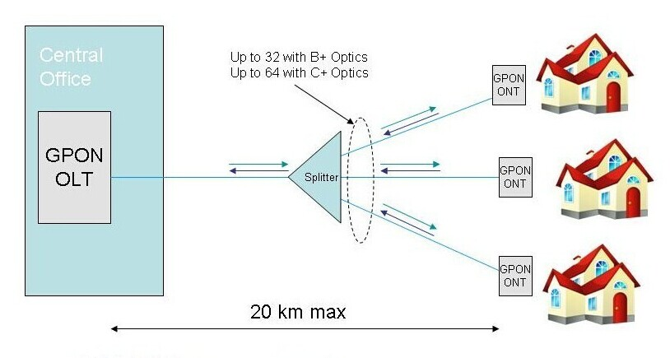

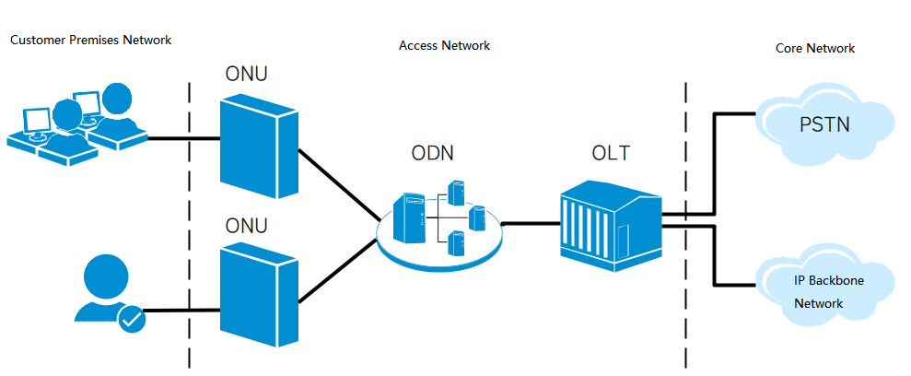

<http://www.fiber-optic-cabling.com/fiber-optic/what-are-relations-between-olt-odn-onu-and-ont/>