**חלק ב**

**Decision Tree :**

**1.**

**2.**

**3.**

**4.**

**5.**

**Random Forest:**

**1.**

**2.**

**3.**

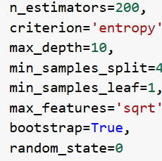

**4.**

**5.**

**AdaBoost:**

**1.**

**2.**

**3.**

**4.**

**5.**

