מטלה 2- חלק ב

1.



-----------------------------------------------------------------

2.



----------------------------------------------------------------------

3.



----------------------------------------------------------------------

4.



----------------------------------------------------------------------



----------------------------------------------------------------------

6.



----------------------------------------------------------------------

7.



----------------------------------------------------------------------

8.



----------------------------------------------------------------------

9.

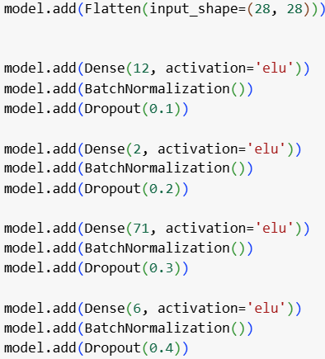



----------------------------------------------------------------------

10.



----------------------------------------------------------------------

11.

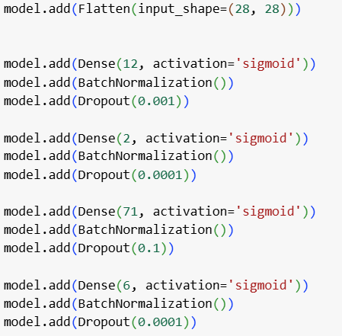



12.



----------------------------------------------------------------------

13.



----------------------------------------------------------------------

14.



15.

