Helen and John C. Hartmann Department of Electrical and Computer Engineering

ECE 414 Senior Design Project Proposal

Team number

Project Title: Multilingual Sign-to-Speech Communication Device: Edge-Deployed ASL Recognition with Confidence-Gated Speech Output

Name(s): Zeynep Hafsa Cakici ID# ________

Name(s): Dorukhan Cakir ID# ________

Name(s): Merrick Simmons ID# ________

Name(s): Asmar Hasanova ID# ________
1. Abstract
We propose a portable, self-contained device that recognizes American Sign Language and speaks the result aloud in a selected language. A camera captures the signer, an on-board machine-learning model recognizes signs from a defined vocabulary, and the output is spoken only after the user confirms it on screen. The system abstains rather than voice an uncertain reading. A microphone and speech recognition display the hearing person's reply as text, making the exchange two-way. Components: camera, embedded graphics processing unit (GPU) computer, microphone, speaker, display. Intended for Deaf users, hospitals, schools and public services, where on-demand interpreters are costly or unavailable.

2. Table of Contents
Right-click here and choose Update Field to build the table of contents.

3. Introduction
American Sign Language (ASL) is a complete natural language with its own grammar and vocabulary, distinct from English, and it is the primary language of about 500,000 Deaf and hard-of-hearing people in the United States [1]. When a Deaf ASL user needs to communicate with a hearing person who does not sign, a certified interpreter is usually needed, but one is often unavailable. Automatic translation could help fill this gap.

3.1 Background
Automatic sign language processing has advanced quickly, but no system yet translates ASL reliably enough for general real-world use [1]. Research is divided into two tasks. Isolated sign language recognition (ISLR) identifies a single sign from a fixed vocabulary. On the ASL Citizen dataset, which contains 83,399 videos of 2,731 signs from 52 signers, the best published baseline reaches 63.1% top-1 accuracy on signers not seen during training [2]. Sign language translation (SLT) converts continuous signing into full sentences. SLT models have traditionally been trained on glosses, written labels for each sign in a sentence, which are expensive to annotate and scarce for ASL [3].
Recent research is therefore moving toward gloss-free and self-supervised models. SignDino, for example, learns sign representations from video without any gloss or text labels [4]. Gan et al. similarly learn sign features without text supervision and use them for gloss-free translation [5]. A parallel trend is lightweight models that work on body and hand landmarks rather than on full video frames, which makes them small and fast enough for embedded hardware. MediaPipe is a widely used framework for extracting such landmarks [6]. The winning solution of the Google – Isolated Sign Language Recognition competition on Kaggle, a one-dimensional convolutional neural network (1D-CNN) combined with a transformer, is one example of a landmark-based recognizer [7]. Pose-only models have also been applied to continuous sign language recognition [8].
Because gloss-free continuous translation still requires large models and datasets, our project uses landmark-based isolated recognition over a limited vocabulary. This approach runs offline on an embedded graphics processing unit (GPU), can be evaluated sign by sign, and produces confidence scores that the device can use to abstain rather than guess.

3.2 Problem Statement
Deaf ASL users often cannot get an interpreter when they need one. In a recent survey of 32 U.S. Deaf and hard-of-hearing ASL users, participants most often wanted an interpreter but could not get one in medical settings, followed by professional and educational settings [1]. These are exactly the settings where interpreting is legally mandated, which shows that the problem is not only one of law but of availability [1]. Interpreters are costly, often must be booked in advance, and can take hours to arrive, especially in rural areas or at short notice [1].
Existing automated approaches also have three practical weaknesses. First, they typically output a translation even when uncertain, and a wrong translation can be worse than none, especially in high-stakes settings. Second, cloud-based systems need a reliable internet connection and stream video of the user to remote servers, which raises privacy concerns. Third, most are one-way: they convert signing to text but give the hearing person no way to reply without a second device.
Our device addresses each of these weaknesses. All processing runs locally on an embedded GPU, so the device works without a network connection and no video leaves it. A built-in microphone converts the hearing person's speech to on-screen text, so a single device supports a two-way conversation. The device speaks a sentence only after the user confirms it on screen, and when its confidence is low it shows a list of candidate signs instead of guessing. The device is intended to provide access when an interpreter is unavailable, such as at a service counter, a front desk, or while waiting for an interpreter to arrive. It is not a replacement for certified interpreters.

3.3 Objectives
The objective of this project is to design and build a portable prototype that lets a Deaf ASL user hold a short two-way conversation with a hearing person who speaks English, Turkish or Spanish, without an internet connection. The prototype is scoped to structured, everyday exchanges such as those at a service counter or front desk. Its technical goals, summarized in Table 1, are to recognize a vocabulary of 100–250 ASL signs at no less than 75% top-1 and 90% top-5 accuracy on signers not seen during training; to speak a confirmed sentence in the selected language within 1.2 s of the user's confirmation; to show the hearing person's spoken reply as English text; and to run entirely on an embedded GPU. The project also has a reliability objective: the device should abstain rather than voice a translation it is not confident in, and we will report its accuracy on the sentences it does speak, not only its overall accuracy. These figures are design targets; measured results will be reported as the project progresses.
We chose the service-counter setting based on Deaf users' own priorities. Fig. 1 summarizes the survey ratings by setting. “Going into a business” received the highest willingness to use automatic translation, and every participant showed at least some willingness there; self-service kiosks and informal educational activities followed, while mental healthcare, education settings and formal personal events ranked lowest (Fig. 1(b)) [1]. Business settings also show a moderate unmet need for interpreters (Fig. 1(a)), so a device there would fill a real gap where users are most open to the technology. Participants also held their lowest accuracy expectations for kiosk-type exchanges and their highest for medical settings [1]. A service counter is therefore a realistic first target for a system with a vocabulary of a few hundred signs.
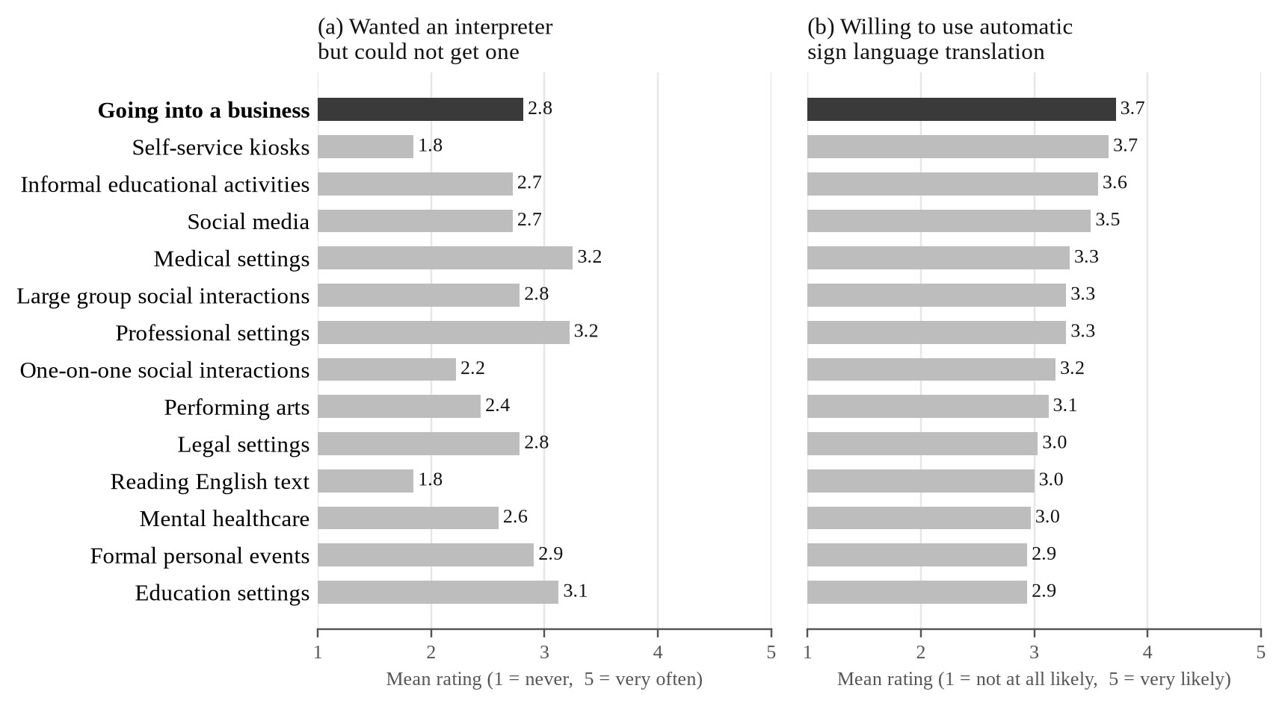
Fig. 1. Mean ratings by setting from a survey of 32 Deaf and hard-of-hearing ASL users: (a) how often they wanted a professional interpreter but could not get one; (b) how willing they would be to use automatic sign language translation. Settings are ordered by (b); the target setting of this project is highlighted. Data from Tran et al. [1]; means computed from the published response distributions.
Table 1. Design targets for the proposed device.
Parameter | Target | Rationale
Vocabulary | 100–250 ASL signs, with fingerspelling as a fallback | Covers common service-counter exchanges
Top-1 accuracy (unseen signers) | ≥ 75% | Best published baseline is 63.1% on all 2,731 ASL Citizen signs [2]
Top-5 accuracy (unseen signers) | ≥ 90% | The correct sign should almost always appear in the candidate list
Latency | < 1.2 s from confirmation to speech | Keeps the conversation flowing
Output languages | English, Turkish, Spanish | Chosen by the user on the touchscreen
Connectivity | Fully offline | Works anywhere; no video leaves the device
Platform | NVIDIA Jetson Orin Nano | Embedded GPU in a portable enclosure

3.4 Proposed Approach
Fig. 2 shows how the device is used at a service counter. A single red-green-blue (RGB) camera and the touchscreen face the Deaf user, while the speaker and microphone face the hearing staff member. Body, hand and face landmarks are extracted from each camera frame with MediaPipe [6]. In natural signing, signs flow into each other with minimal pauses, and segmenting them automatically is still an open research problem [9]. The user therefore signs one sign at a time and returns the hands to a rest position between signs, and the device uses this rest pose to mark where each sign ends. A lightweight landmark-based model classifies each sign and outputs its five most likely labels with confidence scores; its design follows the winning Kaggle solution [7]. The model will be trained on the ASL Citizen dataset and evaluated on its signer-independent test split, as well as on recordings from our own test users [2]. Words outside the vocabulary, such as names, will be handled by a fingerspelling fallback that recognizes letters one at a time.
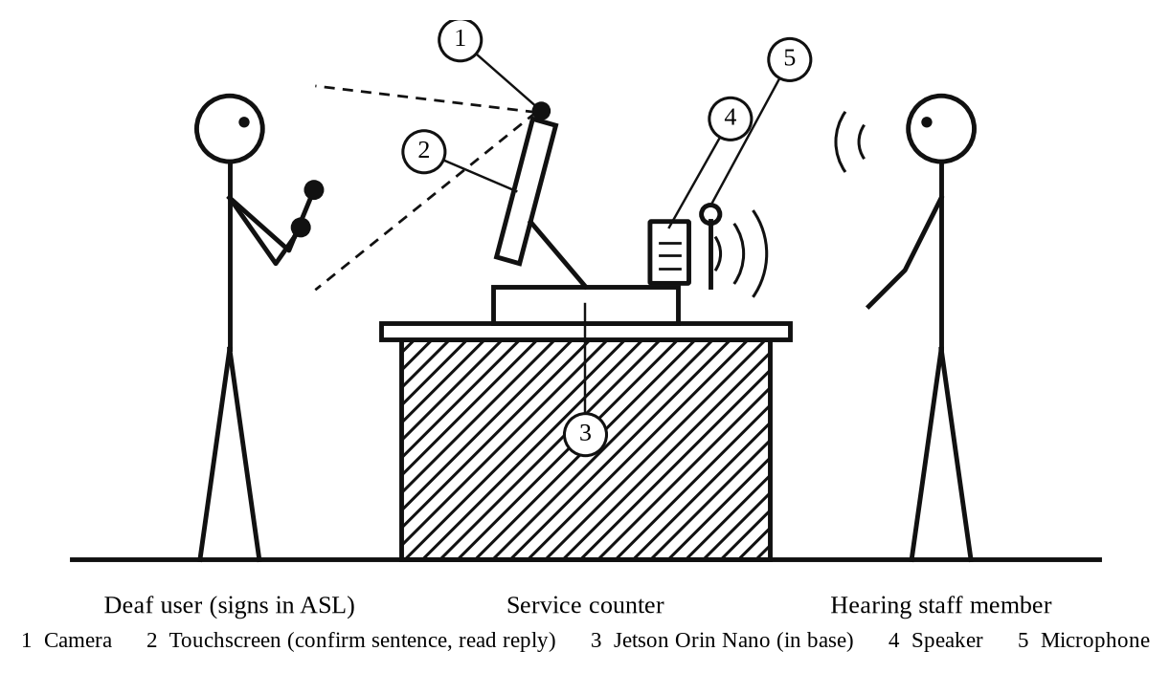
Fig. 2. The proposed device in use at a service counter (side view). The camera and touchscreen face the Deaf user; the speaker and microphone face the hearing staff member. All processing runs on the Jetson Orin Nano inside the base, without a network connection.
The recognized signs are ASL glosses, not English. ASL has its own word order and grammar, so a sequence such as STORE ME GO must become “I am going to the store.” A sentence builder performs this step, using templates for common phrases in the target setting and a small language model as a fallback, in line with recent work that applies pretrained language models to gloss-to-text translation [10]. The English sentence is shown on the touchscreen for the user to confirm or edit. Only confirmed sentences are translated into Turkish or Spanish with the No Language Left Behind (NLLB-200) translation model [11]. They are then spoken by Piper, an offline neural text-to-speech system [12]. In the reverse direction, a voice-activity detector starts listening when the hearing person speaks, and the microphone is muted while the device itself is speaking so that it does not transcribe its own voice. The reply is then transcribed and translated into English by the Whisper speech recognition model [13]. The text appears on the same touchscreen, so the hearing person needs no screen: they hear the device's speaker and speak into its microphone.
The device decides when to speak using the recognizer's confidence. If the confidence for a sign is above a threshold, the top sign is accepted; otherwise the touchscreen shows the five most likely candidates and the user picks one or signs again. Nothing is spoken until the user confirms the complete English sentence. This follows the idea of selective prediction, in which a model may abstain on uncertain inputs to raise accuracy on the answers it does give [14]. We will evaluate this trade-off with risk–coverage curves and report accuracy separately for each test signer.

3.5 Current Trends
Three trends shape the field. First, research is moving from gloss-based pipelines toward gloss-free and self-supervised models that learn from large amounts of unlabeled video [4], [5]. Pretrained language models are also increasingly used for the language side of translation [10]. Second, models are moving onto consumer and embedded hardware. Landmark-based recognizers are small enough to run in real time on phones and single-board computers, which makes offline, privacy-preserving devices practical [6], [7]. Third, the field increasingly recognizes that sign language technology must be designed with Deaf communities rather than for them. Researchers have called for systems built around specific, real-world use cases with input from Deaf culture and linguistics experts [15]. Deaf and hard-of-hearing participants in recent studies also emphasize Deaf-led design and warn of harm when they are excluded from decisions [16]. Our project follows the second and third trends directly; it does not attempt gloss-free continuous translation, which still requires large models and datasets.

3.6 Existing Systems
No automatic ASL translation system is yet reliable enough for general use [1]. The best-known commercial effort, SignAll, combines multiple cameras with natural language processing to translate ASL into English text [17]. Patents show several other approaches, summarized in Table 2. Avodah's system uses multiple cameras with a depth sensor [18]. Sign-Speak's system recognizes signs from a single camera using cloud processing [19]. Bosch's system uses gloves with motion sensors [20], and an earlier Hitachi system uses data gloves or a camera with speech output [21]. The closest to our design is Sign-Speak's system, which also works from a single camera and, in one embodiment, lets the user choose among the three most likely translations [19]. As Fig. 3 shows, however, its recognition runs on a remote server, so it needs a network connection and sends the user's data off the device [19]. Our device differs from all four in combining single-camera input, fully offline processing on an embedded GPU, confidence-gated output and speech in several languages. It is also a form factor the Deaf community is open to: 69% of the survey participants were comfortable using a stand-alone system of this kind, compared with 38% for wearables [1].
Table 2. Comparison of patented sign language translation systems with the proposed device.
System | Input | Processing | Output
Avodah [18] | Multiple cameras and a depth sensor | On device and in the cloud | Text, speech or a signing avatar; two-way
Sign-Speak [19] | Single camera | Remote server (requires a network connection) | Text in a target language; optional menu of the three most likely translations
Bosch [20] | Gloves with motion sensors | External processor | Text or audio in one or more languages
Hitachi [21] (expired) | Data gloves or camera | Local computer | Text or synthesized speech
Proposed device | Single RGB camera and microphone | On device, fully offline | Speech in English, Turkish or Spanish after user confirmation; reply shown as English text

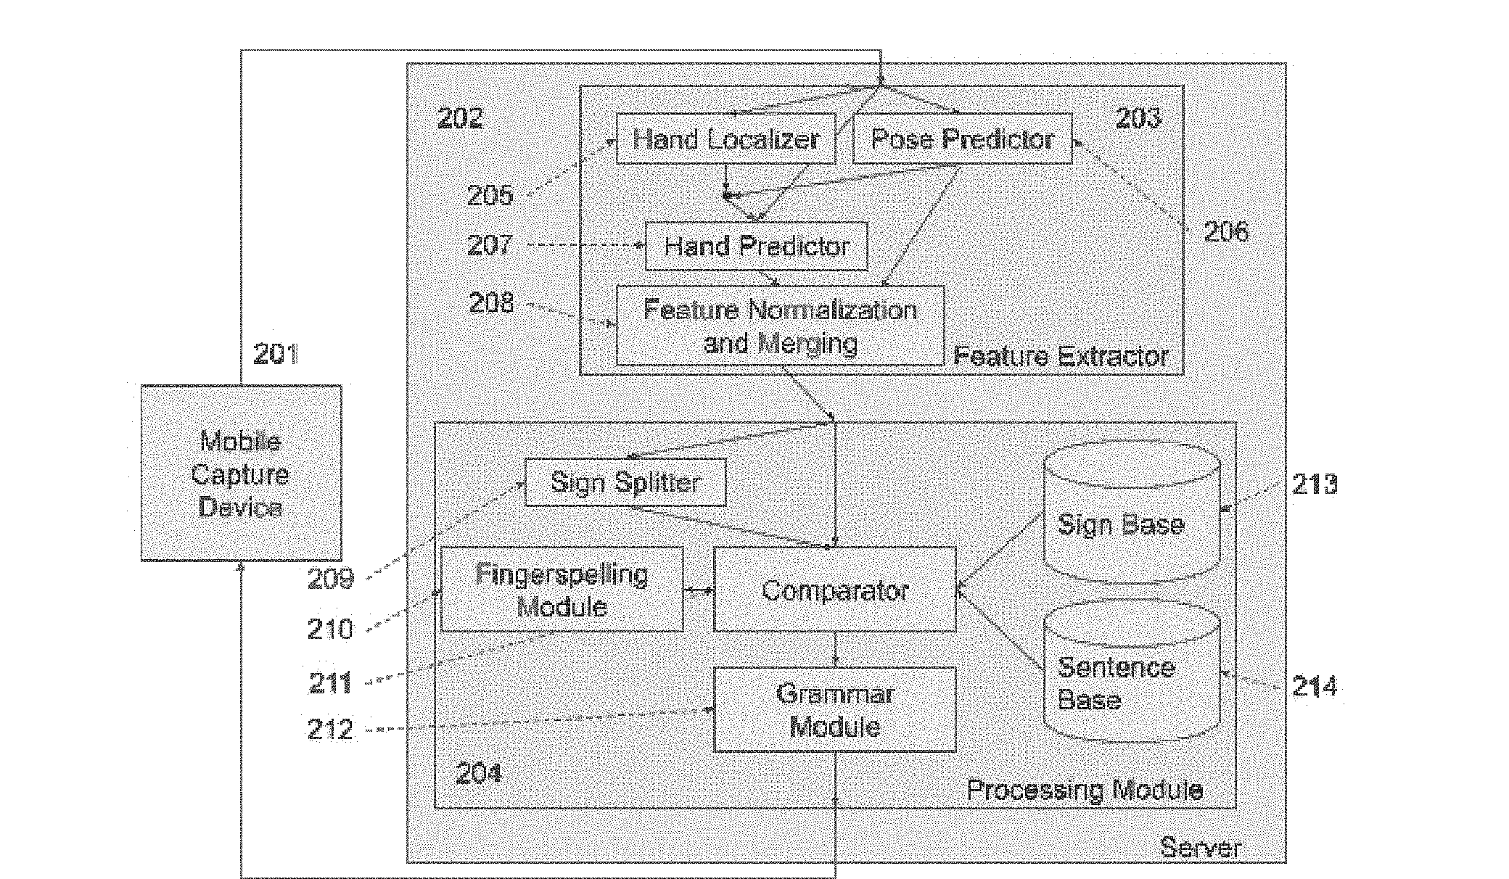
Fig. 3. Translation architecture in the Sign-Speak patent. A mobile capture device sends data to a remote server, where features are extracted and signs are matched against a sign and sentence base. Reproduced from U.S. Patent Appl. Pub. 2022/0327961 A1 [19].

3.7 Ethics, Economics and Sustainability
Surveys of Deaf communities also identify the ethical risks of this technology. More than 80% of the participants in the U.S. survey were concerned about hearing people profiting from ASL, systems missing ASL grammatical features, automatic translation weakening the legal right to other accommodations, and poorer performance for some users than others [1]. A 2025 global survey found the same pattern: about 80% of Deaf respondents were concerned about hearing people making money from sign language technology, and about 70% about the lack of Deaf people leading or contributing to it (Fig. 4) [16]. We address these concerns directly. The device is presented as a way to communicate when an interpreter is unavailable, not as a substitute that could justify withholding one. Its limits are stated plainly: it recognizes individual signs and does not capture facial grammar or continuous signing. Accuracy will be reported for each test signer, not only as an average. We will seek input from Deaf ASL users when choosing the vocabulary and testing the device, as recommended by previous studies [15], [16]. Because video never leaves the device, the design also avoids the privacy risk of streaming a user's image to a remote server.
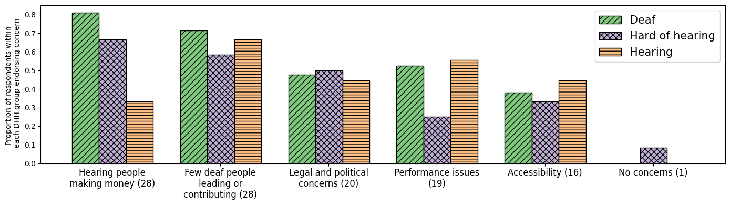
Fig. 4. Concerns about sign language technologies among Deaf, hard-of-hearing and hearing respondents in a global survey; numbers in parentheses are the number of mentions. Reproduced from Atwell et al. [16] under the Creative Commons Attribution 4.0 (CC BY 4.0) license.
Economically, certified interpreters are costly and often must be scheduled in advance [1]. Our device is built from off-the-shelf components (an embedded GPU module, a camera, a microphone, a speaker and a display) and uses open-source models, so once built it has no per-use service fees or cloud costs. A detailed cost estimate is given in Section 9. For sustainability, the device runs on a low-power embedded module rather than a desktop GPU or cloud servers, which keeps energy use low and avoids continuous data transmission. Standard, replaceable components make the device repairable and upgradable, and the software can be moved to newer hardware instead of the device being discarded.

12. References
1. Tran, N., Ladner, R. E., and Bragg, D. U.S. Deaf community perspectives on automatic sign language translation. Proceedings of the 25th International ACM SIGACCESS Conference on Computers and Accessibility (ASSETS ’23), New York, NY, USA, 2023. doi:10.1145/3597638.3614507.
2. Desai, A., Berger, L., Minakov, F. O., Milan, V., Singh, C., Pumphrey, K., Ladner, R. E., Daumé III, H., Lu, A. X., Caselli, N., and Bragg, D. ASL Citizen: A community-sourced dataset for advancing isolated sign language recognition. Advances in Neural Information Processing Systems, 36 (Datasets and Benchmarks Track), 2023. arXiv:2304.05934.
3. Zhang, X., and Duh, K. Approaching sign language gloss translation as a low-resource machine translation task. Proceedings of the 1st International Workshop on Automatic Translation for Signed and Spoken Languages (AT4SSL), 60–70, 2021.
4. Hu, J., He, Z., Huang, H., Li, Z., Li, Z., and Fang, Y. SignDino: Self-supervised sign language representation learning via temporal-axis self-distillation. arXiv preprint arXiv:2609.06296, 2026.
5. Gan, S., Liu, X., Yin, Y., Liu, N., Liu, K., Tuerdaken, D., Jiang, Z., Xie, L., Lu, S., and Wen, H. Learning effective sign features without text for gloss-free sign language translation. Proceedings of the IEEE/CVF Conference on Computer Vision and Pattern Recognition (CVPR), 9827–9836, 2026.
6. Lugaresi, C., Tang, J., Nash, H., McClanahan, C., Uboweja, E., Hays, M., Zhang, F., Chang, C.-L., Yong, M. G., Lee, J., Chang, W.-T., Hua, W., Georg, M., and Grundmann, M. MediaPipe: A framework for building perception pipelines. arXiv preprint arXiv:1906.08172, 2019.
7. Sohn, H. 1st place solution: 1DCNN combined with Transformer. Google – Isolated Sign Language Recognition Competition, Kaggle, 2023. Available: https://www.kaggle.com/competitions/asl-signs/writeups/hoyeol-sohn-1st-place-solution-1dcnn-combined-with [Accessed: 25-Sep-2026].
8. Licciardello, R., Fargetta, G., Ortis, A., and Battiato, S. CSLRTransformer: A pose-only system for continuous sign language recognition. Proceedings of the IEEE/CVF Conference on Computer Vision and Pattern Recognition (CVPR) Workshops, 2026.
9. Moryossef, A., Jiang, Z., Müller, M., Ebling, S., and Goldberg, Y. Linguistically motivated sign language segmentation. Findings of the Association for Computational Linguistics: EMNLP 2023, 12703–12724, 2023.
10. Fayyazsanavi, P., Anastasopoulos, A., and Košecká, J. Gloss2Text: Sign language gloss translation using LLMs and semantically aware label smoothing. Findings of the Association for Computational Linguistics: EMNLP 2024, 16162–16171, 2024.
11. NLLB Team, Costa-jussà, M. R., Cross, J., et al. No Language Left Behind: Scaling human-centered machine translation. arXiv preprint arXiv:2207.04672, 2022.
12. Hansen, M. Piper: A fast, local neural text to speech system. GitHub repository, 2023. Available: https://github.com/rhasspy/piper [Accessed: 25-Sep-2026].
13. Radford, A., Kim, J. W., Xu, T., Brockman, G., McLeavey, C., and Sutskever, I. Robust speech recognition via large-scale weak supervision. Proceedings of the 40th International Conference on Machine Learning (ICML), PMLR, 202, 28492–28518, 2023.
14. Traub, J., Bungert, T. J., Lüth, C. T., Baumgartner, M., Maier-Hein, K. H., Maier-Hein, L., and Jaeger, P. F. Overcoming common flaws in the evaluation of selective classification systems. Advances in Neural Information Processing Systems, 37, 2024.
15. Bragg, D., Koller, O., Bellard, M., Berke, L., Boudreault, P., Braffort, A., Caselli, N., Huenerfauth, M., Kacorri, H., Verhoef, T., Vogler, C., and Morris, M. R. Sign language recognition, generation, and translation: An interdisciplinary perspective. Proceedings of the 21st International ACM SIGACCESS Conference on Computers and Accessibility (ASSETS ’19), 16–31, 2019.
16. Atwell, K., Imai, S., Bragg, D., and Alikhani, M. “Nothing about us without us”: Perspectives of global Deaf and hard-of-hearing community members on sign language technologies. arXiv preprint arXiv:2512.08839, 2025.
17. SignAll Technologies. SignAll translates sign language to English automatically. PRWeb press release, 2018. Available: https://www.prweb.com/releases/signall-translates-sign-language-to-english-automatically-868736288.html [Accessed: 25-Sep-2026].
18. Menefee, M., Nash, D., and Chandler, T. Automated sign language translation and communication using multiple input and output modalities. U.S. Patent No. 10,489,639 B2, 2019.
19. Kelly, N. A. Realtime AI sign language recognition. U.S. Patent Application Publication No. 2022/0327961 A1, 2022.
20. Zhou, Z., Menne, T., Li, K., Xu, K., Feng, Z., and Lee, C.-H. System and method for automated sign language recognition. U.S. Patent Application Publication No. 2016/0307469 A1, 2016.
21. Sakou, H., Sagawa, H., Abe, M., Ichikawa, A., Inoue, K., Arai, K., Shimura, T., and Toda, Y. Sign recognition apparatus and method and sign translation system using same. U.S. Patent No. 5,887,069, 1999.

