Helen and John C. Hartmann Department of Electrical and Computer Engineering

ECE 414 Senior Design Project Proposal

Team Number: 9

Project Title: Multilingual Sign-to-Speech Communication Device: Edge-Deployed ASL Recognition with Confidence-Gated Speech Output

Name(s): Zeynep Hafsa Cakici ID# 31699521

Name(s): Dorukhan Cakir ID# 31699799

Name(s): Merrick Simmons ID# 31623224

Name(s): Asmar Hasanova ID# 31699507
- Abstract

We propose a portable, self-contained device that recognizes American Sign Language and speaks the result aloud in a selected language. A camera captures the signer, an on-board machine-learning model recognizes signs from a defined vocabulary, and the output is spoken only after the user confirms it on screen. The system abstains rather than voice an uncertain reading. A microphone and speech recognition display the hearing person's reply as text, making the exchange two-way. Components: camera, embedded graphics processing unit (GPU) computer, microphone, speaker, display. Intended for Deaf users, hospitals, schools and public services, where on-demand interpreters are costly or unavailable.

2. Table of Contents
3. Introduction 3
3.1 Background 3
3.2 Problem Statement 4
3.3 Objectives 4
3.4 Proposed Approach 6
3.5 Current Trends 8
3.6 Existing Systems 8
3.7 Ethics, Economics and Sustainability 9
4. Technical Goals 10
4.1 Goal 1: Sign Recognition with Abstention 11
4.2 Goal 2: Confirmed Multilingual Speech and Two-Way Conversation 12
4.3 Goal 3: Offline Embedded Integration 12
4.4 Team Responsibilities 13
5. Projected Community Impact and Relevant Ethical Issues 14
5.1 Community Impact 14
5.2 Ethical Issues 15
6. Relevant Engineering Standards, Project Constraints, Risk and Uncertainty 17
6.1 Relevant Engineering Standards 17
6.2 Project Constraints 19
6.3 Risk and Uncertainty Assessment 22
7. Design Methodology, Prototyping, Validation and Hardware Block Diagram 26
7.1 Design Flow 26
7.2 Design Objectives, Benchmarking and Design Concept 28
7.3 Component Design 30
7.4 Hardware Block Diagram 32
7.5 Preliminary Data and Simulations 34
7.6 Prototyping Plan 40
7.7 Verification and Validation 42
7.8 Prototype Assembly and Integration 46
8. Literature Review: Articles and Patents 47
8.1 Article 1: ASL Citizen Dataset 47
8.2 Article 2: U.S. Deaf Community Perspectives on Automatic Sign Language Translation 49
8.3 Patents 50
8.4 Originality and Comparison 58
12. References 60

3. Introduction
American Sign Language (ASL) is a complete natural language with its own grammar and vocabulary, distinct from English, and it is the primary language of about 500,000 Deaf and hard-of-hearing people in the United States [1]. When a Deaf ASL user needs to communicate with a hearing person who does not sign, a certified interpreter is usually needed, but one is often unavailable. Automatic translation could help fill this gap.

3.1 Background
Automatic sign language processing has advanced quickly, but no system yet translates ASL reliably enough for general real-world use [1]. Research is divided into two tasks. Isolated sign language recognition (ISLR) identifies a single sign from a fixed vocabulary. On the ASL Citizen dataset, which contains 83,399 videos of 2,731 signs from 52 signers, the best published baseline reaches 63.1% top-1 accuracy on signers not seen during training [2]. Sign language translation (SLT) converts continuous signing into full sentences. SLT models have traditionally been trained on glosses, written labels for each sign in a sentence, which are expensive to annotate and scarce for ASL [3].
Recent research is therefore moving toward gloss-free and self-supervised models. SignDino, for example, learns sign representations from video without any gloss or text labels [4]. Gan et al. similarly learn sign features without text supervision and use them for gloss-free translation [5]. A parallel trend is lightweight models that work on body and hand landmarks rather than on full video frames, which makes them small and fast enough for embedded hardware. MediaPipe is a widely used framework for extracting such landmarks [6]. The winning solution of the Google – Isolated Sign Language Recognition competition on Kaggle, a one-dimensional convolutional neural network (1D-CNN) combined with a transformer, is one example of a landmark-based recognizer [7]. Pose-only models have also been applied to continuous sign language recognition [8].
Because gloss-free continuous translation still requires large models and datasets, our project uses landmark-based isolated recognition over a limited vocabulary. This approach runs offline on an embedded graphics processing unit (GPU), can be evaluated sign by sign, and produces confidence scores that the device can use to abstain rather than guess.

3.2 Problem Statement
Deaf ASL users often cannot get an interpreter when they need one. In a recent survey of 32 U.S. Deaf and hard-of-hearing ASL users, participants most often wanted an interpreter but could not get one in medical settings, followed by professional and educational settings [1]. These are exactly the settings where interpreting is legally mandated, which shows that the problem is not only one of law but of availability [1]. Interpreters are costly, often must be booked in advance, and can take hours to arrive, especially in rural areas or at short notice [1].
Existing automated approaches also have three practical weaknesses. First, they typically output a translation even when uncertain, and a wrong translation can be worse than none, especially in high-stakes settings. Second, cloud-based systems need a reliable internet connection and stream video of the user to remote servers, which raises privacy concerns. Third, most are one-way: they convert signing to text but give the hearing person no way to reply without a second device.
Our device addresses each of these weaknesses. All processing runs locally on an embedded GPU, so the device works without a network connection and no video leaves it. A built-in microphone converts the hearing person's speech to on-screen text, so a single device supports a two-way conversation. The device speaks a sentence only after the user confirms it on screen, and when its confidence is low it shows a list of candidate signs instead of guessing. The device is intended to provide access when an interpreter is unavailable, such as at a service counter, a front desk, or while waiting for an interpreter to arrive. It is not a replacement for certified interpreters.

3.3 Objectives
The objective of this project is to design and build a portable prototype that lets a Deaf ASL user hold a short two-way conversation with a hearing person who speaks English, Turkish or Spanish, without an internet connection. The prototype is scoped to structured, everyday exchanges such as those at a service counter or front desk. Its technical goals, summarized in Table 1, are to recognize a vocabulary of 100–250 ASL signs at no less than 75% top-1 and 90% top-5 accuracy on signers not seen during training; to speak a confirmed sentence in the selected language within 1.2 s of the user's confirmation; to show the hearing person's spoken reply as English text; and to run entirely on an embedded GPU. The project also has a reliability objective: the device should abstain rather than voice a translation it is not confident in, and we will report its accuracy on the sentences it does speak, not only its overall accuracy. These figures are design targets; measured results will be reported as the project progresses.
We chose the service-counter setting based on Deaf users' own priorities. Fig. 1 summarizes the survey ratings by setting. “Going into a business” received the highest willingness to use automatic translation, and every participant showed at least some willingness there; self-service kiosks and informal educational activities followed, while mental healthcare, education settings and formal personal events ranked lowest (Fig. 1(b)) [1]. Business settings also show a moderate unmet need for interpreters (Fig. 1(a)), so a device there would fill a real gap where users are most open to the technology. Participants also held their lowest accuracy expectations for kiosk-type exchanges and their highest for medical settings [1]. A service counter is therefore a realistic first target for a system with a vocabulary of a few hundred signs.
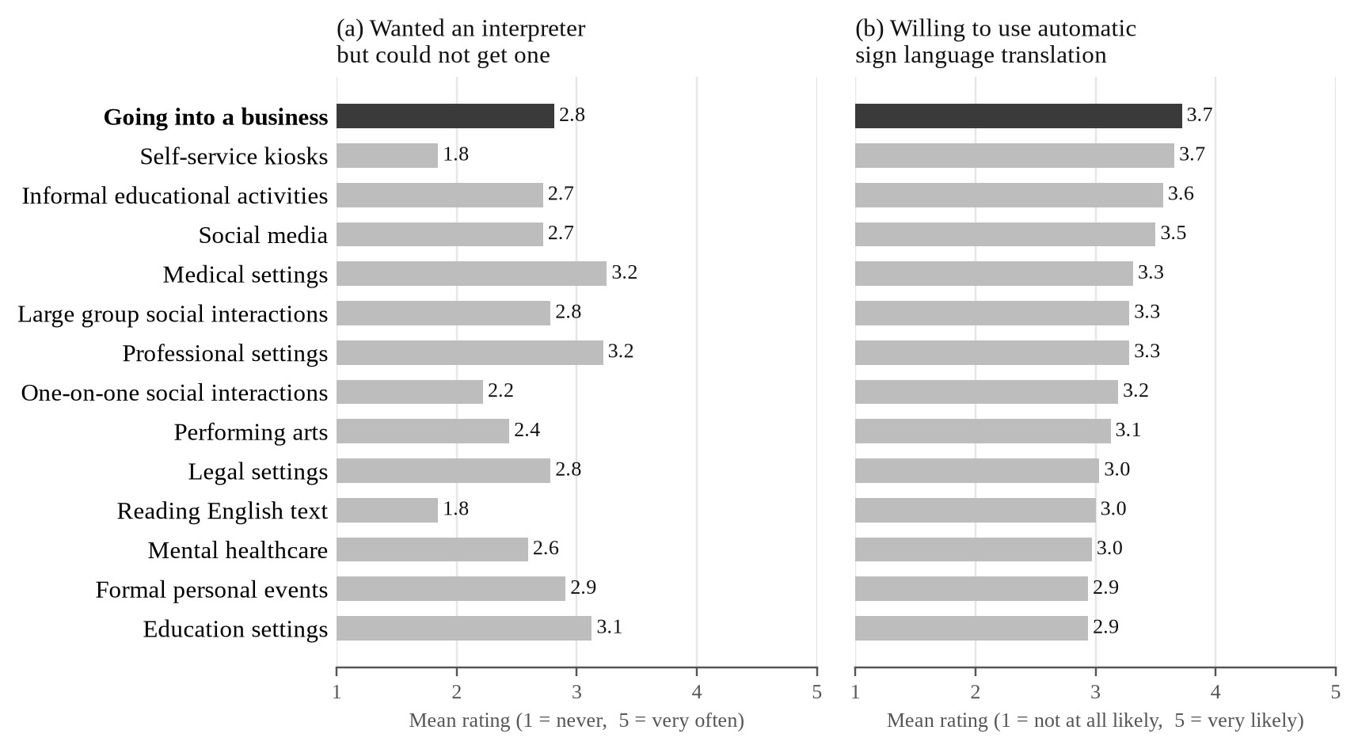
Fig. 1. Mean ratings by setting from a survey of 32 Deaf and hard-of-hearing ASL users: (a) how often they wanted a professional interpreter but could not get one; (b) how willing they would be to use automatic sign language translation. Settings are ordered by (b); the target setting of this project is highlighted. Data from Tran et al. [1]; means computed from the published response distributions.
Table 1. Design targets for the proposed device.
Parameter | Target | Rationale
Vocabulary | 100–250 ASL signs, with fingerspelling as a fallback | Covers common service-counter exchanges
Top-1 accuracy (unseen signers) | ≥ 75% | Best published baseline is 63.1% on all 2,731 ASL Citizen signs [2]
Top-5 accuracy (unseen signers) | ≥ 90% | The correct sign should almost always appear in the candidate list
Latency | < 1.2 s from confirmation to speech | Keeps the conversation flowing
Output languages | English, Turkish, Spanish | Chosen by the user on the touchscreen
Connectivity | Fully offline | Works anywhere; no video leaves the device
Platform | NVIDIA Jetson Orin Nano | Embedded GPU in a portable enclosure

3.4 Proposed Approach
Fig. 2 shows how the device is used at a service counter. A single red-green-blue (RGB) camera and the touchscreen face the Deaf user, while the speaker and microphone face the hearing staff member. Body, hand and face landmarks are extracted from each camera frame with MediaPipe [6]. In natural signing, signs flow into each other with minimal pauses, and segmenting them automatically is still an open research problem [9]. The user therefore signs one sign at a time and returns the hands to a rest position between signs, and the device uses this rest pose to mark where each sign ends. A lightweight landmark-based model classifies each sign and outputs its five most likely labels with confidence scores; its design follows the winning Kaggle solution [7]. The model will be trained on the ASL Citizen dataset and evaluated on its signer-independent test split, as well as on recordings from our own test users [2]. Words outside the vocabulary, such as names, will be handled by a fingerspelling fallback that recognizes letters one at a time.
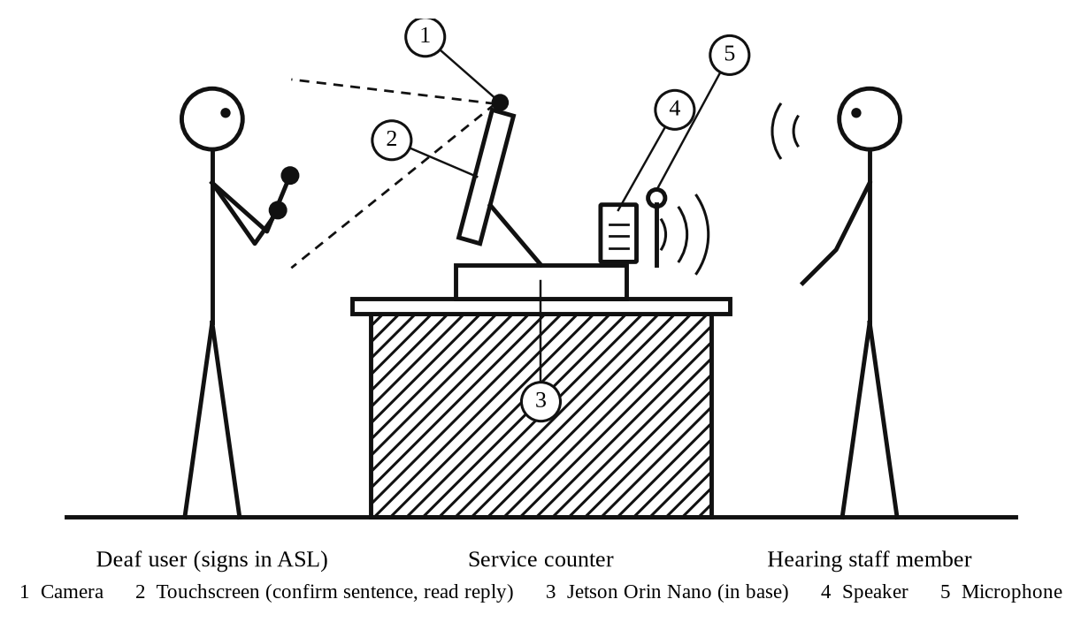
Fig. 2. The proposed device in use at a service counter (side view). The camera and touchscreen face the Deaf user; the speaker and microphone face the hearing staff member. All processing runs on the Jetson Orin Nano inside the base, without a network connection.
The recognized signs are ASL glosses, not English. ASL has its own word order and grammar, so a sequence such as STORE ME GO must become “I am going to the store.” A sentence builder performs this step, using templates for common phrases in the target setting and a small language model as a fallback, in line with recent work that applies pretrained language models to gloss-to-text translation [10]. The English sentence is shown on the touchscreen for the user to confirm or edit. Only confirmed sentences are translated into Turkish or Spanish with the No Language Left Behind (NLLB-200) translation model [11]. They are then spoken by Piper, an offline neural text-to-speech system [12]. In the reverse direction, a voice-activity detector starts listening when the hearing person speaks, and the microphone is muted while the device itself is speaking so that it does not transcribe its own voice. The reply is then transcribed and translated into English by the Whisper speech recognition model [13]. The text appears on the same touchscreen, so the hearing person needs no screen: they hear the device's speaker and speak into its microphone.
The device decides when to speak using the recognizer's confidence. If the confidence for a sign is above a threshold, the top sign is accepted; otherwise the touchscreen shows the five most likely candidates and the user picks one or signs again. Nothing is spoken until the user confirms the complete English sentence. This follows the idea of selective prediction, in which a model may abstain on uncertain inputs to raise accuracy on the answers it does give [14]. We will evaluate this trade-off with risk–coverage curves and report accuracy separately for each test signer.

3.5 Current Trends
Three trends shape the field. First, research is moving from gloss-based pipelines toward gloss-free and self-supervised models that learn from large amounts of unlabeled video [4], [5]. Pretrained language models are also increasingly used for the language side of translation [10]. Second, models are moving onto consumer and embedded hardware. Landmark-based recognizers are small enough to run in real time on phones and single-board computers, which makes offline, privacy-preserving devices practical [6], [7]. Third, the field increasingly recognizes that sign language technology must be designed with Deaf communities rather than for them. Researchers have called for systems built around specific, real-world use cases with input from Deaf culture and linguistics experts [15]. Deaf and hard-of-hearing participants in recent studies also emphasize Deaf-led design and warn of harm when they are excluded from decisions [16]. Our project follows the second and third trends directly; it does not attempt gloss-free continuous translation, which still requires large models and datasets.

3.6 Existing Systems
No automatic ASL translation system is yet reliable enough for general use [1]. The best-known commercial effort, SignAll, combines multiple cameras with natural language processing to translate ASL into English text [17]. Patents show several other approaches, summarized in Table 2. Avodah's system uses multiple cameras with a depth sensor [18]. Sign-Speak's system recognizes signs from a single camera using cloud processing [19]. Bosch's system uses gloves with motion sensors [20], and an earlier Hitachi system uses data gloves or a camera with speech output [21]. The closest to our design is Sign-Speak's system, which also works from a single camera and, in one embodiment, lets the user choose among the three most likely translations [19]. As Fig. 3 shows, however, its recognition runs on a remote server, so it needs a network connection and sends the user's data off the device [19]. Our device differs from all four in combining single-camera input, fully offline processing on an embedded GPU, confidence-gated output and speech in several languages. It is also a form factor the Deaf community is open to: 69% of the survey participants were comfortable using a stand-alone system of this kind, compared with 38% for wearables [1].
Table 2. Comparison of patented sign language translation systems with the proposed device.
System | Input | Processing | Output
Avodah [18] | Multiple cameras and a depth sensor | On device and in the cloud | Text, speech or a signing avatar; two-way
Sign-Speak [19] | Single camera | Remote server (requires a network connection) | Text in a target language; optional menu of the three most likely translations
Bosch [20] | Gloves with motion sensors | External processor | Text or audio in one or more languages
Hitachi [21] (expired) | Data gloves or camera | Local computer | Text or synthesized speech
Proposed device | Single RGB camera and microphone | On device, fully offline | Speech in English, Turkish or Spanish after user confirmation; reply shown as English text

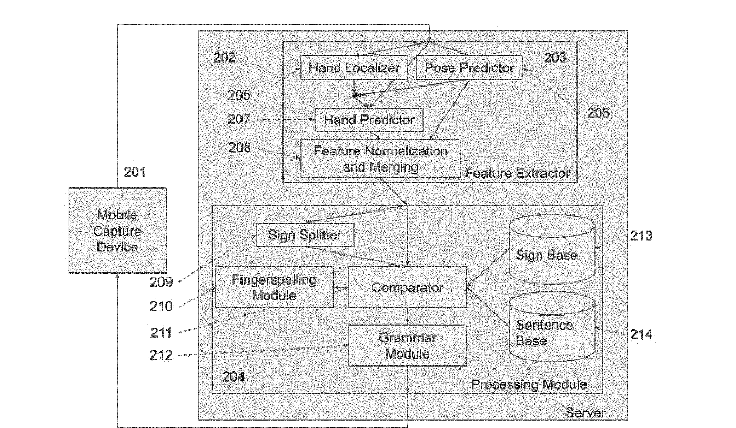
Fig. 3. Translation architecture in the Sign-Speak patent. A mobile capture device sends data to a remote server, where features are extracted and signs are matched against a sign and sentence base. Reproduced from U.S. Patent Appl. Pub. 2022/0327961 A1 [19].

3.7 Ethics, Economics and Sustainability
Surveys of Deaf communities also identify the ethical risks of this technology. More than 80% of the participants in the U.S. survey were concerned about hearing people profiting from ASL, systems missing ASL grammatical features, automatic translation weakening the legal right to other accommodations, and poorer performance for some users than others [1]. A 2025 global survey found the same pattern: about 80% of Deaf respondents were concerned about hearing people making money from sign language technology, and about 70% about the lack of Deaf people leading or contributing to it (Fig. 4) [16]. We address these concerns directly. The device is presented as a way to communicate when an interpreter is unavailable, not as a substitute that could justify withholding one. Its limits are stated plainly: it recognizes individual signs and does not capture facial grammar or continuous signing. Accuracy will be reported for each test signer, not only as an average. We will seek input from Deaf ASL users when choosing the vocabulary and testing the device, as recommended by previous studies [15], [16]. Because video never leaves the device, the design also avoids the privacy risk of streaming a user's image to a remote server.
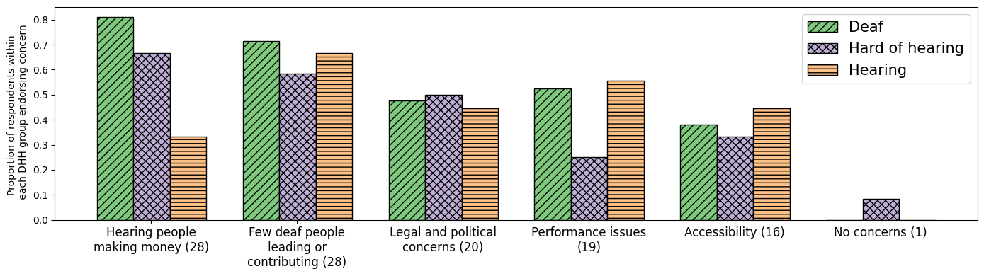
Fig. 4. Concerns about sign language technologies among Deaf, hard-of-hearing and hearing respondents in a global survey; numbers in parentheses are the number of mentions. Reproduced from Atwell et al. [16] under the Creative Commons Attribution 4.0 (CC BY 4.0) license.
Economically, certified interpreters are costly and often must be scheduled in advance [1]. Our device is built from off-the-shelf components (an embedded GPU module, a camera, a microphone, a speaker and a display) and uses open-source models, so once built it has no per-use service fees or cloud costs. A detailed cost estimate is given in Section 9. For sustainability, the device runs on a low-power embedded module rather than a desktop GPU or cloud servers, which keeps energy use low and avoids continuous data transmission. Standard, replaceable components make the device repairable and upgradable, and the software can be moved to newer hardware instead of the device being discarded.

4. Technical Goals
This section defines the three major technical goals of the project. Each goal corresponds to one part of the system shown in Fig. 2 and has measurable targets, so that the prototype can be validated objectively during ECE 416. The goals build on each other: Goal 1 produces recognized signs, Goal 2 turns them into a confirmed spoken sentence and carries the reply back, and Goal 3 makes the complete system run on portable hardware without a network connection. Table 3 summarizes the targets and how each will be verified, and Table 4 lists the team members responsible for each goal.

4.1 Goal 1: Sign Recognition with Abstention
The first goal is to recognize a vocabulary of 100–250 ASL signs from the camera image, and to know when the recognition is not reliable. The vocabulary will be chosen for the service-counter setting, covering greetings, common requests, questions about prices and directions, numbers and basic responses. To make sure the selected signs are the ones Deaf users actually need, the vocabulary will be reviewed with Deaf ASL users before training begins.
Recognition works on body and hand landmarks rather than raw video, which keeps the model small enough for the embedded hardware. MediaPipe extracts the landmarks from each frame [6], and the user returns the hands to a rest position between signs so that the device can tell where each sign ends. A lightweight landmark-based classifier, following the design of the winning Kaggle solution [7], will be trained on the ASL Citizen dataset [2] and outputs the five most likely signs with a confidence score for each.
The confidence scores are as important as the predictions themselves, because the device uses them to decide whether to accept a sign or to ask the user. A calibration step will adjust the scores so that, for example, signs reported with 90% confidence are correct about 90% of the time. The targets are at least 75% top-1 and 90% top-5 accuracy on signers not seen during training, measured on the ASL Citizen signer-independent test split and on recordings from our own test users. In addition, we will report the accuracy on the signs the device accepts together with the share of signs it accepts, using risk–coverage analysis [14]. Accuracy will be reported separately for each test signer, so that any signer for whom the system performs poorly is visible rather than hidden in an average. The fingerspelling fallback described in Section 3.4, which handles words outside the vocabulary such as names by recognizing letters one at a time, is treated as a stretch goal: it will be added once the main vocabulary meets the targets above, and it is not part of the accuracy targets.

4.2 Goal 2: Confirmed Multilingual Speech and Two-Way Conversation
The second goal is to turn the recognized signs into a correct spoken sentence in the language the user selects, and to carry the hearing person's reply back as text. Recognized signs are ASL glosses, so a sentence builder first produces natural English. It uses templates for frequent service-counter phrases, such as “I would like ___” or “How much is ___?”, and falls back to a small language model for other sign sequences [10].
The English sentence is shown on the touchscreen, where the user can confirm it, replace a word with another candidate, delete a word, or sign again. Only a confirmed sentence is passed on. If Turkish or Spanish is selected, the sentence is translated with NLLB-200 [11]; if English is selected, translation is skipped. Piper then speaks the sentence with a voice for the selected language [12]. In the reverse direction, a voice-activity detector starts recording when the hearing person speaks, and the microphone is muted while the device is speaking. Whisper transcribes the reply and translates it into English [13], using the selected language as a hint to improve accuracy, and the text is shown on the touchscreen.
The main target for this goal is a latency of less than 1.2 s from the user's confirmation to the start of speech, which keeps the conversation flowing. Translation quality will be checked on a fixed test set of service-counter phrases, with each Turkish and Spanish output rated by native speakers. The accuracy of the reply channel will be measured as the word error rate of the transcription on recorded test replies.

4.3 Goal 3: Offline Embedded Integration
The third goal is to run the complete system on an NVIDIA Jetson Orin Nano, which the team will purchase, in a portable enclosure with a camera, touchscreen, microphone and speaker. All processing must happen on the device without any network connection, which is what allows the device to protect users' privacy and to work in places without internet access.
Running several neural networks at the same time on an embedded module is the main engineering challenge of the project. The landmark extractor, sign recognizer, sentence builder, translation model, text-to-speech system and speech recognizer all share the module's 8 GB of memory and its graphics processor. The models will therefore be converted to optimized runtimes such as ONNX Runtime or TensorRT, and the smallest model size that meets the accuracy targets will be chosen for each component. The targets are landmark extraction and recognition at no less than 15 frames per second during live use, all models fitting within the available memory, and a complete conversation working with networking disabled. We will also measure the device's power draw in watts, both idle and in use, to choose between battery and wall power.

4.4 Team Responsibilities
Each technical goal has a responsible team member, listed in Table 4. Goal 2 has the most separate components, from the sentence builder and touchscreen interface to translation, text-to-speech and speech recognition, so it is shared by two members. Tasks that span the whole project, including the schedule, reports, presentations and testing with Deaf ASL users, are shared by the entire team, and members will support each other at integration points such as the interface between the recognizer and the sentence builder.
Table 3. Measurable targets and verification methods for the technical goals.
Goal | Target | How it will be verified
1. Sign recognition | ≥ 75% top-1 and ≥ 90% top-5 accuracy on unseen signers, for 100–250 signs | ASL Citizen signer-independent test split and recordings from our own test users
1. Sign recognition | Accuracy on accepted signs reported together with the share of signs accepted | Risk–coverage curves over a range of confidence thresholds
1. Sign recognition (stretch goal) | Fingerspelling of out-of-vocabulary words such as names | Letter accuracy on recorded fingerspelled words
2. Language and speech | < 1.2 s from the user's confirmation to the start of speech | Timestamps logged on the device for every test sentence
2. Language and speech | Turkish and Spanish output judged acceptable for service-counter phrases | A fixed test set of phrases rated by native speakers
2. Language and speech | Hearing person's reply shown as readable English text | Word error rate of the transcription on recorded test replies
3. Embedded integration | ≥ 15 frames per second for landmark extraction and recognition | Profiling on the Jetson Orin Nano during live use
3. Embedded integration | All models fit within 8 GB of memory; full conversation works offline | Memory monitoring and end-to-end tests with networking disabled
3. Embedded integration | Power draw measured to select the power supply | Power measurement in watts during idle and active use

Table 4. Team responsibilities for the technical goals.
Goal | Responsible members | Main tasks
Goal 1: Sign recognition | Asmar Hasanova | Vocabulary selection with Deaf ASL users, landmark extraction, rest-pose segmentation, model training, confidence calibration, accuracy evaluation
Goal 2: Language and speech | Dorukhan Cakir, Zeynep Hafsa Cakici | Sentence builder, touchscreen interface, translation, text-to-speech, speech recognition, latency measurement
Goal 3: Embedded integration | Merrick Simmons | Hardware purchase and setup, enclosure, deployment and optimization on the Jetson Orin Nano, frame-rate and power measurement

5. Projected Community Impact and Relevant Ethical Issues

5.1 Community Impact
The main beneficiaries of this project are Deaf ASL users, a group whose need for interpreters often goes unmet [1]. In everyday situations such as buying something at a store, asking a question at a bank or checking in at a front desk, a Deaf person today often has to write notes, rely on a family member to interpret, or simply leave without the information they needed. The device lets them communicate in their own language and on their own, with the hearing person hearing a spoken sentence instead of reading a note. Because the user confirms every sentence before it is spoken, they stay in control of what is said on their behalf.
The device also serves multilingual communities. Because the spoken output can be in English, Turkish or Spanish, a Deaf customer can communicate directly with staff or family members who are more comfortable in Turkish or Spanish than in English. This matters in diverse regions such as New Jersey, where many families and workers speak a language other than English at home.
Businesses and public services benefit as well. Under the Americans with Disabilities Act (ADA), businesses and nonprofits that serve the public must communicate effectively with people who have communication disabilities [22]. For long or complex conversations, a qualified interpreter remains the right solution, and the device does not replace one. For short, routine exchanges for which an interpreter is rarely available at short notice, the device gives staff a practical way to communicate. Because it runs offline, it can also be used in rural areas and in buildings without reliable internet access.
The design also has environmental benefits. Running on a low-power embedded module instead of cloud servers reduces energy use and avoids the continuous upload of video. Because the device is built from off-the-shelf, replaceable parts and open-source software, it can be repaired and upgraded rather than discarded, and its software can be moved to newer hardware at the end of the module's life.

5.2 Ethical Issues
We follow the IEEE Code of Ethics, which asks engineers to hold paramount the safety, health and welfare of the public, to protect the privacy of others, to avoid harm, to treat all persons fairly, and to be honest and realistic in stating claims [23]. The most important ethical issues for this project are discussed below, and Table 5 summarizes all of them together with our response to each.
The first issue is the risk of replacing interpreters. In the U.S. survey, 28 of the 32 Deaf and hard-of-hearing participants (88%) were concerned that automatic translation could weaken the legal protections of their right to accommodations such as interpreters [1]. A device like ours could be misused by an organization as a cheaper substitute in situations where a qualified interpreter is required. We will therefore describe and label the device as an aid for situations where no interpreter is available, and state this both in its documentation and on its start screen.
The second issue is harm from wrong translations. A misrecognized sign can change the meaning of a sentence, and in medical, legal or financial situations the consequences can be serious. Our design addresses this in two ways: the device abstains and shows candidate signs when it is unsure, and nothing is spoken until the user has read and confirmed the English sentence. High-stakes settings remain outside the intended use of the prototype.
The third issue is fairness. Sign recognition systems can work less well for some people, for example because of differences in signing style, handedness, skin tone or lighting. We will test with signers who differ in these respects, report accuracy for each signer rather than only an average, and publish any limits we find. Privacy and consent are closely related: the camera captures users' faces and bodies, so all processing stays on the device and no video or audio is stored or transmitted. We use consent-based training data such as ASL Citizen [2], and any recordings we make ourselves will be collected with written consent.
Finally, Deaf involvement is the issue that Deaf communities themselves rank highest. Both surveys cited in Section 3 show that the strongest concerns are hearing people profiting from ASL and sign language technology being built without Deaf input [1], [16]. We will therefore contact the ASL community at NJIT before choosing the vocabulary, invite Deaf signers to test the prototype, credit their contributions, and adjust the design based on their feedback. Any testing with people will follow NJIT's requirements for research involving human participants.
Table 5. Ethical issues and how the project addresses them.
Issue | Risk | Our response
Replacing interpreters | Organizations could use the device to avoid providing a required interpreter, weakening Deaf users' legal rights | Present and label the device as an aid for when no interpreter is available, in all documentation and on its start screen
Wrong translations | A mistranslation in a medical, legal or financial exchange can cause harm | Nothing is spoken without user confirmation; the device abstains when unsure; high-stakes settings are out of scope
Unequal performance | Accuracy may be lower for some signers because of signing style, handedness, skin tone or lighting | Test with diverse signers and report accuracy for each signer, along with known limits
Privacy | The camera captures users' faces and bodies, and the microphone records the reply | All processing stays on the device; no video or audio is stored or transmitted
Data consent | Training data come from real people | Use consent-based datasets such as ASL Citizen; obtain written consent for any recordings we make
Deaf involvement | Hearing-led projects that profit from ASL are the community's top concern | Involve Deaf ASL users in vocabulary selection and testing, and credit their contributions
Scope and honesty | Users may expect full ASL translation | State plainly that the device recognizes individual signs and does not capture facial grammar
Accessibility | Replies shown as English text may be hard for users less fluent in written English | Use short sentences and an adjustable font size; record this as a known limitation

6. Relevant Engineering Standards, Project Constraints, Risk and Uncertainty
This section lists the engineering standards that guide the design and testing of the device, the constraints that limit the design, and the main risks to the project together with the steps we will take to reduce them.

6.1 Relevant Engineering Standards
We searched the IEEE Standards Association catalog and U.S. national standards for documents that apply to an artificial intelligence (AI) based assistive device that records people with a camera and a microphone. Six standards were selected: four IEEE standards covering ethical design, data privacy, verification and model evaluation, and two national documents covering equipment safety and AI risk management. Each is given below with its number, title, a short description and its relevance to the project.
IEEE 7000-2021, IEEE Standard Model Process for Addressing Ethical Concerns during System Design [24]
Description. This standard defines a process for identifying the values of the people a system affects, turning those values into ethical requirements, and tracing them through the system design and its risk assessment. It applies from the earliest concept stage and works with an organization's existing development life cycle.
Relevance to the project. The Deaf community's main concerns about sign language technology are being left out of its design, harm from wrong translations, and the replacement of human interpreters [1], [16]. IEEE 7000 gives us a structured way to address these concerns instead of treating them as an afterthought. We will collect values from Deaf ASL users at NJIT during vocabulary selection, write them as requirements (for example, “nothing is spoken without the user’s confirmation” and “the device never presents itself as a replacement for an interpreter”), and trace each requirement to a design feature and a test. Table 5 in Section 5 is the starting point of this trace.
IEEE 7002-2022, IEEE Standard for Data Privacy Process [25]
Description. This standard specifies an engineering process for building privacy into products and systems that use personal data. It includes privacy impact assessments, which find where privacy controls are needed, and checklists to confirm that those controls are in place.
Relevance to the project. The device continuously captures the user’s face, body and hands, and the hearing person’s voice, which are personal data. We will carry out a privacy impact assessment for both the device and our own test recordings. It will document that all processing stays on the device, that no video or audio is stored or transmitted during normal use, and that test recordings are made only with written consent, saved as body and hand landmarks rather than video where possible, and kept in the team’s private storage.
IEEE 1012-2024, IEEE Standard for System, Software, and Hardware Verification and Validation [26]
Description. This standard defines verification and validation (V&V) processes, tasks, inputs and outputs for the whole life cycle of systems, software and hardware, including off-the-shelf and reused components. The required V&V tasks grow with the integrity level of each part of the system. It replaces IEEE 1012-2016.
Relevance to the project. Our system combines a sign recognition model that we train with off-the-shelf models (MediaPipe, NLLB-200, Piper and Whisper) and purchased hardware. Following this standard, we will write a V&V plan that links every target in Table 3 to a verification method, the test data and a pass criterion, and that verifies each component on its own before the end-to-end tests on the Jetson Orin Nano. Because a wrong spoken sentence can mislead the listener, the confidence threshold and the confirmation screen are treated as the highest-integrity parts of the system and are tested most thoroughly.
IEEE 2841-2022, IEEE Recommended Practice for Framework and Process for Deep Learning Evaluation [27]
Description. This recommended practice gives a set of evaluation indicators and a process for assessing deep learning algorithms through the requirements, design, implementation and operation stages, with the aim of improving their reliability.
Relevance to the project. Sign recognition, translation, speech synthesis and speech recognition in our device are all deep learning models. We will use this framework to define how each model is evaluated: on test signers who were never seen during training, with accuracy reported for each signer, calibration error and risk–coverage curves [14], and not only a single average accuracy. This is important because our preliminary results already show large differences in accuracy between signers (Section 6.3).
ANSI/UL 62368-1 (3rd edition, 2019), Audio/Video, Information and Communication Technology Equipment – Part 1: Safety Requirements [28]
Description. This is the U.S. national safety standard for electronic equipment such as computers, displays and audio devices, harmonized with the international standard IEC 62368-1. It classifies the energy sources inside the equipment (electrical, thermal and fire) and specifies safeguards that protect users from them.
Relevance to the project. The device is used close to people for long periods and contains a power supply, a processor module that runs hot under load, and possibly a lithium-ion battery. We will use only power supplies and batteries already certified to this standard, keep the outside of the enclosure at a safe touch temperature, provide ventilation for the Jetson module, and protect cables against strain and short circuits. We will not certify the prototype itself, but designing to this standard keeps the path to a real product open.
NIST AI 100-1, Artificial Intelligence Risk Management Framework (AI RMF 1.0) [29]
Description. This voluntary U.S. framework from the National Institute of Standards and Technology helps organizations manage the risks of AI systems through four functions: Govern, Map, Measure and Manage. It is organized around the characteristics of trustworthy AI, including validity and reliability, safety, fairness, privacy and transparency.
Relevance to the project. The framework matches the way we handle errors in this project. We map where a recognition error can harm a user, measure the error (accuracy for each signer, calibration and acceptance of signs outside the vocabulary), and manage it through abstention, user confirmation and a clear statement of what the device cannot do. The risk assessment in Section 6.3 follows this structure.

6.2 Project Constraints
The design is limited by six groups of constraints: technical, economic, legal and regulatory, ethical and social, time, and environmental, health and safety constraints. Each is explained below.
Technical constraints. The complete system must run on an NVIDIA Jetson Orin Nano, which has 8 GB of memory shared between the processor and the graphics processing unit (GPU). Landmark extraction, sign recognition, the sentence builder, translation (NLLB-200), speech synthesis (Piper) and speech recognition (Whisper) must all fit in this memory, which limits model size and requires reduced numerical precision and loading some models only when they are needed. The device must also meet the timing targets in Table 3: at least 15 frames per second for landmark extraction and recognition, and less than 1.2 s from the user’s confirmation to the start of speech. Input comes from a single RGB camera with no depth sensor, so lighting, background, camera angle and distance all affect the landmarks. Recognition is limited to a fixed vocabulary of 100–250 signs made one at a time or a few in a row, and facial grammar is not modeled. Finally, the device must work fully offline, so no cloud services can be used for any part of the pipeline.
Economic constraints. The prototype has no outside funding: the four team members will split its cost equally. It therefore uses off-the-shelf parts and open-source software with no license fees. Table 6 gives the estimated hardware cost of one prototype, about $495–$665, or about $125–$165 per team member (the detailed estimate will be given in Section 9). Model training uses free or low-cost cloud GPU time (Kaggle and Google Colab), which limits how large the models and how long the training runs can be. For the device to be useful to businesses and public services, its total cost must stay far below the cost of repeated interpreter services [1].
Table 6. Estimated hardware cost of one prototype (prices to be confirmed at purchase).
Component | Purpose | Estimated cost (USD)
NVIDIA Jetson Orin Nano developer kit | Runs all models on the device | 250
NVMe solid-state drive, 256 GB | Operating system and model storage | 30–40
USB RGB camera, 1080p | Captures the signer | 40–70
USB microphone | Captures the hearing person’s reply | 20–40
Powered speaker | Plays the spoken output | 15–30
7-inch touchscreen display | Confirmation screen and reply text | 60–90
Enclosure (3D printed), cables and mounts | Housing and assembly | 20–40
Battery pack (optional) | Portable operation | 50–80
DisplayPort-to-HDMI adapter, push button, LED and power switch | Display connection, controls and power selection (Fig. 6) | 10–25
Total |  | 495–665

Legal and regulatory constraints. Under the Americans with Disabilities Act (ADA), businesses and public services must communicate effectively with Deaf people, which often means providing a qualified interpreter [22]. The device must therefore never be presented as a replacement for an interpreter. The data and models we use also carry license conditions. ASL Citizen may be used only for non-commercial research, and neither the data nor anything derived from it may be redistributed; the Kaggle competition data may not be redistributed either; and the NLLB-200 translation models are released for non-commercial use only, and each Piper voice has its own license that must be checked. A commercial version would need a different translation model and newly licensed training data. Recordings of Deaf participants require written consent, and we must check with NJIT whether Institutional Review Board (IRB) approval is needed before we record them. If the device became a product, it would need Federal Communications Commission (FCC) equipment authorization under Part 15 as a digital device before it could be sold, and safety certification (Section 6.1). It would also need a freedom-to-operate review of the active patents in Section 8, in particular the granted Sign-Speak patent [19], whose main claim covers pose-based sign recognition in general terms.
Ethical and social constraints. As discussed in Section 5, the device must not speak a sentence the user has not confirmed, must work fairly for different signers, must state its limits honestly, and must be designed with Deaf ASL users rather than for them [16]. These are design constraints and not only goals: for example, the confirmation step adds time to every sentence, but it cannot be removed to meet the latency target.
Time constraints. The proposal must be completed within one semester, following the ECE 414 schedule, and the device must be built and tested in ECE 416. Each training run of the recognizer takes several hours on the available cloud GPUs, hardware delivery takes time, and work with Deaf participants depends on their availability and on any IRB review. These limits favor proven, existing models over new research, and require the three technical goals to be developed in parallel using the interfaces agreed between them.
Environmental, health and safety constraints. The device should be portable and run for a full working session, so its power draw must be low enough for a battery; the Jetson module offers several power modes, such as 15 W and 25 W, and the final mode will be chosen from measurements. Heat from the module must be removed without making the enclosure hot to touch. The device must be electrically safe (Section 6.1), and it uses standard, replaceable parts so that it can be repaired or upgraded instead of becoming electronic waste.

6.3 Risk and Uncertainty Assessment
Each risk was rated by how likely it is to happen and how much it would affect the project. Table 7 defines the high, moderate and low levels, and Table 8 lists the main risks and uncertainties for each task, with the steps we will take to reduce them. Where possible, the ratings are based on our preliminary experiments with the Google Isolated Sign Language Recognition (Kaggle) and ASL Citizen data, a laptop prototype of the recognizer, and first measurements of the language and speech models (Section 7.5).
Table 7. Definitions of the risk levels.
Level | Definition (likelihood and impact) | Response
High | Likely to happen (more than about 50%) or already seen in preliminary tests, and would cause a target in Table 3 to be missed or a technical goal to be redesigned | Mitigation starts now; a backup plan is prepared and reviewed at every milestone
Moderate | Possible (about 20–50%), and would delay a task by weeks or reduce performance, although the targets can still be met with extra work | Mitigation is planned in advance; the risk is reviewed at team meetings
Low | Unlikely (less than about 20%), or the effect is small and can be handled within the normal schedule | Monitored; no extra action now

Table 8. Risk and uncertainty assessment for the project tasks.
Task | Risk or uncertainty | Level | Mitigation
Goal 1: Train the sign recognizer | Accuracy with our own camera and users stays below the ≥ 75% top-1 target. On recorded data the targets are met: v5 reaches 86.6% top-1 and 98.2% top-5 on 11 unseen ASL Citizen signers (134 words), up from 67.2% and 83.9% for v4 on the 250 Kaggle signs | Moderate | Fine-tuning on ASL Citizen (done, v5); merge signs that are spoken the same, such as HURT and PAIN; fine-tune on recordings from our own camera; abstain and show five candidates when unsure
Goal 1: Recognition for different signers | Accuracy differs between people: 79% to 89% top-1 across the 11 ASL Citizen test signers for v5 (46% to 79% across three Kaggle signers for v4); at the threshold chosen for 5% error, the weakest v5 signer gets 12.9% error | Moderate | Test with diverse Deaf signers and report accuracy for each; set the threshold with recordings from many signers made with our own camera
Goal 1: Signs outside the vocabulary | The model must choose among known signs; in tests, about 15% to 28% of signs outside a 30-sign list were accepted, depending on the model | Moderate | Add an “other” class trained on unknown signs; the confirmation screen catches the remaining errors
Goal 1: Several signs without a pause | The method that splits signs made without lowering the hands has been tested on only three recordings by one signer | Moderate | Keep the rest pose between signs as the default, with a button as backup; test on more recordings and compare with a published segmentation model [9]
Goal 1: Use with our own camera | The first live test of v5 with a laptop webcam was worse than v4, although v5 is far better on recorded test signers; the live pipeline (camera, lighting, frame rate or preprocessing) differs from the training videos | High | Compare the models on saved recordings, also slowed down, to find the cause; body-relative coordinates (v4, v5); record a test set with the device camera and fine-tune on it
Goal 1: Fingerspelling fallback (stretch goal) | Letter-by-letter recognition of names and other words outside the vocabulary may not be ready in time | Low | Not part of the accuracy targets; started only after the main vocabulary meets them (Section 4.1)
Project: Vocabulary selection with Deaf ASL users | Recruiting participants and any IRB review may take longer than planned; some service-counter words, such as RECEIPT and RETURN, were not found in either training dataset | Moderate | Contact the NJIT ASL community early; start from the draft list of 134 service-counter words already used to train v5; record missing signs from many signers or replace them with available signs; use team recordings only for debugging
Goal 2: Signs to English sentence | Templates cannot cover every sign sequence, and the language model fallback may produce a wrong or invented sentence | Moderate | Templates for the most frequent phrases first; the fallback may use only the recognized words; every sentence is shown for confirmation before it is spoken
Goal 2: Translation to Turkish and Spanish | NLLB-200 may translate short, informal phrases poorly; in a first test of 20 translations, three began with a stray dash and one Turkish word was misspelled | Moderate | Check the template phrases with native speakers and store approved translations; remove stray punctuation; rate a fixed test set
Goal 2: Speech output | Voice quality or naturalness may be poor in one of the three languages | Low | Piper provides voices for all three languages; choose and test voices early
Goal 2: Reply channel | Background noise at a service counter raises Whisper's word error rate, Turkish and Spanish replies must also be translated into English, and larger models may be too slow; even on clean synthetic speech, Whisper small had 12.5% error in Turkish (0% English, 2.4% Spanish) | Moderate | Directional microphone; voice-activity detection tuned on noisy recordings; choose the model size from the measured error rate and speed in each language
Goal 3: Landmark extraction on the Jetson | MediaPipe Holistic has not yet been tested on the Jetson’s ARM processor; it may not run there, or may run below 15 frames per second | High | Test it in the first week after purchase; alternatives are separate pose and hand models or other pose models run with TensorRT, and a lower camera resolution
Goal 3: Memory and latency on the Jetson | All models may not fit together in 8 GB, or the 1.2 s latency target may be missed; the estimates are favourable (about 4.4 GB of 8 GB; 0.71–0.73 s from confirmation to first audio on a 4-core CPU) but not yet measured on the Jetson | Low | Reduced precision (FP16 or INT8); load Whisper only while the hearing person speaks; store translations and audio of template phrases; time each step on a laptop first
Goal 3: Power and heat | Power draw may be too high for a battery, or the module may slow down when hot | Low | Measure power and choose the power mode; use wall power if needed; add a fan and vents
Goal 3: Hardware purchase | Delivery delays or higher prices than estimated | Low | Order early; develop on laptops in parallel until the hardware arrives
Project: Integration and schedule | Parts built separately by different team members may not work together late in the project | Moderate | Agree on the data passed between goals now and test each part with sample data; run a full integration test at each milestone
Project: Data licenses | Training data or models derived from it could be published by mistake, for example in a public repository | Low | Keep datasets and trained models in private team storage only; check every license before use

The highest risks are now the gap between recorded test data and live use with our own camera, and landmark extraction on the Jetson. On recorded unseen signers the recognizer already meets its targets (Section 7.5), and its remaining errors are reduced by the main design choice of the project: because the device abstains when it is unsure and speaks only after the user confirms, lower accuracy mainly makes the conversation slower, since most wrong signs are caught before anything is spoken. The camera gap is being investigated now, and landmark extraction will be tested first, as soon as the hardware arrives, so that an alternative can be adopted early if needed.

7. Design Methodology, Prototyping, Validation and Hardware Block Diagram
This section describes how the device is designed, built and tested. The design follows the flow chart recommended for ECE capstone projects, adapted to the three technical goals of Section 4 (Fig. 5). The flow chart is explained block by block in Sections 7.2 and 7.3, and the hardware it leads to is shown as a block diagram in Section 7.4 (Fig. 6). Section 7.5 gives the preliminary data and simulations available so far. Section 7.6 describes the five prototypes we will build and the category each belongs to, Section 7.7 describes how they will be verified and validated, and Section 7.8 describes how the final prototype will be assembled.

7.1 Design Flow
Fig. 5 shows the design flow of the project. It keeps the blocks and links of the recommended chart and replaces the generic components X, Y and Z with our three technical goals. Design starts from the objectives, requirements and specifications of Tables 1 and 3, which are compared with published results, patented systems and the specifications of the target hardware [30] (benchmarking). They lead to a design concept that respects the constraints of Section 6.2 and is checked against business and economic factors. The concept is divided into three components, which the responsible team members design in parallel (Table 4) and which meet again in prototyping, testing and integration. Double arrows mark steps that feed back into each other: a component that cannot meet its target on the embedded hardware changes the concept, and a benchmark that turns out to be easy to beat changes the specification. We added one link to the recommended chart, the dashed line on the left: when a test misses its target, the work returns to the design concept instead of moving on to assembly.
The order of the work is driven by risk. The highest risks in Table 8 are tested first, with the cheapest prototype that can answer the question. Sign recognition was therefore prototyped first, on a laptop, and landmark extraction on the Jetson will be the first test once the hardware arrives.
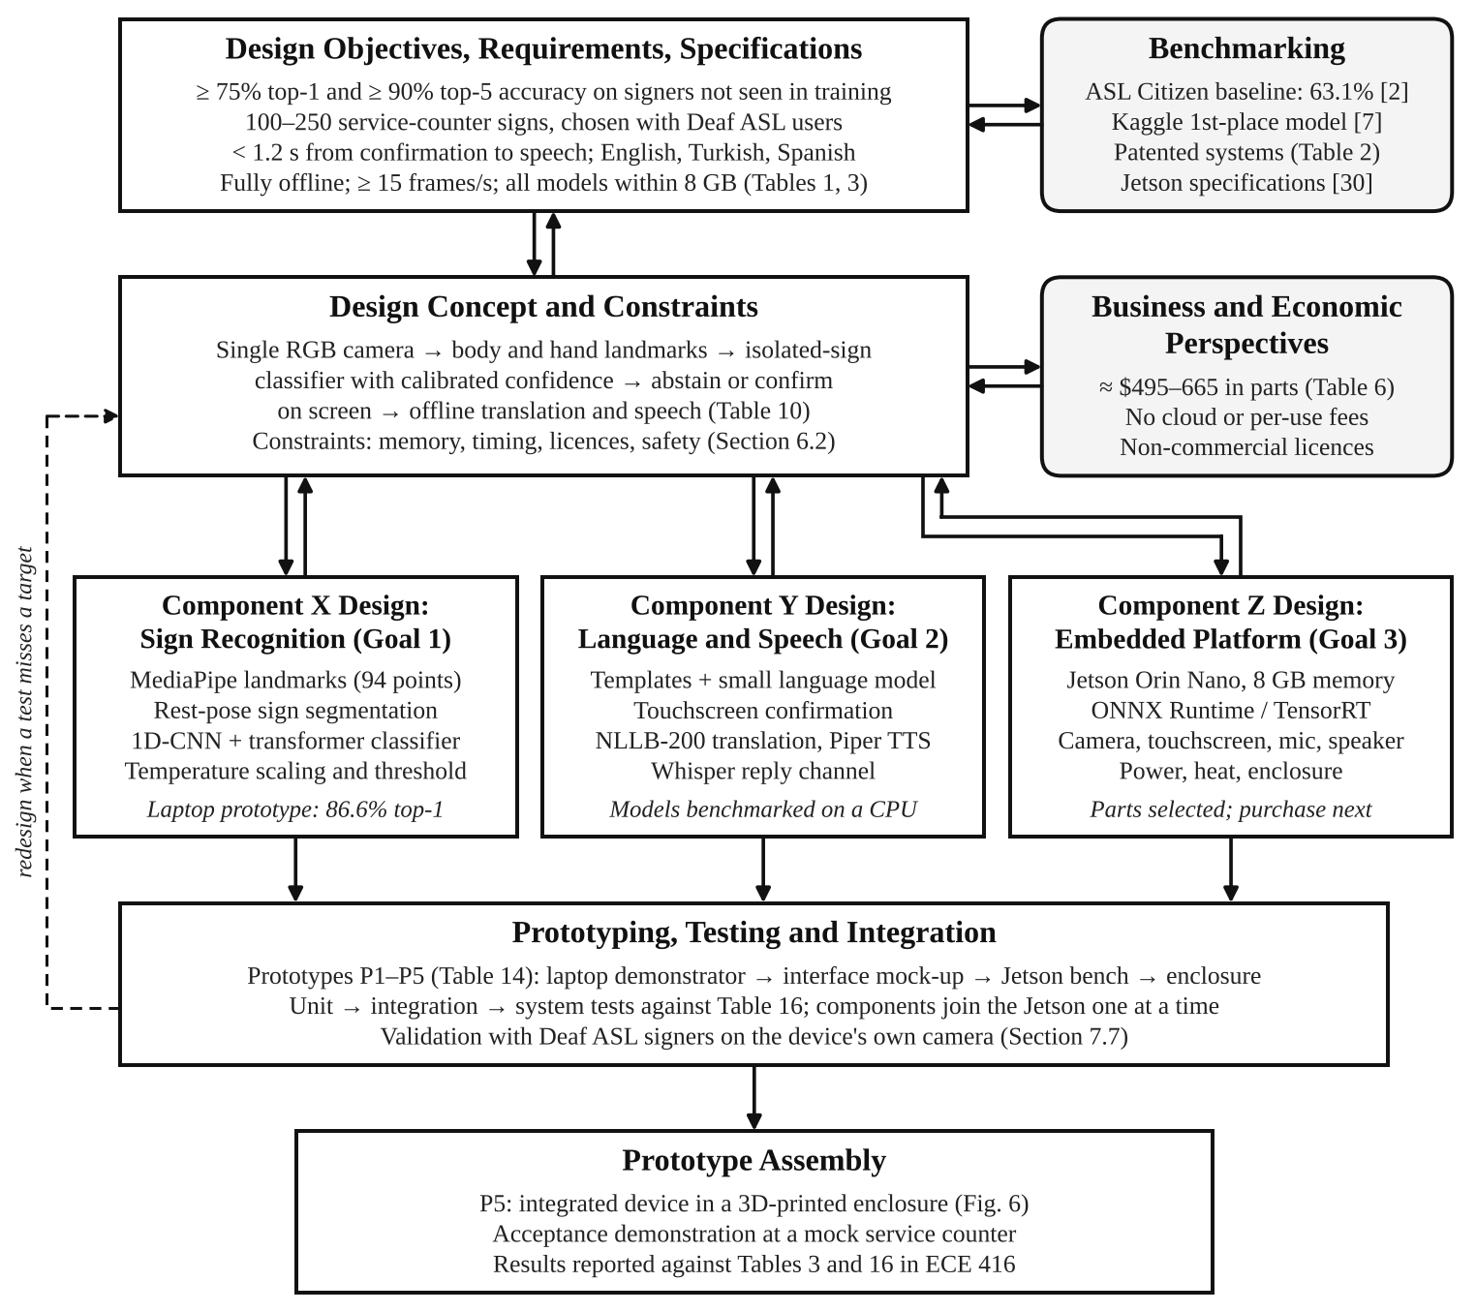
Fig. 5. Design flow chart of the project, based on the flow chart recommended for ECE capstone senior design projects. Components X, Y and Z are the three technical goals of Section 4, and the italic line at the bottom of each gives its status in October 2026. The dashed feedback line was added to the recommended chart.

7.2 Design Objectives, Benchmarking and Design Concept
Design objectives, requirements and specifications. The objectives come from the problem statement in Section 3.2 and from the needs Deaf users reported in surveys [1], [16]. They are stated as measurable targets in Tables 1 and 3 and as constraints in Section 6.2. In Section 7.7 every requirement receives an identifier, a verification method and a pass criterion (Table 16), so that each specification can be traced to the test that checks it, as IEEE 1012 requires [26].
Benchmarking. Table 9 lists the benchmarks the design is compared with. They show which targets are realistic and where the design must differ from existing systems. The ASL Citizen baseline [2] set the accuracy target: 75% top-1 accuracy is above the best published result on unseen signers, but for a much smaller vocabulary than the 2,731 signs of the full dataset. The Kaggle first-place solution [7] became the starting architecture of our recognizer. The patented systems of Table 2 show what the design must not copy, and the specifications of the Jetson Orin Nano set the memory and power budget for everything else.
Table 9. Benchmarks used in the design and the current position of the project.
Benchmark | What it represents | Reference value | Our design or result
ASL Citizen baseline [2] | Best published isolated-sign accuracy on signers not seen in training | 63.1% top-1 on all 2,731 signs | v5: 86.6% top-1 on a 134-word subset (not directly comparable: smaller vocabulary)
Kaggle first-place solution [7] | State-of-the-art landmark model and training recipe | 1D-CNN + transformer on 250 signs | Recipe adopted in v3: +4.1 points top-1 over our v2 on the same test signers
Sign-Speak patent [19] | Closest existing system: one camera, menu of three candidates | Recognition on a remote server | Same candidate idea with five candidates, fully offline
SignAll [17], Avodah [18] | Commercial and patented multi-sensor systems | Several cameras or a depth sensor | One ordinary RGB camera
Jetson Orin Nano [30] | Capacity of the target platform | 8 GB shared memory, 1024 CUDA cores, 7–25 W | All models estimated at 4.4 GB (Fig. 9(c))

Design concept. The concept is the chain shown in Fig. 2: one RGB camera, landmarks instead of video, recognition of single signs with a calibrated confidence, a confirmation screen, and offline translation and speech. Each link of the chain was chosen from several alternatives. Table 10 lists the main decisions, the options considered and the reason for each choice, with the evidence we have so far.
Table 10. Main design decisions and the alternatives considered.
Decision | Options considered | Chosen | Reason and evidence
Input sensing | Sensor gloves; depth camera; several cameras; one RGB camera | One RGB camera | Nothing to wear and lowest cost; 69% of surveyed Deaf users were comfortable with a stand-alone system, 38% with wearables [1]
Model input | Video frames; body and hand landmarks | 94 of the 543 MediaPipe landmarks [6] | Small and fast model (1.8 M parameters, 4.0 ms per sign on one CPU core); the Kaggle training data shrank from 56 GB to 2.02 GB
Recognition task | Continuous translation; isolated signs from a fixed vocabulary | Isolated signs, rest pose between signs | Continuous translation still needs large models and data [4], [5]; isolated signs can be tested one by one and give a confidence for each
Handling uncertainty | Always speak the top sign; abstain and confirm | Calibrated threshold, five candidates, confirmation before speech | Selective prediction [14]; v5 accepts 85.1% of signs at 6.5% error, and the right sign is among five candidates 98.2% of the time
Where processing runs | Cloud server; on the device | On the device, fully offline | No video leaves the device and no network is needed; the main difference from Sign-Speak [19]
Processing platform | Jetson Orin Nano; Raspberry Pi 5; laptop; cloud | Jetson Orin Nano | Highest score in the weighted decision matrix (Table 11)
Signs to sentence | Rules only; large language model; templates with a small model as fallback | Templates + small language model | Templates are fast and predictable for frequent phrases; the model covers the rest; every sentence is confirmed by the user
Translation and speech | Cloud services; offline open models | NLLB-200, Piper, Whisper | Run offline in all three languages; first timings in Table 13

For the processing platform we used a weighted decision matrix, a method described in the course textbook [31]. Each option was scored from 1 (poor) to 5 (excellent) on six criteria, and the scores were multiplied by the weight of each criterion (Table 11). The weights follow the requirements: running all models in real time matters most, followed by privacy and offline operation. The scores are the team's judgment, based on published specifications and our own measurements on a laptop and a cloud processor (Section 7.5). The Jetson Orin Nano scores highest because it is the only option that combines a graphics processor for the larger models with a small, low-power module. A Raspberry Pi 5 would be cheaper and smaller, but without a usable graphics processor the translation and speech recognition models would leave little time for the rest of the pipeline. A laptop is fast but costs more, is larger, and is not a realistic basis for a product. A cloud server fails the offline constraint and is shown only for comparison.
Table 11. Weighted decision matrix for the processing platform (scores from 1 = poor to 5 = excellent).
Criterion | Weight | Jetson Orin Nano | Raspberry Pi 5 | Laptop with GPU | Cloud server*
Runs all models in real time | 0.30 | 4 | 2 | 5 | 5
Privacy and offline operation | 0.20 | 5 | 5 | 5 | 1
Cost | 0.15 | 4 | 5 | 2 | 3
Size and power | 0.15 | 4 | 5 | 2 | 3
Software support (CUDA, TensorRT, ONNX) | 0.10 | 5 | 3 | 5 | 4
Path to a product | 0.10 | 4 | 4 | 2 | 2
Weighted score (out of 5) | 1.00 | 4.30 | 3.80 | 3.80 | 3.20

*Fails the offline requirement; shown for comparison only.
Business and economic perspectives. The prototype costs about $495–$665 in parts (Table 6), uses open-source software, and has no per-use or cloud fees, which keeps its cost far below that of repeated interpreter services [1]. Two economic factors shaped the design. First, the parts are standard and replaceable, so a failed part does not end the device's life. Second, ASL Citizen and NLLB-200 may be used only for non-commercial purposes (Section 6.2). Translation is therefore kept behind a narrow interface, an English sentence in and a translated sentence out, so that a commercially licensed model could later replace NLLB-200 without changes elsewhere. A product would also use the Jetson Orin Nano module on a smaller custom carrier board instead of the developer kit.

7.3 Component Design
The concept is divided into three components, one per technical goal (Fig. 5). They exchange data through interfaces agreed at the start of the project, so that each can be developed and tested with saved sample data before the others are ready. The recognizer writes one line of JavaScript Object Notation (JSON) per stretch of signing, with the five most likely signs, their probabilities, their start and end times and an abstain flag, and the sentence builder reads these lines. The confirmed English sentence and the chosen language are passed on to translation and speech. Agreeing on these interfaces first lets the three goals progress in parallel and makes the integration tests of Section 7.7 simple to define.
Component X: sign recognition (Goal 1). MediaPipe Holistic [6] converts each camera frame into body, hand and face landmarks. Of its 543 landmarks the recognizer keeps 94: 40 around the lips, 21 on each hand and 12 on the upper body. The landmarks are converted to body coordinates (origin between the shoulders, shoulder width equal to 1), which removes the effect of the camera's distance and image proportions, and each hand is also described relative to its own wrist so that hand shape is visible to the model. A sign starts when a hand rises above a rest line below the shoulders and ends when it is lowered; several signs made without lowering the hands are split where the hands slow down, keeping the cuts whose pieces the recognizer finds most convincing. The classifier is a one-dimensional convolutional network combined with a transformer, following the Kaggle first-place solution [7], with 1.78 million parameters. Its scores are calibrated by temperature scaling [32] on signers held out for validation, and a threshold on the calibrated confidence decides whether a sign is accepted or its five most likely labels are shown. The component went through five versions (Section 7.5); each change was judged on validation signers only, and the test signers were used once per version.
Component Y: language and speech (Goal 2). The sentence builder turns the accepted signs into English with templates for frequent service-counter phrases and a small language model for other sign sequences. The touchscreen shows the sentence together with the candidate signs, and only a confirmed sentence continues. Because the 1.2 s latency budget starts at the confirmation, this path is kept short: translation with NLLB-200 [11] is skipped for English, template phrases can be translated and synthesized in advance, and Piper [12] starts playing the first part of a sentence while the rest is still being produced. The reply channel uses voice-activity detection and Whisper [13], which transcribes a Turkish or Spanish reply and translates it into English in one step. The microphone is muted while the device speaks. First timings of these models are given in Section 7.5.
Component Z: embedded platform (Goal 3). The platform is the Jetson Orin Nano developer kit with the peripherals of Fig. 6. The main design problem is to make all models share one 8 GB memory and one graphics processor. The models are exported to the Open Neural Network Exchange (ONNX) format and run with ONNX Runtime [33] or TensorRT at reduced precision (16-bit floating point or 8-bit integers), Whisper is loaded only while the hearing person speaks if memory runs short, and the power mode (7–25 W [30]) is chosen from the measured frame rate, latency and temperature. The recognizer has already been exported to ONNX and checked against the original model (Section 7.5). The enclosure holds the camera and screen toward the Deaf user, turns the speaker and microphone toward the hearing person, and leaves room for air to flow around the module's heatsink and fan.

7.4 Hardware Block Diagram
Fig. 6 is the hardware block diagram of the device. The blocks are its principal parts, grouped by the side of the counter they face, and the lines show how they are connected: solid lines carry data in the direction of the arrow, and dashed lines carry power. All processing happens on the Jetson Orin Nano module inside the base; every other block is an input, an output, storage or the power supply. Table 12 gives the proposed part, connection, function and estimated power of each block.
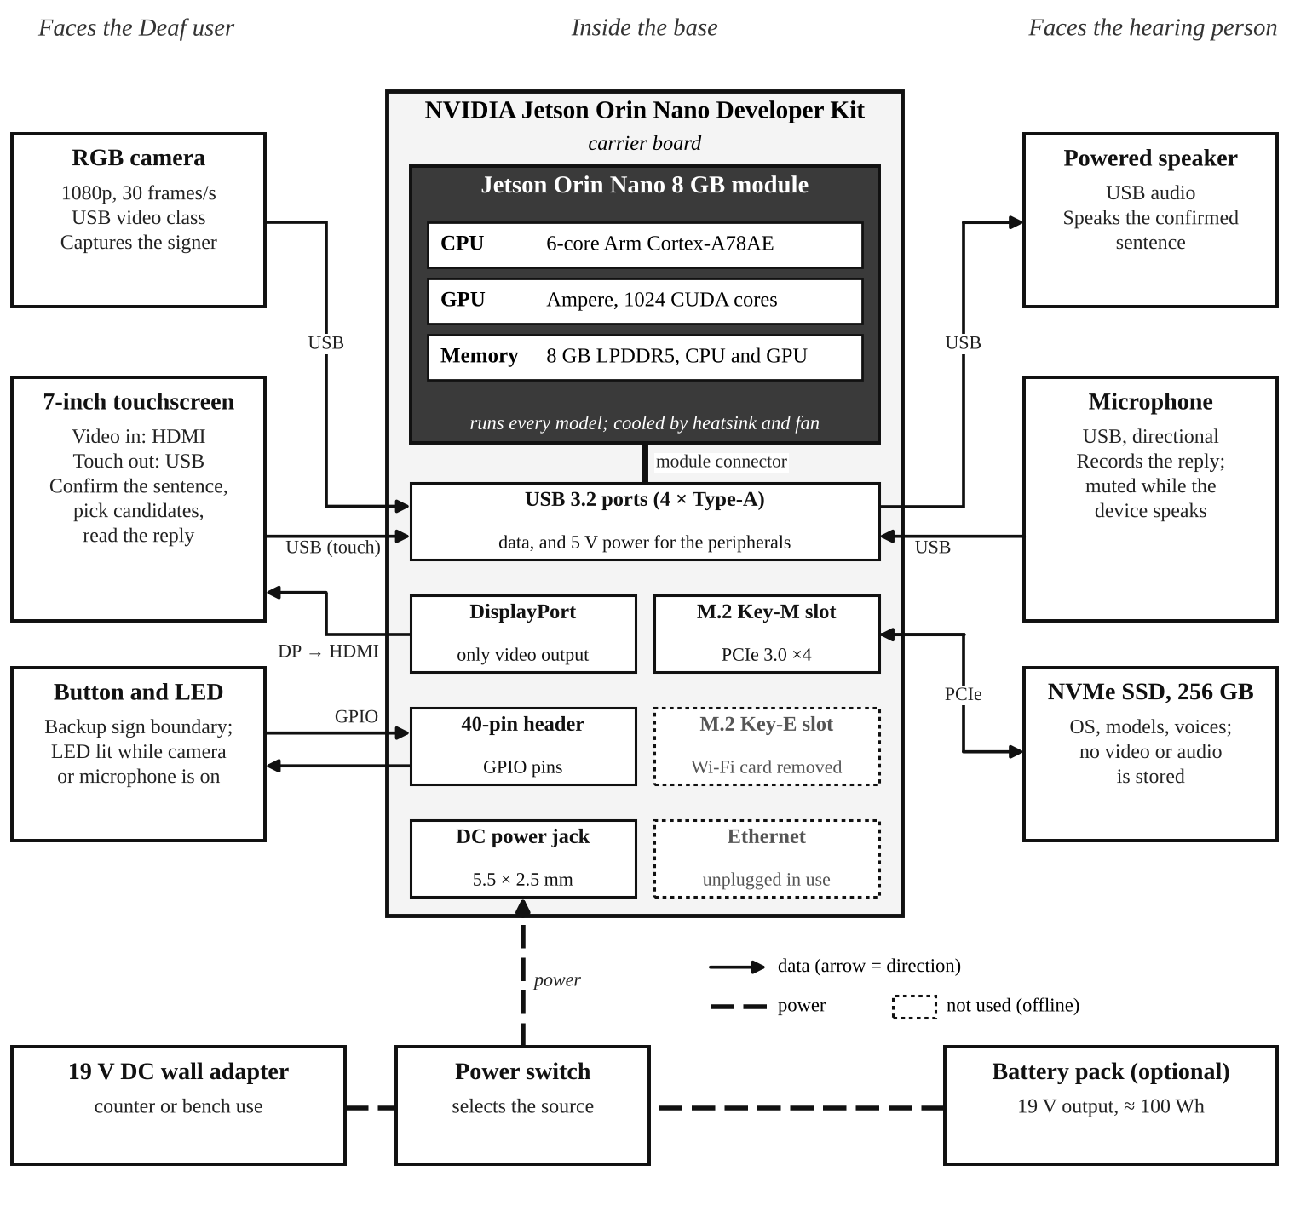
Fig. 6. Hardware block diagram. Light-emitting diode (LED), solid-state drive (SSD); interfaces as documented for the developer kit [34]. The Wi-Fi card is removed and Ethernet is unplugged, so the device has no network connection in use.
The connections follow from the developer kit's carrier board [34]. Its only video output is DisplayPort, so the touchscreen is driven through a DisplayPort-to-HDMI adapter, while its touch panel connects over the Universal Serial Bus (USB). The camera, microphone and speaker also use the four USB 3.2 ports, which supply 5 V power as well as data; each pair of ports is limited to 3 A [34], enough for the display and the speaker. A push button and an LED use general-purpose input/output (GPIO) pins on the 40-pin header. The button is the backup for marking the end of a sign, and the LED is lit whenever the camera or microphone is on, so that everyone at the counter can see when the device is recording. The operating system and the models are stored on a 256 GB NVMe SSD in the M.2 Key-M slot, because the kit includes no storage of its own [34].
Two blocks are deliberately not used. The kit ships with a Wi-Fi card in its M.2 Key-E slot [34]; we remove it, and the Ethernet port stays unplugged except during development. This turns the offline requirement into a physical property of the device that can be checked by inspection (Section 7.7). Power comes from the 19 V adapter supplied with the kit [34] or, optionally, from a battery pack with the same output, selected by a switch. With an estimated total of about 20 W in normal use and 40 W at peak (Table 12), a 100 Wh battery would last about 4.5 h of normal use, assuming 90% conversion efficiency. These estimates will be replaced by the measurements of Goal 3.
Table 12. Hardware blocks, connections and estimated power (power figures are estimates to be measured).
Block | Proposed part | Connection | Function | Power (W)
Processing | Jetson Orin Nano 8 GB developer kit | — | Runs all models: 6-core Arm CPU, 1024-core GPU, 8 GB shared memory [30] | 7–25 (power mode)
Camera | USB RGB camera, 1080p, 30 frames/s | USB 3.2 | Video of the signer for landmark extraction | ≈ 1–1.5
Touchscreen | 7-inch HDMI touchscreen | DisplayPort → HDMI; USB for touch | Shows the sentence, candidates and reply; language selection | ≈ 3–4
Button and LED | Push button; LED with resistor | GPIO, 40-pin header | Backup sign boundary; recording indicator | < 0.1
Microphone | USB directional microphone | USB 3.2 | Records the hearing person's reply | < 0.5
Speaker | USB-powered speaker | USB 3.2 | Plays the spoken sentence | ≈ 1–5
Storage | 256 GB NVMe SSD | M.2 Key-M, PCIe 3.0 | Operating system, models and voices | ≈ 1–3.5
Power | 19 V adapter (in the kit); optional 19 V battery pack, ≈ 100 Wh | DC jack via a switch | Supplies the kit, which powers the USB devices | —
Not used | Wi-Fi card; Ethernet | M.2 Key-E; RJ45 | Removed or unplugged for offline use | 0
Total |  |  | Normal use / peak | ≈ 20 / 40

7.5 Preliminary Data and Simulations
Most preliminary data come from Goal 1, which already has a working laptop prototype (P1 in Section 7.6). We also ran measurements and simulations that do not need the final hardware: the computing cost of the recognizer, first timings of the language and speech models on a cloud processor, a simulation of how often a user will have to correct the device, and a memory budget. All accuracy numbers below are for people who were never seen in training.
Recognition accuracy. Fig. 7(a) shows the five versions of the recognizer. Versions v1–v4 were trained on the Kaggle data (250 signs, 21 signers) and tested on three signers not used in training. Each version added one group of changes: more augmentation (v2), the Kaggle first-place training recipe (v3), and body coordinates with hand-shape features (v4). v4 reached 67.2% top-1 and 83.9% top-5 accuracy, short of both targets. v5 is v4 fine-tuned on ASL Citizen for a 134-word service-counter vocabulary and tested on its 11 Deaf test signers. It reaches 86.6% top-1 and 98.2% top-5, above both targets of Table 3. The same model trained from random weights reached 85.7% and 97.8%, so pretraining on the Kaggle data adds about one point here, but it shortens training and helps the weakest signers. Fig. 7(b) shows that the spread between signers shrank from 46–79% (v4 on Kaggle) to 79–89% (v5), and that the weakest v5 signer is above the 75% target. The most frequent remaining confusions are signs that look nearly the same or mean the same thing, such as HURT and PAIN, TOILET and BATHROOM, or COST and PRICE; these pairs will be merged into one spoken word, while pairs such as GOOD and THANK-YOU are left to the confirmation screen.
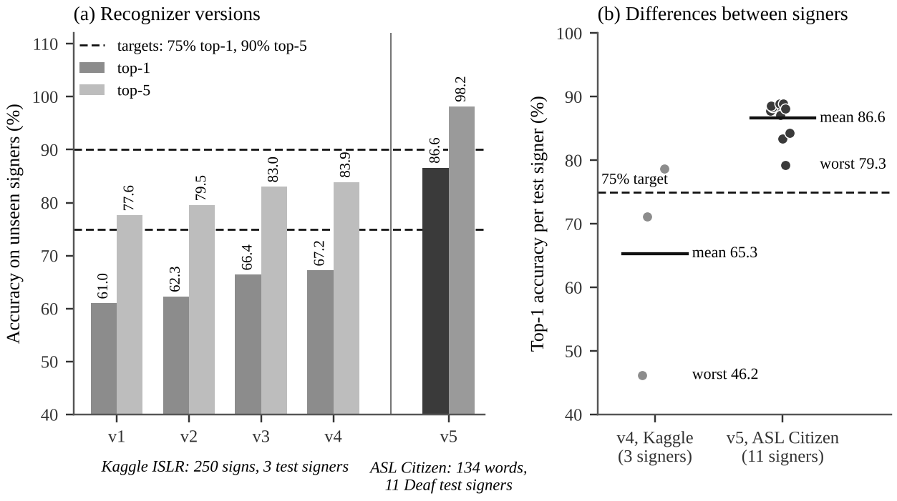
Fig. 7. Preliminary recognition results on signers never seen in training. (a) Top-1 and top-5 accuracy of the five recognizer versions; v1–v4 were trained and tested on the Kaggle data (250 signs), and v5 was fine-tuned and tested on ASL Citizen (134 words). (b) Top-1 accuracy for each test signer; the horizontal bars are the means.
Calibration and abstention. Fig. 8 shows how well the confidence of v5 matches its accuracy. The raw confidences are too low: temperature scaling with T = 0.55 lowers the expected calibration error from 14.6% to 1.5%. With a threshold of 0.62, chosen on the validation signers for a 5% error, the device accepts 85.1% of the test signs and 6.5% of the accepted signs are wrong; the other signs go to the candidate list, which contains the right sign 98.2% of the time. For the weakest signer, however, the same threshold gives 12.9% error. A threshold fitted on a few signers does not hold for everyone, so it will be re-validated with our own camera and many signers (Section 7.7).
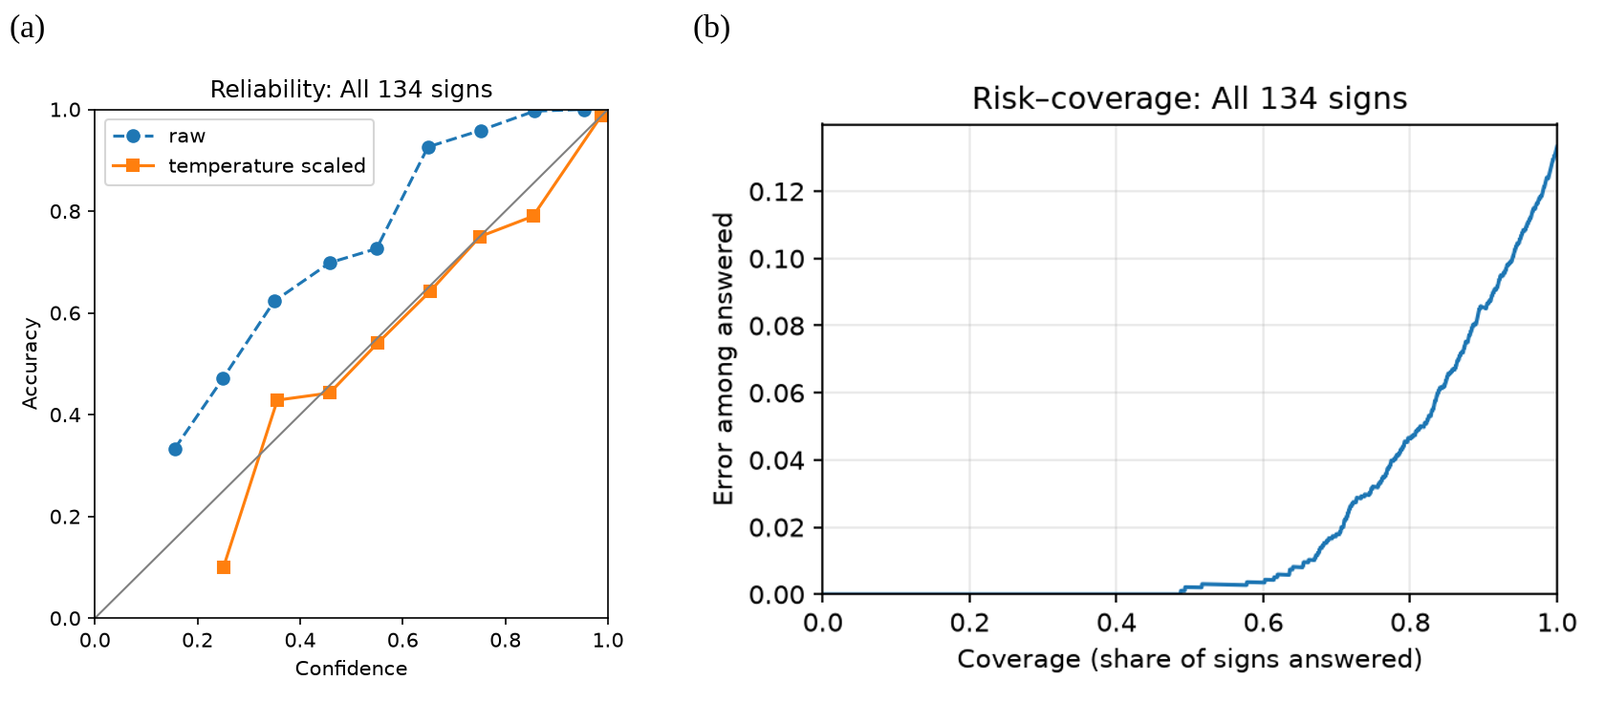
Fig. 8. Calibration of the v5 recognizer on the 11 ASL Citizen test signers (134 words). (a) Reliability diagram: accuracy against confidence before (raw) and after temperature scaling; the diagonal is perfect calibration. (b) Risk–coverage curve: error among the signs the device answers against the share of signs it answers. The chosen operating point answers 85.1% of signs at 6.5% error.
Live tests and segmentation. P1 runs at about 20 frames per second on a team member's laptop. Splitting several signs made without lowering the hands was correct in all three recordings tested (HELLO, WATER, PLEASE), but with a single signer this is not yet a reportable result. The first live test of v5 was worse than v4, although v5 is far better on ASL Citizen's recorded test signers. This points to a difference between the live pipeline and the training videos rather than to the model, and it is being investigated. It is also why recordings made with our own camera are part of the accuracy requirement (Table 16).
Computing cost of the recognizer. The v5 recognizer has 1.78 million parameters (7.1 MB at 32-bit precision) and needs about 113 million multiply-accumulate operations per sign. Exported to ONNX, it runs in 4.0 ms per sign on one core of a cloud processor with ONNX Runtime [33], and its output matches the original model to within 4 × 10⁻⁸. The recognizer is therefore a negligible part of the time and memory budget; the landmark extractor and the language models dominate both.
Timing of the language and speech models. Table 13 gives first measurements of the Goal 2 models on a 4-core cloud processor (Intel Xeon, 2.8 GHz), with ten typical service-counter sentences such as "How much is this?" and "I want to pay with a credit card." These are not Jetson measurements, but they show where the 1.2 s budget goes. Converting NLLB-200 to 8-bit integers with CTranslate2 [35] cut the median translation time from 1.13 s to 0.64 s for Turkish and from 1.15 s to 0.66 s for Spanish, and shrank the model from 2.5 GB to 0.63 GB. Piper produced the first audio of a sentence within 0.21 s in all three languages and synthesized speech about 19 times faster than real time. From confirmation to the first audio, the median was therefore 0.71 s for Turkish and 0.73 s for Spanish (Fig. 9(b)), within the 1.2 s budget before any use of the graphics processor. A first reading of the 20 translations found most of them correct, but three began with a stray dash and the Turkish word for "appointment" was misspelled. This supports the mitigation in Table 8: translations of template phrases will be checked by native speakers and stored, and the model will be used only for other sentences.
For the reply channel we played the synthesized sentences back into Whisper. The small model transcribed them with a word error rate of 0% in English, 2.4% in Spanish and 12.5% in Turkish, and took about 1.9 s to turn a Turkish reply of about 1.5 s into English text; the base model was more than twice as fast but reached 18.8% error in Turkish. Synthetic speech in a quiet room is an optimistic test, so the Turkish reply channel is the weakest link found so far. It will be tested with recorded voices and background noise, and a larger Whisper model on the graphics processor will be tried if needed.
Table 13. First timing and size measurements on a 4-core cloud processor (median over ten service-counter sentences; not yet on the Jetson).
Model | Task | Size | Time (median)
Sign recognizer (v5), ONNX | Classify one sign, 1 processor core | 7.1 MB | 4.0 ms
NLLB-200 distilled 600M, 32-bit | Translate English → Turkish / Spanish | 2.5 GB | 1.13 s / 1.15 s
NLLB-200, 8-bit (CTranslate2) | Translate English → Turkish / Spanish | 0.63 GB | 0.64 s / 0.66 s
Piper, medium voices | First audio, English / Turkish / Spanish | 63 MB per voice | 0.07 / 0.07 / 0.06 s
Piper, medium voices | Synthesis time ÷ audio length (EN / TR / ES) |  | 0.05 / 0.05 / 0.05
Whisper base (16-bit file, run in 8-bit) | Transcribe a Turkish / Spanish reply in English | 148 MB | 0.77 s / 0.74 s
Whisper small (16-bit file, run in 8-bit) | Transcribe a Turkish / Spanish reply in English | 486 MB | 1.86 s / 1.75 s

Simulation of user corrections. Fig. 9(a) uses the measured acceptance and error rates of each v5 test signer to estimate how often a sentence of n signs needs a correction, that is, a sign picked from the candidate list because it was not accepted, or a wrongly accepted sign replaced on the confirmation screen. Signs are assumed to be independent. For a three-sign sentence, the average signer would need no correction 51% of the time and 0.6 corrections on average; the weakest signer would need 0.9. A Monte Carlo run of 100,000 sentences per signer gave the same mean (0.61). Corrections are therefore a normal part of every conversation, and the confirmation screen must make them a single tap on a candidate rather than a repeated sign.
Memory budget. Fig. 9(c) adds up the memory the device needs. The sizes of the recognizer, NLLB-200, the Piper voices and Whisper are measured from the model files; the operating system and desktop (2.0 GB), the graphics runtime (0.5 GB), the landmark extractor (0.1 GB) and the sentence builder's language model, which is not yet chosen (0.5 GB), are assumed allowances. The total, about 4.4 GB, leaves about 3.6 GB of the 8 GB for working memory and buffers, so all models should be able to stay loaded at the same time. This estimate will be checked on the Jetson (requirement R11 in Table 16).
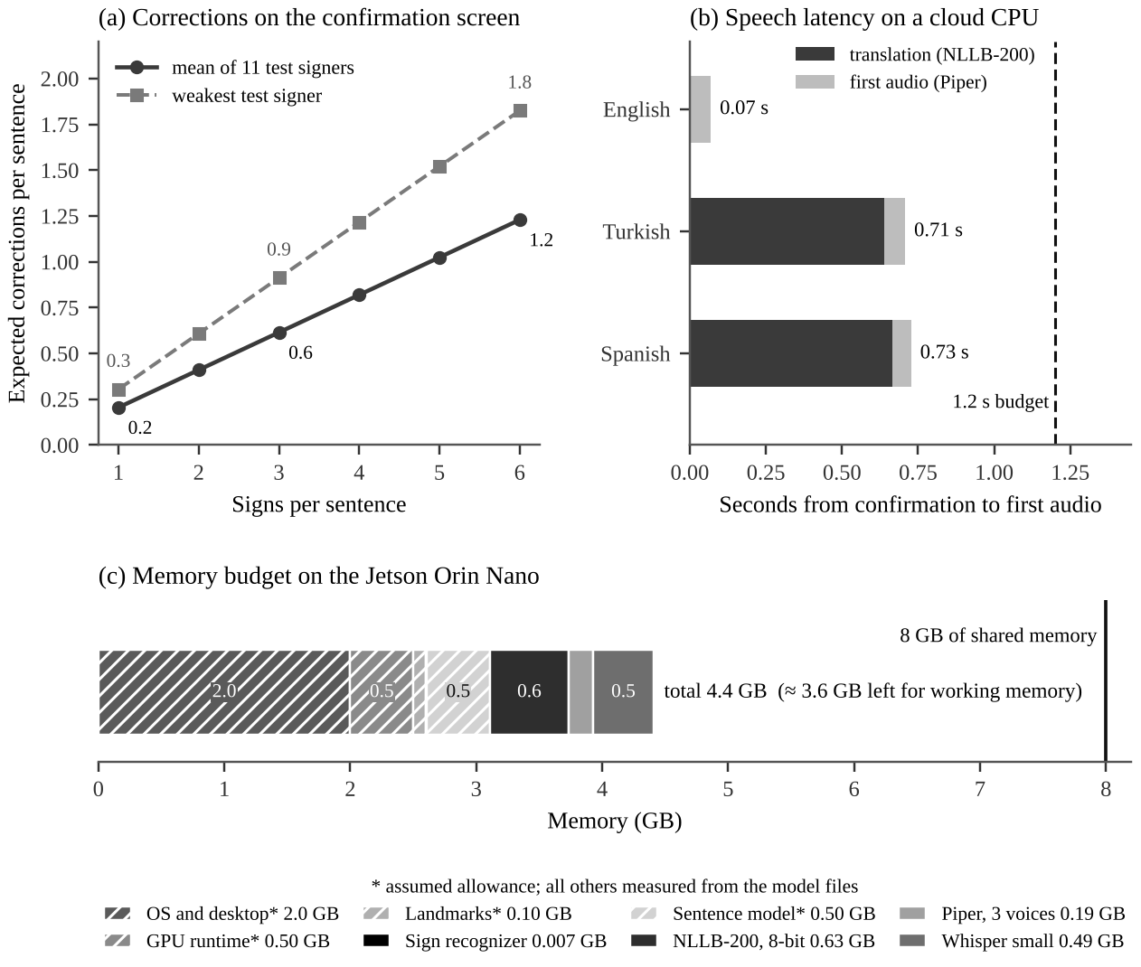
Fig. 9. Simulations and estimates based on measured data. (a) Expected corrections per sentence from the measured acceptance and error rates of the v5 test signers (mean signer and weakest signer). (b) Median time from confirmation to the first audio on a cloud processor, against the 1.2 s budget. (c) Memory budget of all models on the 8 GB Jetson Orin Nano; hatched parts are assumed allowances.

7.6 Prototyping Plan
A prototype is an early version of a product, built to test a concept or to learn from it before the final version is made [36]. Prototypes are grouped into categories by what they represent: function, appearance, or the user's experience. We plan five prototypes, P1–P5, each in a different category and each built to answer specific questions as cheaply as possible (Table 14). Their order follows the risks of Table 8, so the riskiest questions are answered first. This is the idea of rapid prototyping: building part of a design quickly to test its riskiest aspects [36].
P1: proof-of-principle prototype (built). A proof-of-principle prototype verifies key functional aspects of a design without the rest of its functions [36]. P1 is the laptop demonstrator of Goal 1: a webcam, landmark extraction, sign segmentation and the recognizer, which shows the three most likely signs on screen. It has shown that one ordinary camera and a small landmark model can recognize signs live, and its results are in Section 7.5.
P2: user-experience prototype (paper and Wizard of Oz). A user-experience prototype represents enough of the appearance and function of a product to be used for user research, and a paper prototype is a drawn version of a software interface used for early testing [36]. P2 consists of printed and then clickable mock-ups of the confirmation screen, tested with Deaf ASL users before the Goal 2 software is finished. In a Wizard of Oz prototype, a hidden person plays the part of the computer [36]; a team member will play the sentence builder and the voice, so that the full conversation can be tried before it is built. P2 answers whether users understand the screen and can correct a sentence quickly, which Fig. 9(a) shows they will need to do often.
P3: functional bench prototype. An electronics prototype, often built on a breadboard, is electrically like the final design but not physically like it [36]. P3 is the Jetson developer kit with all USB peripherals on the bench, without an enclosure. It answers the main Goal 3 questions: whether MediaPipe runs on the Jetson at 15 frames per second or more, whether all models fit in 8 GB, whether the 1.2 s latency is met, and how much power the device draws.
P4: visual (form-study) prototype. A visual prototype represents the size and appearance of a product but not its function, and a form study emphasizes its geometry [36]. P4 is an enclosure without electronics, first in cardboard and then 3D-printed, placed on a real counter. It checks the screen angle, the camera's view of a signer, the direction of the speaker and microphone, and the space for vents and cables.
P5: working prototype (alpha, then beta). A working prototype represents all or nearly all of the functions of the final product [36]. P5 combines the electronics of P3 with the enclosure of P4 and the complete software. Its software follows the usual stages [36]: an alpha version that runs end to end with few functions (English only, template sentences only), then a feature-complete beta version used for verification and for validation with Deaf ASL users.
Table 14. Prototypes of the project and their categories.
No. | Category | What is built | Questions it answers | Status (Oct. 2026)
P1 | Proof of principle (technology demonstrator) | Laptop and webcam: landmarks, segmentation, recognizer, top-3 display | Can one RGB camera and a landmark model recognize signs live? | Built; v5 at 86.6% top-1 on unseen signers
P2 | User experience: paper and Wizard of Oz | Printed, then clickable, confirmation screen; a team member plays the sentence builder and voice | Do Deaf users understand the screen? How fast can they correct a sentence? | Planned with the NJIT ASL community
P3 | Functional bench (breadboard-style) | Jetson developer kit with USB peripherals, no enclosure | Frame rate, memory, latency and power on the real hardware | After the purchase
P4 | Visual and form study | Cardboard, then 3D-printed, enclosure without electronics | Screen angle, camera view, speaker and microphone direction, ventilation | Planned
P5 | Working prototype (alpha, then beta) | P3 electronics in the P4 enclosure with all software | Does the device meet Table 16, and do Deaf users find it useful? | ECE 416

Each prototype ends with a short review against Tables 3 and 8. A target that is met closes the related risk; a missed target sends the work back to the design concept, which is the dashed line in Fig. 5.

7.7 Verification and Validation
Verification asks whether the device is built right, that is, whether it meets its specifications; validation asks whether the right device is built, that is, whether it meets the needs of its users and other stakeholders [37]. Both are needed. A recognizer can meet its accuracy target on a dataset and still fail Deaf users at a real counter, as the first live test of v5 already showed. Our plan follows IEEE 1012 [26] and the V-model of Fig. 10: each design level on the left is checked by a test level on the right, from unit tests of each component up to validation with Deaf ASL users, and the prototypes of Section 7.6 are the objects being tested at each level.
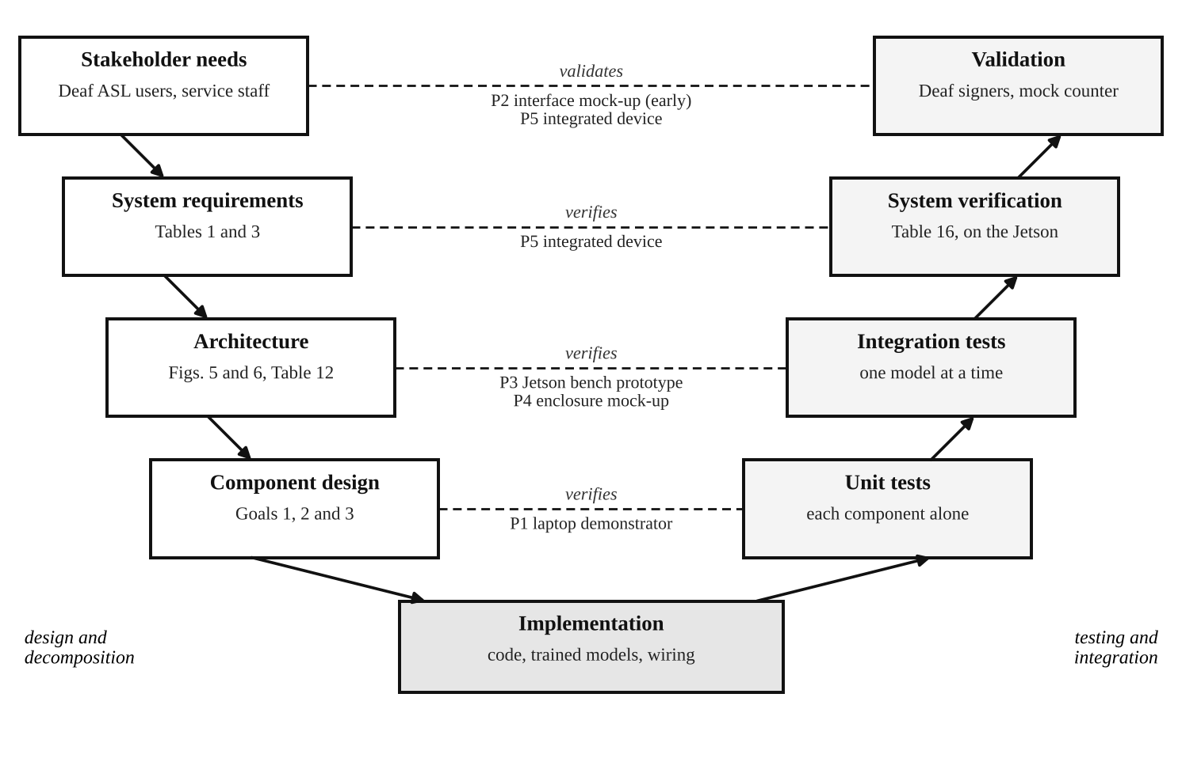
Fig. 10. V-model of verification and validation. Each design level (left) is verified or validated by the test level opposite it (right); the prototypes used at each level are named between them. P2 validates the user interface early, before P5 exists.
Verification methods. Each requirement is verified by one or more of four standard methods [38]: test, a measurement under controlled conditions; analysis, a calculation or simulation; inspection, an examination of the design, code or device; and demonstration, showing that a function works without measuring it. Table 16 is the verification matrix of the project. It gives each requirement of Tables 1, 3 and 5 and of Section 6.1 an identifier, its method, its pass criterion and the preliminary result, so it also serves as a status report.
Validation and qualification categories. Table 15 lists the categories of validation and qualification [37] and how each applies to this project. Most of our results so far are retrospective: they check the recognizer against recorded datasets. Before any result is reported, we also fix the test protocol, the pass criteria and the threshold in advance and use the test data only once (prospective validation). Re-validation matters especially for a learned model: every retraining, vocabulary change, new threshold, software update or new camera can change the results, so a fixed set of regression tests is re-run after each change. For the hardware, the qualification stages check that the purchased parts meet their specification (design qualification), that the device is set up correctly (installation qualification), that every function works within its limits (operational qualification) and that the device performs in real use (performance qualification).
Table 15. Validation and qualification categories and how the project applies them.
Category | Meaning | Application in this project | When
Validation
Retrospective | Checking against existing, recorded data | Recognizer tested on Kaggle and ASL Citizen signers never seen in training (Figs. 7, 8) | Done for v1–v5
Prospective | Done before release, with criteria fixed in advance | Protocol, pass criteria and threshold fixed on validation signers before the test set is opened; test set used once | Before every reported result
Partial | A limited test of the most important effects, e.g. a pilot | Pilot checks such as fluent splitting on three recordings and first live tests; not reported as results | Ongoing
Concurrent | Done during normal operation | The device logs times, confidences and corrections (never video or audio) during sessions with Deaf signers | P5 sessions
Cross-validation | Confirming a result with independent data or a second method | Same model on Kaggle and ASL Citizen; pretrained against trained from scratch; our own camera recordings as a third data set | Done; own data planned
Re-validation | Repeated after a change, repair or move | Regression tests after retraining, a vocabulary, threshold or software change, or a new camera | After every change
Qualification
Design (DQ) | Purchased equipment meets the written specification | Jetson, camera, display, microphone and speaker checked against Tables 6 and 12 | Before purchase
Installation (IQ) | The equipment is installed and configured correctly | Operating system version, model checksums, Wi-Fi card removed, networking off | P3 and P5
Operational (OQ) | Every function works within its operating limits | Frame rate, latency, memory, temperature and power in each power mode | P3 and P5
Performance (PQ) | The system performs under real conditions | Mock service counter with Deaf signers, background noise and different lighting | P5

Validation with Deaf ASL users. The final validation uses P5 at a mock service counter. Deaf and fluent ASL signers from the NJIT community (target: at least five people, depending on recruitment and the IRB review of Section 6.2) will complete short scripted tasks with a hearing staff member, such as ordering an item, asking a price and asking for directions. We will measure whether each task is completed, the time per sentence, the number of corrections, the accuracy of the spoken sentences and, through a short questionnaire in ASL or English, whether the participants would use the device. Their feedback on the vocabulary and the screen goes back into the design concept, as in Fig. 5.
Table 16. Verification matrix (T = test, A = analysis, I = inspection, D = demonstration).
ID | Requirement | Method | Pass criterion | Preliminary result (Oct. 2026)
R1 | Top-1 accuracy on unseen signers | T | ≥ 75% on the ASL Citizen test split and on recordings from our own test users | 86.6% on ASL Citizen (11 signers); own recordings pending
R2 | Top-5 accuracy on unseen signers | T | ≥ 90%, same data as R1 | 98.2% on ASL Citizen; own recordings pending
R3 | Accuracy reported for each signer | I | Every test signer listed | 79.3–88.9% (Fig. 7(b))
R4 | Accuracy of accepted signs | A | Risk–coverage curve and operating point reported | 85.1% accepted at 6.5% error (Fig. 8)
R5 | Vocabulary of 100–250 signs | I | Final list reviewed with Deaf ASL users | Draft list of 134 words; review pending
R6 | Nothing spoken without confirmation | T, I | No speech without a confirmation event in any test log; code review | Planned (P2, P5)
R7 | Latency from confirmation to speech | T | < 1.2 s for every test sentence | 0.71 s (TR) and 0.73 s (ES) median on a CPU; Jetson pending
R8 | Turkish and Spanish output quality | T | Rated acceptable by native speakers | Sample translations produced; rating pending
R9 | Reply shown as readable English | T | Word error rate reported per language | 0% / 12.5% / 2.4% (EN / TR / ES) on synthetic speech; real voices pending
R10 | Frame rate on the Jetson | T | ≥ 15 frames/s for landmarks and recognition | About 20 frames/s on a laptop; Jetson pending
R11 | All models within 8 GB | A, T | Estimate, then measured peak use below 8 GB | Estimate 4.4 GB (Fig. 9(c))
R12 | Fully offline operation | D, I | Full conversation with Wi-Fi removed and networking off | Planned (IQ)
R13 | No video or audio stored or sent | I, T | No media files written and no network traffic during a session | Planned (IQ, OQ)
R14 | Power draw measured | T | Idle and active power in each power mode | Planned (P3)
R15 | Safe surface temperature | T | Enclosure within the touch-temperature limits of ANSI/UL 62368-1 [28] after 1 h at full load | Planned (P5)

7.8 Prototype Assembly and Integration
The final prototype is assembled step by step, so that a problem can always be traced to the last part added. After the purchase, the Jetson is first set up and checked (installation qualification), and landmark extraction is tested on it before anything else, because it is the highest Goal 3 risk in Table 8. The recognizer is added next, followed by the sentence builder and the touchscreen, then translation and speech, and finally the reply channel. After each addition the frame rate, memory use and latency are measured again; if a limit is exceeded, the last component is optimized before the next one is added. The electronics are then mounted in the enclosure designed with P4, with strain relief on the cables and vents around the module, as Section 6.1 requires. The complete device, P5, is verified against Table 16 and validated with Deaf ASL users, and the results will be reported in ECE 416.

8. Literature Review: Articles and Patents
This section reviews in detail the two research articles and the four patents that are closest to the proposed device, and explains for each how our proposal differs from it. Articles were found with Google Scholar (https://scholar.google.com) and patents with Google Patents (https://patents.google.com), using combinations of the terms sign language recognition, sign language translation, isolated sign, pose, camera, speech and confidence. Patents were selected for being close to our design and for representing the main approaches: a single camera with cloud processing (Sign-Speak), multiple cameras with a depth sensor (Avodah), translation inside a video relay service (Sorenson) and sensor gloves (Bosch). For every patent the abstract is quoted from Google Patents, and the legal status was checked there on 26 October 2026. For the articles, the identifiers (DOI, ISBN and pages) were confirmed with the publishers' records. Section 8.4 compares all of them with the proposed device.

8.1 Article 1: ASL Citizen Dataset
Table 17. Bibliographic record of Article 1.
Item | Details
Title | ASL Citizen: A Community-Sourced Dataset for Advancing Isolated Sign Language Recognition
Authors | Aashaka Desai, Lauren Berger, Fyodor O. Minakov, Vanessa Milan, Chinmay Singh, Kriston Pumphrey, Richard E. Ladner, Hal Daumé III, Alex X. Lu, Naomi Caselli, Danielle Bragg
Published in | Advances in Neural Information Processing Systems 36 (NeurIPS 2023), Datasets and Benchmarks Track, pp. 76893–76907, 2023 [2]
ISBN / ISSN | ISBN 978-1-7138-9911-2 (proceedings volume 36); ISSN 1049-5258
DOI | 10.52202/075280-3360 (proceedings); 10.48550/arXiv.2304.05934 (preprint)
Links | https://doi.org/10.52202/075280-3360; https://arxiv.org/abs/2304.05934; dataset: https://www.microsoft.com/en-us/research/project/asl-citizen/

Description. The article introduces ASL Citizen, the first crowdsourced isolated sign language recognition dataset collected with the consent of its participants. It contains 83,399 videos of 2,731 distinct ASL signs, recorded by 52 Deaf and hard-of-hearing signers with their own webcams in everyday environments, about 30 videos per sign. Recruitment and consent materials were presented in ASL first, and participants were compensated. The authors frame isolated sign recognition as dictionary retrieval: a user demonstrates a sign to a webcam and the system returns a ranked list of matching signs. The 52 signers are divided into fixed training, validation and test sets so that test signers are never seen in training, and results are reported as recall at 1, 5 and 10 (recall at 1 is ordinary accuracy), discounted cumulative gain and mean reciprocal rank.
Two baselines are trained. An appearance model, I3D, a three-dimensional convolutional network applied to the video frames, reaches 63.10% top-1, 86.09% top-5 and 90.86% top-10 accuracy on the unseen test signers. A pose model, ST-GCN, which works on MediaPipe Holistic keypoints, reaches 59.52% top-1. The authors also show that the source of the training data matters more than the model: on the signs shared with the older WLASL dataset, a model trained on ASL Citizen reaches 74.16% top-1 against 8.49% for the same model trained on WLASL. The data may be used for non-commercial research only.
Difference from our proposal and how we use it. ASL Citizen is a dataset and benchmark, not a device, so it is a resource for our project rather than a competing design. It is the main training and test data of our recognizer (Section 7.5): our v5 model, fine-tuned on a 134-word service-counter subset of it, reaches 86.6% top-1 and 98.2% top-5 on the same unseen test signers. The two results are not directly comparable, because the article ranks all 2,731 signs while our device chooses among 134 words. Beyond the dataset, our proposal adds what a deployed device needs and the article does not address: a small pose-based model that runs offline on embedded hardware (1.78 million parameters, about 4 ms per sign on one processor core), calibrated confidence with abstention and risk–coverage evaluation, accuracy reported for each signer, and the language and speech path from recognized signs to a spoken sentence. Its use case, dictionary look-up, is also different from ours, a conversation at a service counter.

8.2 Article 2: U.S. Deaf Community Perspectives on Automatic Sign Language Translation
Table 18. Bibliographic record of Article 2.
Item | Details
Title | U.S. Deaf Community Perspectives on Automatic Sign Language Translation
Authors | Nina Tran, Richard E. Ladner, Danielle Bragg
Published in | Proceedings of the 25th International ACM SIGACCESS Conference on Computers and Accessibility (ASSETS ’23), New York, NY, USA, October 22–25, 2023, pp. 1–7 [1]
ISBN | 979-8-4007-0220-4 (ASSETS ’23 proceedings, ACM)
DOI | 10.1145/3597638.3614507
Links | https://dl.acm.org/doi/10.1145/3597638.3614507; https://www.microsoft.com/en-us/research/publication/u-s-deaf-community-perspectives-on-automatic-sign-language-translation/

Description. The article reports a survey of 32 Deaf and hard-of-hearing ASL users in the United States about automatic sign language translation. Participants completed an ASL check, and ASL was the primary language of 81% of them. For 14 everyday settings they rated how often they had wanted an interpreter but could not get one, and how willing they would be to use automatic translation. The unmet need was largest in medical, professional and educational settings, while willingness was highest for going into a business, followed by self-service kiosks and informal education; attitudes toward medical use were sharply divided. Participants expected the highest accuracy in medical settings and the lowest for kiosk-type exchanges. On form factors, 91% were comfortable with a phone app, 69% with a stand-alone system such as a computer on a counter, 38% with a wearable and 6% with an implant.
The survey also measured concerns. More than 80% of participants were concerned about hearing people profiting from ASL, systems missing ASL grammatical features, automatic translation weakening the legal right to other accommodations, poorer performance for some users than for others, and limited Deaf involvement in leadership. The most valued benefit was access in more places and at the last minute. The authors conclude that developers should target specific settings chosen with the community and should involve Deaf people throughout.
Difference from our proposal and how we use it. This article is a user study, not a technical system, and it is the main evidence behind several of our design decisions (Sections 3.3 and 5). Following its results, our device targets the business and service-counter setting, where willingness is highest and accuracy expectations are lower; it is a stand-alone counter device, the form factor 69% of participants accepted, rather than a wearable; it reports accuracy for each signer; and it is presented as an aid when no interpreter is available rather than as a replacement. The article goes further than our device in one respect: 91% of participants were concerned about systems that miss ASL grammar, and our device recognizes individual signs without facial grammar. We state this limitation openly instead of claiming full translation.

8.3 Patents
Four patents are reviewed in detail below, from the closest to our design to the most distant. Fig. 11 reproduces one drawing from each of the three closest. An expired Hitachi patent [21] is summarized at the end for completeness.
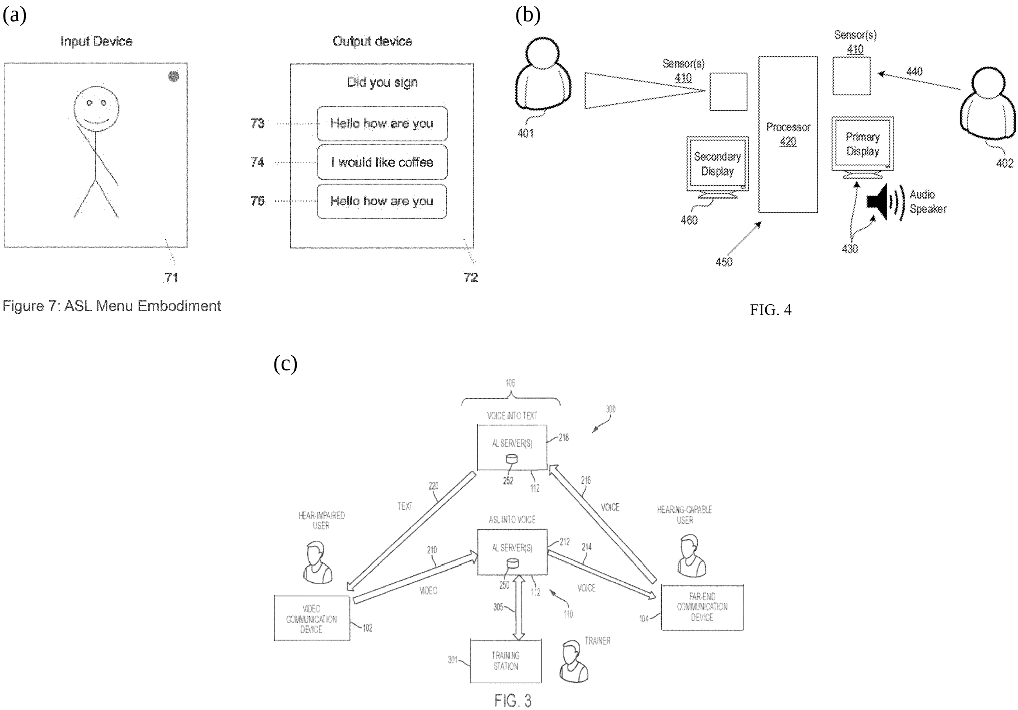
Fig. 11. Drawings reproduced from the reviewed patents. (a) Sign-Speak, FIG. 7: after the user signs, the three most likely sentences are shown for confirmation [19]. (b) Avodah, FIG. 4: one device between two people, with sensors, two displays and a speaker [18]. (c) Sorenson, FIG. 3: a video relay service in which artificial intelligence (AI) servers turn ASL video into voice and voice into text, with a training station [39].
Patent 1: Realtime AI Sign Language Recognition (Sign-Speak)
Table 19. Record of Patent 1.
Item | Details
Title | Realtime AI sign language recognition
Number | U.S. Patent No. 12,518,653 B2, granted January 6, 2026 [19]; published as application US 2022/0327961 A1 on October 13, 2022
Inventor / assignee | Nikolas Anthony Kelly / Sign-Speak Inc.
Dates | Priority May 11, 2020; filed May 11, 2021
Legal status | Active; Google Patents gives January 23, 2043 as the expected expiration
Link | https://patents.google.com/patent/US12518653B2/en

Abstract. "A real time sign language recognition method that allows Deaf and Hard of Hearing individuals to sign into any apparatus with a camera to extract target information (such as a translation in a target language) is proposed."
Description. The patent addresses conversations between Deaf signers and non-signers in impromptu settings where an interpreter cannot be provided immediately. It criticizes earlier systems that need gloves, 3D cameras or camera arrays, per-user calibration, or heavy computation on the device, and instead requires "only a device with internet connection and a single lens camera". Its general architecture has four stages, a capture device, a feature extractor, a processing module and an output device, and at least the feature extractor or the processing module must run, at least in part, on a cloud server.
In the translation embodiment, a convolutional pose machine estimates the body pose, a region-based convolutional network finds the hands, and a second pose network gives the keypoints of the dominant and non-dominant hands. These are merged into one flattened feature vector per frame, normalized so that the head is at the origin and the shoulders are one unit apart, smoothed and appended to a feature queue. A one-dimensional convolutional network splits the queue into sign, transition and non-signing regions. A comparator first looks for the whole signed passage in a base of pre-recorded sentences using k-nearest neighbours with dynamic time warping; if none matches, each sign is matched in the same way against a base of single signs, and fingerspelled regions go to a separate sequence model. The resulting glosses are translated into English by a sequence-to-sequence grammar model and returned to the device as text. Other embodiments highlight the person who is signing in a video conference, answer signed questions, and show an "ASL menu" of the three most likely sentences from the sentence base for the user to confirm (Fig. 11(a)). The granted claim 1 is broader than the published application: it claims capturing images, a first pose network for the body and a second for the hands, a flattened feature vector of fixed size, a feature queue, and its conversion into a target-language output, without requiring a server.
Difference from our proposal. Sign-Speak is the closest prior art. Both systems use one ordinary camera, body and hand pose features normalized to the body, sign splitting, a fingerspelling path and a list of candidates that the user confirms. Our proposal differs in four ways. First, Sign-Speak needs a network connection and sends the user's data to a server, while our device runs fully offline on an embedded GPU and no video leaves it. Second, Sign-Speak matches signs to stored examples by nearest neighbour, while we use a trained neural classifier whose output is calibrated as a probability. Third, Sign-Speak's candidate menu is a separate mode that always offers three whole sentences from a fixed bank, while our device decides for each sign, from its calibrated confidence, whether to accept it or to show five candidates, always asks for confirmation of the complete sentence before speaking, and measures this trade-off with risk–coverage curves (Fig. 8). Fourth, Sign-Speak returns English text, while our device speaks English, Turkish or Spanish and shows the hearing person's spoken reply as text. One caution follows from the review: because the granted claim 1 describes pose-based recognition with body and hand pose networks in general terms, a pipeline like ours, which uses the MediaPipe body and hand models and a sequence of flattened per-frame features, may fall within its scope even though the differences above are real. The differences establish the originality of the proposed system but do not by themselves avoid the claim, so a commercial version would need a freedom-to-operate review (Section 6.2).
Patent 2: Automated Sign Language Translation Using Multiple Input and Output Modalities (Avodah)
Table 20. Record of Patent 2.
Item | Details
Title | Automated sign language translation and communication using multiple input and output modalities
Number | U.S. Patent No. 10,489,639 B2, granted November 26, 2019 [18]; continuations include US 10,956,725 B2 and US 12,183,123 B2
Inventors / assignee | Michael Menefee, Dallas Nash, Trevor Chandler / Avodah, Inc. (originally Avodah Labs, Inc.)
Dates | Priority February 12, 2018; filed January 25, 2019
Legal status | Active; the four-year maintenance fee was paid in 2023
Link | https://patents.google.com/patent/US10489639B2/en

Abstract. "Methods, apparatus and systems for recognizing sign language movements using multiple input and output modalities. One example method includes capturing a movement associated with the sign language using a set of visual sensing devices, the set of visual sensing devices comprising multiple apertures oriented with respect to the subject to receive optical signals corresponding to the movement from multiple angles, generating digital information corresponding to the movement based on the optical signals from the multiple angles, collecting depth information corresponding to the movement in one or more planes perpendicular to an image plane captured by the set of visual sensing devices, producing a reduced set of digital information by removing at least some of the digital information based on the depth information, generating a composite digital representation by aligning at least a portion of the reduced set of digital information, and recognizing the movement based on the composite digital representation."
Description. The patent describes a device that lets a signer and a non-signer communicate in both directions. The device has a set of sensor inputs and outputs for each party; it identifies the language each person uses and outputs the translation in the form the other person prefers: text, audible speech, or a visual language such as glyphs, animations or a signing avatar, possibly in a different sign language. It can be used face to face (Fig. 11(b): sensors facing each person, a processor, a primary and a secondary display and a speaker) or by two parties in different places connected over a network. Translation can be performed "locally, remotely or both", with cloud resources used, for example, when many output sign languages must be supported.
The claims focus on how the signing is captured. Several visual sensors with multiple apertures view the signer from different angles, and a depth sensor, either structured light or time of flight, measures depth perpendicular to the image plane. The depth is used to discard part of the image data, for example the background, and the remaining views are aligned into one composite three-dimensional representation, from which a neural network recognizes the movement. Dependent claims add the capture of eyebrow movements, gaze direction and blinks, which carry grammatical information in sign languages. The patent has 30 claims, and Avodah holds a family of related patents on gesture recognition, training and user interfaces.
Difference from our proposal. Avodah's face-to-face embodiment is the closest to our device in layout: one unit between two people, with inputs and screens facing each side and a speaker (compare Fig. 11(b) with Fig. 2). The technical approach, however, is different. Every independent claim requires multiple camera apertures and a depth sensor, while our device uses one ordinary RGB camera and no depth sensor, which makes it cheaper and simpler and keeps it outside those claims. Avodah also captures facial grammar, which we do not, and outputs signing avatars and several sign languages, while our device recognizes ASL only and speaks three spoken languages. Offline operation is optional in Avodah's design and mandatory in ours, and Avodah does not describe abstaining or confirming before output, which are central to our design.
Patent 3: Translating Sign Language Content into Word Content and Vice Versa (Sorenson)
Table 21. Record of Patent 3.
Item | Details
Title | Methods, systems, and machine-readable media for translating sign language content into word content and vice versa
Number | U.S. Patent No. 12,131,586 B2, granted October 29, 2024 [39]
Inventors / assignee | John Carlock, Conrad Maxwell / Sorenson IP Holdings, LLC
Dates | Priority and filing April 9, 2021
Legal status | Active; Google Patents gives February 12, 2042 as the expected expiration
Link | https://patents.google.com/patent/US12131586B2/en

Abstract. "Communication systems, methods, and non-transitory machine-readable storage media are disclosed herein. A communication system may include a communication device configured to receive a video stream including sign language content and any content indicators associated with the video stream during a real-time communication session within a single communication device or between a plurality of communication devices. The communication system may also include a translation engine configured to automatically translate the sign language content into word content during the real-time communication session without assistance of a human sign language interpreter. Further, the communication system may be configured to output the word content translation to a communication device during the real-time communication session."
Description. Sorenson provides video relay services, in which a Deaf person signs over video to an interpreter who voices the call to a hearing person. This patent describes replacing or assisting that interpreter with a translation engine. The engine divides the incoming video into sign language segments and compares each with stored video files, each linked to word content, and combines the matched words into a translation. It uses context in two ways: words already translated earlier in the session, and "content indicators", the facial expressions, body language and other visual cues that accompany the hand and arm movements and can change the meaning, express emotion or mark punctuation. The engine also works in reverse, producing sign language video from words.
Three configurations are described: a single device, such as a cell phone, that acts as a personal translator with an on-board translation engine; several devices connected over a network; and a video relay service in which servers translate ASL video into voice for the hearing party and the hearing party's voice into text for the Deaf user (Fig. 11(c)). In the relay configuration a training station, operated by a human who knows sign language or by an AI training engine, monitors sessions and updates the engine's databases to improve accuracy. The independent claim covers a communication device and a translation engine that translates each segment using the words already determined from earlier segments and the content indicators.
Difference from our proposal. This patent shows that a major provider of interpreting by video relay is itself pursuing automatic translation, which confirms the commercial interest in the field. Its setting, however, is a remote call through a relay service, while ours is a face-to-face conversation at a counter, where a relay service is not involved. It aims at continuous translation that uses context and facial cues, which is more ambitious than our recognition of single signs from a fixed vocabulary, and it relies on servers and a monitoring trainer, while our device works alone and offline. The patent does not describe a confidence threshold or a confirmation step: the translation is passed to the other party during the session. In our device the Deaf user sees and confirms every sentence before it is spoken, and uncertain signs are offered as a list of candidates.
Patent 4: System and Method for Automated Sign Language Recognition (Bosch)
Table 22. Record of Patent 4.
Item | Details
Title | System and method for automated sign language recognition
Number | U.S. Patent No. 10,109,219 B2, granted October 23, 2018 [20]; published as application US 2016/0307469 A1; related EP 3284019 B1, CN 107690651 B, WO 2016/168591 A1
Inventors / assignee | Zhengyu Zhou, Tobias Menne, Kehuang Li, Kui Xu, Zhe Feng, Chin-Hui Lee / Robert Bosch GmbH
Dates | Priority April 16, 2015; filed April 15, 2016
Legal status | Active; the eight-year maintenance fee was paid in April 2026
Link | https://patents.google.com/patent/US10109219B2/en

Abstract. "A method for sign language recognition includes receiving, with an input device, an input based on a plurality of hand movements and postures of a user that correspond to a sequence of signs, extracting a plurality of features from the input corresponding to the plurality of hand movements and postures, identifying, a start of the sequence of signs in the input based on a first set of features in the plurality of features and a first Hidden Markov Model (HMM) stored in the memory and identifying a first sign in the input based on a second set of features in the plurality of features and a second HMM stored in the memory. The method also includes generating an output corresponding to the first sign from the input."
Description. The patent applies the methods of speech recognition to continuous sign language. Its input comes from "sensor signals from wearable device and/or image sequences from a camera", in its embodiments mainly digital gloves that measure the movements and angles of both hands. Each sign is modeled by a hidden Markov model, and the key idea is to model the movement between signs explicitly: separate models describe the transition before the first sign of a phrase, between two signs and after the last sign. The sign and transition models are connected into a decoding network, as words and pauses are in speech recognition, and a language model gives the prior probability of each sentence, so that a whole phrase can be recognized without pauses between signs. The system treats the dominant and non-dominant hand separately; it can use only the global angles of the non-dominant hand, which allows a simpler glove on that hand, and it ties the non-dominant-hand parameters of one-handed signs to the transition model to reduce errors. The output device produces a text or audio translation of the recognized signs.
The granted claims are narrower than this general description. Independent claim 1 requires separate inputs for the movements of the dominant and the non-dominant hand, finger-related features extracted from the dominant hand and global-angle features from the non-dominant hand, a first hidden Markov model that detects the start of a sign sequence, a second one that identifies the first sign, and an output for that sign; the dependent claims add the transition and end models. The patent was also filed in Europe, China and through the Patent Cooperation Treaty, which shows that Bosch saw commercial value in sign language recognition as a human-machine interface, not only as an assistive aid.
Difference from our proposal. Bosch relies on wearable sensors, while our device needs nothing worn: the signer stands in front of one camera, which matches the preference of the Deaf users surveyed, of whom only 38% were comfortable with wearables [1]. Bosch uses hidden Markov models, while we use a neural network on body and hand landmarks. Its explicit transition models solve a problem we also face, recognizing several signs made without a pause; we currently handle it differently, with a rest pose between signs and, for fluent signing, candidate cuts where the hands slow down that the recognizer then scores (Section 7.3). Bosch's system is one-way and does not describe abstention, confirmation or multilingual speech.
Expired patent: Hitachi, U.S. Patent No. 5,887,069 [21]. Granted in 1999 to Hitachi, Ltd. with a priority date of 1992, this patent recognizes continuous sign language from data gloves or a camera by matching compressed time sequences against averaged reference patterns, and describes a translation system that also recognizes the signer's facial expression and adds the matching emotion to synthesized speech. Google Patents lists it as expired, so its methods are free to use. It shows that sign-to-speech translation has been patented for three decades; our device differs in using learned models, a single ordinary camera, abstention and confirmation, and several output languages.

8.4 Originality and Comparison
Table 23 compares the reviewed patents with the proposed device. Each feature of our design exists somewhere in the prior art: a single camera in Sign-Speak and Sorenson, a two-way device between two people in Avodah, user confirmation of candidate sentences in Sign-Speak, and several output languages in Avodah. No reviewed system, however, combines them, and none decides from a calibrated confidence when to accept a sign and when to abstain. The originality of our proposal therefore lies in the combination of fully offline processing on an embedded GPU with one ordinary camera, calibrated abstention followed by confirmation of every sentence before it is spoken, and multilingual speech with a reply channel in one stand-alone device; and in its evaluation, which reports accuracy for each signer and the trade-off between answering and abstaining. The review also showed the limits of this claim: recognition from body and hand pose is itself claimed by the granted Sign-Speak patent, and a major provider of relay services is working on the same problem. These findings are reflected in the legal constraints of Section 6.2.
Table 23. Comparison of the reviewed patents with the proposed device.
Feature | Sign-Speak [19] | Avodah [18] | Sorenson [39] | Bosch [20] | Hitachi [21] | Proposed device
Input | One camera | Several cameras and a depth sensor | Video from one device | Gloves (camera possible) | Data gloves or camera | One RGB camera
Where processing runs | Server required | Local, remote or both | Phone or relay servers | Local processor | Local computer | On the device, fully offline
Recognition method | Pose keypoints, nearest neighbour with time warping | Neural network on a 3D composite | Matching to stored videos with context | Hidden Markov models | Pattern matching | Pose landmarks, neural network
Calibrated confidence, abstains when unsure | Not described | Not described | Not described | Not described | Not described | Yes
User confirms before output | Yes, menu of three sentences | Not described | Not described | Not described | Not described | Yes, every sentence
Output | Text | Speech, text or avatar | Voice or text | Text or audio | Text or speech with emotion | Speech in EN, TR, ES
Reply from the hearing person | Not described | Yes | Yes, voice to text | Not described | Not described | Yes, speech to text
Legal status (Oct. 2026) | Active to 2043 | Active | Active to 2042 | Active | Expired | —

12. References
1. Tran, N., Ladner, R. E., and Bragg, D. U.S. Deaf community perspectives on automatic sign language translation. Proceedings of the 25th International ACM SIGACCESS Conference on Computers and Accessibility (ASSETS ’23), 1–7, New York, NY, USA, 2023. doi:10.1145/3597638.3614507.
2. Desai, A., Berger, L., Minakov, F. O., Milan, V., Singh, C., Pumphrey, K., Ladner, R. E., Daumé III, H., Lu, A. X., Caselli, N., and Bragg, D. ASL Citizen: A community-sourced dataset for advancing isolated sign language recognition. Advances in Neural Information Processing Systems, 36 (Datasets and Benchmarks Track), 76893–76907, 2023. doi:10.52202/075280-3360.
3. Zhang, X., and Duh, K. Approaching sign language gloss translation as a low-resource machine translation task. Proceedings of the 1st International Workshop on Automatic Translation for Signed and Spoken Languages (AT4SSL), 60–70, 2021.
4. Hu, J., He, Z., Huang, H., Li, Z., Li, Z., and Fang, Y. SignDino: Self-supervised sign language representation learning via temporal-axis self-distillation. arXiv preprint arXiv:2609.06296, 2026.
5. Gan, S., Liu, X., Yin, Y., Liu, N., Liu, K., Tuerdaken, D., Jiang, Z., Xie, L., Lu, S., and Wen, H. Learning effective sign features without text for gloss-free sign language translation. Proceedings of the IEEE/CVF Conference on Computer Vision and Pattern Recognition (CVPR), 9827–9836, 2026.
6. Lugaresi, C., Tang, J., Nash, H., McClanahan, C., Uboweja, E., Hays, M., Zhang, F., Chang, C.-L., Yong, M. G., Lee, J., Chang, W.-T., Hua, W., Georg, M., and Grundmann, M. MediaPipe: A framework for building perception pipelines. arXiv preprint arXiv:1906.08172, 2019.
7. Sohn, H. 1st place solution: 1DCNN combined with Transformer. Google – Isolated Sign Language Recognition Competition, Kaggle, 2023. Available: https://www.kaggle.com/competitions/asl-signs/writeups/hoyeol-sohn-1st-place-solution-1dcnn-combined-with [Accessed: 25-Sep-2026].
8. Licciardello, R., Fargetta, G., Ortis, A., and Battiato, S. CSLRTransformer: A pose-only system for continuous sign language recognition. Proceedings of the IEEE/CVF Conference on Computer Vision and Pattern Recognition (CVPR) Workshops, 2026.
9. Moryossef, A., Jiang, Z., Müller, M., Ebling, S., and Goldberg, Y. Linguistically motivated sign language segmentation. Findings of the Association for Computational Linguistics: EMNLP 2023, 12703–12724, 2023.
10. Fayyazsanavi, P., Anastasopoulos, A., and Košecká, J. Gloss2Text: Sign language gloss translation using LLMs and semantically aware label smoothing. Findings of the Association for Computational Linguistics: EMNLP 2024, 16162–16171, 2024.
11. NLLB Team, Costa-jussà, M. R., Cross, J., et al. No Language Left Behind: Scaling human-centered machine translation. arXiv preprint arXiv:2207.04672, 2022.
12. Hansen, M. Piper: A fast, local neural text to speech system. GitHub repository, 2023. Available: https://github.com/rhasspy/piper [Accessed: 25-Sep-2026].
13. Radford, A., Kim, J. W., Xu, T., Brockman, G., McLeavey, C., and Sutskever, I. Robust speech recognition via large-scale weak supervision. Proceedings of the 40th International Conference on Machine Learning (ICML), PMLR, 202, 28492–28518, 2023.
14. Traub, J., Bungert, T. J., Lüth, C. T., Baumgartner, M., Maier-Hein, K. H., Maier-Hein, L., and Jaeger, P. F. Overcoming common flaws in the evaluation of selective classification systems. Advances in Neural Information Processing Systems, 37, 2024.
15. Bragg, D., Koller, O., Bellard, M., Berke, L., Boudreault, P., Braffort, A., Caselli, N., Huenerfauth, M., Kacorri, H., Verhoef, T., Vogler, C., and Morris, M. R. Sign language recognition, generation, and translation: An interdisciplinary perspective. Proceedings of the 21st International ACM SIGACCESS Conference on Computers and Accessibility (ASSETS ’19), 16–31, 2019.
16. Atwell, K., Imai, S., Bragg, D., and Alikhani, M. “Nothing about us without us”: Perspectives of global Deaf and hard-of-hearing community members on sign language technologies. arXiv preprint arXiv:2512.08839, 2025.
17. SignAll Technologies. SignAll translates sign language to English automatically. PRWeb press release, 2018. Available: https://www.prweb.com/releases/signall-translates-sign-language-to-english-automatically-868736288.html [Accessed: 25-Sep-2026].
18. Menefee, M., Nash, D., and Chandler, T. Automated sign language translation and communication using multiple input and output modalities. U.S. Patent No. 10,489,639 B2, 2019.
19. Kelly, N. A. Realtime AI sign language recognition. U.S. Patent No. 12,518,653 B2, 2026 (published as application No. 2022/0327961 A1, 2022).
20. Zhou, Z., Menne, T., Li, K., Xu, K., Feng, Z., and Lee, C.-H. System and method for automated sign language recognition. U.S. Patent No. 10,109,219 B2, 2018 (published as application No. 2016/0307469 A1, 2016).
21. Sakou, H., Sagawa, H., Abe, M., Ichikawa, A., Inoue, K., Arai, K., Shimura, T., and Toda, Y. Sign recognition apparatus and method and sign translation system using same. U.S. Patent No. 5,887,069, 1999.
22. U.S. Department of Justice, Civil Rights Division. ADA requirements: Effective communication. ADA.gov, 2020. Available: https://www.ada.gov/resources/effective-communication/ [Accessed: 01-Oct-2026].
23. IEEE. IEEE Code of Ethics. IEEE Policies, Section 7.8, 2020. Available: https://www.ieee.org/about/corporate/governance/p7-8.html [Accessed: 01-Oct-2026].
24. IEEE. IEEE Standard Model Process for Addressing Ethical Concerns during System Design. IEEE Std 7000-2021, 2021. Available: https://standards.ieee.org/ieee/7000/6781/ [Accessed: 14-Oct-2026].
25. IEEE. IEEE Standard for Data Privacy Process. IEEE Std 7002-2022, 2022. Available: https://standards.ieee.org/ieee/7002/6898/ [Accessed: 14-Oct-2026].
26. IEEE. IEEE Standard for System, Software, and Hardware Verification and Validation. IEEE Std 1012-2024, 2025. Available: https://standards.ieee.org/ieee/1012/7324/ [Accessed: 15-Oct-2026].
27. IEEE. IEEE Recommended Practice for Framework and Process for Deep Learning Evaluation. IEEE Std 2841-2022, 2023. Available: https://standards.ieee.org/ieee/2841/7674/ [Accessed: 14-Oct-2026].
28. UL. Audio/Video, Information and Communication Technology Equipment – Part 1: Safety Requirements. ANSI/UL 62368-1, 3rd ed., 2019. Available: https://webstore.ansi.org/standards/ul/ul62368ed2019 [Accessed: 15-Oct-2026].
29. National Institute of Standards and Technology. Artificial Intelligence Risk Management Framework (AI RMF 1.0). NIST AI 100-1, 2023. doi:10.6028/NIST.AI.100-1.
30. NVIDIA. Jetson Orin Nano Super Developer Kit: technical specifications. NVIDIA, 2026. Available: https://www.nvidia.com/en-us/autonomous-machines/embedded-systems/jetson-orin/nano-super-developer-kit/ [Accessed: 22-Oct-2026].
31. Hyman, B. Fundamentals of Engineering Design, 2nd ed. Prentice Hall, Upper Saddle River, NJ, 2003.
32. Guo, C., Pleiss, G., Sun, Y., and Weinberger, K. Q. On calibration of modern neural networks. Proceedings of the 34th International Conference on Machine Learning (ICML), PMLR, 70, 1321–1330, 2017.
33. ONNX Runtime developers. ONNX Runtime: cross-platform, high performance ML inferencing and training accelerator. GitHub repository, 2026. Available: https://github.com/microsoft/onnxruntime [Accessed: 22-Oct-2026].
34. NVIDIA. Jetson Orin Nano Developer Kit user guide: hardware layout and quick start. NVIDIA Developer Documentation, 2026. Available: https://docs.nvidia.com/jetson/orin-nano-devkit/user-guide/latest/ [Accessed: 22-Oct-2026].
35. OpenNMT. CTranslate2: fast inference engine for Transformer models. GitHub repository, 2026. Available: https://github.com/OpenNMT/CTranslate2 [Accessed: 22-Oct-2026].
36. Wikipedia contributors. Prototype. Wikipedia, The Free Encyclopedia, 2026. Available: https://en.wikipedia.org/wiki/Prototype [Accessed: 22-Oct-2026].
37. Wikipedia contributors. Verification and validation. Wikipedia, The Free Encyclopedia, 2026. Available: https://en.wikipedia.org/wiki/Verification_and_validation [Accessed: 22-Oct-2026].
38. NASA. NASA Systems Engineering Handbook. NASA/SP-2016-6105 Rev2, National Aeronautics and Space Administration, Washington, DC, 2016.
39. Carlock, J., and Maxwell, C. Methods, systems, and machine-readable media for translating sign language content into word content and vice versa. U.S. Patent No. 12,131,586 B2, 2024.

