An age-length cannibal model for South hake with GADGET

S. Cerviño¹, F. Cardador³, D. Howell⁴, E. Jardim³, I. Olaso², A. Punzón², I, Preciado², and F. Velasco²

(1) IEO Vigo (Spain) (santiago.cervino@vi.ieo.es)
(2) IEO Santander (Spain)
(3) IPIMAR Lisbon (Portugal)
(2) MRI Bergen (Norway)

Abstract

This work shows the first implementation of a trophic-cannibal model to southern hake stock with GADGET. GADGET is a toolbox developed to implement marine ecosystem models considering the fishing effect. This first implementation continues the work presented last year (an age-length model for south hake) with the implementation of a cannibal process into the model. The goal is trying to understand if the consideration of trophic process into assessment models could change our perception about the consequences of alternative management options. The results should be considered preliminary since the cannibal consumption was not fully integrated into the model, but this preliminary results show that the incorporation of cannibalism process into the assessment model gives a different view about the recovery possibilities and future yield of Southern hake in medium and long.

Introduction

The present work refers to the first implementation of South hake cannibal assessment model. At present southern hake assessment is performed with XSA, an implementation of VPA using abundance indices to calibrate the trends in abundance at age solving the cohorts in a coherent way. XSA has some assumptions that may by critical in some situations. Among others, the main XSA assumptions are: (1) VPA assumes catch at age and M are known without errors; (2) XSA assumes abundance indices are related with VPA abundance at age with constant catchability (although catchability dependent on abundance are also possible); (3) age based models assume main processes in the assessment procedure depends on age (catchability, maturity, selectivity, etc) although it is well known these process are highly size dependent and (4) single species model assumes that trophic interactions has not effect on the future stock dynamics. Alternative models based on size and able to incorporate trophic relationships could provide another view of the stock dynamics helping to understand better its relationship with the fishing activities and providing alternative management options less dependent in the afore mentioned assumptions.

Gadget stands for Globally applicable Area-Disaggregated General Ecosystem Toolbox. GADGET is a software tool developed to model marine ecosystems taking into account the impact of the interactions between species and the impact of fishing on the species. Gadget allows the user to include a number of features of the ecosystem into the model: one or more species, each of which may be split into multiple components; multiple areas with migration between areas; predation between and within species; growth; maturation; reproduction and recruitment; multiple commercial and survey fleets taking catches from the populations. Gadget works by running an internal forward projection model based on many parameters describing the ecosystem, and then comparing the output from this model to observed measurements to get a likelihood score. A full description of GADGET may be found in Begley and Howell (2004). Gadget has successfully been used to investigate the population dynamics of stock complexes in Icelandic waters (Taylor and Stefansson, 2004), the Barents Sea, the North Sea, the Irish and Celtic Seas and the Sofala Bank fishery of Mozambique. This work shows the first implementation of GADGET to southern hake stock.

Multiespecies model are implemented in GADGET linking two or more single species models through a trophic link (Trenkel et al., 2003; Taylor and Stefansson, 2004). Along this project it was not possible to develop appropriate single species models for other species like blue whiting or horse mackerel due to lack of data (this stocks are broad extended with many countries implied in the catches) and time (hake stock model spend more time than expected). Given this difficulties we decide to implement a cannibalistic process linking hake as predator with hake as prey as a multiespecies model

The goal of this work is trying to understand if the consideration of trophic process into assessment models could change our perception about the consequences of alternative management options. This single species GADGET model developed last year (cerviño et al., 2007) will be complemented with a trophic process in order to evaluate the possibility of improve the single species model advice. To do this we will implement the trophic link into the GADGET single species model and compare results regarding historic and present status as well as short, medium and long term predictions under different management scenarios.

Material and methods

Data
Model definition and the estimated parameters are conditioned by the available information. Data were implemented in an ad-hoc Data Warehouse (DW).

Data available

- Spanish data:
  - Catches (total and length distribution)
    - Quarterly from 1990 to 1999 (length just since 1994)
    - Monthly from 2000 to 2005
    - Fleets (trawl, pair trawl, gillnet, long line, artisanal)
    - 5 subareas
  - Survey (length distribution)
    - Demersal survey from 1990 to 2005
  - Biological data
    - Ages, weights from 1994 to 2005
    - Trophic information (cannibal)

- Portuguese data
  - Catches (total and length distribution)
    - Monthly from 1994 to 2005
    - Fleets (trawl and artesanal)
  - Demersal survey from 1994 to 2005

Not all the data were implemented in the present model. Monthly catches length distribution are not available for Spanish catches from 1994 to 1999, just quarterly data were implemented. Ageing was not included into the model due to present problems in hake growth (GADGET may work just with a growth model like Von Bertalanffy with parameters estimated out of the model)

Model implementation

The original idea for the first implementation of GADGET to Southern hake is trying to replicate, as far as possible, the present assessment model based on XSA in order to have a reference to compare with. GADGET works as a forward projection, so it needs initial guesses to recruitment (age 0 1990 to 2005) and abundance at age for year 1 to 8+ in 1990. Following this order, fish are caught by the fleets with a defined selection pattern, afterwards it dies by natural mortality, then growths and ages. Other process may be applied with GADGET (migration, maturation, trophic relationships, recruitment, etc) but are not in implemented in the present model.

General features
Area: Atlantic coast of Iberian Peninsula ICES subDiv. VIIIc and IXa (without Gulf of Cadiz).
Time: From 1990 to 2005 by quarter
Ages from 0 to 8+
Length from 4 to 100 cm

Fisheries model
Every quarter the total catch in biomass are fished. The length distribution of this catch follows different models for every fleet. Three fleet components where implemented in the model namely: mixed (commercial catches), Spanish survey and Portuguese. Selectivity parameters of these fleets were estimated by the model. Although just the “mixed” fleet amount has a significant impact on South hake dynamics, survey length distribution was implemented in GADGET as fleet activity to calibrate the population abundance.

“Mixed” fleet length distribution comprises all commercial fleets together from 1994 to 2005 and is modelled as GADGET “exponentialL50” function as:

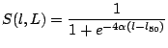

Spanish survey length distribution from 1990 to 2005 is modelled as GADGET “Andersen” function. Portuguese survey (NCT) from 1994 to 2005 (excluding 1996, 99, 30 and 04) was also modelled as “Andersen” function. This function is asymmetric following the next equation,

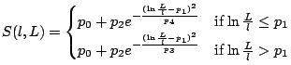 | Eq 1

p₀ and p₂ were set to 0 and 1 respectively, just p₁, p₃ and p₄ are estimated by the model.
L is the length of the predator. Gadget considers the fleet as a predator, but their length has no sense and it is fix as half of maximum length (50 cm).

Population Model
Recruits at age 0 from 1990 to 2005 (estimated by the model)
Abundance at age (1 to 8+) in 1990 (estimated by the model).
Growth Von Bertalanffy: loo=100, k=0.128 (Piñeiro and Sainza, 2003)
Length weight relationship: a=0.00000659 b=3.01721 (ICES WGHMM)
M = 0.2 for all ages (ICES WGHMM)

Trophic process description (Cannibalism)

Starting with the single species model (Cerviño et al., 2007), the next step is the implementation of the cannibal trophic process into the single species model in order to estimate the consumption. The consumption determines how much of a given prey is consumed by the predator. This will result in the population of the prey being reduced. GADGET estimates the consumption of a prey as dependent on the length of both the predator and the prey.

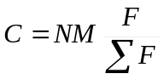

< C > is the consumption of a given predator (hake) size on a prey size group
< N > is the number of predators in a given size range
< M > is the maximum possible consumption of hake. This is function of temperature and predator length.
< F > gives the amount of a given prey in a length cell consumed by a predator. This is the product of suitability (S), prey abundance (N) and mean weight (W) [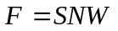]

Information needed to set a trophic link in GADGET to estimate the consumption are:

- Maximum consumption by predator size
- Predator-prey suitability
- Prey energy content
- Proportion of prey in predator diet

All this information was derived from Cantabric Sea field data presented this year in the Velasco PhD Thesis (2007).

1. Maximum consumption
Maximum consumption in Kjul/month was estimated from stomach contents data in weight at age (Velasco, 2007). Age was transformed in size with Von Bertalanffy function. Energy content in hake stomach was estimated as 5.2 Kjul/gr. Field consumption data by length was used to estimate the GADGET model parameters for maximum consumption as

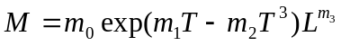

< T > is the temperature, set as 12 ºC for south hake. m₁ and m₂ were those estimated for captive cod by Jobling (1988).
< L > is the predator length.
m₀ and m₃ were estimated fitting the model to observed consumption

Final maximum consumption GADGET parameters for south hake are:
m₀ = 1.9; m₁ = 0.104; m₂ = 0.000112; m₃ = 1.5,
and the resulting function is showed in figure 1:
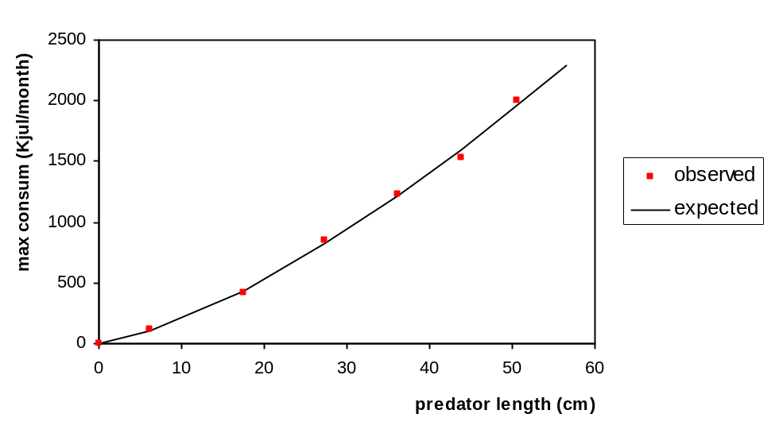
Figure 1. Maximum consumption (Kjul/month) by predator length

2. Prey suitability
Prey suitability determines how predators act on the preys. GADGET provides 6 different functions to model suitability. Andersen suitability is the more general suitability function and depends on the ratio of the predator length to the prey length as given by the following equation:

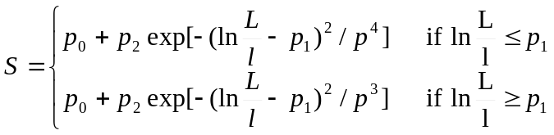

Suitability was reparametrized as Andersen function (above) using plots from Velasco (2007) relationship among predator-prey size.

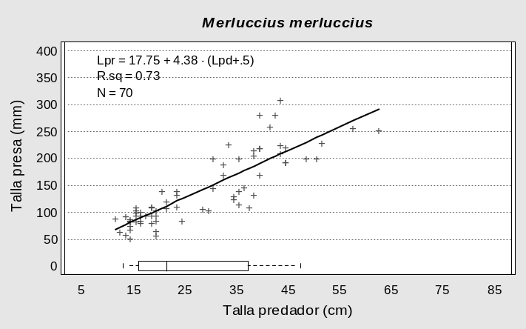
Predator-prey size relationshipfor hake cannibalism from Velasco (2007)

Cannibalism starts at small sizes, about 15 cm eating hakes of about 7 cm. The longer prey observed was 31 cm long. This plot shows a mean size prey preference of about half of predator size. This is determined by p₁ parameter that was set as 0.71. p_{o} and p₂ were set as 0 and 1. The “spreading” of prey size around mean values is determinate by parameters p₃ and p₄. These parameters were set following the plot distribution values; the plot shows an increase in the “spread” with the predator size. For 15 cm predator, the prey size varies from 6 to 9 cm, meanwhile 40 cm predators eat fish from 10 to 30 cm. Previous studies (Trenkel et al., 2004) set these parameters for cod as 0.05. After some sensitivity analysis in GADGET trying different parameters, the final values for p₃ and p₄ were set to 0.1, and the final suitability function with this parameters (p_{o}=0; p₁=0.71; p₂=1; p₃=0.1; p₄=0.1) looks as follow (figure 2):

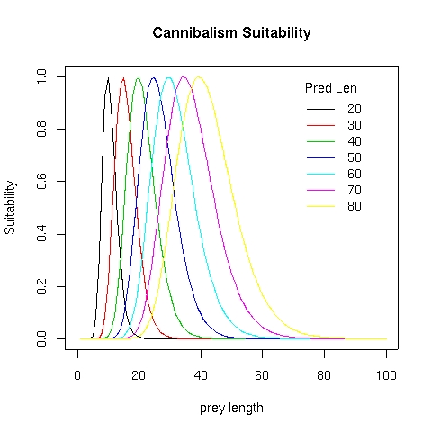
Figure 2. Predator prey Andersen suitability function for hake cannibalism

3. Prey energy content depends on specie, size, season and areas. Mean value for hake was estimated following Velasco (2007) as 4.2 Kjul/gr.

4. Prey proportion in predator diet varies with size of predator, season, area, density, etc. Main cannibalism area for South hake is the Galician cost between Finisterre and Estaca capes, that is a main nursery area. Velasco work include all preys, being the most important: blue whiting, mackerel, horse mackerel, sardine and crustacean for smaller fish. After 2 cm fish represents more than 50% of diet and after 18 cm hake eats fish in a 99%. Velasco (2007) identify 3 length group for cannibalism: 9-14 cm with 2.5% cannibalism; 15-23 cm with 5.2% >23 with <1%.

Cannibal parameters

Cannibalism proportion was initially implemented in GADGET as a constant proportion for al predator lengths; starting with a minimum value (0.1 %) and increasing the proportion progressively. This strategy was implemented because the initial trials with values about 3-5% cannibalism did not work because the model was not able to produce fish enough in a consistent way for the fishery (catches) and the food (cannibalism). This is a well know problem for forward dynamics models like GADGET. GADGET call this event “understoking” and deals with it overweighting it in the likelihood function and trying different parameters combination until the “understoking” disappears. One of the trials was with the “spread” parameters (P3 and p4) in the suitability function where we get that high values (~0.1) provide better fit that low ones (0.05). Nevertheless in this cannibalism model the “understoking” did not disappear and the maximum cannibalism proportion that the model was able to deal with (without “understoking”) was 1.2%. A posterior cannibalism increase (3%) drives to inconsistent results with initial population values near 0 for ages 2 to 7, so this model was rejected for predictions.

Trophic parameters implemented in South hake GADGET model:
Maximum consumption by length: m₀ = 1.9; m₁ = 0.104; m₂ = 0.000112; m₃ = 1.5
Cannibalism Andersen Suitability: p_{o}=0; p₁=0.71; p₂=1; p₃=0.1; p₄=0.1
Hake energy content: 4.2 Kjul/gr
Cannibalism proportion in stomach: 1.2%

This parameters were implemented into the singles species model as trophic process with the same likelihood function so the likelihood score may be comparable as an indicator of quality fit.

Estimated parameters and likelihood function

The estimated parameters in the present model are presented in the next table:

name | number | description
age* | 7 | abundance at age in the initial population in 1990 (age1 to age7)
rec* | 16 | abundance in recruits per year (age 0) from 1990 to 2005
*comm | 2 | catch selection parameters in function ExponentialL50 (acomm and L50comm)
spsurv* | 3 | Spain survey selection parameters in function Andersen (SpSurv1, SpSurv3 and SpSurv4))
ptsurv* | 3 | Portuguese survey selection parameters in function Andersen (PtSurv1, PtSurv3 and PtSurv4)

Total: 31 parameters

Model parameters are estimated minimizing differences among observations and model results. The present model implements 13 different likelihood components:

Component | description
total.ldist | total catch length distribution by 2 cm length
SpDem.ldist | Spanish survey length distribution by 2 cm length
PtDem.ldist | Portuguese survey length distribution by 2 cm length
SpIndex10cm.* | Spanish survey abundance from 4 cm every 10 cm (5 likelihood components)
PtIndex10cm.* | Portuguese survey abundance from 4 cm every 10 cm (5 likelihood components)

Functions for GADGET CatchDistribution likelihood component (total.ldist, SpDem.ldist and PtDem.ldist) are given by next equation:

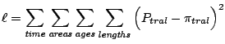
where:
< P > is the proportion of the data sample for that time/area/age/length combination
< π > is the proportion of the model sample for that time/area/age/length combination

The GADGET SurveyIndices likelihood component (SpIndex10cm.* and PtIndex10cm.*) were aggregated into 10 cm length groups with the exception of last group for every survey that was grouped as plus group. The likelihood component used is the sum of squares of a linear regression in log scale fitted to the difference between the modelled data and the specified index, given by next equation below:

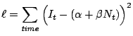
where:
I is the log of observed survey index
N is the corresponding index calculated in the Gadget model in log scale
β is set to 1
α is exp(catchability)

Weights for every component were calculated following Stefansson (2003) taking into account the amount of information provided, in terms of quantity and quality. Estimated weights are presented in the table 1, below.

The final likelihood function is the sum of these 13 individual functions weighted by the corresponding factors.

Results

Diagnosis
The model fit quality are quantify by likelihood scores and residuals analysis (see annex 1 for residuals plots). The presented model was chosen among other cannibalism models because showed the lower likelihood score and because it presented a well balanced residuals distribution.

Likelihood scores for every component in mulitspecies model are presented in next table:

Component | Function Type | Weight | Score | Weighted Scores | % differ (sing sp)
total.ldist | CatchDistribution | 7630 | 0.2522 | 1924.29 | -16.5%
SpDem.ldist | CatchDistribution | 5103 | 0.4729 | 2413.21 | 19.4%
PtDem.ldist | CatchDistribution | 4660 | 0.2161 | 1007.03 | 75.7%
SpIndex10cm.1 | SurveyIndices | 3.14 | 8.413 | 26.42 | -13.8%
SpIndex10cm.2 | SurveyIndices | 15.64 | 5.943 | 92.95 | -3.4%
SpIndex10cm.3 | SurveyIndices | 56.14 | 2.214 | 124.29 | -17.5%
SpIndex10cm.4 | SurveyIndices | 42.51 | 2.319 | 98.58 | -28.1%
SpIndexplus.44 | SurveyIndices | 42.5 | 3.312 | 140.76 | -15.3%
PtIndex10cm.1 | SurveyIndices | 1.18 | 11.27 | 13.30 | -1.7%
PtIndex10cm.2 | SurveyIndices | 6.71 | 1.65 | 11.07 | 34.8%
PtIndex10cm.3 | SurveyIndices | 6.68 | 1.329 | 8.88 | -3.4%
PtIndex10cm.4 | SurveyIndices | 8.07 | 0.9628 | 7.77 | -23.3%
PtIndexplus.44 | SurveyIndices | 8.07 | 1.798 | 14.51 | 3.6%
total |  |  |  | 5883.05 | 6.3%

The final model score is 5883.05

Likelihood components, weight and values were estimated in the same way than single species model but is was added an extra column in the right (“% differ.”) showing the difference in scores compared with the single species model. The total score is higher in cannibal model (a 6%) compared to single species one. The main components reducing the score are: total.ldist and the 5 Spanish survey indices, meanwhile length distribution for both surveys (SpDem.ldist, PtDem.ldist) are the main contributors to the score increase.

The distribution of these scores by year and quarter are presented in Figure 3. Yearly scores are well above the mean at the beginning of the time series (see upper left plots for total.ldist, SpDem.ldist and Pt.Dem.ldist) showing that the quality of the model is worst for this period. This score distribution is similar than those from single species model. This is caused by the lack of information in this period (1990-1993) when there was only information from Spanish survey (not quarterly catch length distribution).

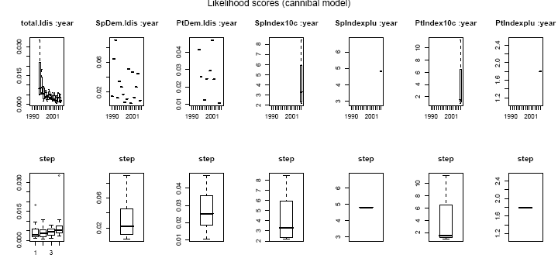
Figure 3. Cannibalism model likelihoods scores distribution by year and quarter (step)

Appendix 1 figures 1 (a,b,c,d) shows how modelled proportions at length for commercial fleet (by quarter), Spanish survey and Portuguese survey fit the observed proportions. Appendix 1 figure 3 to 4 show the residuals in index abundance by length group and survey.
Residuals from appendix 1 show that the main fitting problem is the same than those from single species i.e.. the beginning of the time series but the fit of catch selectivity is good in recent years (2001 to 2005).

Estimated model parameters values are:

Abundance in 1990 (mill):
age1 | age2 | age3 | age4 | age5 | age6 | age7
853.96 | 342.63 | 18.93 | 0.08 | 0.00 | 94.52 | 137.05

Recruitment at age 0 (mill):
rec90 | rec91 | rec92 | rec93 | rec94 | rec95 | rec96 | rec97 | rec98 | rec99 | rec00 | rec01 | rec02 | rec03 | rec04 | rec05
1563 | 1668 | 1823 | 2268 | 1857 | 1831 | 1893 | 2020 | 1962 | 1827 | 1596 | 1578 | 1838 | 2326 | 2219 | 6331

Selection pattern parameters for commercial, Spanish and Portuguese survey:
acomm | L50comm | SpSurv1 | SpSurv3 | SpSurv4 | PtSurv1 | PtSurv3 | PtSurv4
0.166 | 27 | 1.109 | 0.153 | 0.021 | 1.132 | 0.049 | 10

According with the bad model definition at the beginning of the time series, abundance figures in 1990 shows a rare pattern with near to 0 abundance at ages 4 and 5 and high values at ages 6 and 7, similar than single species results for this year. Recruitment at age 0 and selection parameters do not show any apparent inconsistency.

Results and comparison with single species model
Standard outputs for F (2-5), catches, SSB and recruitment from single species model compared with cannibalistic model results are presented in figure 4.

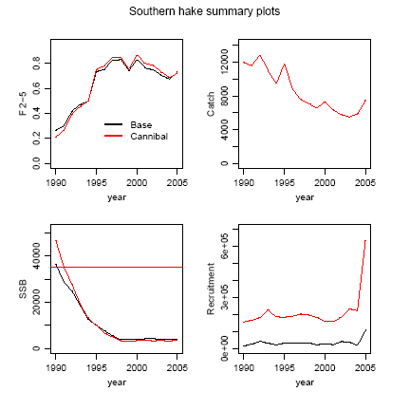

Figure 4. Summary of stock trends for main single species parameters (base) and a comparison with cannibalism models (Cannibal)

F mean and SSB follow a similar trend in both models. Small differences happen in the beginning of the time series with lower F and higher SSB in cannibal model. This may be explained by the fit difficulties (figure 5) due to lack of data at the beginning (1990-93). Catch area the same in both models; this clarify the “understocking” problem did not occur. Main differences happen in Recruitment with a similar trend but different amounts, being the cannibalism figures clearly higher than those from single species model.

In general we may conclude that both model shows similar trends although there are discrepancies in the amounts. This discrepancies are more evident at the beginning of the time series, with lower Fs and higher SSB in cannibalistic model.

Main differences happen in recruitment, although these differences does not have effects neither on mean F (2-5) nor on SSB. F at ages 0 to 2 is higher in cannibalism model and F 3 to 7 is lower; this together with cannibalism that mainly happened in younger ages explains why high recruit does not produce high SSB compared with single species model.

Predictions and management alternatives. Comparison between single and multiespecies models.

Data for predictions

The work performed until now provide the information needed for predictions: (1) initial conditions (abundance at size and age in 2005); (2) recruitment from 2006 and (3) a fishing strategy based on estimated selectivity for commercial fleet and (4) seasonal effort distribution. Other process like natural mortality, growth and maturity are assumed constant in time and equal than those used for the past.

Initial conditions (abundance at length and age)
Abundance at age and length are provided by GADGET at the end of 2005.

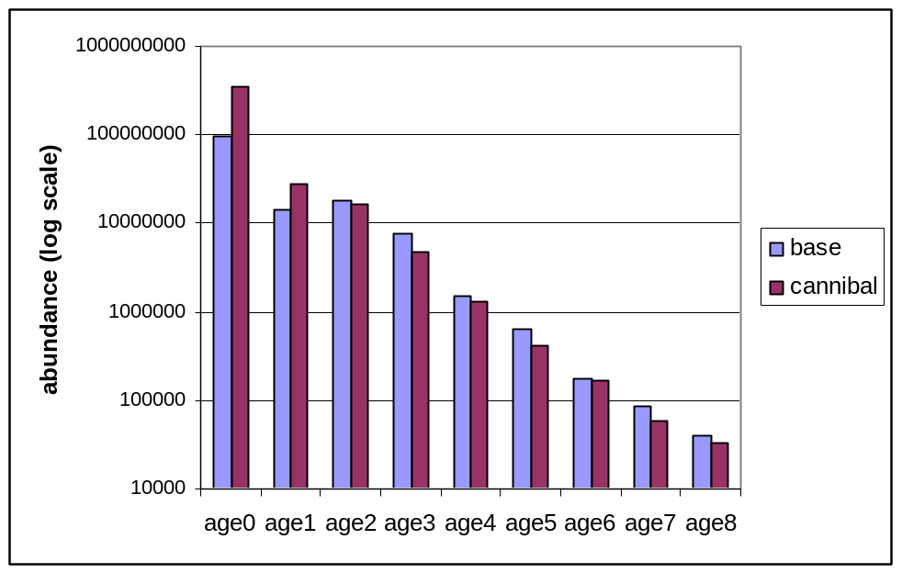
Figure 5. Abundance at age at the beginning of 2006.

Figure 5 presents the abundance at age (in log scale) in 2006. The estimated population structure change in both models. Cannibal model shows higher values at younger ages (0 and 1) and lower figures at 2 and older ages. The slope in cannibal model is steeper than those from single species model. This slope represents the total mortality; since natural mortality and catches (total and length distribution by quarters) are the same in both models, this difference may be explained by the cannibal induced mortality as well as an adaptation of the population structure to the new dynamic.

Recruitment
In order to progress on time from 2006 forwards we need a predictor for abundance at age 0 every year. The signal of SSB-recruitment relationship is pour, covering an small time period

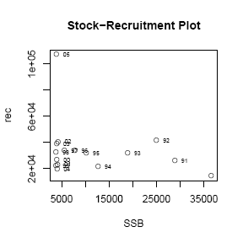

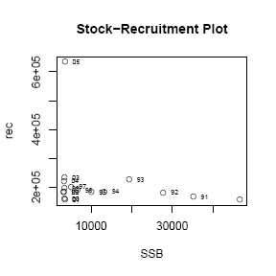

Figure 6. SSB-recruitment plot. Single species model in the left and cannibal model in the right.

Figure 6 shows SSB against recruitment from 1990 to 2005. XSA SSB values were estimated high at the beginning of the series, from 1982 forwards, providing the image that the probability of getting good recruitments are higher with SSB up to 25000 tons, that is the point of reference for Blim (35000 t). The shortness of GADGET series, starting in 1990 due to data availability is an important limitation to compare stock perception in both models. In the cannibal model recruitment trends and SSB trends are similar than those from single species model (Cerviño et al., 2007 ). SSB in the first years are probably overestimated and is not recommended to use it to model a SSB/recruit relationship. 2005 recruitment is clearly higher than the rest recruits and is probably overestimated. The recommended recruitment for predictions is the same in both models, i.e. a mean recruit from 1990 to 2004 (29 mill in single species and 188 mill in cannibal model). Recruitment for 2005 was also substituted by these mean values.

It is not recommended the use of any kind of stock recruitment model for predictive purposes since the heavy peak of SSB in 1990-1993 (and the corresponding low F) are probably caused by the quality of the fit in this period.

Selectivity
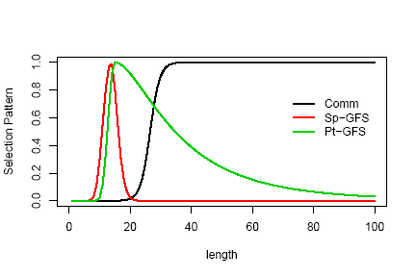
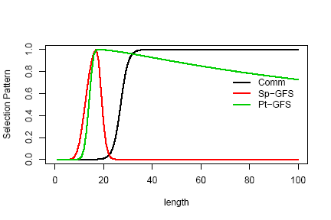
Figure 7. Estimated selection pattern by length in the thee fleets: commercial fleets, Spanish and Portuguese surveys. Single species model (up) and cannibal model (down)

Figure 7 shows the three selection pattern estimated by both models. We can see that Spanish survey are more efficient for fish smaller than 20 cm mean and mode in 17 cm while Portuguese survey are more efficient than Spanish one for longer fish (mode in 19 cm) and continue being efficient for longer fish. The main difference in both models happen in the Portuguese selection pattern, more flat for older fish in cannibal model. Spanish and Portuguese survey are only used to help in abundance fit and are not used for management.

Single species commercial selection pattern fit to an logistic function with L-50 at 26.5 cm, and slope 0.159. Cannibal model commercial selection pattern presents a L-50 at 27 cm and slope parameter equal to 0.166, both slightly higher than single species model. Since the commercial fleet groups all fleets together and the quality of the fit in recent years is good, these parameters will be used to make predictions, although we have to take into account that discards are not included into the model and this pattern represent only landings.

Quarterly fishing mortality
One of the advantages of GADGET against XSA or other assessment models is the temporal steepness that may be monthly or quarterly. XSA assumes F just happens in the middle of the year (Pope’s approximation) and for projections it is assumed a F equally shared all over the year. GADGET let us find out different seasonal patterns that may used to understand better the population and fishing behaviour, and they may be used for more realistic predictions.

Figure 8 shows the seasonal behaviour of F at age (upper panels for single species model and lower panels for cannibal model - Left plot for years 94-97, middle plot for 98-01 and right plot for 02-05). Differences among single (upper panels) and cannibal model (lower panels) focus mainly on the age to get the maximum F; mean ages 4 and older are full recruited in single species model, for cannibalism model the age of full recruit is age 3.F is higher in the 2nd and 3rd quarter and lower in the 1st and 4th in all the period. Differences among the beginning of the series (1994-97) and the end (02-05) are scarce.

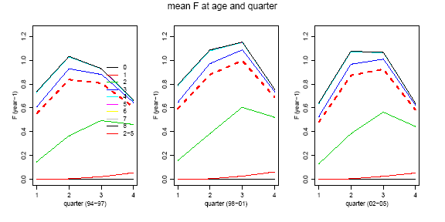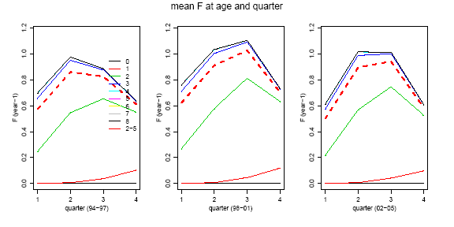
Figure 8. F by quarter. Single species model (upper panels) and cannibal model (lower panels). Red discontinuous line for mean of ages 2 to 5.

F distribution by quarter in 2005 will be used for predictions. Next table shows these values for both models.

 | 1st quarter | 2nd quarter | 3rd quarter | 4th quarter
Single sp | 0.58 | 0.99 | 1.00 | 0.62
Cannibal | 0.52 | 0.93 | 0.94 | 0.55

Management strategies
The main goal of this exercise is to compare both model predictions evaluating the effect of trophic process incorporation. Two different predictions will be performed in order to do this comparison:

- Following the recovery plan for South Hake
- Trying different levels of constant effort multipliers (from1 to 0)

In both cases the deadline is 2020 and the input values are those presented before

South hake Recovery Plan
There is a management goal defined for South hake in the Recovery Plan (EC nº 2166/2005) that is to get a SSB over 35 000 t (Bpa) by 2015 decreasing the fishing mortality a 10% annual until F=0.27. The equivalent for this Bpa could not be evaluated given the short time period in the GADGET model (1990-2005).

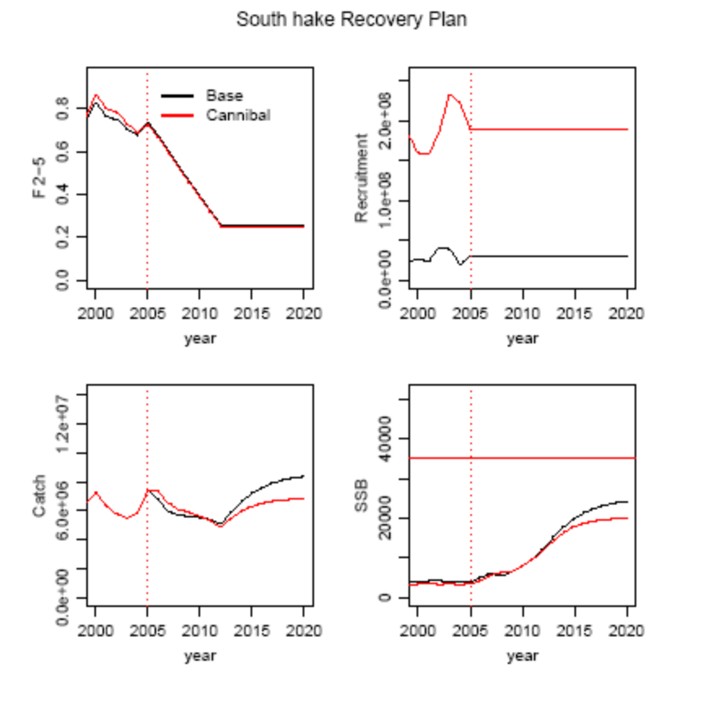
Figure 9. South hake recovery plan applied to GADGET model. A comparison between single species and cannibal model. Dotted red line represents the initial year for predictions.

Figure 9 shows the trend in interest predicted values for different variables: F mean and recruitment as input variables and catch and SSB as output variables. F mean in both models is really similar in 2005 (0.73 in single sp and 0.72 in cannibal model) so just a small difference in the trends are showed. Recruitment is clearly higher in cannibalism model (aprox. 6 times higher).

The catch follows a similar trend in both models, although with some important differences. There is a decreasing trend from 7 thousand tonnes in 2005 to a minimum of 5 thousand tonnes in 2012 and afterwards the catch increase until 2020 with 7 thousand tonnes in the base model and only 6 in the cannibal model.

In terms of recovery, SSB is the reference variable, and the decreasing trend in F produces a clear recovery in SSB in both models, although there are also important differences. Both models present a similar SSB until 2012 but afterwards base model recovers quickly with 25 thousand tonnes in 2020 meanwhile cannibal model just get until 20 thousand tonnes in 2020.

In summary, regarding the catch, in the short and medium term time the cannibal model produce more yield, specially when it decreases, and in the long term cannibal model produces less yield. Regarding SSB, both models produce similar SSB in short and medium term but single sp model produces more SSB in long term.

Constant effort multipliers
Assuming Fsq = F2005 we may apply different multipliers to this F to analyze an effort reduction strategy and see what happen in the sort, medium and long tern. The selected multipliers always represent a reduction from 1 (Fsq) to 0 (no fishing) each 0.2
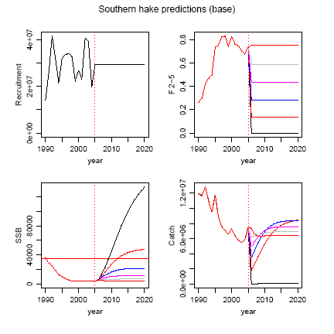

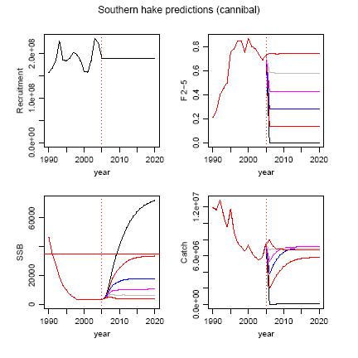
Figure 10. Predictions with constant F multipliers: 0 or Fsq (black), 0.2 (red), 0.4 (blue), 0.6 (pink), 0.8 (grey) and 1 (red). Upper panels present single sp predictions (base) and lower panels present cannibalistic predictions (cannibal). Dotted red line represent the initial point for predictions (2005), and horizontal red line represents the official Biomass Limit (Blim=35000t)

Panels in figure 10 (single species model in upper and cannibal model in lower) show the trends in catch and SSB under different F levels and with a constant recruitment. SSB keep constant when F is kept constant regarding F 2005 (Fsq), and increases when F decreases in both models. Bpa (35 Kt) is just reached with F=0 and when F= Fsq*0.2 in base model but in cannibal model just reach Bpa with F=0. Cannibal model needs a bigger F reduction to achieve a recovery in terms of Recovery Plan.

In terms of catches (or yield) and in both models, all the Fs implies a lost of yield in short term (except F=0) although after that the yield increases in the medium term until stabilize at different levels in both models. In the medium term the recovery is slower in cannibal model than in the base model and in long term the base model shows yields higher than those from cannibal model always above the present yields. Meanwhile in the cannibal model when F=Fsq*0.2 the yield stabilize below the present yield and when F increase the yield increase but never over the present yield.

We have to take into account that the reference (Bpa=35 Kt) cannot be assessed by the GADGET model due to time range limitations and the misfit at the beginning of the period. Furthermore, taken into account the ICES assessment, the mean recruitment (1990-2004) represents a period of low recruitment, and should be expected a quicker recovery with higher recruitments in the future. Due to this two limitations this predictions cannot be used for assessment purposes

Conclusions

First implementation of multiespecies model

Most of the results are similar than those from single species model, with the exception of recruitment, that shows a similar trend but different level.

The present time series (1990-2005) is shorter than those from the official assessment, starting in 1982. This is a problem to compare reference points because past values are the basis to set B_{lim} in ICES (35 000 t). The diagnosis is similar in both models, with a bad fit among model and observations at the beginning of the time series; this is an extra difficulty to compare biological reference points. Given these two constrains it was not possible to set reference points based in multiespecies model.

Two problems dominate the GADGET implementation of trophic process: first the data availability and second, the model implementation. Trophic data were provided by Velasco PhD (2007) and these data are not in the adequate format to work in GADGET, so the process parameters (maximum consumption and suitability) were estimated out of the model and implemented in GADGET in the simplest way, i.e. process does not change with size, area, season or year. The cannibalism proportion was not possible to implement directly due to “understoking” problems (i.e.: the model does not produce enough fish to be caught plus the fish to be consumed by predators). Since cannibalism model definition implies a stock eating itself, the “understoking” problem was not properly solved and the final multiespecies model was only able to implement a 1.2% of hake proportion on hake stomachs although it was observed that this proportion may reach a 15% in some areas and season and mean values for the whole stock of about 4%.

Apart from model limitations, the present results provide an opportunity to compare if the trophic model may provide different view for management purposes than single species model.

Regarding present status and historical results

  - Recruitment estimated in the cannibalistic model is about 6 times higher than single species model in all time series.
  - The age structure is different in both models with high recruitment and high mortality in cannibalistic model
  - Both models provided a similar historic view in terms of SSB and F mean (ages 2 to 5).
  - Both models provide a bad fit at the beginning of the time series. It seems like abundance is overestimated and F underestimated.

Regarding future projections

  - At short term there is not differences in SSB or yield between both models
  - At medium term cannibal based model gives a quick recovery in yield than single species model.
  - At long term cannibal based model do not achieve the same SSB levels than single species model and produces yields below those in single species model

Based on the work performed, the main conclusion should be that the incorporation of cannibalism process into the assessment model gives a more pessimistic view of the recovery possibilities and future yield of Southern hake in medium and long term. Nevertheless we have to take into account that the present cannibalistic process is constrained by the small proportion in stomach. Waiting for a better future cannibalistic model now we are in conditions to affirm that the initial hypothesis that “cannibalism matters” on assessment and advice continue being plausible although it needs for more work.

References

Begley, J. and D. Howell. 2004. An overview of Gadget, the globally applicable Area-Disaggregated General Ecosystem Toolbox. ICES CM 2004/FF:13

Cerviño, S., L. Taylor, E, Jardim, F. Cardador, F. Velasco and A. Punzón. 2007. A preliminary length based assessment for Southern hake with GADGET. WD 22. ICES WGHMM, 8-17 May 2007, Vigo

Gunnar, S. 2003. Issues in multispecies models. Nat. Res. Mod. Vol 16 (4) pp 415-437.

Jobling, M. 1988. A review of the Physiological and Nutritional energetic of Cod, Gadus morhua L., with particular reference to growth under farmed conditions. Aquaculture, 70 pp 1-19

Piñeiro, C. and C. Sainza. 2003. Age estimation, growth and maturity of the European hake (Merluccius merluccius) from Iberian Atlantic waters. ICES J. Mar. Science, 60:1086-1102

Stefansson, G. 2003. Issues in multiespecies models. Natural Resource Modelling. Vol 16 (4).

Taylor, L. and G. Stefansson. 2004. Gadget models of cod-capelin-shrimp interactions in Iceland waters. ICES CM 2004/FF:29

Trenkel, V.M., J.K. Pinnegar, J.L. Blanchard and A.N. Tidd. 2004. Can multispecies models be expected to provide better assessments for Celtic sea groundfish stocks? ICES CM 2004/FF:05

Velasco, F. 2007. Alimentación de la merluza europea (Merluccius merluccius L.) en el Mar Cantábrico. PhD Thesis. Universidad de Madrid.

ICES, 2007. Report of the Working Group on the Assessment of Southern Shelf Stocks of Hake, Monk and Megrim (WGHMM). Vigo, Spain, 8 - 17 May 2007. ICES CM 2007/ACFM:21

Annex 1. Cannibalistic model diagnostic plots

Figure 1. Cannibal model. Comparison of expected and observed length distribution in commercial catch by quarter

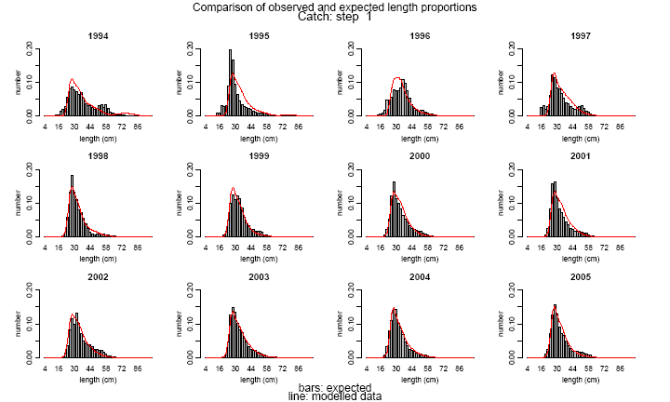
Fig 1.a. First quarter

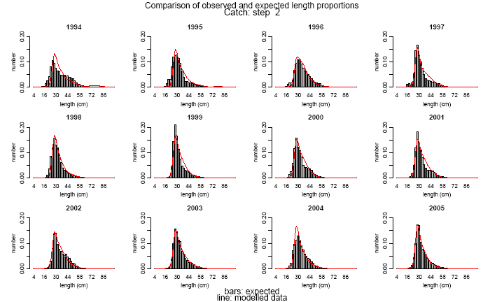

Fig 1.b. Second quarter

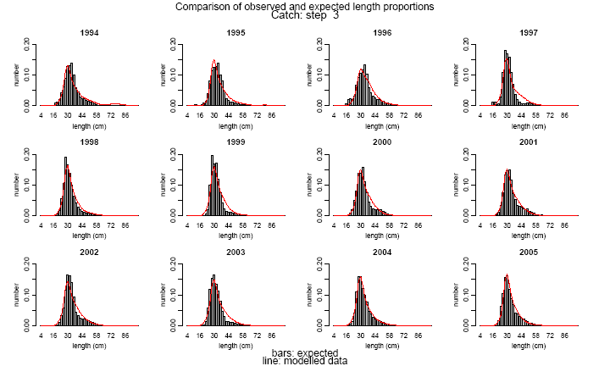

Fig 1.c. Third quarter

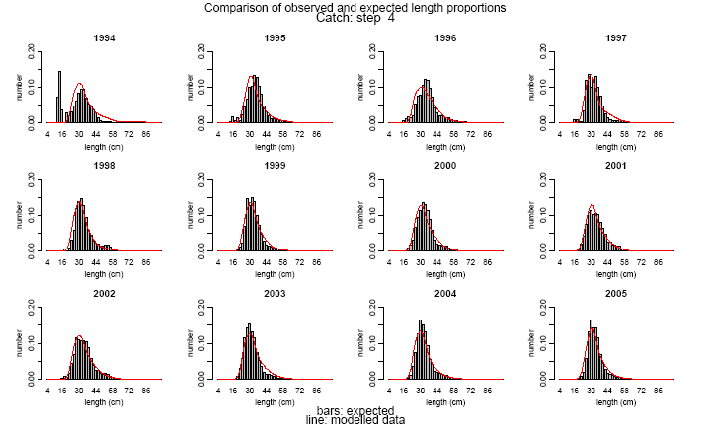

Fig 1.d. Four quarter
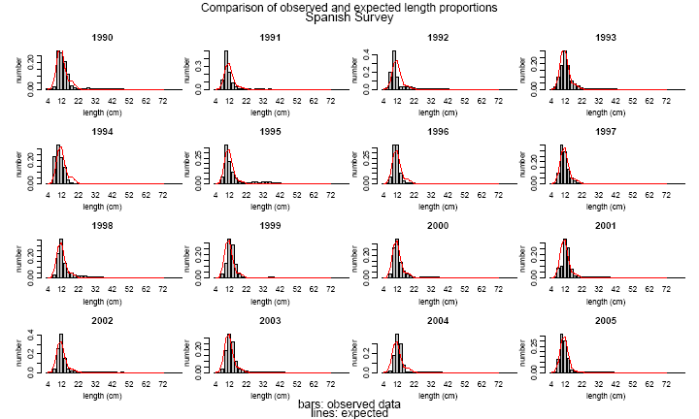

Figure 2. Cannibal model. Comparison of expected and observed length distribution in Spanish survey

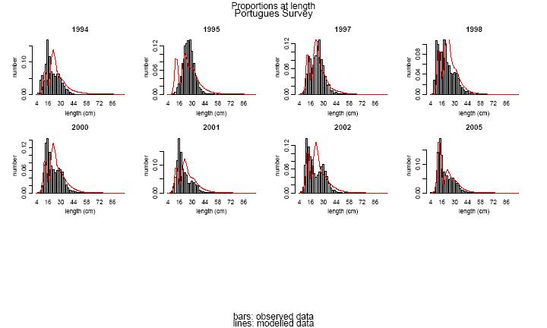

Figure 3. Cannibal model. Comparison of expected and observed length distribution in Portuguese survey
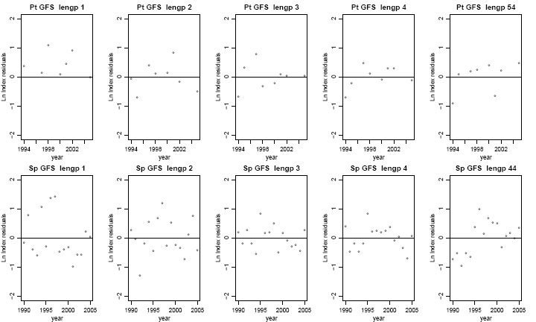

Figure 4. Cannibal model. Residuals in survey indices by length group. Portuguese survey in upper plots and Spanish in lower plots. Length group 1 (4 to 14 cm); Length group 1 (14 to 24 cm); Length group 1 (24 to 34 cm); Length group 1 (34 to 44 cm) and Length group plus from 44 cm until the last length

