**Paper 1. Infection dynamics**

The idea here is to use the model to examine various what if experiments to gain insight into infection dynamics.

Some ideas:

1. **Rodents: effect of different shedding assumptions (intermittent, high life long, low life long) on level of infection in various agents and in strain distribution**

Right now, the rodent strain SeroR dominates the system very quickly, including infecting the dogs which then shed seroR. this is consistent with reports from urban slum is brazil, for example, where they have a single strain circulating and causing pretty much all infections.

I wonder under what conditions this is no longer the case so we see both SeroR and SeroD circulating: Lower shedding concentration? Intermittent, some threshold of rodent abundance?

Initial results (model version October 2017): Infection in rodents over time: note that infection of rodents with dog serovar occurs early, but does not persist.

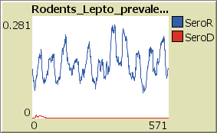

1. **Dogs: effect of immunity duration and shedding duration when infection with seroD. Right now, we assume immunity is one year. From Jarlath: “If a dog becomes infected with SeroD, it is a long term persistent infection…eventually there will be a tipping point when the host immune response clears the infection and shedding stops…if a dog starts to shed again, we don’t know if it is due to recrudescent shedding or re-exposure…we see an analogous situation in cattle.”**

We can try to get at a similar point with the model by looking at the relationship between duration of immunity and shedding may be. Right now in the model: …

*E3.5.5 Dog disease progression*

When the quantity of leptospires shed drops below 100 leptospires per day, a dog is considered recovered and immune from the serovar with which it was infected. Immunity is lifelong against seroR for dogs, [27,85] and immunity lasts one-year against seroD, as extrapolated from vaccine studies that suggest one-year protection with artificial immunity [page 12]

Lifelong immunity after infection with seroR is okay.

Immunity after infection with seroD is one year .

In the current model, results show very little infection with seroD. Infection in dogs but with seroR (see first point above).

Infection in stray dogs:

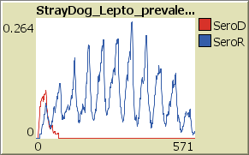

Infection in Owned dogs:

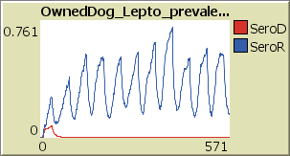

Note: prevalence of infection in owned dogs in much higher than in stray dogs??? Check!

1. **Environment: effect of different survival duration.**

We can look at the contamination load (concentration and proportion of contaminated patches in total and by Sero) for various survival rates .. as well as the different shedding options mentioned above for dogs and rodents.

1. **People: effect of contact rates with various agents (dog, rodents, and environment).**

Impact of transmission probability and contact rates

Infection in Humans. Right now , most of the infection is with SeroR. Most of those are from rodents that shed seroR but it could also be from dogs infected with seroR. so some infection is “due to dog contact” but dog infected with seroR.

