NASA Ames Space Settlement Contest
2021-22

EDNA 2.0

INDEX

Serial No. | Chapter Name
Section 1 | Introduction
Ch 1.1 | Executive Summary
Ch 1.2 | Inspiration for name EDNA
Ch 1.3 | Location
Section 2 | Asteroid 16-Psyche
Ch 2.1 | Structure
Ch 2.2 | About 16-Psyche
Section 3 | Settlement Edna
Ch 3.1 | Introduction
Ch 3.2 | Major Components
Ch 3.3 | Construction Sequence
Ch 3.4 | Materials
Section 4 | Life Support
Ch 4.1 | Air Management
Ch 4.2 | Water management
Ch 4.3 | Waste management
Ch 4.4 | Electricity generation
Section 5 | Operations and infrastructure
Ch 5.1 | Radiation protection
Ch 5.2 | Transport
Ch 5.3 | Recreation
Ch 5.4 | Communication
Section 6 | Human factors
Ch 6.1 | Residential facilities
Ch 6.2 | Government
Section 7 | Finance and cost

CHAPTER 1: INTRODUCTION
Chapter 1.1 : Executive summary
“I don’t think the human race will survive the next thousand years, unless we spread into space. There are too many accidents that can befall life on a single planet. But I’m an optimist. We will reach out to stars” - Stephen Hawking
In the next 30-40 years earth will be clogged with humans and they will fight to survive. So to prevent that we are planning another hope for survival without any type of issues so this the theme of the project EDNA.
So to construct this amazing idea we need money so to get money we also have a plan, we are going to mine an asteroid and extract minerals from it to get the money for the project.
AIM:
- To provide the same habitat as on earth in space.
- To mine asteroid 16-Psyche and extract minerals from it from which we will get the money to construct the space colony.
Because Asteroid 16-Psyche orbits in the main asteroid belt between Mars and Jupiter, it never comes close to Earth. Therefore, our mining vessel, Sirius, will be an autonomous deep-space miner. We will launch Sirius from Earth orbit in 2045. Using advanced ion propulsion, it will reach Psyche in the main belt by 2050-51 to begin extraction.
Now, coming to the space colony we have a well-designed structure with 7 tori from which 3 will be for residential purposes and the other 4 for agriculture, industry etc….

Chapter 1.2: Inspiration for name
“EDNA”
Life has no limitations unless you make. – Les Brown

The word “Edna” Hebrew word meaning rejuvenation or the action of process giving new energy. We all have chosen this name as we want to do exactly same thing as its meaning. We want to build a better life as earth has limited space and in future, we will need to migrate off this planet so this is our project creating life in space. For that we have chosen the name EDNA.

Chapter 1.3: Location and orbit
Location or placement of the settlement is very crucial. It decides the materials to be used to attain the sustainability of the settlement. Hence, we have decided to place the settlement in the orbit. This is kms from earth which makes it easy for us to transport the materials and our residents.

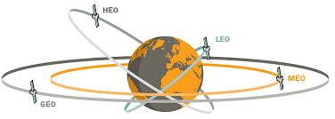

Sirius will be constructed in GEO (Geostationary Earth Orbit) before embarking on its deep-space journey. Once it arrives at Psyche in the main belt, it will extract the minerals and use electromagnetic catapults (mass drivers) to launch pods of refined material back toward Earth orbit, where EDNA is being constructed.

Section 2: Asteroid 16-Psyche

Chapter 2.1: Structure

In this chapter, we will look at the structure of Sirius, the deep-space asteroid mining vessel. Because the journey to the main asteroid belt is vast, Sirius will be launched from GEO orbit around 2044-45. Upon arrival at Psyche around 2050, it will deploy its extraction tools. The picture of Sirius is given below:
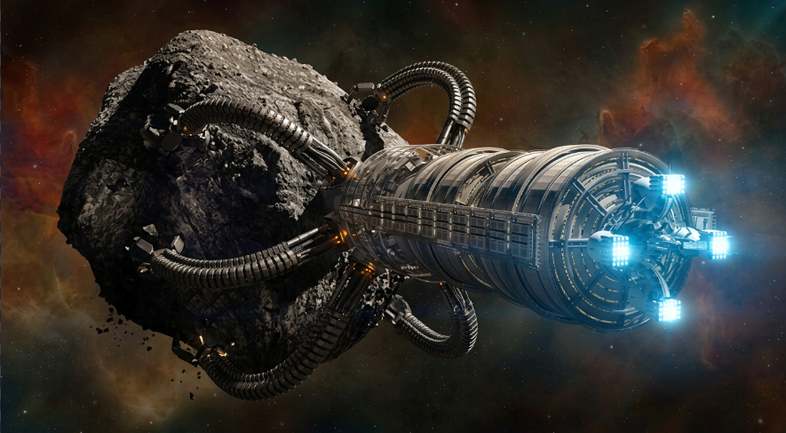

Chapter 2.2: About 16-Psyche
16-Psyche is a large asteroid discovered by the Italian astronomer Annibale de Gasparis, working in Naples, on 17 March 1852 and named after the Greek mythological figure Psyche. It is over 200 km in diameter. It is a massive metal-rich M-type asteroids. Its composition and density match mesosiderite meteorites.
Characteristics:
Recent data indicates that 16-Psyche is not a solid monolithic block of metal, but rather a highly porous "rubble pile" consisting of a mix of metallic and silicate rock. This significantly reduces the energy required for mining, as the asteroid is already heavily fractured.
The surface has about 20% of metallic contents, although reflection spectra are anomalous and difficult to match with theoretical composition models as in 2021.
So, with the above characteristics and other information we were going with 16-Psyche.

Section 3: Settlement Edna
Chapter 3.1 Introduction

The idea behind the structure of our project ENDA is to provide a safe, hospitable environment in the deadly harsh environment of space. EDNA provides a secure home for around 35000 residents, with all type of recreational, agricultural and industrial facilities along with a comfortable and luxurious amenity. Precisely considered, and feature-filled docking port; and much more.

Chapter 3.2: Major Components

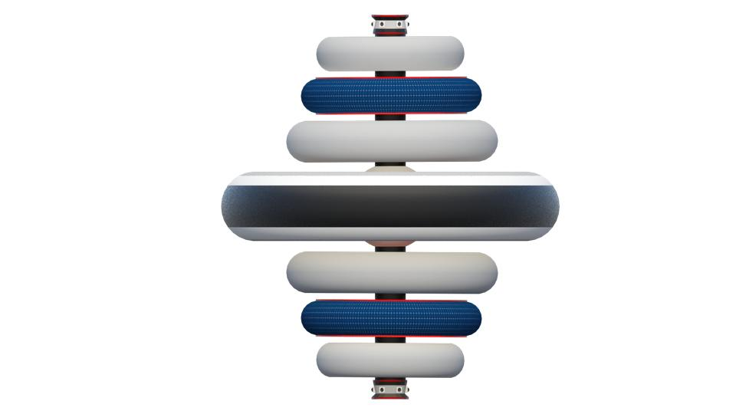
So, in the above picture as you can see, we have 7 tori, 2 docking ports and 1 central cylinder and a central sphere.


The above picture shows the top view of the settlement.

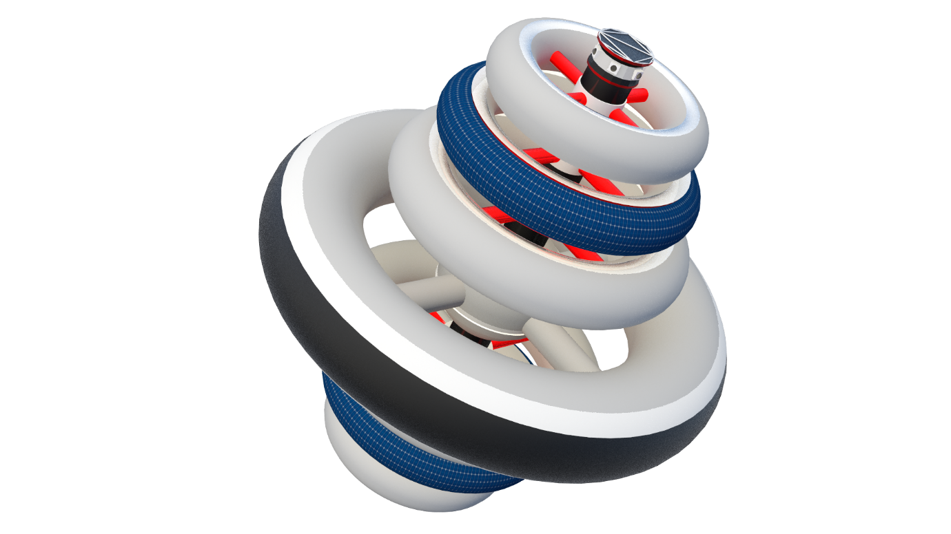

The Residential Hybrid Tori
The residential hybrid tori are the 3 central tori as shown below:

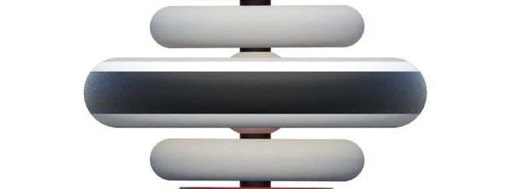

The residential tori radii are as follows: the 2 inner tori are 1000m, and the larger outer torus is 2534m in radius. For the inner tori, gravity generation requires a rotation speed of 0.891 RPM, providing a comfortable 0.89G (near Earth-gravity). The larger outer torus rotates at a slower 0.366 RPM to generate 0.38G (Martian gravity), which makes heavy manufacturing and cargo handling much easier. Because they spin at different rates, the tori are connected via a Central Magnetic Hub with frictionless electromagnetic bearings. Workers commute from the residential tori to prevent muscle atrophy in the lower gravity zone.
The Industrial torus
The industrial torus top second torus and the top one is for storage and living for the workers.
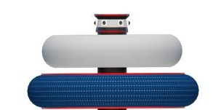
So, we will have numerous types of industries here :
Name of industry | Location
Information technology | Industrial torus
Paper and stationary | Industrial torus & residential  tori
Pharmaceutical | Industrial torus & residential  tori
Furniture | Industrial torus
Accessories | Industrial torus & residential  tori
Textiles | Industrial torus
Consumer electronics | Industrial torus
Printing | Industrial torus

The Agricultural tori
The agricultural tori are the bottom 2 form which one is the storage the other for cultivation. So we are going to use 2 methods of cultivation:

1) Hydroponics: Hydroponics is a type of horticulture and a subset of hydroculture which involves growing plants (usually crops) without soil, by using mineral nutrient solutions in an aqueous solvent. ... Hydroponics offers many advantages, notably a decrease in water usage in agriculture. The nutrients used in hydroponic systems can come from many different sources, including fish excrement, duck manure, purchased chemical fertilizers, or artificial nutrient solutions.

Plants commonly grown hydroponically, on inert media, include tomatoes, peppers, cucumbers, strawberries, lettuces, cannabis, and model plants like Arabidopsis thaliana.

Hydroponics offers many advantages, notably a decrease in water usage in agriculture. To grow 1 kilogram (2.2 lb) of tomatoes using intensive farming methods requires 400 l (88 imp gal; 110 U.S. gal) of water;[citation needed] using hydroponics, 70 l (15 imp gal; 18 U.S. gal); and only 20 l (4.4 imp gal; 5.3 U.S. gal) using aeroponics. Since hydroponics takes much less water to grow produce, it could be possible in the future for people in harsh environments with little accessible water to grow their own food. Few examples of plants which can be grown using hydroponics include lettuce, spinach, strawberries, herbs, hot peppers, beans….etc.

2) Aeroponics: Aeroponics is the process of growing plants in an air or mist environment without the use of soil or an aggregate medium. ... It is sometimes considered a type of hydroponics, since water is used in aeroponics to transmit nutrients.
The basic principle of aeroponic growing is to grow plants suspended in a closed or semi-closed environment by spraying the plant's dangling roots and lower stem with an atomized or sprayed, nutrient-rich water solution. The leaves and crown, often called the canopy, extend above. The roots of the plant are separated by the plant support structure. Often, closed-cell foam is compressed around the lower stem and inserted into an opening in the aeroponic chamber, which decreases labour and expense; for larger plants, trellising is used to suspend the weight of vegetation and fruit.

Ideally, the environment is kept free from pests and disease so that the plants may grow healthier and more quickly than plants grown in a medium. However, since most aeroponic environments are not perfectly closed off to the outside, pests and disease may still cause a threat. Controlled environments advance plant development, health, growth, flowering and fruiting for any given plant species and cultivars.

Due to the sensitivity of root systems, aeroponics is often combined with conventional hydroponics, which is used as an emergency "crop saver" – backup nutrition and water supply – if the aeroponic apparatus fails.

High-pressure aeroponics is defined as delivering nutrients to the roots via 20–50 micrometre mist heads using a high-pressure (80 pounds per square inch (550 kPa)) diaphragm pump.

The Central Sphere
The central sphere is responsible for controlling the settlement and communication.
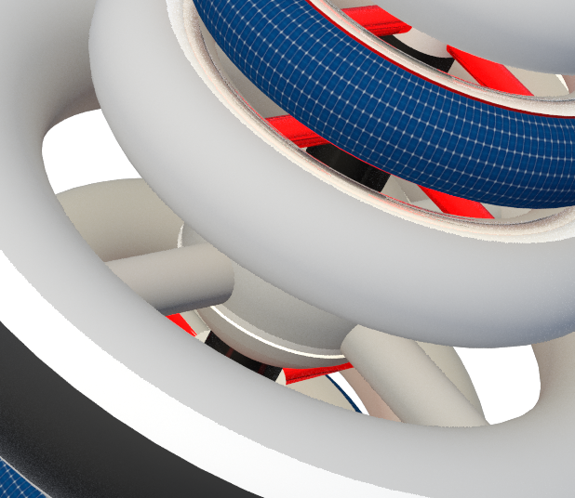

Chapter 3.3: Construction Sequence

This is the first step, the central cylinder.

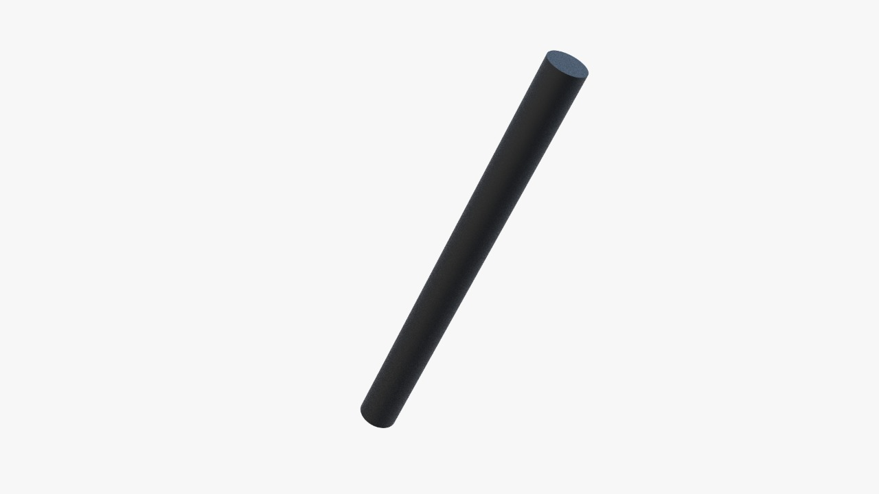

This is the second step; the central sphere will be inserted.
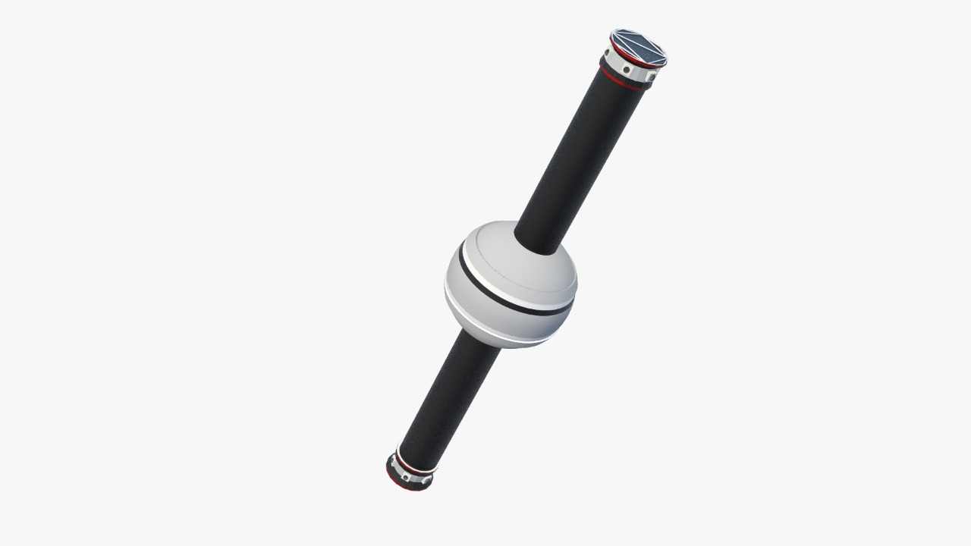

In the third step all the spokes will the inserted.
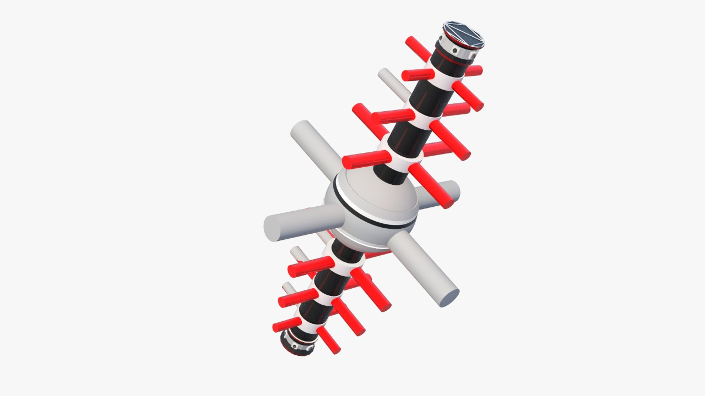

All the tori will be inserted at last.
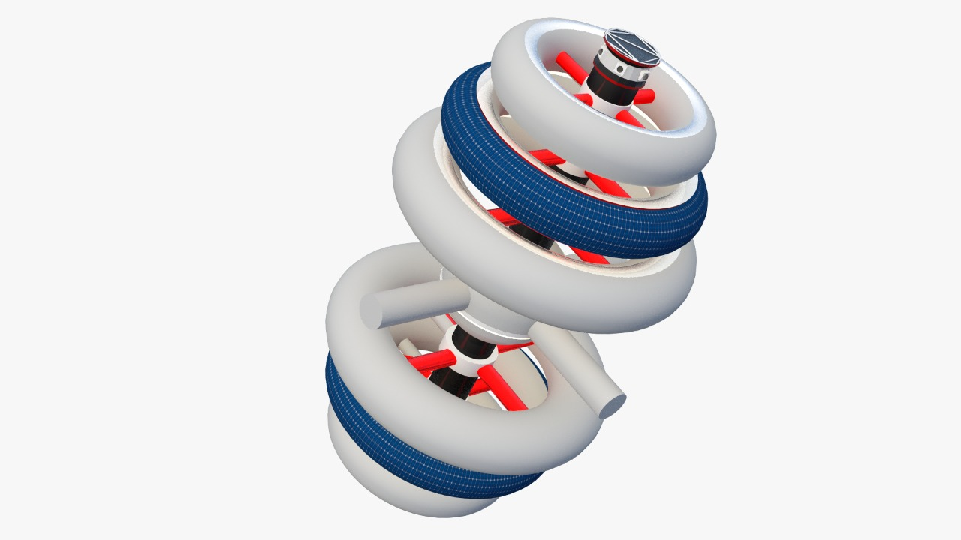
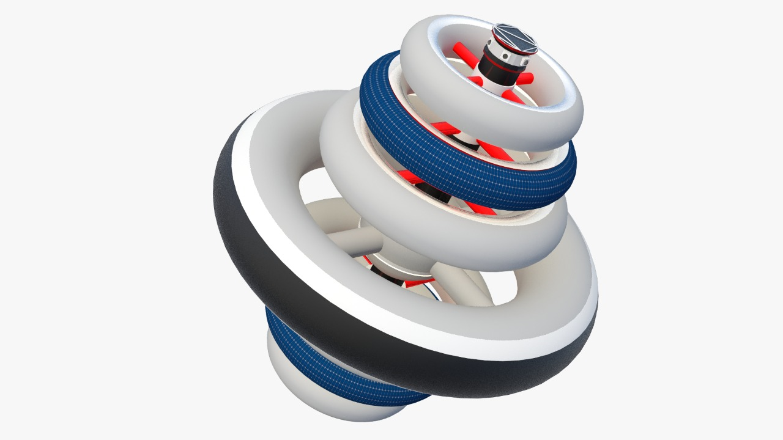
Chapter 3.4: Materials
The materials used cannot be monolithic i.e., a single and uniform layer of materials cannot be used for construction of components of the structure which themselves are enormous in size. Therefore, Tiles of materials would be constructed and then frame made up of Titanium-11 would be used to bond them together to form a large layer of tiles of that material. Several layers of tiles would gradually be constructed and then connected together using titanium frame.

The materials used are listed below:
- Titanium: the settlement must be safe from the harmful sun rays. So, it is good for us to use the metals which have high melting points. Titanium is one of them. It also has excellent strength and is light in weight so, we are going to use it for all tori except 3, which have the solar panels and the observation window.
- Aluminium: we are using it for the central sphere and the cylinder. Its characteristics are: Easily machined and cast. Lightweight yet durable. Non-magnetic and non-sparking. Good heat and electrical conductor.
- Carbon-Nano tubes: we will use them for device modelling, automotive parts, boat hulls, sporting goods, water filters, thin-film electronics, coatings, actuators and electromagnetic shields. device modelling, automotive parts, boat hulls, sporting goods, water filters, thin-film electronics, coatings, actuators and electromagnetic shields.
- Gallium arsenide-based solar cells: these are going to be used on the 2 tori, the 2nd from above and 2nd from below.

Section 4: Life Support
Chapter4.1: Air Management
Oxygen generation:
Most part of the settlement is going to get oxygen by running electricity through water. This is called electrolysis. The air and water on the Space Station all originally came from Earth. And more oxygen will be generated by Vika or TGK which is an oxygen generating system for spaceflight.
Air Filtration:
M.P.P.S Hyper HEPA
Hyper HEPA uses an aggregate of fibres to disinfect air with an efficiency of 99.97 to ≥99.98 % (removing particles as small as 0.003 microns). Sheets of thin Aluminium Filter fibres along with activated carbon slab and zeolites would facilitate air
purification.

One Atmosphere Uniform Glow:
Discharge Plasma (OAUGDP)
Plasma tubes would also install in M.P.P.S Hyper
HEPA. The air will be allowed to pass through very
low power plasma tubes which contain the dark
discharge coronas. When the air containing impurities
will pass through the plasma tubes and dark coronas, the impurities
will get ionized with different charges and hence, will move to their respective terminals that are sheets having positive and negative charges. The air particles will then be allowed to pass through but this air will still contain the microbial bodies which are smaller than 3 nm and cannot be separated from the air simply using the Silver Nano Particles. For removing the microbial bodies which are smaller than 3 nm, an increase in size of these bodies will be applied by reduction and calcination at 450oC.

Weather and Climate
The people residing in EDNA would not be able to live without any appropriate climate and humidity control system, mimicking the conditions of Earth.
Cycle of seasons
The seasons in the residential hybrid tori will
be controlled according to Table 3.2.6. The
seasons will not change within a day.
Creation of Artificial Seasons
Controlling heat and cold
Thermo-acoustic Refrigeration (for decreasing temperature). The source from which acoustic waves are produced is known as the “driver”. The driver emits a sound frequency in a tube filled with high pressure gases. This tube is known as the resonator. Between the tubes there is a “stack” of porous material which is solid in order to block the path of the sound frequencies. Then thermoacoustic effect takes place in order to cool down the other end and produce refrigeration. Planting this technique on large scale can produce artificial air-cooling in EDNA so that the people could experience winter. Thermal Induction (for increasing temperature) Water will be used to increase the temperature of the living areas. This will be done using Thermal Induction. Waste water will be heated using thermal induction and then the air produced in the heating will be directly supplied to the residential hybrid tori.

Controlling Humidity
Humidity will be controlled using these devices Ultrasonic Humidifiers (for increasing humidity)
Ultrasonic Humidifiers have a metallic diaphragm which pulsates at a frequency that cannot be heard by human ear. This technique is similar to loudspeakers. This frequency will produce water droplets. Molecular sieves (for decreasing humidity). The molecular sieves which will be used to remove humidity from the climate will have pores which are of 0.19 nanometres.

Rain and Snow
Climate-Controlled Biomes (Misting Systems)
Instead of unpredictable indoor cloud seeding, EDNA utilizes Climate-Controlled Biomes. High-tech overhead misting and humidity systems accurately simulate rainfall for agricultural and park sectors without risking electronic infrastructure. During the rainy season, these systems simulate rain about once or twice a week.

Chapter4.2: Water management

Water Recycling
Black Water will be purified using the following Processes
1. Centrifugation will be done to Remove the solid faeces,
immiscible liquids, and all other impurities in liquids.
2. Aeration Water then will be sent for Aeration and Aerobic Respiration which will
remove many microbial impurities and the methane gas and the waste water will
be sent to the agricultural sector.
3. Electrode-ionization This can remove most harmful Metals present in water.
The ions in the Water will be exchanged with the ions of the healthy water,
forcing all the metals, and the compounds to be removed from the water.
Water storage
Water will be stored in permanent tanks which will have inbuilt water heaters. These tanks will send the water to different areas as per the water requirement. The spring shown in the figure will act as a scanner for viruses. This tank will approximately contain up to 510l of water and 12 of them will be installed in EDNA in life support system zones.

Chapter4.3: Waste Management

A settlement also needs proper waste management systems in order to be hygienic and a pleasant place to live in. Both solid and liquid waste shall be collected from the houses through pipelines to a storage tank in the residential torus. This waste shall then be transferred through the pipeline system to HWWMB. In the unit the waste shall be separated as biodegradable and non-biodegradable.
1. Biodegradable: Biodegradable materials shall be collected and processed to produce manure and bio-fertilizers which shall be used as manure for kitchen gardens and home gardens.
2. Non-biodegradable: All the non-biodegradable products shall be collected and recycled via a technique called Thermal depolymerization. In this technique complex organic molecules are converted into simpler ones by applying intense pressure and heat and produces useful crude oil and glass.

Chapter4.4: Electricity Generation
We shall employ Photon enhanced thermionic emission (PETE) solar panels.

Mechanism of transfer of electricity
The surplus electricity in the settlement shall be converted into microwaves which shall be transmitted to earth through a channel of satellites. For the purpose of transfer of electricity to satellites, solar power satellite (SPS) (working as receiver) shall be placed in an orbit whose mean distance from earth is 192201 km. It will further direct the microwaves to SPS placed in geostationary orbit facing the respective halves of the earth. Two ground stations shall be established on earth in the line-of-sight of the two respective satellites in order to receive electricity in form of microwaves. Here, it shall be converted back into usable electricity.

Section 5: Operations and Infrastructure
Chapter 5.1: Radiation Protection
Types of Radiation
Outside of earth’s Ozone protection anything bigger than an atom can be dangerous. The types of radiation that would have to be blocked in EDNA are:-
• Neutron Radiation: This type of radiation consists of radiation with completely free neutrons.
• Cosmic Radiation: Cosmic Radiation has extremely high energy and also is highly penetrative. The Cosmic Radiations are of 2 types:
- Galactic Cosmic Rays (GCR)
- Solar Cosmic Rays (SCR) As, many of these radiations are harmful for the human beings, we need to protect VONA by blocking these radiations so that they do not enter the settlement
• X-ray and Gamma Radiation

Materials Used for protection
The materials used for the illuminated or transparent areas will be: The first layer will be made out of Lunar Glass. The layer below it will be made out of Palladium Based Metallic Glass followed by Silica Aerogel which is light, transparent and absorbs radiation very well and Lead Glass. Subsequent layers would be made out of RXF1, Transparent Aluminium and Diamond Aerogel the final layer will be of Electro chromic Smart glass. The non-illuminated areas will be covered with Graded z Shield to protect from almost all types of ionizing radiations. The layer 1: Copper, Tin, Tantalum and Lead.

Protection at the Docks
But all around the structure there are openings to radiation like docks. But here artificial electromagnetic radiation will be produced using machines in order to counter all the ionizing radiations so that the docks will be undisturbed by the radiation.

Monitoring Radiation:
Monitoring of radiation is done as follow:
• External exposure monitoring refers to measuring Radiation levels in and around work areas, and other areas as well.
• Radiation monitoring is carried out to access workplace conditions and individual exposures, to ensure acceptably safe and satisfactory radiological conditions in the workplace and to keep records of monitoring.
Chapter 5.2: Transport
Transportation within EDNA prioritizes high efficiency, safety, and zero emissions. Instead of relying on unproven hyper-futuristic vehicles, the settlement utilizes advanced, highly feasible electric transit systems:
1. Mass Transit (The Maglev Ring): The primary mode of transportation around the circumference of each torus is a Magnetic Levitation (Maglev) train network. Running along the inner spine of the rings, this provides rapid, frictionless transit for thousands of residents.
2. Personal Rapid Transit (PRT): For individual travel, residents use a network of lightweight, autonomous electric pods and electric bicycles on dedicated pathways, eliminating the need for heavy, dangerous personal cars.
3. Spoke Elevators: To travel between the different gravity zones, commuters use high-speed pressurized elevator cabins that travel up the structural "spokes" to the zero-gravity central hub, allowing safe transfer between the rotating rings.
Concept art of the Maglev and PRT systems:
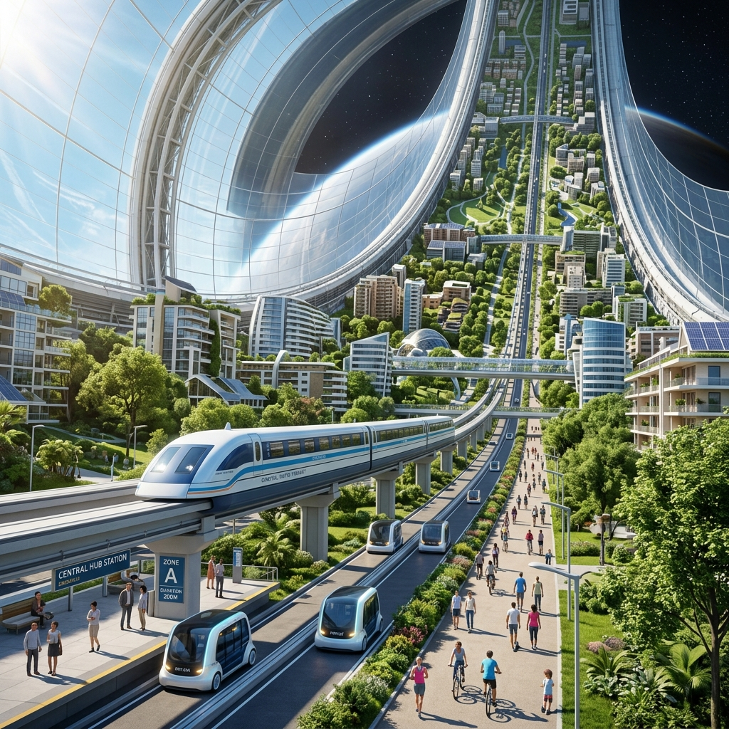

Chapter 5.3: Recreation

Recreation Activities in the Recreational centre:
Omni Directional Treadmill: Omni-Directional treadmill is basically a virtual reality-based simulator that requires the user to wear virtual reality glasses. There is a large treadmill that can move in any direction depending upon the apparent direction in which the user wishes to move. Using virtual reality glasses, several environments can be generated.
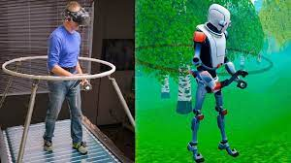
Galactic Racing: Galactic racing is bike racing in micro gravity on tracks that have metaled roads on the side. High-speed bikes that use Hydroxyl Terminated Poly Butadiene propulsion and super aligned polystyrene polymer coated tires would be operated in Galactic racing.

Amusement parks: we will have these as same as on earth.
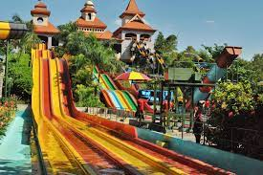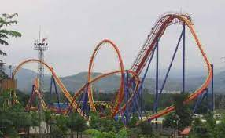

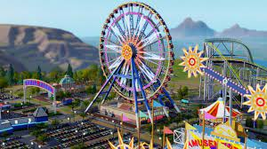

Virtusphere: Virtusphere basically works on the same principles as the Omni-directional treadmill. The only difference is that it uses a freely rotating sphere for movement of the user making it a better simulator for shooter games.
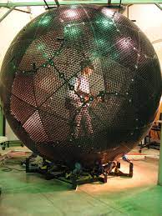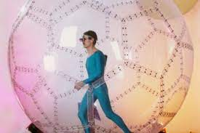

Chapter 5.4: Communication

Fibre-optic communication:
Fibre-optic communication is a method of transmitting information from one place to another by sending pulses of infrared light through an optical fibre. The light is a form of carrier wave that is modulated to carry information. Fibre is preferred over electrical cabling when high bandwidth, long distance, or immunity to electromagnetic interference is required. This type of communication can transmit voice, video, and telemetry through local area networks or across long distances.

Optical fibre is used by many telecommunications companies to transmit telephone signals, Internet communication, and cable television signals. Researchers at Bell Labs have reached a record bandwidth–distance product of over 100 petabit × kilometres per second using fibre-optic communication.

DEEP SPACE OPTICAL COMMUNICATION
Communication with Earth is handled via a Deep Space Optical/Laser Communication Network. This modern laser-based system provides high-definition, broadband-speed data transfer across the solar system. It ensures high-speed transmission and is currently the leading technology tested by space agencies for deep space outposts.

Section 6: Human Factors
Chapter6.1: Residential Facilities
RESIDENTIAL ACCOMMODATIONS
Business Class
Mansions
These will house the residents belonging to the richer sections of the economy.
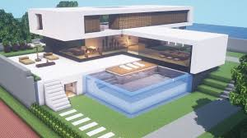

Villa
These would have 2 rooms on each of its 3 floors.


Bungalows
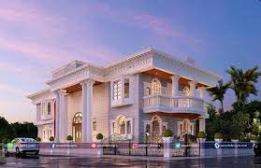

Appartments
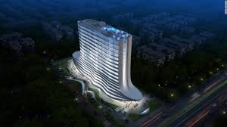

Chapter 6.2: Government

• Constitution The constitution of our settlement will follow the system of democracy and equality. Every person on VONA shall be granted obligatory privileges, which will protect and serve each person’s equality and self-respect. The following shows the obligatory privileges granted to every person.
• Preamble The preamble of EDNA provides foundation for its constitution. The preamble of EDNA has all the basic requirements and oaths that ever y citizen on EDNA shall follow. The Preamble serves the needs and provides equality to the people.
The permeable is same as the permeable of India.


Building a massive orbital settlement using only Earth-launched materials would cost tens of trillions of dollars. However, Project EDNA bypasses this limitation through In-Situ Resource Utilization (ISRU). Because the massive steel and titanium hulls are refined directly from Asteroid 16-Psyche in space, the raw material cost is effectively zero. The budget below calculates the cost of R&D, launching the Sirius miner, and transporting complex electronics, life support systems, and organic soil from Earth to the orbital construction site.
Section 7: Finance & Cost

Sirius Miner & Deep Space Logistics | $ 250,000,000,000
Radiation Shielding Systems | $ 45,500,000,000
Transportation (Maglev & PRT) | $ 85,200,000,000
Internal Construction & Architecture | $ 150,000,000,000
External Construction Assembly | $ 105,000,000,000
Life Support & Climate Systems | $ 180,400,000,000
Agriculture (Biosphere & Earth Soil) | $ 120,600,000,000
Recreation & Public Services | $ 35,000,000,000
TOTAL COST (Phase 1 & 2) | $ 971,700,000,000

CONCLUSION
If you assemble your dreams like a mosaic pattern of a jigsaw puzzle, you see your future realized only when the puzzle is complete. The lessons we learnt in making little mistakes while completing the project made all the difference. We may not remember specifically, but many factors have made the larger picture brighter… The journey of this project has been an amazing, dynamic endeavour. The sense of accomplishment we experience outweighs the toil and hard-work consumed. Creating something from nothing is incredibly inspiring; not only for the creator, but for everyone who observes. Everything begins with “Inspiration “ and the attitude that “Impossible is Nothing”. It may be cliché to say “Don’t sweat the small stuff”, but according to us “if you sweat the small stuff, make sure it counts”. Law of motion states “Objects in motion stay in motion”, therefore a mind once stretched by intellect and reasoning will keep on thinking out of the box.
EDNA, IS THE OUTCOME OF ALL THE DIFFICULTIES THE TEAM HAS FACED IN FINDING ALL THE INFORMATION AND THE BRILLIANT IDEAS……

