**NATIONAL RESEARCH UNIVERSITY**

**HIGHER SCHOOL OF ECONOMICS**

The faculty of Business and Management

***Team project***

***on  
«****Programming****»***

Participants:

Menshina А. S. (gr. 156 (1)), BI

Levina A. I. (gr. 156 (1)), BI

Sineglazov A. S. (gr. 156 (1)), BI

Moscow, 2016

Content

Topic of the project 3

Annotation 3

Central Repository Adress 3

Members of the team and their roles 3

List of classes with short description 3

Program interface 4

Description of results and test example 7

1. **Topic of the project**

The database of economic activities of different countries of the world.

1. **Annotation**

This information system will show data about countries and their economic situation. Using this application, a user can get to know such economic parameters as unemployment, inflation, GDP and GDP Growth, export, import, national debt and population of each country for each year from the period from 2005 to 2015. It is also possible to view this data by year.

1. **Central repository address**

<https://github.com/anyalevina/economicdb.git>

1. **Members of the team and their roles**

Menshina Anastasia 156(1) - general logic, abstractions   
Levina Anna 156(1) - database interconnection, testing  
Sineglazov Artem 156(1) – UI

1. **List of classes with short description**

There are 2 projects in our solution: Mysolution_Data and Mysolution_UI

1. Mysolution_Data
   1. *Class1* Entity classes that have the structure as in the resources. This classes are automatically generated.
   2. *Context* Standardclass with DbSets
   3. *EconomyViewModel*
   4. *YearlyDinamicsViewModel*

This classes are alike and they are used between logic class and the interface for viewing information by year and by country.

* 1. *Repository* A class with requests that are seen in the application. Requests are about getting largest (smallest) economies, fastest (lowest) growing economies. It also represent data about each parameter such as unemployment, inflation, GDP and GDP Growth, export, import, national debt and population. There is also a request for getting the list of all countries if user do not want to search for certain countries.

1. Mysolution_UI
   1. *MainWindow* The welcoming window that have two buttons for searching information by country and by year.
   2. *CountryWindow* This window goes after the main one and displays information according to the selected country. It is also possible to see the list of countries.
   3. *YearWindow* is used for display information by year. It is possible to set the quantity of countries that the user wants to see.
   4. *ExportWindow* has a common interface for all windows that appear when user select the country and select the parameter he wants to see. (For all parameters the interface is the same).

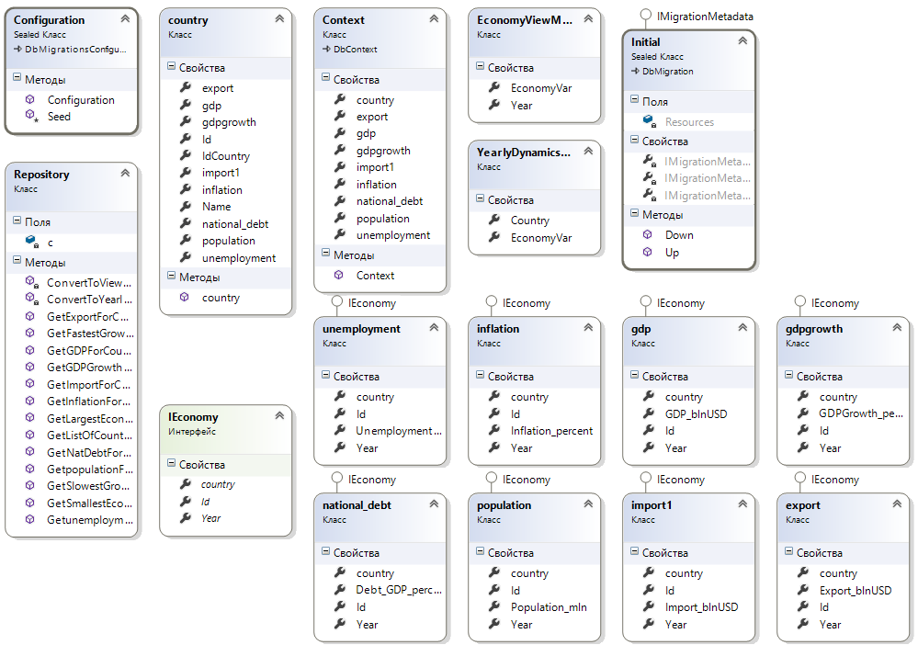

**6. Program Interface**

The solution is presented in WPF-application. This window will appear after clicking «Debug» (pic. 6.1)

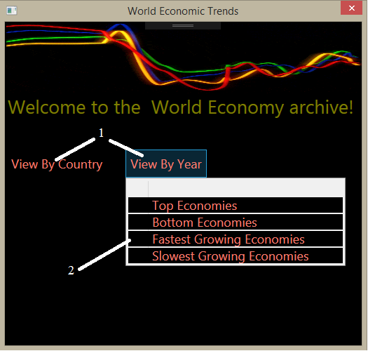

pic. 6.1 Initial window

1. Two ways (MenuItems) to present economic data (consequences of clicking «View By Country» in pic. 6.2).
2. Four requests for viewing data by year (consequences of clicking are presented in pic. 6.4).

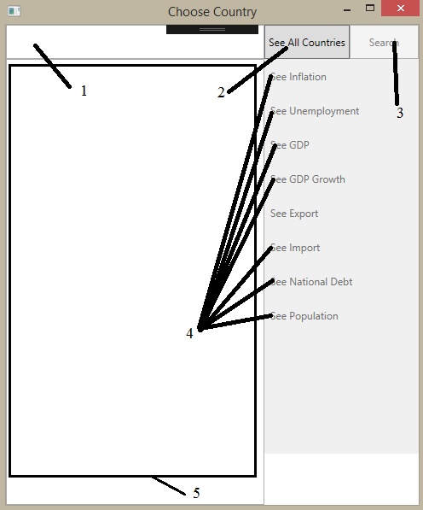

pic. 6.2 «Choose Country» window

1. The field for entering the name of the country
2. The button for an appearance of the list of all countries
3. The button that the user should click after entering the name of necessary country to search it in the list.
4. The buttons that the user should click to call the next window (pic. 6.3) showing necessary economic statistics for the period 2005-2015
5. The field for the list of countries

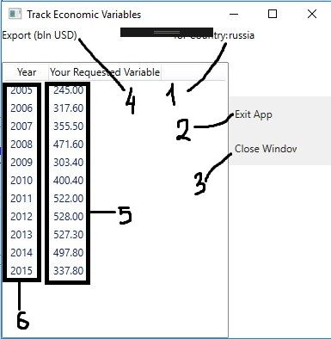

pic. 6.3 Window of necessary economic data

1. The field for selected country
2. The button for exiting the application
3. The button for closing current window
4. The field of automatically generated description of the clicked button (pic. 6.2, object 4)
5. The field of appropriate economic parameters
6. The field for the list of years

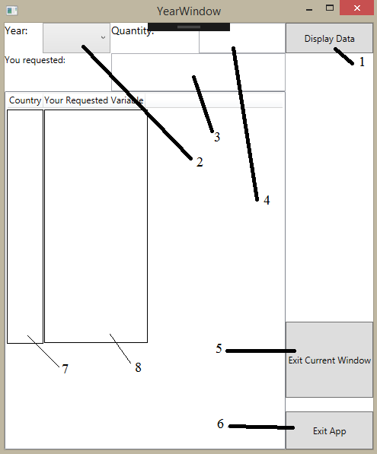

pic. 6.4 «Year» window

1. This button is used for displaying necessary economic data
2. The ComboBox allows the user to select a year from 2005 to 2015
3. The field of automatically generated description of user’s selected request (pic. 6.1, object 2)
4. The field for enter the quantity of countries that the user want to see in the rating
5. The button for exit current window
6. The button for exiting the application
7. The field for the list of selected number (4) of countries that are at the top of the rating (pic. 6.1, object 2)

**7. The description of the results and the test example**

A user should click «Debug» on the top bar of Visual Studio to start the program. After this he sees the main window (pic. 6.1). There are 2 variants to see the economic data about countries: «by country» and «by year».

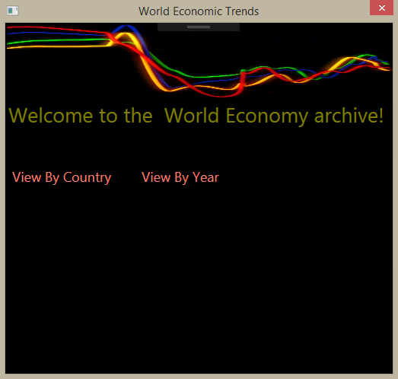

pic. 6.1 Main window

*The first variant*

The user clicks «View by Country» and the window (pic. 6.2) will be opened.

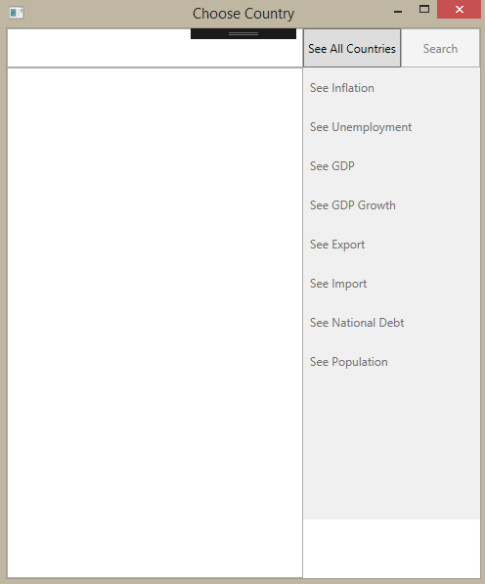

pic. 6.2 «Choose Country» window

He can click «See All Countries» to see a list of all countries (pic. 6.3) and to choose one of them.

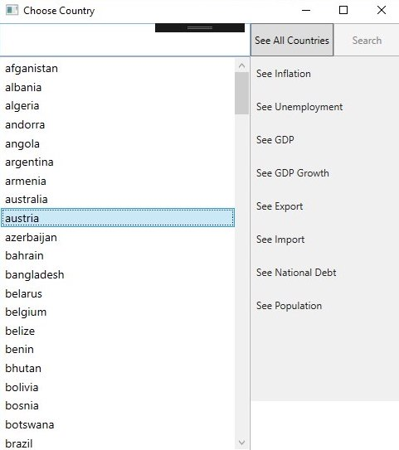

pic. 6.3 After clicking «See All Countries»

If he doesn’t want to scroll all the list to find necessary country, it is possible to enter the name of the country in the TextBox and to click «Search» (pic. 6.4).

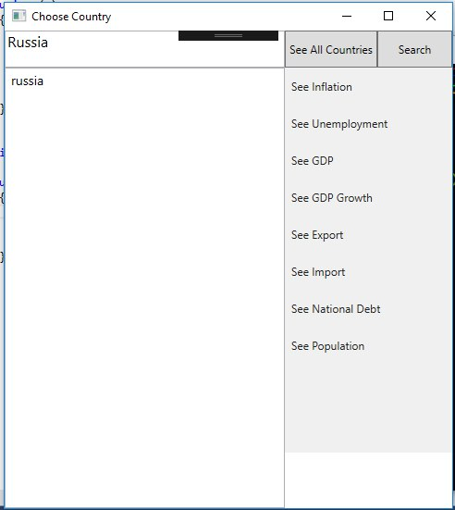

pic. 6.4 Enter the name of the country in the TextBox

Then he should click on the name of the country (pic. 6.5) in the ListBox to select it.

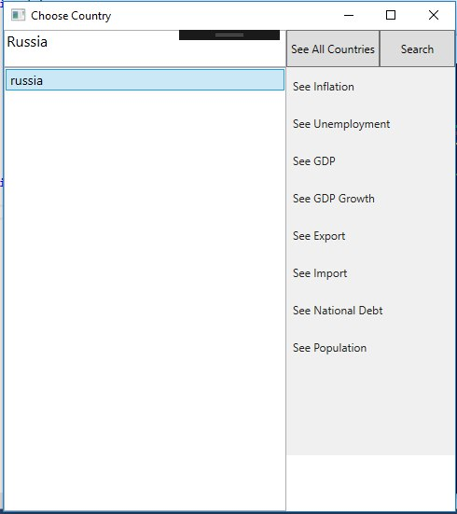

pic. 6.5 Selecting the country in the ListBox

There are several buttons to see appropriate economic parameters of the selected country («See Unemployment», «See Inflation», «See GDP», «See GDP Growth», «See Export», «See Import», «See National Debt» and «See Population»). The user should click one of them to call next window (pic. 6.6) showing the necessary economic statistics for the period 2005-2015. Also there are 2 buttons to close this window and to exit the application.

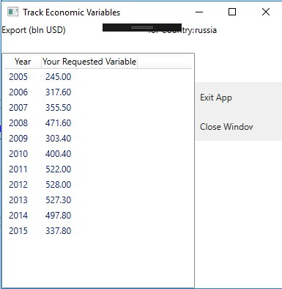

pic. 6.6 Window of necessary economic data

*The second variant*

The user hovers his mouse over the button «View by Year» and sees 4 available requests to select (to see top economies, bottom economies, fastest growing economies and slowest growing economies) (pic. 6.7).

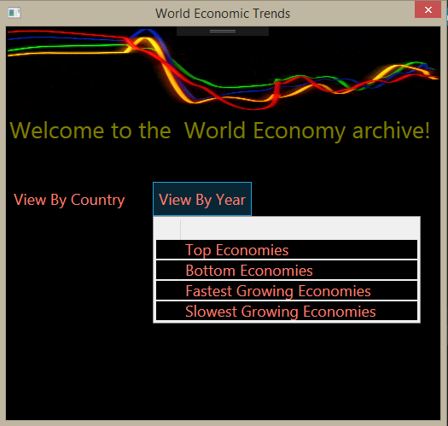

pic. 6.7 Four requests of «View by Year»

Then he should select one of the requests and next window (pic. 6.8) will be opened.

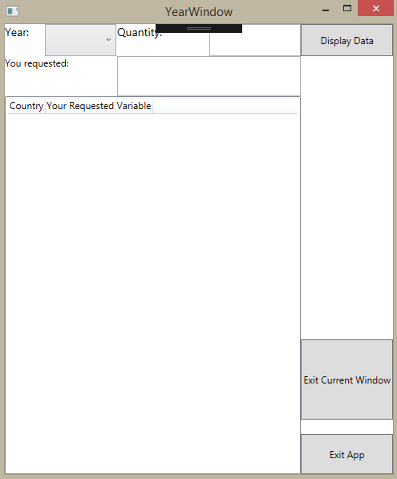

pic. 6.8 Year window

The user should select an interesting year in ComboBox and enter the quantity of countries that are in the top of the selected ranking (pic. 6.9).

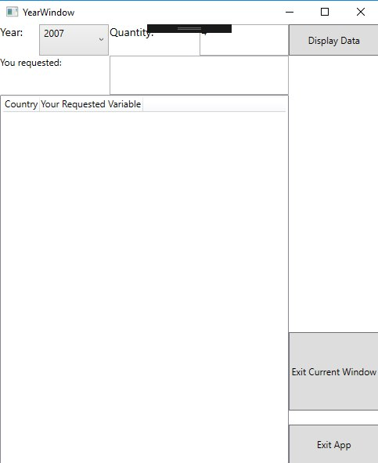

pic. 6.9 Select a year and enter the quantity of countries

After this he needs to press «Display Data» to view the top ranking countries with appropriate economic parameters (pic. 6.10). Opened window also has 2 buttons to exit current window and to exit the application.

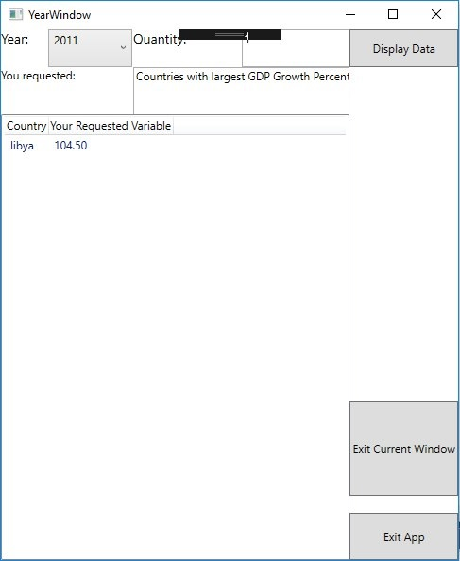

pic. 6.10 the top ranking countries with appropriate economic parameters