**Resolve**

**Version 1.0**

**School of Dentistry**

**University of Washington, Seattle**



**Revision and Signoff Sheet**

**Change Record**

|  |  |  |  |
| --- | --- | --- | --- |
| **Date** | **Author** | **Version** | **Change Reference** |
| 14th March 2020 | Palash Jhamnani | 1.0 | First Draft |
| 1st May 2020 | Palash Jhamnani | 1.0.1 |  |

**Reviewers**

|  |  |  |  |
| --- | --- | --- | --- |
| **Date** | **Reviewer** | **Version** | **Comments** |
|  | Anya L. Levysmith | 1.0 |  |

Contents

Objective 4

Chosen Technology 4

Security 7

Authentication 7

Authorization 7

Data Layer (Models) 7

Model Descriptions 7

Entity Relationship Diagram 9

Business Logic Layer (Controllers) 10

Additional Case Types 10

Approval Workflow 10

Front End Layer (Views) 12

# Objective

Resolve is a case management software developed to manage cases, which are service requests created by University of Washington (UW) community members in the UW School of Dentistry. These requests/cases then go through an approval workflow. Reporting dashboards would be created using the database entities for business reporting purposes.

**GitHub Link:** <https://github.com/palashjhamnani/Resolve.git>

## Chosen Technology

Microsoft .Net Core Framework for building the web application

The chosen options have been highlighted in YELLOW in the screenshots below, while developing the application.

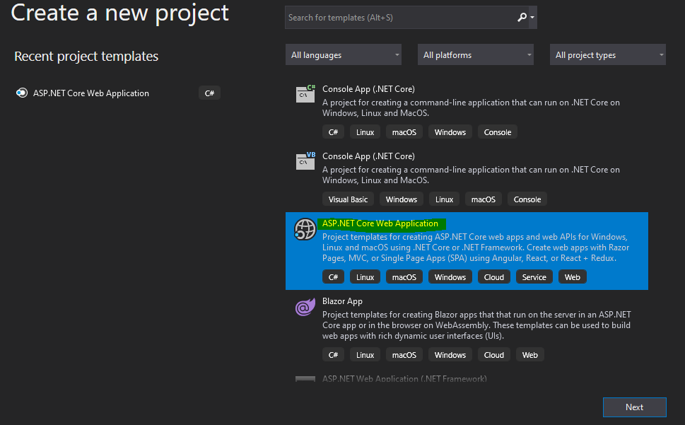

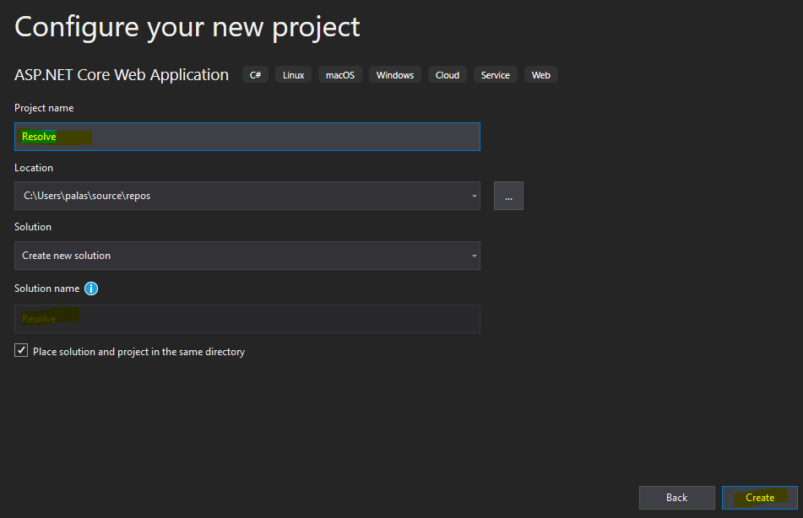

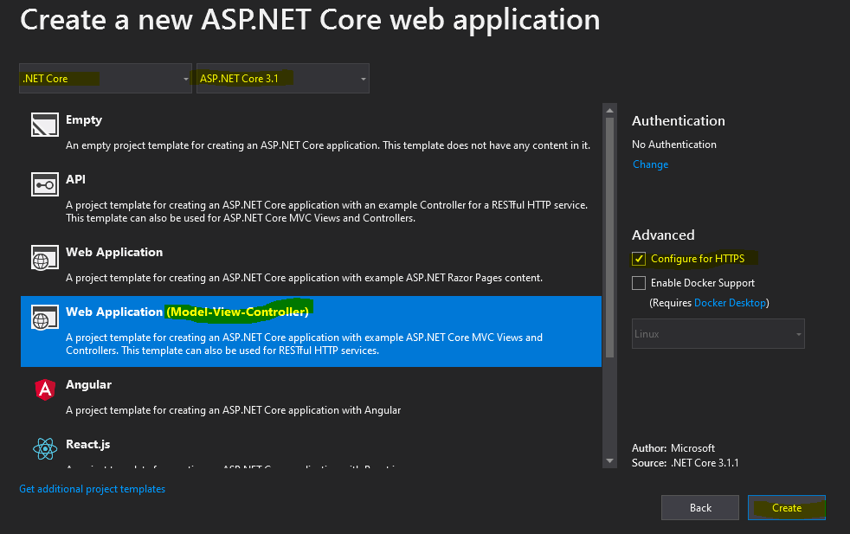

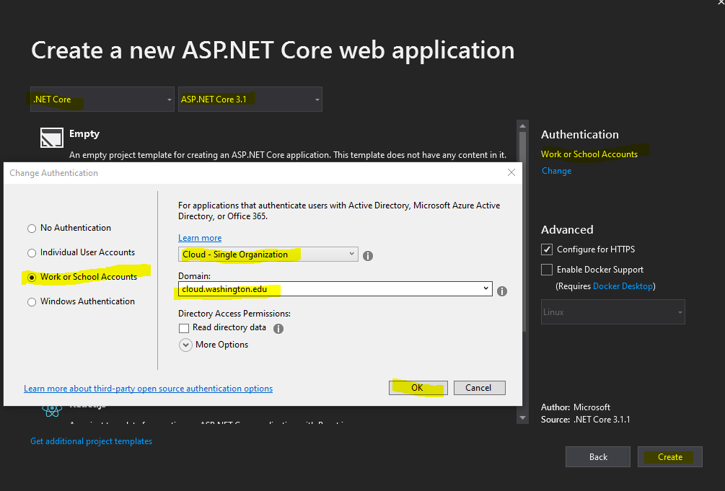

Link to authentication document for integrating UW Net ID

<https://itconnect.uw.edu/wares/msinf/authn/ldap/ldap-authentication-primer/>

<https://itconnect.uw.edu/wares/msinf/authn/ldap/>

<https://wiki.cac.washington.edu/display/infra/Shibboleth+for+UW+Web+Applications>

# Security

## Authentication

## 

## Authorization

Groups assigned to the application in Azure portal

# Data Layer (Models)

## Model Descriptions

CaseType: Sequential Approval? (Bit)

CaseTypeGroup:

Order: if Sequential Approval bit is on, order is checked before sending out emails for approval, else emails go out parallelly. ?

**Entity/Model Description Table**

|  |  |  |  |  |
| --- | --- | --- | --- | --- |
| **No** | **Entity Name** | **Attributes** | **Why is Entity Included?** | **Relation with other Entities** |
| **Folder: Models** | | | | |
| 1 | LocalUser | * FirstName * LastName * NetID * EmailID | Local User table is managed automatically. An entry in this table is created when a user logs in to Resolve for the first time. The data is picked from AzureAD | None |
| 2 | LocalGroup | * LocalGroupID * GroupName * GroupDescription * FK: LocalUser | This table is managed manually by the admin. Groups are created as part of the application setup. ID comes from AzureAD (ObjectID) | One LocalUser is assigned to a LocalGroup as a default lead/approver |
| 3 | UserGroup | * FK: LocalUser * FK: LocalGroup | This table is managed automatically. Entries are created as per User claims from AzureAD | Many-to-many mapping between LocalUser and LocalGroup |
| 4 | CaseType | * CaseTypeID * CaseTypeTitle * LongDescription * GroupNumber | This table is manually managed by the admin. Newer Case Types can be added as required by the application users. | GroupNumber is the the number of groups attached to this CaseType to whom the Case would be assigned. |
| 5 | Case | * CaseID * Auto: CaseCID * OnBehalfOf * CaseStatus * Auto: CaseCreationTimestamp * FK: CaseType * FK: LocalUser | Case table is managed by the Users. An entry is created for every new case created by a user. | Many-to-One relationship with CaseType and LocalUser. A new Case can be of one CaseType and can be created by one LocalUser |
| 6 | OnBehalf | * PK, FK: Case * FK: LocalUser | This table is managed by the Users. When a case is created by a user on behalf of another user, an entry is created in this table. One case can have only one entry; hence Case is PK. | One-to-One relationship with Case table, and Many-to-One relation with LocalUser table |
| 7 | CaseAttachment | * CaseAttachmentID * FK: Case * FK: LocalUser * FilePath * FileName * Auto: AttachmentTimestamp | Managed by LocalUsers, an entry created for every new attachment, created for a Case by a LocalUser. | Many-to-One relation with Case table and LocalUser table. Many entries can be created for the same Case by many Users |
| 8 | CaseComment | * CaseCommentID * Comment * Auto: CommentTimestamp * FK: Case * FK: LocalUser | Managed by LocalUsers, an entry created for every new comment, created for a Case by a LocalUser. | Many-to-One relation with Case table and LocalUser table. Many entries can be created for the same Case by many Users |
| 9 | CaseAudit | * CaseAuditID * Auto: AuditTimestamp * AuditLog * FK: Case * FK: LocalUser | Managed automatically. An entry is created for every action taken by any user. A function call has to be made at code level by developer for data generation in this table | Many-to-One relation with Case table and LocalUser table. Many entries can be created for the same Case by many Users |
| 10 | GroupAssignment | * FK: Case * FK: LocalGroup | By default, a Case is assigned to one group (as defined in CaseType table), however, if further group assignments are required, then an entry is created in this table. | Many-to-One relation with Case table and LocalGroup table. One Case can be assigned to multiple LocalGroups |
| 11 | CaseTypeGroup | * PK, FK: CaseTypeID * PK, FK: LocalGroupID * Approved * Order | This table managed by Admins, for every CaseType’s GroupNumber, entry to be created in this table. | Composite Primary key comprising of CaseTypeID and LocalGroupID |
| 12 | Approver | * FK: Case * FK: LocalUser * Approved * Order | One entry is created in this table automatically for every new case created (Case -> CaseType -> DefaultGroup -> DefaultApprover). However, more approvers can be added by the admin or the pre-assigned approver. | Many-to-One relation with Case table and LocalUser table. One Case can be assigned to multiple LocalUsers |
| **Sub Folder: CaseTypeModels** | | | | |
| 13 | SampleCaseType1 | * PK, FK: Case * Attribute1 * Attribute2 * … | To add specific details for a Case Type, new entities can be created by the admin/developer as required by the users. For every new Case Type added, a new model must be created under the “~/Models/CaseTypeModels/” folder, if specific details are required for that CaseType | One-to-One relation with Case table. Only one entry can be created in this table per Case. |
| 14 | SampleCaseType2 | * PK, FK: Case * Attribute1 * Attribute2 * … |  |  |
|  | … | * PK, FK: Case * … |  |  |

PK: Primary Key

FK: Foreign Key

Auto: Automatically Generated by Database on addition of a row

Database used: Microsoft SQL Server

Below is the connection string specified in the *appsettings.json* file.



## Entity Relationship Diagram

# Business Logic Layer (Controllers)

## Additional Case Types

Steps to add a new case type:

* Create a model under "~/Models/CaseTypeModels/{CaseTypeTitle}.cs"
* P.S - Name of the model must be same as "CaseTypeTitle" from CaseType entity
* Add entry to "~/Data/ResolveCaseContext.cs"
* Add entry to "~/Models/Case.cs"
* Add controller under "~/Areas/CaseSpecificDetails/Controllers/{CaseTypeTitle}Controller.cs"
* Add view under "~/Areas/CaseSpecificDetails/Views/{CaseTypeTitle}/Index.cshtml"
* Add view under "~/Areas/CaseSpecificDetails/Views/{CaseTypeTitle}/Details.cshtml"
* Add an entry to “Details” action in “~/Controllers/CasesController.cs” to include details of new Case Type.

## Approval Workflow

In the **Approver** model, the ‘*Approved’* attribute can have 3 values as described below:

|  |  |
| --- | --- |
| ***‘Approved’* Attribute Value** | **Significance** |
| -1 | Disapproved/Rejected |
| 0 (Default) | Neutral (Newly added approver) |
| 1 | Approved/Accepted |

When an approver approves a case or rejects a case, the value is set automatically in the ‘Approved’ attribute.

Below are the business rules programmed for Approval Workflow:

For a case to be deemed approved, it needs to have an approval by ALL assigned approvers, or by the admin, on behalf of all assigned approvers. Even if there is a single reject, the Case is deemed to remain in rejected status.

* When a Case is created, a default approver is assigned to it, i.e. an entry in the **Approver** model is created.
* This default approver comes from the flow: Case -> CaseType -> Default LocalGroup -> DefaultApprover.
* Every Case will belong to a CaseType, every CaseType will have a Default LocalGroup associated with it, and every LocalGroup will have a default Approver (LocalUser) associated with it.
* Multiple approvers can be assigned to a Case.
* An Admin, or an existing Approver can add additional approvers for the Case. For other users, the option to add additional approvers will remain disabled.
* Admins can approve any Case. When an Admin approves a Case, the value for ‘Approved’ attribute for all approvers will be set to 1 and the Case will be marked as Resolved.
* Once the case is approved by all assigned approvers or the admin, the buttons to Approve/Reject get replaced by Reopen, and a badge with “Resolved” keyword is put for the case.
* Until the Case is resolved, a badge with “# Approvals Pending” is put for the case.

Logic for managing approvals:



# Front End Layer (Views)