**Resolve – User Guide**

**Version 1.0**

**School of Dentistry**

**University of Washington, Seattle**



**Revision and Signoff Sheet**

**Change Record**

|  |  |  |  |
| --- | --- | --- | --- |
| **Date** | **Author** | **Version** | **Change Reference** |
| 21st July 2020 | Palash Jhamnani | 1.0 | First Draft |

**Reviewers**

|  |  |  |  |
| --- | --- | --- | --- |
| **Date** | **Reviewer** | **Version** | **Comments** |
|  | Anya L. Levysmith | 1.0 |  |

Contents

Introduction 4

Authentication 5

Sign in 5

Sign Out 6

Homepage 7

Cases Created by You 7

Cases Assigned to You 7

Cases Assigned to your Groups 7

Filter/Search/Sort 8

Creating a Request/Case 8

Case Details 10

General Case Details 10

Reassign 11

Assign to Self 12

Specific Case Details 13

Assignments **Error! Bookmark not defined.**

Individuals **Error! Bookmark not defined.**

Groups **Error! Bookmark not defined.**

Approvals/Rejections 13

Case Reopening 14

Edit Case Details 14

Case Cancellation 14

Case Audit Logs 14

Comments 14

Attachments 14

Search 15

Past Cases 16

User Preferences 17

# Introduction

Resolve is a case management software developed to manage cases, which are service requests created by members of an organization, going through an approval workflow.

# Authentication

## Sign in

Sign up and Sign in is automatic when you visit the below mentioned URL

Application URL: <https://apps.dental.uw.edu/Resolve>

The first time you sign in, you will be asked to provide permission to ResolveProd to read your profile, after that you can sign in directly through the above link. You would require UW NET ID to sign in to Request Manager, as the application sign in page will redirect you to UW’s NetID sign in.

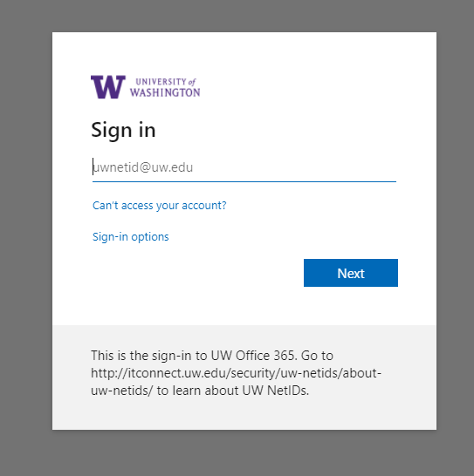

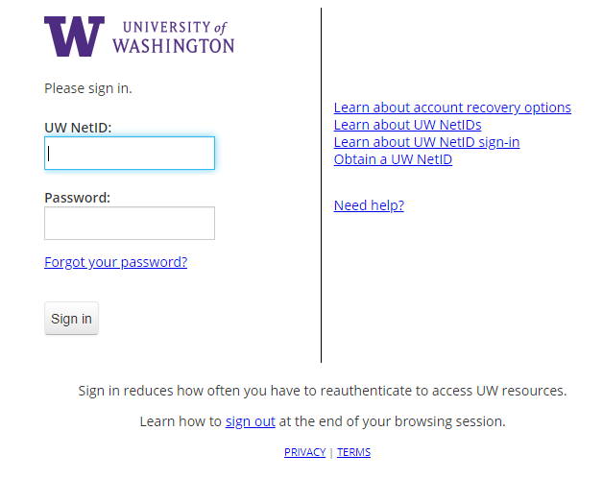

## Sign Out

To sign out of the application, you would sign out from the net id system, similar to sign out for other UW applications like Canvas etc.

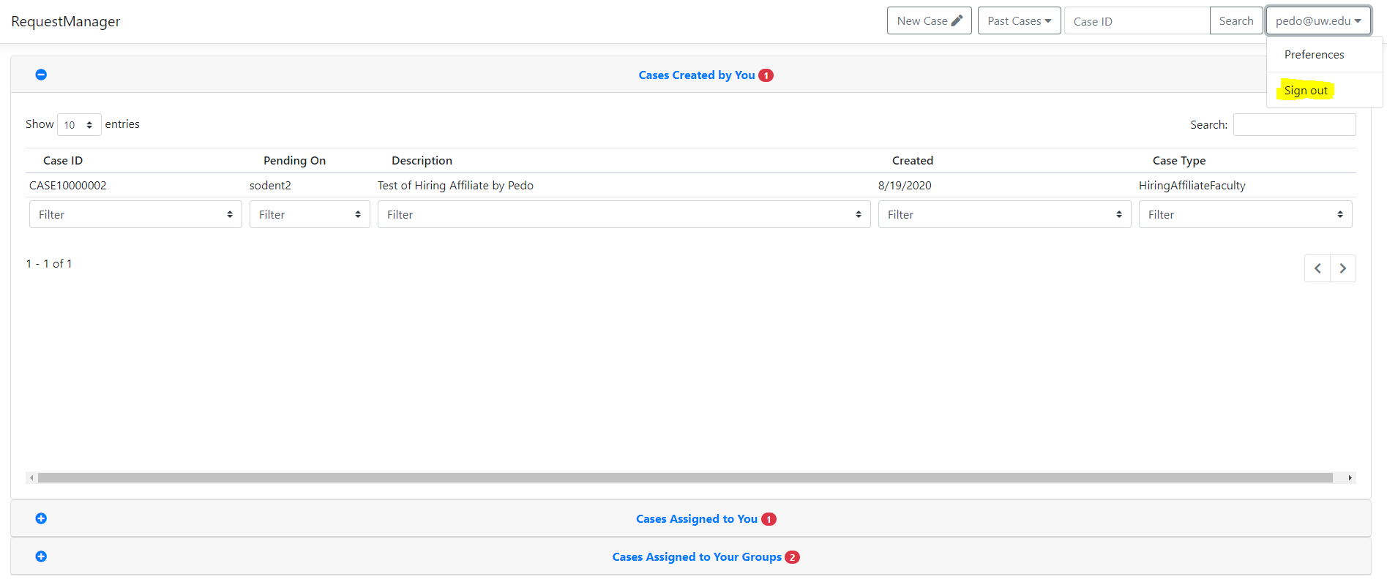

# Homepage

On sign in, you will land up on the home page of the application, which consists of 3 areas described below.

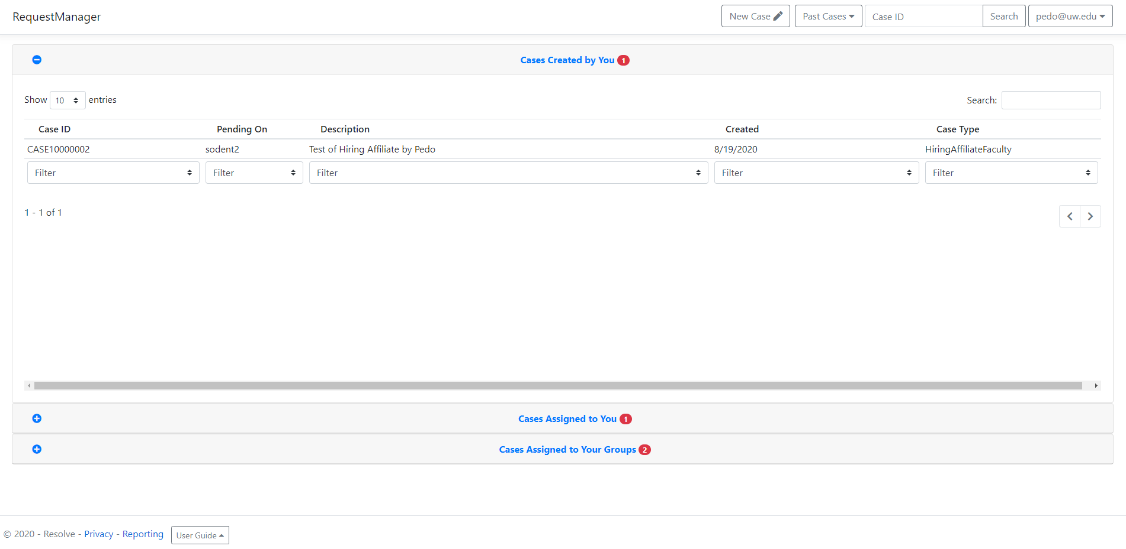

## Cases Created by You

This section contains Cases created by you to track. They will disappear from this area once the Case is completely processed by the approvers. You could track the status of the cases directly through this table and can view on whom is the case currently pending.

## Cases Assigned to You

On expanding this area, you would see Cases that are assigned to you. These cases require your action as you are the assigned approver for those cases in the workflow. Once you take an action on the Case under this category (The action could be Approve/Reject/Cancel), the Case moves forward in the workflow and won’t show up on your homepage, unless someone re-assigns the case to you, in any case you will receive an email notification as well.

## Cases Assigned to your Groups

Cases that show up under this area are the ones that are pending and are assigned to someone who belongs to one of your groups. This area exists, so that you could pick up cases assigned to your groups, in case your group member is on leave (given the case is pending on that group member)

## Filter/Search/Sort

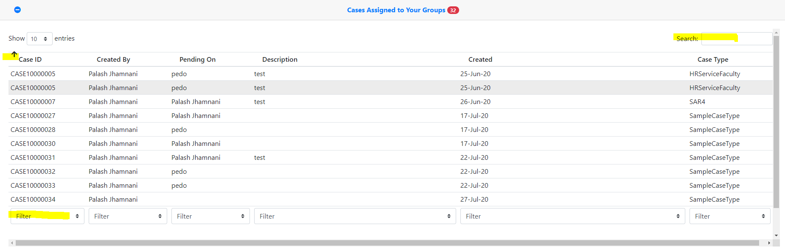

In any of the areas, you could filter, search, and sort cases as per your requirements.

## Creating a Request/Case

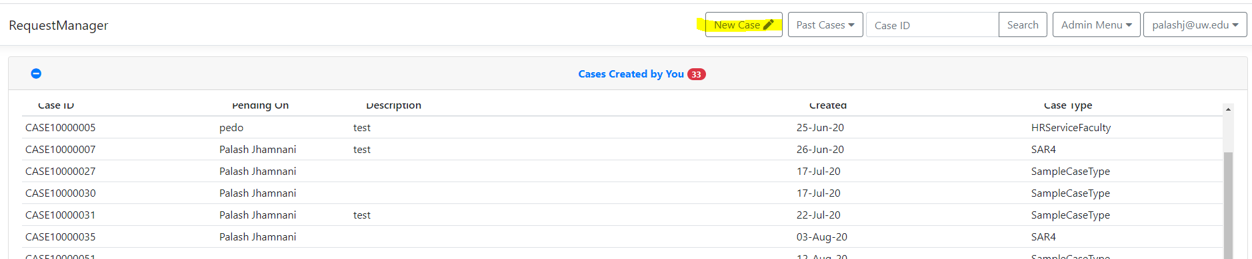

You can create a new request by going to “New Case”

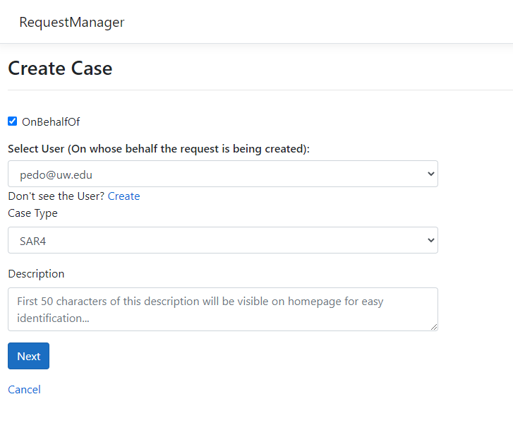

You could create the Case on someone else’s behalf, or for yourself. You would need to select the Case Type and fill out the short description. This description would show up on your and the approvers homepage and would help them to identify the Case they would be handling, so it is important that you write a short note briefly describing your request.

On the next page, you would be served a form that you would be specific to the Case Type you selected. You could edit the information at a later point in time as well, before the Case gets marked as processed.

# Case Details

After a Case is created, you could then visit the Case Details page by clicking on the Case row on homepage.

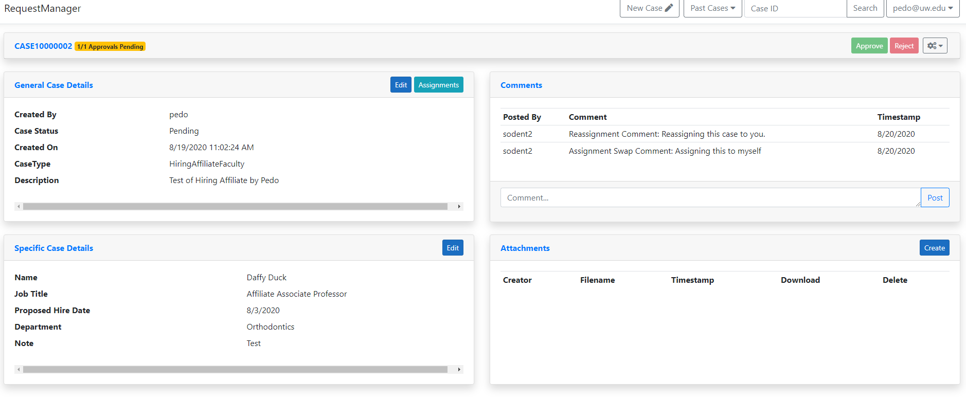

There are 4 sections on this page and some other option as described below.

## General Case Details

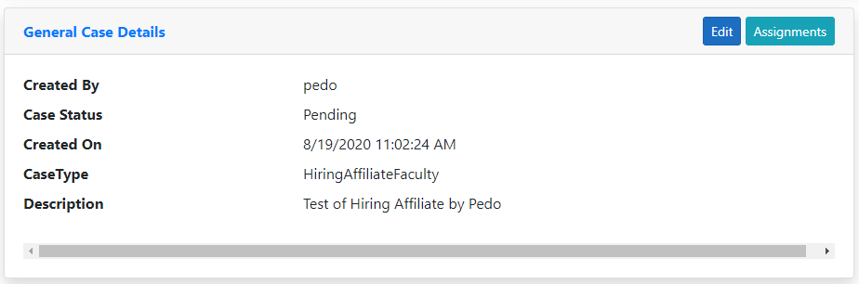

In this section you would see “Edit” button, which would remain enabled only until the Case is processed. A User can only edit the Case Description after a case is created.

The Assignments button shows the Approvers and Groups to which the case is **currently** assigned.

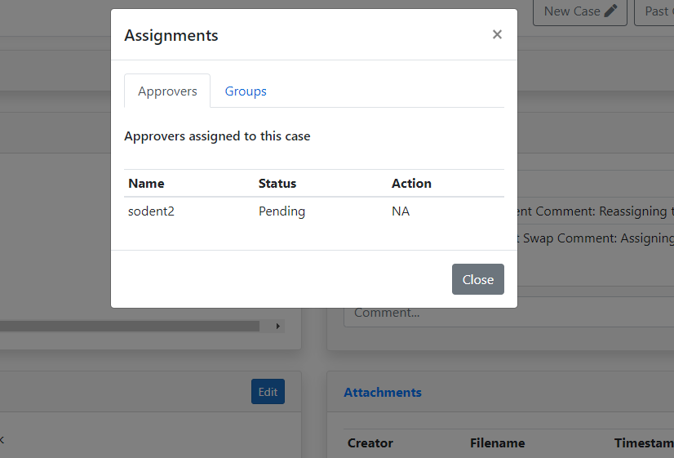

Here you can see the Status of the approver, which can be either Pending, Approved, Rejected or Cancelled. Under the Action column, you can see 3 options, either “NA”, or “Reassign” or “Assign to Self”. NA signifies that no action can be taken for that approver by you. The other 2 options are as described below:

### Reassign

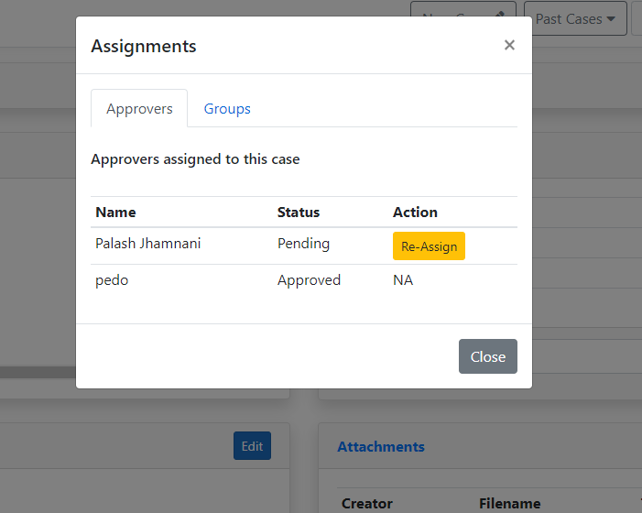

When this button appears, you (as an approver, if you are one to whom the case is assigned to) can reassign the case to someone else from your within your group who you feel knows more about the case and would be better suitable to handle it.

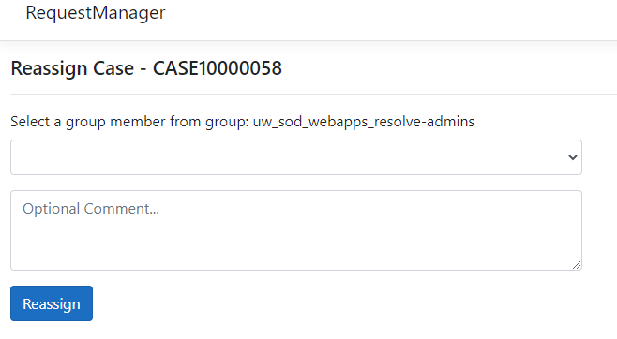

You would need to select the group member on the next page as shown above and provide an optional comment, so that the new approver knows why it was assigned to them.

### Assign to Self

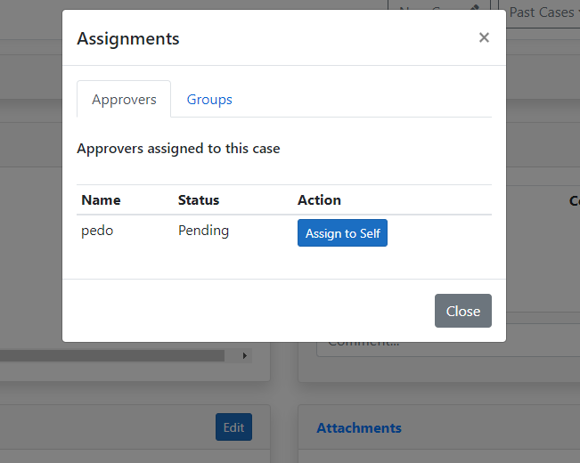

Similar to Reassign, the “Assign to Self” button allows you to take up the case from your group member and assign it to yourself, if you think you would be better suited to handle the Case, or if your group member is on a leave.

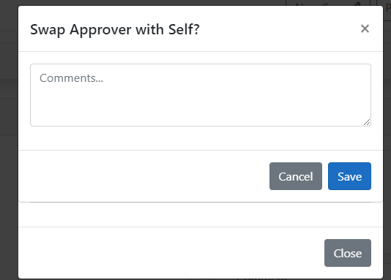

## Specific Case Details

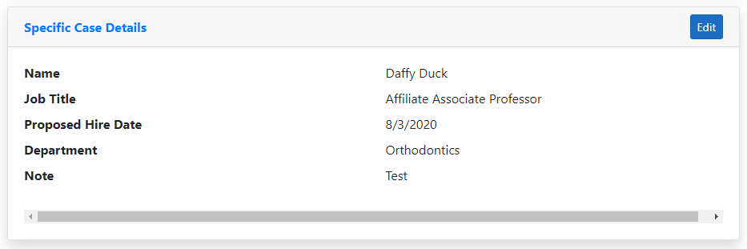

Specific case details are specific to the Case Type of the Case. You can edit these details until the Case is marked as processed.

A processed case means either it falls in one of the below mentioned Status categories:

* Approved
* Rejected
* Cancelled

## Approvals/Rejections

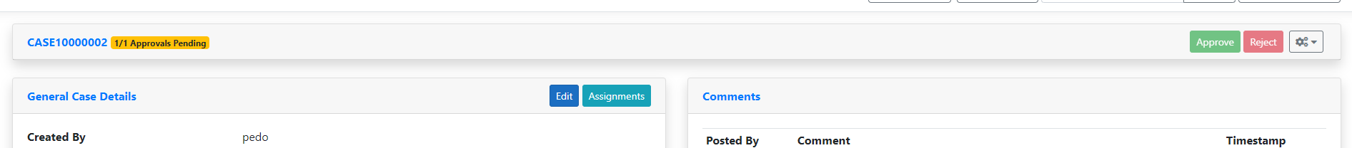

On the area above the four sections, you would see the option to Approve/Reject a Case.

## Case Reopening

## Edit Case Details

## Case Cancellation

## Case Audit Logs

## Comments

## Attachments

# Search

# Past Cases

# User Preferences