WEEK 4 TASK
PREDICTIVE MODELING AND OPTIMIZATION IN LOGISTICS SYSTEMS
Predicting Delivery Time with Machine Learning
Prepared by: Kanchana Anyam
Dataset: Hypothetical / simulated logistics shipments

1. Executive Summary
This project predicts shipment delivery time in days using 600 simulated shipment records. Features include distance, weight, volume, transport mode, region, weather and traffic. Linear Regression, Decision Tree and Random Forest were compared, then Random Forest was tuned with five-fold cross-validation. The tuned model achieved test MAE 0.684 days, RMSE 0.834 days and R-squared 0.881. These are illustrative results from synthetic data and do not establish real-world performance.

2. Problem Definition
Logistics planners need estimated arrival times to set delivery promises, allocate warehouse and carrier capacity, and identify shipments at risk of delay. This is a supervised regression problem: predict Delivery_Time_days using information available when a shipment is planned.

3. Dataset and Features
The simulated dataset has 600 rows and 10 columns. Each row represents one shipment. A fixed random seed supports reproducibility.
Feature | Type | Purpose
Distance_km | Numeric | Route distance
Weight_kg | Numeric | Shipment weight
Shipment_Volume_units | Numeric | Shipment size
Transport_Mode | Categorical | Road, Rail, Air or Sea
Region | Categorical | Operating region
Weather | Categorical | Clear, Rain or Storm
Traffic_Level | Categorical | Low, Medium or High
Delivery_Time_days | Numeric target | Days to forecast
Transportation_Cost_USD | Numeric | Supplementary cost analysis; excluded from predictors
Shipment_ID | Identifier | Unique ID; excluded from modeling

4. Data Preparation
Pandas reads the CSV. The target is separated from predictors and data is split into 80% training and 20% test subsets (random_state=42). Numeric columns are median-imputed and standardized; categorical columns are imputed with the most frequent category and one-hot encoded. Preprocessing is included in a scikit-learn Pipeline so it is fitted within training folds and applied consistently to held-out data.

5. Model Selection
- Linear Regression is an interpretable baseline for approximately linear relationships.
- Decision Tree can capture nonlinear patterns and interactions but may overfit without depth/leaf limits.
- Random Forest averages many decision trees, capturing nonlinear relationships while generally reducing the variance of a single tree.
The models are compared on the same held-out test set. Random Forest hyperparameters are tuned with GridSearchCV using five-fold cross-validation and MAE as the selection score.

6. Evaluation and Validation
Model | Test MAE (days) | Test RMSE (days) | Test R²
Linear Regression | 0.822 | 1.053 | 0.810
Decision Tree | 0.751 | 0.958 | 0.843
Random Forest | 0.674 | 0.834 | 0.881
Tuned Random Forest | 0.684 | 0.834 | 0.881

Five-fold cross-validation best mean MAE: 0.596 days. Best hyperparameters: {'model__max_depth': 10, 'model__min_samples_leaf': 2}.
MAE is average absolute error in days (lower is better). RMSE is also in days and penalizes larger misses more heavily (lower is better). R² compares model fit with a mean-only baseline; values nearer 1 indicate better explanatory fit.
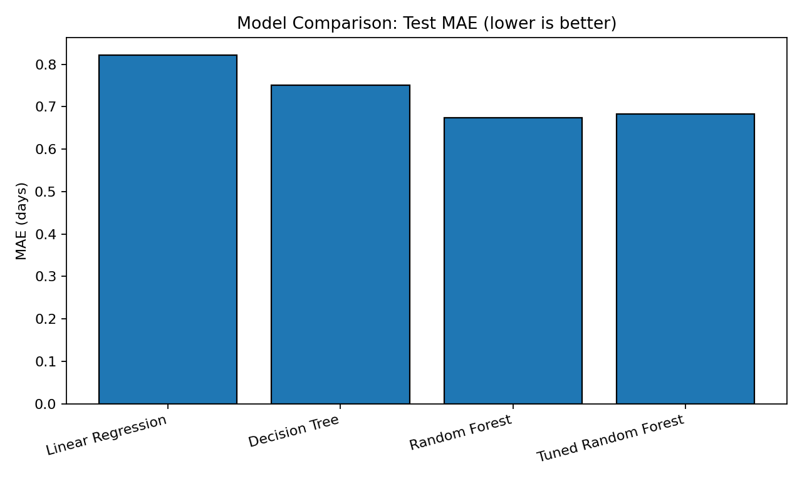
Figure 1. Test MAE comparison. A bar chart clearly compares typical prediction error across models; shorter bars are better.
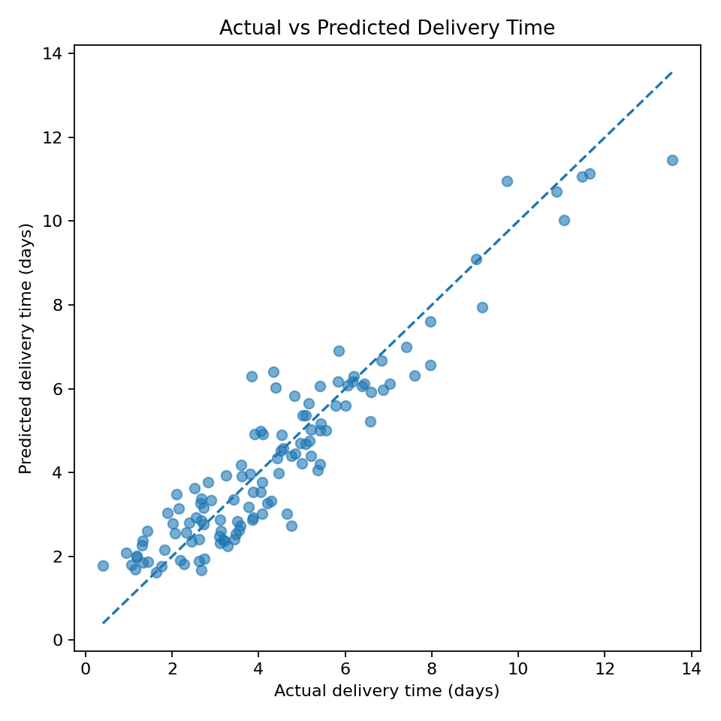
Figure 2. Actual versus predicted values. Points near the diagonal indicate more accurate predictions; consistent offsets can indicate bias.
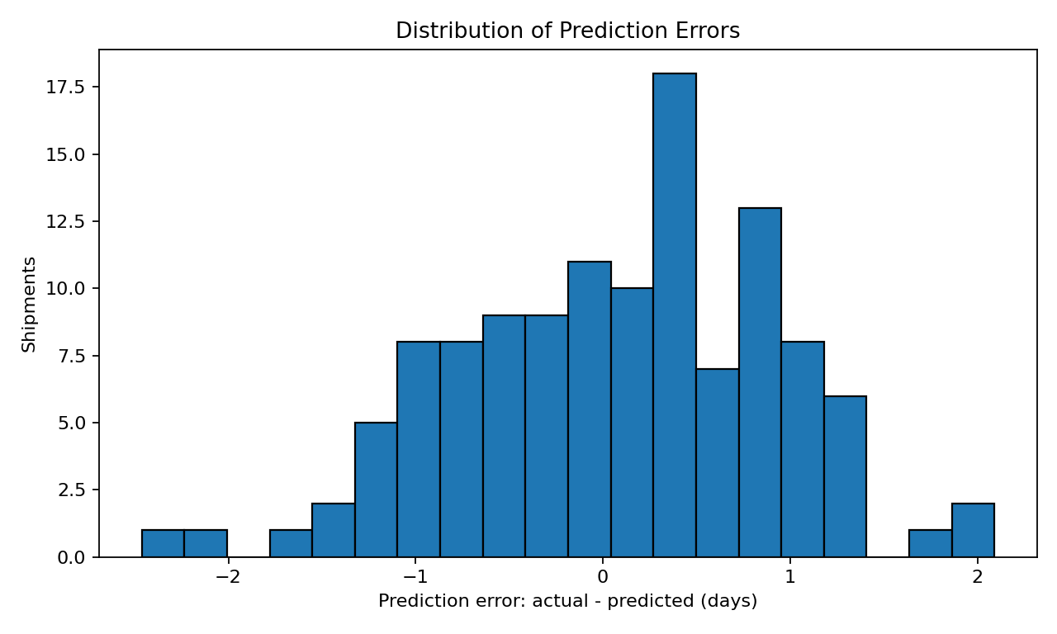
Figure 3. Prediction error distribution. A distribution centered near zero suggests limited overall bias; wide tails indicate less predictable shipments.
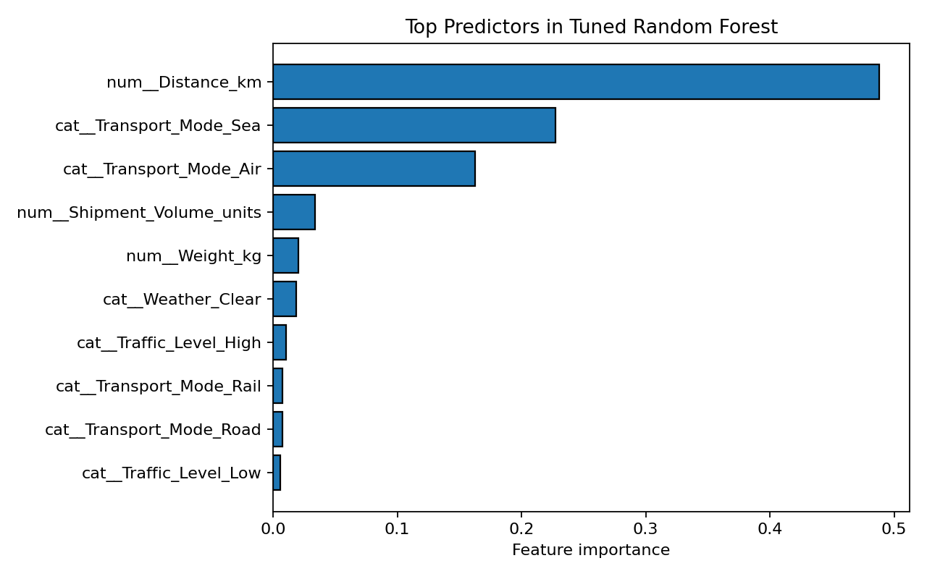
Figure 4. Top Random Forest feature importances. These scores show which variables the model uses for splits, but do not prove causation.

7. Predictive Insights
The tuned model's test MAE of 0.68 days means predictions differ from actual simulated delivery durations by about 0.68 days on average. RMSE is 0.83 days, and test R² is 0.88. Compare these measures with the simpler baselines to decide whether model complexity is justified. Feature importance can guide further investigation into route and operating conditions.
Because the data is synthetic, the relationships partly reflect the simulation rules. Real use requires evaluation on verified historical shipments and preferably chronological validation.

8. Optimization Strategies
A what-if analysis was performed by predicting delivery time for the same sample of 100 test shipments while changing the transport-mode feature. It illustrates how predictions can support scenario comparison, not an automatic dispatch decision.
Mode scenario | Mean predicted delivery time (days)
Air | 2.53
Road | 4.34
Rail | 4.83
Sea | 6.76

- Risk-based dispatch: flag shipments whose predicted arrival is close to or beyond the customer promise and review them before dispatch.
- Mode selection: compare predicted time with transport cost, capacity, service-level requirements and shipment urgency; fastest is not always cheapest or best.
- Resource allocation: use shipment volume and predicted delay risk to plan warehouse shifts, loading teams and carrier capacity.
- Delay prevention: review high-traffic and severe-weather shipments for alternative departure windows or routes.
- Monitoring: track MAE, RMSE, late-delivery rate and prediction bias weekly; retrain when data or performance changes.

9. Limitations and Responsible Use
This dataset is hypothetical and does not represent a real company. Random train/test splitting is acceptable for this demonstration, but chronological validation is usually more appropriate for forecasting future shipments. Feature importance is not causal evidence. Before production use, validate data quality, rare disruptions, service-level outcomes and cost trade-offs. Human planners should review high-impact decisions.

10. Conclusion
The project demonstrates a complete predictive workflow: define a target, simulate data, prepare numeric and categorical inputs, compare regression models, tune Random Forest with cross-validation, evaluate on a held-out test set, visualize errors and propose operational optimizations. The next step is to repeat the workflow using real historical shipment records.

Appendix: Core Python Code
pipeline = Pipeline([("prep", preprocessor),
("model", RandomForestRegressor(random_state=42))])
params = {"model__max_depth": [6, 10, None],
"model__min_samples_leaf": [2, 4, 6]}
search = GridSearchCV(pipeline, params,
cv=KFold(n_splits=5, shuffle=True, random_state=42),
scoring="neg_mean_absolute_error")
search.fit(X_train, y_train)
pred = search.best_estimator_.predict(X_test)
mae = mean_absolute_error(y_test, pred)
rmse = mean_squared_error(y_test, pred) ** 0.5
r2 = r2_score(y_test, pred)
Supporting files: week4_logistics_prediction_dataset.csv, week4_logistics_prediction.py, mode_scenario_comparison.csv and the PNG charts. Keep the dataset and script in the same folder when running the code.

