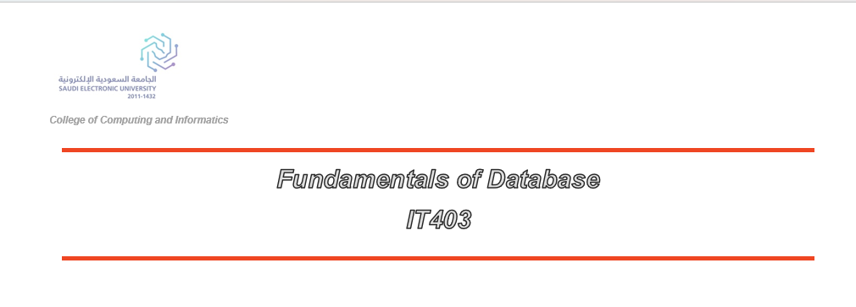
Smart Clinic Database System
Final Project Report
Date: August 2026
Student Details: CRN:
Name: Hanadi Abdullah Alshehri  Name: Sakinah Ali Almuhaini  Name: Sarah hadi alyami  Name: Kadi Alharbi |  | ID: S230035637  ID: S210033402  ID: S220002526  ID: S230019734

Table of Contents

1. Introduction 3
2. Project Objectives 3
3. System Requirements Analysis 4
4. Database Design 5
5. Database Implementation 7
6. SQL Operations and Queries 12
7. Testing and Results 15
8. Database Features 16
9. Challenges and Solutions 17
10. Conclusion 18
11. References 19
Appendix B: Screenshots 20

1. Introduction
The Smart Clinic Database System is a comprehensive relational database management system designed to organize, manage, and improve the daily operations of a modern private clinic. With the increasing importance of digital transformation in the healthcare sector, effective management of medical information has become essential for improving service quality and operational efficiency.
This project provides a structured database solution for managing essential clinic information, including patient records, employee details, doctor and nurse information, appointments, treatments, prescriptions, medicine inventory, and payment transactions.
The main objective of this project is to design and implement an efficient, secure, and scalable database system using MySQL. By centralizing data and establishing well-defined relationships between database entities, the system reduces data redundancy, improves data consistency, minimizes manual errors, and enables faster access to accurate healthcare information.
The project applies important relational database concepts, including entity relationships, normalization, primary and foreign keys, SQL queries, views, and triggers, providing a reliable foundation that can be extended in the future to support additional healthcare services and technological improvements.

2. Project Objectives
The main objective of this project is to design and implement a reliable relational database system for managing the operations of a smart clinic. The project aims to organize healthcare-related information efficiently while applying essential and advanced database concepts.
The key objectives of the project are:
- To design a structured relational database that supports clinic management activities.
- To store and manage patient medical information in an organized and secure manner.
- To efficiently manage information related to doctors, nurses, receptionists, and other clinic employees.
- To manage patient appointments and track treatments effectively.
- To maintain accurate medicine inventory records and prescription history.
- To develop and execute complex SQL queries for data retrieval, analysis, and reporting.
- To implement advanced database features, including Views, Triggers, Primary and Foreign Key constraints, and Referential Integrity to ensure data consistency and reliability.

3. System Requirements Analysis

3.1 System Description
The Smart Clinic system serves as a central hub for various users, including medical professionals and administrative staff. The system is built around several core entities that interact to provide a seamless workflow.
Entity | Description
Employee | Base information for all staff, specialized into Doctors, Nurses, and Receptionists.
Patient | Comprehensive records of patients including contact and medical details.
Appointment | Scheduling mechanism linking patients with specific doctors.
Treatment | Records of medical procedures performed during appointments.
Medicine | Inventory management for medications available in the clinic.
Prescription | Legal medical orders issued by doctors for patients.
Payment | Financial tracking for treatments and consultations.

4. Database Design

4.1 Entity Relationship Diagram (ERD)
The database design process began with the creation of an Enhanced Entity Relationship (EER) model. This model captures the complex relationships and constraints required for a healthcare environment.
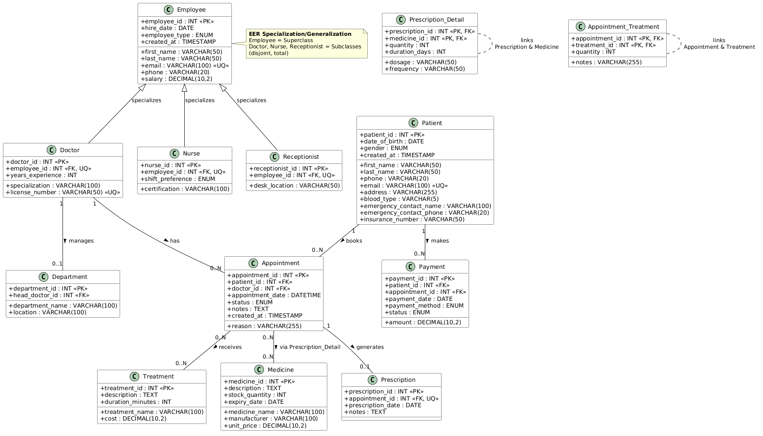
Figure 1: Smart Clinic ER Diagram

4.2 Relational Schema
The EER model was mapped to a relational schema, ensuring that all tables are normalized to the Third Normal Form (3NF). This design prevents data anomalies and ensures consistency.
- Key relationships include:
- Specialization: Employee table as superclass with Doctor, Nurse, and Receptionist as subclasses.
- Many-to-Many: Appointments and Treatments are linked via a junction table.
- One-to-Many: A Doctor can have multiple Appointments; a Patient can have multiple Prescriptions.

5. Database Implementation
The database was implemented using MySQL. The script includes the creation of the database, tables, constraints, and the insertion of sample data to verify the system's functionality.

5.1 Tables Creation

Employee Table
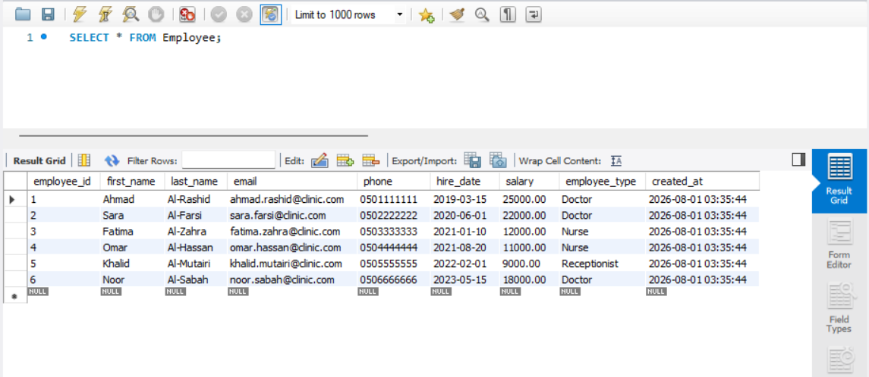
Screenshot: Employee Table

Doctor Table
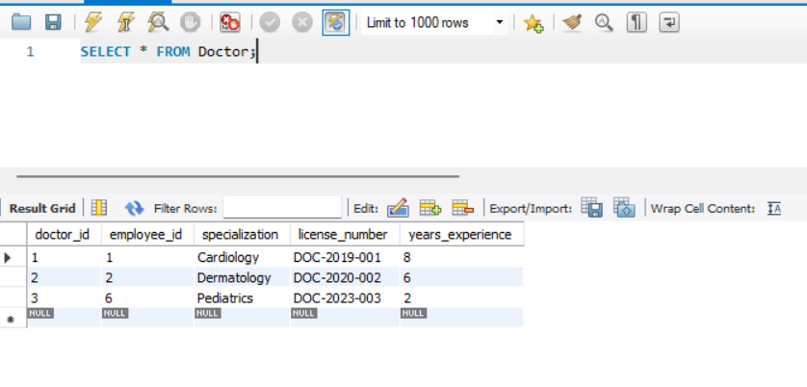
Screenshot: Doctor Table

Nurse Table
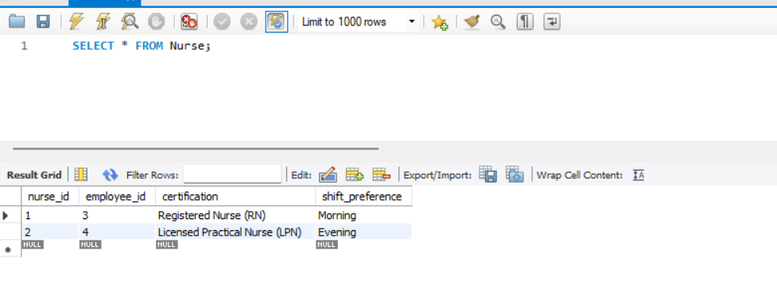
Screenshot: Nurse Table

Patient Table
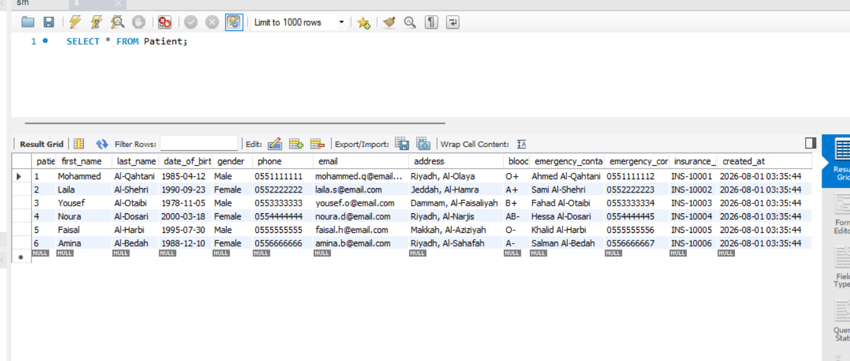
Screenshot: Patient Table

Appointment Table
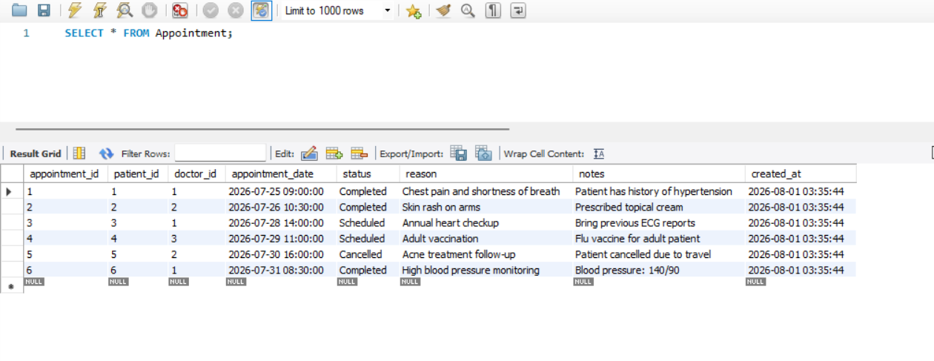
Screenshot: Appointment Table

Treatment Table
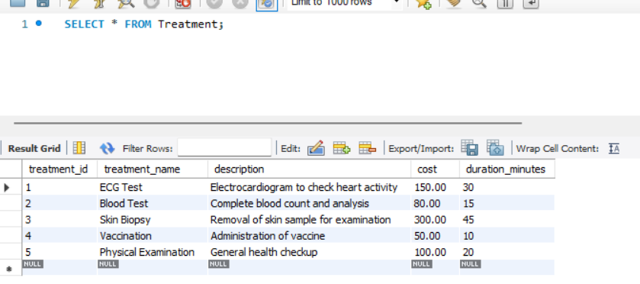
Screenshot: Treatment Table

Medicine Table
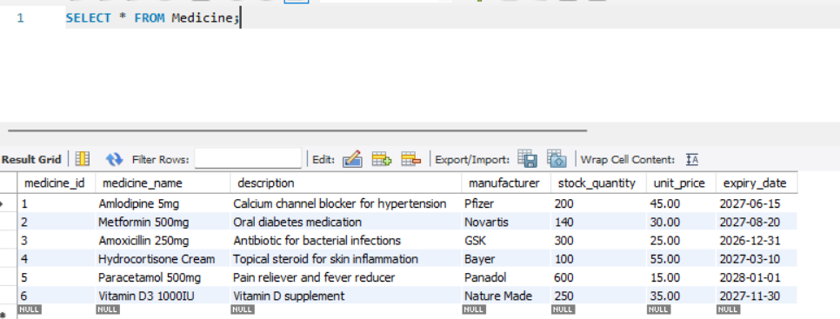
Screenshot: Medicine Table

Prescription Table
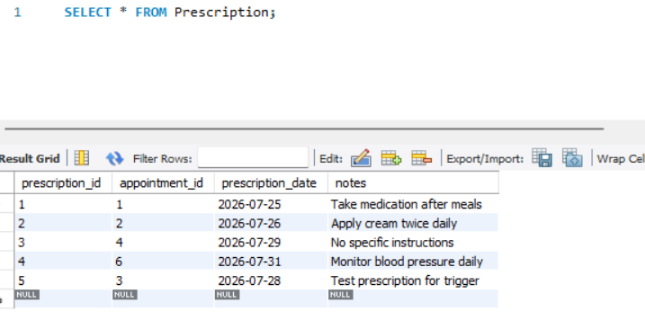
Screenshot: Prescription Table

Payment Table
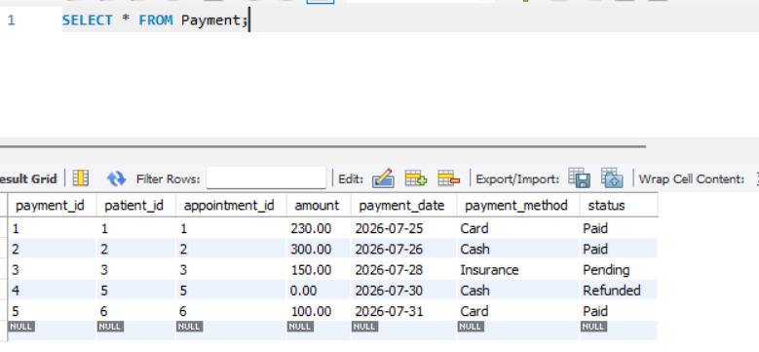
Screenshot: Payment Table

6. SQL Operations and Queries
To demonstrate the system's capability to handle real-world scenarios, several SQL operations were implemented, ranging from basic data retrieval to complex analytical queries.

Basic SELECT Query
Used to retrieve all patient records.
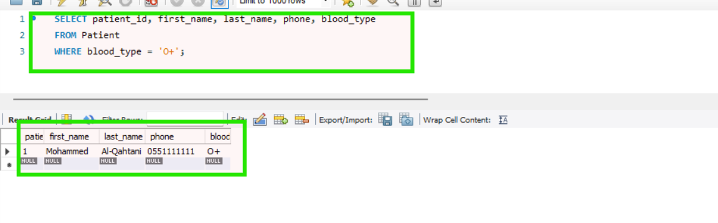
Execution Result: Basic SELECT Query

JOIN Query
Combines Patient and Appointment data to show scheduled visits.
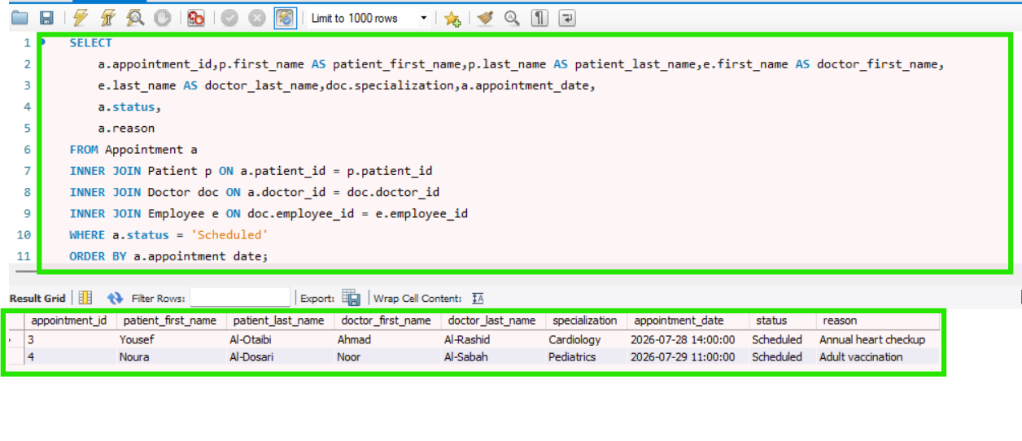
Execution Result: JOIN Query

Nested Query
Identifies doctors who have handled more than the average number of appointments.
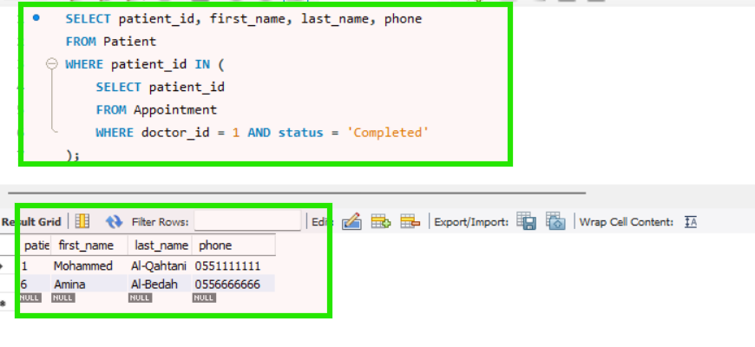
Execution Result: Nested Query

Aggregate Function
Calculates the total revenue generated from payments.
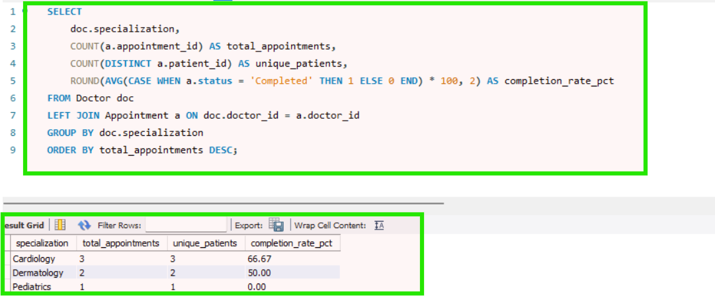
Execution Result: Aggregate Function

UPDATE Operation
Modifies employee salary or patient contact details.
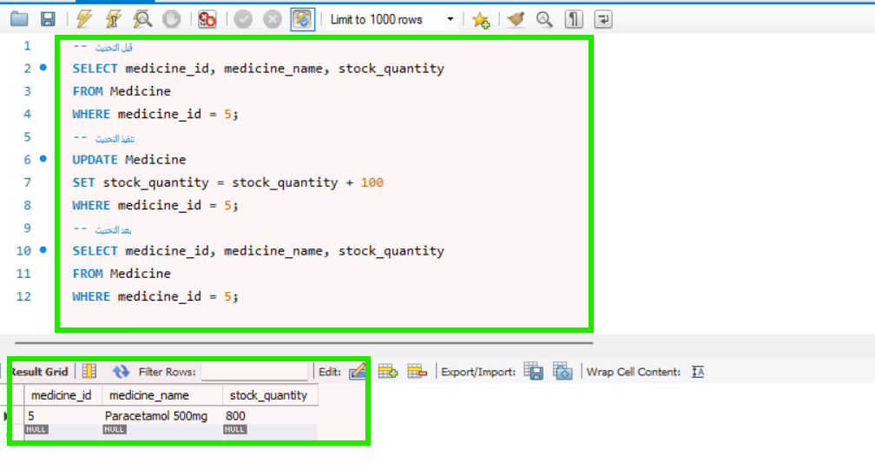
Execution Result: UPDATE Operation

VIEW Implementation
A virtual table providing a summary of daily clinic activities.
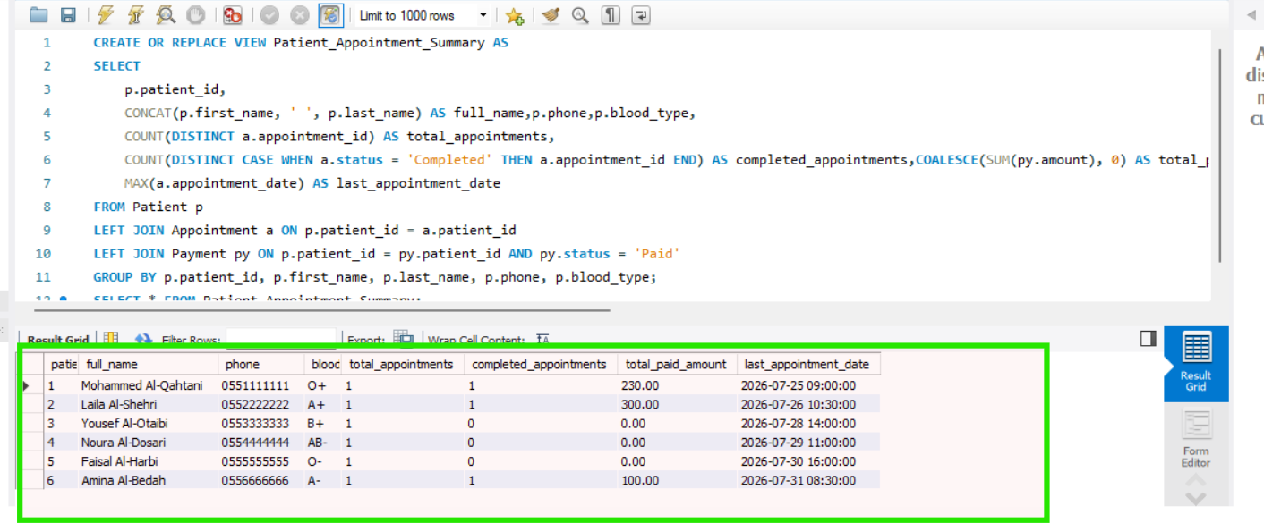
Execution Result: VIEW Implementation

7. Testing and Results
The Smart Clinic Database System underwent comprehensive testing to ensure data integrity, accuracy, and reliable performance. All SQL scripts were executed and verified using MySQL Workbench, and the obtained results were compared with the predefined system requirements.
The testing process included several important areas:

1. Referential Integrity Testing
The database relationships and constraints were tested to ensure data consistency. Foreign key constraints were verified to prevent invalid operations, such as deleting a patient record that is associated with existing active appointments. This ensured that related data remains accurate and protected from unintended deletion.

2. Trigger Testing
The implemented database trigger was tested to verify automatic updates in the medicine inventory. The test confirmed that medicine stock quantities are automatically reduced when a new prescription detail is added, ensuring accurate inventory management without requiring manual updates.

3. SQL Query Testing
All implemented SQL operations, including SELECT queries, JOIN queries, nested queries, aggregate functions, UPDATE, DELETE, views, and triggers, were executed successfully. The results confirmed that the database can efficiently retrieve, modify, and manage clinic information according to the project requirements.
Overall, the testing results demonstrated that the Smart Clinic Database System satisfies the required functionality and maintains data integrity through proper database design and implementation.

8. Database Features
The Smart Clinic Database System provides several important features that improve reliability, efficiency, and maintainability.

1. Data Integrity
Data integrity is maintained through the implementation of Primary Keys, Foreign Keys, and NOT NULL constraints. These constraints ensure that data remains accurate, consistent, and properly connected between related tables.

2. Scalability
The database structure follows normalization principles, allowing the system to be easily expanded in the future. New features, such as additional medical departments, healthcare services, or employee roles, can be added without significant changes to the existing design.

3. Automation
Database automation is achieved through the use of Triggers. For example, the implemented trigger automatically updates medicine stock levels when prescription details are added, reducing manual work and improving accuracy.

4. Security and Access Control
The system design supports future implementation of role-based access control. Different permissions can be assigned based on employee classifications, such as doctors, nurses, and receptionists, ensuring that users can access only the information required for their roles.

9. Challenges and Solutions

Challenges and Solutions

Challenge 1: Designing the Employee Specialization Hierarchy
Challenge:
One of the main challenges was designing the specialization hierarchy for employees, as the system includes different employee types such as doctors, nurses, and receptionists, while sharing common employee information.
Solution:
An Enhanced Entity-Relationship (EER) model was implemented using a superclass/subclass approach. The common attributes were stored in the Employee superclass, while role-specific attributes were managed in separate tables for Doctor, Nurse, and Receptionist. This design reduced data redundancy and improved database organization.

Challenge 2: Managing the Many-to-Many Relationship Between Treatments and Appointments
Challenge:
Another challenge was handling the many-to-many relationship between appointments and treatments, where one appointment may include multiple treatments and one treatment can be associated with multiple appointments.
Solution:
A junction table named Appointment_Treatment was created to resolve this many-to-many relationship. This approach maintained database normalization up to the Third Normal Form (3NF), improved data integrity, and ensured efficient relationship management between appointments and treatments.

10. Conclusion
The Smart Clinic Database System project successfully achieved its objective of designing and implementing a reliable relational database solution for healthcare management. The system provides an organized approach for managing essential clinic operations, including employee management, patient records, appointments, treatments, prescriptions, medicines, and payments.
By applying fundamental and advanced database concepts, such as entity relationships, primary and foreign keys, SQL queries, views, and triggers, the project demonstrated the practical application of database design and implementation principles.
This project provided valuable practical experience in database modeling, MySQL implementation, query development, system testing, and technical documentation. The developed system can serve as a foundation for future improvements and can be extended to support additional healthcare features and modern technological requirements.

11. References
- Oracle. (2026). MySQL Documentation.
Available at: https://dev.mysql.com/doc/
- Oracle. (2026). MySQL Workbench Documentation.
Available at: https://dev.mysql.com/doc/workbench/en/
- Elmasri, R., & Navathe, S. B. (2015). Fundamentals of Database Systems (7th Edition). Pearson.
- Silberschatz, A., Korth, H. F., & Sudarshan, S. Database System Concepts. McGraw-Hill.
- IT403 Database Course Materials, King Saud University.
- Git Documentation.
Available at: https://git-scm.com/doc
- GitHub Repository – Smart Clinic Database System Project.
Available at: https://github.com/anyanymouse/SmartClinic-Database

Appendix B: Screenshots
This appendix contains additional evidence of the system implementation.
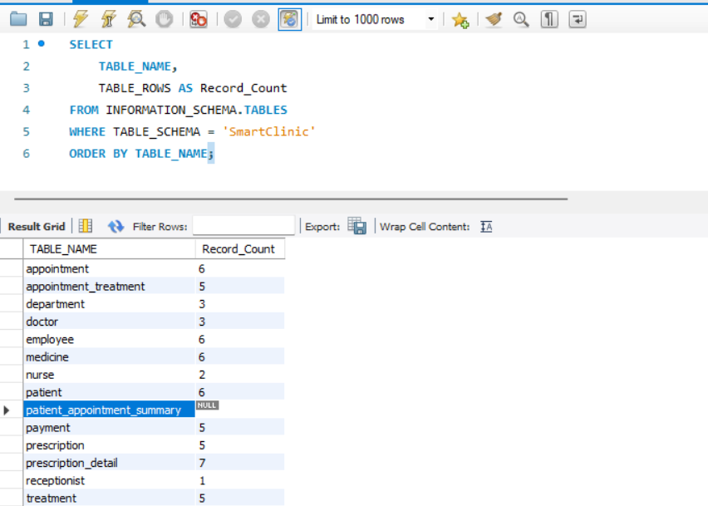
Figure: Verification of Data Insertion

