

FRIDA

Document template

Project Code : FR/SD-CT/191
Issue : 1.B
Date : 19/03/2015
No. of pages : 21

Approval control
Prepared by | Almudena Prieto  José Antonio Acosta
Approved by | Beatriz Sánchez  Project Manager
Authorized by | Alberto López  Principal Investigator | Date: 10/05/2013
Applicable documents

Nº | Document title | Code | Issue
A.1 | FRIDA Exposure Time Calculator | DC | 1.A

Reference documents

Nº | Document title | Code | Issue
R.1
List of acronyms and abbreviations

GTC Gran Telescopio Canarias
IA-UNAM Instituto de Astronomía – Universidad Nacional Autónoma de México
IAC Instituto de Astrofísica de Canarias
UF University of Florida

CONTENTS

1. Summary 6
2. Requirements 6
2.1 Primary Requirements 6
2.2 Secondary Requirements 7
2.3 Structure of the Web page 8
3. THE METHOD 10
3.1 STREHL RATIO AND ENCIRCLED ENERGY 10
3.1.1 Expected GTCAO performance 11
3.1.2 Encircled energy – S/N reference area 12
3.1.3 Using PSF models 13
3.2 THE ATMOSPHERIC CONTRIBUTION 14
3.3 TARGET DEFINITION PARAMETERS 14
3.4 THE IMAGING CASE 15
3.5 THE INTEGRAL FIELD SPECTROSCOPY CASE 15
Appendix A 16

Summary
This document describes the ETC for FRIDA in imaging mode and IFS mode. It follows similar methodology used for equivalent AO- assisted instruments at ESO and Gemini. The calculation will relay on a code developed in PHP or Java, and will be available to the user via a web server.

Requirements
This section describes the requirements the ETC must fulfil. Requirements are defined according to their priority as basic or additional, which will be followed as an implementation guideline.
The ETC will be made available to the user via a web-page sitting in a web server which location (TBD) may be either the UNAM or/and the IAC, in any case these will be mirroed sites. The web interface will be used to input the relevant parameters defining a FRIDA observation. The calculations will relay on a code to be developed in any languaje compatible with HTML applications (Java, PHP, or Python).
The ETC will have two independent modes, serving FRIDA imaging mode and IFS mode, respectively.

Primary Requirements
The ETC should be able to estimate (as accurately as possible) the S/N of a measurement to be obtained using the following FRIDA observing configurations:
- There will be two basic choices for the source morphology: point source and extended source (uniform brightness).
- The brightness of the source will be specified as magnitude of the continuum and optionally the flux of a emission line.
- Transmission and emission of the Earth atmosphere must be included for variety of conditions (humidity and temperature).
- the instrument can operate using two generic observing modes: imaging (broad-band and narrow-band) and Integral Field Spectroscopy.
- there are 3 spatial scales for both imaging and IFS modes.
- The ETC will produce a table showing basic output quantities: achieved SNR ratio, or required exposure time to achieve a given SNR.
- Graphical output showing the variation of SNR vs exposure time (similar to Fig. 1).
- Graphical output showing the variation of SNR vs lambda for IFS observing mode, including sky emission (similar to Fig. 2).

Secondary Requirements

- Use as input a set of modelled PSFs as expected for GTCAO, equivalenty simulate GTCAO system to provide a matrix of PSFs for different values of seeing, guide star magnitude and distance…
- Include a variety of morphologies for extended objects (Sersic profiles and exponential disks)
- Include different spectral shapes as input for the spectroscopy mode (blackbody, power-law, stellar templates, galaxy templates).
- Provide an output image simulating that expected by FRIDA.
- …
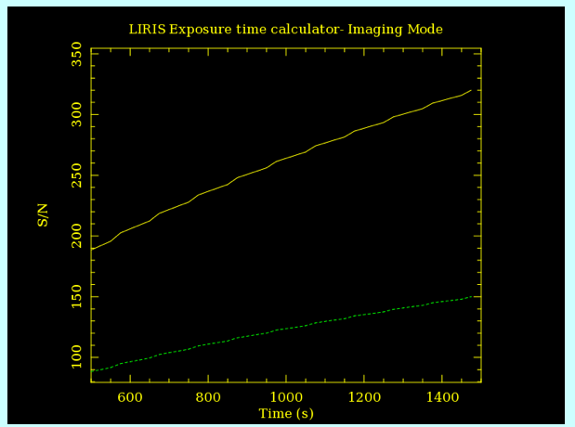
Figure 1: S/N ratio variation with exposure time

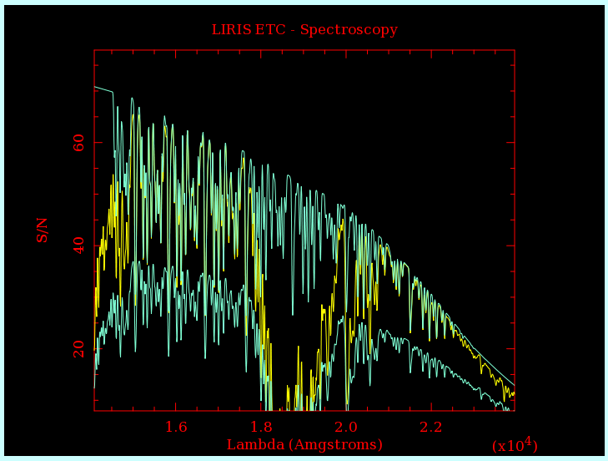  Figure 2: S/N ratio of the observed spectrum, including variations due to sky emission and absorption. | 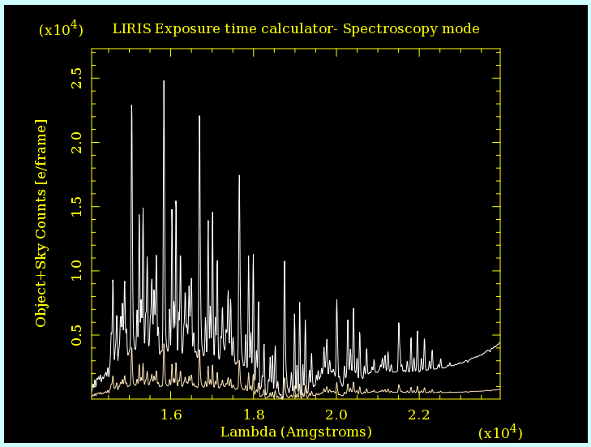  Figure 3: Simulated clean spectrum including sky OH emission lines and telluric absorption.

Structure of the Web page

The web form will be divided into different sections:
- Target related parameters (point source or extended source, brightness, spectral energy distribution, etc.)
- Observing conditions (seeing, airmass).
- AO reference target (distance to the science target and magnitude).
- Telescope and instrument configuration (GTCAO, minimum integration time)
- Instrument configuration (imaging or IFS, spatial scale, filters or grating)

The structure of the WEB page will be similar to what is presented in Fig. 4

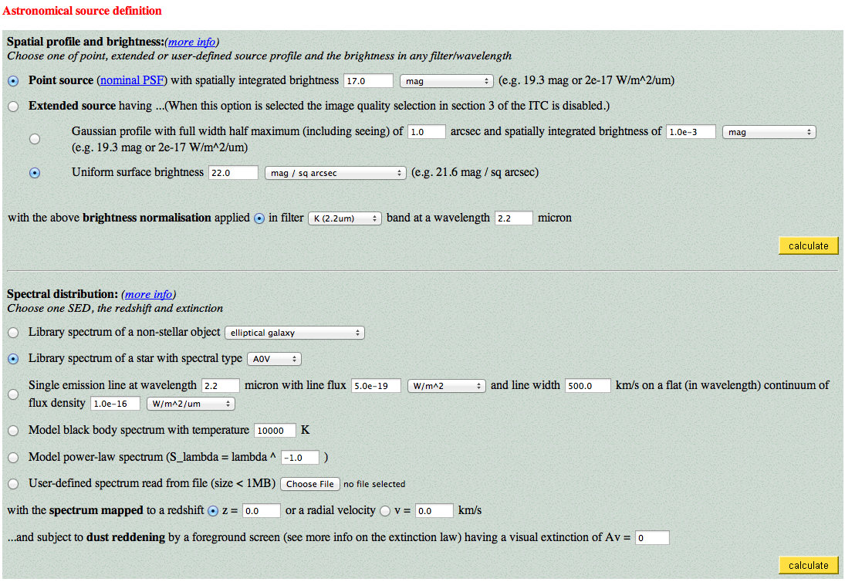
Figure 4: Screen capture of the FRIDA ETC - Astronomical source parameter
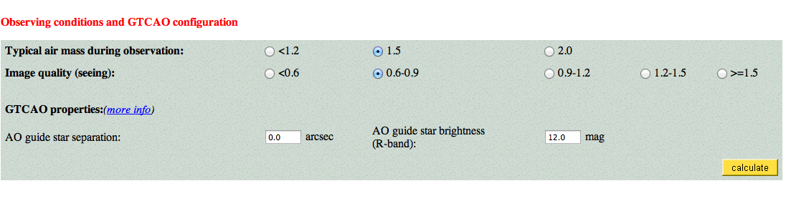
Figure 5: Screen capture of the FRIDA ETC - Telescope and GTCAO related parameters

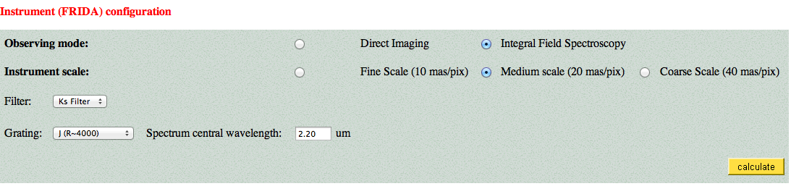
Figure 6: Screen capture of the FRIDA ETC - Instrument parameters

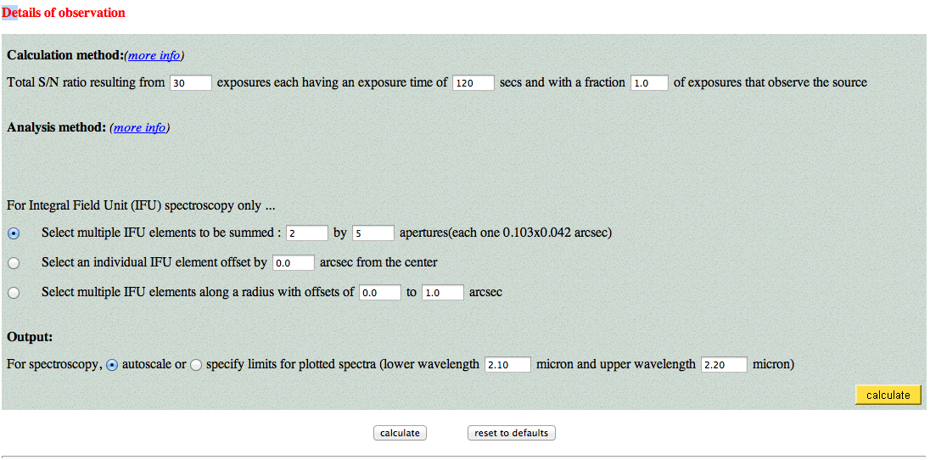
Figure 7: Screen capture of the FRIDA ETC - output parameters

THE METHOD
This section includes all relevant formulae and auxiliary information (sky emission and absorption). Firstly, the expressions used to estimate the Strehl ratio and the encircled energy are presented. Advanced versions of the ETC will allow the user to do the same computation using a library of model PSFs generated for GTCAO+FRIDA. The derivation of Signal-to-Noise ratio for the direct imaging and IFS modes are also described here.

STREHL RATIO AND ENCIRCLED ENERGY

The ability of GTCAO system to correct the wavefront and provide a good correction for the PSF will depend on the brightness and off-axis distance of the wavefront reference target, the so-called AO guide star. The total signal from a point source will be computed as the sum of an AO-corrected core plus an uncorrected (seeing limited) halo. The Strehl ratio dictates the contribution of each of these two components. In order to compute the S/N ratio the flux contained in an user-defined aperture will be used, which is also called “Encircled Energy”. Here we will describe a simple theorical approximation to compute the Strehl ratio. In future evolved versions of the ETC we will include computation of Strehl ratio and encircled energy from a set of simulated PSF describing GTCAO expected behaviour.

Expected GTCAO performance

The Strehl ratio can be approximated by the following expression:
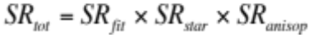
and
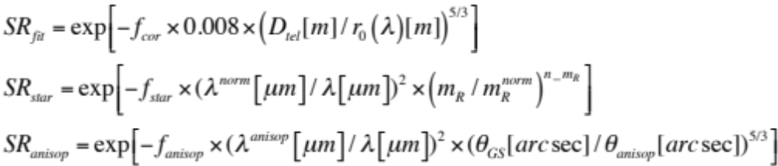
where SR_{fit} is the Strehl due to the system fitting error (limited number of actuactors), SR_{star} is the Strehl loss due to the limited number of photons from the guide star (assuming photon noise limited, which is certainly an optimistic case), SR_{anisop} is the expected Strehl loss due to anisoplanatism. The values of λ^{norm}, m_{R}^{norm} and n_m_{R} will be determined after characterization of GTCAO, for the time being the following values are proposed λ^{norm}=2.2 μm, m_{R}^{norm}=14.5 and n_m_{R}=16. The value of θ_{anisop} is also a parameter to be measured during GTCAO characterization, the value θ_{anisop} =1.93” at λ_{anisop}=0.5μm is proposed as an initial guess. The Fried parameter r0 at the wavelength of the selected filter/grating can be computed from the value of seeing given at the reference wavelength (λ_{ref}), using the following expression:
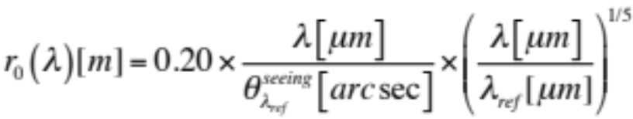

Usually, the seeing will be specified at λ_{ref}=0.5μm.
The values of f_{cor}, f_{star} and f_{anisop} can be determined from the requirements/specs of GTCAO, although they should be close to unity. As stated in the document “GTCAO system Advanced design Overview”, a SR ratio equals to 0.75 is expected at 2.2 μm for a bright guide star in good seeing conditions (θ_{seeing}=0.5” at l=0.5 μm, which implies r₀[λ=0.5 μm] = 21 cm). In the case of a fainter star, mR=14.5, the SR ratio decreases to 0.1. Using these figures and taking r0(2.2mm)=1.18m it results f_{cor}≈1., f_{star}≈2., f_{aniso}≈1.
Once the Strehl ratio is known the encircled energy within an user defined aperture can be obtained as the ratio between the flux within the aperture and the total flux (or number of photons). The shape of the point spread function (PSF) is required in order to estimate the spatial distribution of photons onto the detector. A simplified model with two components: a core corresponding to the expected diffraction limit (PSF) and a halo associated with the uncorrected part of the seeing disk. Both components will be simulated by Gaussian functions with FWHM, or equivalently σ , which are computed from the following expressions:
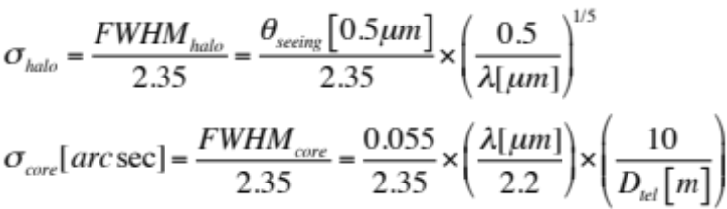
The flux within a circular aperture is computed as the integral up to a radius ρ_{aper}
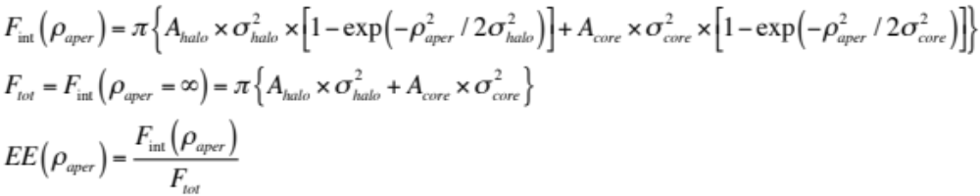
The values of A_{halo} and A_{core} are related by the Strehl ratio, as the following expression
. 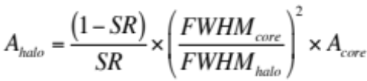

Encircled energy – S/N reference area

The user has to specify the radius of a ‘S/N reference area’ in mas (Rref ). This is the area on the sky over which the photons for the S/N calculation (both object and sky) are collected. For an extended source (and the sky) the number of object (sky) photons is given by multiplying the target’s (sky’s) surface brightness by: Ω = pi Rref². In the case of an extended source, it should be possible to specify a certain position within the FOV.
The reference area could be:
- The core of a point source – f x FWHM(~λ/D) [f is a factor specified by the user]
- the size of a single spaxel – a spatial element- Rref = SQR (Ωp /pi)
- the size of the object, Rref = SQR (Nspec Ωp /pi)

For a point source the S/N reference area is the size of the PSF at the observing band, which depends on GTCAO performance, i.e on the spatial resolutuion achieved. In order to asses this performance in the ETC, per each observing band, seeing, target / NGS (natural guide star) separation, and NGS magnitude, a grid of GTCAO-FRIDA PSFs database will be constructed which will serve as input to the ETC (see below).
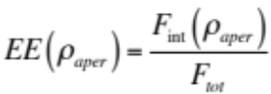
The final S/N is calculated per spectral resolution element, i.e. the object’s (and the sky’s) light is integrated over Δλ = λ_{ref}/R, R is the spectral resolution. In FRIDA, Δλ = 2 pixels
Nspec determines the number of detector pixels over which the light collected from the S/N reference area is spread: Npix = 2Nspec, where the factor 2 comes from the integration over wavelength. Hence, Nspec determines the readout noise and dark current.
A graph of encircled energy and S/N ratio vs. the aperture radius would be offer in order to permit the user to select a proper selection of the aperture.

Using PSF models

The simulated GTCAO+FRIDA PSFs will cover a limited parameter space in seeing, NGS magnitude and target-NGS separation, with a possible 4-D grid as follows:
- filters (3) = [ Z,J, H, K]
- seeings (6) = [0".4, 0".6, 0".8, 1".0, 1".2, 1".4]
- target/NGS sep. (4) = [0", 10", 20", 30"]
- NGS mag. (3) = [13,15,17]
Using this limited set of values will lead to a database of 216 GTCAO+FRIDA PSFs. From these, different quantities required for the ETC, e.g. encircled energy at given radius, shall be derived. For the ETC, the user's input parameters relevant to the AO may be different from the above parameter grid. We shall decide on whether parameters others than the ones quoted are derived from a multidimensional linear interpolation (as done in VLT-SINFONI), or – for sake of simplicity- are selected from a fixed parameter-range drop-down list offered at the ETC GUI page.

THE ATMOSPHERIC CONTRIBUTION
In the near-IR the sky brightness is dominated by the ‘emission line’ component (mostly OH airglow) and is quite uncertain. The reason is that the airglow is known to vary systematically by several tenths of a mag, as a function of season and time along the night, as well as randomly on shorter timescales and as a function of position on the sky. The sky continnum component – mainly controlled by the moon phase- is much less important.
The ETC will model the sky background contribution and its dependence on wavelength as the sum of OH-sky emission lines plus thermal emission from the atmosphere, telescope and instrument.

Fback(λ)= continuum ( λ) +em.lines( λ) + atm( λ) + tel(λ)

Overall, for the nominal resolutions of FRIDA, R ~ 4000, we shall use the sky spectrum measured with LIRIS at La Palma and compared with existing published models. In the case of the FRIDA high resolution mode R=30,000, we may use the OH spectrum measured by e.g. ESO/CRIRES.

From the second half of the K-band onwards the background is dominated by the thermal emission from the atmosphere and the telescope. In this case, we will resort to the thermal emission used in Canaricam or EMIR when available.

The atmospheric transmission in the IR, ξ, is caused by molecular absorption which depends on the airmass. This may be derived from an atmospheric model.
For completeness purpose and consistency check we shall used the sky model described in Noll et al. (2012) which is fully implemented at ESO in the code SM-01, and will be available to us: http://www.eso.org/observing/etc/bin/gen/form?INS.MODE=swspectr+INS.NAME=SKYCALC

TARGET DEFINITION PARAMETERS
The target’s flux is specified by its magnitude in any of the allowed bands, Z, J, H and K, and its flux distribution. The latter is integrated over the chosen band and then normalised to the specified magnitude. The zeropoints of the magnitude scale may be either Vega or AB (cf. Table 1). The input magnitude and the flux distribution determine the object flux, Fobj, at the observing wavelength, λref.
For a selection of flux distributions, a library of stellar spectra ( e.g. the Pickles library which covers up to K-band), non-stellar library (elliptical and spiral galaxies) may be offered in the ETC.

The target’s flux at λref could also be specified directly in mJy.
The source geometry can be chosen to be a point source or an extended source.

Table 1. Photometric zeropoints
Band | Central wavelength  [μm] | ZVega = −log Fo  [W/m2/μm] | ZAB = −log Fo  [W/m2/μm]
I | 0.79 | 7.91 | 7.77
J | 1.25 | 8.51 | 8.14
H | 1.65 | 8.94 | 8.39
K | 2.16 | 9.40 | 8.64

THE IMAGING CASE

The Signal-to-Noise ratio will be computed using the following expressions:
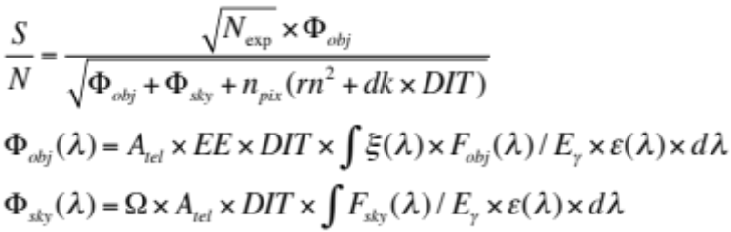

THE INTEGRAL FIELD SPECTROSCOPY CASE

The Signal-to-Noise ratio will be computed using the following expressions:
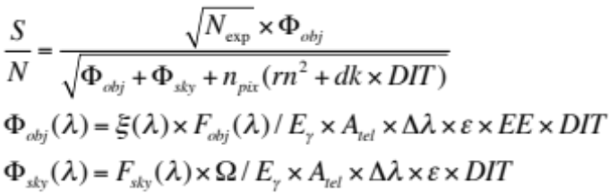

Appendix A
A description of the parameters used in the definition of this ETC follows:

- m_{obj}: Object magnitude (for a point source) or object surface brightness (for an extended
source) in a specified band (J, H, K) and magnitude system (Vega orAB) [mag or mag/arcsec2]

- Fo = 10^{−Z:} Photometric zeropoint [W/m2/μm]
Z may be either Vega or AB magnitude. The various values for the different bands are listed in
Table 1.

- F_{obj}: Object flux (point source) or surface brightness (extended source) at the top of
the atmosphere [W/m2/μm or W/m2/μm/arcsec2]
F_{obj} = Fo10−^{0.4 mobj}

This formula is only true for the case of a uniform flux distribution. Otherwise m_{obj} is used to normalise the flux distribution so that the distribution’s integral over the band is equal to the flux given by m_{obj}.
The user can specify m_{obj} or use directlyF_{obj} [mJy or mJy/arcsec2]

- χ: Airmass.
Options: 1, 1.15, 1.5 or 2.

- D: Telescope diameter. [m]

- A: Photon collecting area of the telescope. [m2]
A = Pi/4 (D² − d²), where d is the diameter of the central obstruction.

- Rref : Radius of the circular S/N reference area [mas]
Rref –point-like source = size of the PSF at the observing band
Rref -extended source = size of the spaxel (ie. S/N is calculated in a single spectrum) or size of the object

- Ω : Size of the S/N reference area. Ωp = Size of the spaxel [mas2]
Ω = pi Rref²

- Nspec: Number of individual spectra on the detector covering the S/N reference area. In FRIDA, the separate spatial element (spaxel) is equal to at least 2 Nspec.

- λref : Observing wavelength, the S/N is calculated as a function of wavelength centered in λref. [μm]

- R: Spectral resolution

- Δλ: Wavelength range used for the integration over wavelength. [μm]
Set equal to a resolution element: Δλ = λref/R = 2 detector pixels in FRIDA

- ξ: Atmospheric transmission
Depends on airmass and λref

- <Fobj>: Object flux (point source) or object surface brightness (extended source) at the telescope entrance [W/m2/μm or W/m2/μm/arcsec2]
<Fobj> = ξ F_{obj}

- ε: Total efficiency of telescope + FRIDA

• Eγ: Photon energy at λref [J/γ]
Eγ = 1.985 x 10⁻¹⁹/ λref

• c: Total conversion factor from energy flux incident at the telescope entrance to detected
number of photo-electrons.[e−/s per W/m2/μm]
c = ε Δλ A / Eγ

• T: Detector exposure time for one exposure (DIT) [s]

• nexp: Number of exposures (NDIT)

• e: Encircled energy or fraction of PSF in the S/N reference area.

• Nobj: Number of detected electrons from object in the S/N reference area per exposure [e−]
For a point source: Nobj = <Fobj> e c T
For an extended source: Nobj = <Fobj> Ω c T

• Fsky: Background surface brightness [W/m2/μm/arcsec2]

• Nsky: Number of detected electrons from the background in the S/N reference area per
exposure [e−]
Nsky = Fsky Ω c T

• Npix: Number of detector pixel over which the light from the S/N reference area is
spread.
Npix = 2 Nspec, where the factor 2 comes from the integration over wavelength.

• d: Detector dark current [e−/s/pixel]

• r: Detector read-out noise [e−/pixel]

• S/N: Signal-to-noise ratio per resolution element
S/N = SQR(nexp) Nobj / SQR ( Nobj + Nsky + Npix r² + Npix d T )

