DATA PROTECTION IMPACT ASSESSMENT
DPIA Report
Prepared in accordance with the Nigeria Data Protection Act, 2023 and the Nigeria Data Protection Act General Application and Implementation Directive (GAID), 2025
Organisation | [Insert organisation name]
Processing activity / product | [Insert product or processing activity]
Report reference | [DPIA-YYYY-001]
Version / status | v1.0 - Draft for management review
Date of assessment | [Insert date]
Prepared by | Dr. Ivan Anya, Data Protection Officer, Business Intelligence Technologies Ltd (NDPC Internship Programme)

CONFIDENTIAL - Contains information about the organisation's data protection risk posture. Distribution restricted to the controller's management, the DPO and the Nigeria Data Protection Commission (NDPC) where required.

Document Control
Version | Date | Author | Change
1.0 | [Date] | Dr. Ivan Anya, DPO | Initial DPIA

Contents
1. Executive Summary
2. Scope, Methodology and Legal Basis
3. Organisation Identity
4. Product Description
5. Processing Activity
6. Necessity and Proportionality
7. Risk Assessment and Risk Chart
8. Risk Treatment and Controls
9. Residual Risk and DPO Opinion
10. Action Plan
11. Sign-off and NDPC Consultation

1. Executive Summary
This Data Protection Impact Assessment (DPIA) evaluates the personal data processing associated with [product / processing activity] operated by [organisation name] (the "Controller"). It has been carried out under section 28 of the Nigeria Data Protection Act, 2023 (NDPA) and the DPIA requirements of the Nigeria Data Protection Act General Application and Implementation Directive (GAID), 2025, because the processing is likely to result in a high risk to the rights and freedoms of data subjects.

9  Risks identified | 2 / 5  Critical / High (inherent) | 0 / 0  Critical / High (residual) | MEDIUM  Overall residual rating

Key findings
- Scope of processing. The processing involves large-scale collection of identity, contact and transactional data, and is therefore subject to the DPIA obligation and to registration and compliance-audit obligations as a data controller of major importance where applicable.
- Inherent risk. Before controls, the assessment recorded two Critical risks (unauthorised access / data breach, score 20; weak consent and transparency, score 16) and five High risks relating to cross-border transfers, retention, processor oversight, data subject rights and insider misuse.
- Residual risk. With the recommended technical and organisational controls implemented, all identified risks reduce to Low or Medium. No residual risk remains Critical or High.
- Conclusion. The processing may proceed once the priority actions in Section 10 are completed. Should any High residual risk persist, the Controller must consult the NDPC before commencing or continuing the processing.

Priority recommendations
- Implement encryption at rest and in transit, multi-factor authentication and role-based access control (R1, R9).
- Deploy a layered privacy notice and a recorded, withdrawable consent mechanism (R3).
- Execute NDPA/GAID-compliant data processing agreements with all processors and put transfer safeguards in place before any cross-border flow (R4, R6).
- Approve and enforce a retention schedule with automated deletion; operationalise a data subject rights request procedure with a 30-day response target (R5, R7).
- Test the breach response plan, including NDPC notification within 72 hours of becoming aware of a reportable breach (R1).

2. Scope, Methodology and Legal Basis

2.1 Why a DPIA is required
A DPIA is required where processing is likely to result in a high risk to the rights and freedoms of individuals. The following GAID screening triggers were considered:
Screening criterion | Applies? | Comment
Large-scale processing of personal data | [Yes/No] | [Comment]
Processing of sensitive personal data | [Yes/No] | [Comment]
Systematic monitoring / profiling or automated decision-making | [Yes/No] | [Comment]
Use of new or innovative technology | [Yes/No] | [Comment]
Processing of children's or vulnerable persons' data | [Yes/No] | [Comment]
Cross-border transfer of personal data | [Yes/No] | [Comment]

2.2 Methodology
The assessment followed five stages: (1) describe the processing; (2) assess necessity and proportionality against the NDPA data protection principles; (3) identify and score risks to data subjects; (4) identify measures to mitigate each risk; and (5) record residual risk, DPO advice and sign-off.
Risks were scored on a 5 x 5 matrix: Risk score = Likelihood (1-5) x Impact (1-5). Ratings are Low (1-4), Medium (5-9), High (10-15) and Critical (16-25). Impact is assessed from the perspective of the data subject, including financial loss, identity theft, discrimination, distress and loss of control over personal data.

2.3 Legal and regulatory references
- Nigeria Data Protection Act, 2023 - in particular the principles of processing (s.24), lawful basis (s.25), consent (s.26), data subject rights (ss.34-38), breach notification (s.40), cross-border transfers (ss.41-43) and DPIA (s.28).
- Nigeria Data Protection Act General Application and Implementation Directive (GAID), 2025 - DPIA procedure and content, privacy notices, compliance audit returns, breach notification and DPO obligations.
- Constitution of the Federal Republic of Nigeria, 1999 (as amended), s.37 - right to privacy.
- Sector-specific rules applicable to the Controller: [insert, e.g. CBN, NCC, NHIA, NUC guidelines].

3. Organisation Identity
This section identifies the Controller, any joint controllers and processors, and the persons responsible for data protection.

3.1 Data controller
Legal name | [Insert registered name]
RC / registration number | [Insert CAC number]
Registered address | [Insert address]
Sector / industry | [Insert sector]
Website | [Insert URL]
NDPC registration status | [Registered as DCPMI - Ultra High / Extra High / Ordinary High Level, or not applicable]
NDPC registration number | [Insert, if applicable]
Number of data subjects | [Insert approximate number]

3.2 Data Protection Officer
DPO name | Dr. Ivan Anya
Organisation | Business Intelligence Technologies Ltd
Contact email / phone | [Insert]
Independence confirmed | [Yes / No - reports directly to highest management level]

3.3 Senior accountable executive
Name and title | [Insert]
Contact | [Insert]

3.4 Processors and recipients
Entity | Role / service | Location | DPA in place?
[Cloud hosting provider] | Hosting and storage | [Country] | [Yes/No]
[Payment processor] | Payment processing | [Country] | [Yes/No]
[Analytics / messaging vendor] | Communications / analytics | [Country] | [Yes/No]

4. Product Description
Product / service name | [Insert]
Version / release stage | [Pilot / Live / Redesign]
Product owner | [Insert]
Target users | [Customers / students / patients / employees]
Delivery channel | [Web / mobile app / USSD / API / in-person]
Technology stack | [Insert hosting, database, key components]
Go-live date | [Insert]

4.1 Purpose and nature
[Describe in plain language what the product does, the problem it solves, why personal data is needed, and the benefits to data subjects and to the Controller.]

4.2 Key features that affect personal data
- User registration and identity verification.
- Profile management and communications preferences.
- Transactions, service delivery and record-keeping.
- Analytics, personalisation or automated decision-making [confirm whether present].
- Integration with third-party services and APIs.

4.3 Data flow summary
Data subject > Collection point (app / web / form) > Application server > Database / cloud storage > Processors and authorised recipients > Archive / secure deletion.

5. Processing Activity

5.1 Description of processing
Purpose(s) of processing | [List specific, explicit purposes]
Lawful basis (NDPA s.25) | [Consent / contract / legal obligation / vital interest / public interest / legitimate interest]
Categories of data subjects | [Customers, staff, students, patients, minors]
Volume and frequency | [Records processed per month; continuous / batch]
Collection method | [Direct from data subject / third party / automated]
Automated decision-making | [Yes / No - describe]
Cross-border transfer | [Yes / No - destination countries and safeguard relied on]
Storage location | [Country / data centre]

5.2 Personal data inventory
Data category | Examples | Lawful basis | Source | Retention
Identity data | Name, date of birth, gender, NIN / BVN [if used] | Consent / legal obligation | Registration | Duration of relationship + [x] years
Contact data | Phone, email, address | Contract / consent | Registration | Duration of relationship + [x] years
Transaction data | Payments, usage logs, service history | Contract / legal obligation | System generated | [x] years per regulatory requirement
Technical data | IP address, device ID, cookies | Legitimate interests | Automatic | [x] months
Sensitive data [if any] | Health, biometric, financial or children's data | Explicit consent | Registration / service use | [Minimum necessary]

Rows above are indicative and must be confirmed against the Controller's Record of Processing Activities (ROPA).

5.3 Data subject rights and transparency
Data subjects are able to exercise the rights of access, rectification, erasure, restriction, objection, data portability and the right not to be subject to solely automated decisions (NDPA Part VI). Requests are handled through [channel] and answered within [30] days. A layered privacy notice is presented at the point of collection.

6. Necessity and Proportionality
NDPA principle (s.24) | Assessment
Lawfulness, fairness, transparency | A lawful basis has been identified for each purpose and a privacy notice is provided. [Confirm]
Purpose limitation | Data is collected for specified purposes only; secondary use requires fresh assessment.
Data minimisation | Only data necessary for the stated purposes is collected; optional fields are clearly marked.
Accuracy | Users can update their data; periodic data quality checks are scheduled.
Storage limitation | A retention schedule defines retention periods and secure deletion.
Integrity and confidentiality | Encryption, access controls, logging and vendor assurance are applied.
Accountability | DPO appointed; ROPA maintained; DPIA documented; annual compliance audit returns filed with the NDPC where applicable.

7. Risk Assessment and Risk Chart
Nine risks to the rights and freedoms of data subjects were identified. Inherent risk is the level of risk before any additional controls; residual risk is the level after the controls in Section 8 are implemented.

7.1 Inherent risk register
ID | Risk | Description | Potential harm | L | I | Score
R1 | Unauthorised access / data breach | Hacking, weak authentication or misconfiguration exposes personal data | Identity theft, fraud, distress | 4 | 5 | 20 Critical
R2 | Excessive collection | More data collected than needed for the purpose | Loss of control, privacy intrusion | 3 | 3 | 9 Medium
R3 | Weak consent and transparency | Unclear notices; bundled or non-withdrawable consent | Unfair processing, loss of autonomy | 4 | 4 | 16 Critical
R4 | Cross-border transfer without safeguards | Data hosted or accessed abroad without adequate protection | Reduced legal remedies | 3 | 4 | 12 High
R5 | Excessive retention | Data kept beyond purpose or legal need | Increased breach exposure | 4 | 3 | 12 High
R6 | Processor non-compliance | Vendors process data outside instructions or lack security | Unauthorised use or disclosure | 3 | 4 | 12 High
R7 | Failure to honour data subject rights | Requests missed, delayed or not authenticated | Breach of rights; complaints to NDPC | 3 | 4 | 12 High
R8 | Inaccurate data / automated decisions | Wrong data or unreviewed algorithmic outcomes | Unfair denial of services | 3 | 3 | 9 Medium
R9 | Insider misuse | Staff access data without business need | Privacy intrusion, reputational harm | 3 | 4 | 12 High

L = Likelihood (1-5); I = Impact (1-5). Scores shown are illustrative starting values and must be validated by the Controller's DPO and process owners.

7.2 Risk heat map
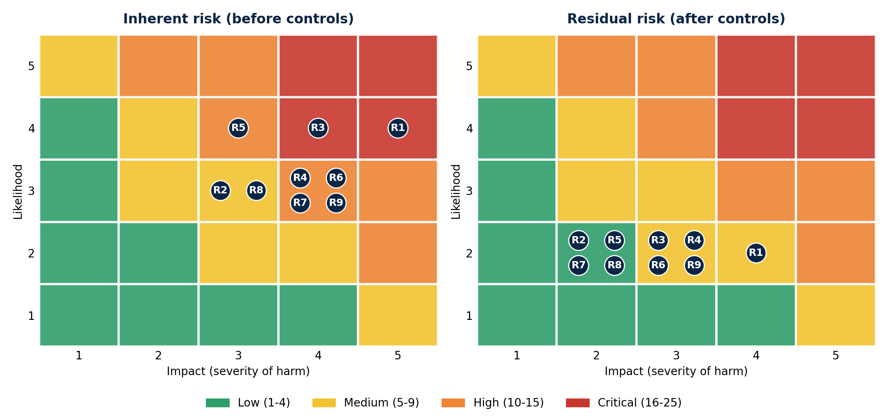

7.3 Inherent versus residual risk score
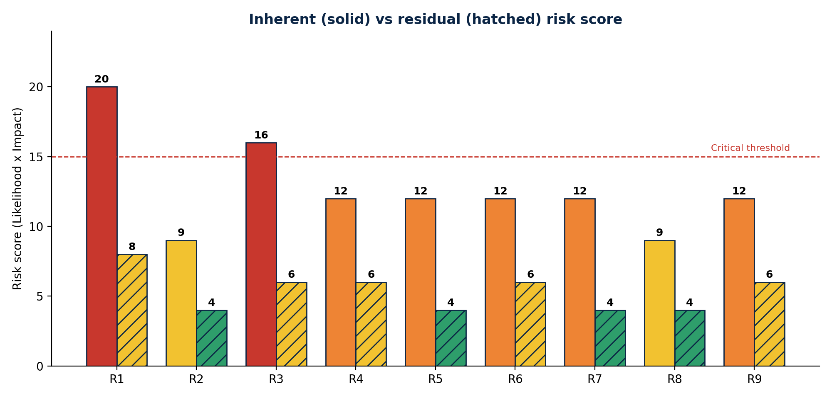

8. Risk Treatment and Controls
ID | Mitigating controls | Owner | Target date
R1 | MFA, encryption at rest and in transit, network segmentation, vulnerability scanning and annual penetration test; tested breach response plan with 72-hour NDPC notification | CISO / IT | [Date]
R2 | Data minimisation review of all forms and APIs; remove non-essential fields | Product owner | [Date]
R3 | Layered privacy notice; granular, recorded and withdrawable consent; consent log | DPO / Legal | [Date]
R4 | Transfer impact assessment; contractual safeguards; prefer in-country hosting | DPO / Legal | [Date]
R5 | Approved retention schedule; automated deletion and anonymisation | IT / Records | [Date]
R6 | NDPA/GAID-compliant DPAs; vendor due diligence and annual review; audit rights | Procurement / DPO | [Date]
R7 | DSAR procedure, identity verification, request tracker and 30-day SLA | DPO | [Date]
R8 | Data quality checks; human review of automated decisions; right to contest | Product owner | [Date]
R9 | Least-privilege access, access logging and review, confidentiality agreements, staff training | HR / IT | [Date]

9. Residual Risk and DPO Opinion
ID | Risk | Inherent | Residual | Rating | Accepted?
R1 | Unauthorised access / data breach | 20 | 8 | Medium | [Yes / No]
R2 | Excessive collection | 9 | 4 | Low | [Yes / No]
R3 | Weak consent and transparency | 16 | 6 | Medium | [Yes / No]
R4 | Cross-border transfer without safeguards | 12 | 6 | Medium | [Yes / No]
R5 | Excessive retention | 12 | 4 | Low | [Yes / No]
R6 | Processor non-compliance | 12 | 6 | Medium | [Yes / No]
R7 | Failure to honour data subject rights | 12 | 4 | Low | [Yes / No]
R8 | Inaccurate data / automated decisions | 9 | 4 | Low | [Yes / No]
R9 | Insider misuse | 12 | 6 | Medium | [Yes / No]

DPO opinion
Subject to completion of the controls in Section 8, the Data Protection Officer is of the opinion that the processing complies with the NDPA and GAID requirements and that residual risks to data subjects are acceptable. The processing should not go live (or continue in its current form) until the priority actions marked High priority in Section 10 are closed. This DPIA must be reviewed annually and whenever the nature, scope, purpose or technology of the processing changes materially.

10. Action Plan
# | Action | Priority | Owner | Due
1 | Implement MFA, encryption and RBAC | High | IT | [Date]
2 | Publish layered privacy notice and consent mechanism | High | DPO | [Date]
3 | Execute DPAs with all processors | High | Legal | [Date]
4 | Approve retention schedule and automate deletion | Medium | IT | [Date]
5 | Run breach simulation and finalise NDPC notification playbook | High | DPO / IT | [Date]
6 | Staff training on NDPA/GAID | Medium | HR | [Date]
7 | File or update ROPA and compliance audit return | Medium | DPO | [Date]

11. Sign-off and NDPC Consultation
If, after applying the controls above, a High residual risk remains, the Controller must consult the Nigeria Data Protection Commission before processing begins. Based on this assessment, prior consultation is: [Required / Not required].

Role | Name | Signature | Date
DPO (author) | Dr. Ivan Anya
Process / product owner
Senior accountable executive
Head of IT / Security

Next review date: [Insert - not later than 12 months from sign-off].

