class04.R

wolfi

2024-04-11

#this is a text file  
x <- 1:50  
plot(x,sin(x))

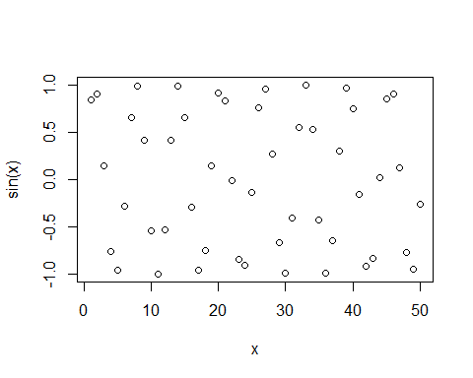

plot(x,sin(x),typ='l',col="red",lwd = 3)

