MAHINE LEARNING

HW2

YUN LI 6035800416

Problem1 Kernelized Perceptron
(a)When 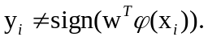 We update w by the following rules:
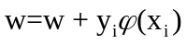
Since 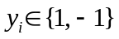, w will always be the linear combination of 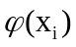. We can write the conclusion in the following formula:
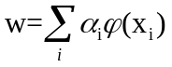
Where 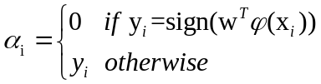 and 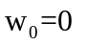
(b)In this case, we make prediction by
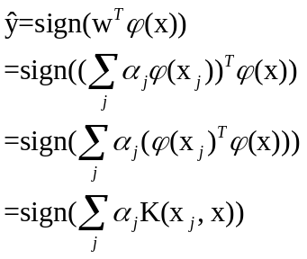
This prediction depends only on the inner products of feature vector x
(c) When We update w by the following rules:
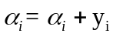
At first, vector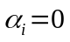 for length of n.

Problem2 Support Vector Machine without Bias Term
(a) primal form:
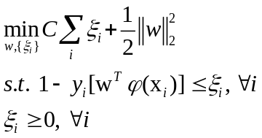
(b) add lagrange multipliers 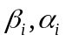 to each term :
(c) take derivatives
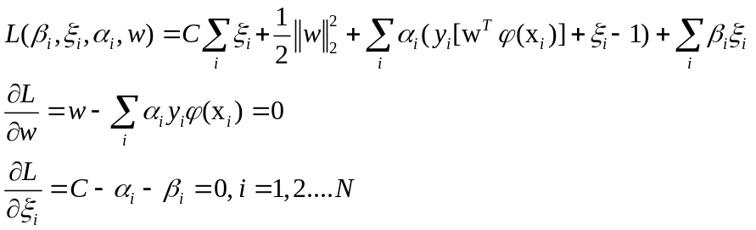
Thus we have:
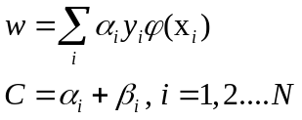
(d) Substituting the above equations into Lagrangian.
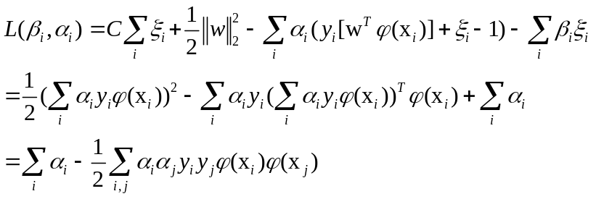
(e)Dual form:
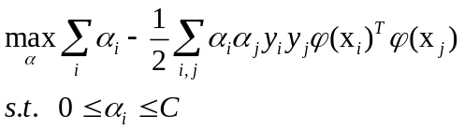
(f) The main difference is the condition constrains. Here, we only have 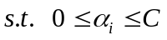, while in the lecture, it is 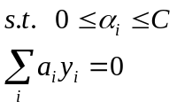
(g) compute the second order derivative:
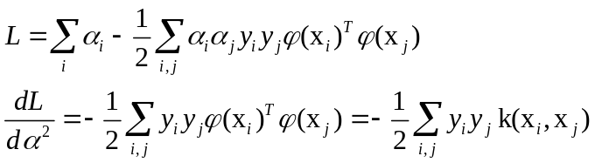
Because 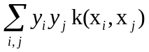 is a positive definite matrix (kernel function), we have 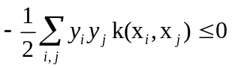. Thus the dual form is a concave function.
In conclusion, we need to maximize the dual function.

Problem 3 Sample Questions
3.1
The object function is：
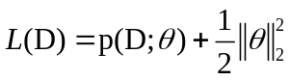
We need to maximize the object function

3.2
(a)Posterior probabilities are:
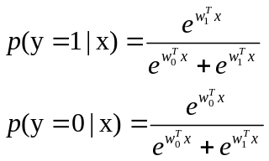
(b)stay unchanged:
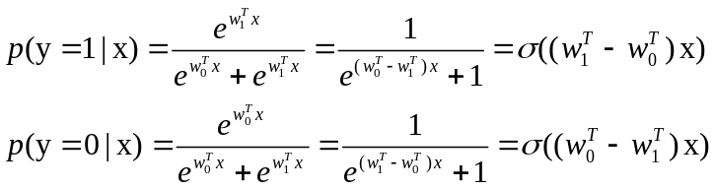
If we add a constant vector b to both weight vectors, the above equations will stay unchanged because 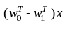 is constant.

(c ) suppose:
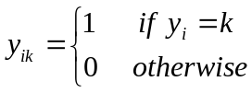
After Adding the regularization, we get
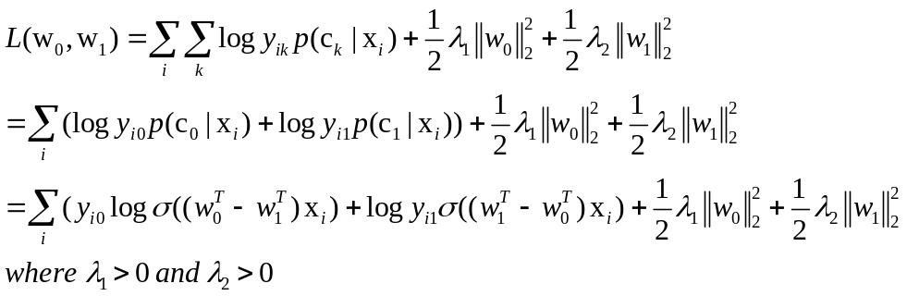

Let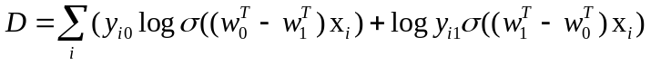
Then 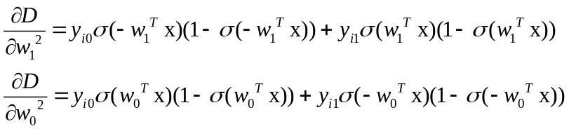
Both of them are convex (Hessian Metrix).

L is a strictly convex function, because the first term is convex, the second term and third term is strictly convex. Thus it has a unique solution.

Problem4 Programming
4.3 Implement linear SVM
(a) Report the cross-valiation accuracy and average training time on different C
result\C | 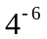 | 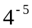 | 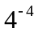 | 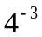 | 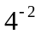 | 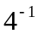 | 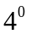 | 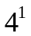 | 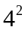
Average accuracy | 0.5300 | 0.7860 | 0.8010 | 0.8000 | 0.7950 | 0.7870 | 0.7880 | 0.7900 | 0.7910
Average Training time | 0.9781 | 0.6813 | 0.7250 | 0.8625 | 1.2250 | 1.1281 | 1.1875 | 1.1469 | 1.1969

When C increases, the averaged accuracy first increases, achieving the maximum, then decreases, and then increases again; the averaged time first decreases, achieving the minimum, then increases, then decreases and increases again. But when optimal averaged accuracy achieved, the averaged training time is also near optimal.
To explain this, C controls the trade-off between errors of the SVM on training data and margin maximization. For large values of C, the optimizer will choose a smaller-margin hyperplane if that hyperplane does a better job of getting all the training points classified correctly. It may overfit and the complexity of the model increases. That is why accuracy increases and training time also increases. Conversely, a very small value of C will cause the optimizer to look for a larger-margin separating hyperplane, even if that hyperplane misclassifies more points. It may underfit and the complexity of this model is smaller. In this case, the accuracy and training time also decreases.
(b) C=4^-4
(c) 0.8543

4.4 Use linear SVM in LIBSVM

result\C
averaged accuracy | 0.5170 | 0.7830 | 0.8040 | 0.8030 | 0.8030 | 0.8030 | 0.8030 | 0.7980 | 0.7960
Averaged Training time | 0.3593 | 0.3281 | 0.2500 | 0.2500 | 0.2343 | 0.3281 | 0.8593 | 2.8437 | 14.5468
(a) The accuracy is different from mine
(b)Generally, it is much faster.

4.5 Use kernel SVM in LIBSVM
(a) Polynomial Kernel
Averaged accuracy:

degree\C |  |  |  |  |  |  |  | 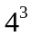 | 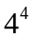 | 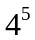 | 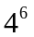 | 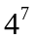
1 | 0.5170 | 0.5170 | 0.7820 | 0.8010 | 0.8050 | 0.8000 | 0.8020 | 0.8030 | 0.7980 | 0.7960 | 0.7970 | 0.7960
2 | 0.5170 | 0.5170 | 0.5170 | 0.6530 | 0.7340 | 0.7130 | 0.7090 | 0.7090 | 0.7090 | 0.7090 | 0.7090 | 0.7090
3 | 0.5170 | 0.5170 | 0.5170 | 0.6180 | 0.7920 | 0.8010 | 0.7990 | 0.7990 | 0.7990 | 0.7990 | 0.7990 | 0.7990
Training time(cputime, win8, ie7, 64):

degree\C
1 | 0.3594 | 0.3438 | 0.3281 | 0.2500 | 0.2188 | 0.2500 | 0.3750 | 1.0469 | 2.6250 | 13.3750 | 43.5938 | 72.7344
2 | 0.3750 | 0.3750 | 0.3750 | 0.3750 | 0.3594 | 0.4688 | 0.4531 | 0.4219 | 0.4375 | 0.4375 | 0.4375 | 0.4375
3 | 0.3750 | 0.3750 | 0.3750 | 0.3594 | 0.3906 | 0.4531 | 0.4063 | 0.4063 | 0.4531 | 0.4063 | 0.3906 | 0.4219

(b)RBF kernel
Averaged accuracy
C\gamma | 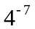
 | 0.5170 | 0.5170 | 0.5170 | 0.5170 | 0.5170 | 0.5170 | 0.5170
 | 0.5170 | 0.5170 | 0.5170 | 0.5170 | 0.5170 | 0.5170 | 0.5170
 | 0.5170 | 0.5170 | 0.5170 | 0.5400 | 0.6080 | 0.5170 | 0.5170
 | 0.5170 | 0.5170 | 0.7400 | 0.8020 | 0.8390 | 0.5170 | 0.5170
 | 0.5170 | 0.7600 | 0.7950 | 0.8230 | 0.8580 | 0.7620 | 0.5700
 | 0.7680 | 0.7900 | 0.8110 | 0.8470 | 0.8800 | 0.7780 | 0.5740
 | 0.7900 | 0.8050 | 0.8240 | 0.8790 | 0.8770 | 0.7780 | 0.5740
 | 0.8000 | 0.8090 | 0.8420 | 0.8770 | 0.8770 | 0.7780 | 0.5740
 | 0.8030 | 0.8110 | 0.8790 | 0.8770 | 0.8770 | 0.7780 | 0.5740
 | 0.8100 | 0.8400 | 0.8750 | 0.8770 | 0.8770 | 0.7780 | 0.5740
 | 0.8070 | 0.8750 | 0.8750 | 0.8770 | 0.8770 | 0.7780 | 0.5740
 | 0.8410 | 0.8740 | 0.8750 | 0.8770 | 0.8770 | 0.7780 | 0.5740

Training time (cputime, win8, ie7, 64):
C\gamma
 | 0.3906 | 0.3906 | 0.4063 | 0.3906 | 0.4063 | 0.4063 | 0.4219
 | 0.3906 | 0.3906 | 0.4219 | 0.3906 | 0.4063 | 0.4063 | 0.4375
 | 0.3906 | 0.3906 | 0.4219 | 0.3906 | 0.4219 | 0.4219 | 0.4219
 | 0.3906 | 0.3906 | 0.4063 | 0.3438 | 0.3594 | 0.4063 | 0.4531
 | 0.3906 | 0.4219 | 0.3281 | 0.2813 | 0.3125 | 0.4219 | 0.4375
 | 0.4063 | 0.3281 | 0.2969 | 0.2500 | 0.3906 | 0.4688 | 0.5000
 | 0.3281 | 0.2656 | 0.2500 | 0.2969 | 0.4063 | 0.4844 | 0.4688
 | 0.2656 | 0.2344 | 0.2813 | 0.4063 | 0.3906 | 0.4375 | 0.4375
 | 0.2500 | 0.2656 | 0.5000 | 0.4063 | 0.4531 | 0.4844 | 0.4531
 | 0.2813 | 0.4688 | 0.6094 | 0.4063 | 0.3906 | 0.4531 | 0.4531
 | 0.4844 | 1.1406 | 0.5938 | 0.4063 | 0.3906 | 0.4375 | 0.4531
 | 1.1250 | 1.5469 | 0.5938 | 0.4219 | 0.3906 | 0.4375 | 0.4531

I will choose the RBF kernel, C=4 and gamma=
Test accuracy is 90.4368%

