Machine Learning

HW4

YUN LI 6035800416

1 Boosting

1.a Gradient Calculation
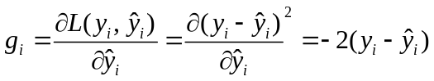

1.b Weak Learner Selection
To compute the optimal value of the step size , we first compute the gradient of 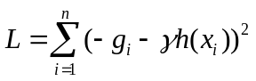 :
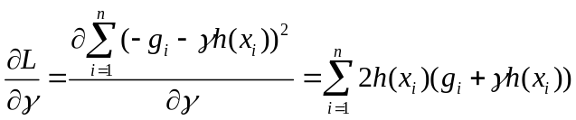
Let the gradient equals to zero, we get the optimal:
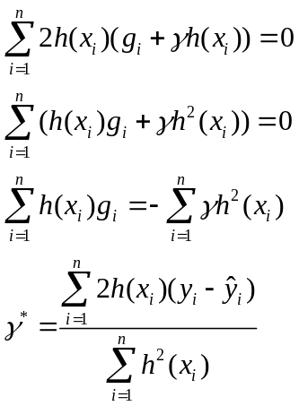
Once we have the optimaland replace it in the original formula, the selection of 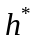 will be derived independent of .

1.c Step Size Selection
To compute the optimal value of the step size , we first compute the gradient of 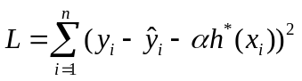 :
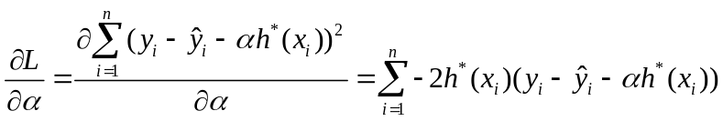
Let the gradient equals to zero, we get the optimal:

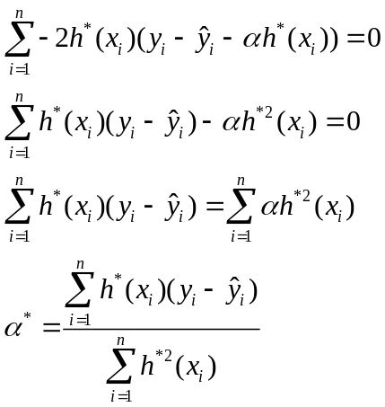

2 Neural Network
2.a. Prove
Suppose there are D inputs, M linear-activation hidden layers, K outputs. Suppose 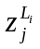 denotes the th node in hidden layer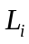, 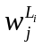denotes the weight, and each hidden layerhasnodes. Then we have 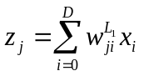 for the first hidden layer. The second layer we have 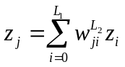… Thus we have :
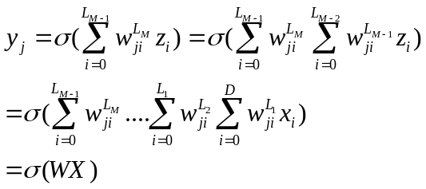
Where 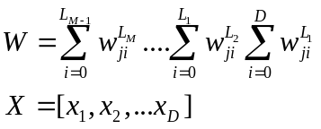

2.b. we have:
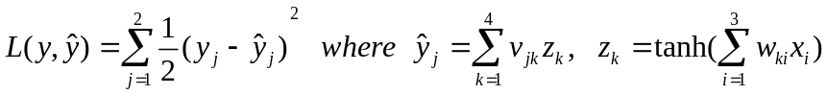
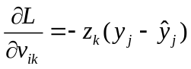
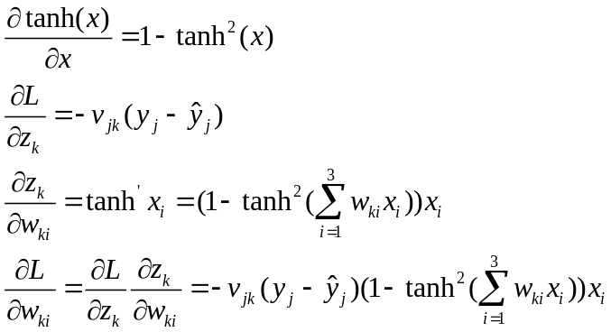

Thus, the update rule is:
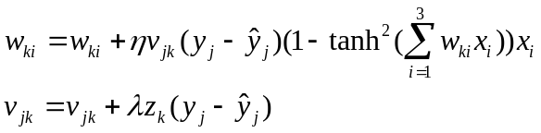

3 Clustering
3.a. Prove:
we take derivatives for D and let it equals to 0 :
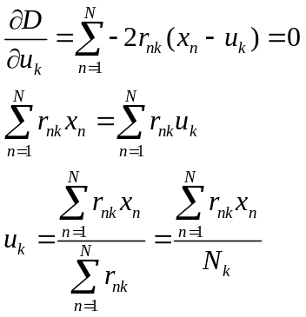

Thus the above equation happens only when 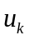 is the mean of all data points assigned to the cluster k.

3.b. In order to prove that optimal is the elementwise median of all data points assigned to the k-th cluster, we firstly prove that, for a given vector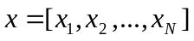(1-D), the optimal that minimize 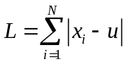 equals to the median of vector x:
Prove:
Suppose is optimal, and there are m numbers on the left of , n numbers on the right of (sorted array). Now let shifts to left by d distance. Then the distance between and any left-hand number will decrease by d, the distance between and any right-hand number will increase by d. The overall distance L will decrease by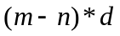( if m>n ) . Similarly, if shifts to right by d, L will decrease by 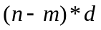( if m< n ). Thus only if m=n, L would achieve the global minimal. In either odd/even case, is the median.
Now we derive the above conclusion to multi-dimensionalities. We can see only when is the elementwise median of cluster k, 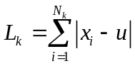 has the minimal value. Suppose there are K clusters, the overall loss 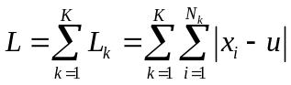 will also be minimal, which equals to 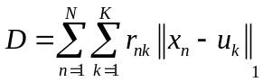

4 Mixture Models
4.a. Log-likelihood:

Incomplete log-likelihood as follows:
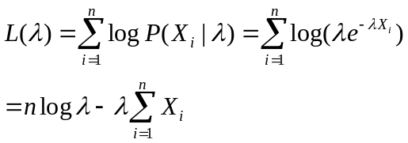

4.b. E-step
We need to find 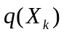:
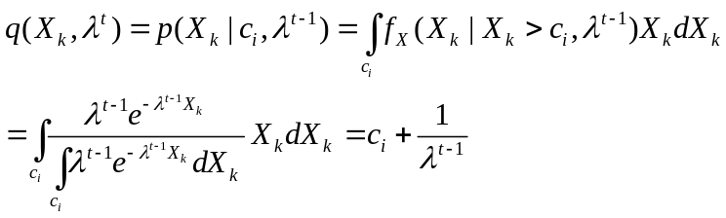

3.c. M-step
In this step, we need to maximize the following equation:
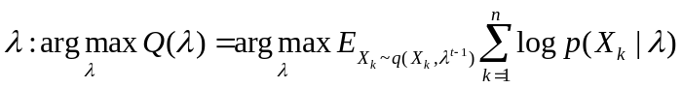
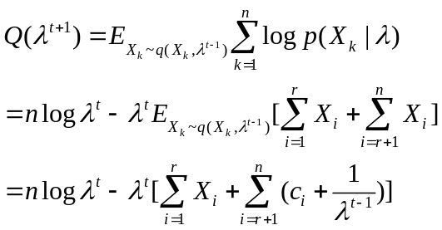
Now, take the derivative, set it to zero and compute the optimal
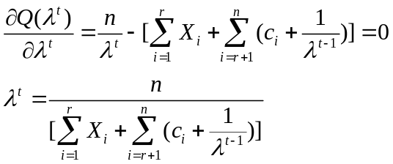

5 Programming
5.2 Implement k-means
5.2.a.
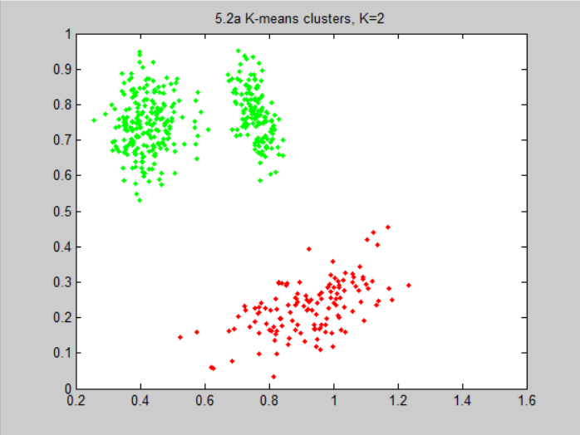
K=2
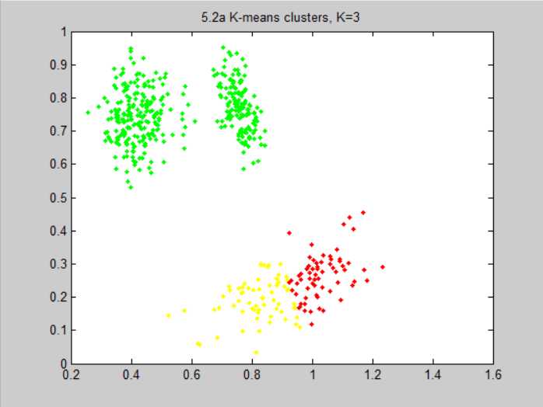
K=3

K=5
5.2.b.
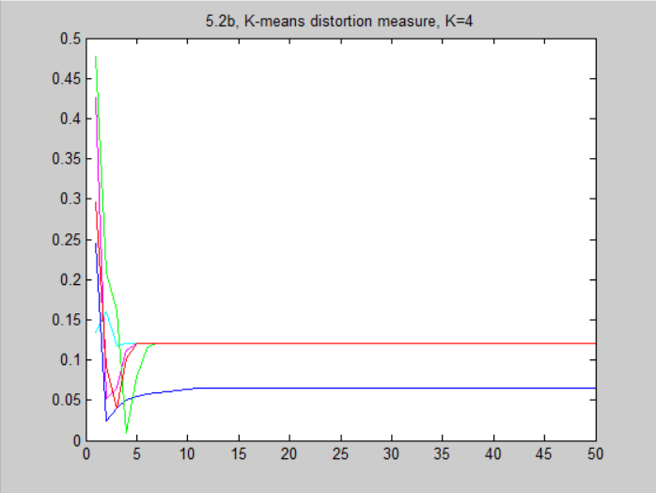

5.2.c. Yes. I will always converge. Because each iterative step necessarily lowers the cost, and the cost monotonically decrease.

5.3 Vector Quantization Using k-mean

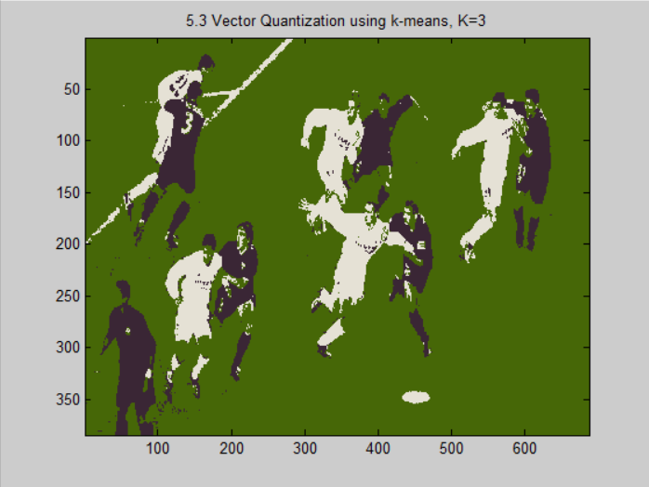
K=3
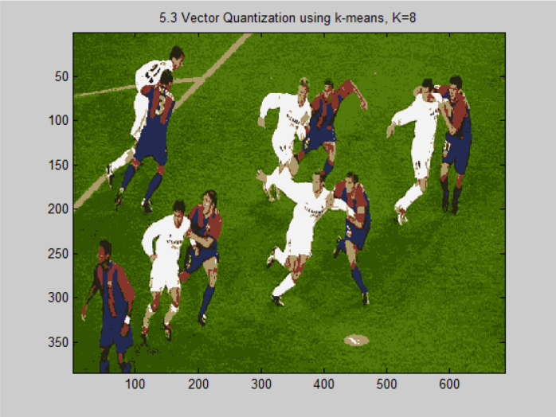
K=8
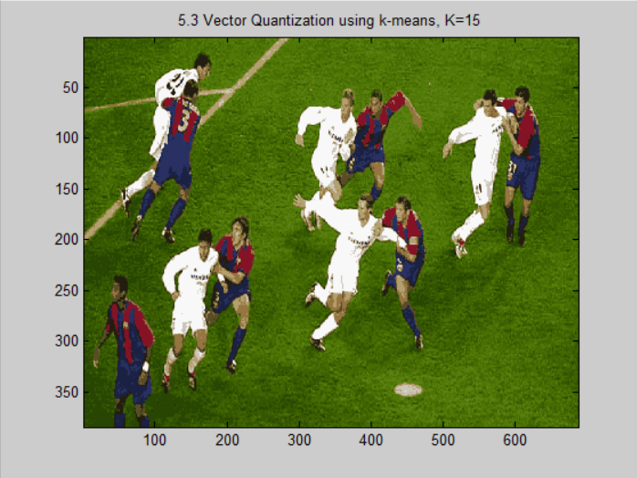

K=15

