Machine Learning

HW5

YUN LI 6035800416

1 Principal Component Analysis
  - Deriving PCA in terms of minimum reconstruction error
- Take derivatives with respect to z and set it to zero:
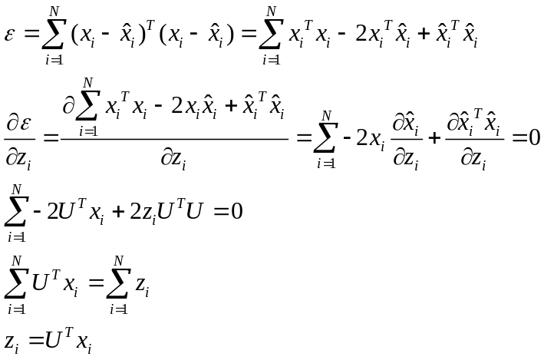

- Take derivatives with respect to u
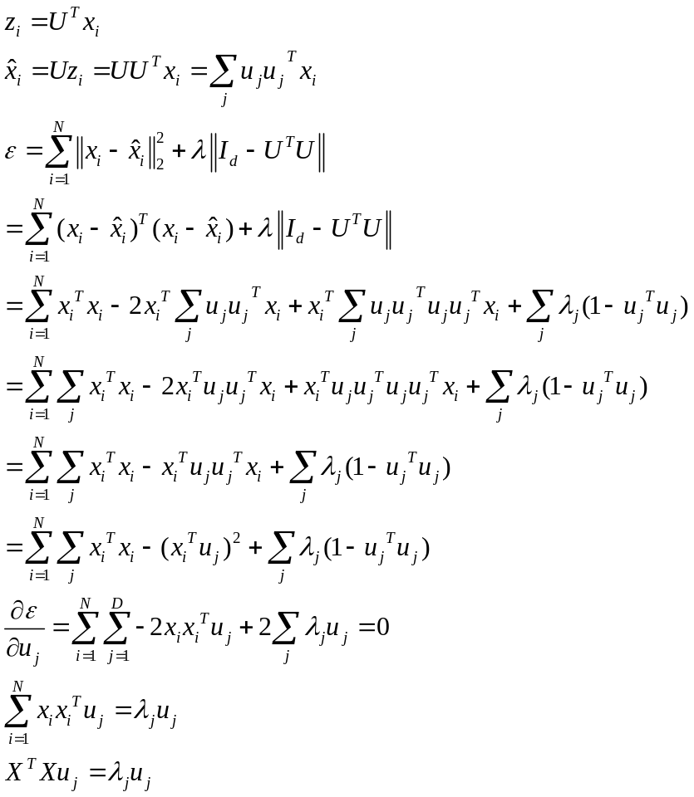
Thus, we can see that the optimal U leads to PCA solution

  - Projecting a Gaussian distribution
- Derive the optimal solution p
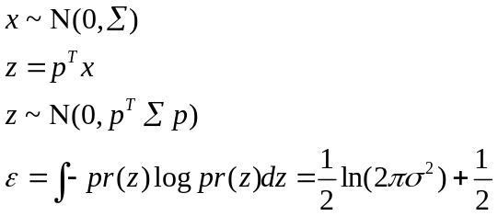
To derive with respect to p, we add a regularizer:
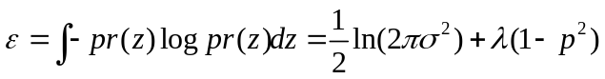
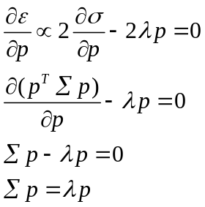
What we get is 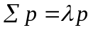, and we solve this expression by computing the eigenvectors and eigenvalues of the matrix .

- Show that p also maximizes the variance of z
To compute optimal p for the variance of z, we define the following functions:
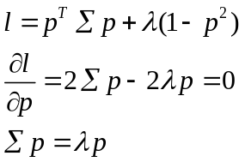
We can see that optimal p also maximize the variance of z

2 Hidden Markov Models
a. probability of the sequence e
Forword Algorithm:
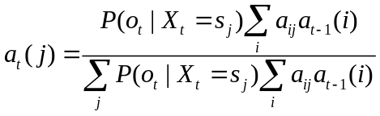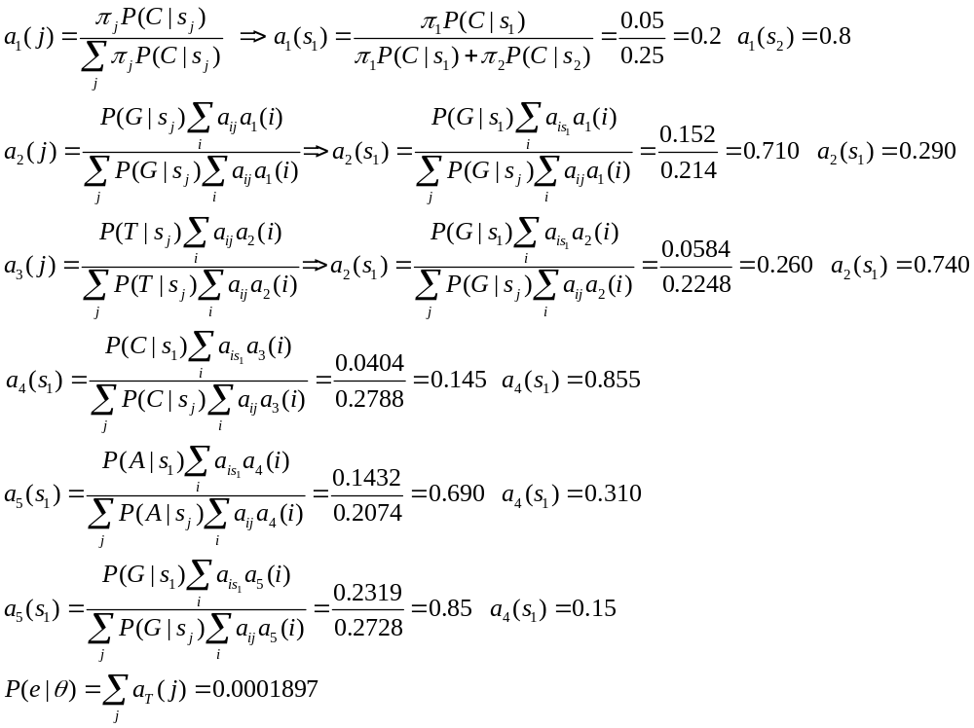Backword Algorithm:
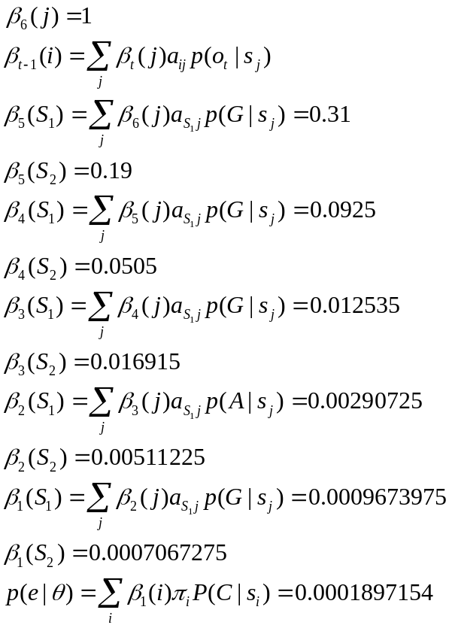
b. Probability for the hidden state Xt to be Si for each time step
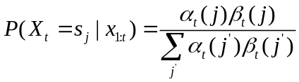
 | 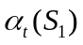 | 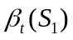 | 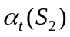 | 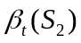 | 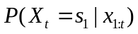 | 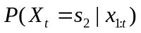
1 | 0.2 | 0.00096739750 | 0.8 | 0.00070672750 | 0.2550 | 0.7450
2 | 0.71 | 0.002907250 | 0.29 | 0.005112250 | 0.5820 | 0.4180
3 | 0.26 | 0.012535 | 0.74 | 0.0169150 | 0.2066 | 0.7934
4 | 0.145 | 0.0925 | 0.855 | 0.0505 | 0.2370 | 0.7630
5 | 0.69 | 0.31 | 0.31 | 0.19 | 0.7841 | 0.2159
6 | 0.85 | 1 | 0.15 | 1 | 0.85 | 0.15

c. Calculate the most likely path of hidden states Xt for emissions e

(1) Calculate independently:
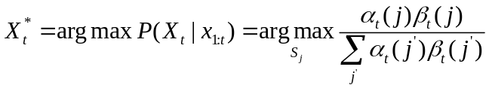
Thus, to use the conclusion from b, we get the most likely path: 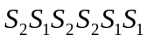
(2) Vitierbi algorithm:
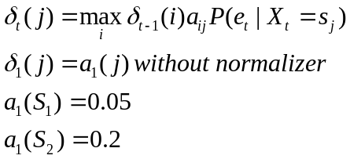
 | 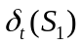 | 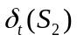
1 | 0.05 | 0.2
2 | 0.014 | 0.014
3 | 0.00098 | 0.00392
4 | 0.0001176 | 0.0010976
5 | 0.0001317 | 7.68e-05
6 | 3.69e-05 | 5.73e-06

Using Viterbi algorithm, the most likely path is 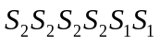
Thus, the sequence of most likely states estimated independently does not necessarily form the most likely path.

- Predict the most likely emitted symbol at the end of sequence e
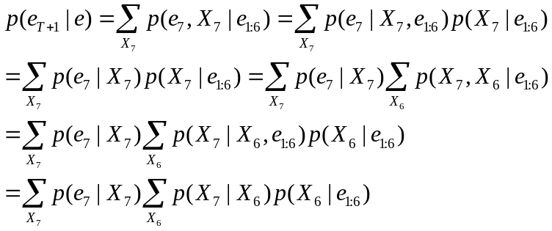
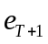 | 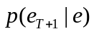
A | 0.2920
C | 0.2080
G | 0.2920
T | 0.2080
So the most likely is A or G

Programming
- Obtain Eigenfaces
 top 1  top2 top3
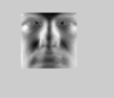top 4 top 5

- Classification

d | C(linear svm) | TestAccuracy(100% linear svm) | AveragedTestAccuracy(100% linear svm) | C(rbf svm) | g(rbf svm) | TestAccuracy(rbf svm) |  | Averaged TestAccuracy(100%rbf svm)
20 | 0.2500 | 100.0000 | 88.6240 | 6.55E+04 | 9.54E-07 |  | 100.0000 | 87.0138
20 | 0.0625 | 100.0000 | 88.6240 | 4.10E+03 | 1.53E-05 |  | 100.0000 | 87.0138
20 | 0.2500 | 100.0000 | 88.6240 | 65536 | 9.54E-07 |  | 99.1667 | 87.0138
20 | 0.2500 | 87.8571 | 88.6240 | 4.00E+00 | 0.00390625 |  | 86.4286 | 87.0138
20 | 0.2500 | 55.2632 | 88.6240 | 2.62E+05 | 9.54E-07 |  | 49.4737 | 87.0138
50 | 0.2500 | 100.0000 | 90.7518 | 1.02E+03 | 0.000244141 |  | 100.0000 | 88.8496
50 | 0.2500 | 100.0000 | 90.7518 | 4.10E+03 | 6.10E-05 |  | 100.0000 | 88.8496
50 | 0.2500 | 100.0000 | 90.7518 | 65536 | 9.54E-07 |  | 100.0000 | 88.8496
50 | 0.2500 | 94.2857 | 90.7518 | 4.00E+00 | 0.00390625 |  | 92.1429 | 88.8496
50 | 0.2500 | 59.4737 | 90.7518 | 4.00E+00 | 0.00390625 |  | 52.1053 | 88.8496
100 | 0.2500 | 100.0000 | 91.1804 | 4.10E+03 | 1.53E-05 |  | 100.0000 | 89.4887
100 | 0.2500 | 100.0000 | 91.1804 | 4.10E+03 | 6.10E-05 |  | 100.0000 | 89.4887
100 | 0.2500 | 100.0000 | 91.1804 | 16384 | 3.81E-06 |  | 100.0000 | 89.4887
100 | 0.2500 | 96.4286 | 91.1804 | 1.60E+01 | 0.00390625 |  | 94.2857 | 89.4887
100 | 0.2500 | 59.4737 | 91.1804 | 4.00E+00 | 0.00390625 |  | 53.1579 | 89.4887
200 | 0.2500 | 100.0000 | 90.8270 | 6.55E+04 | 9.54E-07 |  | 100.0000 | 89.2105
200 | 0.0625 | 100.0000 | 90.8270 | 6.55E+04 | 9.54E-07 |  | 100.0000 | 89.2105
200 | 0.2500 | 100.0000 | 90.8270 | 65536 | 9.54E-07 |  | 100.0000 | 89.2105
200 | 0.2500 | 95.7143 | 90.8270 | 16 | 0.00390625 |  | 95.0000 | 89.2105
200 | 0.2500 | 58.4211 | 90.8270 | 4 | 0.00390625 |  | 51.0526 | 89.2105

