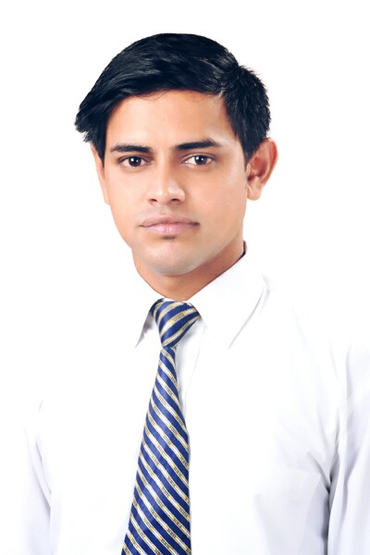

**Rahul Rawat**

**Mobile: +**91 9711744238, 7398782369**~ E-Mail: rahul.rawat25july@gmail.com.**

**Seeking career assignments in Customer Service & operations.**

Location Preference : LUCKNOW

**Professional Snapshots**

* A competent professional seeking career assignment in **Customer Service**, **Airport Security**, **Passenger amenities** etc.
* One year diploma in **Aviation, Hospitality** and **Travel** from **Frankfinn Institute. ( Lucknow )**
* A self decisive person with **Good Communication** and **Customer Service** skills .

**Organisational Experience:**

Worked as a BRANCH manager in BHARAT ENGINEERING COMPANY AT CHARBAGH & ALAMBAGH RAILWAY STATION (Lucknow) (From MARCH 2022 to till date) on CONTRACT basis.

* Look after the Water Supply at Charbagh & Alambagh Railway Station, Lucknow.
* To Handle the **Loaring** and **Unloaring** of all the water pumps at Lucknow station.
* To manage the team and look after the allocation of the staff at Charbagh Railway Station, Lucknow.

Working as a LOGISTIC MANAGER in R CUBE GROUP OF COMPANIES

(Lucknow) From (DEC. 2019 till NOV. 2021).

**Key Deliverables**

* Looking for import and export material all over Uttar Pradesh.
* Arrangement of vehicle’s and driver’s for the office staffs.
* Arrangement of all tour & travels for the staffs.
* Booking tickets & arrangments of Hotels.

Worked as a customer service agent in Indo Saudia Airlines (Lucknow)

From (july 2018 to Nov 2019). CONTRACT BASIS.

* Look after the Checking Counters, Passengers Enquries and Departure.
* Handle the securities, Immigration, GD’s documents Departures crew.
* To look after Arrival baggage, Deportees,Manual PIR ,ULD records.
* Important Announcements during Flight Operation & Updations.

Worked as a Business Excutive in Aeroengineers Vidyapeeth pvt. ltd.(Delhi)

From (Dec 2015 to Feb 2017)

* Structure business processes and requirements.
* Researches client organization’s industry and competitive position.
* Assist in the collection and consolidation of required information and data**.**

Worked as a Customer Service Agent in AirIndia Sats for AirIndia.(Delhi)

From (Feb 2014 to Nov 2015)

**Key Deliverables**

* Responsible to handle all passenger during Flight Operation.
* Looking after Deportee’s and Retagging of bags.
* Responsible for Arrival and Departure of AirIndia Flights.
* To look after the passengers connecting flights domestic or international.

Worked as a supervisor in Karvy.(Lucknow)

(Project of central government in contract basis)

From (oct 2012 to june 2013)

**Key Deliverables**

* Supervising team and look after the allocation of the staff.
* Collect and backup of data from the team employees everyday.
* To provide Training regarding the projects & Equipments.

Educational Credentials

* **Graduate from Kanpur University.(Kanpur)**
* **Senior Secondary certificate from UP Board.(Lucknow)**
* **Secondary certificate from UP Board.(Lucknow)**
* **One year diploma in computer application.(Lucknow)**

Summer Training and Internship

#### Cabin Crew training by JET AIRWAYS FLIGHT and also Familiared with INFLIGHT CABIN CREW operations, AIRPORT GROUND HANDLING SERVICES including CHECKIN, SECURITY PROCEDURE and ARRIVAL services.

#### SWIMMING Certificate from FRANKFINN INSTITUTE (Swimming Training Camp) by ELDECO FITNESS, ORKIDE. (Lucknow)

**IT Skills:**

Well versed with Excel, MS Office, Internet Browsers .

**Leisure Activities:**

Listening to Rock Music and Plyaing to Guitar.

**Personal Strengths:**

* Responsible person , Communicative, Patience ,Energetic.

Personal Profile

Father's Name : Mr JP Shastri

Date of Birth : 25 July 1985

Nationality : Indian

Marital Status : Married

Languages : Hindi and English (Professional Proficiency)

Passport : Yes

Address : H.NO-2/142 Lamatinere Purwa Hazratganj ,

Lucknow.

**Date : (Rahul Rawat)**