Starting slenium hub on windows machine

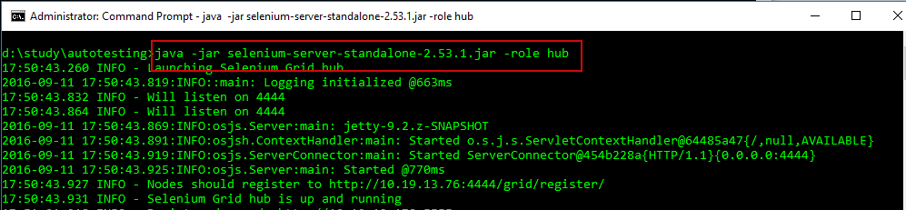

Adding ubuntu linux node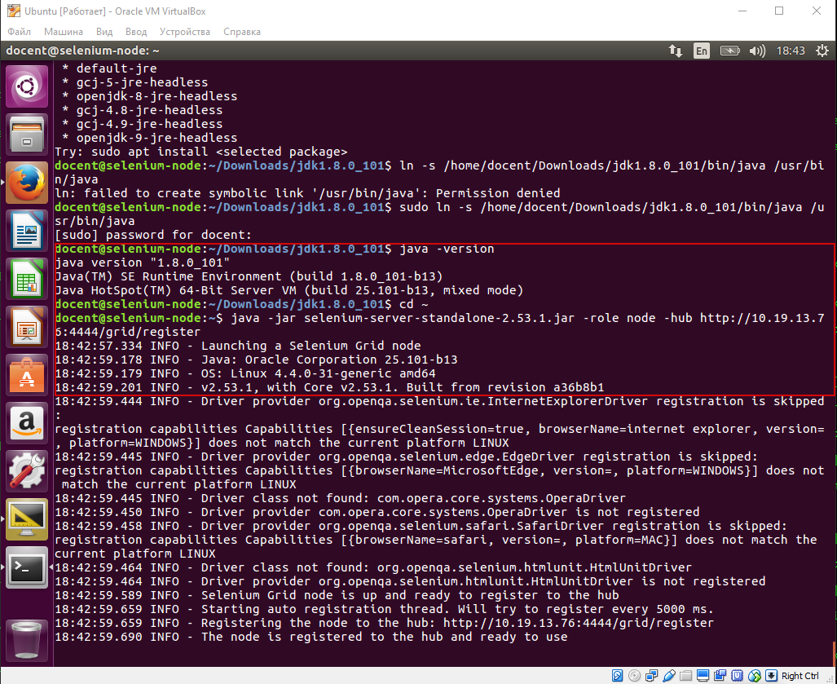

Adding a windows node

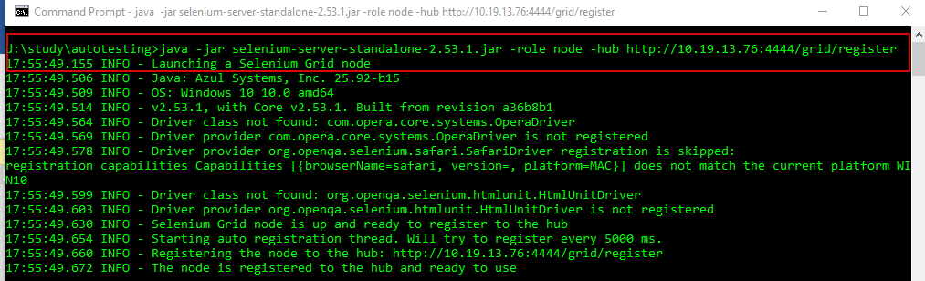

Grid status

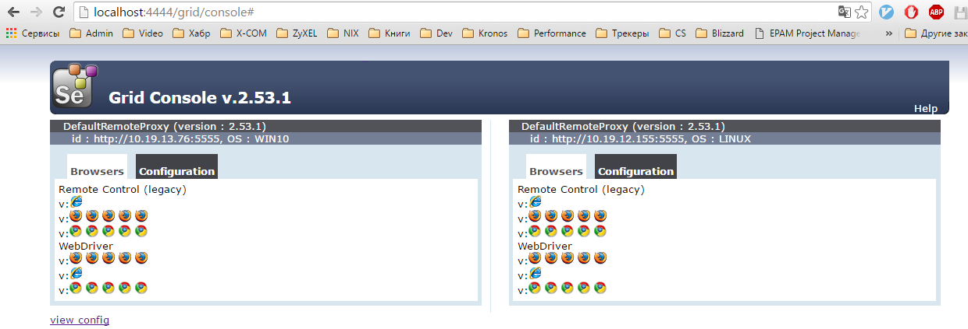

Launching tests on windows node:

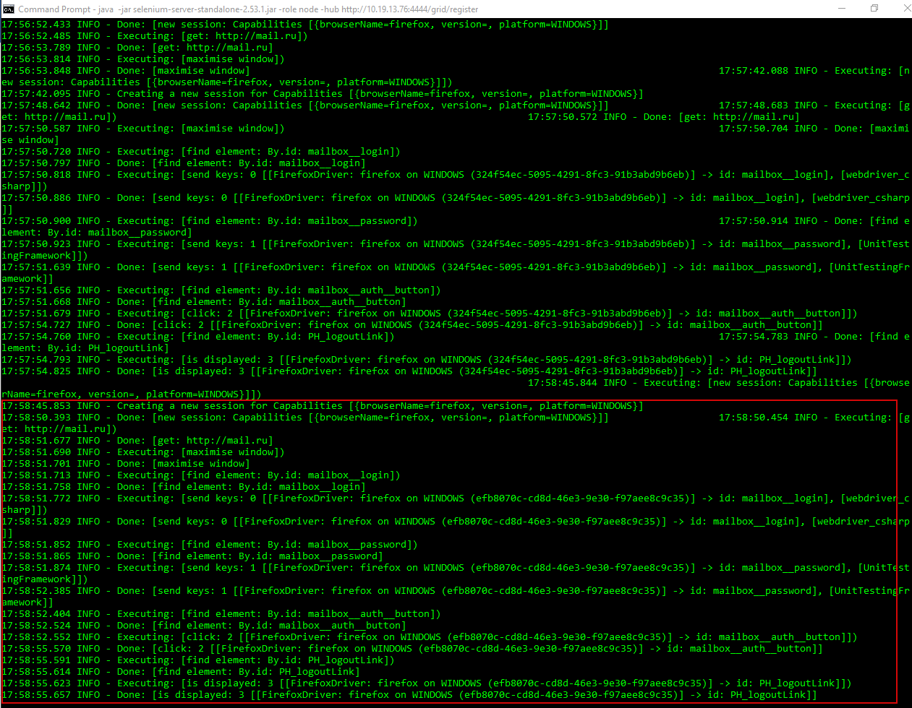

Launching test on linux node:

