CodeBlocks 中使用 SP++

- 将SP++压缩包解压到某一路径下，如D:\Program Files\SP++。

- 打开CodeBlocks，在Settings->Compler and Debugger对话框中选中Search directories选项，在Compiler中加入D:\Program Files\SP++\include，如下图所示：
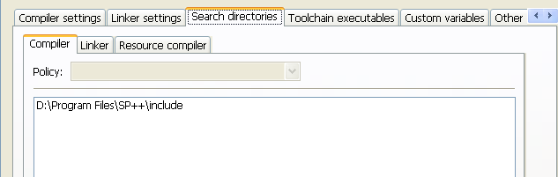

- 同第二步，在Linker中加入D:\Program Files\SP++\lib，如下图所示：
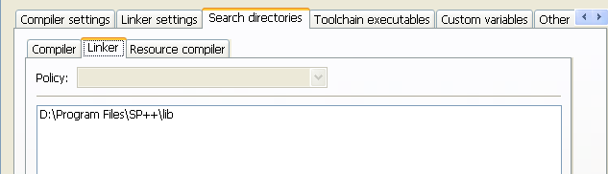

- 在Settings->Compler and Debugger对话框中选中Linker settings选项，在Link libraries中加入D:\Program Files\SP++\libfftw3f.a与D:\Program Files\SP++\libfftw3.a，如下图所示：
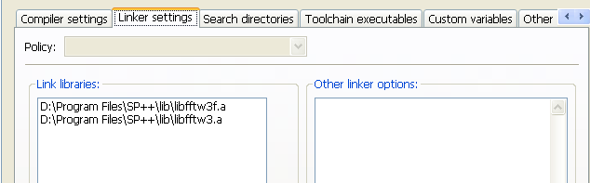

- 在 CodeBlocks 中建立 C++ 工程，例如SP++Test，代码如下：

/**==================================================================
* Steepest descent method testing
*=================================================================*/

#define BOUNDS_CHECK

#include <iostream>
#include "function.h"
#include "steepdesc.h"

using namespace std;
using namespace itlab;

typedef double Type;

int main()
{
ObjFunc<Type> f( 1.0, 1.0, 1.0 );
Vector<Type> x0(2);
x0(1) = 0.5;
x0(2) = 0.5;

SteepDesc< Type, ObjFunc<Type> > steep;
steep.optimize( f, x0 );
if( steep.isSuccess() )
{
Vector<Type> xmin = steep.getOptValue();
int N = steep.getItrNum();
cout << "The iterative number is: " << N << endl << endl;
cout << "The number of function calculation is: " << steep.getFuncNum() << endl << endl;
cout << "The optimal value of x is: " << xmin << endl;
cout << "The minimum value of f(x) is: " << f(xmin) << endl << endl;
cout << "The gradient's norm at x is: " << steep.getGradNorm()[N] << endl << endl;
}
else
cout << "The optimal solution cann't be found!" << endl;

return 0;
}

运行结果如下图所示：
