System Design Assignment
API Design · Rate Limiting · Load Balancing

Date: April 13, 2026
Assignment: System Design — Three Mini-Projects
Stack: Node.js · Express · PostgreSQL · Redis · Docker
Repository: github.com/anynomous001/System-Design

Assignment Overview
This assignment covers three interconnected mini-projects that explore core system design concepts: API design, rate limiting, and load balancing. Each task was approached from a designer's perspective — reasoning about tradeoffs before writing any code.

Task | What was built | Key concept
Task 1 | URL Shortener with PostgreSQL + Redis | API design, caching, data modelling
Task 2 | Rate Limiter middleware (Sliding Window) | Rate limiting, Redis sorted sets
Task 3 | Round Robin Load Balancer + 3 mock servers | Load balancing, reverse proxy

Task 1 — URL Shortener Lite
POST /shorten · GET /:shortId · PostgreSQL + Redis + Prisma

Overview
A lightweight URL shortening service. The most important design question asked first was: which operation is more frequent — shortening (write) or redirecting (read)? The answer is reads, by a large margin. This single insight shaped every architectural decision that followed.

Step 1 — Understanding the Read/Write Ratio
In a real URL shortener, a link is created once but clicked thousands of times. Reads vastly outnumber writes (~8:2 ratio). This means:
- The GET /:shortId path must be as fast as possible.
- The POST /shorten path can afford slightly more work (duplicate detection, hashing).
- A cache layer in front of the database is essential.

Operation | Endpoint | Frequency | Priority
Write | POST /shorten | ~3 out of 10 | Correctness over speed
Read | GET /:shortId | ~8 out of 10 | Speed is critical

Step 2 — Short ID Generation (Base62)
The assignment recommends Base62 encoding. With 6 characters, Base62 gives 62^6 = 56 billion unique combinations. Rather than a random ID, the URL itself is hashed (SHA-256), and the first 48 bits of the hash are encoded as Base62. This provides automatic duplicate detection: the same URL always produces the same hash, and therefore the same short ID.
Code — shortId.js
const crypto = require('crypto');
const BASE62 = '0123456789ABCDEFGHIJKLMNOPQRSTUVWXYZabcdefghijklmnopqrstuvwxyz';

function hashUrl(url) {
return crypto.createHash('sha256').update(url).digest('hex');
}

function toBase62(hexHash, length = 6) {
let num = BigInt('0x' + hexHash.slice(0, 12));
let result = '';
while (result.length < length) {
result = BASE62[Number(num % 62n)] + result;
num = num / 62n;
}
return result.slice(0, length);
}

function generateShortId(urlHash, attempt = 0) {
if (attempt === 0) return toBase62(urlHash);
const salt = crypto.randomBytes(4).toString('hex');
return toBase62(crypto.createHash('sha256').update(urlHash + salt).digest('hex'));
}

Design Decision
Hashing the URL (rather than generating a random ID) means duplicate URLs automatically get the same short link. The hash is also indexed in PostgreSQL so duplicate detection costs only one indexed read.

Step 3 — Data Schema (Prisma + PostgreSQL)
The schema was kept minimal — only fields that serve a direct purpose were included. Access tracking was excluded since no analytics are required.
Code — prisma/schema.prisma
model Url {
id Int @id @default(autoincrement())
shortId String @unique @map("short_id") @db.VarChar(10)
originalUrl String @map("original_url")
urlHash String @unique @map("url_hash") @db.VarChar(64)
createdAt DateTime @default(now()) @map("created_at")
expiresAt DateTime @default(dbgenerated("NOW() + INTERVAL '30 days'")) @map("expires_at")

@@index([shortId]) // critical — every GET /:shortId (8/10 traffic)
@@index([urlHash]) // duplicate detection on POST /shorten
}

Design Decision — Two Indexes
The shortId index is hit on every redirect request. The urlHash index is on the hash rather than the raw URL to avoid performance issues with very long URL strings (2000+ characters).

Step 4 — Storage Architecture (PostgreSQL + Redis)
A two-layer storage architecture was chosen: PostgreSQL for durable storage and Redis as a read-through cache using the Cache-Aside (Lazy Loading) pattern.

GET /:shortId
│
├─► Check Redis cache
│ ├─ HIT → 302 redirect immediately (fast path)
│ └─ MISS → Query PostgreSQL
│ ├─ Not found → 404
│ ├─ Expired → 410 Gone
│ └─ Found → Populate Redis (dynamic TTL) → 302 redirect

Code — Dynamic TTL Synchronisation
// Redis TTL = expires_at − now (dynamic, not a fixed 30 days)
// Prevents cache and database from drifting out of sync after restarts.
const ttlSeconds = Math.floor((record.expiresAt - new Date()) / 1000);
await cache.setEx(`url:${shortId}`, ttlSeconds, record.originalUrl);

Step 5 — API Endpoints
Code — POST /shorten
router.post('/shorten', async (req, res) => {
const { url } = req.body;
const urlHash = hashUrl(url);

// Duplicate check — same URL always returns same short ID
const existing = await prisma.url.findUnique({ where: { urlHash } });
if (existing) return res.json({ shortUrl: '.../' + existing.shortId });

// Generate with collision handling
let shortId, attempt = 0;
while (true) {
shortId = generateShortId(urlHash, attempt);
const conflict = await prisma.url.findUnique({ where: { shortId } });
if (!conflict) break;
attempt++;
}

const record = await prisma.url.create({ data: { shortId, originalUrl: url, urlHash } });
return res.status(201).json({ shortUrl: '.../' + record.shortId, expiresAt: record.expiresAt });
});
Code — GET /:shortId
router.get('/:shortId', async (req, res) => {
const { shortId } = req.params;

// Cache-Aside: Redis first
const cached = await cache.get('url:' + shortId);
if (cached) return res.redirect(302, cached);

// Cache miss — query PostgreSQL
const record = await prisma.url.findUnique({ where: { shortId } });
if (!record) return res.status(404).json({ error: 'Short URL not found' });
if (new Date() > record.expiresAt) return res.status(410).json({ error: 'Expired' });

// Populate cache with dynamic TTL
const ttlSeconds = Math.floor((record.expiresAt - new Date()) / 1000);
await cache.setEx('url:' + shortId, ttlSeconds, record.originalUrl);
return res.redirect(302, record.originalUrl);
});

Testing & Screenshots
curl -X POST http://localhost:3000/shorten \
-H "Content-Type: application/json" \
-d '{"url": "https://web.whatsapp.com/"}'
# { "shortUrl": "http://localhost:3000/VEMizT", "expiresAt": "2026-05-13T..." }

curl -v http://localhost:3000/VEMizT
# → HTTP 302 Location: https://web.whatsapp.com/


URL Shortener UI — https://web.whatsapp.com/ shortened to http://localhost:3000/VEMizT · Expires May 13 2026

Task 2 — Rate Limiter Mini
Sliding Window Counter · Redis Sorted Sets · 5 requests / 60 seconds / IP

Overview
A rate limiter middleware applied globally to all API routes. It restricts each user (identified by IP address) to 5 requests per 60-second sliding window. The implementation uses Redis sorted sets, which work correctly across multiple server instances.

Step 1 — Why Rate Limiting?
Without a rate limiter, a single bad actor can hammer the API with thousands of requests per second, overwhelming the server for all legitimate users.
- Protects system resources from abuse
- Ensures fair usage across all users
- Prevents denial-of-service scenarios

Step 2 — Fixed Window vs Sliding Window
The requirement is "5 requests per minute," but Fixed Window has a well-known boundary exploit: a user can fire 5 requests at T=:59 and 5 more at T=:01, sending 10 requests in 2 seconds while both windows report "within limit."

Fixed Window exploit:
Minute 1: [──────────────── 5 req ──────────────────] allowed
Minute 2: [5 req ───────────────────────────────────] allowed
↑ 10 requests in 2 seconds — NOT rate limited!

Sliding Window fix:
At any moment, look back exactly 60s from NOW.
No matter when requests arrive — always max 5 in any 60s window. ✓

Step 3 — Algorithm using Redis Sorted Set
Each user's requests are stored in a Redis Sorted Set where the score is the request timestamp in milliseconds. This allows efficient range queries to find and remove entries outside the window.

Key: "rl::1" (Sorted Set)
score (timestamp ms) member
────────────────── ──────────────────────
1744558020000 → "1744558020000-0.42"
1744558040000 → "1744558040000-0.87"

On new request at now = 1744558080000:
Step 1: ZREMRANGEBYSCORE key -inf (now-60000) → evict stale entries
Step 2: ZCARD key → count = 2 (within limit)
Step 3: ZADD key now "...new..." → log this request
Step 4: EXPIRE key 60 → auto-cleanup

Step 4 — Implementation
Code — rateLimiter.js
async function rateLimiter(req, res, next) {
const ip = req.ip || req.connection.remoteAddress;
const key = `rl:${ip}`;
const now = Date.now();
const windowStart = now - WINDOW_MS;

// Atomic pipeline — 4 ops run as one Redis transaction
const results = await client.multi()
.zRemRangeByScore(key, '-inf', windowStart)
.zCard(key)
.zAdd(key, { score: now, value: `${now}-${Math.random()}` })
.expire(key, Math.ceil(WINDOW_MS / 1000))
.exec();

const requestCount = results[1];
res.setHeader('X-RateLimit-Remaining', Math.max(0, MAX_REQUESTS - requestCount - 1));

if (requestCount >= MAX_REQUESTS) {
const oldest = await client.zRangeWithScores(key, 0, 0);
const retryAfterSec = Math.ceil(((oldest[0].score + WINDOW_MS) - now) / 1000);
res.setHeader('Retry-After', retryAfterSec);
return res.status(429).json({ error: 'Too Many Requests', retryAfter: retryAfterSec });
}
next();
}

Design Decision — Atomic Pipeline
All four Redis operations run in a multi().exec() pipeline. This ensures they execute atomically — no race conditions between concurrent requests from the same IP.
Design Decision — Accurate Retry-After
Retry-After is calculated from the oldest entry in the sorted set, not a fixed 60s. If the first request was 40 seconds ago, the retry is 20 seconds — not 60.
Design Decision — Redis over In-Memory Dictionary
An in-memory dictionary only works on a single server. With a load balancer, each server would see only a fraction of the real request count. Redis as shared state solves this completely.

Testing & Screenshots
for i in 1 2 3 4 5; do curl -s -D - http://localhost:4000/api/hello | grep Remaining; done
# X-RateLimit-Remaining: 4
# X-RateLimit-Remaining: 3
# X-RateLimit-Remaining: 2
# X-RateLimit-Remaining: 1
# X-RateLimit-Remaining: 0

curl http://localhost:4000/api/hello
# { "error": "Too Many Requests", "retryAfter": 47 }

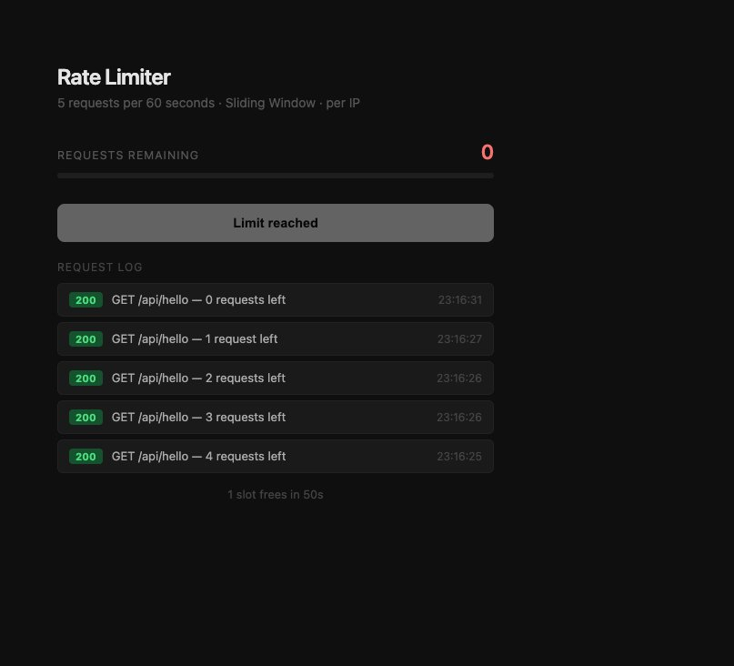
Rate Limiter — 5 requests consumed (HTTP 200, quota draining) · 6th blocked: Limit reached · 1 slot frees in 50s

Task 3 — Load Balancer Simulation
Round Robin · Reverse Proxy · 3 Mock Backends · Health Checks every 10s

Overview
A Round Robin load balancer that acts as a reverse proxy, distributing incoming requests across 3 mock backend servers. The user never interacts with backends directly — all traffic flows through the load balancer on port 8080.

Step 1 — Why Load Balancing?
- Single server gets overwhelmed as traffic grows
- Response times increase for all users
- A crash takes down the entire service
A load balancer spreads traffic across multiple servers so no single server bears the full load, enabling horizontal scaling.

Step 2 — Round Robin Algorithm
Round Robin is the simplest load balancing strategy. Requests are distributed to servers one-by-one in rotation. After the last server, it cycles back to the first. The entire algorithm requires just one piece of state: a counter.

Request counter: 0 1 2 3 4 5 6 ...
Server selected: S1 S2 S3 S1 S2 S3 S1 ...

Formula: server = servers[ counter % totalServers ]

Request # | Formula (counter % 3) | Server Selected
Request 1 | 0 % 3 = 0 | Server 1
Request 2 | 1 % 3 = 1 | Server 2
Request 3 | 2 % 3 = 2 | Server 3
Request 4 | 3 % 3 = 0 | Server 1 (cycles back)

Step 3 — Implementation
Code — getNextServer()
let requestCounter = 0;

function getNextServer() {
const healthyServers = servers.filter((s) => s.healthy);
if (healthyServers.length === 0) return null;
const server = healthyServers[requestCounter % healthyServers.length];
requestCounter++;
return server;
}

Design Decision — Filter Healthy Servers First
Round Robin runs on the healthy subset only. If Server 2 goes down, traffic distributes between Server 1 and Server 3 automatically — the dead server is never selected.
Code — Reverse Proxy Route
app.use((req, res) => {
const server = getNextServer();
if (!server) return res.status(503).json({ error: 'Service Unavailable' });

res.setHeader('X-Served-By', `Server-${server.id}`);
server.requests++;
proxy.web(req, res, { target: server.url });
});
Code — Health Checks
async function checkHealth(server) {
try {
const res = await fetch(server.url, { signal: AbortSignal.timeout(2000) });
server.healthy = res.ok || res.status < 500;
} catch {
server.healthy = false; // timeout or connection refused
}
}
setInterval(() => servers.forEach(checkHealth), 10_000);

Testing & Screenshots
for i in 1 2 3 4 5 6; do curl -s http://localhost:8080/_lb/send; done
# { "routedTo": 1, "requestNumber": 1 }
# { "routedTo": 2, "requestNumber": 2 }
# { "routedTo": 3, "requestNumber": 3 }
# { "routedTo": 1, "requestNumber": 4 } ← cycles back
# { "routedTo": 2, "requestNumber": 5 }
# { "routedTo": 3, "requestNumber": 6 }

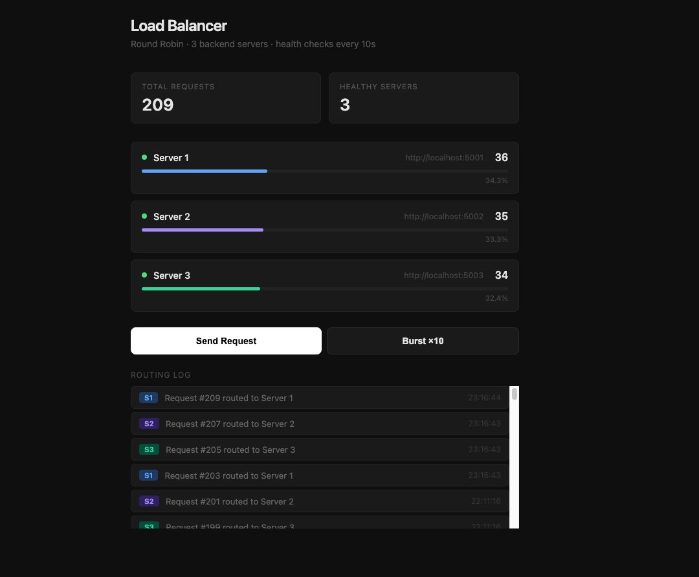
Load Balancer — 209 total requests · Round Robin cycling S1→S2→S3 · Even distribution: 34.3% / 33.3% / 32.4% · All 3 servers healthy

Final Notes

Key Learnings
- Read/write ratio is the most fundamental question in system design. Identifying that URL shortener reads vastly outnumber writes shaped every decision — the caching layer, the index strategy, and the two-layer storage architecture.
- The Cache-Aside pattern is one of the most practical caching strategies. Check cache → on miss, fetch DB → populate cache. Simple, effective, and avoids cache stampedes on cold starts.
- Sliding Window rate limiting eliminates the Fixed Window boundary exploit. At any moment, the window covers the most recent 60 seconds from now — no user can double their effective rate at boundaries.
- Redis sorted sets are a natural fit for time-series rate limiting. Scoring entries by timestamp enables efficient range removal (ZREMRANGEBYSCORE) and instant counts (ZCARD) in a single atomic pipeline.
- A load balancer is fundamentally a reverse proxy. It shields backend servers from direct exposure, enables horizontal scaling, and routes around failed servers transparently.
- Modulo arithmetic is an elegant solution for Round Robin rotation. servers[counter % n] cycles infinitely through any number of servers with a single incrementing integer.
- Dynamic TTL calculation prevents cache/database drift. Setting Redis TTL to expiresAt minus now ensures both layers expire at exactly the same time, regardless of when data was cached.
- Accurate Retry-After improves user experience. Anchoring the retry countdown to the oldest request in the window — not a fixed 60s — tells users the real wait time.

Challenges Faced and Solutions

Challenge | Solution
Port conflict — another Redis container already using port 6379 | Assigned separate ports (6380 for URL shortener, 6381 for rate limiter) in docker-compose.yml
Rate limiter Retry-After was hardcoded to 60s — inaccurate for mid-window blocks | Used ZRANGEWITHSCORES to fetch the oldest entry and calculate the real remaining window time
Load balancer status endpoint intercepted by the catch-all proxy route | Registered status and send endpoints before app.use() so Express matches them first
Redis cache and PostgreSQL TTLs drifting out of sync after cache restarts | Switched to dynamic TTL: expiresAt minus Date.now(), recalculated on every cache population
Short ID hash collisions producing duplicate shortIds | Added retry loop: on collision, salt the hash with random bytes and regenerate until unique

System Design Assignment · April 2026

