VOYA BAREFOOT
STORE REDESIGN & CRO SPECIFICATION
Structured master document — strategy, UX, content, visual system, CRO, Shopify components and implementation
Version 2.0 • September 2026
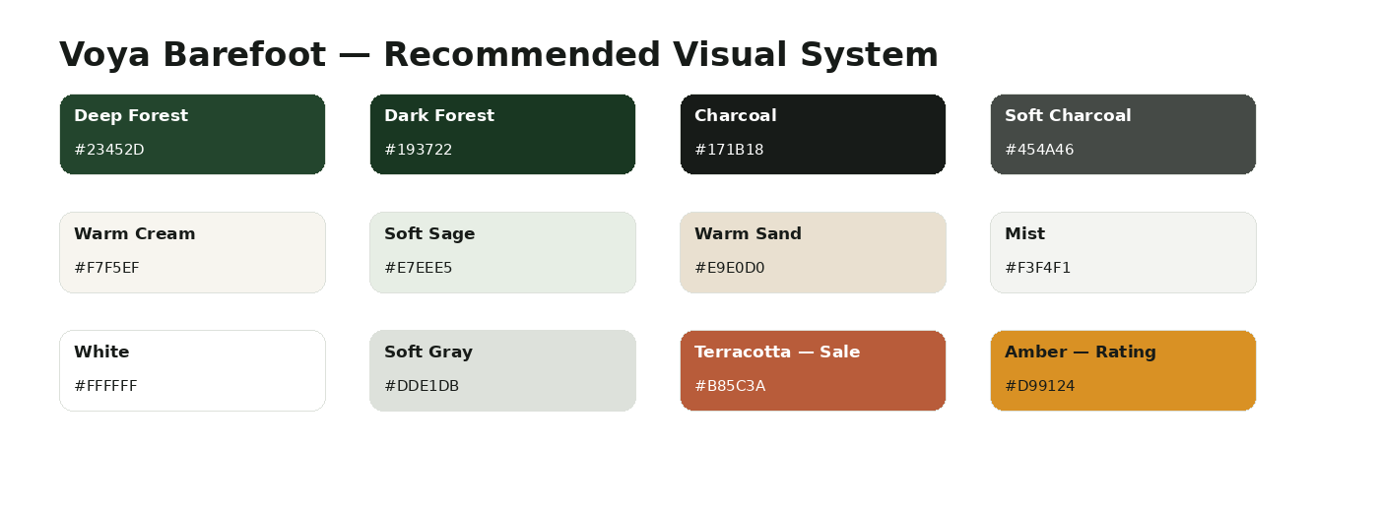
Document intent
This version consolidates and restructures the full redesign information into one implementation-oriented SPEC. Visual diagrams are included to make the intended information architecture and design direction easier for design, Shopify, content and development teams to execute.

1. Executive Summary
Voya Barefoot should be redesigned as a guided barefoot-footwear shopping experience rather than a large product catalog. The core conversion problem is not simply lack of products or reviews; it is decision friction: customers must understand barefoot benefits, choose the right use case, trust the fit, and select among many products before purchase.
The recommended system uses a consistent funnel: Attention → Problem → Education → Solution → Product → Proof → Trust → Decision → Purchase.
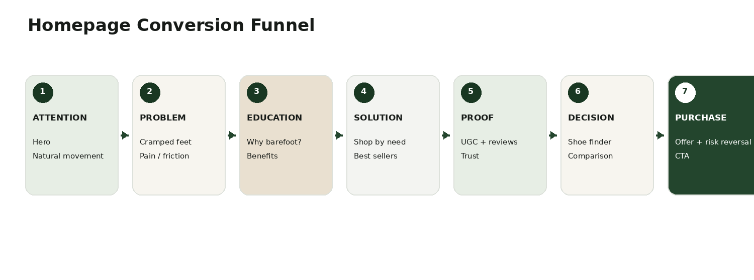
Area | Current | Target | Primary issue
Overall store | 64/100 | 85+ | Inconsistent merchandising and decision guidance
Brand positioning | 62/100 | 85 | Functional claims are stronger than emotional/lifestyle positioning
Homepage | 67/100 | 88 | Needs stronger storytelling and guided discovery
Main collection | 53/100 | 85 | Large catalog creates choice overload
Product page | 68/100 | 90 | Needs stronger proposition, fit confidence and storytelling
Product proposition | 61/100 | 85 | Benefits need clearer differentiation
Trust / social proof | 78/100 | 90 | Strongest existing asset; needs better placement/mining
Offer / pricing | 65/100 | 82 | Offer can support AOV without becoming the brand
UX / shopping | 62/100 | 88 | Need better filtering, comparison and fit support
Meta landing readiness | 54/100 | 90 | Ad angle and landing message should match more tightly
Highest-priority work
P0: rebuild main collection merchandising, rebuild the Mirox PDP, and create ad-angle-specific landing pages. P1: strengthen positioning, homepage storytelling, review mining and fit UX. P2: bundles/AOV, Shoe Finder and comparison.

2. Current Store Snapshot
The current site was re-checked against the live Voya Barefoot pages in September 2026. The barefoot-shoe collection currently exposes 69 products, while the broader shop/all pages expose larger catalogs. The Mirox PDP currently shows strong review proof and several functional benefit claims.
Observed area | Current evidence | Design implication
Main barefoot collection | 69 products listed; many color/variant-style entries appear in the grid. | Group product families and organize discovery by use case, fit and need.
Mirox PDP | Current /products/starstride resolves to a Mirox product page; $79.99 shown on the current canonical page. | Verify URL/product naming consistency and make the hero proposition explicit.
Reviews | Current Mirox page shows 4.7/5 from 66 reviews on the canonical page. | Turn review themes into structured proof, filters and creative hooks.
Product benefits | Claims include developed with orthopedists, all-day comfort, easy-clean/slip-resistant and free/easy returns. | Keep claims evidence-based and visually explain what the customer gets.
Shipping / returns | Current PDP states 30-day returns and region-specific shipping windows. | Move risk-reversal closer to purchase decision.
Brand story | About page emphasizes minimalist functional footwear, natural movement, wide toe box, thin soles, natural comfort and zero-drop heel. | Translate technical philosophy into a simple customer-facing emotional promise.
Important content QA
The supplied /products/starstride URL has been observed as Mirox on the current live page. Earlier page variants also surfaced StarStride/Mirox naming. Before redesign implementation, audit handles, product titles, canonical URLs, redirects, feeds and ad URLs so customers never see conflicting product identities.
Current live sources: Voya Barefoot Barefoot Shoes collection, Mirox product page and About Us page.
Sources: https://voyabarefoot.com/collections/barefoot-shoes • https://voyabarefoot.com/products/starstride • https://voyabarefoot.com/pages/about-us

3. ICP, Audience and Positioning

3.1 Primary ICP
Health-conscious, active adults — especially a comfort-seeking 35–55 segment — who spend significant time walking or standing and want lightweight, flexible footwear with more toe room while still looking like a modern everyday sneaker.
Audience segment | Need | Barrier | Recommended message
Comfort Seekers | All-day comfort, more room, less shoe awareness | May not understand barefoot | Give Your Feet Room to Move.
Active Adults | Flexibility, grounded feel, lightweight movement | Compare against performance shoes | Move naturally without giving up everyday style.
Travelers | Lightweight, versatile, comfortable for long days | Need confidence before travel | One lightweight pair for walks, travel and everyday life.
Barefoot Enthusiasts | Natural movement, wide toe box, zero drop | Already category-aware | Barefoot construction made for everyday life.
Foot-comfort seekers | Room, flexibility, easy wear | May respond to health claims | Lead with comfort and product design; avoid unsupported medical promises.

3.2 Emotional insight
Core customer thought
“I want my feet to feel better, but I don't want ugly orthopedic shoes.”
This means Voya should not make “foot health” the entire identity. Functional design is the reason to believe; freedom and natural movement are the emotional territory; modern everyday style keeps the product relevant to mainstream buyers.

3.3 Positioning
Layer | Recommendation
Brand promise | Give Your Feet Room to Move.
Functional value | More toe room + flexible sole + lightweight construction.
Emotional value | Freedom, comfort and a more natural-feeling stride.
Lifestyle value | A modern everyday sneaker that does not look overly orthopedic.
Reason to believe | Barefoot/minimalist construction, wide toe box, flexible sole, zero-drop positioning where product specs support it.
Category language | Use “barefoot” as the product technology/category; use “natural movement” and “room to move” for broader customer-facing communication.

4. Customer Journey & Conversion Logic
Stage | Customer question | Site response
Attention | Why should I care? | Hero promise + recognizable pain point
Problem | What is wrong with normal footwear? | Cramped-toe / constrained-feet education
Education | What is barefoot footwear? | Simple visual explanation
Solution | Which type is right for me? | Shop by need / use case
Product | Why this shoe? | Clear proposition + benefits + demonstration
Proof | Does it actually work for people like me? | Reviews, UGC, real use cases
Trust | What if the fit is wrong? | Fit guide, returns, shipping, payment trust
Decision | Which model should I buy? | Comparison + Shoe Finder
Purchase | Is there a reason to buy now? | Transparent offer, bundle value and strong CTA

5. Homepage SPEC
Homepage objective: establish the category, create desire, reduce skepticism, route the visitor to the correct use case, and then hand the visitor to a high-intent product or collection.

Section | Purpose | Recommended content
Announcement Bar | Immediate trust/offer | Free shipping, 30-day guarantee, or truthful current offer.
Navigation | Fast orientation | Barefoot Shoes, Winter Boots, Kids, Shop, About; add search and cart.
Hero | Create desire | Eyebrow: NATURAL MOVEMENT. EVERYDAY COMFORT. H1: Give Your Feet Room to Move.
Trust Bar | Reduce risk | Wide Toe Box / Flexible Sole / Lightweight / All-Day Comfort where supported.
Problem | Create recognition | Your Feet Weren't Made to Be Squeezed.
Why Barefoot? | Educate | Wide Toe Box, Flexible Sole, Zero Drop, Lightweight.
Shop by Need | Route intent | Everyday, Walking & Travel, Active & Training, Outdoor & Trail, Casual Style.
Best Sellers | Reduce choice | 4–5 hero products, with use-case labels and review proof.
Why Voya? | Differentiate | Natural movement + modern style + comfort + trust.
UGC / Customer Stories | Proof | Real customer photos/videos and real language.
Review Highlights | Reassure | Comfort, fit, lightweight, toe room, everyday use themes.
Shoe Finder | Decision aid | ~30-second quiz.
Brand Story | Meaning | Why barefoot, how Voya designs, what the brand believes.
Bundle / Offer | Increase AOV | 1 pair / 2 pair / 3 pair value structure where operationally supported.
FAQ | Remove objections | Sizing, transition, shipping, returns, care, use cases.
Final CTA | Close | Ready to Give Your Feet More Room?

5.1 Hero copy direction
Recommended hero
Eyebrow: NATURAL MOVEMENT. EVERYDAY COMFORT.
H1: Give Your Feet Room to Move.
Supporting copy: Comfortable, stylish barefoot shoes designed for everyday life. More freedom for your feet. A more natural way to move.
Primary CTA: Shop Best Sellers
Secondary CTA: Why Barefoot?

6. Main Collection SPEC
The main collection is the largest merchandising opportunity. The current collection exposes 69 products, so the goal is not simply to improve the grid; it is to turn the catalog into guided discovery.
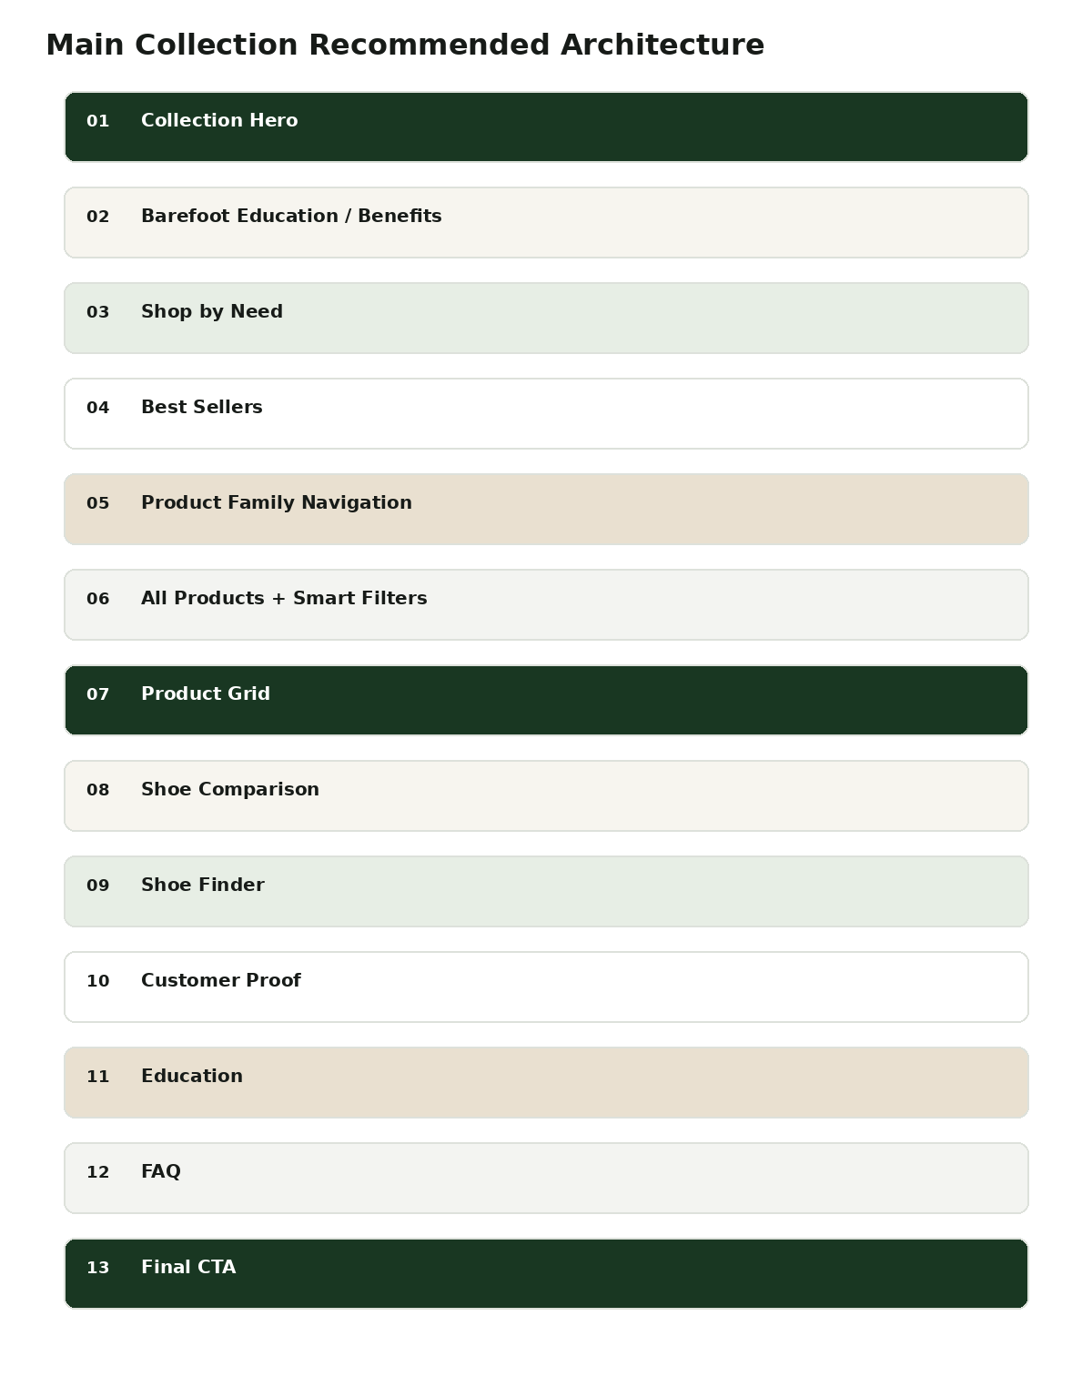
Section | Requirement
Collection Hero | Headline: Barefoot Shoes Made to Move Naturally. Supporting copy should explain who the collection is for.
Education | Show Wide Toe Box, Flexible Sole, Zero Drop and Lightweight with simple diagrams.
Shop by Need | Everyday, Walking, Active, Outdoor, Travel, Casual.
Best Sellers | Curated first choice for low-awareness visitors.
Product Family Nav | Group variants/colors into product families where Shopify data supports it.
Smart Filters | Use, Style, Fit, Features, Season, Price.
Product Cards | Image, meaningful badge, name, one-line benefit, rating/reviews, 2–3 benefits, price, compare-at price, swatches, Quick Add/Quick View.
Comparison | Compare Mirox, Solyn, Neuro, FluxTrail or other verified hero products.
Shoe Finder | Help customers choose instead of browsing every SKU.
Proof | Category-specific reviews and UGC.
Education / FAQ | Explain barefoot concepts and category objections.

6.1 Product-card standard
- Do not let color variants visually behave like unrelated products when they are the same family.
- Use customer-oriented labels such as Best for Everyday, Best for Walking, Lightweight, Outdoor, Travel.
- Keep rating and review count visible.
- Use real product photography first; use lifestyle imagery as secondary proof.
- Make Quick Add useful but do not hide the need for size selection or fit guidance.

7. Collection Detail Page SPEC
Intent-specific collection pages should solve one customer problem instead of presenting the entire catalog.
Section | Example — Walking
Hero | WALKING BAREFOOT SHOES — Walk Further. Feel Lighter.
Benefits | Roomy Toe Box, Flexible Sole, Lightweight, All-Day Comfort.
Best Sellers | Category-specific hero products.
Product Grid | Only products that fit the walking intent.
How to Choose | Distance, surface, weather, fit and flexibility.
Comparison | Mirox vs Solyn vs Neuro vs FluxTrail, only using verified attributes.
Use Cases | Daily walks, travel, errands, outdoor.
UGC | Walking/travel customer content.
FAQ | Walking-specific sizing, comfort, transition and care questions.
CTA | Shop Walking Barefoot Shoes.

8. Product Detail Page SPEC
Target: move the current PDP from approximately 68/100 to 90/100 by improving proposition clarity, fit confidence, product demonstration, proof and decision support.
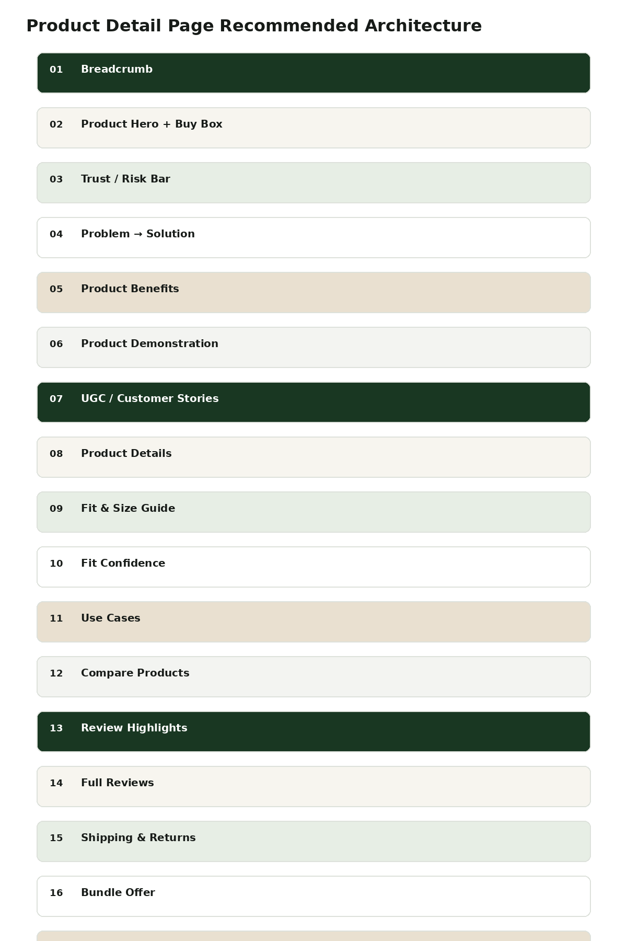
Section | Requirement
Breadcrumb | Clear path back to intent-specific collection.
Hero / Buy Box | Product name, one-line differentiated proposition, rating, benefits, price, variants, size, CTA.
Trust / Risk Bar | Shipping, returns, secure checkout and other verified reassurance.
Problem → Solution | Explain the customer problem before listing features.
Benefits | Translate construction into customer outcomes.
Demonstration | Walking, flex test, toe area, sole, weight and lifestyle use.
UGC | Real customers using the shoe.
Details | Materials, sole, closure, care, construction.
Fit & Size Guide | Foot length/width, measuring instructions, toe-room expectations.
Fit Confidence | Toe room, width, flexibility, cushioning, weight — only if backed by product data.
Use Cases | Walking, travel, errands, active, everyday.
Compare | Show which model is best for which use case.
Reviews | Highlights + full review system with filters.
Shipping / Returns | Close to CTA and decision point.
Bundle | 1 / 2 / 3 pair value where supported.
Related | Next-best product based on intent.
FAQ | Answer objections.
Final CTA | Repeat proposition + purchase action.

8.1 Mirox hero direction
Recommended Mirox hero
H1: Feels Like Barefoot. Looks Like a Sneaker.
Supporting: Lightweight, flexible everyday footwear with a roomy toe area designed for natural-feeling movement.
Proof: 4.7/5 · 66 reviews on the current canonical Mirox page.
Benefits: Roomy Toe Box / Flexible Sole / Lightweight / All-Day Comfort.
CTA: Add to Cart — current price should be dynamically pulled from Shopify.
Reassurance: Free Shipping / 30-Day Returns / Secure Checkout where applicable.

8.2 Current review themes to mine
- Comfort: “Very comfortable”, “all day”, “barely even know you're wearing a shoe.”
- Toe room: customers mention room for toes and wide-toe comfort.
- Lightweight: repeated comments describe the shoes as very light.
- Barefoot feel: customers compare the feel to being barefoot, socks or slippers.
- Style: some customers mention that the shoes are cute, attractive or do not look overly sporty.
- Everyday use: reviews mention errands, walks, work shifts, travel-like activity and light workouts.
- Fit risk: there are also reviews describing sizing as too small or inconsistent. This is a CRO opportunity for clearer fit guidance, not something to hide.
Use review language as a source for hooks, but do not turn anecdotal customer comments into medical claims. Keep health-related statements attributed to customers and consistent with legal/compliance review.

9. Visual Design System
Visual personality: Natural · Premium · Modern · Active · Human
Token | Value | Usage
Primary | #23452D | Primary CTA, active states, key accents
Dark Primary | #193722 | Hover, deep backgrounds
Heading | #171B18 | Headings/product names
Body | #454A46 | Body/UI text
Cream | #F7F5EF | Education/editorial sections
Sage | #E7EEE5 | Benefits/wellness
Sand | #E9E0D0 | Lifestyle/offers
Mist | #F3F4F1 | Cards/UI
White | #FFFFFF | Shopping surfaces
Border | #DDE1DB | Borders/dividers
Sale | #B85C3A | Sale only
Rating | #D99124 | Stars/rating cues

9.1 Typography
Element | Recommendation
Headings / product names / buttons | Manrope
Body / UI | Inter
H1 | 56–64px desktop / 38px mobile, ExtraBold
H2 | 38–44px desktop / 30–32px mobile, Bold
H3 | 22–26px, SemiBold
Body | 16–18px desktop / 15–16px mobile
Small UI | 12–14px, Medium
Eyebrow | 12–14px, uppercase, tracking
Price | 20–22px, Bold
Button | 14–15px, SemiBold

9.2 Design rules
- Green = action.
- Cream / Sage = education and wellness.
- White = shopping.
- Lifestyle photography = emotion.
- Product photography = proof.
- Use restrained shadows and 8–16px image/card radius.
- Pill buttons are acceptable for filters and secondary controls.
- Use one consistent icon family; avoid mixed emoji/icon styles in production.

10. Customer Voice & Creative System
Theme | Hook seed | Where to use
Toe Room | Your feet weren't made to be squeezed. | Hero, collection, Meta landing page
Barefoot Feel | The weirdest thing about these shoes? I forget I'm wearing them. | PDP, UGC, video hook
Lightweight | So light you forget they're there. | Product card, ad, PDP
Comfort | One pair. All day. | Hero, PDP, ads
Style | Barefoot comfort without the orthopedic look. | Hero, lifestyle ads
Creative system should combine real customer language with visual demonstrations. The core reusable atoms are: visual hook, audio hook, problem shot, product reveal, demonstration, transformation, social proof, comparison, authority, emotional story and offer.
Creative atom | Example
Visual hook | Person showing cramped toes / uncomfortable footwear before product reveal.
Problem montage | Quick cuts of pinched toes, long walking day, shoe discomfort.
Product reveal | Show Mirox after problem is established.
Demonstration | Flex sole, show toe area, walking footage, weight/feel if measurable.
Social proof | Verified review overlay + customer video/photo.
Transformation | Normal shoe constraint → roomy flexible barefoot shoe.
Comparison | Conventional shoe shape vs wide toe box.
Offer | Transparent bundle or current offer, never fabricated scarcity.

11. Meta Ads & Landing Page Strategy
Paid traffic should be routed by message match instead of sending every ad to a generic collection.
Ad angle | Landing page | Hero direction
Cramped toes | Wide Toe Box landing page | Give Your Toes More Room.
Barefoot feeling | Barefoot education / hero PDP | Feels Like Barefoot. Looks Like a Sneaker.
All-day comfort | Everyday collection / hero PDP | One Pair. All Day.
Travel | Walking / Travel collection | Lightweight Comfort for Long Days.
Outdoor | Outdoor collection | Move Naturally Outside.
Style | Lifestyle PDP / collection | Barefoot Comfort Without the Orthopedic Look.
Flow: Ad angle → matching hero → proof → product → offer. The landing page should repeat the promise made in the ad within the first viewport, then substantiate it.
Meta landing-page rule
Do not optimize only for click-through rate. Measure landing engagement, product click-through, add-to-cart rate and purchase conversion by angle.

12. Offer, Pricing & AOV
The offer should support conversion and AOV without making the store feel like a permanent discount marketplace.
Layer | Recommendation
Desire | Lead with comfort, freedom and natural movement.
Product | Show why the specific shoe is right.
Proof | Reviews + UGC.
Risk reversal | Shipping + returns + secure payment.
Price | Show current price and truthful compare-at price.
Offer | 1 pair standard; 2 pair savings; 3 pair best value where supported.
AOV | Mix-and-match bundle can be tested if inventory and Shopify logic support it.
Scarcity | Use only truthful inventory-based urgency.
Offer hierarchy: Desire → Product → Proof → Risk Reversal → Price/Offer → Purchase.

13. Shopify Component Architecture
Component | Purpose
AnnouncementBar | Offer/trust message
HeaderNavigation | Primary navigation, search, cart
HeroBanner | Primary promise + CTA
TrustBar | Benefits / reassurance
ProblemSolution | Problem → solution narrative
BarefootBenefits | Education on category benefits
ShopByNeed | Intent routing
BestSellerCarousel | Curated products
ProductFamilyNav | Family/variant grouping
CollectionProductGrid | Product discovery
SmartFilter | Use/fit/style/features/season/price
ProductCard | Decision-ready merchandising unit
ProductQuickView | Low-friction product inspection
ProductComparison | Reduce choice friction
ShoeFinder | Guided product selection
UGCCarousel | Customer proof
ReviewHighlights | Theme-based proof
ReviewGrid | Full review exploration
FitGuide | Sizing confidence
UseCaseCards | Contextualize product
EducationCards | Category education
BundleOffer | AOV
ShippingReturns | Risk reversal
FAQAccordion | Objection handling
FinalCTA | Conversion close

14. CRO Measurement Framework
Page | Primary KPI | Supporting KPIs
Homepage | Hero → product/collection CTR | Best seller CTR, Shoe Finder starts
Collection | PDP CTR | Filter usage, product-card CTR, quick-add rate
PDP | Add-to-cart rate | Gallery engagement, size-guide use, review engagement
Cart | Checkout initiation | AOV, bundle selection, abandonment
Checkout | Purchase conversion | Payment success, refund/return rate
Paid landing | Purchase conversion | Landing engagement, PDP CTR, ATC rate, message match

14.1 Testing roadmap
- Test hero proposition: “Give Your Feet Room to Move” vs use-case-specific variants.
- Test problem-first vs benefit-first section ordering.
- Test Best Sellers before vs after education.
- Test Shoe Finder visibility and entry point.
- Test comparison table on PDP.
- Test 2-pair / 3-pair bundles against single-pair default.
- Test review theme filters such as Comfort, Fit, Walking, Style and Quality.

15. Implementation Roadmap
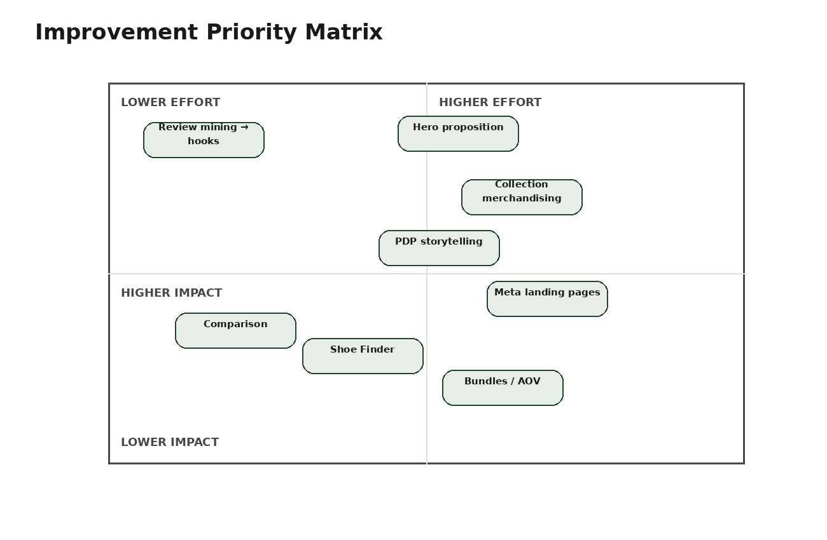
Priority | Workstream | Outcome
P0 | Main collection merchandising | 53 → 85 target
P0 | Mirox PDP redesign | 68 → 90 target
P0 | Meta angle-specific landing pages | ~54 → 90 target
P1 | Brand positioning | 62 → 85 target
P1 | Homepage storytelling | 67 → 88 target
P1 | Review mining → creative system | 78 → 90 target
P1 | Size / fit experience | ~62 → 88 target
P2 | Bundles / AOV | 65 → 82 target
P2 | Shoe Finder | ~53 → 85 target
P2 | Product comparison | ~53 → 82 target

15.1 Suggested delivery sequence
- Week 1: audit product taxonomy, product families, handles, claims, inventory and analytics events.
- Week 2: design system + homepage/collection/PDP wireframes.
- Week 3: build reusable Shopify sections/components.
- Week 4: launch collection + PDP improvements.
- Week 5: launch first message-matched Meta landing pages.
- Week 6+: test bundles, Shoe Finder, comparison and review-theme UX.

16. Definition of Done
Area | Definition
Brand | Customer can explain what Voya stands for in one sentence.
Homepage | Visitor understands the problem, category, benefits and next action without reading the full page.
Collection | Visitor can narrow 69+ products by need/use/fit without feeling overwhelmed.
PDP | Visitor understands why the product is different, whether it fits, what it is for, and why they should trust it.
Reviews | Review proof is structured around customer concerns and remains authentic.
Paid traffic | Ad message and landing hero match within the first viewport.
Offer | Discounts/bundles are transparent and do not replace the core value proposition.
Analytics | All key funnel events are measurable by page, product and campaign angle.
Mobile | All core shopping actions are usable one-handed and key proof appears before purchase friction.

17. Live References & Source Notes
The following live pages were used as current references for the store snapshot:
- https://voyabarefoot.com/collections/barefoot-shoes
- https://voyabarefoot.com/products/starstride
- https://voyabarefoot.com/pages/about-us
The visual product reference used during the audit was the current Mirox-Ash Rose product photography exposed by the live product page. In the production redesign, use the brand's licensed/original assets and real UGC rather than recreating or inventing customer content.
Note: Current prices, inventory, review counts and product availability are dynamic Shopify data. They should be pulled live at implementation time rather than hard-coded into the design.

