1. Cannot add more than 10 Pieces
2. In size chart, the measuring units are missed
3. In size chart, text ->Mens Polo t-shirt's Size Chart > t is in lower case, mens >’ is missed.
4. Need to add the clothes description like> cotton, nylon, polyester.
5. Once the user adds the product into add to cart>In checkout window, provide option for continuing the shopping.
6. Once there are few items in cart, change the icon cart to shade instead of empty.

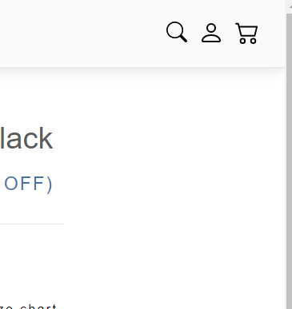

1. NO GST in the bill.> taxes cannot be b4 discount.

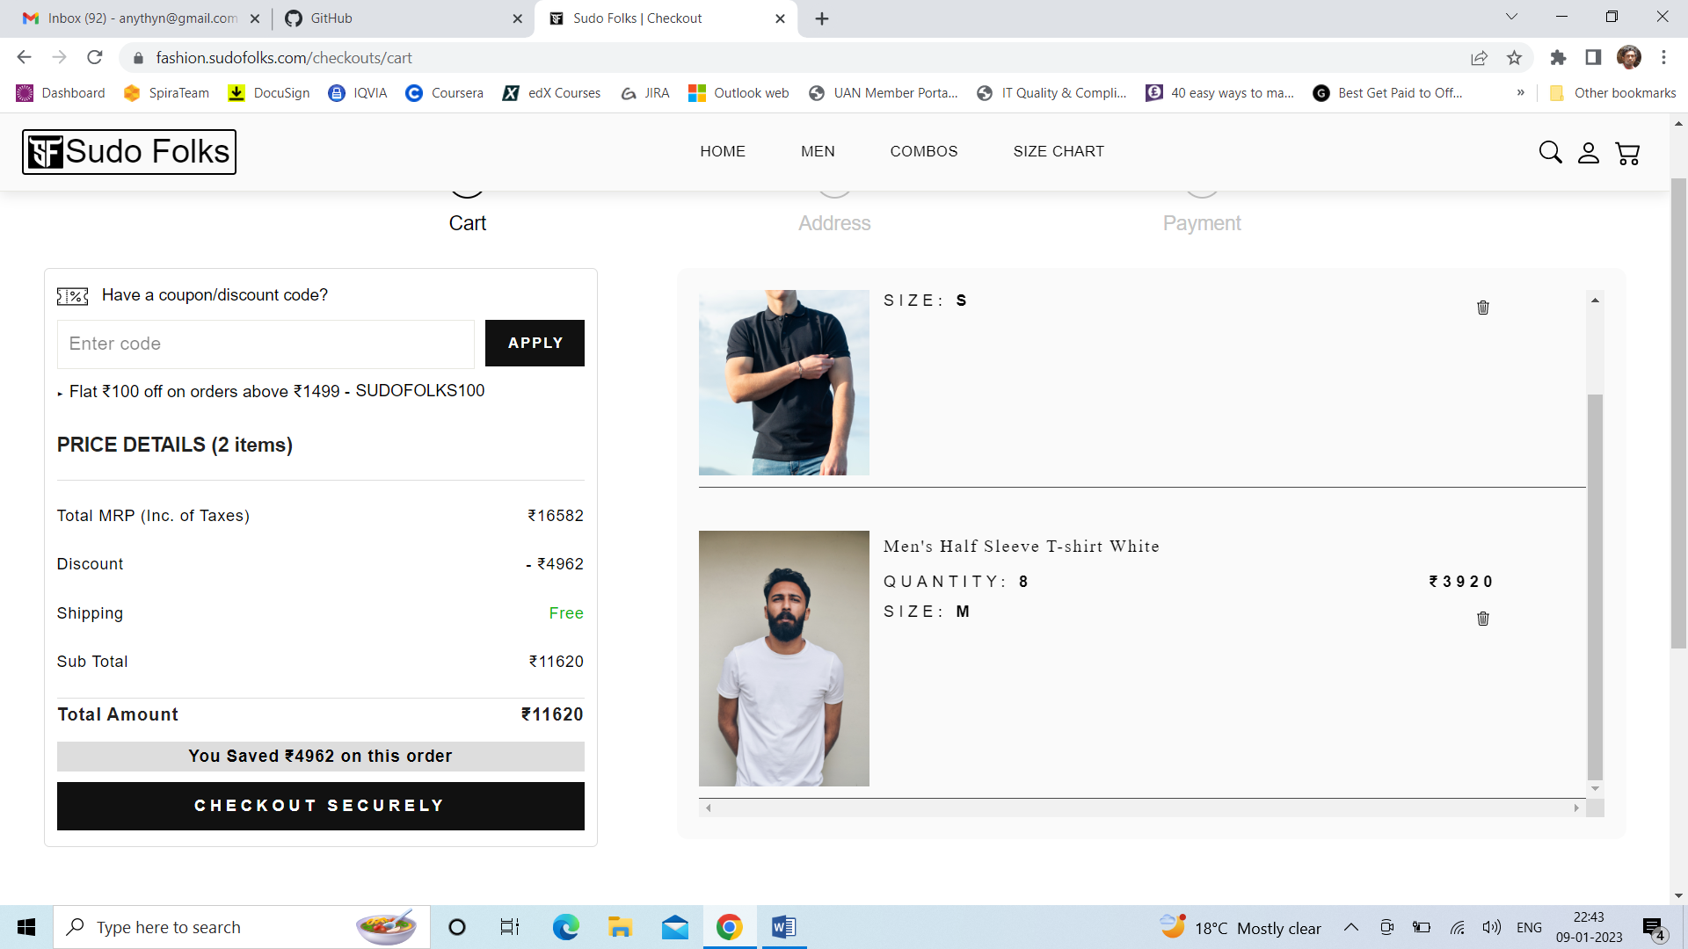

1. Provide option to update the Quantity in the checkout page.
2. Couponcode is not valid. No error is displaying nor discount is applied and proceeding
3. Oversize word may be bit Harsh, if possible update it to Plus size or extra size or any other name.
4. Mouse hover is not displaying for some of the icons like> search, account, cart
5. Address details are overflown out of the bounds

