IEC Fusor Diagnostic Report: -1 kV / 10 A bistable behaviour + under-relaxation

Section A: run24_no_relax — bistable oscillation
Cathode -1 kV, 10 A matched ion + electron currents, 800K particles each, deuterium, h = 0.3 mm mesh, j<=20 cap, threshold = 1 V. Run killed at 2 h after 14 iterations started (13 fully completed).

A.1 V(r=0) per iteration
Iter | V(r=0) (V) | State
1 | -931.36 | vacuum
2 | -1909.04 | shallow
3 | -2438.41 | shallow
4 | -1371.42 | shallow
5 | -4339.05 | DEEP (virtual cathode)
6 | -1255.24 | shallow
7 | -4816.69 | DEEP (virtual cathode)
8 | -1233.87 | shallow
9 | -4942.52 | DEEP (virtual cathode)
10 | -1229.28 | shallow
11 | -4936.44 | DEEP (virtual cathode)
12 | -1228.21 | shallow
13 | -4975.86 | DEEP (virtual cathode)
V(r=0) entered a period-2 limit cycle between -1228 V (shallow) and -4940 V (deep). V more negative than V_cathode is allowed by Poisson with negative space charge, but a real plasma cannot sustain this macroscopic oscillation — it is an artefact of the un-relaxed self-consistent iteration.
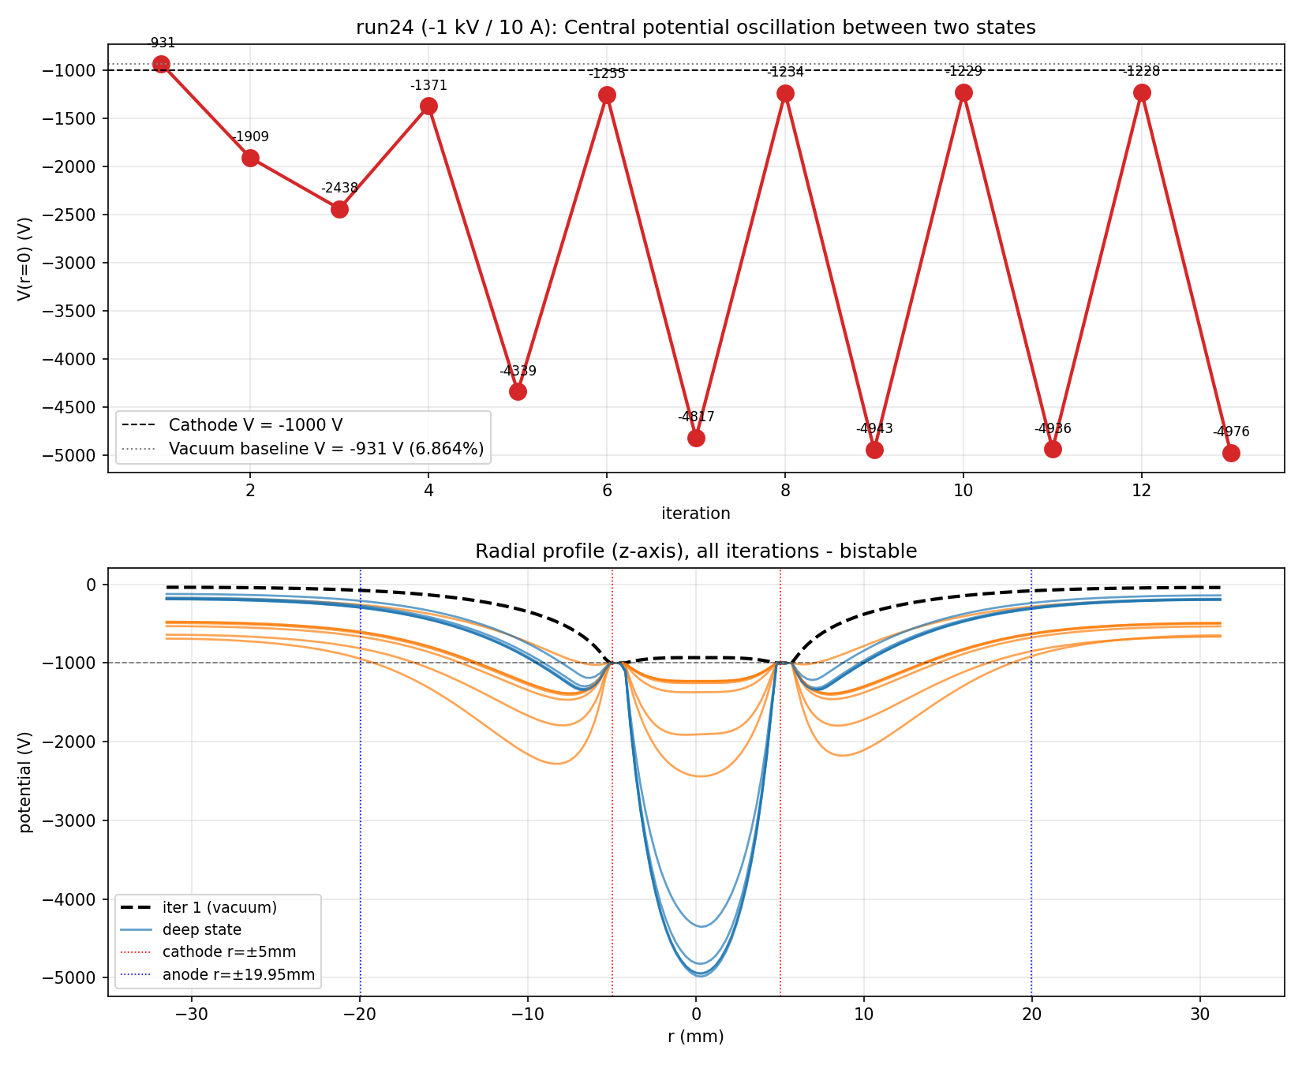
V(r=0) vs iter (top); all radial profiles by state (bottom).
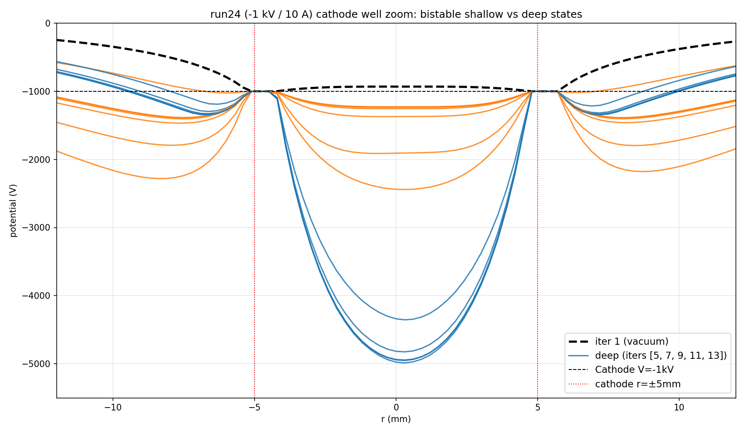
Cathode well zoom showing the two distinct states.

A.2 Particle losses by boundary (iters 1-6)

Iteration 1
Species | b5 mesh | b6 mesh | b7 chamber | b8 cathode | b9 anode | Capped | Avg steps | Total steps
Ions | 2184 | 3344 | 582 | 792637 | 19 | 40 | 55.3 | 44256482
Electrons | 6491 | 2158 | 649970 | 0 | 141357 | 0 | 37.7 | 30133073

Iteration 2
Species | b5 mesh | b6 mesh | b7 chamber | b8 cathode | b9 anode | Capped | Avg steps | Total steps
Ions | 67920 | 47554 | 10 | 99900 | 3 | 582738 | 840.4 | 672290630
Electrons | 17423 | 19104 | 58711 | 682645 | 6423 | 0 | 63.4 | 50694071

Iteration 3
Species | b5 mesh | b6 mesh | b7 chamber | b8 cathode | b9 anode | Capped | Avg steps | Total steps
Ions | 24522 | 31360 | 269 | 717049 | 10 | 6027 | 144.7 | 115750714
Electrons | 64185 | 70278 | 421203 | 163995 | 54329 | 0 | 51.1 | 40901044

Iteration 4
Species | b5 mesh | b6 mesh | b7 chamber | b8 cathode | b9 anode | Capped | Avg steps | Total steps
Ions | 95067 | 112695 | 1 | 393074 | 0 | 188340 | 474.9 | 379913310
Electrons | 4894 | 6185 | 24516 | 757475 | 3062 | 2 | 77.5 | 62039066

Iteration 5
Species | b5 mesh | b6 mesh | b7 chamber | b8 cathode | b9 anode | Capped | Avg steps | Total steps
Ions | 15565 | 22447 | 4834 | 734485 | 337 | 16216 | 201.0 | 160837763
Electrons | 64841 | 65822 | 396036 | 193391 | 51483 | 0 | 50.9 | 40695051

Iteration 6
Species | b5 mesh | b6 mesh | b7 chamber | b8 cathode | b9 anode | Capped | Avg steps | Total steps
Ions | 90857 | 92012 | 1 | 525466 | 0 | 79469 | 342.3 | 273818164
Electrons | 9129 | 10130 | 37899 | 731321 | 3822 | 5 | 75.3 | 60210508
Recirculation evidence: iter 1 ions take avg 55 steps before mostly hitting the cathode (single-pass, no virtual-anode mirror exists yet). Iter 2 ions take avg 840 steps, with 73% hitting the maxsteps=1000 cap — this is IEC recirculation: ions oscillate through cathode grid gaps many times before either being absorbed by a wire or hitting the step cap. Pattern alternates with the bistable V(r=0) state.

Section B: run24 with under-relaxation (α = 0.3)
Same parameters (cathode -1 kV, 10 A, 800K particles), but the loop now applies after each Poisson solve:
epot(a) = α · epot_new(a) + (1 − α) · epot_old(a), α = 0.3
Iteration cap reduced to 5. Oscillation is heavily damped. V(r=0) progresses with small overshoot/undershoot toward an equilibrium near -1700 V — no period-2 cycle.

B.1 V(r=0) per iteration (under-relaxed)
Iter | V(r=0) (V)
1 | -931.36
2 | -1224.67
3 | -1943.61
4 | -1766.41
5 | -1629.50

B.2 Convergence history
Iter | epot_max_error (V)
2 | 1436.31
3 | 722.60
4 | 178.13
5 | 215.61
Max error trend: 1436 → 723 → 178 → 216 V. Damping ~2× per iter (geometric, expected for α=0.3). With more iterations (j cap raised to ~15-20), should converge to the ~10 V MC noise floor.
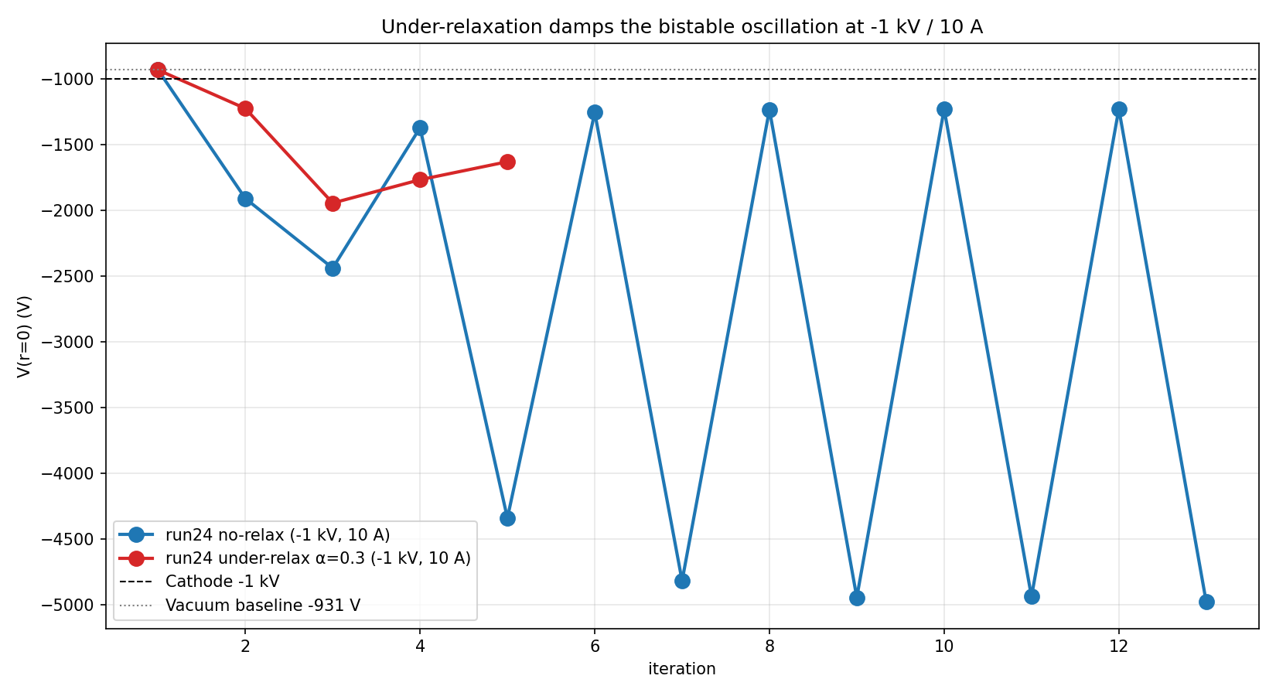
Under-relaxation (red) vs no relaxation (blue) at -1 kV / 10 A. No-relax bounces ±1900 V; under-relax oscillates ±200 V around equilibrium ~-1700 V.
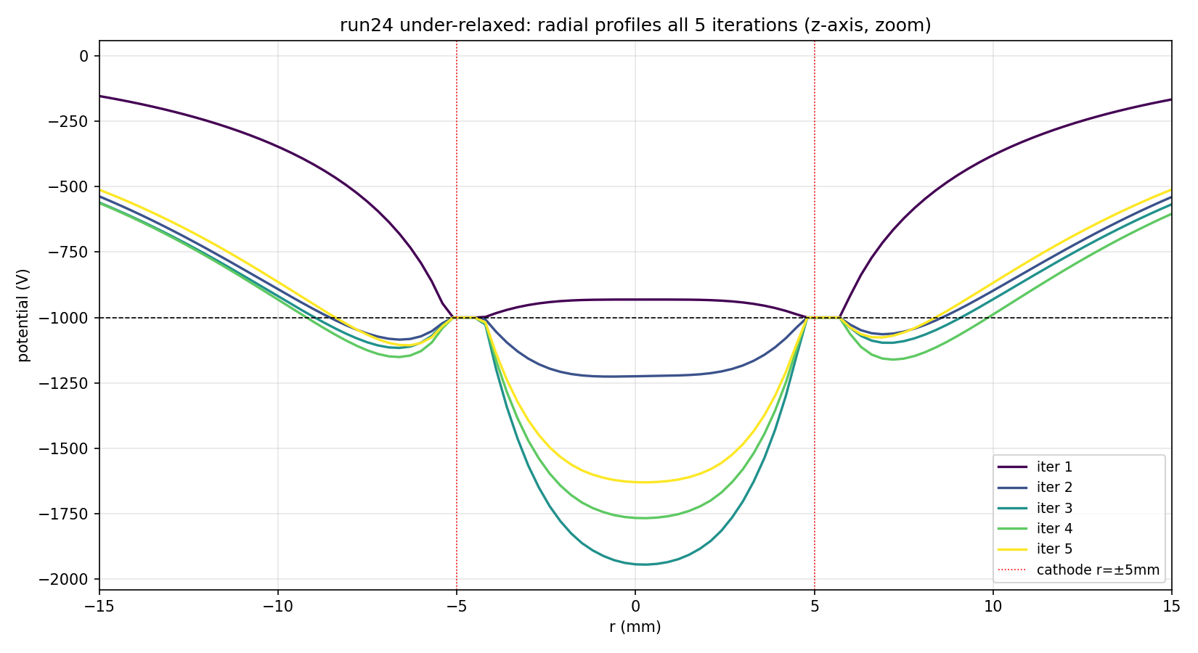
Under-relaxed radial profiles, all 5 iterations color-coded.

Section C: run25 reference (-10 kV / 10 A, no relaxation, K=316)
Reference at 10× the voltage of run24. Demonstrates the bistable oscillation is voltage-dependent: at -10 kV the loop converges without under-relaxation — the larger geometric well dominates over the space-charge perturbation.

C.1 V(r=0) per iteration
Iter | V(r=0) (V)
1 | -9313.60
2 | -9622.65
3 | -9647.61
4 | -9646.59
5 | -9646.48
6 | -9646.54
7 | -9646.69
8 | -9646.62
9 | -9646.54
10 | -9646.50
11 | -9646.52
12 | -9646.61
13 | -9646.58
14 | -9646.62
15 | -9646.60
16 | -9646.64
17 | -9646.63
18 | -9646.52
19 | -9646.58
20 | -9646.60
At -10 kV / 10 A: V(r=0) settles at -9646.6 V (±0.1 V) from iter 3 onwards. Drop from vacuum -9313.6 V = 333 V. Loop hit j=20 cap because MC noise floor (~11-17 V) is just above the 10 V threshold, but V(r=0) is stable to <0.2 V across 18 consecutive iters — converged in the practical sense.

C.2 Embedded plots from run25
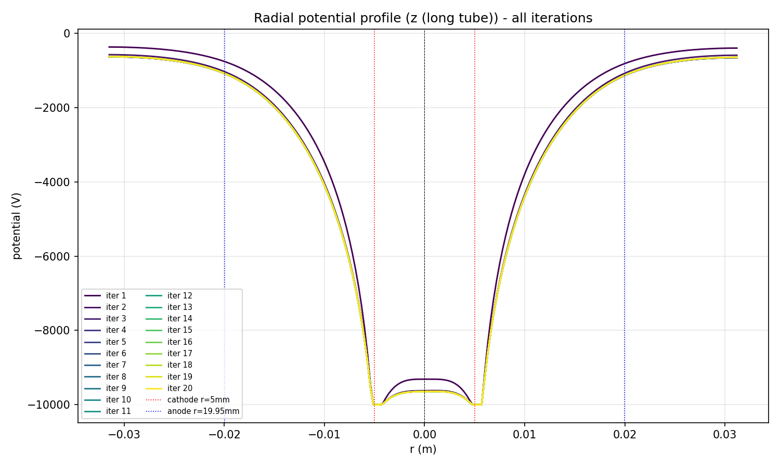
run25 z-axis radial profile, all 20 iterations
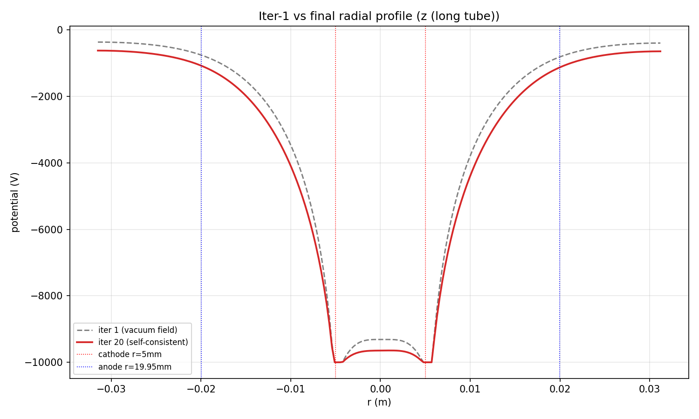
run25 vacuum vs converged radial profile - gap = space-charge effect
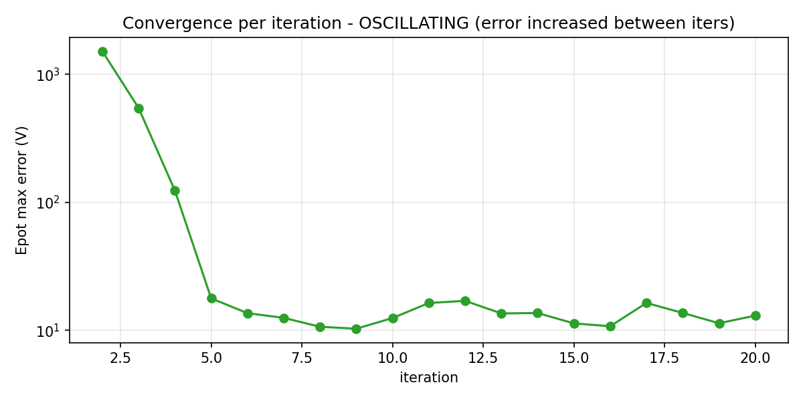
run25 epot_max_error vs iteration
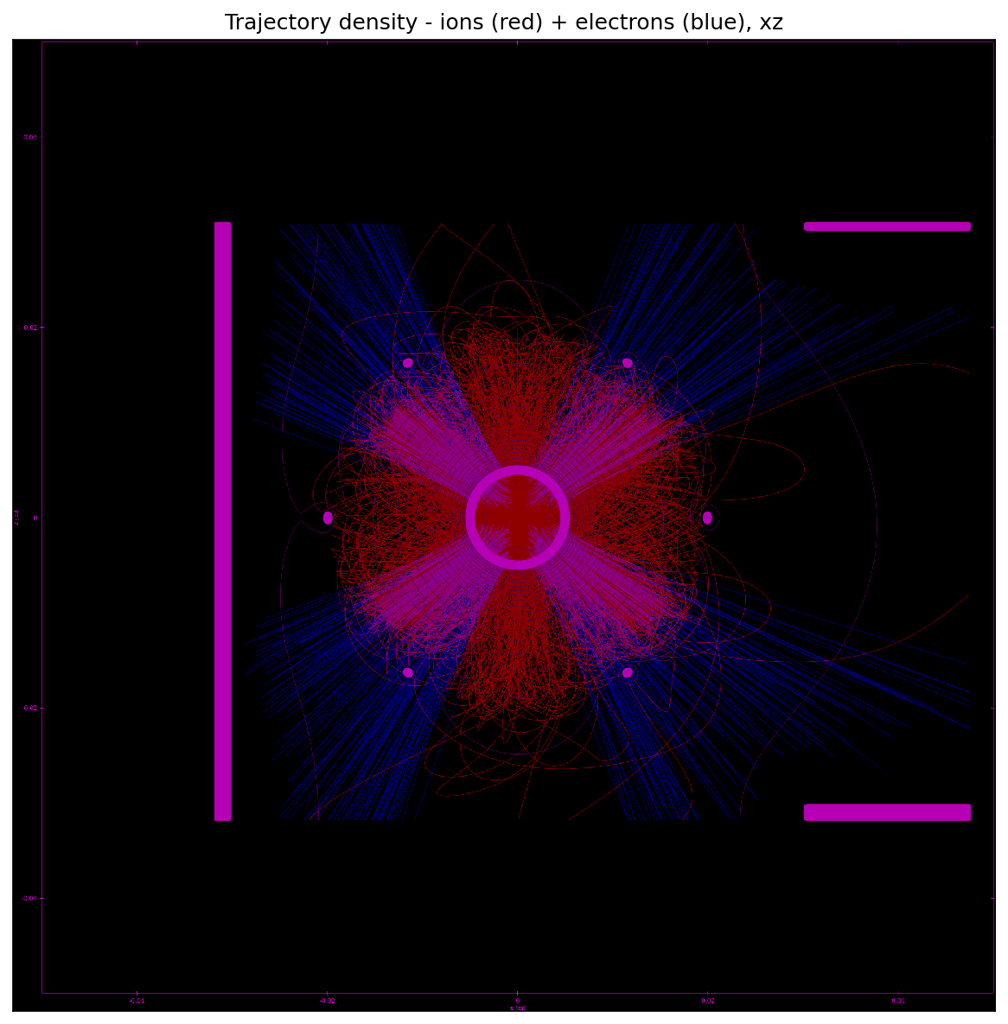
run25 trajectory density (red=ions, blue=electrons, magenta=overlap), XZ slice

Section D: Physical interpretation & implications
1. Bistability is voltage-specific. At -10 kV the loop converges; at -1 kV it limit-cycles. The geometric well dominates at high V, the space-charge perturbation dominates at low V.
2. Under-relaxation at α=0.3 successfully damps the -1 kV oscillation. Equilibrium V(r=0) lies in the -1500 to -2000 V range (still drifting at iter 5); higher j cap needed for tight convergence.
3. Double-well behaviour requires both recirculating ions (positive space charge inside cathode) AND trapped electrons (overshooting the positive island). Both species need equilibrium populations at the centre.
4. Limitation of this simulation: ions are all born at the anode at rest, gaining the full eV_cathode of kinetic energy. They zoom through the centre too fast at high V to contribute much density. In real IEC fusors (e.g. Gu & Miley), ions are produced by gas-discharge ionisation volumetrically with a range of starting energies — the slow population fills the centre and creates the dense focus needed for a robust virtual anode.
5. Practical takeaway: the -1 kV / 10 A regime is not useful for fusion (ion energy way below reaction threshold, power demand prohibitive). To see double-wells at fusion-relevant voltages (50-100 kV), the simulation needs a more realistic ion birth distribution (volumetric source with thermal energy spread) — a significant code change.

