Run 25 - 10 A / -1 kV, 800K particles, Deuterium

Central Anode Height
Cathode voltage | -1000.0 V (-1 kV)
Central potential (avg of x/y/z probes) | -9646.60 V
Central potential (x axis) | -9646.60 V
Central potential (y axis) | -9646.60 V
Central potential (z axis) | -9646.60 V
Central anode height | -864.660 % of |V_cathode|
Height % = (|V_cathode| - |V_centre|) / |V_cathode|. Positive value = central potential is LESS negative than the cathode (space-charge / geometric 'virtual anode' lift).

Radial Profile Extrema (z-axis, final iter)
Prominence filter: only extrema with prominence > 10.0 V (1% of |V_cathode|) are reported to suppress mesh-resolution noise.
# | r (m) | V (V) | kind
1 | -0.0048 | -10000.00 | min
2 | +0.0012 | -9644.19 | max
3 | +0.0051 | -10000.00 | min
An interior local MAX inside the cathode (|r| < 5 mm) is a virtual-anode signature; an interior local MIN above the cathode floor is a virtual-cathode (double-well) signature.

Iter-1 (vacuum) vs Final (self-consistent) profile
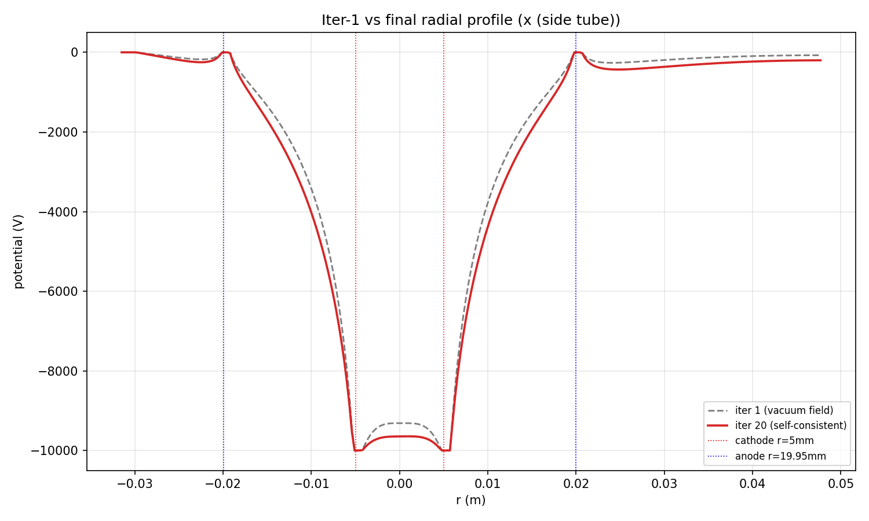
x (side tube) - gap between dashed and solid = space-charge contribution
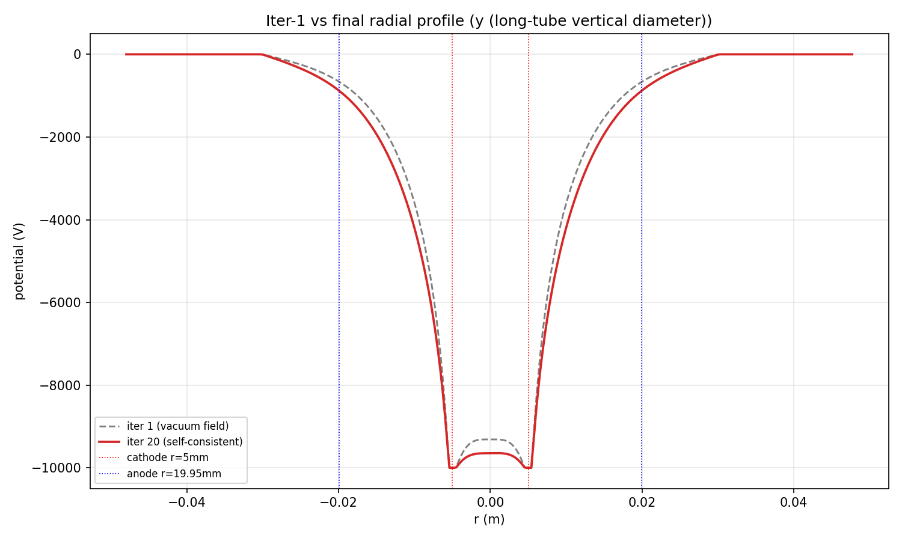
y (long-tube vertical diameter) - gap between dashed and solid = space-charge contribution
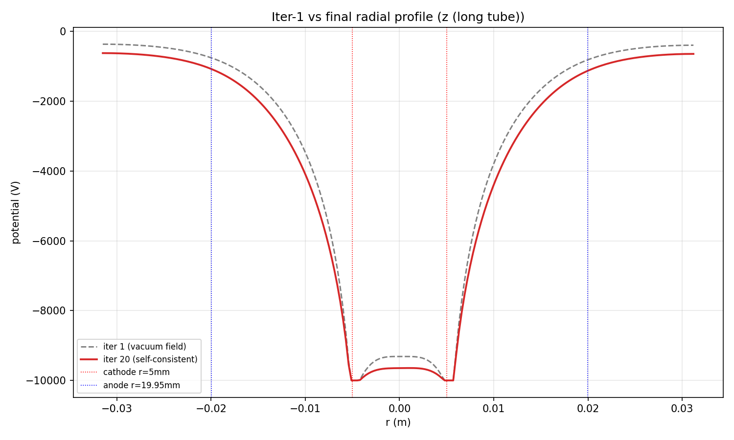
z (long tube) - gap between dashed and solid = space-charge contribution

Radial Potential Profiles
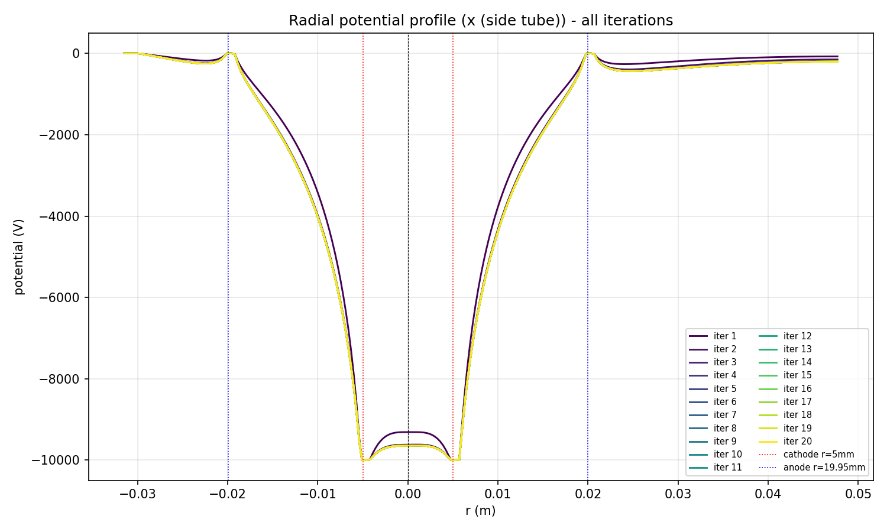
Radial potential along x (side tube), all iterations overlaid
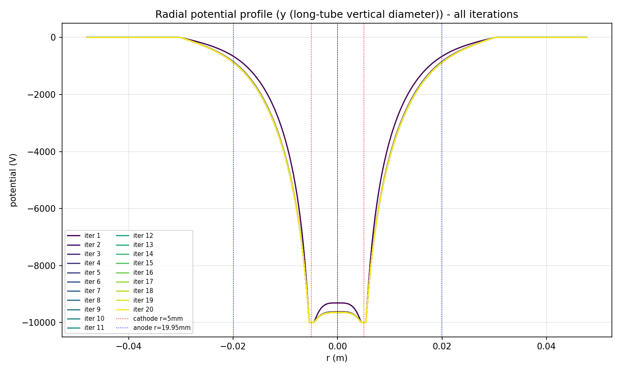
Radial potential along y (long-tube vertical diameter), all iterations overlaid
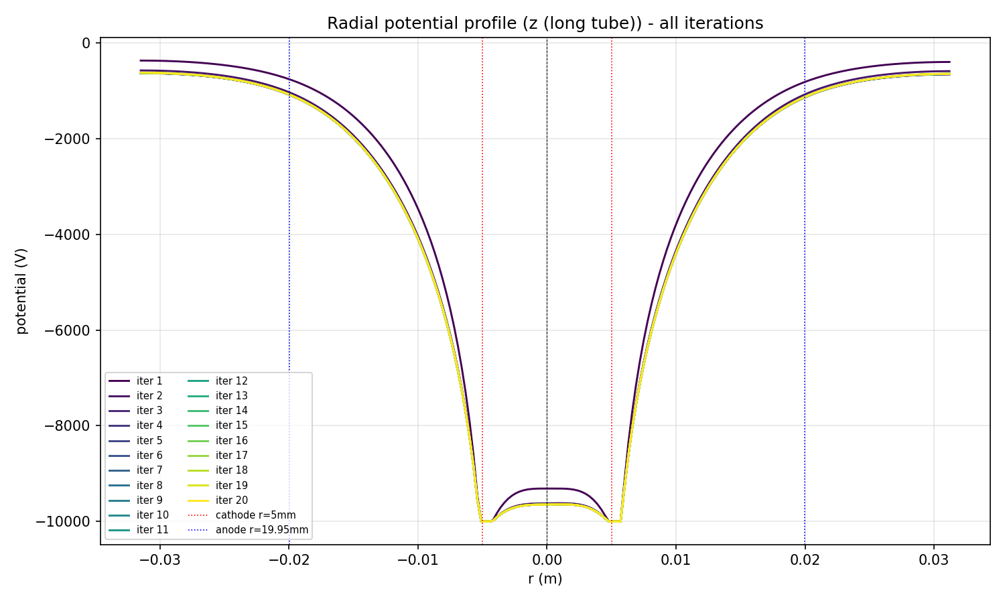
Radial potential along z (long tube), all iterations overlaid

Final Potential Field
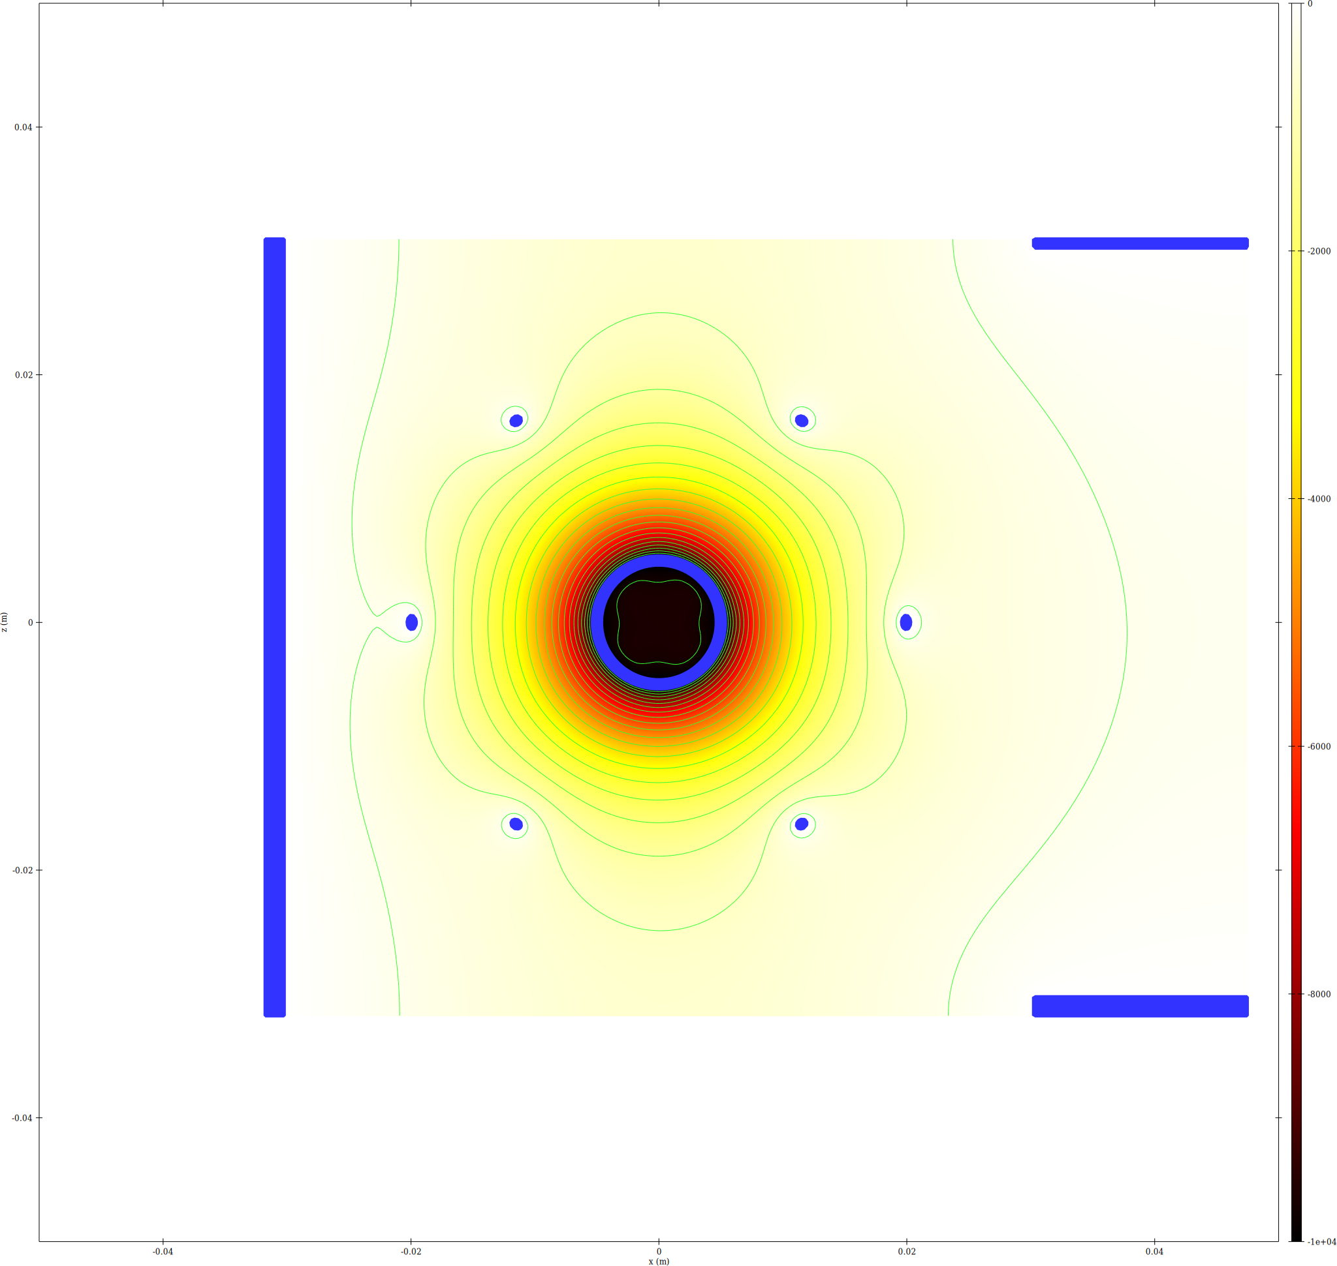
epot XZ slice
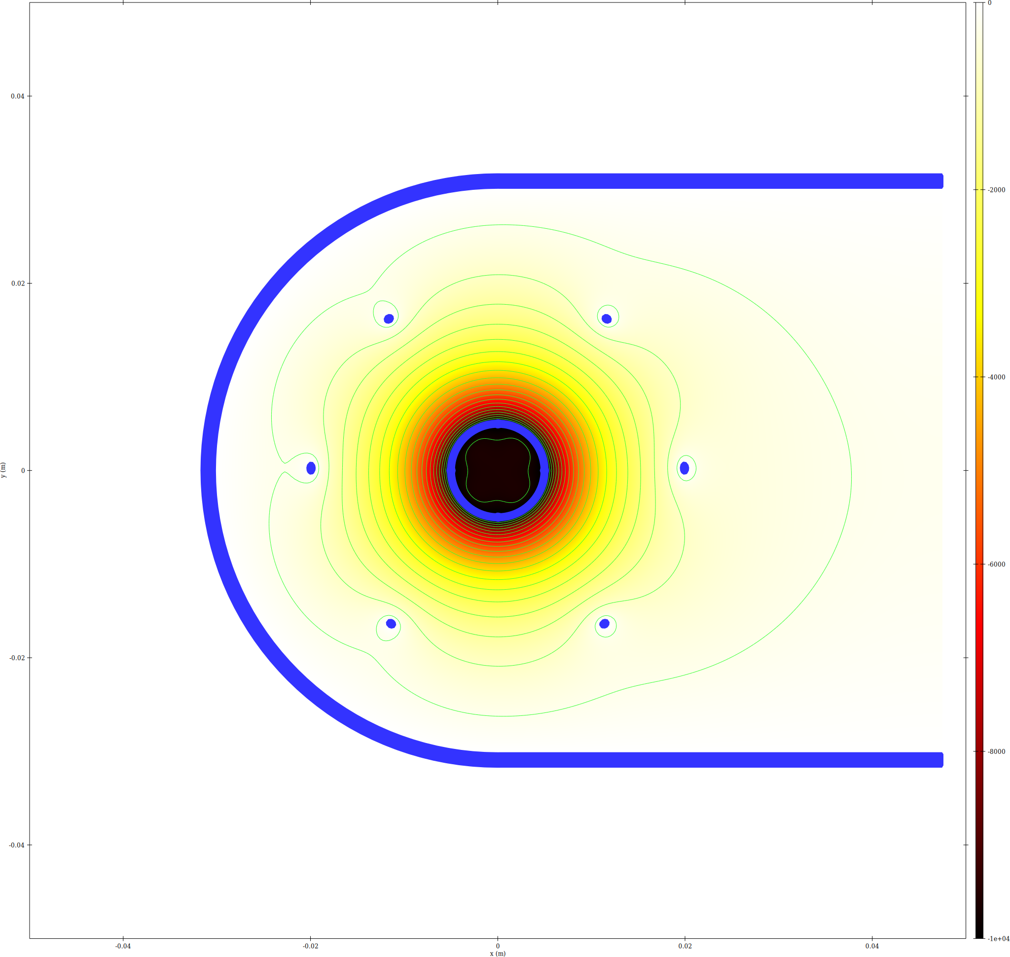
epot XY slice
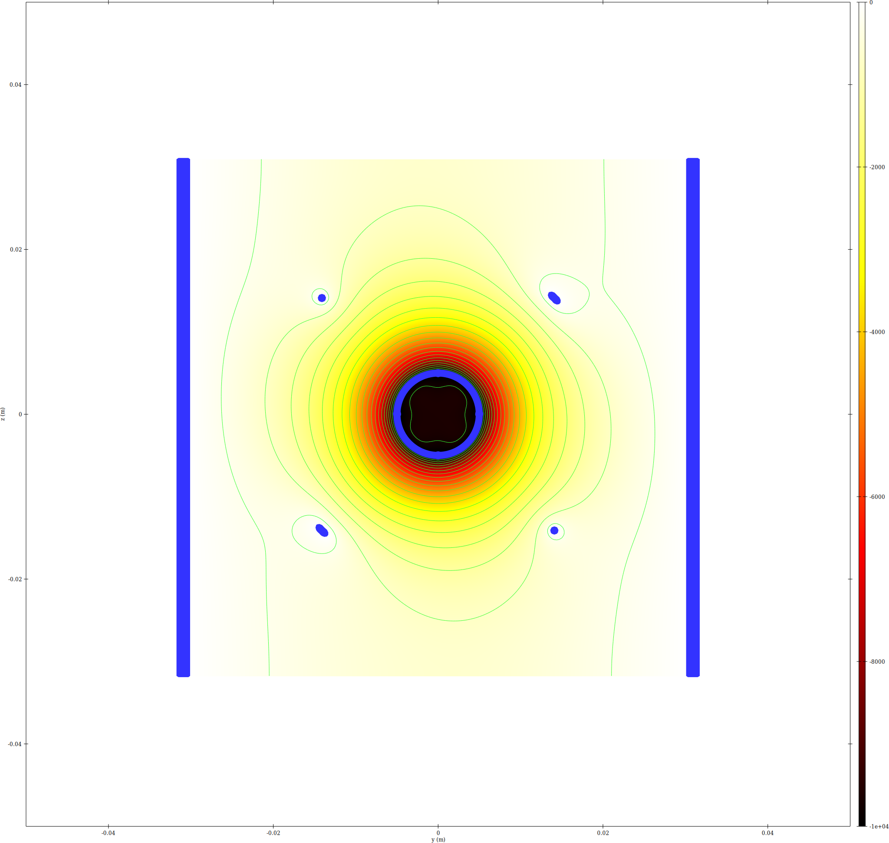
epot YZ slice at x=0

Trajectory Density

Ions
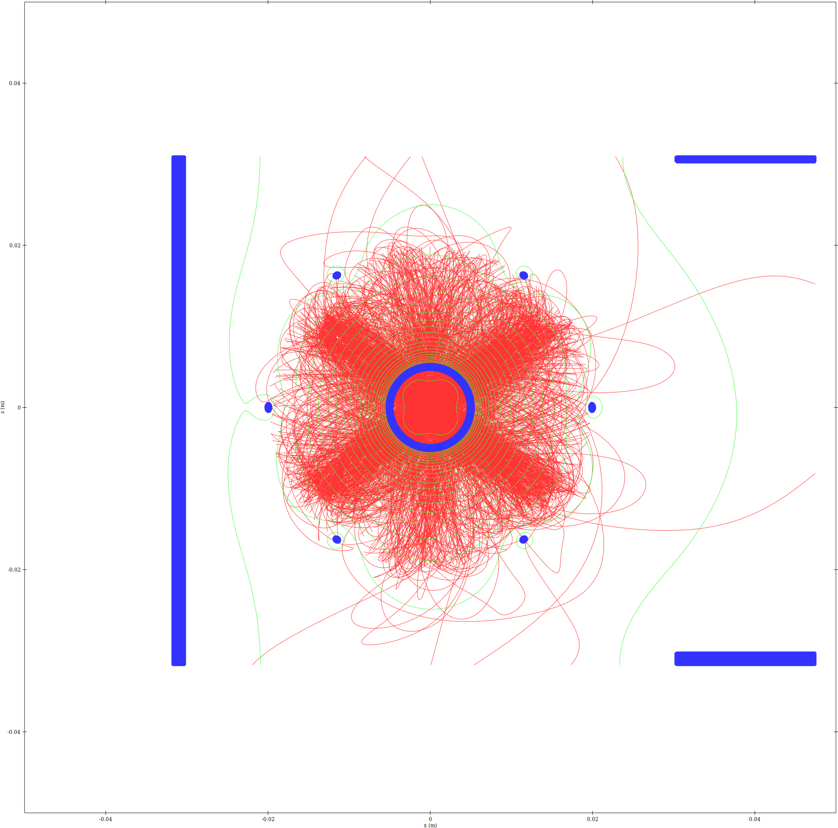
Ion trajectory density - XZ slice
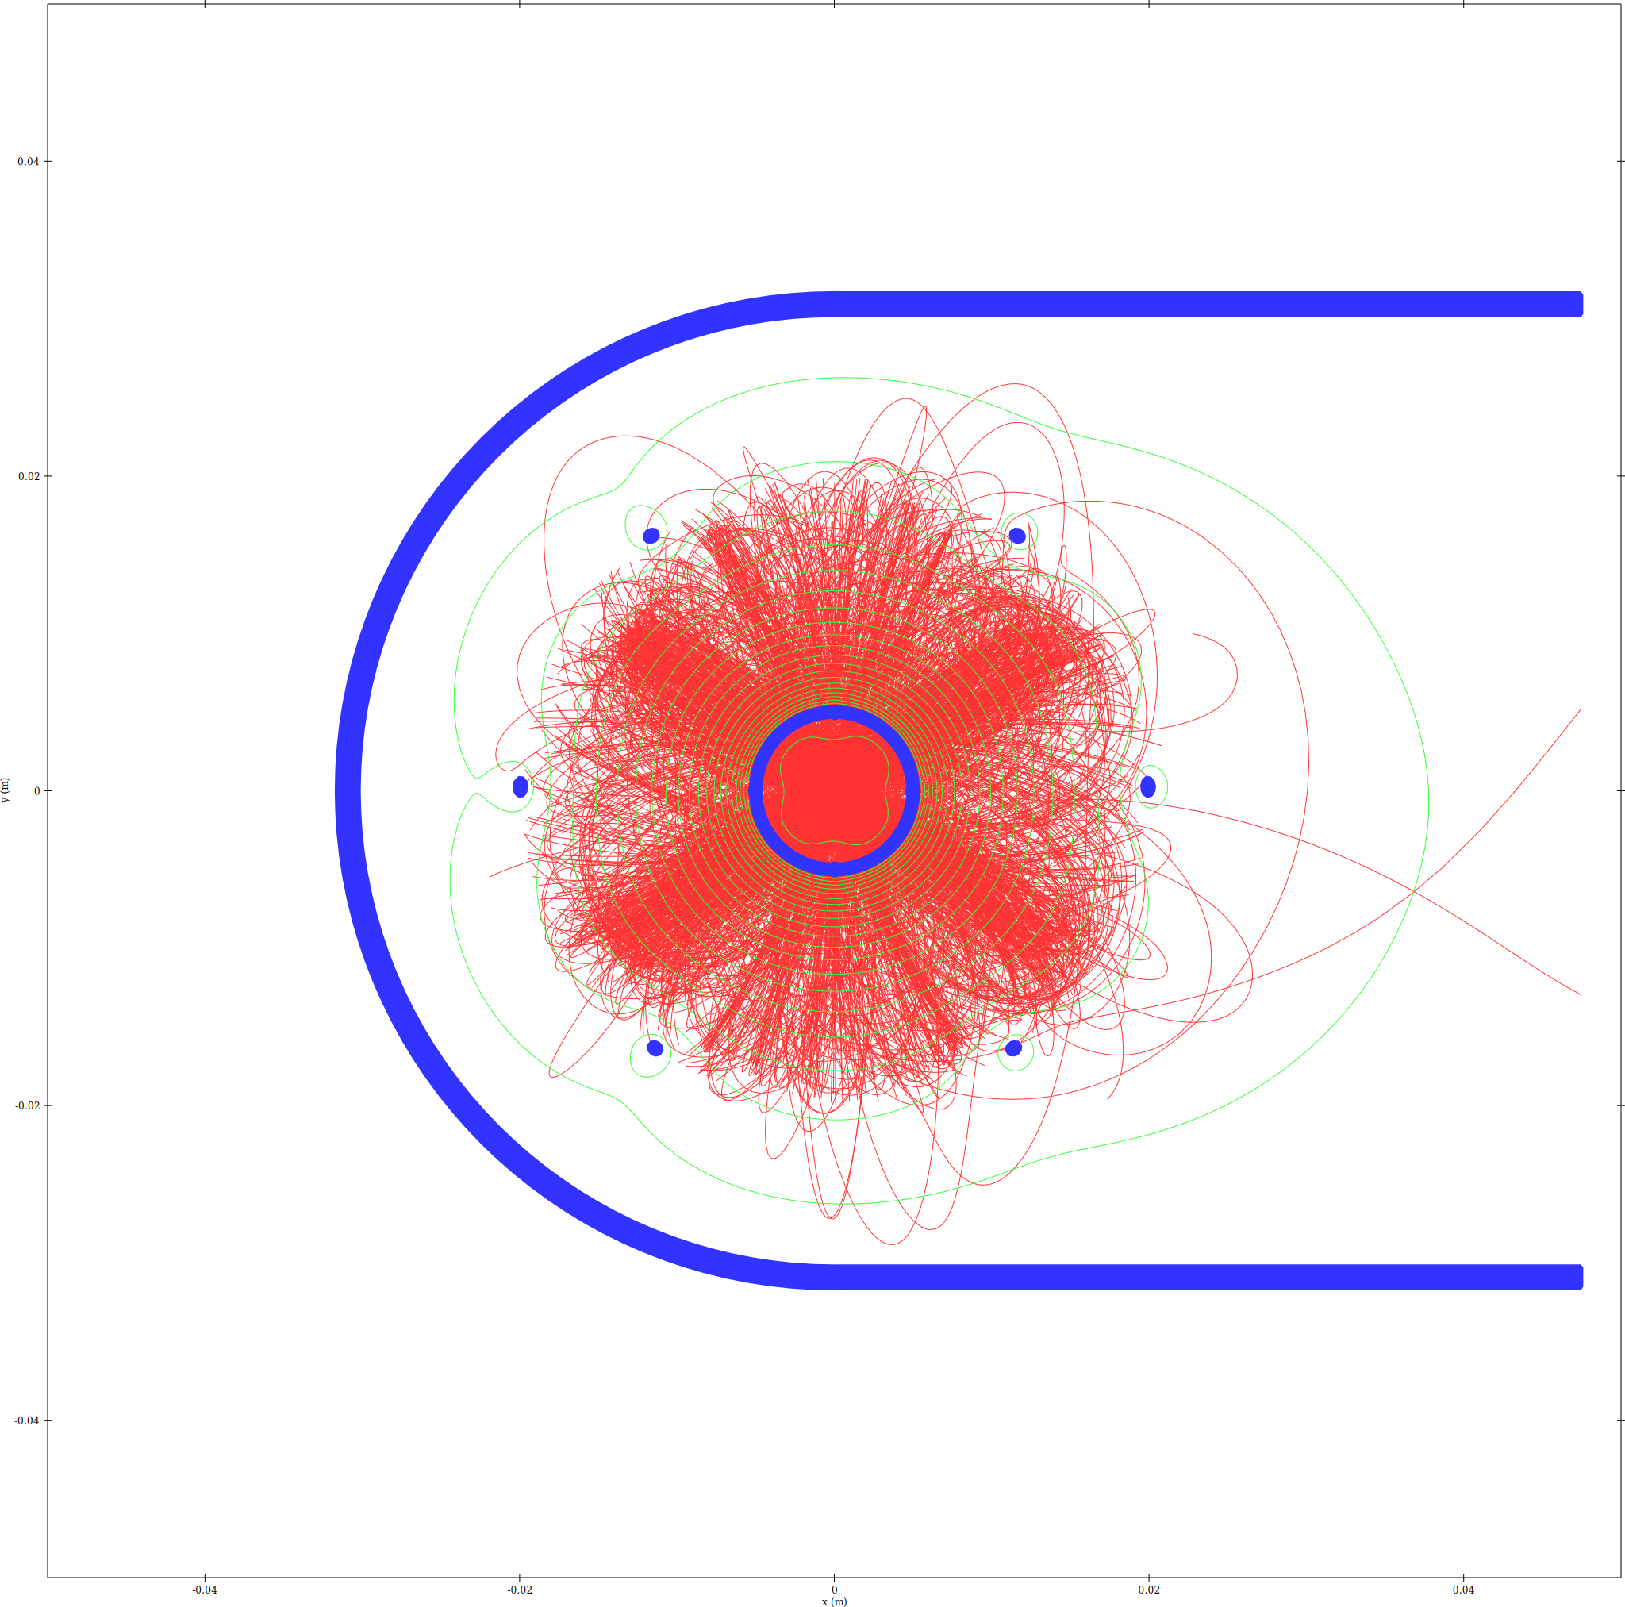
Ion trajectory density - XY slice
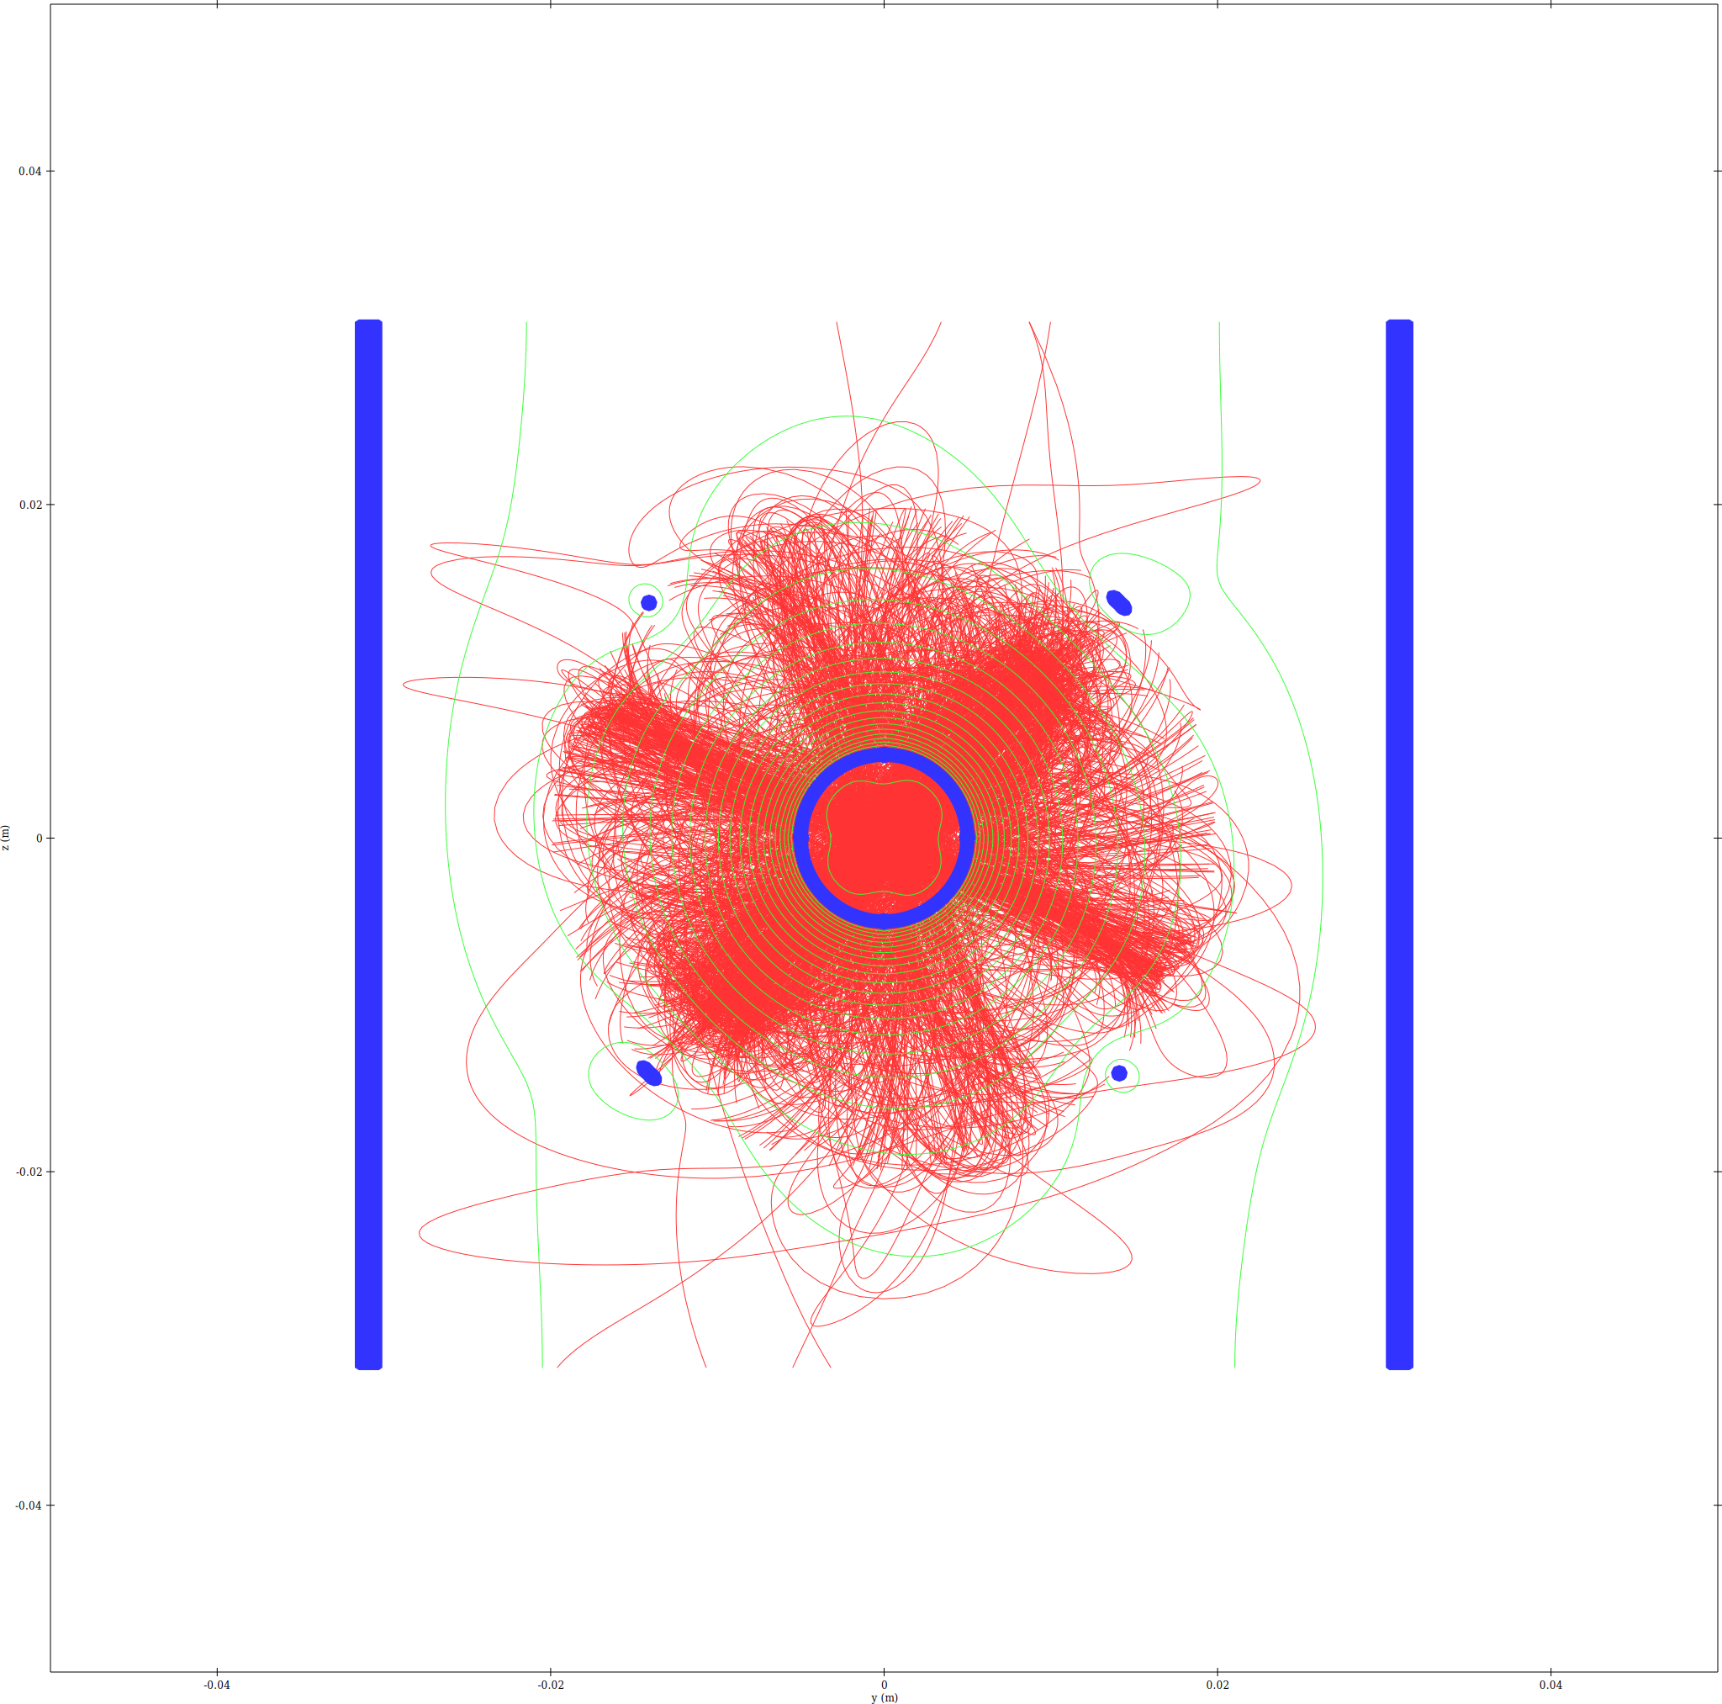
Ion trajectory density - YZ_X0 slice

Electrons
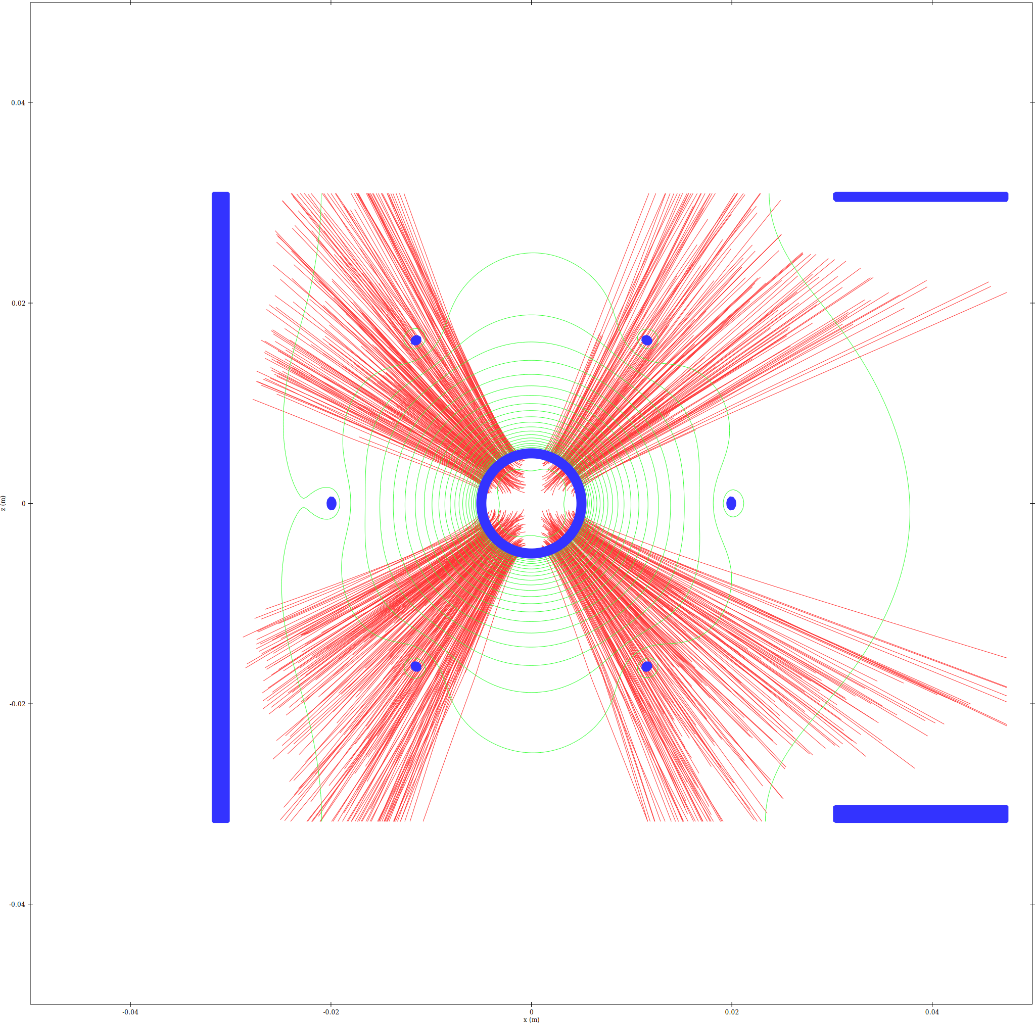
Electron trajectory density - XZ slice
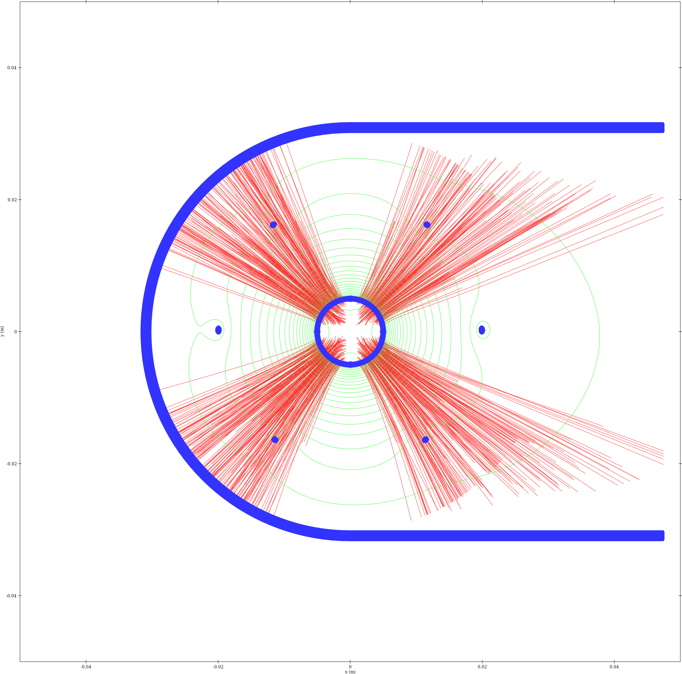
Electron trajectory density - XY slice
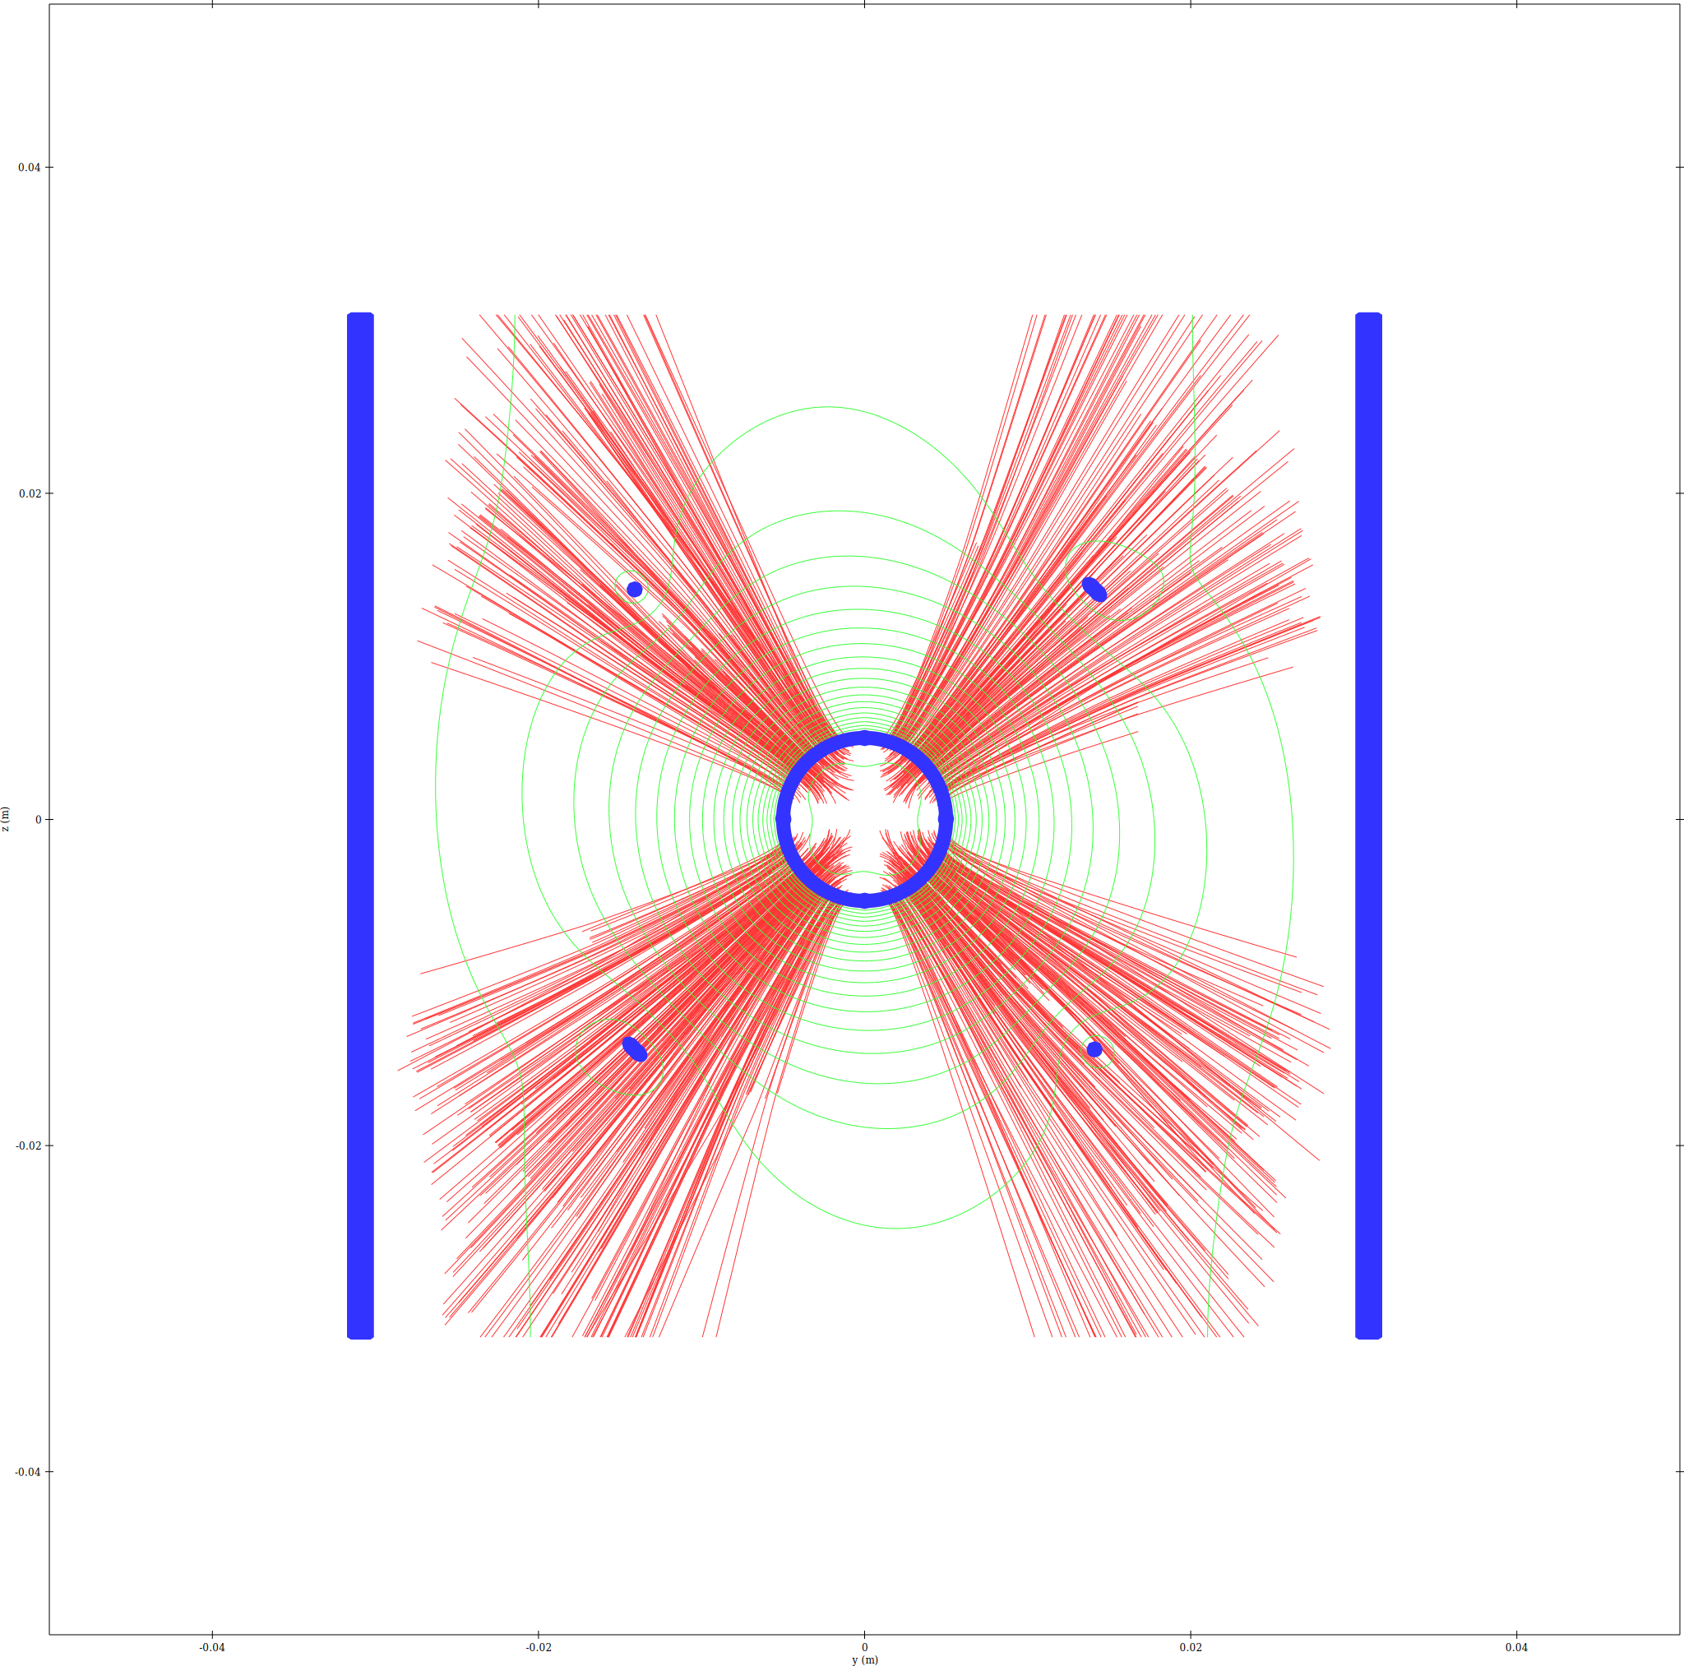
Electron trajectory density - YZ_X0 slice

Combined (ions=red, electrons=blue, overlap=magenta)
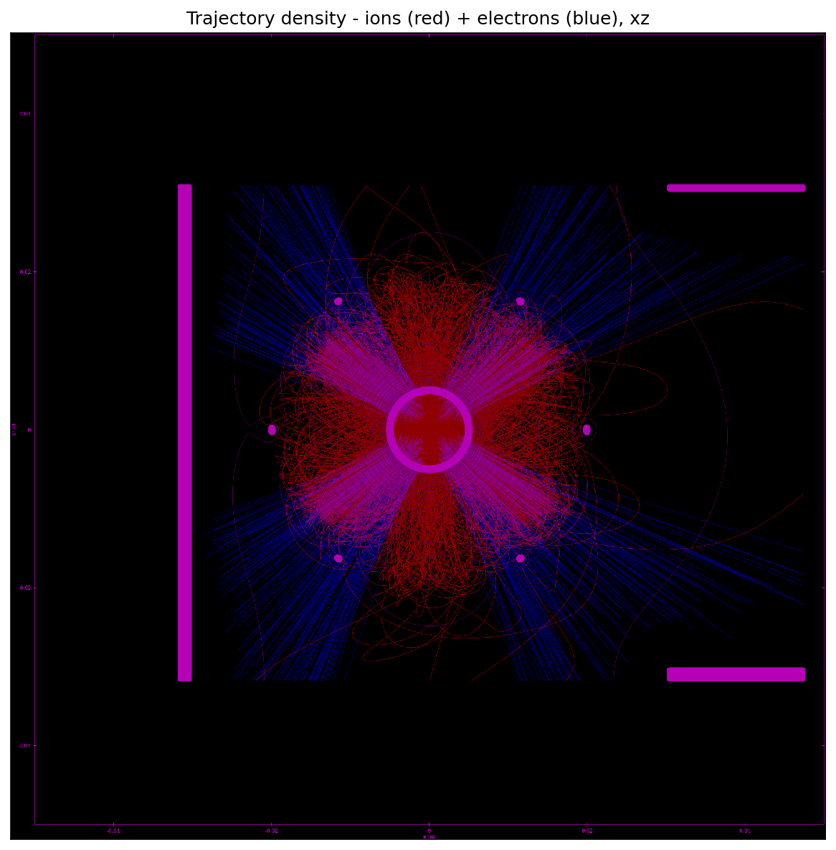
Combined trajectory density - XZ slice
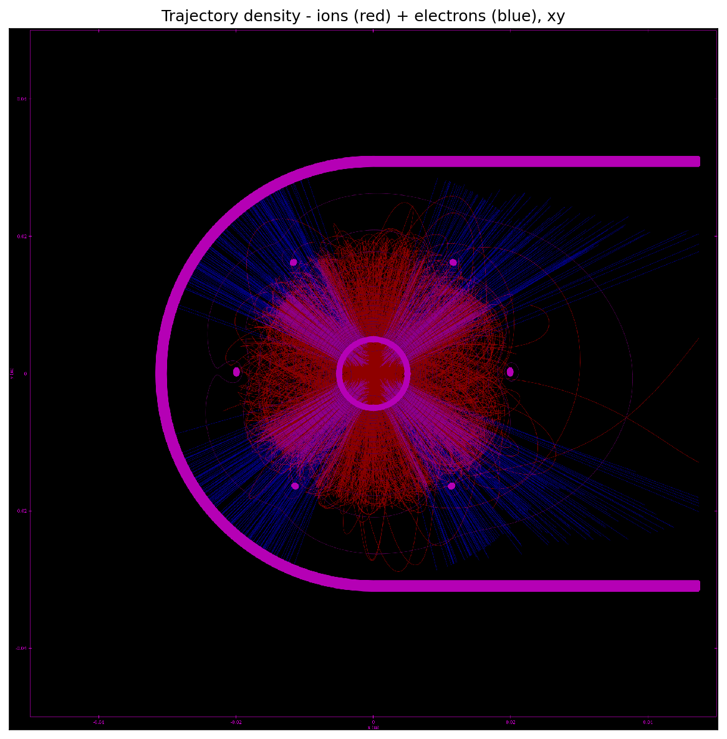
Combined trajectory density - XY slice
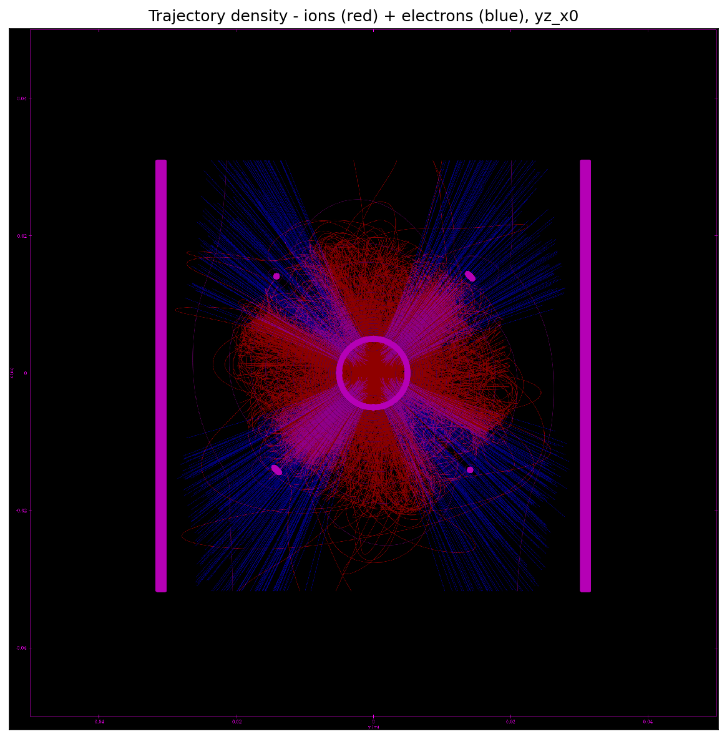
Combined trajectory density - YZ_X0 slice

Memory Estimate
Memory breakdown for run25/
N_clouds (ions) = 800000
N_clouds_e (electrons) = 800000
bytes/particle = 108, bytes/step = 56
Mesh nodes = 17808000 (4 scalar + 1 vector(3) fields)
Mesh-field memory = 0.929 GB
Solver workspace est. = 1.858 GB
Geometry est. = 0.066 GB
Constant overhead total = 2.853 GB
Particle data (constant) = 0.161 GB
iteration | ion_steps | e_steps | traj_MB | overhead_MB | total_GB
1 | 61060166 | 31389189 | 4937.33 | 3085.88 | 7.8352
2 | 98765900 | 44814122 | 7668.00 | 3085.88 | 10.5018
3 | 103499717 | 45638562 | 7964.84 | 3085.88 | 10.7917
4 | 100589200 | 48438473 | 7958.94 | 3085.88 | 10.7860
5 | 100675174 | 48636368 | 7974.10 | 3085.88 | 10.8008
6 | 100570418 | 48431753 | 7957.57 | 3085.88 | 10.7846
7 | 100522796 | 48563306 | 7962.06 | 3085.88 | 10.7890
8 | 100347354 | 48330542 | 7940.26 | 3085.88 | 10.7677
9 | 100583749 | 48594947 | 7967.00 | 3085.88 | 10.7938
10 | 100570476 | 48481305 | 7960.22 | 3085.88 | 10.7872
11 | 100121439 | 48391021 | 7931.42 | 3085.88 | 10.7591
12 | 100550797 | 48504006 | 7960.39 | 3085.88 | 10.7874
13 | 100651579 | 48377529 | 7959.01 | 3085.88 | 10.7860
14 | 100436668 | 48510144 | 7954.62 | 3085.88 | 10.7817
15 | 101156668 | 48434312 | 7989.02 | 3085.88 | 10.8153
16 | 99912900 | 48614882 | 7932.24 | 3085.88 | 10.7599
17 | 100654084 | 48383116 | 7959.45 | 3085.88 | 10.7864
18 | 100472421 | 48574776 | 7959.98 | 3085.88 | 10.7870
19 | 100655712 | 48501286 | 7965.84 | 3085.88 | 10.7927
20 | 100820811 | 48462899 | 7972.61 | 3085.88 | 10.7993

Convergence
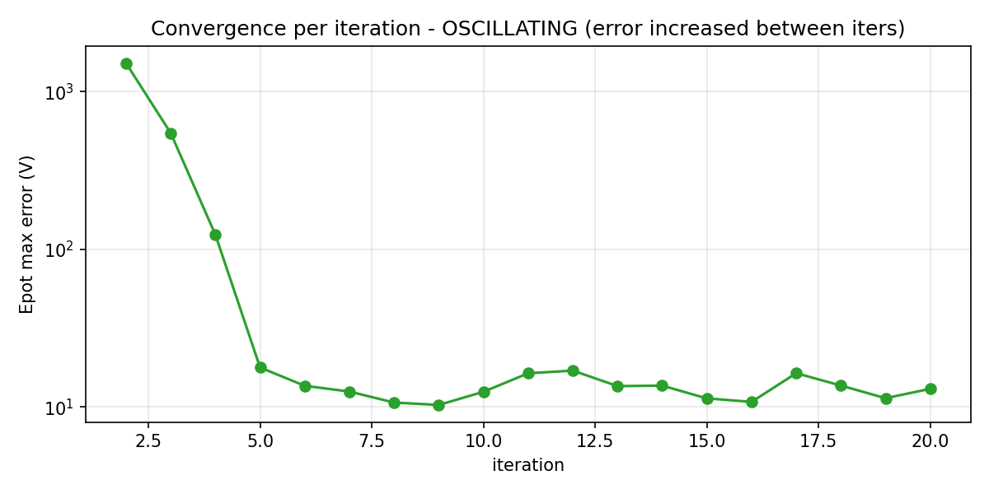
Epot max error per iteration (oscillation flag in title if error grew between iters)
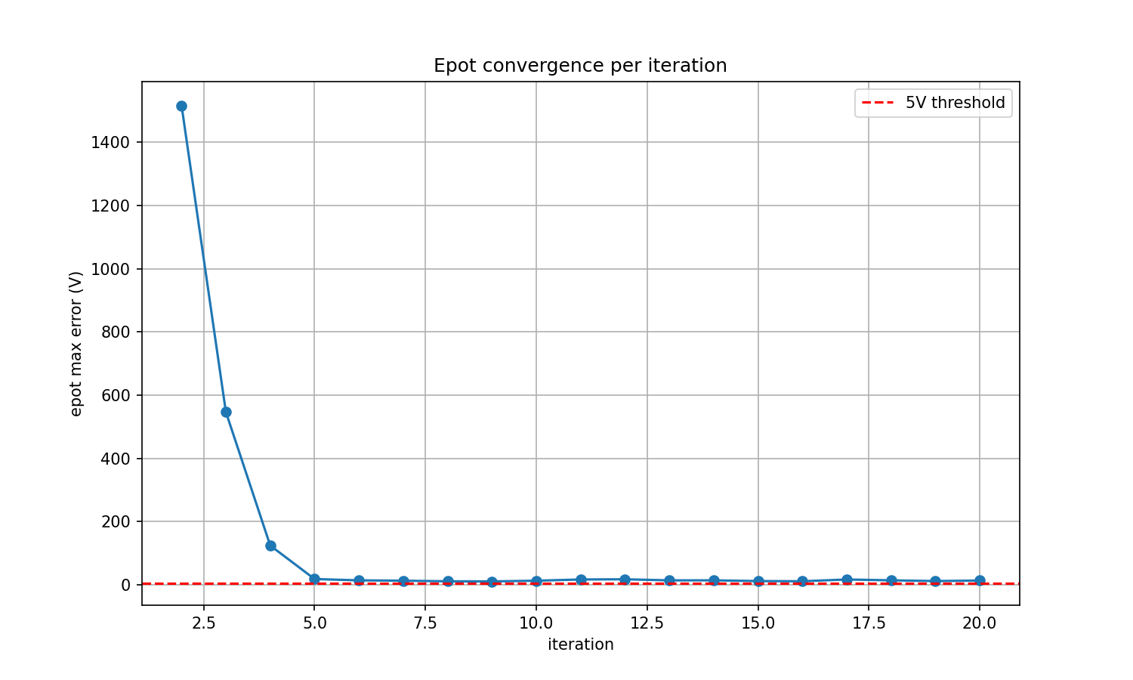
Epot max error vs iteration (postprocess plot)

