Project Management Plan(Template)

Table of Contents

Table of Contents 1

1.Project Definition 2

1.1 Project Purpose 2

1.2 Project Characteristics 2

1.3 Project Completion Criteria 2

1.4 Business Function Overview 2

1.5 System Configuration Overview and Network Configuration Overview 4

2. Project development policy and goals 4

3. Assumptions/Constraints 4

4. Project deliverables(Руководство пользователя) 4

5. Overall system development plan 6

5.1.Master schedule and milestones 6

5.1.1. Master schedule 6

5.1.2. Milestones 6

5.2. Organization/Personnel Plan 6

5.2.1. Project organization/personnel chart 6

5.3. Facility/environmental plan 7

5.3.1. Working location and working environment 7

6.Management Plan 7

6.1 Scope management 7

6.2 Schedule management 7

6.3 Communication management 7

6.4 Cost Management 7

6.5 Quality Management 7

6.6 Risk Management 7

6.7 Purchasing management 7

1.Project Definition

1.1 Project Purpose

Establish a streamlined and user-friendly time management system that enhances the working environment, ensuring employees find it efficient and enjoyable to use.

Recognize and reward employees for their exemplary commitment to time management, acknowledging those who consistently meet or exceed productivity goals.

Automate and simplify the time-tracking and reporting processes to increase overall efficiency and accuracy, providing a seamless experience for both administrators and employees.

Foster a culture of punctuality and accountability through the time management platform, encouraging employees to meet deadlines and optimize their work hours effectively.

Improve communication and collaboration within the organization by integrating features that allow real-time updates on project timelines and task progress.

1.2 Project Characteristics

The "Time Management" system is designed for effective time management within an enterprise. It provides tools for both administrators and employees, including time tracking, geolocation verification, photography, and reporting.

1.3 Project Completion Criteria

Deliver the deliverables that has been approved by the clients.

1.4 Business Function Overview

Overview:

Time management pro is a comprehensive time management project aimed at providing users and administrators with robust tools to optimize time usage and enhance productivity. The project revolves around the development and implementation of a sophisticated time tracking application designed to meet the diverse needs of both individual users and businesses.

Key Business Functions:

1. User Time Tracking:

- Description: Users can easily start, pause, and stop their working time sessions, enabling precise tracking of their activities.

- Objective: To empower individuals to monitor and manage their time efficiently, fostering personal productivity.

2. Reporting and Analytics:

- Description The application generates detailed reports on time usage, offering insights into how users allocate their time across various tasks and projects.

- Objective:To provide users with actionable data to enhance decision-making and optimize their time allocation.

3. Administrator Management:

- Description: Administrators have the capability to add, delete, and edit employee profiles within the system.

- Objective: To facilitate easy management of user profiles and ensure accurate representation of the organizational structure within the application.

4. Employee Productivity Dashboard:

- Description: Administrators can access a comprehensive dashboard displaying real-time and historical time tracking data for all employees. This includes summaries of individual and team productivity.

- Objective: To offer administrators a centralized view of employee activities, aiding in resource allocation, performance evaluation, and overall project management.

5. Notification and Alerts:

- Description: The system sends notifications and alerts to users and administrators based on predefined criteria, such as approaching deadlines or excessive time spent on a task.

- Objective: To proactively inform users and administrators about critical time-related events, promoting timely actions and interventions.

6. Integration with Project Management Tools:

- Description: Seamless integration with popular project management tools, enabling users to link time tracking data to specific projects and tasks.

- Objective: To enhance project planning and coordination by aligning time tracking with broader project management activities.

Benefits:

- Improved personal productivity for users.

- Enhanced project management capabilities for administrators.

- Informed decision-making through detailed reports and analytics.

- Efficient allocation of resources based on real-time data.

- Streamlined collaboration through integration with project management tools.

Conclusion:

The project aims to revolutionize time management by offering a feature-rich application that caters to both individual and organizational needs. With a focus on user-friendly interfaces and seamless integration, the project endeavors to redefine how time is perceived, utilized, and optimized in professional settings.

1.5 System Configuration Overview and Network Configuration Overview

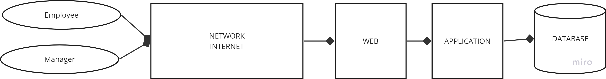

2. Project development policy and goals

Goals : "The main goal of the Time Management project:

Increase the efficiency of time use in the organization through the implementation of a modern time management system."

3. Assumptions/Constraints

**1. Constraints**

|  |
| --- |
| 1) Time limit 2) Budget restrictions = 100000$ 3) Resource limitation  **2. Assumptions**  1) We assume that the above estimate is based on the consideration that there will be no significant changes.  2) We assume that resources will be available as needed, otherwise there will be a delay in overall supplies.  3) We assume active participation of interested parties, otherwise delays in deliveries may occur. |
|  |
|  |
|  |

4. Project deliverables(Руководство пользователя)

The test results match the specification requirements.

The Time Management program is designed to monitor the working time of company employees. The application tracks the user's location: if the user is more than 100 meters from the place of work, the program displays the message "You are beyond 100 meters from the place of work!" When the user is at the workplace, he enters the program, where the "Start" button is displayed:  
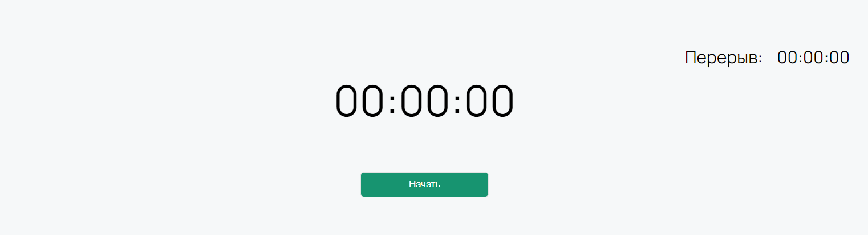

After pressing the button, the camera opens and the user takes a photo of himself for reporting.

Using a timer, the program calculates hours worked. If necessary, the user can click on the "Pause" button, then the user sees that the break timer has started:

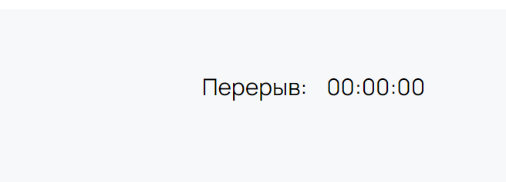

In one day (24 hours), you can start your workday only once.

At the end of the working day, the user takes a photo recording the completion of working hours and the following window is displayed:



A report on the user's hours worked is available at the bottom of the interface. Thus, an employee can view information about the days on which he worked, the duration of working hours, the duration of breaks and the end time of work:

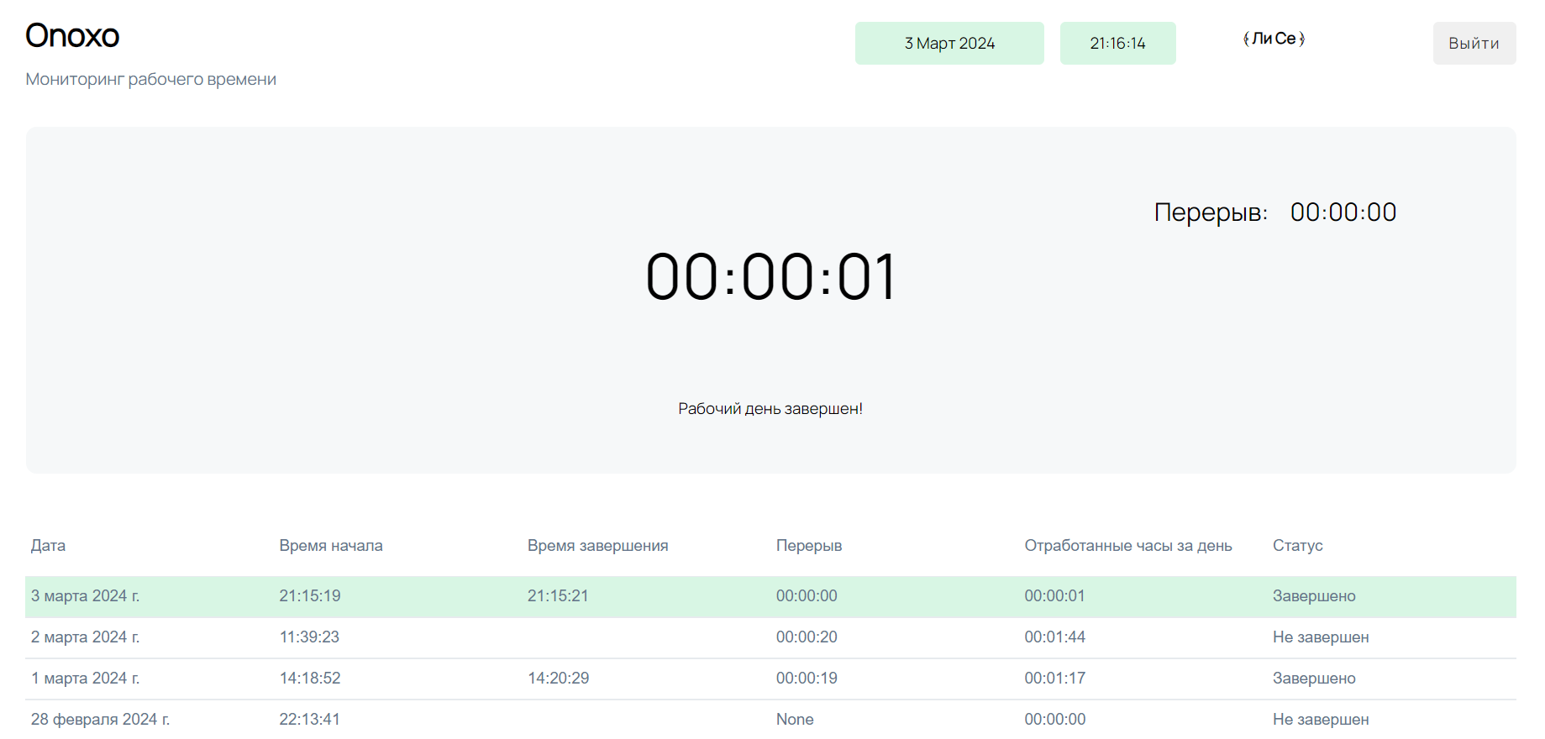

You can also see the name of the company where you work in the upper left corner:

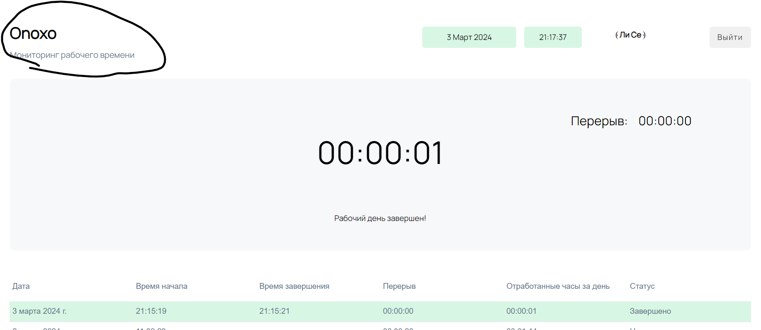

5. Overall system development plan

5.1.Master schedule and milestones

5.1.1. Master schedule

The master schedule for this project is shown in “Master Schedule.”

|  |  |  |  |
| --- | --- | --- | --- |
| Research of the subject area and choice of platform for project development | in progress | 02.02.2024 | NA |
| Design | in progress | 05.02.2024 | NA |
| Database creation | in progress | 07.02.2024 | NA |
| Development of an administrative panel | in progress | 12.02.2024 | NA |
| Development of a system for users | in progress | 17.02.2024 | NA |
| Testing | not startet | 25.02.2024 | NA |
| Report | not startet | 01.03.2024 | NA |
|  |  |  |  |

5.1.2. Milestones

The milestones of this project are belows .

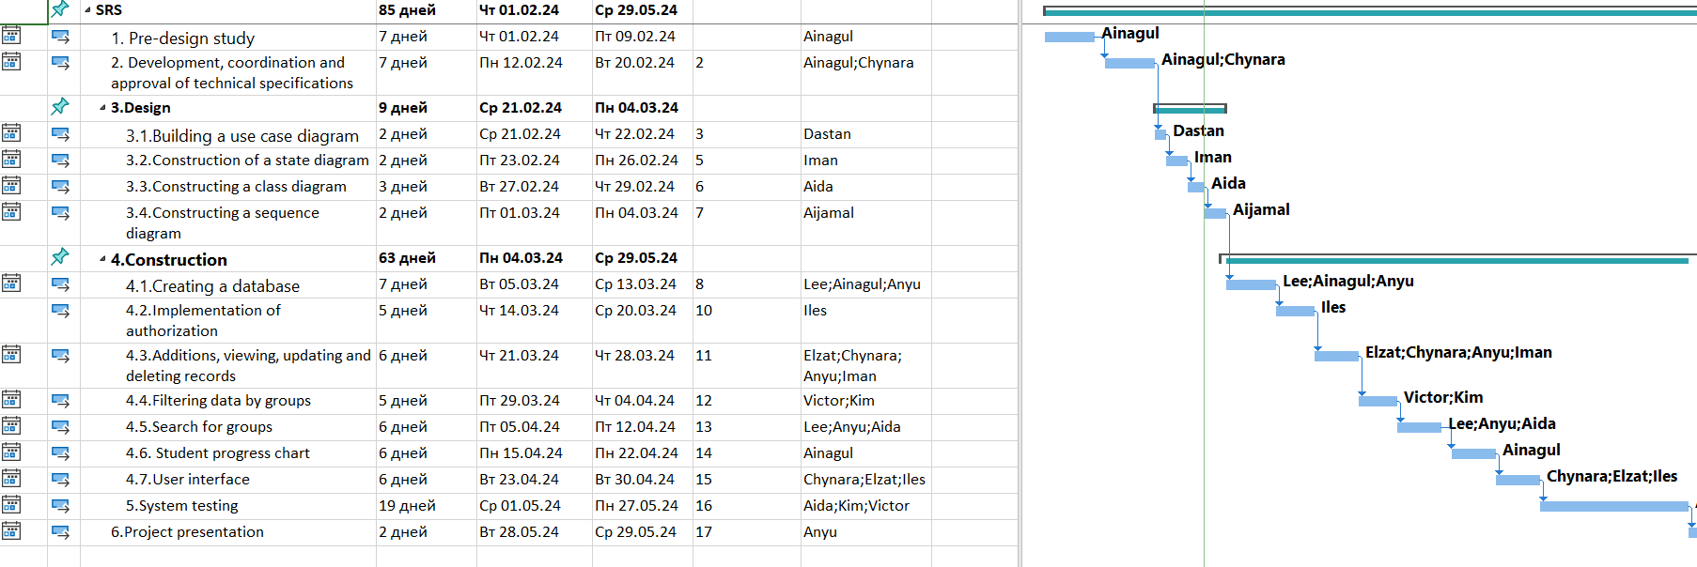

5.2. Organization/Personnel Plan

5.2.1. Project organization/personnel chart

The organization/personel chart of this project is belows,

NewTech company

Xxx Student and teacher

IT Dep.

-Ainagul

-Lee

-Chang

XX Service

Sales Dep.

-Asanbekov Omurbek

Customer Service

-Lee

Technical

- manager

ABC Hard Corp.

Sales Dep.

-Asanbekov Omurbek

Customer Service

-Lee

Technical

-(manager)

AppDep.

-Ainagul Omurbekova

Operation Dep.

-Abdyshova Aida

Infra Dep.

-Se Lee Hen

5.3. Facility/environmental plan

5.3.1. Working location and working environment

The work location and work environment for this project are NewTech company office.

6.Management Plan

The management plan and rules for this project will be described in each management plans.

6.1 Scope management

The scope management procedures refer to the "Scope Management Plan".

6.2 Schedule management

The schedule management procedures refer to the "Schedule Management Plan".

6.3 Communication management

The communication management procedures refer to the "Communication Management Plan”

6.4 Cost Management

The cost management procedures refer to the "Cost Management Plan".

6.5 Quality Management

The quality management procedures refer to the "Quality Management Plan".

6.6 Risk Management

The project risks procedures refer to the "Risk Management Plan"

6.7 Purchasing management

The purchasing management procedures refer to the “Procurement Management Plan".