**AYUSH TRIPATHI** January 16TH, 2024

**22CS3021**

**WEB TECHNOLOGY LAB-1 ASSIGNMENT**

**T1:** html code:

<!DOCTYPE html>

<html lang="en">

<head>

    <meta charset="UTF-8">

    <meta name="viewport" content="width=device-width, initial-scale=1.0">

    <title>Simple Web Page</title>

</head>

<body>

    <header> <h1>Welcome to Web Technology</h1> </header>

    <p>A computer science portal for B. Tech.</p>

</body>

</html>

Web Page:

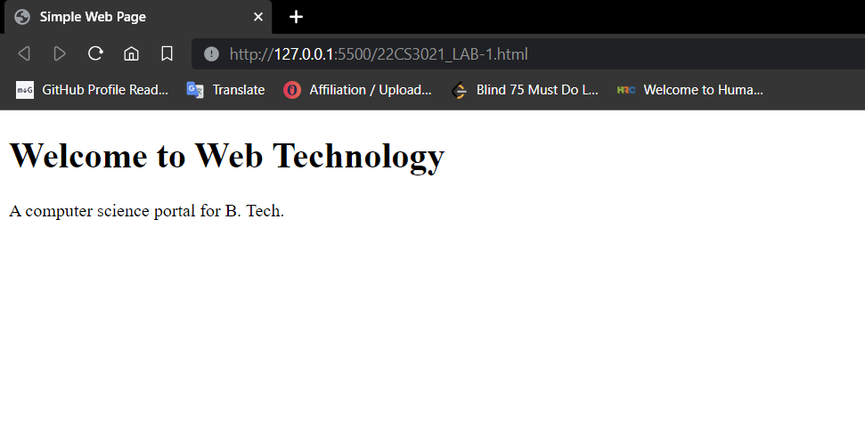

**T2:** html code:

<!DOCTYPE html>

<html lang="en">

<head>

    <meta charset="UTF-8">

    <meta name="viewport" content="width=device-width, initial-scale=1.0">

    <title>Simple Web Page</title>

</head>

<body>

    <header>

        <h1>Welcome to Web Technology</h1>

        <h2>Welcome to Web Technology</h2>

        <h3>Welcome to Web Technology</h3>

        <h4>Welcome to Web Technology</h4>

        <h5>Welcome to Web Technology</h5>

        <h6>Welcome to Web Technology</h6>

        <p>Welcome to Web Technology</p>

    </header>

    <br>

    <p>A computer science portal for B. Tech.</p>

</body>

</html>

Web Page:

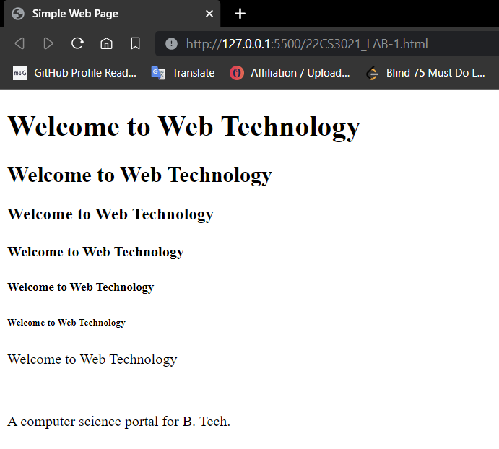

**T3:** html code:

<!DOCTYPE html>

<html lang="en">

<head>

    <meta charset="UTF-8">

    <meta name="viewport" content="width=device-width, initial-scale=1.0">

    <title>Simple Web Page</title>

</head>

<body>

    <header>

        <h1>Multiline Paragraph</yh1>

    </header>

    <br>

    <p>Lorem, ipsum dolor sit amet consectetur adipisicing elit. Doloremque, sed.</p>

    <p>Lorem ipsum dolor sit amet consectetur adipisicing elit. Iste quam at consequuntur facere fugit, corrupti nostrum libero nulla quas porro.</p>

    <p>Lorem ipsum, dolor sit amet consectetur adipisicing elit. Adipisci iusto aspernatur commodi veniam! Facere omnis itaque, placeat possimus maxime dolores dignissimos quae! Explicabo rerum illo, debitis in accusantium hic totam numquam earum beatae impedit expedita minus cumque esse aperiam ab eum quod neque, repudiandae vel deleniti porro eligendi suscipit nisi labore. Odit, assumenda repellendus dolores nobis dolore libero fugit nemo commodi tempore explicabo maiores, omnis tempora labore veniam quae unde!</p>

    <p>Lorem ipsum dolor sit amet consectetur adipisicing elit. Cupiditate, minima voluptates provident temporibus nemo deserunt?</p>

</body>

</html>

**Web Page:**

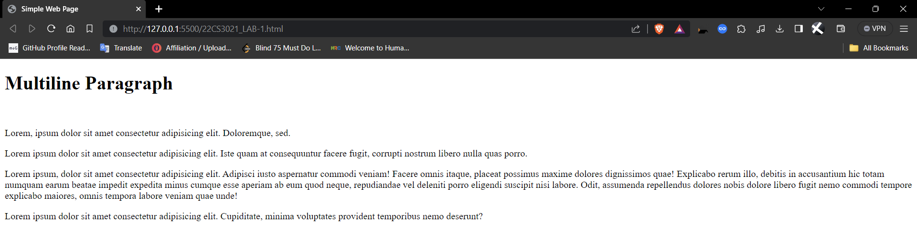

**T4:** html code:

<!DOCTYPE html>

<html lang="en">

<head>

    <meta charset="UTF-8">

    <meta name="viewport" content="width=device-width, initial-scale=1.0">

    <title>Simple Web Page</title>

</head>

<body>

    <header>

        <h1>Multiline Paragraph</yh1>

    </header>

    <br>

    <p>Lorem, ipsum dolor sit amet <p>This is nested paragraph under a paragraph</p>  consectetur adipisicing elit. Doloremque, sed.</p>

</body>

</html>

Web Page:

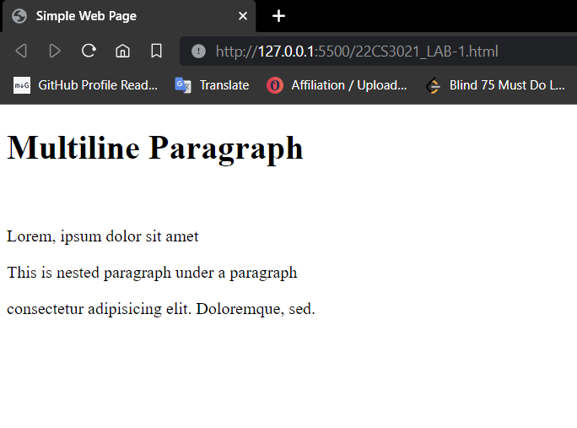

**H5:** html code:

<!DOCTYPE html>

<html lang="en">

<head>

    <meta charset="UTF-8">

    <meta name="viewport" content="width=device-width, initial-scale=1.0">

    <title>Simple Web Page</title>

</head>

<body>

    <p>Lorem, ipsum dolor sit amet <h1>This is a heading nested in a paragraph</h1>  consectetur adipisicing elit. Doloremque, sed.</p>

</body>

</html>

Web Page:

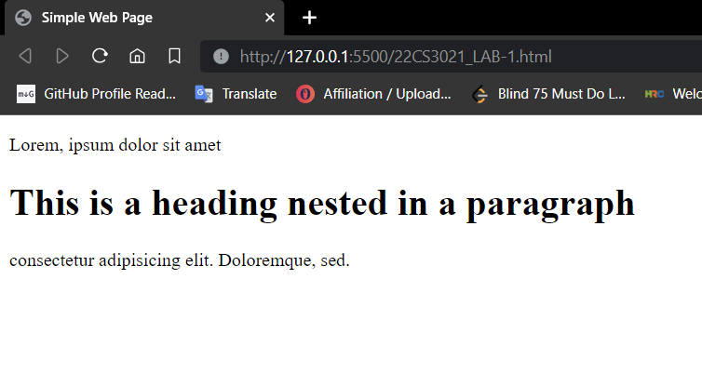

**H6:** html code:

<!DOCTYPE html>

<html lang="en">

<head>

    <meta charset="UTF-8">

    <meta name="viewport" content="width=device-width, initial-scale=1.0">

    <title>Simple Web Page</title>

</head>

<body>

    <h1>This is a heading with <p>This is paragraph nested inside heading</p> a paragraph nested inside it.</h1>

</body>

</html>

Web Page:

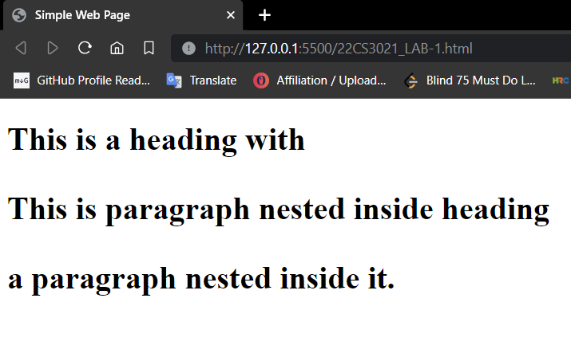

**H7:** html code:

<!DOCTYPE html>

<html lang="en">

<head>

    <meta charset="UTF-8">

    <meta name="viewport" content="width=device-width, initial-scale=1.0">

    <title>Simple Web Page</title>

</head>

<body>

    <h1>This is a heading with <h2>This is heading nested inside another heading</h2> another heading nested inside it.</h1>

</body>

</html>

Web Page:

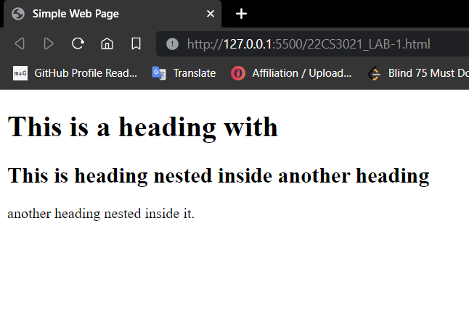

**H8:**  html code:

<!DOCTYPE html>

<html lang="en">

<head>

    <meta charset="UTF-8">

    <meta name="viewport" content="width=device-width, initial-scale=1.0">

    <title>Simple Web Page</title>

</head>

<body>

    <h1>Image tag below this:</h1>

    <img src="https://www.codingdojo.com/blog/wp-content/uploads/9-Types-of-Developers-Which-One-Will-You-Be-01.jpg" alt="Boy Image">

</body>

</html>

Web page:

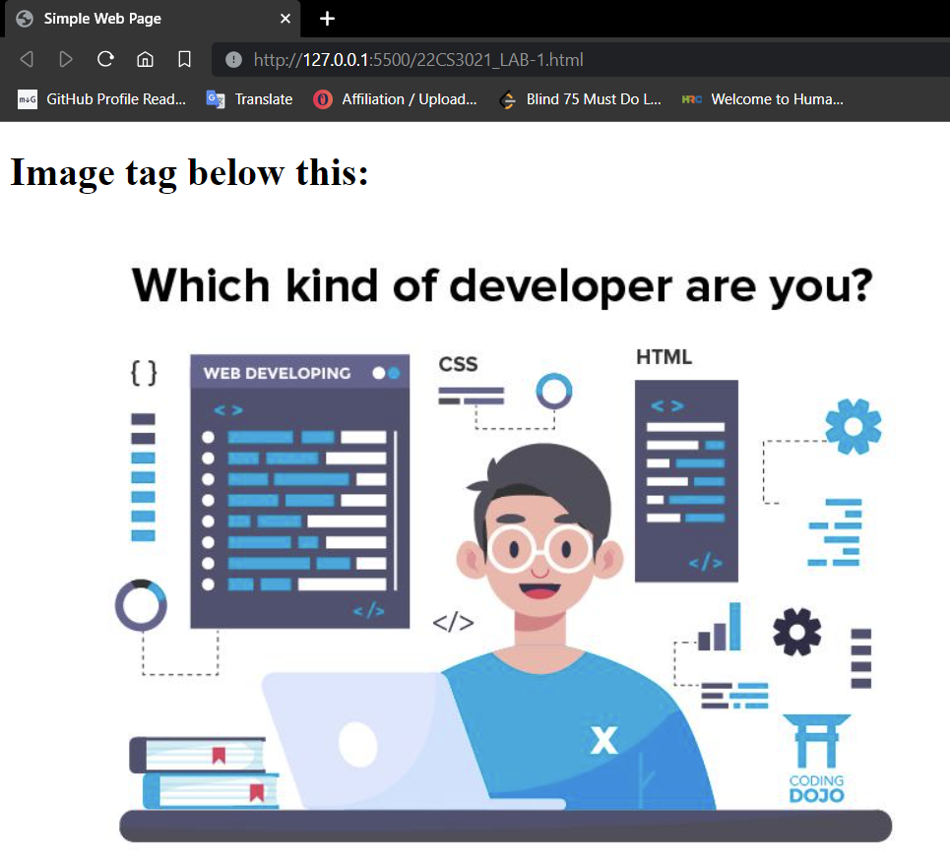

**H9:** html code:

<!DOCTYPE html>

<html lang="en">

<head>

    <meta charset="UTF-8">

    <meta name="viewport" content="width=device-width, initial-scale=1.0">

    <title>Simple Web Page</title>

    <style>

        img{

            width: 250px;

            height: 200px;

        }

    </style>

</head>

<body>

    <h1>Image tag below this:</h1>

    <p>Changed image height and width of the image using styling method inside head tag</p>

    <img src="https://www.codingdojo.com/blog/wp-content/uploads/9-Types-of-Developers-Which-One-Will-You-Be-01.jpg" alt="Boy Image">

</body>

</html>

Web Page:



