Ayush Tripathi 2nd of April, 2024

22CS3021

Web Technology Assignment Lab-10

1: Connect to a MongoDB server using MongoDB Compass.

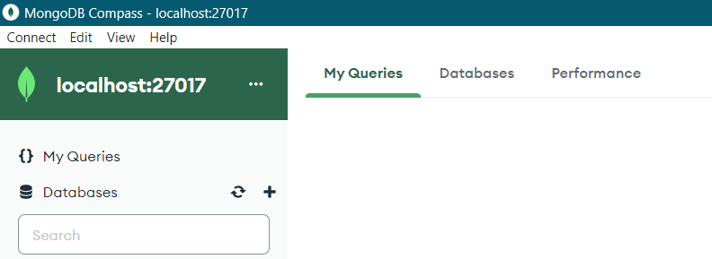

2 and 3: Create a new database named "testdb" in MongoDB Compass. And Create a new collection named "students" in the "testdb" database.

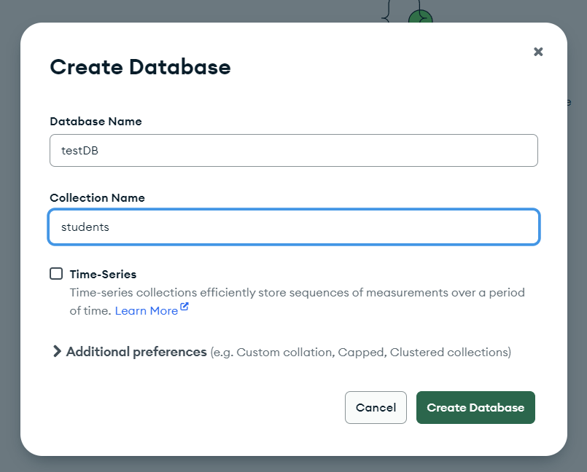

4: Insert ten documents into the "students" collection with the following fields: name, age, and email.

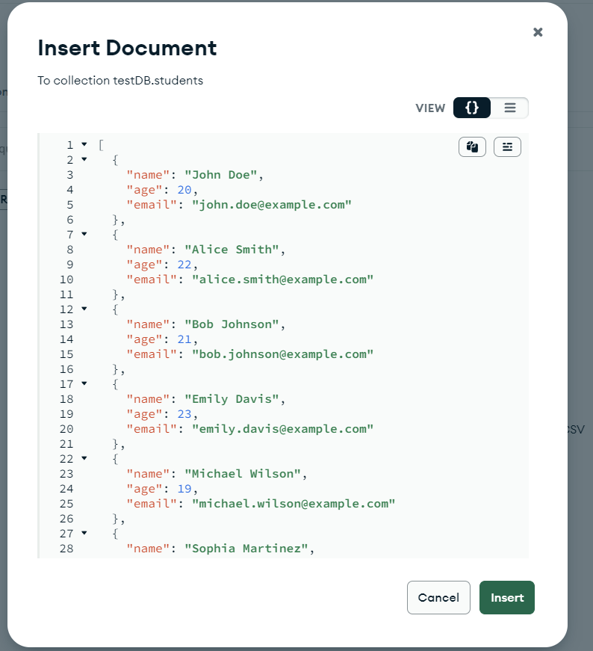

5: View the contents of the "students" collection.

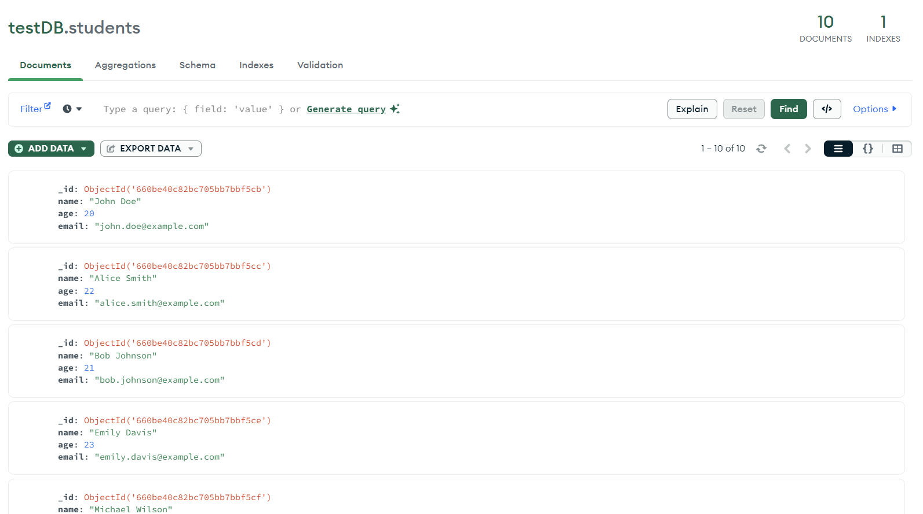

6: Update the age of a specific student in the "students" collection.

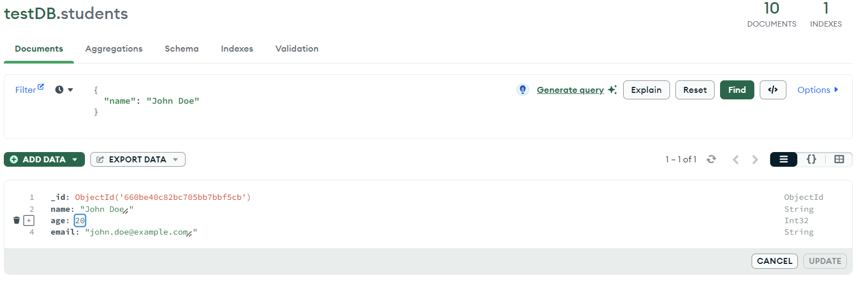

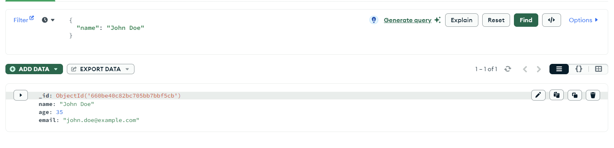

Updated age of john doe from 20 to 35

7: Delete a document from the "students" collection based on a specific

condition.

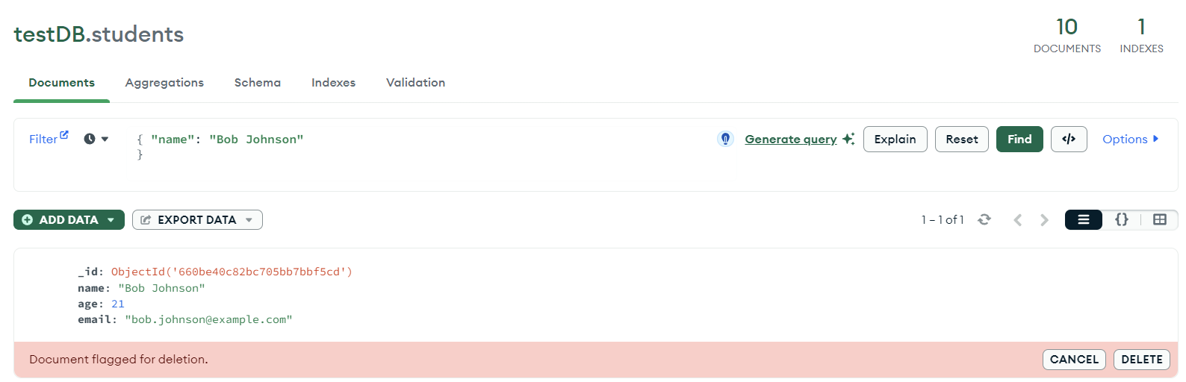

8: Use the aggregation pipeline to calculate the average age of all students in the "students" collection.

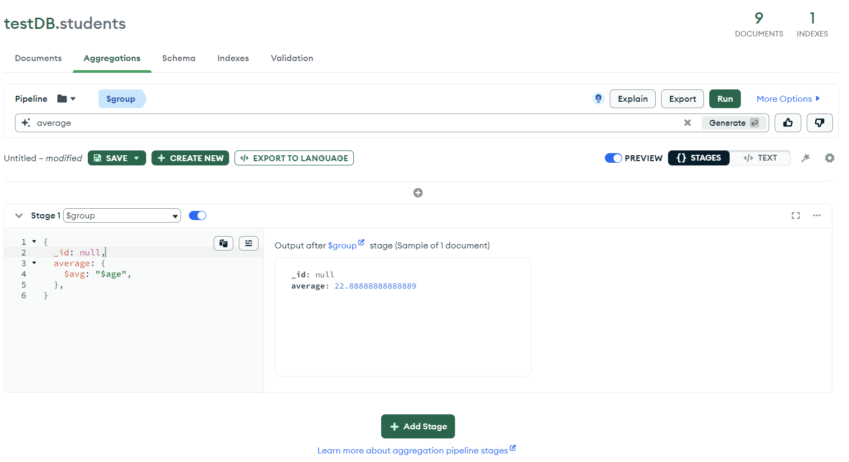

Here average is : 22.88

9: Create an index on the "name" field in the "students" collection.

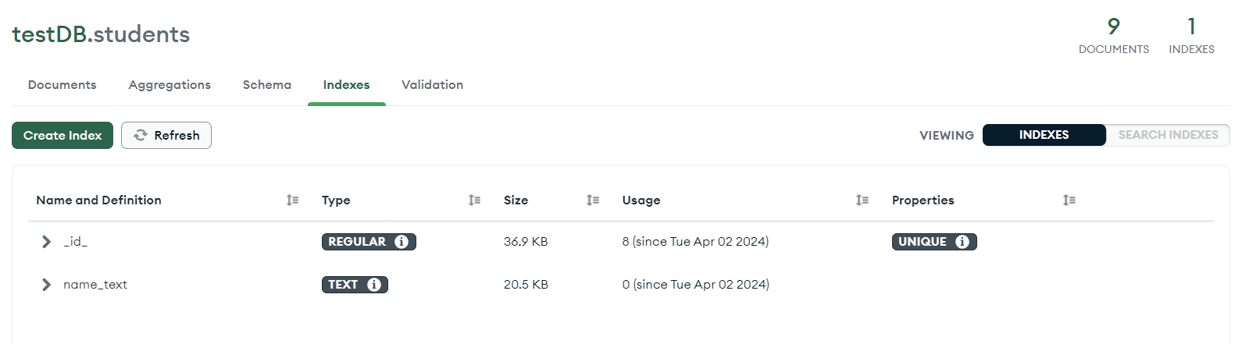

10: Export the contents of the "students" collection to a JSON file.

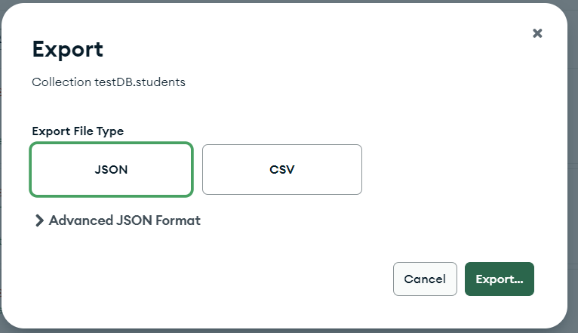

11: Perform a complex aggregation operation to find the top 5 oldest students in the "students" collection.

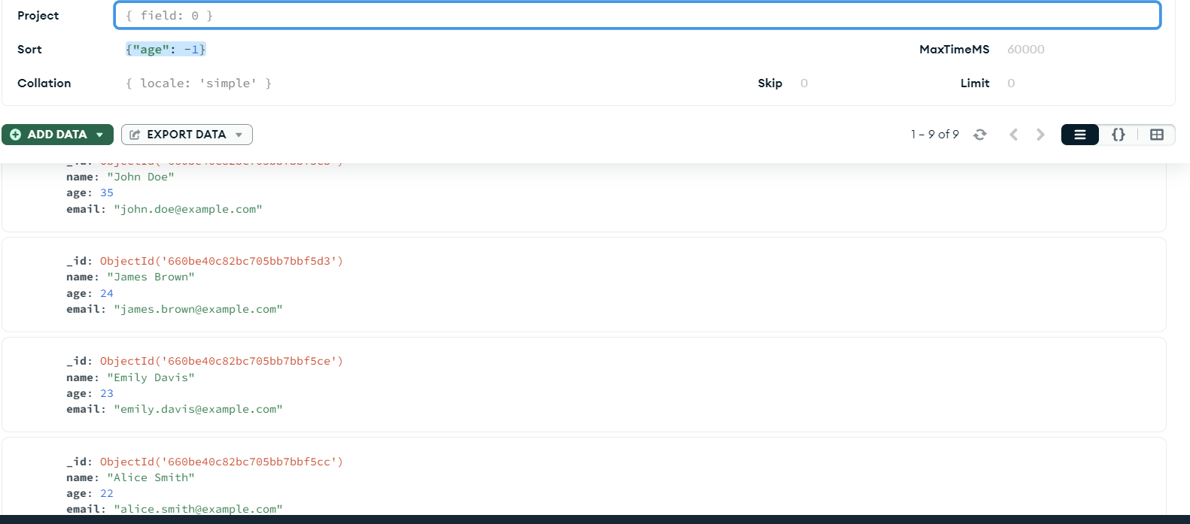

12: Create a geospatial index on a field representing the location of students.

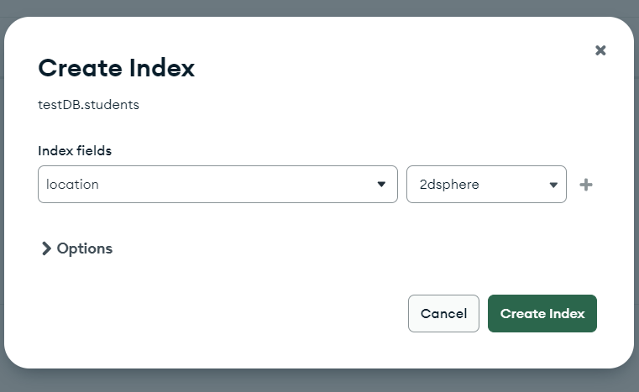

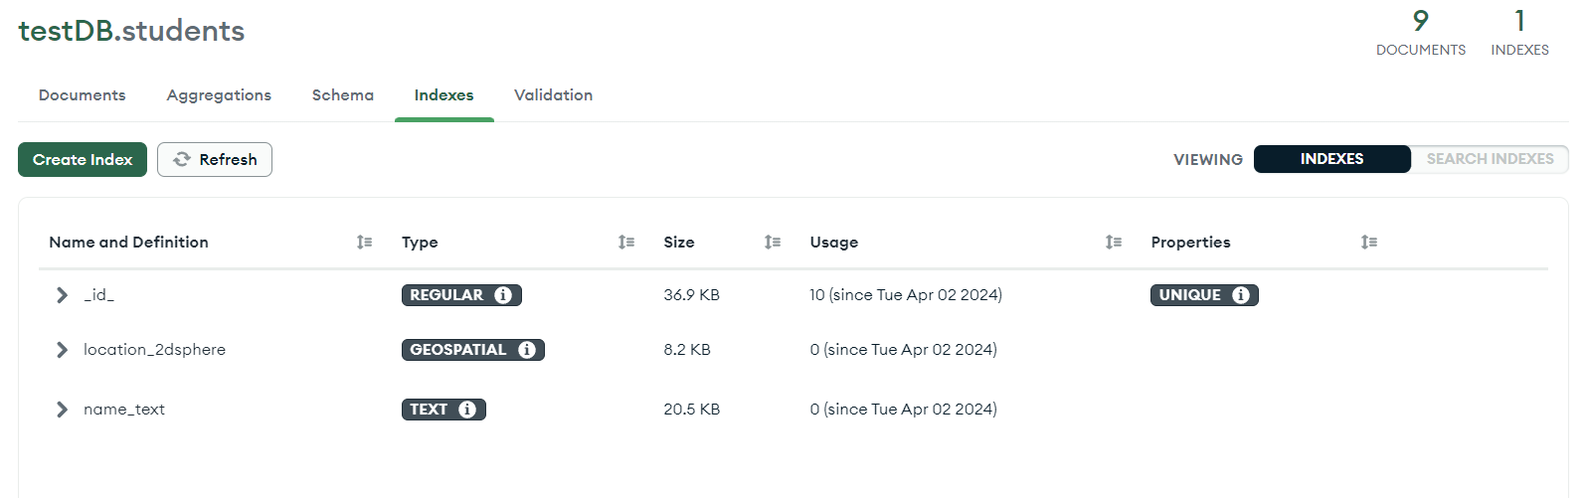

13: Use MongoDB Compass to visualize the data distribution in the "students" collection.

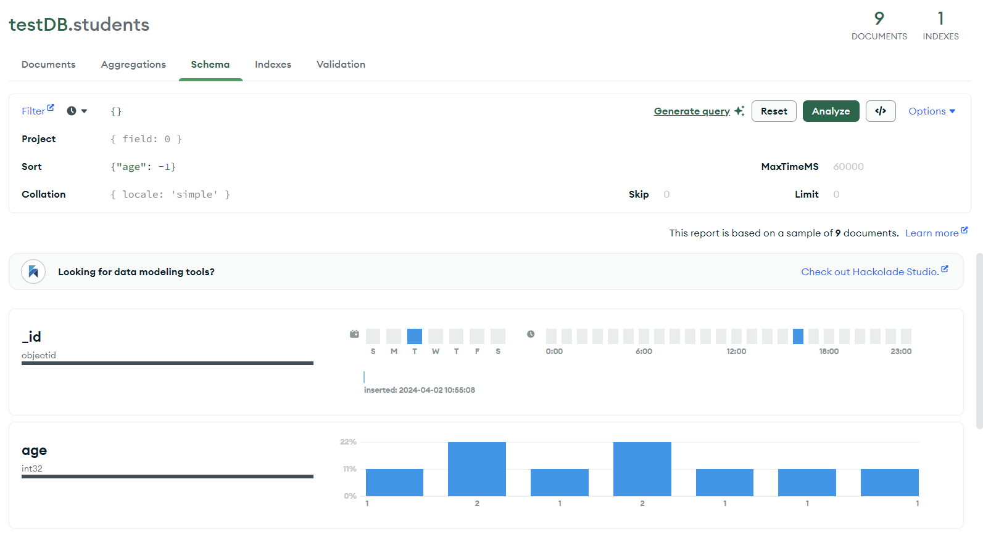

14: Set up a data validation rule to ensure that documents in the "students" collection must have a non-empty name field.

