Ayush Tripathi 13th February, 2024

22CS3021

Web Technology Assignment-5

T1: Code:

<!DOCTYPE html>

<html lang="en">

<head>

<meta charset="UTF-8">

<meta name="viewport" content="width=device-width, initial-scale=1.0">

<title>Word Spinner</title>

<style>

  #word {

    display: inline-block;

    transition: transform 3s ease;

  }

  .spin-animation {

    transform: rotateY(360deg);

  }

</style>

</head>

<body>

  <h2 id="word">Hello</h2>

  <input type="text" id="inputWord" placeholder="Enter a word or phrase">

  <button onclick="changeWord()">Change</button>

  <script>

    function changeWord() {

      const input = document.getElementById("inputWord");

      const newWord = input.value;

      const wordElement = document.getElementById("word");

      wordElement.textContent = newWord;

      wordElement.classList.add("spin-animation");

      setTimeout(() => {

        wordElement.classList.remove("spin-animation");

      }, 1000);

    }

  </script>

</body>

</html>

Web Page:

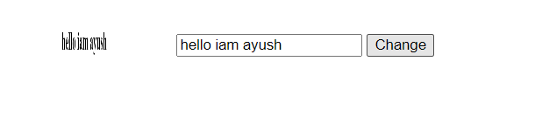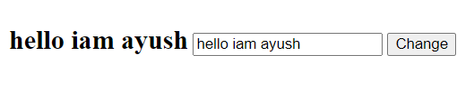

T2: code:

<!DOCTYPE html>

<html lang="en">

<head>

<meta charset="UTF-8">

<meta name="viewport" content="width=device-width, initial-scale=1.0">

<title>Counter</title>

<style>

  #count {

    font-size: 16px; /\* Initial font size \*/

  }

</style>

</head>

<body>

  <button onclick="incrementCount()">Increment Count</button>

  <p id="count">0</p>

  <script>

    let count = 0;

    function incrementCount() {

      count++;

      document.getElementById("count").innerText = count;

      updateFontSize();

    }

    function updateFontSize() {

      const fontSizeIncrement = 2; // You can adjust this value as needed

      const newFontSize = 16 + (count \* fontSizeIncrement);

      document.getElementById("count").style.fontSize = newFontSize + "px";

    }

  </script>

</body>

</html>

Web Page:

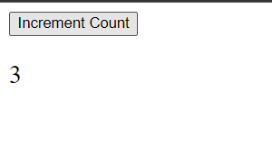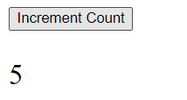

T3: code:

<!DOCTYPE html>

<html lang="en">

<head>

<meta charset="UTF-8">

<meta name="viewport" content="width=device-width, initial-scale=1.0">

<title>Counter with List</title>

<style>

  #countList {

    list-style-type: none;

    padding: 0;

  }

  #countList li {

    font-size: 16px;

    margin-bottom: 5px;

  }

</style>

</head>

<body>

  <button onclick="incrementCount()">Increment Count</button>

  <ul id="countList"></ul>

  <script>

    let count = 0;

    function incrementCount() {

      count++;

      const newListItem = document.createElement("li");

      newListItem.textContent = count;

      document.getElementById("countList").appendChild(newListItem);

      updateFontSize(newListItem);

    }

    function updateFontSize(listItem) {

      const fontSizeIncrement = 2;

      const currentFontSize = parseInt(window.getComputedStyle(listItem).fontSize);

      const newFontSize = currentFontSize + fontSizeIncrement;

      listItem.style.fontSize = newFontSize + "px";

    }

  </script>

</body>

</html>

Web Page:

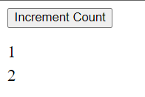 Next => 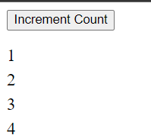

T4: Code:

<!DOCTYPE html>

<html lang="en">

<head>

<meta charset="UTF-8">

<meta name="viewport" content="width=device-width, initial-scale=1.0">

<title>Add Rows to Table</title>

<style>

  body {

    font-family: Arial, sans-serif;

  }

  table {

    width: 50%;

    border-collapse: collapse;

    margin: 20px auto;

  }

  th, td {

    border: 1px solid #dddddd;

    text-align: center;

    padding: 8px;

  }

  th {

    background-color: #f2f2f2;

  }

  button {

    display: block;

    margin: 20px auto;

    padding: 10px 20px;

    font-size: 16px;

    background-color: #4CAF50;

    color: white;

    border: none;

    border-radius: 4px;

    cursor: pointer;

  }

  button:hover {

    background-color: #45a049;

  }

</style>

</head>

<body>

  <button id="addButton">Add Row</button>

  <table id="myTable">

    <thead>

      <tr>

        <th>Row Number</th>

        <th>Sum of Previous Two Rows</th>

      </tr>

    </thead>

    <tbody>

      <tr>

        <td>1</td>

        <td>1</td>

      </tr>

      <tr>

        <td>2</td>

        <td>1</td>

      </tr>

    </tbody>

  </table>

  <script>

    document.getElementById("addButton").addEventListener("click", function() {

      const table = document.getElementById("myTable");

      const tbody = table.getElementsByTagName("tbody")[0];

      const rows = tbody.getElementsByTagName("tr");

      let lastSum, secondLastSum;

      if (rows.length > 0) {

        const lastRow = rows[rows.length - 1];

        lastSum = parseInt(lastRow.lastElementChild.innerText);

        if (rows.length > 1) {

          const secondLastRow = rows[rows.length - 2];

          secondLastSum = parseInt(secondLastRow.lastElementChild.innerText);

        } else {

          secondLastSum = 0;

        }

      } else {

        lastSum = 0;

        secondLastSum = 0;

      }

      const newSum = lastSum + secondLastSum;

      const newRow = document.createElement("tr");

      const newRowNumber = document.createElement("td");

      newRowNumber.innerText = rows.length + 1;

      const newRowSum = document.createElement("td");

      newRowSum.innerText = newSum;

      newRow.appendChild(newRowNumber);

      newRow.appendChild(newRowSum);

      tbody.appendChild(newRow);

    });

  </script>

</body>

</html>

Web Page:

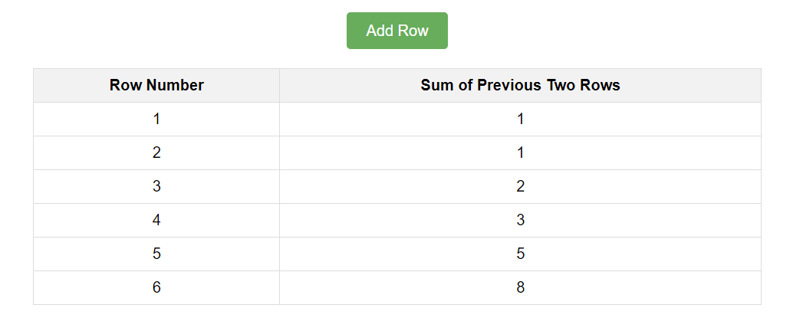

T5: code:

<!DOCTYPE html>

<html lang="en">

<head>

<meta charset="UTF-8">

<meta name="viewport" content="width=device-width, initial-scale=1.0">

<title>Calculator</title>

<style>

  body {

    font-family: Arial, sans-serif;

  }

  input[type="text"] {

    padding: 8px;

    margin: 5px;

    width: 150px;

  }

  button {

    padding: 8px 16px;

    margin: 5px;

    font-size: 16px;

    cursor: pointer;

  }

  #result {

    margin-top: 20px;

    font-size: 20px;

    font-weight: bold;

  }

</style>

</head>

<body>

  <input type="text" id="input1" placeholder="Enter number 1">

  <input type="text" id="input2" placeholder="Enter number 2">

  <br>

  <button onclick="performOperation('+')">+</button>

  <button onclick="performOperation('-')">-</button>

  <button onclick="performOperation('\*')">\*</button>

  <button onclick="performOperation('/')">/</button>

  <br>

  <div id="result"></div>

  <script>

    function performOperation(operator) {

      const input1 = document.getElementById("input1").value;

      const input2 = document.getElementById("input2").value;

      const number1 = parseInt(input1);

      const number2 = parseInt(input2);

      let result;

      switch (operator) {

        case '+':

          result = number1 + number2;

          break;

        case '-':

          result = number1 - number2;

          break;

        case '\*':

          result = number1 \* number2;

          break;

        case '/':

          if (number2 !== 0) {

            result = number1 / number2;

          } else {

            result = "Cannot divide by zero";

          }

          break;

        default:

          result = "Invalid operator";

      }

      document.getElementById("result").innerText = "Result: " + result;

    }

  </script>

</body>

</html>

Web Page:

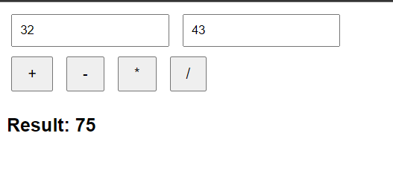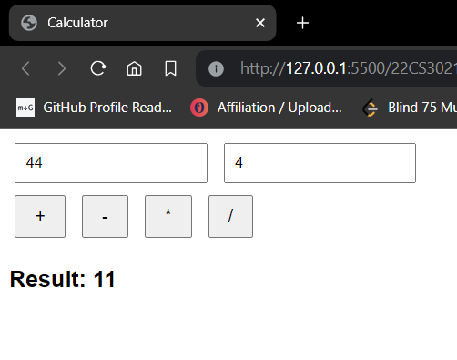

T6: Code:

<!DOCTYPE html>

<html lang="en">

<head>

<meta charset="UTF-8">

<meta name="viewport" content="width=device-width, initial-scale=1.0">

<title>Dynamic Page Creation</title>

<style>

  body {

    font-family: Arial, sans-serif;

    margin: 0;

    padding: 0;

    background-color: #f0f0f0;

    text-align: center;

  }

  #container {

    max-width: 800px;

    margin: 20px auto;

    background-color: #fff;

    padding: 20px;

    border-radius: 10px;

    box-shadow: 0 0 10px rgba(0, 0, 0, 0.1);

  }

  button {

    padding: 10px 20px;

    font-size: 16px;

    background-color: #4CAF50;

    color: white;

    border: none;

    border-radius: 4px;

    cursor: pointer;

  }

  h1 {

    margin-top: 30px;

  }

  ol {

    list-style-type: lower-roman;

    text-align: left;

  }

</style>

</head>

<body>

<button id="createButton">Create Page</button>

<script>

  function createPage() {

    const createButton = document.getElementById("createButton");

    createButton.parentNode.removeChild(createButton);

    const containerDiv = document.createElement("div");

    containerDiv.id = "container";

    const h1 = document.createElement("h1");

    h1.textContent = "Dynamic Page Creation";

    containerDiv.appendChild(h1);

    const paragraph = document.createElement("p");

    paragraph.textContent = "Lorem ipsum dolor sit amet, consectetur adipiscing elit.";

    containerDiv.appendChild(paragraph);

    const ol = document.createElement("ol");

    for (let i = 0; i < 2; i++) {

      const li = document.createElement("li");

      li.textContent = "Item " + (i + 1);

      ol.appendChild(li);

    }

    containerDiv.appendChild(ol);

    document.body.appendChild(containerDiv);

  }

  document.getElementById("createButton").addEventListener("click", createPage);

</script>

</body>

</html>

Web Page:

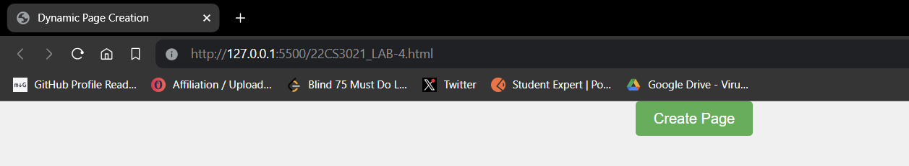

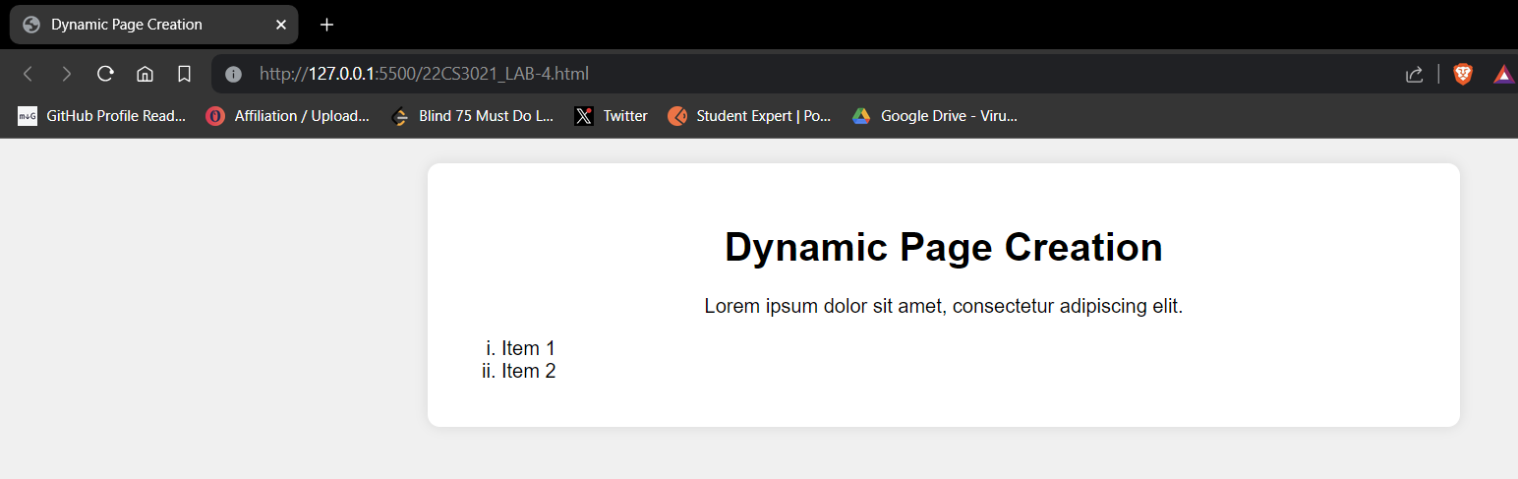

T7: Code:

<!DOCTYPE html>

<html lang="en">

<head>

<meta charset="UTF-8">

<meta name="viewport" content="width=device-width, initial-scale=1.0">

<title>Tip Calculator</title>

<style>

  body {

    font-family: Arial, sans-serif;

    text-align: center;

    background-color: #f0f0f0;

  }

  .container {

    max-width: 400px;

    margin: 100px auto;

    padding: 20px;

    background-color: #fff;

    border-radius: 8px;

    box-shadow: 0 0 10px rgba(0, 0, 0, 0.1);

  }

  input[type="number"] {

    width: 100px;

    padding: 8px;

    margin: 5px;

    border-radius: 4px;

    border: 1px solid #ccc;

  }

  button {

    padding: 10px 20px;

    font-size: 16px;

    background-color: #4CAF50;

    color: white;

    border: none;

    border-radius: 4px;

    cursor: pointer;

  }

  #tipAmount {

    margin-top: 20px;

    font-size: 20px;

    font-weight: bold;

  }

</style>

</head>

<body>

<div class="container">

  <label for="totalAmount">Total Amount (₹):</label>

  <input type="number" id="totalAmount">

  <br>

  <label for="tipPercentage">Tip Percentage (%):</label>

  <input type="number" id="tipPercentage">

  <br>

  <label for="numPeople">Number of People:</label>

  <input type="number" id="numPeople">

  <br>

  <button onclick="calculateTip()">Calculate Tip</button>

  <div id="tipAmount"></div>

</div>

<script>

  function calculateTip() {

    const totalAmount = parseFloat(document.getElementById("totalAmount").value);

    const tipPercentage = parseFloat(document.getElementById("tipPercentage").value);

    const numPeople = parseInt(document.getElementById("numPeople").value);

    if (isNaN(totalAmount) || isNaN(tipPercentage) || isNaN(numPeople) || totalAmount <= 0 || tipPercentage < 0 || numPeople <= 0) {

      document.getElementById("tipAmount").innerText = "Please enter valid numbers.";

    } else {

      const tipAmount = (totalAmount \* (tipPercentage / 100)) / numPeople;

      document.getElementById("tipAmount").innerText = "Tip Amount per Person: ₹" + tipAmount.toFixed(2);

    }

  }

</script>

</body>

</html>

Web Page:

