Ayush Tripathi 5th March, 2024

22CS3O21

Web Tech Assignment Lab-8

T1: Code of App.js file in my React App:-

import React, { useState } from 'react';

const CurrencyConverter = () => {

  const [amount, setAmount] = useState('');

  const [fromCurrency, setFromCurrency] = useState('INR');

  const [toCurrency, setToCurrency] = useState('USD');

  const [convertedAmount, setConvertedAmount] = useState(0);

  const exchangeRate = 0.014;

  const handleAmountChange = (e) => {

    setAmount(e.target.value);

  };

  const handleFromCurrencyChange = (e) => {

    setFromCurrency(e.target.value);

  };

  const handleToCurrencyChange = (e) => {

    setToCurrency(e.target.value);

  };

  const convertCurrency = () => {

    const converted = amount \* exchangeRate;

    setConvertedAmount(converted.toFixed(2));

  };

  return (

    <div>

      <h2>Currency Converter</h2>

      <div>

        <label>Amount:</label>

        <input type="number" value={amount} onChange={handleAmountChange} />

      </div>

      <div>

        <label>From:</label>

        <select value={fromCurrency} onChange={handleFromCurrencyChange}>

          <option value="INR">INR</option>

        </select>

      </div>

      <div>

        <label>To:</label>

        <select value={toCurrency} onChange={handleToCurrencyChange}>

          <option value="USD">USD</option>

        </select>

      </div>

      <button onClick={convertCurrency}>Convert</button>

      {convertedAmount > 0 && (

        <div>

          <h3>Converted Amount:</h3>

          <p>{convertedAmount} {toCurrency}</p>

        </div>

      )}

    </div>

  );

};

export default CurrencyConverter;

React App:

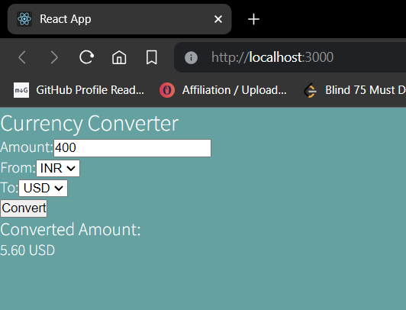

T2: Code of App.js file in my react app:

import React, { useState } from 'react';

const Stopwatch = () => {

  const [time, setTime] = useState(0);

  const [isRunning, setIsRunning] = useState(false);

  const [intervalId, setIntervalId] = useState(null);

  const startTimer = () => {

    if (!isRunning) {

      const id = setInterval(() => {

        setTime(prevTime => prevTime + 1);

      }, 1000);

      setIntervalId(id);

      setIsRunning(true);

    }

  };

  const pauseTimer = () => {

    clearInterval(intervalId);

    setIsRunning(false);

  };

  const resetTimer = () => {

    clearInterval(intervalId);

    setTime(0);

    setIsRunning(false);

  };

  const formatTime = (time) => {

    const hours = Math.floor(time / 3600);

    const minutes = Math.floor((time % 3600) / 60);

    const seconds = time % 60;

    const formattedTime = [

      hours.toString().padStart(2, '0'),

      minutes.toString().padStart(2, '0'),

      seconds.toString().padStart(2, '0')

    ].join(':');

    return formattedTime;

  };

  return (

    <div>

      <h2>Stopwatch</h2>

      <div>

        <p>{formatTime(time)}</p>

      </div>

      <div>

        {!isRunning ? (

          <button onClick={startTimer}>Start</button>

        ) : (

          <button onClick={pauseTimer}>Pause</button>

        )}

        <button onClick={resetTimer}>Reset</button>

      </div>

    </div>

  );

};

export default Stopwatch;

React App :-

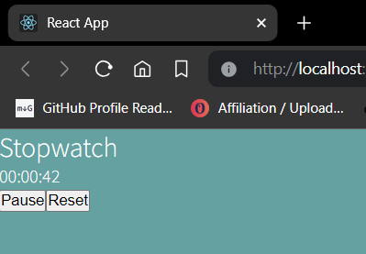

T3: Code from App.js of react app:

import React, { useState } from 'react';

const App = () => {

  const [userAMessages, setUserAMessages] = useState([]);

  const [userBMessages, setUserBMessages] = useState([]);

  const [newMessageA, setNewMessageA] = useState('');

  const [newMessageB, setNewMessageB] = useState('');

  const handleMessageSendA = () => {

    if (newMessageA.trim() !== '') {

      const newMessageObj = {

        text: newMessageA,

        sender: 'A',

        timestamp: new Date().toISOString()

      };

      setUserAMessages([...userAMessages, newMessageObj]);

      setNewMessageA('');

    }

  };

  const handleMessageSendB = () => {

    if (newMessageB.trim() !== '') {

      const newMessageObj = {

        text: newMessageB,

        sender: 'B',

        timestamp: new Date().toISOString()

      };

      setUserBMessages([...userBMessages, newMessageObj]);

      setNewMessageB('');

    }

  };

  return (

    <div className="app">

      <div className="user-section">

        <h2>User A</h2>

        <div className="message-section">

          <h3>Messages from User B</h3>

          <div className="message-container">

            {userBMessages.map((message, index) => (

              <div key={index} className="message from-b">

                <p>{message.text}</p>

                <p className="timestamp">Sent by B at: {new Date(message.timestamp).toLocaleString()}</p>

              </div>

            ))}

          </div>

          <input

            type="text"

            value={newMessageA}

            onChange={(e) => setNewMessageA(e.target.value)}

            placeholder="Type your message..."

          />

          <button onClick={handleMessageSendA}>Send</button>

        </div>

      </div>

      <div className="user-section">

        <h2>User B</h2>

        <div className="message-section">

          <h3>Messages from User A</h3>

          <div className="message-container">

            {userAMessages.map((message, index) => (

              <div key={index} className="message from-a">

                <p>{message.text}</p>

                <p className="timestamp">Sent by A at: {new Date(message.timestamp).toLocaleString()}</p>

              </div>

            ))}

          </div>

          <input

            type="text"

            value={newMessageB}

            onChange={(e) => setNewMessageB(e.target.value)}

            placeholder="Type your message..."

          />

          <button onClick={handleMessageSendB}>Send</button>

        </div>

      </div>

    </div>

  );

};

export default App;

React App:

