Ayush Tripathi 9th April, 2024

22CS3021

Web Technology Lab Assignment-11

Task 1: Portfolio Performance Score on pageSpeed insights

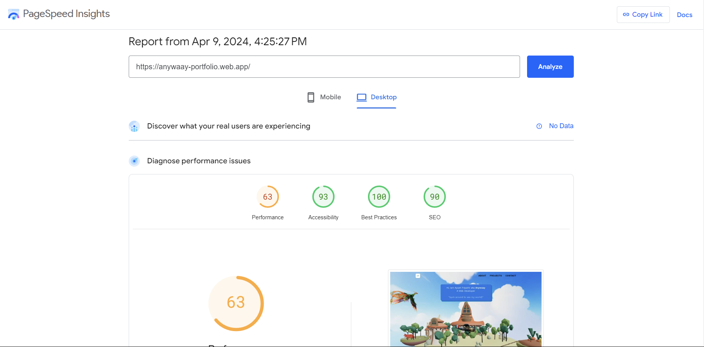

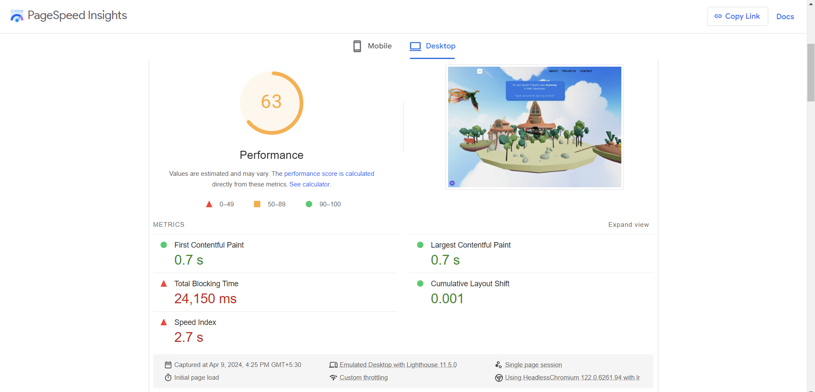

Task 2: MERN (MongoDB)

Mongodb atlas

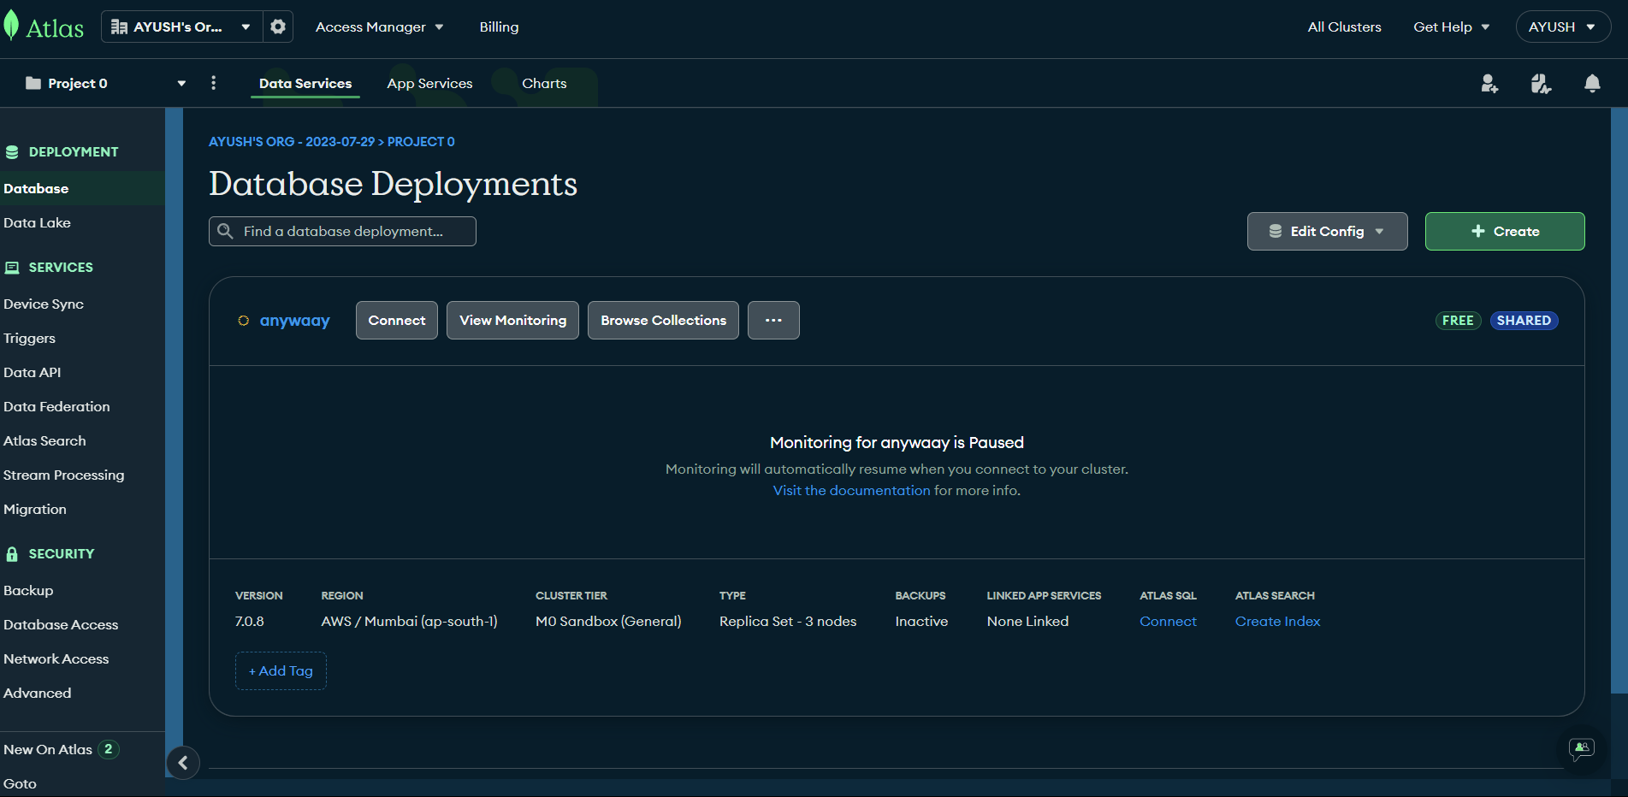

Compass:

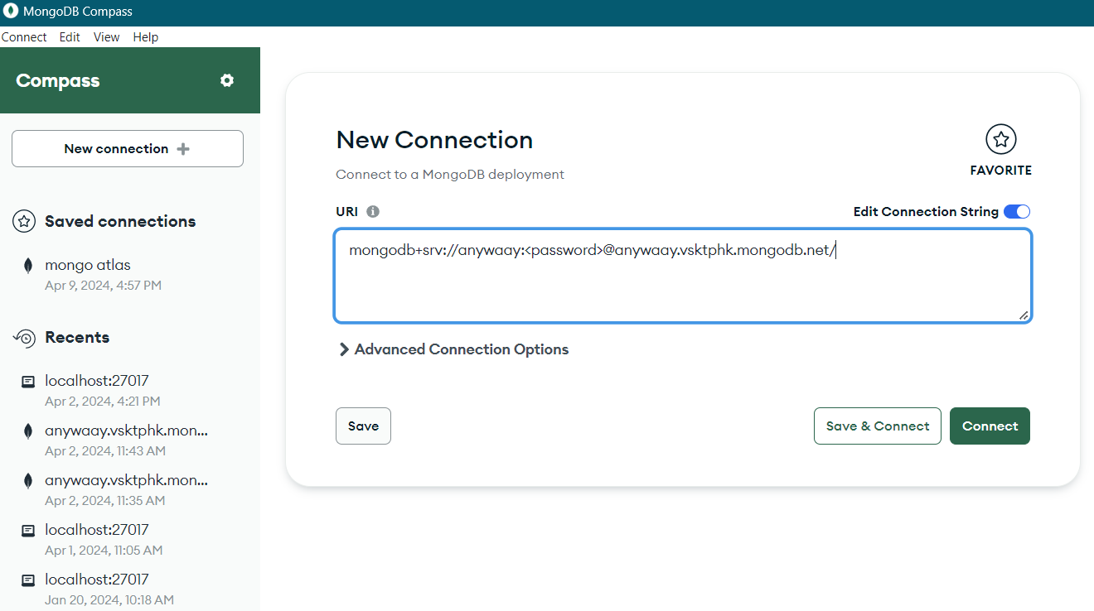

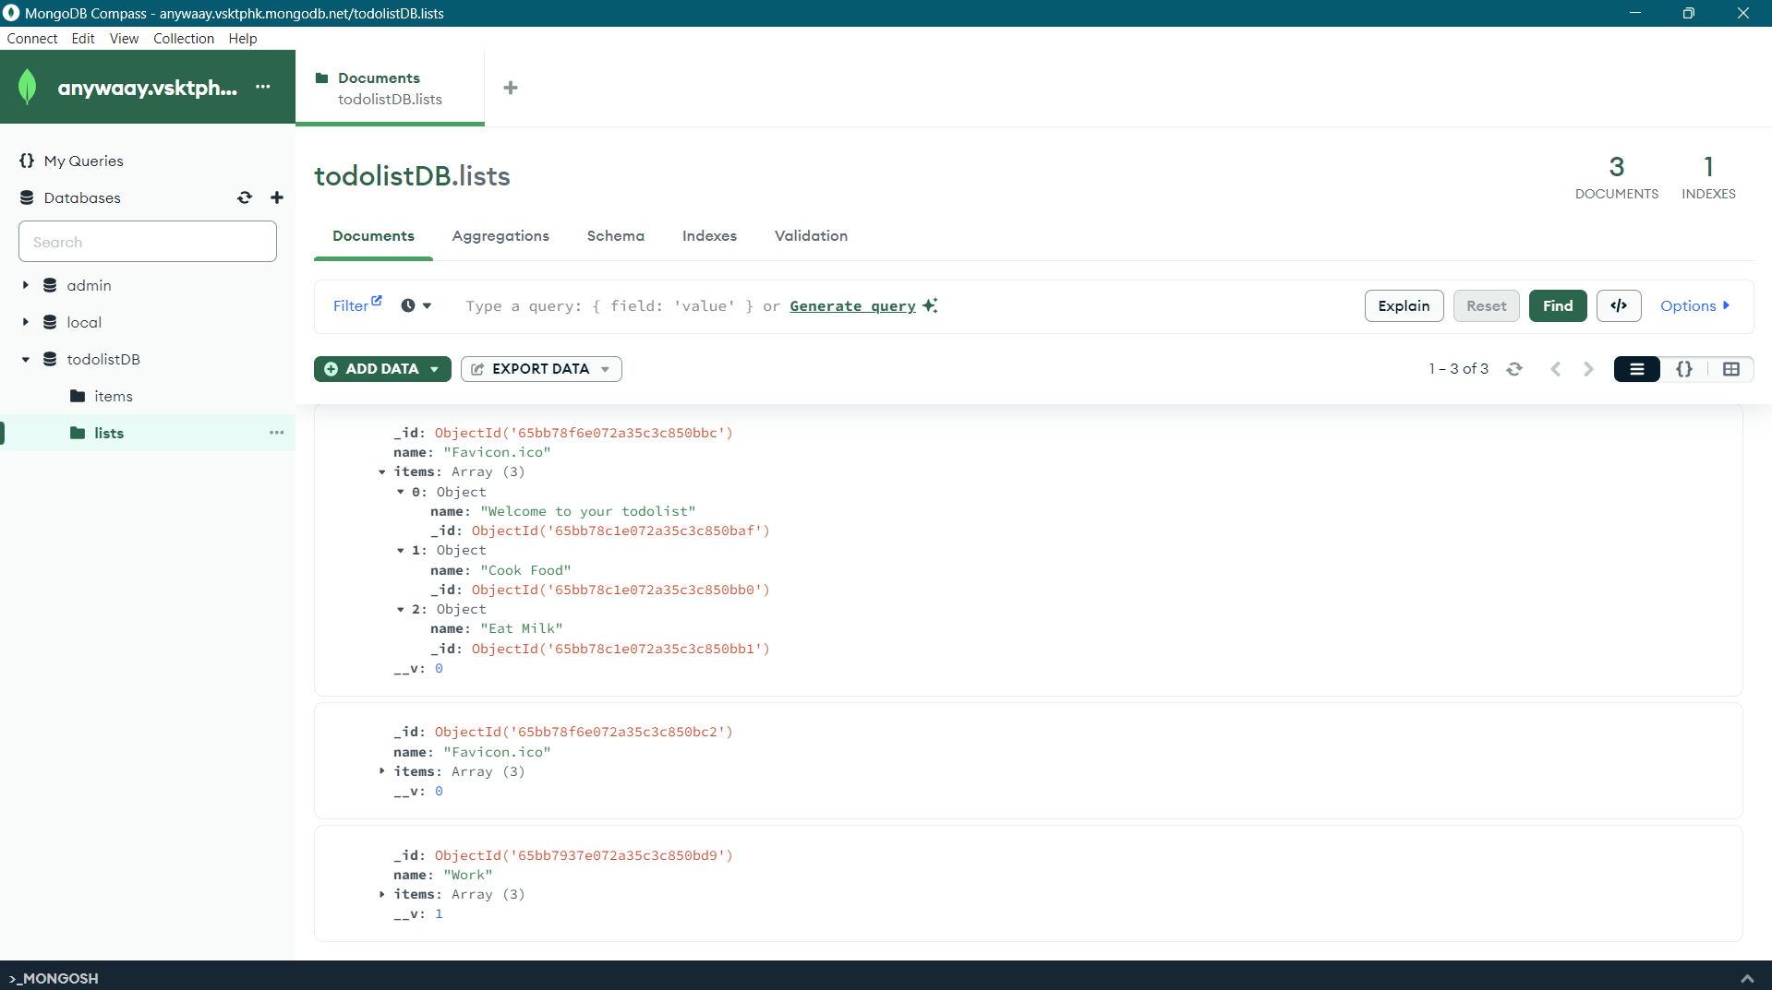

Connection.js:

import { MongoClient, ServerApiVersion } from "mongodb";

const url = process.env.ATLAS_URI;

const client = new MongoClient(url, {

    serverApi: {

        version: ServerApiVersion.v1,

        strict: true,

        deprecationErrors: true,

    },

})

try{

    await client.connect();

    await client.db("admin").command({ping: 1});

    console.log("Pinged your deployment. YOu succesfuly connected to MongoDB")

} catch(err){

    console.log(err)

}

let db = client.db("employees");

export default db;

record.js:

import express from "express";

// This will help us connect to the database

import db from "../db/connection.js";

// This help convert the id from string to ObjectId for the _id.

import { ObjectId } from "mongodb";

const router = express.Router();

// This section will help you get a list of all the records.

router.get("/", async (req, res) => {

  let collection = await db.collection("records");

  let results = await collection.find({}).toArray();

  res.send(results).status(200);

});

// This section will help you get a single record by id

router.get("/:id", async (req, res) => {

  let collection = await db.collection("records");

  let query = { _id: new ObjectId(req.params.id) };

  let result = await collection.findOne(query);

  if (!result) res.send("Not found").status(404);

  else res.send(result).status(200);

});

router.post("/", async (req, res) => {

  try {

    let newDocument = {

      name: req.body.name,

      position: req.body.position,

      level: req.body.level,

    };

    let collection = await db.collection("records");

    let result = await collection.insertOne(newDocument);

    res.send(result).status(204);

  } catch (err) {

    console.error(err);

    res.status(500).send("Error adding record");

  }

});

router.patch("/:id", async (req, res) => {

  try {

    const query = { _id: new ObjectId(req.params.id) };

    const updates = {

      $set: {

        name: req.body.name,

        position: req.body.position,

        level: req.body.level,

      },

    };

    let collection = await db.collection("records");

    let result = await collection.updateOne(query, updates);

    res.send(result).status(200);

  } catch (err) {

    console.error(err);

    res.status(500).send("Error updating record");

  }

});

router.delete("/:id", async (req, res) => {

  try {

    const query = { _id: new ObjectId(req.params.id) };

    const collection = db.collection("records");

    let result = await collection.deleteOne(query);

    res.send(result).status(200);

  } catch (err) {

    console.error(err);

    res.status(500).send("Error deleting record");

  }

});

export default router;

index.js:

import express from "express";

import cors from "cors";

import records from "./routes/record.js";

const PORT = process.env.PORT||5050;

const app = express();

app.use(cors());

app.use(express.json());

app.use("/record", records);

app.listen(PORT, ()=>{

    console.log(`app is listening at port  ${PORT}`);

})