Ayush Tripathi 12th March, 2024

22CS3021

Web Technology Assignment-9

T1: Code in Vue.js

<!DOCTYPE html>

<html lang="en">

<head>

  <meta charset="UTF-8">

  <meta name="viewport" content="width=device-width, initial-scale=1.0">

  <title>Currency Converter</title>

  <style>

    body {

      font-family: Arial, sans-serif;

      background-color: #222;

      color: white;

    }

    #app {

      max-width: 400px;

      margin: 0 auto;

      padding: 20px;

      border: 1px solid #ccc;

      border-radius: 5px;

      background-color: #333;

    }

    input[type="number"], select, button {

      margin-bottom: 10px;

      padding: 5px;

      border: 1px solid #ccc;

      border-radius: 3px;

      background-color: #444;

      color: white;

    }

    button {

      cursor: pointer;

      background-color: #007bff;

      color: white;

      border: none;

    }

    p {

      font-size: 18px;

    }

  </style>

</head>

<body>

  <div id="app">

    <h2>Currency Converter</h2>

    <div>

      <label>

        Amount:

        <input type="number" v-model="amount" />

      </label>

    </div>

    <div>

      <label>

        From:

        <select v-model="fromCurrency">

          <option value="USD">USD</option>

*<!-- Add other currency options here -->*

        </select>

      </label>

    </div>

    <div>

      <label>

        To:

        <select v-model="toCurrency">

          <option value="INR">INR</option>

*<!-- Add other currency options here -->*

        </select>

      </label>

    </div>

    <button @click="convertCurrency">Convert</button>

    <div v-if="convertedAmount">

      <p>{{ amount }} {{ fromCurrency }} = {{ convertedAmount }} {{ toCurrency }}</p>

    </div>

  </div>

  <script src="https://cdn.jsdelivr.net/npm/vue@2"></script>

  <script>

    new Vue({

      el: '#app',

      data: {

        amount: '',

        fromCurrency: 'USD',

        toCurrency: 'INR',

        convertedAmount: null,

        exchangeRate: 75.0 *// Hard-coded exchange rate (1 USD = 75 INR)*

      },

      methods: {

        convertCurrency() {

          this.convertedAmount = (this.amount \* this.exchangeRate).toFixed(2);

        }

      }

    });

  </script>

</body>

</html>

Web Page:

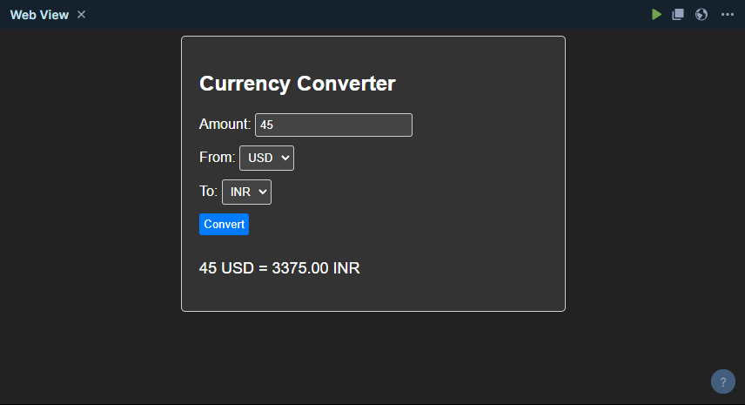

T2: Code in Vue.js

<!DOCTYPE html>

<html lang="en">

<head>

  <meta charset="UTF-8">

  <meta name="viewport" content="width=device-width, initial-scale=1.0">

  <title>Stopwatch</title>

  <style>

    body {

      font-family: Arial, sans-serif;

      color: white;

      background-color: #222;

    }

    .container {

      text-align: center;

      margin-top: 50px;

    }

    .button {

      margin: 5px;

      padding: 10px 20px;

      font-size: 16px;

      cursor: pointer;

      background-color: #007bff;

      color: white;

      border: none;

      border-radius: 5px;

    }

    .button:hover {

      background-color: #0056b3;

    }

    .button:active {

      background-color: #004080;

    }

  </style>

</head>

<body>

  <div id="app" class="container">

    <h2>Stopwatch</h2>

    <div>{{ formatTime }}</div>

    <div>

      <button class="button" @click="startStopwatch" v-if="!running">Start</button>

      <button class="button" @click="pauseStopwatch" v-if="running">Pause</button>

      <button class="button" @click="resetStopwatch">Reset</button>

    </div>

  </div>

  <script src="https://cdn.jsdelivr.net/npm/vue@2"></script>

  <script>

    new Vue({

      el: '#app',

      data: {

        running: false,

        time: 0,

        timer: null

      },

      computed: {

        formatTime() {

          const hours = Math.floor(this.time / 3600);

          const minutes = Math.floor((this.time % 3600) / 60);

          const seconds = this.time % 60;

          return `${hours.toString().padStart(2, '0')}:${minutes.toString().padStart(2, '0')}:${seconds.toString().padStart(2, '0')}`;

        }

      },

      methods: {

        startStopwatch() {

          this.running = true;

          this.timer = setInterval(() => {

            this.time++;

          }, 1000);

        },

        pauseStopwatch() {

          clearInterval(this.timer);

          this.running = false;

        },

        resetStopwatch() {

          clearInterval(this.timer);

          this.running = false;

          this.time = 0;

        }

      }

    });

  </script>

</body>

</html>

Web Page:

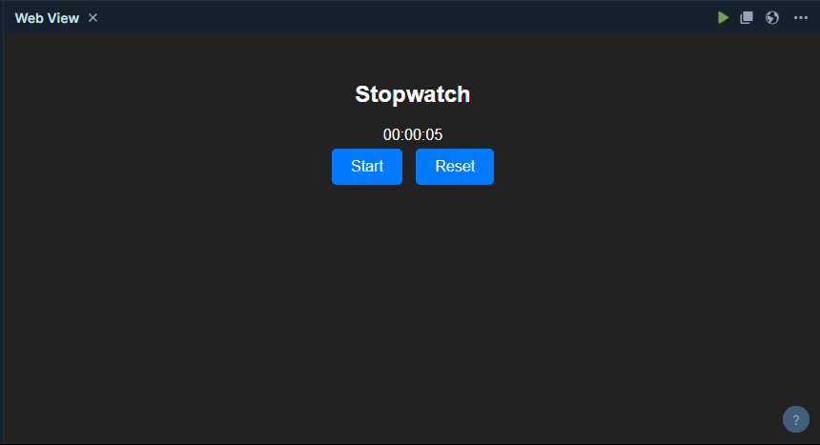

T3: code in vue.js

<!DOCTYPE html>

<html lang="en">

<head>

  <meta charset="UTF-8">

  <meta name="viewport" content="width=device-width, initial-scale=1.0">

  <title>Messaging Application</title>

  <style>

    body {

      font-family: Arial, sans-serif;

      background-color: #f0f0f0;

      margin: 0;

      padding: 0;

    }

    .container {

      display: flex;

      justify-content: space-between;

      height: 100vh;

    }

    .user {

      flex: 1;

      padding: 20px;

      box-sizing: border-box;

      background-color: #fff;

      border: 1px solid #ccc;

      overflow-y: auto;

    }

    .messages {

      margin-bottom: 10px;

    }

    .message {

      background-color: #eaeaea;

      padding: 5px 10px;

      border-radius: 5px;

      margin-bottom: 5px;

    }

    textarea {

      width: 100%;

      padding: 10px;

      box-sizing: border-box;

      margin-bottom: 10px;

    }

    button {

      padding: 10px 20px;

      background-color: #007bff;

      color: white;

      border: none;

      border-radius: 5px;

      cursor: pointer;

    }

    button:hover {

      background-color: #0056b3;

    }

  </style>

</head>

<body>

  <div id="app" class="container">

    <div class="user" id="userA">

      <h2>User A</h2>

      <div class="messages">

        <div v-for="message in userAMessages" class="message">Message from A: {{ message }}</div>

      </div>

      <textarea v-model="userAInput" placeholder="Type your message"></textarea>

      <button @click="sendMessage('userB', userAInput)">Send</button>

    </div>

    <div class="user" id="userB">

      <h2>User B</h2>

      <div class="messages">

        <div v-for="message in userBMessages" class="message">Message from B: {{ message }}</div>

      </div>

      <textarea v-model="userBInput" placeholder="Type your message"></textarea>

      <button @click="sendMessage('userA', userBInput)">Send</button>

    </div>

  </div>

  <script src="https://cdn.jsdelivr.net/npm/vue@2"></script>

  <script>

    new Vue({

      el: '#app',

      data: {

        userAInput: '',

        userAMessages: [],

        userBInput: '',

        userBMessages: []

      },

      methods: {

        sendMessage(*receiver*, *message*) {

          this[receiver + 'Messages'].unshift(message);

          this[receiver + 'Input'] = ''; *// Clear input field after sending message*

        }

      }

    });

  </script>

</body>

</html>

Web Page:

