NAME-ANZAL HUSAIN ABIDI
ROLL-NO. -20BCS009
EXPERIMENT -1
LAB – EMBEDDED SYSTEM

EXPERIMENT 1

AIM: - INSTALLATION OF TOOLS REQUIRED: KEIL, FLASH MAGIC, USB DRIVERS.
APPARATUS USED: -LAPTOP,8051 MICROCONTROLLER KIT

SOFTWARES: -
KEIL(µVision5): The µVision IDE combines project management, run-time environment, build facilities, source code editing, and program debugging in a single powerful environment. It is used to generate HEX code from a C source file

FLASH MAGIC(Version10.9): Flash Magic is a PC tool for programming flash-based microcontrollers from NXP using a serial, Ethernet, CAN bus or SWD while in the target hardware.

PIN DIAGRAM OF 8051: -
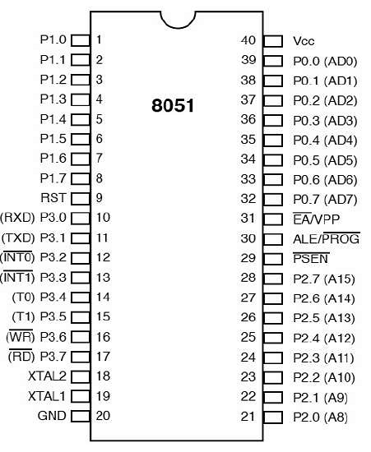

8051 MICROCONTROLLER DEVELOPMENT KIT: -
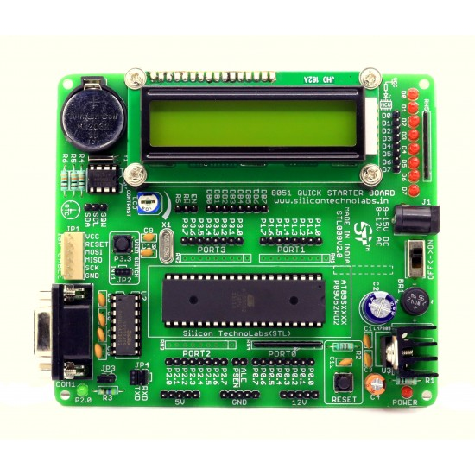

Result: -Successfully installed and Burnt HEX Code on Microcontroller.

