**Analysis and Visualization of globally Natural Disasters due to Climate Change**

The purpose of this notebook is to investigate and present what are the meaningful information in the dataset. Pyplot Library can be used for the purpose of making charts and graph to easily analyze the results. The dataset used is Global Temperature, Climate Change and Natural Disasters, there are some relationships in between these indicators or World Data.

**Visualization 1: Temperature Uncertainty Rising over years**

A line plot is a good option for temperature over year charts because it can effectively show the trend of temperature change over time, handle multiple data series, and allow viewers to compare and draw conclusions about patterns and relationships in the data. It is a common and effective way to present this type of data in scientific and engineering contexts.

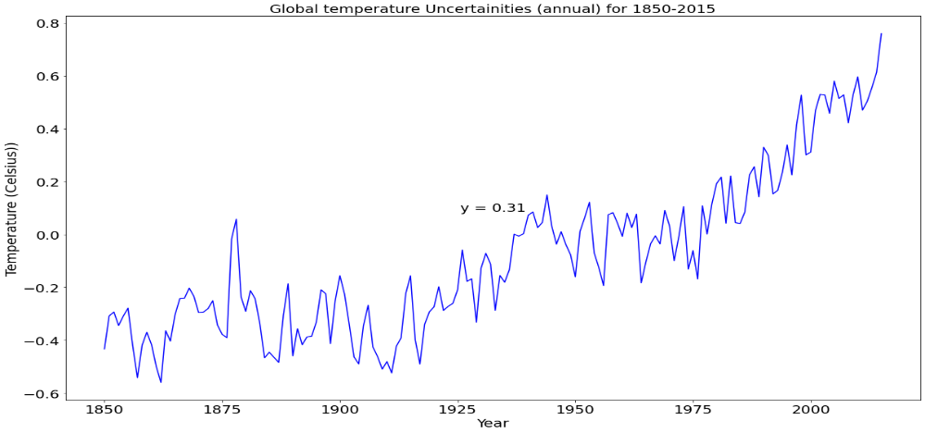

* This Line Chart is showing us the trend of continuously increasing uncertainty. For example, the chart is showing the difference of the temperature with the baseline and it is increasing which means the temperature is continuously rising from the normal baseline temperature and no doubt the temperature of Earth is Rising which is off course alarming.
* After 1930, the temperature Uncertainty can be seen from this chart.

**Visualization 2: Increasing trend of Natural Disasters over years**

A horizontal stacked bar chart is a good option for this chart because it allows us to compare the relative frequencies of different types of natural disasters over time. The horizontal orientation makes it easy to see the trends and changes in the data over time, while the stacked bars allow us to see the contribution of each type of natural disaster to the total count for each year. The stacked bars also make it easy to compare the relative frequencies of different types of natural disasters for each year.

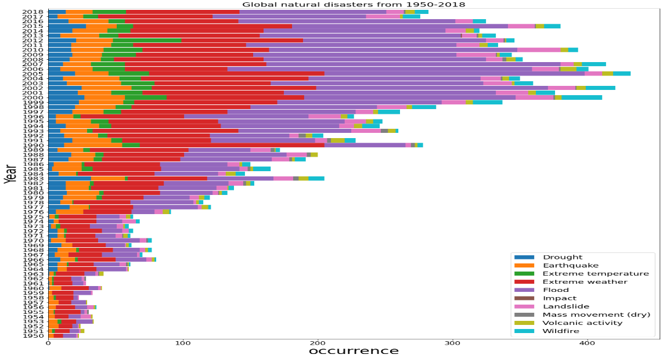

The above bar plot, which has unique stacks for each category of natural disasters, shows that

* The frequency of floods has increased significantly over the years in comparison to other disasters.
* Extreme weather is the second most common disaster, followed by earthquakes.
* The plot also indicates that the total number of natural disasters has been consistently increasing globally.

This is further highlighted by the plot below, which shows a clear upward trend in the frequency of natural disasters from 1950 to 2018. These charts provide a visual representation of the trends and patterns in natural disasters, allowing for easy comparison and analysis of the data. They underscore the importance of disaster preparedness and management in mitigating the impact of these catastrophic events on communities around the world.

**Visualization 3: Relationship between Disasters and Temperature Uncertainty**

A line plot is a good option for this chart because it shows the trend of both variables over time, which is the main focus of the comparison. By plotting both the temperature anomaly and the occurrence of natural disasters on the same graph with two different y-axes, we can easily see any correlation or relationship between these two variables.

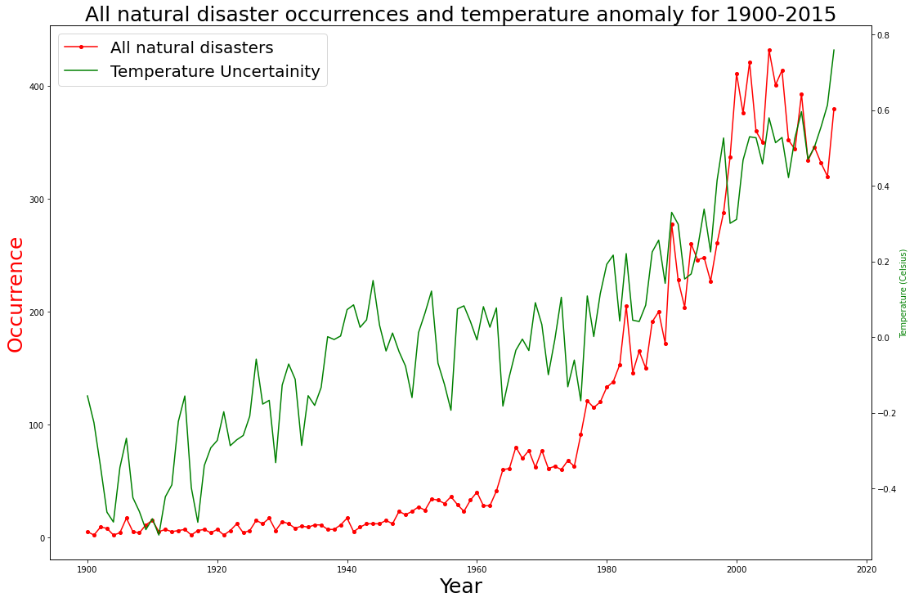

A line plot allows us to easily observe any long-term trends or patterns in the data, which can be difficult to see in other types of plots. Additionally, a line plot allows us to see any fluctuations or variations in the data over time. This is especially useful for studying the impact of natural disasters on global temperature patterns and understanding how these variables are changing over time. Overall, a line plot is an effective way to visualize the relationship between two variables that are changing over time.

**Analysis:** Global natural disasters have been increasing over time, with a sharp rise observed after 1940. This trend coincides with a rise in temperatures, which began to exceed the historical average around the same time. This suggests that there may be a correlation between natural disasters and global temperature patterns. Understanding this relationship is important for predicting future natural disasters and preparing for their impact.

**Visualization 3: Relationship between Disasters and Economy Effected**

A stacked horizontal bar chart is a good option for representing economic damage by type of natural disaster over time as it allows for easy comparison of the contribution of each disaster type to the overall economic loss. Additionally, it helps to identify the trend of economic damage caused by each disaster type.

The economic damage caused by natural disasters is influenced by various factors such as the type of catastrophe, its location, intensity, management activities, etc. Here are some key observations from the plot:

- The overall economic loss from natural disasters has been increasing over time.

- The increase in natural disasters, which is linked to global temperature rise, is the major contributor to this trend. However, not all disasters have the same impact on economic damage.

- Economic development, which leads to greater infrastructure and land productivity, may also be a contributing factor to the increase in economic harm caused by natural disasters.

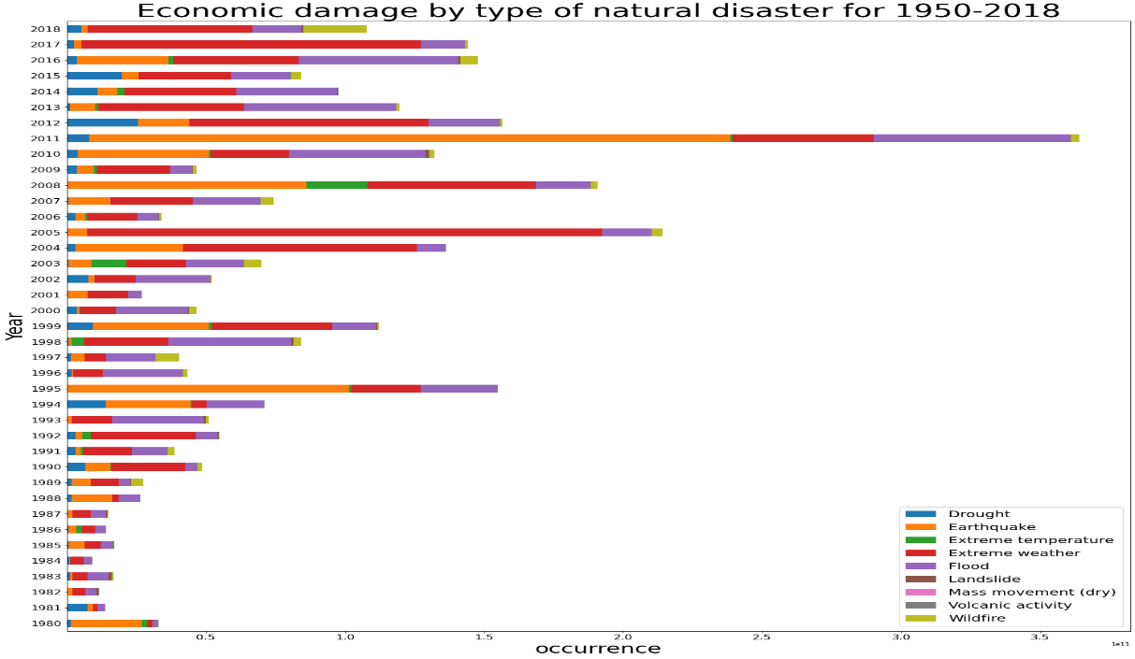

In conclusion, the plot highlights the increasing economic damage caused by natural disasters and the need for effective disaster management strategies to minimize their impact.

**References of Dataset¶**

* The source of the global temperature data is the Kaggle dataset <https://www.kaggle.com/berkeleyearth/climate-change-earth-surface-temperature-data> by Berkeley Earth.
* Natural diasaster data is taken from <https://ourworldindata.org/natural-disasters> (data published by EMDAT (2019): OFDA/CRED International Disaster Database, Université catholique de Louvain – Brussels – Belgium)