Reproduce existing results:

PS C:\project\VBL-VA001> python .\train_knn.py

Shape of Train Data : (3200, 27)

Shape of Test Data : (800, 27)

Max test acc: 0.99625

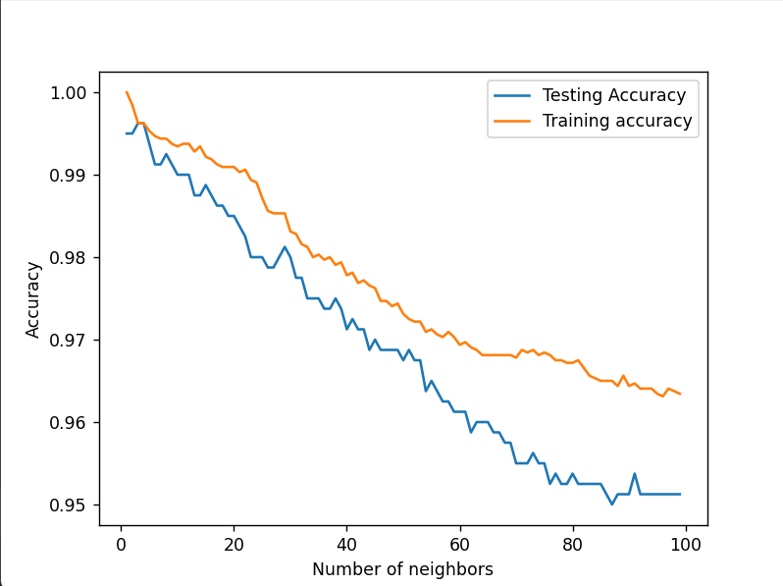

PS C:\project\VBL-VA001> python .\train_knn_5fold.py

[0.5865641 0.77310256 0.798 0.95602564 0.99751276]

[0.59133333 0.74530769 0.77374359 0.95410256 0.99707685]

[0.57369231 0.7765641 0.79894872 0.95620513 0.9975384 ]

[0.57197436 0.77405128 0.79058974 0.95502564 0.99746147]

[0.56246154 0.78169231 0.80269231 0.95717949 0.99774353]

[0.5595641 0.78320513 0.79823077 0.95576923 0.99771789]

[0.55307692 0.78935897 0.80930769 0.95782051 0.99776917]

[0.55171795 0.78941026 0.80471795 0.95687179 0.99769225]

[0.54807692 0.79538462 0.81607692 0.95776923 0.99787174]

[0.5454359 0.79694872 0.81335897 0.95735897 0.99774353]

[0.54351282 0.80051282 0.82330769 0.96020513 0.99782046]

[0.53746154 0.80238462 0.82061538 0.96002564 0.99769225]

[0.53769231 0.80525641 0.82684615 0.96628205 0.99782046]

[0.53012821 0.80638462 0.82364103 0.96607692 0.99782046]

[0.53084615 0.80997436 0.82879487 0.96728205 0.99787174]

[0.52112821 0.81125641 0.82671795 0.967 0.99782046]

[0.52669231 0.81366667 0.8305641 0.96738462 0.99792302]

[0.52030769 0.81530769 0.82894872 0.96715385 0.9978461 ]

[0.52076923 0.81697436 0.83258974 0.96774359 0.99787174]

[0.51623077 0.81815385 0.83092308 0.96758974 0.99782046]

[0.51684615 0.8195641 0.83505128 0.968 0.99787174]

[0.51071795 0.82107692 0.83346154 0.96782051 0.99782046]

[0.51238462 0.82192308 0.83669231 0.96833333 0.9978461 ]

[0.50248718 0.82274359 0.83558974 0.96812821 0.99774353]

[0.50569231 0.82376923 0.83823077 0.96825641 0.99787174]

[0.49661538 0.82428205 0.83741026 0.96817949 0.99779482]

[0.49838462 0.82566667 0.84 0.9684359 0.99787174]

[0.49264103 0.82628205 0.83894872 0.96835897 0.99776917]

[0.49297436 0.82697436 0.84087179 0.96851282 0.99779482]

[0.4905641 0.82776923 0.84066667 0.96848718 0.99771789]

[0.49051282 0.82882051 0.84205128 0.96884615 0.99774353]

[0.48887179 0.82946154 0.841 0.96882051 0.99764097]

[0.48717949 0.83076923 0.84225641 0.96902564 0.99766661]

[0.48594872 0.83079487 0.84192308 0.96897436 0.99758968]

[0.48505128 0.83176923 0.84333333 0.96910256 0.99766661]

[0.4834359 0.83197436 0.84269231 0.969 0.99758968]

[0.48289744 0.83320513 0.844 0.96920513 0.99766661]

[0.48135897 0.83364103 0.84358974 0.96912821 0.99758968]

[0.48435897 0.83451282 0.84441026 0.96938462 0.99761532]

[0.48230769 0.83505128 0.84392308 0.96925641 0.9975384 ]

[0.48564103 0.83576923 0.84538462 0.96953846 0.9975384 ]

[0.48417949 0.83607692 0.84512821 0.96938462 0.99751276]

[0.48471795 0.83735897 0.84615385 0.96946154 0.99751276]

[0.48417949 0.83753846 0.84612821 0.96938462 0.99748712]

[0.48489744 0.83869231 0.84687179 0.96958974 0.99751276]

[0.48384615 0.83879487 0.84687179 0.96958974 0.99748712]

[0.48489744 0.8394359 0.84789744 0.96976923 0.99756404]

[0.48374359 0.84017949 0.84815385 0.96979487 0.99751276]

[0.48507692 0.8405641 0.84894872 0.96987179 0.99748712]

[0.48425641 0.84066667 0.84953846 0.96984615 0.99748712]

[0.4854359 0.84141026 0.85015385 0.96997436 0.99743583]

[0.48489744 0.84174359 0.85030769 0.96997436 0.99751276]

[0.48797436 0.84220513 0.85084615 0.97015385 0.99746147]

[0.48789744 0.84271795 0.85110256 0.97015385 0.99746147]

[0.48920513 0.84261538 0.85205128 0.97017949 0.99743583]

[0.48935897 0.84294872 0.85194872 0.97017949 0.99741019]

[0.48982051 0.84335897 0.85248718 0.97025641 0.99741019]

[0.48974359 0.84333333 0.85246154 0.97028205 0.99743583]

[0.48961538 0.84361538 0.85302564 0.97030769 0.99741019]

[0.48933333 0.84441026 0.85317949 0.97023077 0.99741019]

[0.4894359 0.84451282 0.854 0.97033333 0.99738455]

[0.48938462 0.84464103 0.85379487 0.97030769 0.99733326]

[0.48935897 0.84517949 0.85448718 0.97030769 0.99733326]

[0.48930769 0.84579487 0.85441026 0.97020513 0.99730762]

[0.48992308 0.84546154 0.85517949 0.97035897 0.99733326]

[0.48958974 0.84594872 0.85541026 0.97030769 0.99735891]

[0.48971795 0.84646154 0.85582051 0.97041026 0.99733326]

[0.48971795 0.8465641 0.85582051 0.97041026 0.99730762]

[0.48920513 0.84630769 0.85620513 0.9705641 0.99730762]

[0.48958974 0.84666667 0.85641026 0.97051282 0.99730762]

[0.48905128 0.84620513 0.85684615 0.97064103 0.99728198]

[0.48915385 0.84623077 0.85710256 0.9705641 0.99728198]

[0.48828205 0.8464359 0.85764103 0.97076923 0.99725634]

[0.48858974 0.8465641 0.85782051 0.97069231 0.99725634]

[0.48815385 0.84666667 0.858 0.97074359 0.99725634]

[0.48838462 0.84630769 0.85853846 0.97071795 0.99725634]

[0.48723077 0.84630769 0.85917949 0.97082051 0.99728198]

[0.48751282 0.84633333 0.85951282 0.97076923 0.99728198]

[0.48679487 0.84679487 0.86023077 0.97076923 0.99725634]

[0.48687179 0.84671795 0.86051282 0.97074359 0.99725634]

[0.48651282 0.84684615 0.86102564 0.97076923 0.9972307 ]

[0.48679487 0.84712821 0.86120513 0.97079487 0.99725634]

[0.48630769 0.84702564 0.86192308 0.97089744 0.99725634]

[0.48646154 0.84725641 0.86217949 0.97089744 0.99725634]

[0.48605128 0.84723077 0.86317949 0.97092308 0.99725634]

[0.48630769 0.84723077 0.86317949 0.97094872 0.99725634]

[0.48569231 0.84697436 0.86376923 0.97097436 0.9972307 ]

[0.48589744 0.84697436 0.86407692 0.97092308 0.99717941]

[0.48551282 0.84705128 0.86451282 0.971 0.99717941]

[0.48553846 0.84738462 0.86492308 0.97097436 0.99717941]

[0.48520513 0.84753846 0.86566667 0.971 0.99712813]

[0.48525641 0.84717949 0.866 0.971 0.99715377]

[0.4845641 0.84728205 0.86638462 0.97112821 0.99710249]

[0.48471795 0.84702564 0.86661538 0.97110256 0.99710249]

[0.48420513 0.84712821 0.86720513 0.97112821 0.99707685]

[0.48441026 0.84676923 0.8675641 0.97112821 0.99702556]

[0.48387179 0.84692308 0.868 0.97130769 0.99702556]

[0.48394872 0.84682051 0.86815385 0.97125641 0.99697428]

[0.48364103 0.84651282 0.86835897 0.97138462 0.99702556]

Max test acc: 0.8334307537142636

Best neighbors: 98

PS C:\project\VBL-VA001> python .\train_svm.py

Shape of Train Data : (3200, 27)

Shape of Test Data : (800, 27)

Optimal C: 81

PS C:\project\VBL-VA001> python .\train_svm_5fold.py

[0.99375 0.99625 0.99125 0.9925 0.9925 ]

[0.99375 0.99625 0.99125 0.995 0.9925 ]

[0.99375 0.99625 0.99125 0.9975 0.9925 ]

[0.99375 0.99625 0.99375 0.9975 0.9925 ]

[0.99375 0.99625 0.995 0.9975 0.9925 ]

[0.99375 0.99625 0.995 0.9975 0.9925 ]

[0.99375 0.99625 0.995 0.9975 0.9925 ]

[0.99375 0.99625 0.995 0.9975 0.9925 ]

[0.99375 0.99625 0.995 0.9975 0.9925 ]

[0.99375 0.99625 0.995 0.9975 0.9925 ]

[0.99375 0.99625 0.995 0.9975 0.9925 ]

[0.99375 0.99625 0.995 0.9975 0.9925 ]

[0.99375 0.99625 0.995 0.9975 0.995 ]

[0.99375 0.99625 0.995 0.9975 0.995 ]

[0.99375 0.99625 0.995 0.9975 0.995 ]

[0.99375 0.99625 0.995 0.9975 0.995 ]

[0.99375 0.99625 0.995 0.9975 0.995 ]

[0.99375 0.99625 0.995 0.9975 0.995 ]

[0.99375 0.99625 0.995 0.9975 0.995 ]

[0.99375 0.99625 0.995 0.9975 0.995 ]

[0.99375 0.99625 0.995 0.9975 0.995 ]

[0.99375 0.99625 0.995 0.9975 0.995 ]

[0.99375 0.99625 0.995 0.9975 0.995 ]

[0.99375 0.99625 0.995 0.9975 0.995 ]

[0.99375 0.99625 0.995 0.9975 0.995 ]

[0.99375 0.99625 0.995 0.9975 0.995 ]

[0.99375 0.99625 0.995 0.9975 0.995 ]

[0.99375 0.99625 0.995 0.9975 0.995 ]

[0.99375 0.99625 0.995 0.9975 0.995 ]

[0.99375 0.99625 0.995 0.9975 0.995 ]

[0.99375 0.99625 0.995 0.9975 0.995 ]

[0.99375 0.99625 0.995 0.9975 0.99625]

[0.99375 0.99625 0.995 0.9975 0.99625]

[0.99375 0.99625 0.995 0.9975 0.99625]

[0.99375 0.99625 0.995 0.9975 0.99625]

[0.99375 0.99625 0.995 0.9975 0.99625]

[0.99375 0.99625 0.995 0.9975 0.99625]

[0.99375 0.99625 0.995 0.9975 0.99625]

[0.99375 0.99625 0.995 0.9975 0.99625]

[0.99375 0.99625 0.99625 0.9975 0.99625]

[0.99375 0.9975 0.99625 0.99875 0.99625]

[0.99375 0.9975 0.99625 0.99875 0.99625]

[0.99375 0.9975 0.99625 0.99875 0.99625]

[0.99375 0.9975 0.99625 0.99875 0.99625]

[0.99375 0.9975 0.99625 0.99875 0.99625]

[0.99375 0.9975 0.99625 0.99875 0.99625]

[0.99375 0.9975 0.99625 0.99875 0.99625]

[0.99375 0.9975 0.99625 0.99875 0.99625]

[0.99375 0.9975 0.99625 0.99875 0.99625]

[0.99375 0.9975 0.99625 0.99875 0.99625]

[0.99375 0.9975 0.99625 0.99875 0.99625]

[0.99375 0.9975 0.99625 0.99875 0.99625]

[0.99375 0.9975 0.99625 0.99875 0.99625]

[0.99375 0.9975 0.9975 0.99875 0.99625]

[0.99375 0.9975 0.9975 0.99875 0.99625]

[0.99375 0.9975 0.9975 0.99875 0.99625]

[0.99375 0.9975 0.9975 0.99875 0.99625]

[0.99375 0.9975 0.9975 0.99875 0.99625]

[0.99375 0.9975 0.9975 0.99875 0.99625]

[0.995 0.9975 0.9975 0.99875 0.99625]

[0.995 0.9975 0.9975 0.99875 0.99625]

[0.995 0.9975 0.9975 0.99875 0.99625]

[0.995 0.9975 0.9975 0.99875 0.99625]

[0.995 0.9975 0.9975 1. 0.99625]

[0.995 0.9975 0.9975 1. 0.99625]

[0.995 0.9975 0.9975 1. 0.99625]

[0.99625 0.9975 0.9975 1. 0.9975 ]

[0.99625 0.9975 0.9975 1. 0.9975 ]

[0.99625 0.9975 0.9975 1. 0.9975 ]

[0.99625 0.9975 0.9975 1. 0.9975 ]

[0.99625 0.9975 0.9975 1. 0.9975 ]

[0.99625 0.9975 0.9975 1. 0.9975 ]

[0.99625 0.9975 0.9975 1. 0.9975 ]

[0.99625 0.9975 0.9975 1. 0.9975 ]

[0.99625 0.9975 0.9975 1. 0.9975 ]

[0.99625 0.9975 0.9975 1. 0.9975 ]

[0.99625 0.9975 0.9975 1. 0.9975 ]

[0.99625 0.9975 0.9975 1. 0.9975 ]

[0.99625 0.99875 0.9975 1. 0.9975 ]

[0.99625 0.99875 0.9975 1. 0.9975 ]

[0.99625 0.99875 0.9975 1. 0.9975 ]

[0.99625 0.99875 0.9975 1. 0.9975 ]

[0.99625 0.99875 0.99875 1. 0.9975 ]

[0.99625 0.99875 0.99875 1. 0.9975 ]

[0.99625 0.99875 0.99875 1. 0.9975 ]

[0.99625 0.99875 0.99875 1. 0.9975 ]

[0.99625 1. 0.99875 1. 0.9975 ]

[0.99625 1. 0.99875 1. 0.9975 ]

[0.99625 1. 0.99875 1. 0.9975 ]

[0.99625 1. 0.99875 1. 0.9975 ]

[0.99625 1. 0.99875 1. 0.9975 ]

[0.99625 1. 0.99875 1. 0.9975 ]

[0.99625 1. 0.99875 1. 0.9975 ]

[0.99625 1. 0.99875 1. 0.9975 ]

[0.99625 1. 0.99875 1. 0.9975 ]

[0.99625 1. 0.99875 1. 0.9975 ]

[0.99625 1. 0.99875 1. 0.9975 ]

[0.99625 1. 0.99875 1. 0.9975 ]

[0.99625 1. 0.99875 1. 0.9975 ]

Max test acc: 0.9984999999999999

Best C: 87

PS C:\project\VBL-VA001> python .\train_gnb.py

Shape of Train Data : (3200, 27)

Shape of Test Data : (800, 27)

Max test acc: 0.99375

Optimal var_gnb: 11

Max test accuracy: 0.99375

PS C:\project\VBL-VA001> python .\train_gnb_5fold.py

[0.27328205 0.51689744 0.75215385 0.83717949 0.80250776]

[0.27935897 0.53030769 0.7905641 0.6734359 0.54229596]

[0.4154359 0.59210256 0.80402564 0.6074359 0.52578271]

[0.39641026 0.61989744 0.81053846 0.60558974 0.52537245]

[0.39335897 0.61387179 0.8084359 0.62830769 0.52868022]

[0.40069231 0.58487179 0.78907692 0.7335641 0.54801405]

[0.41030769 0.56638462 0.77517949 0.79466667 0.56568117]

[0.41407692 0.56792308 0.77794872 0.76212821 0.56283494]

[0.41453846 0.58048718 0.78666667 0.69828205 0.54629606]

[0.41802564 0.60884615 0.79835897 0.63776923 0.53042386]

[0.42005128 0.63115385 0.80366667 0.61376923 0.52478269]

[0.41994872 0.629 0.80112821 0.59579487 0.52232109]

[0.42220513 0.59738462 0.78130769 0.61558974 0.52557758]

[0.42823077 0.56761538 0.70187179 0.77615385 0.74371138]

[0.44205128 0.56266667 0.65766667 0.7704359 0.74645504]

[0.4594359 0.56833333 0.64648718 0.76787179 0.74645504]

[0.46669231 0.57017949 0.64576923 0.7675641 0.74645504]

[0.45461538 0.57025641 0.64569231 0.7674359 0.74645504]

[0.44128205 0.57033333 0.64569231 0.7674359 0.74645504]

[0.43784615 0.57033333 0.64569231 0.7674359 0.74645504]

[0.43758974 0.57033333 0.64569231 0.7674359 0.74645504]

[0.43758974 0.57033333 0.64569231 0.7674359 0.74645504]

[0.4375641 0.57033333 0.64569231 0.7674359 0.74645504]

[0.4375641 0.57033333 0.64569231 0.7674359 0.74645504]

[0.4375641 0.57033333 0.64569231 0.7674359 0.74645504]

[0.4375641 0.57033333 0.64569231 0.7674359 0.74645504]

[0.4375641 0.57033333 0.64569231 0.7674359 0.74645504]

[0.4375641 0.57033333 0.64569231 0.7674359 0.74645504]

[0.4375641 0.57033333 0.64569231 0.7674359 0.74645504]

[0.4375641 0.57033333 0.64569231 0.7674359 0.74645504]

[0.4375641 0.57033333 0.64569231 0.7674359 0.74645504]

[0.4375641 0.57033333 0.64569231 0.7674359 0.74645504]

[0.4375641 0.57033333 0.64569231 0.7674359 0.74645504]

[0.4375641 0.57033333 0.64569231 0.7674359 0.74645504]

[0.4375641 0.57033333 0.64569231 0.7674359 0.74645504]

[0.4375641 0.57033333 0.64569231 0.7674359 0.74645504]

[0.4375641 0.57033333 0.64569231 0.7674359 0.74645504]

[0.4375641 0.57033333 0.64569231 0.7674359 0.74645504]

[0.4375641 0.57033333 0.64569231 0.7674359 0.74645504]

[0.4375641 0.57033333 0.64569231 0.7674359 0.74645504]

[0.4375641 0.57033333 0.64569231 0.7674359 0.74645504]

[0.4375641 0.57033333 0.64569231 0.7674359 0.74645504]

[0.4375641 0.57033333 0.64569231 0.7674359 0.74645504]

[0.4375641 0.57033333 0.64569231 0.7674359 0.74645504]

[0.4375641 0.57033333 0.64569231 0.7674359 0.74645504]

[0.4375641 0.57033333 0.64569231 0.7674359 0.74645504]

[0.4375641 0.57033333 0.64569231 0.7674359 0.74645504]

[0.4375641 0.57033333 0.64569231 0.7674359 0.74645504]

[0.4375641 0.57033333 0.64569231 0.7674359 0.74645504]

[0.4375641 0.57033333 0.64569231 0.7674359 0.74645504]

[0.4375641 0.57033333 0.64569231 0.7674359 0.74645504]

[0.4375641 0.57033333 0.64569231 0.7674359 0.74645504]

[0.4375641 0.57033333 0.64569231 0.7674359 0.74645504]

[0.4375641 0.57033333 0.64569231 0.7674359 0.74645504]

[0.4375641 0.57033333 0.64569231 0.7674359 0.74645504]

[0.4375641 0.57033333 0.64569231 0.7674359 0.74645504]

[0.4375641 0.57033333 0.64569231 0.7674359 0.74645504]

[0.4375641 0.57033333 0.64569231 0.7674359 0.74645504]

[0.4375641 0.57033333 0.64569231 0.7674359 0.74645504]

[0.4375641 0.57033333 0.64569231 0.7674359 0.74645504]

[0.4375641 0.57033333 0.64569231 0.7674359 0.74645504]

[0.4375641 0.57033333 0.64569231 0.7674359 0.74645504]

[0.4375641 0.57033333 0.64569231 0.7674359 0.74645504]

[0.4375641 0.57033333 0.64569231 0.7674359 0.74645504]

[0.4375641 0.57033333 0.64569231 0.7674359 0.74645504]

[0.4375641 0.57033333 0.64569231 0.7674359 0.74645504]

[0.4375641 0.57033333 0.64569231 0.7674359 0.74645504]

[0.4375641 0.57033333 0.64569231 0.7674359 0.74645504]

[0.4375641 0.57033333 0.64569231 0.7674359 0.74645504]

[0.4375641 0.57033333 0.64569231 0.7674359 0.74645504]

[0.4375641 0.57033333 0.64569231 0.7674359 0.74645504]

[0.4375641 0.57033333 0.64569231 0.7674359 0.74645504]

[0.4375641 0.57033333 0.64569231 0.7674359 0.74645504]

[0.4375641 0.57033333 0.64569231 0.7674359 0.74645504]

[0.4375641 0.57033333 0.64569231 0.7674359 0.74645504]

[0.4375641 0.57033333 0.64569231 0.7674359 0.74645504]

[0.4375641 0.57033333 0.64569231 0.7674359 0.74645504]

[0.4375641 0.57033333 0.64569231 0.7674359 0.74645504]

[0.4375641 0.57033333 0.64569231 0.7674359 0.74645504]

[0.4375641 0.57033333 0.64569231 0.7674359 0.74645504]

[0.4375641 0.57033333 0.64569231 0.7674359 0.74645504]

[0.4375641 0.57033333 0.64569231 0.7674359 0.74645504]

[0.4375641 0.57033333 0.64569231 0.7674359 0.74645504]

[0.4375641 0.57033333 0.64569231 0.7674359 0.74645504]

[0.4375641 0.57033333 0.64569231 0.7674359 0.74645504]

[0.4375641 0.57033333 0.64569231 0.7674359 0.74645504]

[0.4375641 0.57033333 0.64569231 0.7674359 0.74645504]

[0.4375641 0.57033333 0.64569231 0.7674359 0.74645504]

[0.4375641 0.57033333 0.64569231 0.7674359 0.74645504]

[0.4375641 0.57033333 0.64569231 0.7674359 0.74645504]

[0.4375641 0.57033333 0.64569231 0.7674359 0.74645504]

[0.4375641 0.57033333 0.64569231 0.7674359 0.74645504]

[0.4375641 0.57033333 0.64569231 0.7674359 0.74645504]

[0.4375641 0.57033333 0.64569231 0.7674359 0.74645504]

[0.4375641 0.57033333 0.64569231 0.7674359 0.74645504]

[0.4375641 0.57033333 0.64569231 0.7674359 0.74645504]

[0.4375641 0.57033333 0.64569231 0.7674359 0.74645504]

[0.4375641 0.57033333 0.64569231 0.7674359 0.74645504]

[0.4375641 0.57033333 0.64569231 0.7674359 0.74645504]

Max test acc: 0.6435166344173191

Best var smoothing: 1e-14

Plot X features:

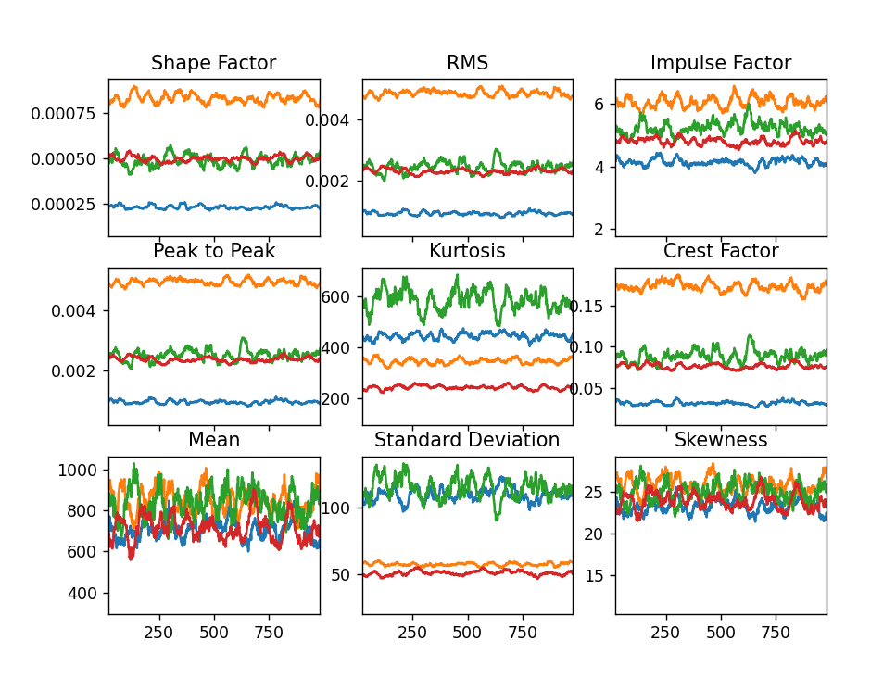

Plot Y features:

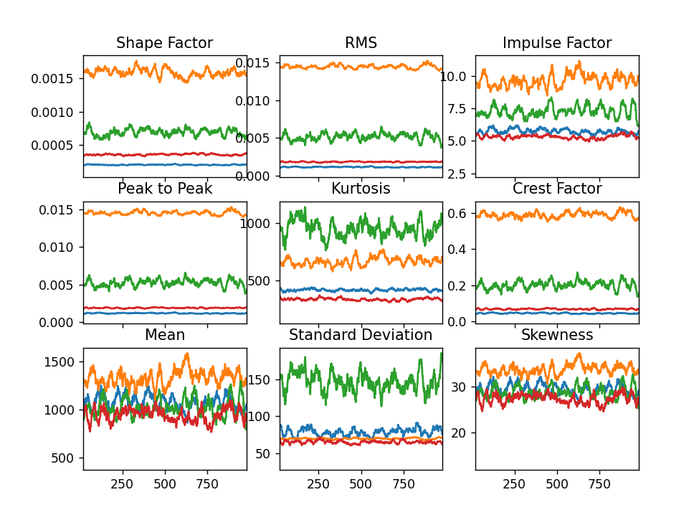

Plot Z features:

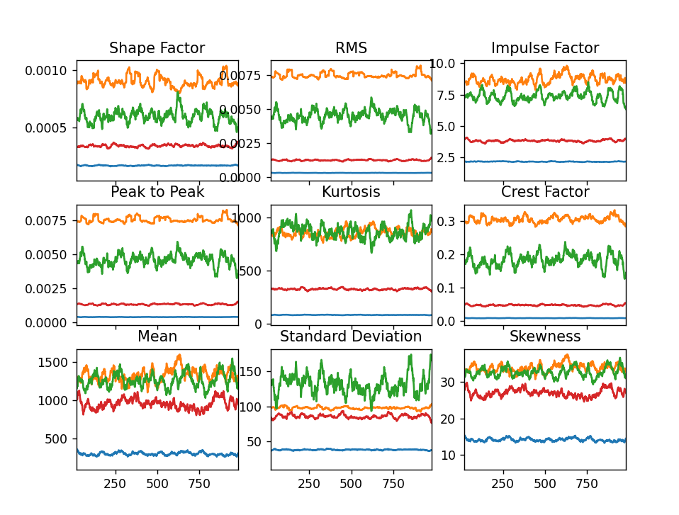

Plot all features:

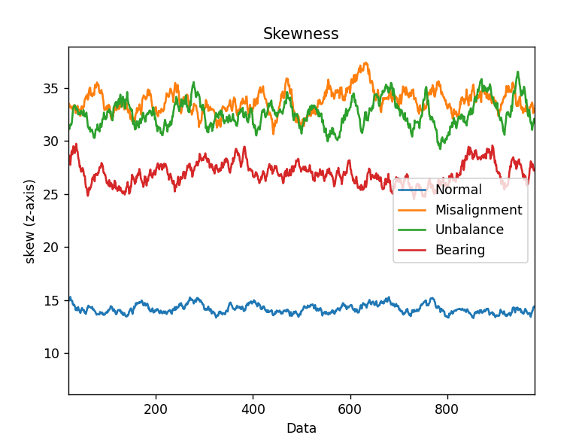

Our Contributions:

BernoulliNB

PS C:\project\VBL-VA001> python .\train_bnb.py

Shape of Train Data : (3200, 27)

Shape of Test Data : (800, 27)

Max test acc: 0.23

Optimal var_gnb: 0

Max test accuracy: 0.23

PS C:\project\VBL-VA001> python .\train_cnb.py

Shape of Train Data : (3200, 27)

Shape of Test Data : (800, 27)

Length: 99

Max test acc: 0.775

Optimal var_gnb: 0

Max test accuracy: 0.775

PS C:\project\VBL-VA001> python .\train_lr.py

Accuracy of logistic regression classifier on test set: 0.31

[[ 35 0 280 0]

[ 0 192 115 0]

[ 0 146 148 0]

[ 0 8 276 0]]

C:\Users\Anzar\anaconda3\Lib\site-packages\sklearn\metrics\_classification.py:1469: UndefinedMetricWarning: Precision and F-score are ill-defined and being set to 0.0 in labels with no predicted samples. Use `zero_division` parameter to control this behavior.

_warn_prf(average, modifier, msg_start, len(result))

C:\Users\Anzar\anaconda3\Lib\site-packages\sklearn\metrics\_classification.py:1469: UndefinedMetricWarning: Precision and F-score are ill-defined and being set to 0.0 in labels with no predicted samples. Use `zero_division` parameter to control this behavior.

_warn_prf(average, modifier, msg_start, len(result))

C:\Users\Anzar\anaconda3\Lib\site-packages\sklearn\metrics\_classification.py:1469: UndefinedMetricWarning: Precision and F-score are ill-defined and being set to 0.0 in labels with no predicted samples. Use `zero_division` parameter to control this behavior.

_warn_prf(average, modifier, msg_start, len(result))

precision recall f1-score support

0 1.00 0.11 0.20 315

1 0.55 0.63 0.59 307

2 0.18 0.50 0.27 294

3 0.00 0.00 0.00 284

accuracy 0.31 1200

macro avg 0.43 0.31 0.26 1200

weighted avg 0.45 0.31 0.27 1200

PS C:\project\VBL-VA001> python .\train_mnb.py

Shape of Train Data : (3200, 27)

Shape of Test Data : (800, 27)

Max test acc: 0.87375

Optimal var_gnb: 0

Max test accuracy: 0.87375

PS C:\project\VBL-VA001> python .\train_randomforest.py

Shape of Train Data : (3200, 27)

Shape of Test Data : (800, 27)

Max test acc: 1.0

Optimal var_gnb: 0

Max test accuracy: 1.0

PS C:\project\VBL-VA001> python .\train_svm_10fold.py

[0.9975 0.99 1. 0.9925 0.99 0.9925 0.9925 0.9925 0.9925 0.9925]

[0.9975 0.99 1. 0.9925 0.99 0.9925 0.995 0.995 0.9925 0.9925]

[0.9975 0.99 1. 0.9925 0.9925 0.9925 1. 0.995 0.9925 0.9925]

[0.9975 0.99 1. 0.9925 0.995 0.9925 1. 0.995 0.9925 0.9925]

[0.9975 0.99 1. 0.9925 0.9975 0.9925 1. 0.995 0.9925 0.9925]

[0.9975 0.99 1. 0.9925 0.9975 0.9925 1. 0.995 0.9925 0.9925]

[0.9975 0.99 1. 0.9925 0.9975 0.9925 1. 0.995 0.9925 0.9925]

[0.9975 0.99 1. 0.9925 0.9975 0.9925 1. 0.995 0.9925 0.9925]

[0.9975 0.99 1. 0.9925 0.9975 0.9925 1. 0.995 0.9925 0.9925]

[0.9975 0.99 1. 0.9925 0.9975 0.9925 1. 0.995 0.9925 0.9925]

[0.9975 0.99 1. 0.9925 0.9975 0.9925 1. 0.995 0.995 0.9925]

[0.9975 0.99 1. 0.9925 0.9975 0.9925 1. 0.995 0.995 0.9925]

[0.9975 0.99 1. 0.9925 0.9975 0.9925 1. 0.995 0.995 0.995 ]

[0.9975 0.99 1. 0.9925 0.9975 0.9925 1. 0.995 0.995 0.995 ]

[0.9975 0.99 1. 0.9925 0.9975 0.9925 1. 0.995 0.995 0.995 ]

[0.9975 0.99 1. 0.9925 0.9975 0.9925 1. 0.995 0.995 0.995 ]

[0.9975 0.99 1. 0.9925 0.9975 0.9925 1. 0.995 0.995 0.995 ]

[0.9975 0.99 1. 0.9925 0.9975 0.9925 1. 0.995 0.995 0.995 ]

[0.9975 0.99 1. 0.9925 0.9975 0.9925 1. 0.995 0.995 0.995 ]

[0.9975 0.99 1. 0.9925 0.9975 0.9925 1. 0.995 0.995 0.995 ]

[0.9975 0.99 1. 0.9925 0.9975 0.9925 1. 0.995 0.995 0.995 ]

[0.9975 0.99 1. 0.9925 0.9975 0.9925 1. 0.995 0.995 0.995 ]

[0.9975 0.99 1. 0.9925 0.9975 0.9925 1. 0.995 0.995 0.995 ]

[0.9975 0.99 1. 0.9925 0.9975 0.9925 1. 0.995 0.995 0.995 ]

[0.9975 0.99 1. 0.9925 0.9975 0.9925 1. 0.995 0.995 0.995 ]

[0.9975 0.99 1. 0.9925 0.9975 0.9925 1. 0.995 0.995 0.995 ]

[0.9975 0.99 1. 0.9925 0.9975 0.9925 1. 0.995 0.995 0.995 ]

[0.9975 0.99 1. 0.9925 0.9975 0.9925 1. 0.995 0.995 0.995 ]

[0.9975 0.99 1. 0.9925 0.9975 0.9925 1. 0.995 0.995 0.995 ]

[0.9975 0.99 1. 0.9925 0.9975 0.9925 1. 0.995 0.995 0.995 ]

[0.9975 0.99 1. 0.9925 0.9975 0.9925 1. 0.995 0.995 0.995 ]

[0.9975 0.99 1. 0.9925 0.9975 0.9925 1. 0.995 0.995 0.995 ]

[0.9975 0.99 1. 0.9925 0.9975 0.9925 1. 0.995 0.995 0.9975]

[0.9975 0.99 1. 0.9925 0.9975 0.9925 1. 0.995 0.995 0.9975]

[0.9975 0.99 1. 0.9925 0.9975 0.9925 1. 0.995 0.995 0.9975]

[0.9975 0.99 1. 0.9925 0.9975 0.9925 1. 0.995 0.995 0.9975]

[0.9975 0.99 1. 0.9925 0.9975 0.995 1. 0.995 0.995 0.9975]

[0.9975 0.99 1. 0.995 0.9975 0.995 1. 0.995 0.995 0.9975]

[0.9975 0.99 1. 0.995 0.9975 0.995 1. 0.995 0.995 0.9975]

[0.9975 0.99 1. 0.995 0.9975 0.995 1. 0.9975 0.995 0.9975]

[0.9975 0.99 1. 0.995 0.9975 0.995 1. 0.9975 0.995 0.9975]

[0.9975 0.99 1. 0.995 0.9975 0.995 1. 0.9975 0.995 0.9975]

[0.9975 0.99 1. 0.995 0.9975 0.995 1. 0.9975 0.995 0.9975]

[0.9975 0.99 1. 0.995 0.9975 0.995 1. 0.9975 0.995 0.9975]

[0.9975 0.99 1. 0.995 0.9975 0.995 1. 0.9975 0.995 0.9975]

[0.9975 0.99 1. 0.995 0.9975 0.995 1. 0.9975 0.995 0.9975]

[0.9975 0.99 1. 0.995 0.9975 0.995 1. 0.9975 0.995 0.9975]

[0.9975 0.99 1. 0.995 0.9975 0.9975 1. 0.9975 0.995 0.9975]

[0.9975 0.99 1. 0.995 0.9975 0.9975 1. 0.9975 0.995 0.9975]

[0.9975 0.99 1. 0.995 0.9975 0.9975 1. 0.9975 0.995 0.9975]

[0.9975 0.99 1. 0.995 0.9975 0.9975 1. 0.9975 0.995 0.9975]

[0.9975 0.99 1. 0.995 0.9975 0.9975 1. 0.9975 0.995 0.9975]

[1. 0.9925 1. 0.995 0.9975 0.9975 1. 0.9975 0.995 0.9975]

[1. 0.9925 1. 0.995 0.9975 0.9975 1. 0.9975 0.995 0.9975]

[1. 0.9925 1. 0.995 0.9975 0.9975 1. 0.9975 0.995 0.9975]

[1. 0.9925 1. 0.995 0.9975 0.9975 1. 0.9975 0.995 0.9975]

[1. 0.9925 1. 0.995 0.9975 0.9975 1. 0.9975 0.995 0.9975]

[1. 0.9925 1. 0.995 0.9975 0.9975 1. 0.9975 0.995 0.9975]

[1. 0.9925 1. 0.995 0.9975 0.9975 1. 0.9975 0.995 0.9975]

[1. 0.9925 1. 0.995 0.9975 0.9975 1. 0.9975 0.995 0.9975]

[1. 0.9925 1. 0.995 0.9975 0.9975 1. 0.9975 0.995 0.9975]

[1. 0.9925 1. 0.995 0.9975 0.9975 1. 0.9975 0.9975 0.9975]

[1. 0.9925 1. 0.995 0.9975 0.9975 1. 0.9975 0.9975 0.9975]

[1. 0.9925 1. 0.995 0.9975 0.9975 1. 0.9975 0.9975 0.9975]

[1. 0.9925 1. 0.995 0.9975 0.9975 1. 0.9975 0.9975 0.9975]

[1. 0.9925 1. 0.995 0.9975 0.9975 1. 1. 0.9975 0.9975]

[1. 0.9925 1. 0.995 0.9975 0.9975 1. 1. 0.9975 0.9975]

[1. 0.9925 1. 0.995 0.9975 0.9975 1. 1. 0.9975 0.9975]

[1. 0.9925 1. 0.995 0.9975 0.9975 1. 1. 0.9975 0.9975]

[1. 0.9925 1. 0.995 0.9975 0.9975 1. 1. 0.9975 0.9975]

[1. 0.9925 1. 0.995 0.9975 0.9975 1. 1. 0.9975 0.9975]

[1. 0.9925 1. 0.995 1. 0.9975 1. 1. 0.9975 0.9975]

[1. 0.9925 1. 0.995 1. 0.9975 1. 1. 0.9975 0.9975]

[1. 0.9925 1. 0.995 1. 0.9975 1. 1. 0.9975 0.9975]

[1. 0.9925 1. 0.995 1. 0.9975 1. 1. 0.9975 0.9975]

[1. 0.9925 1. 0.995 1. 0.9975 1. 1. 0.9975 0.9975]

[1. 0.9925 1. 0.995 1. 0.9975 1. 1. 0.9975 0.9975]

[1. 0.9925 1. 0.995 1. 0.9975 1. 1. 0.9975 0.9975]

[1. 0.9925 1. 0.9975 1. 0.9975 1. 1. 0.9975 0.9975]

[1. 0.9925 1. 0.9975 1. 0.9975 1. 1. 0.9975 0.9975]

[1. 0.9925 1. 0.9975 1. 0.9975 1. 1. 0.9975 0.9975]

[1. 0.9925 1. 0.9975 1. 0.9975 1. 1. 0.9975 0.9975]

[1. 0.9925 1. 0.9975 1. 0.9975 1. 1. 0.9975 0.9975]

[1. 0.9925 1. 0.9975 1. 0.9975 1. 1. 0.9975 0.9975]

[1. 0.9925 1. 0.9975 1. 1. 1. 1. 0.9975 0.9975]

[1. 0.9925 1. 0.9975 1. 1. 1. 1. 0.9975 0.9975]

[1. 0.9925 1. 1. 1. 1. 1. 1. 0.9975 0.9975]

[1. 0.9925 1. 1. 1. 1. 1. 1. 0.9975 0.9975]

[1. 0.995 1. 1. 1. 1. 1. 1. 0.9975 0.9975]

[1. 0.995 1. 1. 1. 1. 1. 1. 0.9975 0.9975]

[1. 0.995 1. 1. 1. 1. 1. 1. 0.9975 0.9975]

[1. 0.995 1. 1. 1. 1. 1. 1. 0.9975 0.9975]

[1. 0.995 1. 1. 1. 1. 1. 1. 0.9975 0.9975]

[1. 0.995 1. 1. 1. 1. 1. 1. 0.9975 0.9975]

[1. 0.995 1. 1. 1. 1. 1. 1. 0.9975 0.9975]

[1. 0.995 1. 1. 1. 1. 1. 1. 0.9975 0.9975]

[1. 0.9925 1. 1. 1. 1. 1. 1. 0.9975 0.9975]

[1. 0.9925 1. 1. 1. 1. 1. 1. 0.9975 0.9975]

[1. 0.9925 1. 1. 1. 1. 1. 1. 0.9975 0.9975]

Max test acc: 0.999

Best C: 89

**Run all algos on large dataset (**[**https://zenodo.org/records/7006575/files/VBL-VA001.zip?download=1**](https://zenodo.org/records/7006575/files/VBL-VA001.zip?download=1)**)**

**Run execute_feature on this data set to obtain feature_VBL-VA001.csv and label_VBL-VA001.csv**

PS C:\project\VBL-VA001> python .\train_knn.py

Shape of Train Data : (155999, 27)

Shape of Test Data : (39000, 27)

Max test acc: 0.9816410256410256

BernoulliNB

C:\project\VBL-VA001>python train_bnb.py

Shape of Train Data : (155999, 27)

Shape of Test Data : (39000, 27)

Max test acc: 0.29

Optimal var_gnb: 0

Max test accuracy: 0.29

ComplementNB

Not working

GaussianNB

C:\project\VBL-VA001>python train_gnb.py

Shape of Train Data : (155999, 27)

Shape of Test Data : (39000, 27)

Max test acc: 0.788923076923077

Optimal var_gnb: 4

Max test accuracy: 0.788923076923077

C:\project\VBL-VA001>python train_gnb_5fold.py

[0.27328205 0.51689744 0.75215385 0.83717949 0.80250776]

[0.27935897 0.53030769 0.7905641 0.6734359 0.54229596]

[0.4154359 0.59210256 0.80402564 0.6074359 0.52578271]

[0.39641026 0.61989744 0.81053846 0.60558974 0.52537245]

[0.39335897 0.61387179 0.8084359 0.62830769 0.52868022]

[0.40069231 0.58487179 0.78907692 0.7335641 0.54801405]

[0.41030769 0.56638462 0.77517949 0.79466667 0.56568117]

[0.41407692 0.56792308 0.77794872 0.76212821 0.56283494]

[0.41453846 0.58048718 0.78666667 0.69828205 0.54629606]

[0.41802564 0.60884615 0.79835897 0.63776923 0.53042386]

[0.42005128 0.63115385 0.80366667 0.61376923 0.52478269]

[0.41994872 0.629 0.80112821 0.59579487 0.52232109]

[0.42220513 0.59738462 0.78130769 0.61558974 0.52557758]

[0.42823077 0.56761538 0.70187179 0.77615385 0.74371138]

[0.44205128 0.56266667 0.65766667 0.7704359 0.74645504]

[0.4594359 0.56833333 0.64648718 0.76787179 0.74645504]

[0.46669231 0.57017949 0.64576923 0.7675641 0.74645504]

[0.45461538 0.57025641 0.64569231 0.7674359 0.74645504]

[0.44128205 0.57033333 0.64569231 0.7674359 0.74645504]

[0.43784615 0.57033333 0.64569231 0.7674359 0.74645504]

[0.43758974 0.57033333 0.64569231 0.7674359 0.74645504]

[0.43758974 0.57033333 0.64569231 0.7674359 0.74645504]

[0.4375641 0.57033333 0.64569231 0.7674359 0.74645504]

[0.4375641 0.57033333 0.64569231 0.7674359 0.74645504]

[0.4375641 0.57033333 0.64569231 0.7674359 0.74645504]

[0.4375641 0.57033333 0.64569231 0.7674359 0.74645504]

[0.4375641 0.57033333 0.64569231 0.7674359 0.74645504]

[0.4375641 0.57033333 0.64569231 0.7674359 0.74645504]

[0.4375641 0.57033333 0.64569231 0.7674359 0.74645504]

[0.4375641 0.57033333 0.64569231 0.7674359 0.74645504]

[0.4375641 0.57033333 0.64569231 0.7674359 0.74645504]

[0.4375641 0.57033333 0.64569231 0.7674359 0.74645504]

[0.4375641 0.57033333 0.64569231 0.7674359 0.74645504]

[0.4375641 0.57033333 0.64569231 0.7674359 0.74645504]

[0.4375641 0.57033333 0.64569231 0.7674359 0.74645504]

[0.4375641 0.57033333 0.64569231 0.7674359 0.74645504]

[0.4375641 0.57033333 0.64569231 0.7674359 0.74645504]

[0.4375641 0.57033333 0.64569231 0.7674359 0.74645504]

[0.4375641 0.57033333 0.64569231 0.7674359 0.74645504]

[0.4375641 0.57033333 0.64569231 0.7674359 0.74645504]

[0.4375641 0.57033333 0.64569231 0.7674359 0.74645504]

[0.4375641 0.57033333 0.64569231 0.7674359 0.74645504]

[0.4375641 0.57033333 0.64569231 0.7674359 0.74645504]

[0.4375641 0.57033333 0.64569231 0.7674359 0.74645504]

[0.4375641 0.57033333 0.64569231 0.7674359 0.74645504]

[0.4375641 0.57033333 0.64569231 0.7674359 0.74645504]

[0.4375641 0.57033333 0.64569231 0.7674359 0.74645504]

[0.4375641 0.57033333 0.64569231 0.7674359 0.74645504]

[0.4375641 0.57033333 0.64569231 0.7674359 0.74645504]

[0.4375641 0.57033333 0.64569231 0.7674359 0.74645504]

[0.4375641 0.57033333 0.64569231 0.7674359 0.74645504]

[0.4375641 0.57033333 0.64569231 0.7674359 0.74645504]

[0.4375641 0.57033333 0.64569231 0.7674359 0.74645504]

[0.4375641 0.57033333 0.64569231 0.7674359 0.74645504]

[0.4375641 0.57033333 0.64569231 0.7674359 0.74645504]

[0.4375641 0.57033333 0.64569231 0.7674359 0.74645504]

[0.4375641 0.57033333 0.64569231 0.7674359 0.74645504]

[0.4375641 0.57033333 0.64569231 0.7674359 0.74645504]

[0.4375641 0.57033333 0.64569231 0.7674359 0.74645504]

[0.4375641 0.57033333 0.64569231 0.7674359 0.74645504]

[0.4375641 0.57033333 0.64569231 0.7674359 0.74645504]

[0.4375641 0.57033333 0.64569231 0.7674359 0.74645504]

[0.4375641 0.57033333 0.64569231 0.7674359 0.74645504]

[0.4375641 0.57033333 0.64569231 0.7674359 0.74645504]

[0.4375641 0.57033333 0.64569231 0.7674359 0.74645504]

[0.4375641 0.57033333 0.64569231 0.7674359 0.74645504]

[0.4375641 0.57033333 0.64569231 0.7674359 0.74645504]

[0.4375641 0.57033333 0.64569231 0.7674359 0.74645504]

[0.4375641 0.57033333 0.64569231 0.7674359 0.74645504]

[0.4375641 0.57033333 0.64569231 0.7674359 0.74645504]

[0.4375641 0.57033333 0.64569231 0.7674359 0.74645504]

[0.4375641 0.57033333 0.64569231 0.7674359 0.74645504]

[0.4375641 0.57033333 0.64569231 0.7674359 0.74645504]

[0.4375641 0.57033333 0.64569231 0.7674359 0.74645504]

[0.4375641 0.57033333 0.64569231 0.7674359 0.74645504]

[0.4375641 0.57033333 0.64569231 0.7674359 0.74645504]

[0.4375641 0.57033333 0.64569231 0.7674359 0.74645504]

[0.4375641 0.57033333 0.64569231 0.7674359 0.74645504]

[0.4375641 0.57033333 0.64569231 0.7674359 0.74645504]

[0.4375641 0.57033333 0.64569231 0.7674359 0.74645504]

[0.4375641 0.57033333 0.64569231 0.7674359 0.74645504]

[0.4375641 0.57033333 0.64569231 0.7674359 0.74645504]

[0.4375641 0.57033333 0.64569231 0.7674359 0.74645504]

[0.4375641 0.57033333 0.64569231 0.7674359 0.74645504]

[0.4375641 0.57033333 0.64569231 0.7674359 0.74645504]

[0.4375641 0.57033333 0.64569231 0.7674359 0.74645504]

[0.4375641 0.57033333 0.64569231 0.7674359 0.74645504]

[0.4375641 0.57033333 0.64569231 0.7674359 0.74645504]

[0.4375641 0.57033333 0.64569231 0.7674359 0.74645504]

[0.4375641 0.57033333 0.64569231 0.7674359 0.74645504]

[0.4375641 0.57033333 0.64569231 0.7674359 0.74645504]

[0.4375641 0.57033333 0.64569231 0.7674359 0.74645504]

[0.4375641 0.57033333 0.64569231 0.7674359 0.74645504]

[0.4375641 0.57033333 0.64569231 0.7674359 0.74645504]

[0.4375641 0.57033333 0.64569231 0.7674359 0.74645504]

[0.4375641 0.57033333 0.64569231 0.7674359 0.74645504]

[0.4375641 0.57033333 0.64569231 0.7674359 0.74645504]

[0.4375641 0.57033333 0.64569231 0.7674359 0.74645504]

[0.4375641 0.57033333 0.64569231 0.7674359 0.74645504]

Max test acc: 0.6435166344173191

Best var smoothing: 1e-14

C:\project\VBL-VA001>python train_lr.py

C:\Users\Anzar\anaconda3\Lib\site-packages\sklearn\linear_model\_logistic.py:460: ConvergenceWarning: lbfgs failed to converge (status=1):

STOP: TOTAL NO. of ITERATIONS REACHED LIMIT.

Increase the number of iterations (max_iter) or scale the data as shown in:

https://scikit-learn.org/stable/modules/preprocessing.html

Please also refer to the documentation for alternative solver options:

https://scikit-learn.org/stable/modules/linear_model.html#logistic-regression

n_iter_i = _check_optimize_result(

Accuracy of logistic regression classifier on test set: 0.26

[[ 0 13668 1288 1]

[ 0 14836 56 0]

[ 0 13371 92 0]

[ 0 13760 1426 2]]

C:\Users\Anzar\anaconda3\Lib\site-packages\sklearn\metrics\_classification.py:1469: UndefinedMetricWarning: Precision and F-score are ill-defined and being set to 0.0 in labels with no predicted samples. Use `zero_division` parameter to control this behavior.

_warn_prf(average, modifier, msg_start, len(result))

C:\Users\Anzar\anaconda3\Lib\site-packages\sklearn\metrics\_classification.py:1469: UndefinedMetricWarning: Precision and F-score are ill-defined and being set to 0.0 in labels with no predicted samples. Use `zero_division` parameter to control this behavior.

_warn_prf(average, modifier, msg_start, len(result))

C:\Users\Anzar\anaconda3\Lib\site-packages\sklearn\metrics\_classification.py:1469: UndefinedMetricWarning: Precision and F-score are ill-defined and being set to 0.0 in labels with no predicted samples. Use `zero_division` parameter to control this behavior.

_warn_prf(average, modifier, msg_start, len(result))

precision recall f1-score support

0 0.00 0.00 0.00 14957

1 0.27 1.00 0.42 14892

2 0.03 0.01 0.01 13463

3 0.67 0.00 0.00 15188

accuracy 0.26 58500

macro avg 0.24 0.25 0.11 58500

weighted avg 0.25 0.26 0.11 58500

train MNB: not working

C:\project\VBL-VA001>python train_randomforest.py

Shape of Train Data : (155999, 27)

Shape of Test Data : (39000, 27)

Max test acc: 0.9998717948717949

Optimal var_gnb: 0

Max test accuracy: 0.9998717948717949

