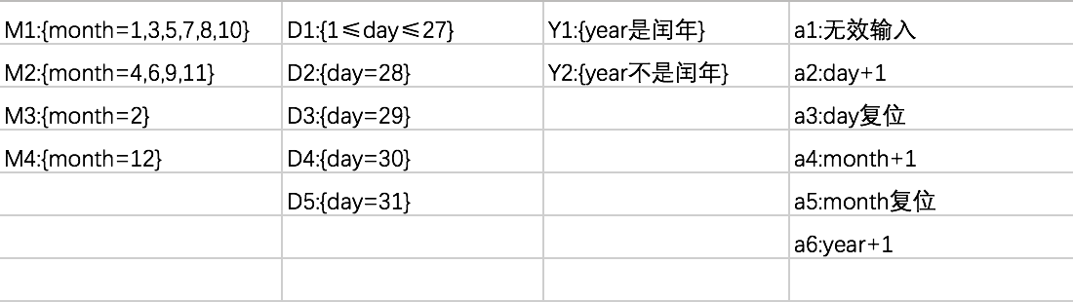

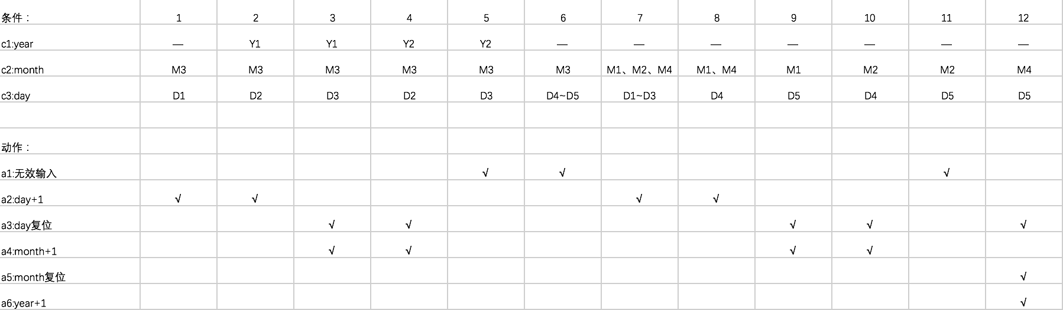

用例：

|  |  |  |  |  |
| --- | --- | --- | --- | --- |
|  | Year | Month | Day | Expect result |
| 1 | 2014 | 2 | 24 | 2014/2/25 |
| 2 | 2008 | 2 | 28 | 2008/2/29 |
| 3 | 2016 | 2 | 29 | 2016/3/1 |
| 4 | 2007 | 2 | 28 | 2007/3/1 |
| 5 | 2015 | 2 | 29 | Error |
| 6 | 2006 | 2 | 30 | Error |
| 7 | 2017 | 4 | 27 | 2017/4/28 |
| 8 | 2014 | 6 | 30 | 2014/6/31 |
| 9 | 2015 | 8 | 31 | 2015/9/1 |
| 10 | 2014 | 11 | 30 | 2014/12/1 |
| 11 | 2007 | 6 | 31 | Error |
| 12 | 2019 | 12 | 31 | 2020/1/1 |