INTERNSHIP REPORT ON

LOAN APPROVAL PREDICTION USING MACHINE LEARNING

In partial fulfillment of the requirements for the Award of the diploma in

Software Development and System Administration

Level-4 Diploma Certificate National Skill Development Corporation
New Delhi

Submitted by

THASMEELA KL

Register No :

DEPARTMENT OF SOFTWARE DEVELOPMENT AND SYSTEM ADMINISTRATION
(2021 ADMISSION)



M.E.S COLLEGE MARAMPALLY
ALUVA-7, KERALA

(Affiliated To Mahatma Gandhi University, Kottayam)
(2023-2024)

M.E.S COLLEGE MARAMPALLY
ALUVA-7, KERALA




DEPARTMENT OF SOFTWARE DEVELOPMENT AND SYSTEM ADMINISTRATION
Certificate
This is to certify that the Report Entitled
LOAN APPROVAL PREDICTION USING MACHINE LEARNING
Has Been Submitted By

THASMEELA KL

ROLL NO

In Partial Fulfillment of the Award of the Diploma in

Software Development and System Administration

Level-4 Diploma Certificate National Skill Development Corporation New Delhi
During the Academic Year 2023-2024
Register No:

Staff in Charge Head of the Department

Submitted for the examination held on………………….
Examiners
1.
2.

M.E.S COLLEGE MARAMPALLY
ALUVA-7, KERALA

DEPARTMENT OF SOFTWARE DEVELOPMENT AND SYSTEM ADMINISTRATION

PROFORMA FOR APPROVAL OF INTERNSHIP REPORT

- Roll Numbers : ………………………………………
- Names of the Students : ………………………………………
- Title of the Internship : ………………………………………
- Name and address of the firm : ………………………………………
: ……………………………………… : ……………………………………… Name of the Guide
(Firm/ Organization) : ………………………………………
- Software used in the Internship : ………………………………………
- Date of Submission : ………………………………………

Signature of the Student Signature of the Guide
(Firm/Organization)

Signature of Staff in charge

AKNOWLEDGEMENT

First of all, I bow my head before the God Almighty in prayer and gratitude for all the blessings showered on me to complete the project work successfully.

I express my heartfelt gratitude to Dr. AJIMS P MOHAMMED Principal and Mrs. SULFATH C Y, Head of the Department, Software Development and System Administration, MES College Marampally for their cooperation and guidance throughout the course of the project work.

I am deeply indebted to my project guide Mrs. SULFATH C Y, Assistant Professor, Software Development and System Administration for her continuous encouragement and valuable guidance given to me. I am also very thankful to all the faculties of the department of Software Development and System Administration for their timely suggestions and encouragement.

I extend my sincere thanks to all the friends for their provoking Suggestions and enlightening discussions which helped me to complete my project successfully.

And last but not the least, I extend my heartfelt thanks to my beloved parents, without their support I could never have reached this point.

THASMEELA KL

Contents

Page no

- Introduction
- Company Profile
- Description of the Internship
  - Technology
  - Internship activities
- Requirements
  - Hardware Specification
  - Software Specification
- Internship Details
- Works Done (screen shorts)

- Conclusion

INTRODUCTION

LOAN APPROVAL PREDICTION
In the financial sector, loan approval is a critical process that involves evaluating the eligibility of applicants based on various parameters. Traditionally, this assessment has been manual, relying heavily on the expertise and intuition of loan officers. However, with the advent of machine learning and data analytics, there is an opportunity to automate and enhance the accuracy of loan approval predictions. This project aims to develop a machine learning model to predict the likelihood of loan approval using Python. By leveraging historical loan data and various predictive algorithms, the model will assist financial institutions in making more informed, efficient, and unbiased decisions. This not only improves operational efficiency but also reduces the risk of default by ensuring that loans are granted to individuals who are most likely to repay.
The primary objectives of this project are to gather and clean a dataset that includes information on previous loan applicants and their loan status, identify and create relevant features to improve the predictive power of the model, evaluate different machine learning algorithms to determine the best model for predicting loan approval, assess the model's performance using appropriate metrics and validation techniques, and create a user-friendly application or interface where loan officers or automated systems can input applicant data and receive a prediction.
Accurate loan approval prediction models can bring several benefits. They mitigate risk by identifying high-risk applicants, thus minimizing defaults and directly impacting profitability. They enhance operational efficiency by reducing the time and resources spent on manual evaluations, allowing quicker decision-making. These models also promote fairness and consistency by reducing human biases, ensuring fairer evaluations based on data-driven insights. Additionally, faster processing of loan applications improves customer experience and satisfaction, potentially leading to greater customer retention.
The project follows a systematic approach to building and validating the predictive model, including data exploration, data preprocessing, feature engineering, model development, model evaluation, hyperparameter tuning, final model selection, and deployment. The tools and technologies used in this project include Python, libraries such as Pandas, NumPy, Scikit-learn, Matplotlib, Seaborn, TensorFlow/Keras, and environments like Jupyter Notebook or any Python IDE, with Flask or Django for web application development.
This loan approval prediction project represents a significant step towards modernizing the loan approval process. By harnessing the power of machine learning, financial institutions can enhance their decision-making processes, reduce risks, and improve overall efficiency. The implementation of such models can lead to more data-driven, fair, and timely loan approvals, benefiting both the institutions and their customers.

COMPANY PROFILE

Camino Infotech Private Limited is an unlisted private company incorporated on 02 March, 2020. It is classified as a private limited company and is located in Ernakulam, Kerala. It's authorized share capital is INR 10.00 lac and the total paid-up capital is INR 25,000.00. The Corporate Identification Number (CIN) of Camino Infotech Private Limited is U72900KL2020PTC061762. The registered office of Camino Infotech Private Limited is at Panadan House Cochin University Post, Kalamassery, ERNAKULAM, Ernakulam, Kerala.
Camino believe that IT infrastructure is the system of all modern organization that connects the various systems and functions. Camino will help to build a robust IT infrastructure. They provide end to end consulting and solutions to our clients. Camino focus on client’s satisfaction. Our philosophy is to have the client at the focus point of all discussions and planning so that the product/service will be essentially client oriented.

IT in India is a vast industry which comprises information technology services, consulting, and outsourcing. The information technology (IT) sector includes companies that produce software, hardware or semiconductor equipment, and companies that provide internet or related services. The global software & services spend stood at $1.7 trillion in 2021, growing at 8.7%. The sector added a total of 4.5 lakh freshers in the current financial year, the highest addition in a single year. Of this, 2 lakh employees were women. Information technology industry deals in the storage, processing and distribution of information. The main factors guiding the location of these industries are resource availability, cost and infrastructure. Artificial Intelligence and Machine Learning are two emerging trends in technologies with real-world insight. AI & ML help to build frameworks that support businesses to gain profit. Camino infotech caters to the prominent AI and ML to deliver high-end solutions. The last reported AGM (Annual General Meeting) of Camino Infotech Private Limited, per records, was held on 30 November, 2022.
Also, its last balance sheet was prepared for the period ending on 31 March,2023


DIRECTORS - KUDUKKULLATTU BABU VYSAKH AND NISHA SANTHOSH BABU ABHAY DEV.

DESCRIPTION OF THE INTERNSHIP

The internship project focused on developing a machine learning model to predict loan approvals using Python. This involved several key steps and methodologies, integrating both technical and analytical skills to create an efficient predictive system.

The first phase of the project entailed understanding the business problem and the requirements of the loan approval process. This included gathering and exploring the dataset provided by the financial institution, which contained various attributes related to applicants' demographic, financial, and credit details.

Data preprocessing was a critical step, involving cleaning the data to handle missing values, encoding categorical variables, and standardizing numerical features. This ensured the dataset was suitable for training machine learning models. Exploratory data analysis (EDA) was conducted to identify patterns, correlations, and insights from the data, helping to inform feature selection and engineering.

Several machine learning algorithms were explored to develop the predictive model. These included logistic regression, decision trees, random forests, and gradient boosting machines. The models were trained and validated using cross-validation techniques to ensure robustness and prevent overfitting. Hyperparameter tuning was performed to optimize the models' performance.

Evaluation metrics such as accuracy, precision, recall, and F1-score were used to assess the models' effectiveness. The best-performing model was selected based on these metrics and further tested on a hold-out validation set to confirm its predictive capability.

The final model was deployed using a Python-based framework, allowing it to be integrated into the financial institution's existing systems. The deployment included creating an API for the model, enabling real-time predictions for new loan applications. Detailed documentation and a user guide were provided to facilitate smooth integration and usage by the institution's staff.

3.1. TECHNOLOGY

Machine learning (ML) is the study of computer algorithms that can improve automatically through experience and by the use of data. It is seen as a part of artificial intelligence. Machine learning algorithms build a model based on sample data, known as training data, in order to make predictions or decisions without being explicitly programmed to do so. Machine learning algorithms are used in a wide variety of applications, such as in medicine, email filtering, speech recognition, and computer vision, where it is difficult or unfeasible to develop conventional algorithms to perform the needed tasks.
Despite the fact that the reasons mentioned are valid, we have added a dimension in the last decade where data is being utilized for predicting what could potentially happen in the future. Then comes Machine Learning which play a significant role in doing so. Machine learning is a subset/subfield of Artificial Intelligence. Generally, the main aim of Machine learning is to understand the structure of data and apply the best possible models that can be utilized or identify a hidden pattern. Developing a machine learning model is one of the key factors in predicting a future problem which again requires machine learning algorithms. There are numerous machine learning algorithms that have been developed and mature enough to solve various real-world business problems.

Although machine learning is a field within computer science, it differs from traditional computational approaches. In traditional computing, algorithms are sets of explicitly programmed instructions used by computers to calculate or problem solve. Machine learning algorithms instead allow for computers to train on data inputs and use statistical analysis in order to output values that fall within a specific range. Because of this, machine learning facilitates computers in building models from sample data in order to automate decision-making processes based on data inputs.

Using Machine learning, information is being turned into knowledge. In the last 5-6 decades, enormous data has been recorded or collected which will be of no use if we don‟t utilize or analyze to find hidden patterns. In order to find useful and significant patterns with complex data, we have several Machine Learning techniques available to ease our struggle for discovery. Subsequently, those identified hidden patterns and knowledge of the problem can be helpful to perform complex decision making and predict future occurrence.

3.2. ITERNSHIP ACTIVITIES

NO | DATE | TIME | ACTIVITIES
1 | 24-04-2024 | 10:00 – 4:00 | - Introduction to python machine learning
2 | 25-04-2024 | 10:00 – 4:00 | - Go through python syntax and variables
3 | 26-04-2024 | 10:00 – 4:00 | - Know about Python dictionary,function and array
4 | 29-04-2024 | 10:00 – 4:00 | - Learn Python lists,tuples and sets
5 | 30-04-2024 | 10:00 – 4:00 | - Understand Python File handling
6 | 25-04-2024 | 10:00 – 4:00 | - Introduction to Machine learning
7 | 01-05-2024 | 10:00 – 4:00 | - Go through data distribution and scatter plot
8 | 02-05-2024 | 10:00 – 4:00 | - Know about train
9 | 03-05-2024 | 10:00 – 4:00 | - Learn Catagorical data and Cross validation
10 | 04-05-2024 | 10:00 – 4:00 | - Select the project topic
11 | 06-05-2024 | 10:00 – 4:00 | - Select the prediction topic
12 | 07-05-2024 | 10:00 – 4:00 | - Discuss about the project
13 | 08-05-2024 | 10:00 – 4:00 | - Understand about Anaconda and Jupyter notebook
14 | 09-05-2024 | 10:00 – 4:00 | - Install anaconda and jupyter notebook
15 | 13-05-2024 | 10:00 – 4:00 | - Create folder and setup jupyter notebook
16 | 14-05-2024 | 10:00 – 4:00 | - Collect details of applicants
17 | 15-05-2024 | 10:00 – 4:00 | - Collect details of applicants
18 | 16-05-2024 | 10:00 – 4:00 | - Create an excel sheet of applicants
19 | 17-05-2024 | 10:00 – 4:00 | - Learn about Pandas
20 | 18-05-2024 | 10:00 – 4:00 | - Studied NumPy
21 | 20-05-2024 | 10:00 – 4:00 | - Learn Matplotlib
22 | 21-05-2024 | 10:00 – 4:00 | - Understand about Seaborn
23 | 22-05-2024 | 10:00 – 4:00 | - Create a barplot
24 | 23-05-2024 | 10:00 – 4:00 | - Learn to import label encoder
25 | 24-05-2024 | 10:00 – 4:00 | - Create a heatmap
26 | 27-05-2024 | 10:00 – 4:00 | - Check the datas
27 | 28-05-2024 | 10:00 – 4:00 | - Studied about classifiers
28 | 29-05-2024 | 10:00 – 4:00 | - Learn X_text and Y_text and find the accuracy
29 | 30-05-2024 | 10:00 – 4:00 | - Final checking of project
30 | 31-05-2024 | 10:00 – 4:00 | - Project submission

REQUIREMENTS

4.1 Software Specification
- Python

- Anaconda

- Jupyter Notebook

4.2 Hardware Specification
- Processor: Intel Core i5

- RAM: 8GB

- OS: Windows

INTERNSHIP DETAILS

Following are the steps to do this project (use Jupyter Notebook):

- Collect the dataset.

- Import the necessary libraries.

- Visualize the dataset.

- Preprocess the data

- Convert text into numerical data

- Train the model
- Test the model and find the accurancy store
- Based on scores ,predict which alogirtham is best for prediction
- Build a deployment
- Predict the accurancy

CODE

import pandas as pd

import numpy as np

import matplotlib.pyplot as plt

import seaborn as sns

data = pd.read_csv("C:/Users/Administrator/Desktop/Internship/1716186353635_LoanApprovalPrediction.csv")

data.head()

obj = (data.dtypes == 'object')

print("Categorical variables:",len(list(obj[obj].index)))

data.drop(['Loan_ID'],axis=1,inplace=True)

obj = (data.dtypes == 'object')

object_cols = list(obj[obj].index)

plt.figure(figsize=(18,36))

index = 1

for col in object_cols:

y = data[col].value_counts()

plt.subplot(11,4,index)

plt.xticks(rotation=90)

sns.barplot(x=list(y.index), y=y)

index +=1

from sklearn import preprocessing

label_encoder = preprocessing.LabelEncoder()

obj = (data.dtypes == 'object')

for col in list(obj[obj].index):

data[col] = label_encoder.fit_transform(data[col])

obj = (data.dtypes == 'object')

print("Categorical variables:",len(list(obj[obj].index)))

plt.figure(figsize=(12,6))

sns.heatmap(data.corr(),cmap='BrBG',fmt='.2f',

linewidths=2,annot=True)

sns.catplot(x='Gender', y="Married",

hue="Loan_Status",

kind="bar",

data=data)

for col in data.columns:

data[col] = data[col].fillna(data[col].mean())

data.isna().sum()

from sklearn.model_selection import train_test_split

X = data.drop(['Loan_Status'],axis=1)

Y = data['Loan_Status']

X.shape,Y.shape

X_train, X_test, Y_train, Y_test = train_test_split(X, Y,

test_size=0.4,

random_state=1)

X_train.shape, X_test.shape, Y_train.shape, Y_test.shape

from sklearn.neighbors import KNeighborsClassifier

from sklearn.ensemble import RandomForestClassifier

from sklearn.svm import SVC

from sklearn.linear_model import LogisticRegression

from sklearn import metrics

knn = KNeighborsClassifier(n_neighbors=3)

rfc = RandomForestClassifier(n_estimators = 7,

criterion = 'entropy',

random_state =7)

svc = SVC()

lc = LogisticRegression()

for clf in (rfc, knn, svc,lc):

clf.fit(X_train, Y_train)

Y_pred = clf.predict(X_train)

print("Accuracy score of ",

clf.__class__.__name__,

"=",100*metrics.accuracy_score(Y_train,

Y_pred))

for clf in (rfc, knn, svc,lc):

clf.fit(X_train, Y_train)

Y_pred = clf.predict(X_test)

print("Accuracy score of ",

clf.__class__.__name__,"=",

100*metrics.accuracy_score(Y_test,

Y_pred))

WORKS DONE

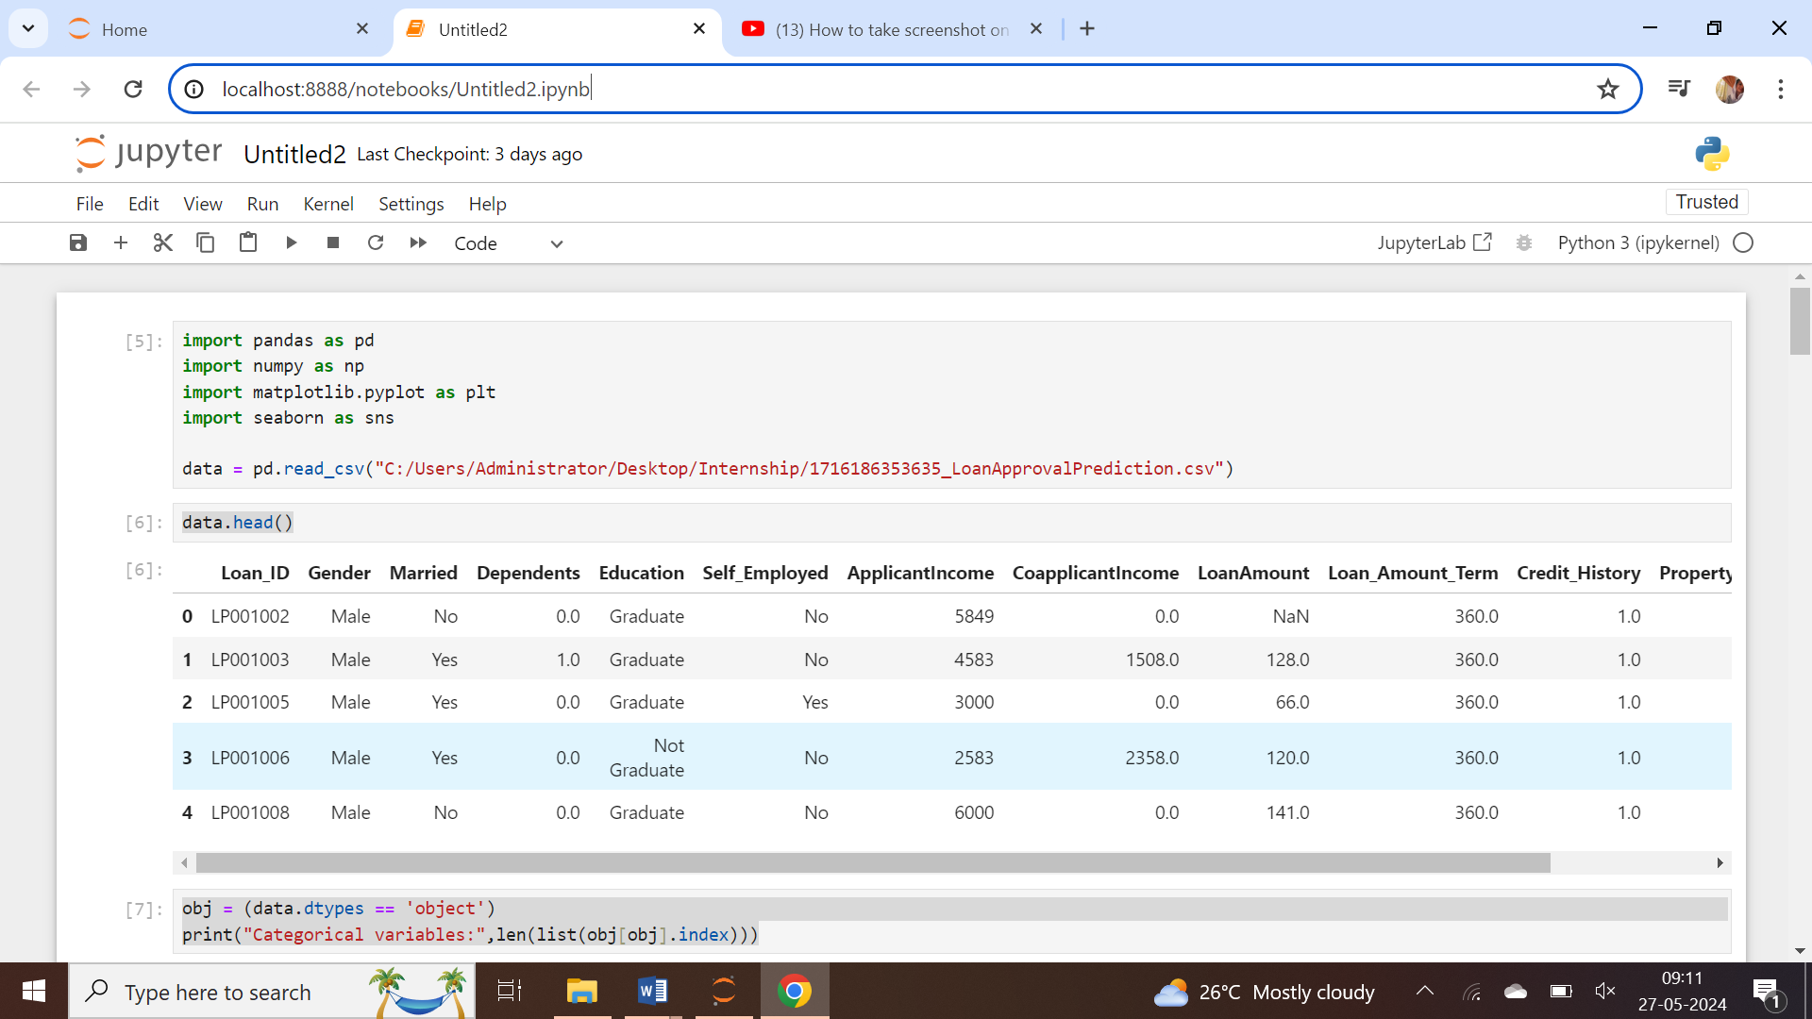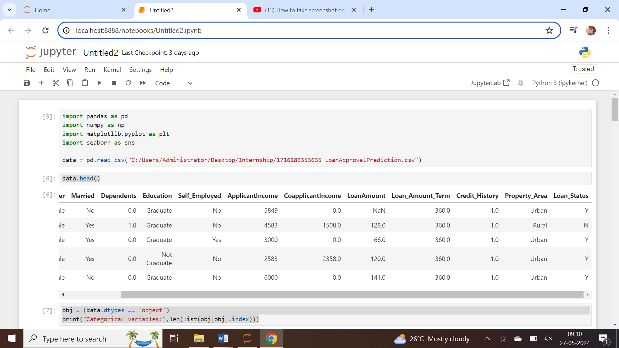

Categorical variables: 7

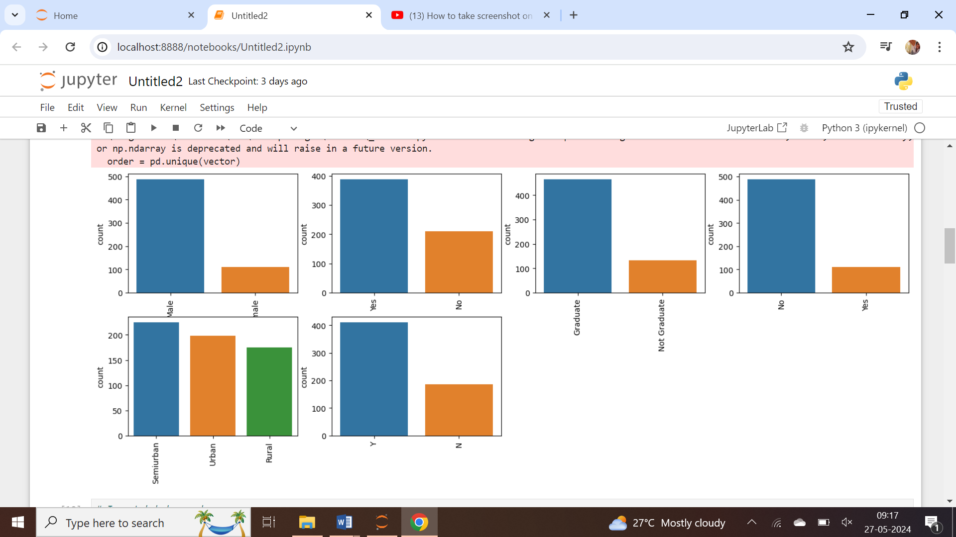

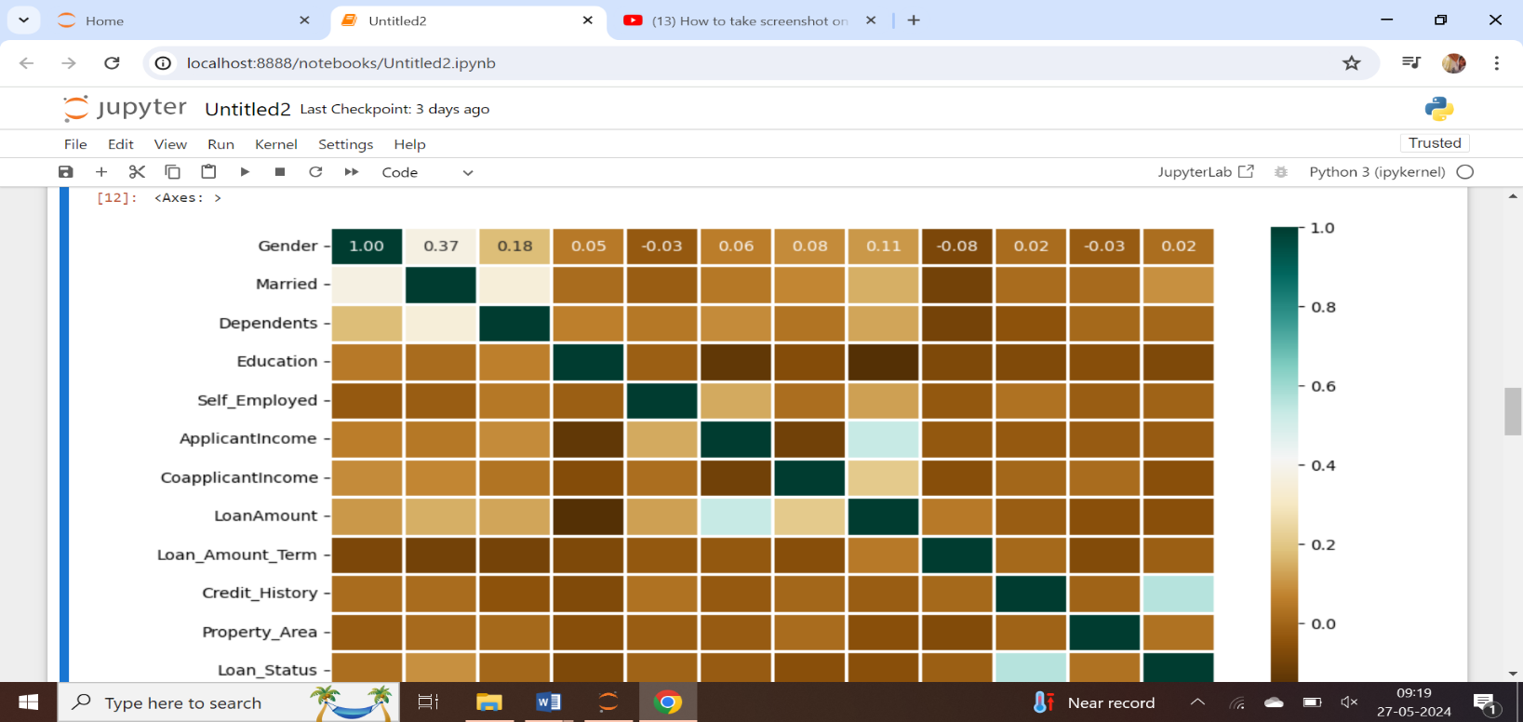
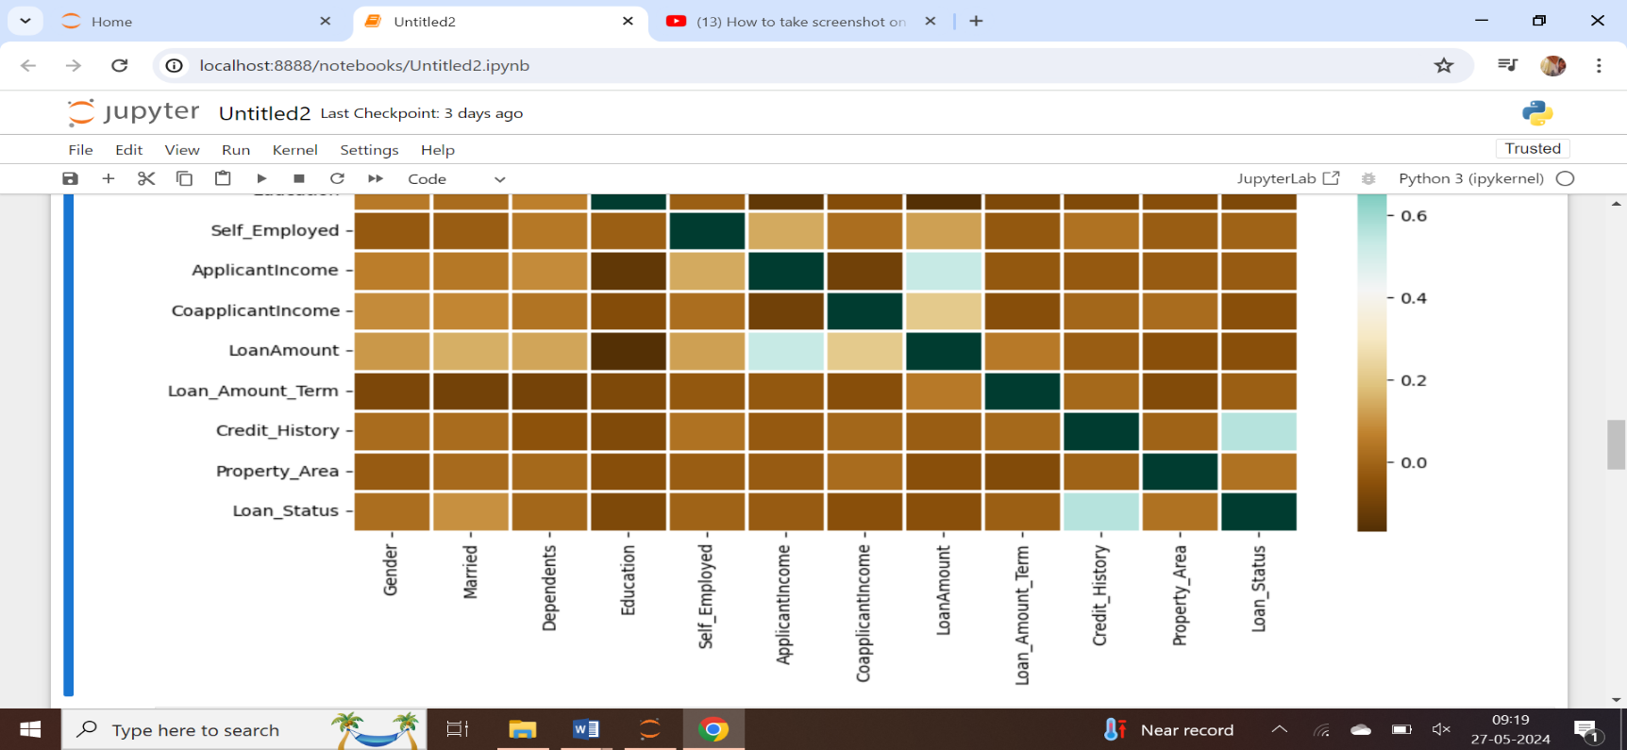

Gender 0
Married 0
Dependents 0
Education 0
Self_Employed 0
ApplicantIncome 0
CoapplicantIncome 0
LoanAmount 0
Loan_Amount_Term 0
Credit_History 0
Property_Area 0
Loan_Status 0
dtype: int64

Accuracy score of RandomForestClassifier = 98.04469273743017
Accuracy score of KNeighborsClassifier = 78.49162011173185
Accuracy score of SVC = 68.71508379888269
Accuracy score of LogisticRegression = 79.88826815642457

Accuracy score of RandomForestClassifier = 82.5
Accuracy score of KNeighborsClassifier = 63.74999999999999
Accuracy score of SVC = 69.16666666666667
Accuracy score of LogisticRegression = 80.0

CONCLUSION

In conclusion, my internship project focused on developing a machine learning model using Python to predict loan approval prediction was a valuable and enriching experience. Throughout the project, I gained hands-on experience in various stages of the machine learning workflow, including data collection, preprocessing, feature selection, model training, and evaluation. I learned the importance of data cleaning and preparation, which are critical for ensuring the accuracy and reliability of the model. Experimenting with different algorithms and hyperparameter tuning provided insights into optimizing model performance. The final model achieved promising results, demonstrating the potential of machine learning in making accurate predictions for loan approval prediction. This internship has significantly enhanced my technical skills and deepened my understanding of machine learning concepts. It has also underscored the importance of continuous learning and adaptation in the rapidly evolving field of data science. I am confident that the knowledge and experience gained from this project will be instrumental in my future career endeavors.

