EXP NO- 6 A
NORMALLY DISTRIBUTED
ANZ JO XAVIER
S6 DS
ROLL NO. - 13
DATE: 07/06/2023

PROGRAM

library("dplyr")
my_data = read.table("/home/dalab13/anz13/data5.txt", sep="", header = TRUE)
print(my_data)
for(i in my_data){
if(is.numeric(i)){
c=shapiro.test(i)
print(c)
if(c[2]>0.05){
print("Data is normally distributed.")
}else{
print("Data is not normally distributed.")
}
}
}

OUTPUT

source("/home/dalab13/anz13/program6a.r", encoding = "UTF-8")
len supp dose
1 11.2 VC 0.5
2 8.2 OJ 0.5
3 10.0 OJ 0.5
4 27.3 OJ 2.0
5 14.5 OJ 1.0
6 26.4 OJ 2.0
7 4.2 VC 0.5
8 15.2 VC 1.0
9 14.5 OJ 0.5
10 26.7 VC 2.0

Shapiro-Wilk normality test

data: i
W = 0.88722, p-value = 0.1578
[1] "Data is normally distributed."
Shapiro-Wilk normality test
data: i
W = 0.73065, p-value = 0.002075
[1] "Data is not normally distributed."

EXP NO- 6 B
VARIANCE, COVARIANCE AND CORELATION
ANZ JO XAVIER
S6 DS
ROLL NO. - 13
DATE: 07/06/2023

PROGRAM

my_data = read.table("/home/dalab13/anz13/data6.txt", sep="", header = FALSE)
print(my_data)
x=my_data[1]
y=my_data[2]
print("Covariance of x and y with pearson method:")
print(cov(x, y, method = "pearson"))
print("Covariance of x and y with kendall method:")
print(cov(x, y, method = "kendall"))
print("Covariance of x and y with spearman method:")
print(cov(x, y, method = "spearman"))
print("Corelation of x and y with pearson method:")
print(cor(x, y, method = "pearson"))
print("Corelation of x and y with kendall method:")
print(cor(x, y, method = "kendall"))
print("Corelation of x and y with spearman method:")
print(cor(x, y, method = "spearman"))

OUTPUT

> source("/home/dalab13/anz13/program6b.r", encoding = "UTF-8")
V1 V2
1 1 3
2 2 4
3 5 10
4 6 20
[1] "Covariance of x and y with pearson method:"
V2
V1 17.16667
[1] "Covariance of x and y with kendall method:"
V2
V1 12
[1] "Covariance of x and y with spearman method:"
V2
V1 1.666667
[1] "Corelation of x and y with pearson method:"
V2
V1 0.9239619
[1] "Corelation of x and y with kendall method:"
V2
V1 1
[1] "Corelation of x and y with spearman method:"
V2
V1 1

EXP NO- 7 A
LINEAR REGRESSION
ANZ JO XAVIER
S6 DS
ROLL NO. - 13
DATE: 07/06/2023

PROGRAM

#linear regression
x <- c(151, 174, 138, 186, 128, 136, 179, 163, 152, 131)
y <- c(63, 81, 56, 91, 47, 57, 76, 72, 62, 48)

rel<-lm(y~x)
a<-data.frame(x=c(162,179))
print(predict(rel,a))

plot(y,x,col = "blue",main = "Height & Weight",
abline(lm(x~y)),cex = 2,pch =16,xlab = "Weight in Kg",ylab = "Height in cm")

OUTPUT

> source("/home/dalab13/anz13/program7.r", encoding = "UTF-8")
1 2
70.83181 82.30018

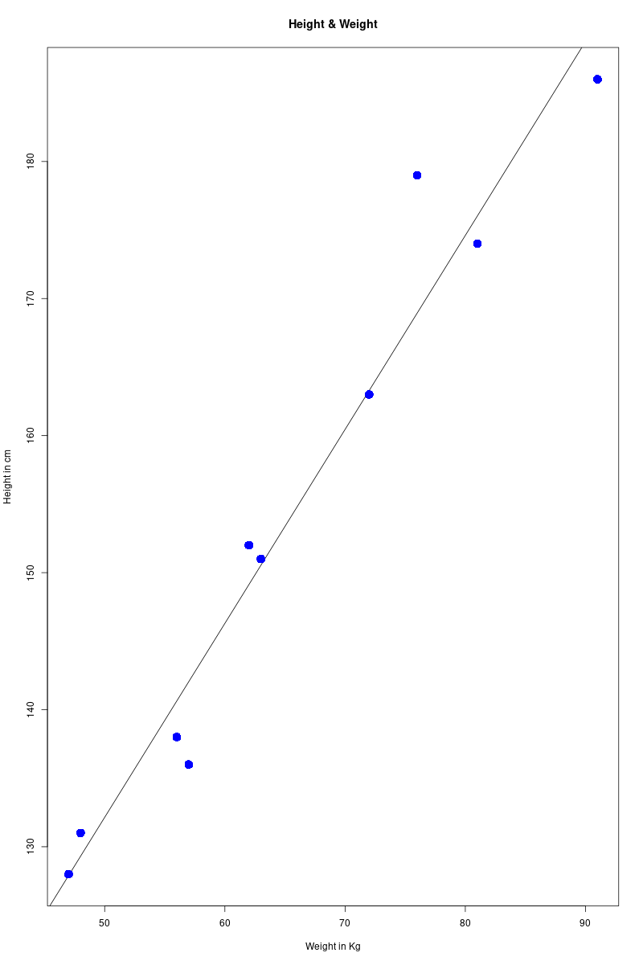
EXP NO- 7 B
LOGISTIC REGRESSION
ANZ JO XAVIER
S6 DS
ROLL NO. - 13
DATE: 07/06/2023

PROGRAM

#fit logistic regression model
model <- glm(vs ~ hp, data=mtcars, family=binomial)

#define new data frame that contains predictor variable
newdata <- data.frame(hp=seq(min(mtcars$hp), max(mtcars$hp),len=500))

newdata$vs = predict(model, newdata, type="response")
plot(vs ~ hp, data=mtcars, col="steelblue")
lines(vs ~ hp, newdata, lwd=2)
print(mtcars)
a <- data.frame(hp=59)
result <- predict(model,a)
print(paste("the value for vs when hp=59 is:",result))

OUTPUT

> source("/home/dalab13/anz13/program8_new.r", encoding = "UTF-8")
mpg cyl disp hp drat wt qsec vs am gear carb

Mazda RX4 21.0 6 160 110 3.90 2.620 16.46 0 1 4 4
Mazda RX4 Wag 21.0 6 160 110 3.90 2.875 17.02 0 1 4 4
Datsun 710 22.8 4 108 93 3.85 2.320 18.61 1 1 4 1
Hornet 4 Drive 21.4 6 258 110 3.08 3.215 19.44 1 0 3 1
Hornet Sportabout 18.7 8 360 175 3.15 3.440 17.02 0 0 3 2
Valiant 18.1 6 225 105 2.76 3.460 20.22 1 0 3 1

[1] "the value for vs when hp=59 is: 4.33294259783079"

