EXP NO- 7 C
K MEANS
ANZ JO XAVIER
S6 DS
ROLL NO. - 13
DATE: 07/06/2023

PROGRAM

data(iris)
print(head(iris))
clusters<-kmeans(iris[, c("Sepal.Length","Petal.Length")], centers=3)
plot(iris[, c("Sepal.Length","Petal.Length")],col=clusters$cluster)

print(clusters$cluster)

OUTPUT

> source("/home/dalab13/anz13/program7c.r", encoding = "UTF-8")
Sepal.Length Sepal.Width Petal.Length Petal.Width Species
1 5.1 3.5 1.4 0.2 setosa
2 4.9 3.0 1.4 0.2 setosa
3 4.7 3.2 1.3 0.2 setosa
4 4.6 3.1 1.5 0.2 setosa
5 5.0 3.6 1.4 0.2 setosa
6 5.4 3.9 1.7 0.4 setosa
[1] 3 3 3 3 3 3 3 3 3 3 3 3 3 3 3 3 3 3 3 3 3 3 3 3 3 3 3 3 3 3 3 3 3 3 3 3 3
[38] 3 3 3 3 3 3 3 3 3 3 3 3 3 1 2 1 2 2 2 2 2 2 2 2 2 2 2 2 2 2 2 2 2 2 2 2 2
[75] 2 2 1 1 2 2 2 2 2 2 2 2 2 2 2 2 2 2 2 2 2 2 2 2 3 2 1 2 1 1 1 1 2 1 1 1 1
[112] 1 1 2 2 1 1 1 1 2 1 2 1 2 1 1 2 2 1 1 1 1 1 1 1 1 1 1 2 1 1 1 2 1 1 1 2 1
[149] 1 2

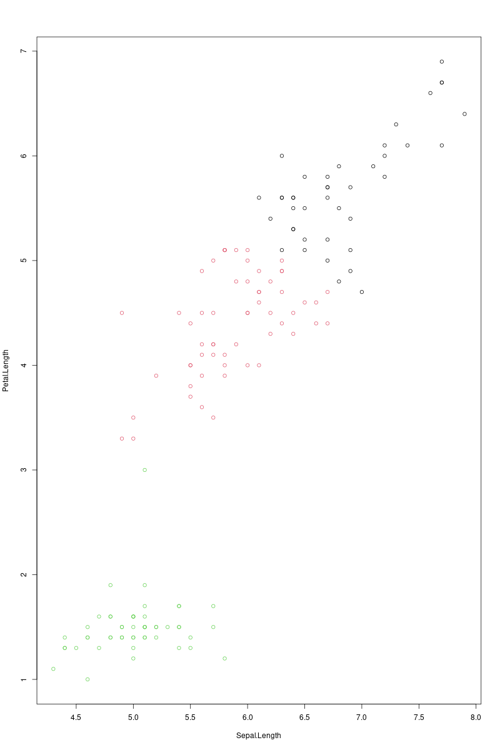
EXP NO. - 8
DECISION TREE
ANZ JO XAVIER
S6 DS
ROLL NO. - 13
DATE: 07/06/2023

PROGRAM

library(datasets)
library(caTools)
library(party)
library(dplyr)
library(magrittr)

data("readingSkills")
print(head(readingSkills))

sample_data = sample.split(readingSkills, SplitRatio = 0.8)
train_data <- subset(readingSkills, sample_data == TRUE)
test_data <- subset(readingSkills, sample_data == FALSE)
model<- ctree(nativeSpeaker ~ ., train_data)
plot(model)
#print(model)
# testing the people who are native speakers
# and those who are not
predict_model<-predict(model, test_data)

# creates a table to count how many are classified
# as native speakers and how many are not
m_at <- table(test_data$nativeSpeaker, predict_model)
acu<-sum(diag(m_at)) / sum(m_at)
print(paste('Accuracy for decision tree of Reading Skills is', acu))

OUTPUT

> source("/home/dalab13/anz13/program8.r", encoding = "UTF-8")
nativeSpeaker age shoeSize score
1 yes 5 24.83189 32.29385
2 yes 6 25.95238 36.63105
3 no 11 30.42170 49.60593
4 yes 7 28.66450 40.28456
5 yes 11 31.88207 55.46085
6 yes 10 30.07843 52.83124
[1] "Accuracy for decision tree of Reading Skills is 0.96"

