1A – 1C

2  
  
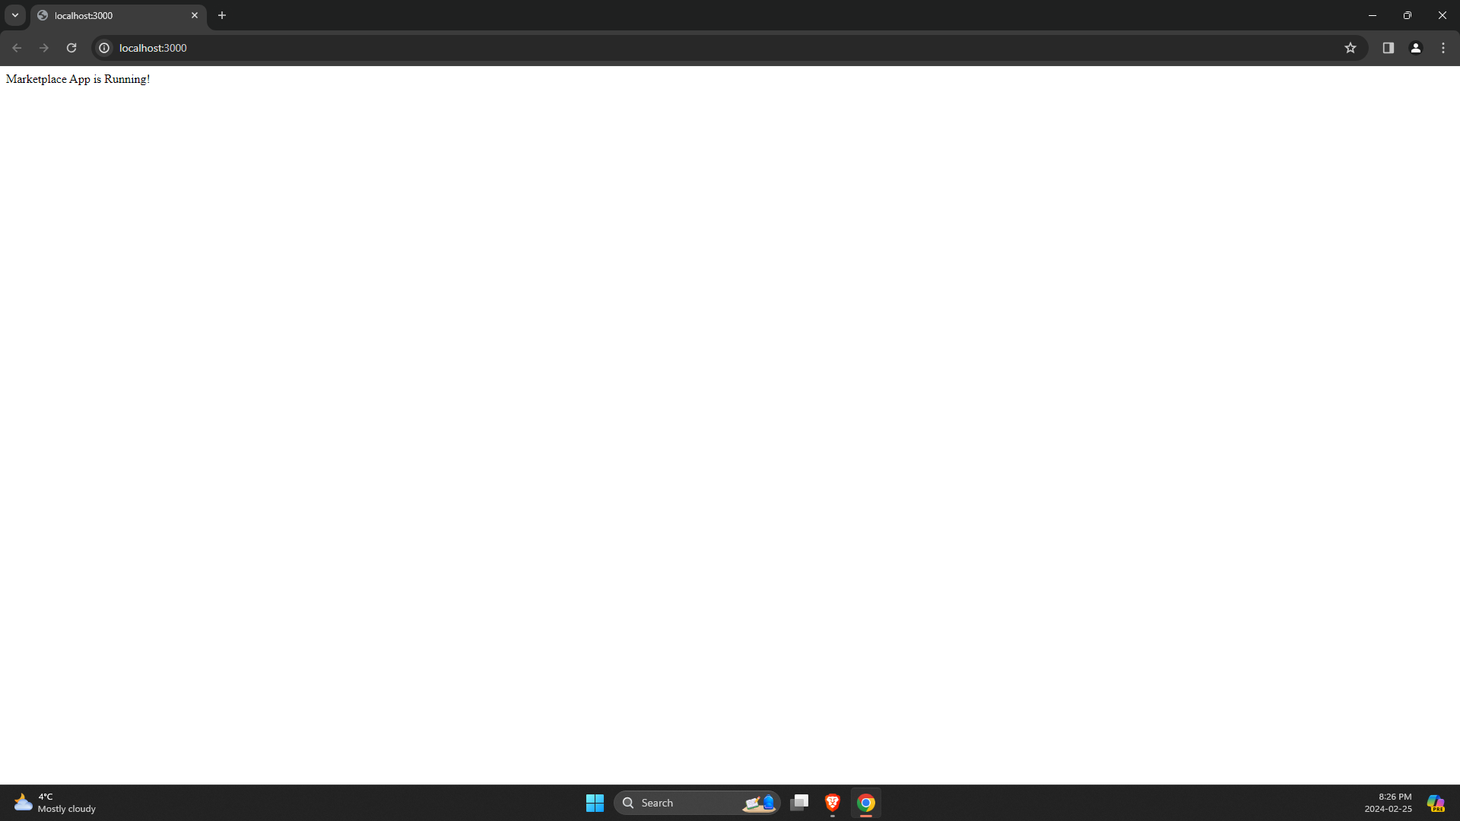

3  
  
GET: api/products/

# POST: api/products/

# GET: api/products/:id

# GET: api/products?name=[kw]

# DELETE: api/products/:id

