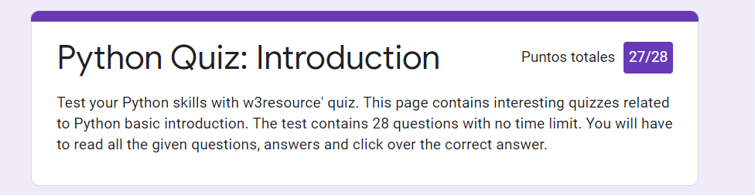

Is it possible to check for more than one error in one except line? Yes, if the exception types are enclosed in parentheses.

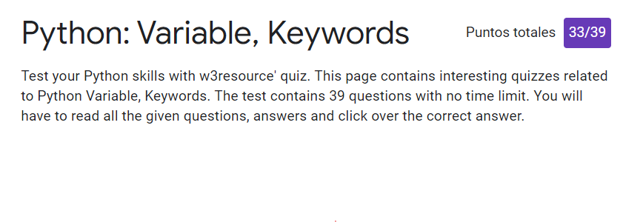

Which of the following is not a keyword? The answer was **open**. However, I thought that **lambda** was the right answer. I thought my answer was right since you use this word when you want to open a file.

All keywords available in Python are in **Both uppercase and lowercase.** This one was very tricky because only None, False and True are uppercase. I thought that **Lowercase** was the right answer.

Which of the following is true for variable names in Python? The answer was **unlimited length**. I thought that none of the alternatives were correct, but I got confused between **identifiers** and **variable names**. The first group has a limited length: 79, while the second do not.

Which of the following is not a variable? The right answer was **in**. I answered **__init__**. However, my answer was not a keyword.

What is the output of the following code?

xx = 25

if False:

xx = 75

def var1():

if True:

xx = 35

print( var1() )

I thought I would get 35 since the code will always apply the if condition; however, the right answer was **None**. I think it is because there is no define a variable to return when the function is executed. Generally, the functions return the last variable defined inside the function environment; however, there was not defined any variable in this function apart from the one inside the if condition.

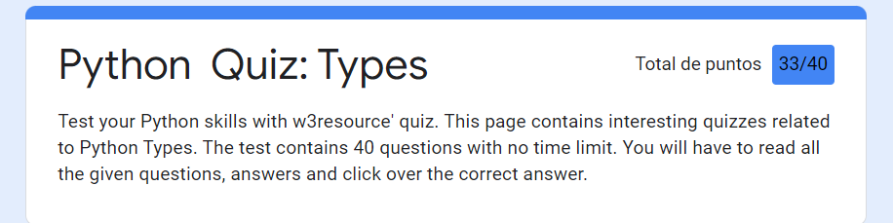

What is the output of the following code?

Print(type(lambda:None))

I knew that lambda is a keyword name, but I did not know that this was a function.

Which of the following is incorrect?

a = 03964

I did not know that leading zeros in decimal integer literals are not permitted.

What is the return value of trunc()?

I have som doubts about it since in my computer trunc() function does not exist. I assume I am using a different Python version.

What will be the output of the following Python code snippet?

This was very tricky since It was difficult to notice the indentation issue.

What gets printed?

def x(): pass

print(type(x()))

I thought that this should return a function, but the result from a pass is a Nonetype.

Boolean type is a subtype of Integer data type in Python

I knew that Boolean was a maintype of Python. I think that is incorrect.

If x and y are strings, which of the following is equivalent to [x] + [y] ?

My answer was wrong since [x].append(y) does not generate any object.

In order to execute an operation over arguments of different data types, convert all of them to the same type beforehand.

I thought that this was true when you wan to operate numpy, dict and pandas, but I was wrong.

Which of the following data types can be used as keys in dictionaries in Python? Select all that apply

The answer for this was any type of value, but for my version type you can only use tuples, strings, and ints as keywords.

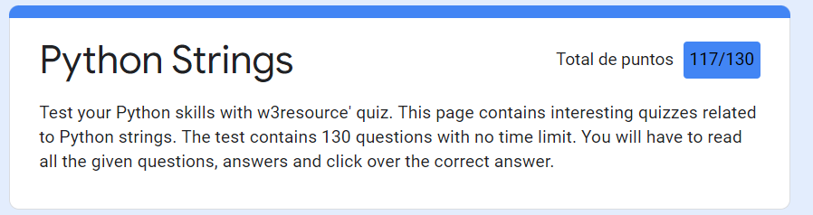

What will be the output of the following Python code?

class test:

def __init(self, id ):

self.id = str( id)

id = 144

x = tester(12)

print(x.id)

I though it will occur an error, but the right answer is 12. Since 12 is an attribute of the class test.

What will be the output of the following Python code?*

Print(“Python {0} and {1}”.format((‘faa’, ‘bin’))

The right answer is an Error, but I tought that it will bring “Python faa and bin”. A tuple will not be indexing in the brackets.

If a class defines the __str__(self) method, for an object obj for the class, you can use which command to invoke the __str__ method.

I just choose one, but the right answer was all the options: obj.__str__(), str(obj) and print obj.

What will be the output of the following Python code snippet?

print(“mnopqropstop”.split(‘op’, -1))

The right answer is ['mn', 'qr', 'st', ''], but I chose [‘mn’, ‘qr’, ‘st’].

What will be the output of the following Python code?

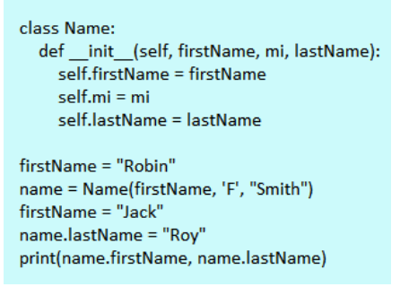

I did not see that in the las line the attribute lastName was changed to Roy. I chose “Robin Smith”, but the right option is “Robin Roy”.

To check whether string s1 contains another string s2, use

I think this answer is wrong because I can use my option (s2 in s1) as the right answer in the quiz (s1.__contains__(s2)).

What will be the output of the following Python code?

Print( ‘*’, ‘pqrstv’.center(7), ‘*’)

Theis question has one issue: duplicated answers.

 What will be the output of the following Python code?

Print(“pq\trs\ttu”.expandtabs(4))

Theis question has one issue: duplicated answers.

 What will be the output of the following Python code?*

Example = ‘beautiful world’

Example[3] = ‘b’

Print example

I learnt that strings do not support index assignment.

 What will be the output of the following Python code snippet?

Print(‘{:#}’.format(3334445556))

I realize that this format does not change the number visualization.

ali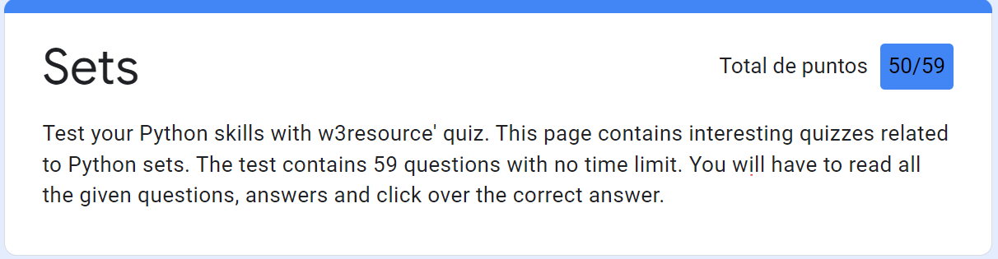

What will be the output of the following Python code?

X = {4,7,8,8,9}

{4,7,8,9}

Sets only have unique values.

 Set members must not be hashable.

Set members can be hashable

 Which of the following functions will return the symmetric difference between two sets, x and y?

x^y

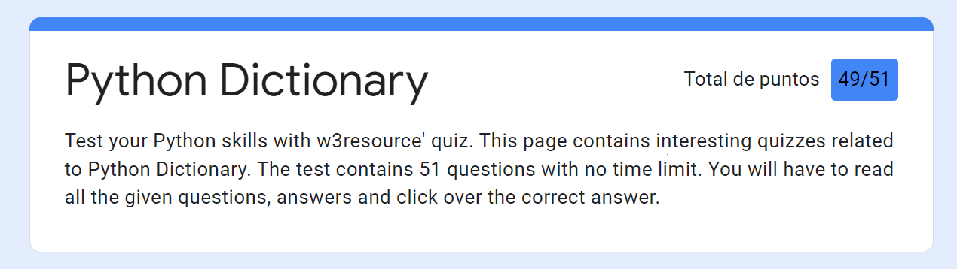

I got confused ‘ with “”.

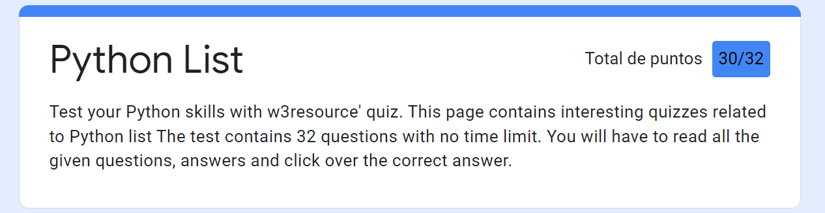

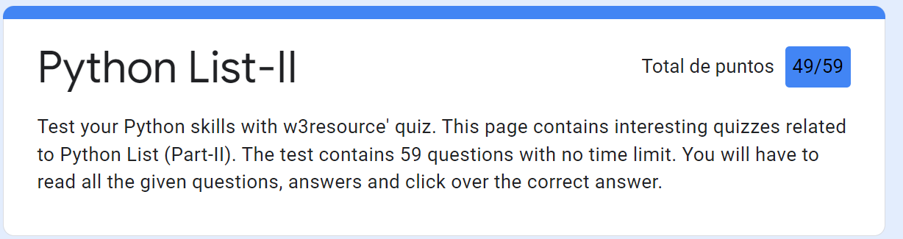

What will be the output of the following code?

X = [2,3,4]

Y = X.append(5)

Print(x)

[2,3,4,5]

Print(y)

None

I realized that appending elements does not return any object. That is tha reason that y is None.

Animals = [‘Monkey’, ‘Tiger’, “Lion”]

Animals2 = animals[:]

The last code generates a new list and not reference to the previous list.

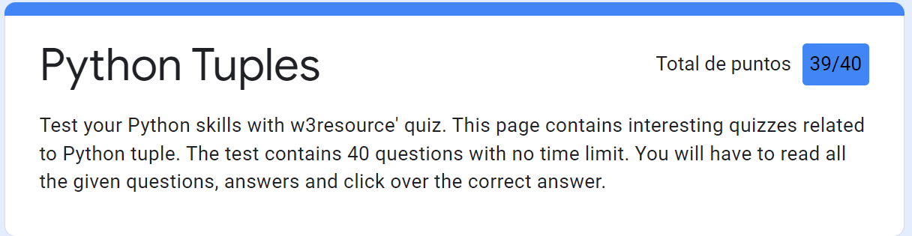

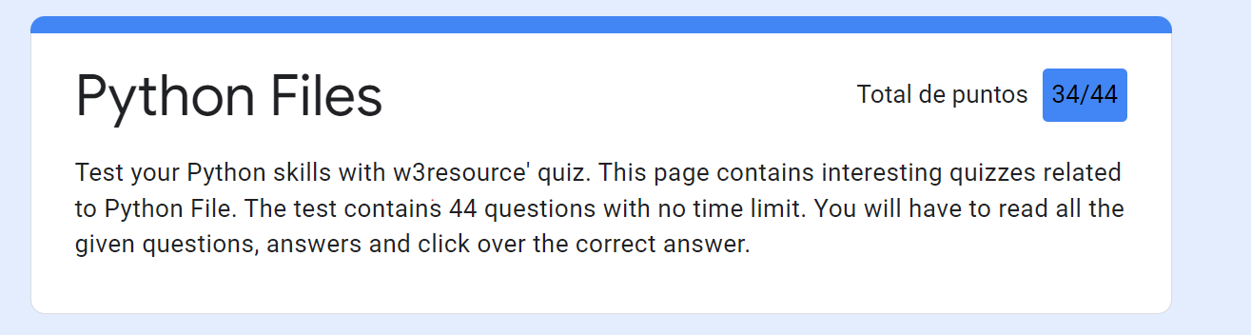

 Which one of the following is not attributes of file?

The right answer was the mode attribute.

 Change the file position to an offset value from the starting position.

The seek function helps you to change your position.

Which function is used to read single line from file?

I tought that readline() is proper for just one line, but the right answer is readlines().

What is the difference between r+ and w+ modes?

The main difference is that r+ the pointer is initially placed at the beginning of the file and the pointer is at the end for w+