**Errors**

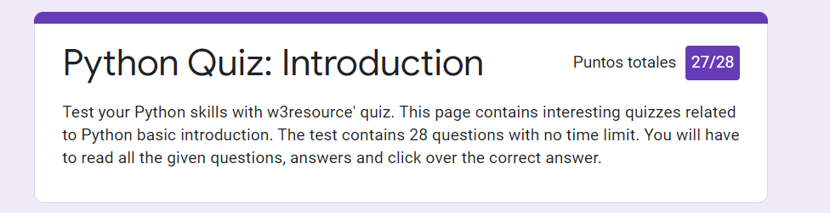**Introduction**

* Is it possible to check for more than one error in one except line?
* Yes, if the exception types are enclosed in parentheses.

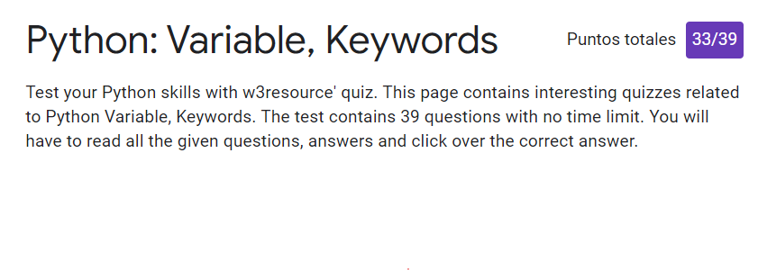

* Which of the following is not a keyword?
* The answer was **open**. However, I thought that **lambda** was the right answer. I thought my answer was right since you use this word when you want to open a file.
* All keywords available in Python are in **Both uppercase and lowercase.**
* This one was very tricky because only None, False and True are uppercase. I thought that **Lowercase** was the right answer.
* Which of the following is true for variable names in Python?
* The answer was **unlimited length**. I thought that none of the alternatives were correct, but I got confused between **identifiers** and **variable names**. The first group has a limited length: 79, while the second do not.
* Which of the following is not a variable?
* The right answer was **in**. I answered **__init__** because I thought it was a build/in function inside classes. However, my answer was not a keyword.
* What is the output of the following code?

xx = 25

if False:

xx = 75

def var1():

if True:

xx = 35

print( var1() )

* I thought I would get 35 since the code will always apply the if condition; however, the right answer was **None**. I think it is because there is no define a variable to return when the function is executed. Generally, the functions return the last variable defined inside the function environment; however, there was not defined any variable in this function apart from the one inside the if condition.

**Types**

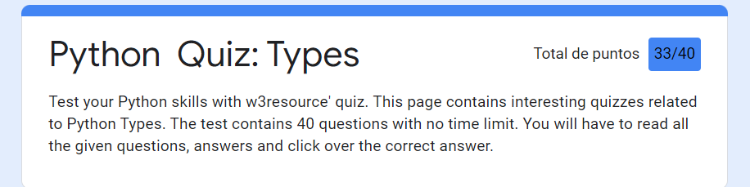

* What is the output of the following code?

Print(type(lambda:None))

* I knew that lambda is a keyword name, but I did not know that this was a function.
* Which of the following is incorrect?

a = 03964

* I did not know that leading zeros in decimal integer literals are not permitted.

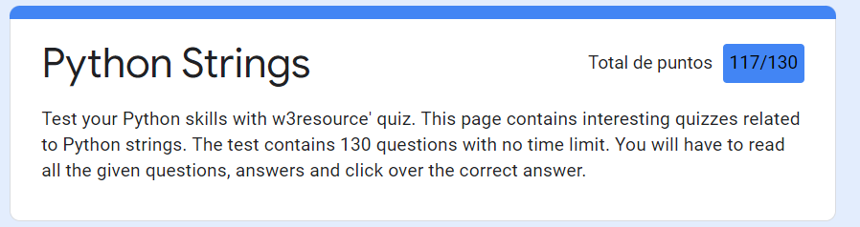 **String**

* What is the return value of trunc()?
* I have some doubts about it since in my computer trunc() function does not exist. I assume I am using a different Python version.
* What will be the output of the following Python code snippet?
* This was very tricky since It was difficult to notice the indentation issue.
* What gets printed?

def x(): pass

print(type(x()))

* I thought that this should return a function, but the result from a pass is a Nonetype.
* Boolean type is a subtype of Integer data type in Python
* I knew that Boolean was a maintype of Python. I think that is incorrect.
* If x and y are strings, which of the following is equivalent to [x] + [y] ?
* My answer was wrong since [x].append(y) does not generate any object.
* In order to execute an operation over arguments of different data types, convert all of them to the same type beforehand.
* I thought that this was true when you wan to operate numpy, dict and pandas, but I was wrong.
* Which of the following data types can be used as keys in dictionaries in Python? Select all that apply
* The answer for this was any type of value, but for my version type you can only use tuples, strings, and int as keywords.
* What will be the output of the following Python code?

class test:

def __init(self, id ):

self.id = str( id)

id = 144

x = tester(12)

print(x.id)

* I though it will occur an error, but the right answer is 12. Since 12 is an attribute of the class test.
* What will be the output of the following Python code?*

print(“Python {0} and {1}”.format((‘faa’, ‘bin’))

* The right answer is an Error, but I tought that it will bring “Python faa and bin”. A tuple will not be indexing in the brackets.
* If a class defines the __str__(self) method, for an object obj for the class, you can use which command to invoke the __str__ method.
* I just choose one, but the right answer was all the options: obj.__str__(), str(obj) and print obj.
* What will be the output of the following Python code snippet?

print(“mnopqropstop”.split(‘op’, -1))

* The right answer is ['mn', 'qr', 'st', ''], but I chose [‘mn’, ‘qr’, ‘st’].

* What will be the output of the following Python code?

Class Name:

def __init__(self, firstName, mi, lastName):

self.firstName = firstName

self.mi = mi

self.lastName = lastName

firstName = “Robin”

name = Name( firstName, ‘F’, “Smith”)

firstName = “Jack”

name.lastName = “Roy”

print(name.firstName, name.lastName)

* I did not see that in the las line the attribute lastName was changed to Roy. I chose “Robin Smith”, but the right option is “Robin Roy”.
* To check whether string s1 contains another string s2, use
* I think the default answer is wrong because I can use my option (s2 in s1) in Python and gives me the same results as the right answer in the quiz (s1.__contains__(s2)).
* What will be the output of the following Python code?

Print( ‘*’, ‘pqrstv’.center(7), ‘*’)

* This question has one issue: duplicated answers.
* What will be the output of the following Python code?

Print(“pq\trs\ttu”.expandtabs(4))

* This question has one issue: duplicated answers.
* What will be the output of the following Python code?*

Example = ‘beautiful world’

Example[3] = ‘b’

Print example

* I learnt that strings do not support index assignment.
* What will be the output of the following Python code snippet?

Print(‘{:#}’.format(3334445556))

* I realize that this format does not change the number visualization.

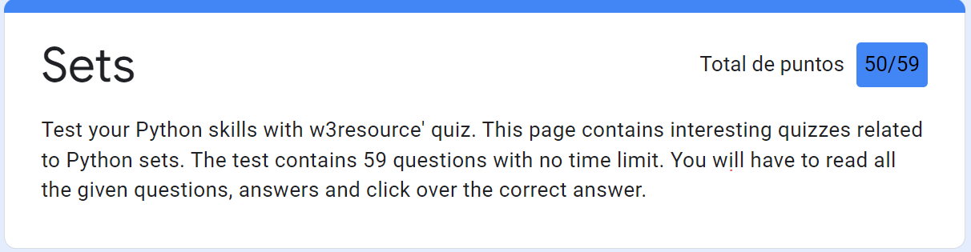**Sets**

* What will be the output of the following Python code?

X = {4,7,8,8,9}

{4,7,8,9}

* I learned that sets only have unique values.Also, set members must not be hashable.
* Which of the following functions will return the symmetric difference between two sets, x and y?
* x^y

**Dictionary**

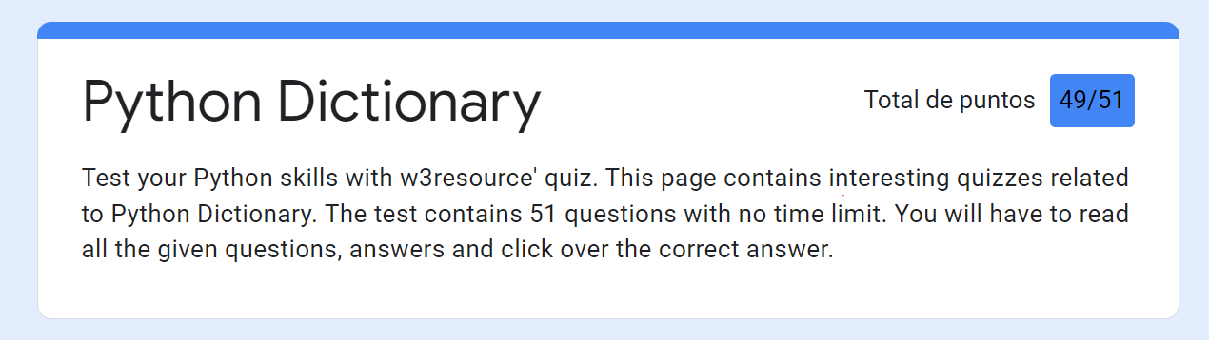

* I got confused ‘ with “”.

**Lists**

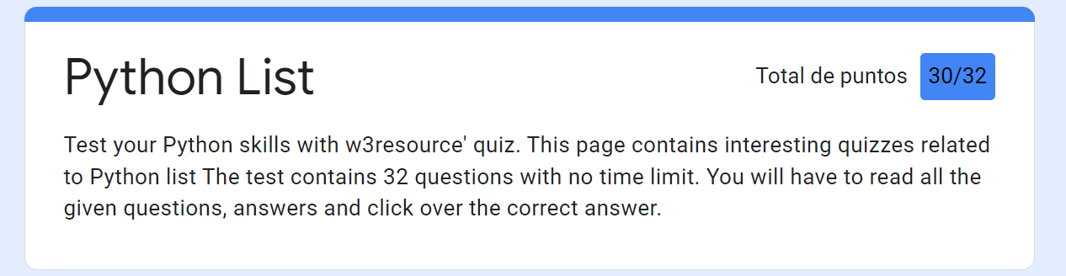

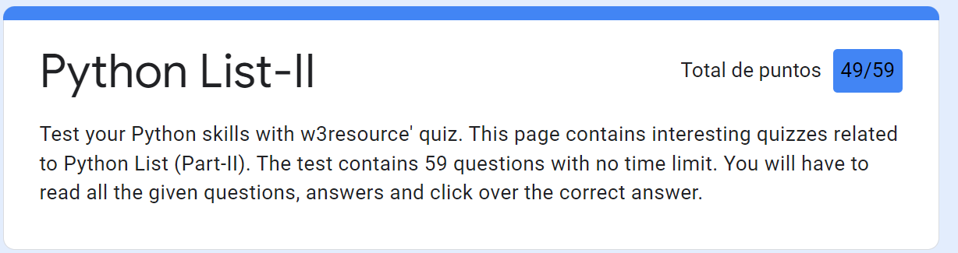

* What will be the output of the following code?

X = [2,3,4]

Y = X.append(5)

Print(x)

[2,3,4,5]

Print(y)

None

* I realized that appending elements does not return any object. That is tha reason that y is None.
* Interpret the following scripts

Animals = [‘Monkey’, ‘Tiger’, “Lion”]

Animals2 = animals[:]

* The last code generates a new list and not reference to the previous list.

**Tuples**

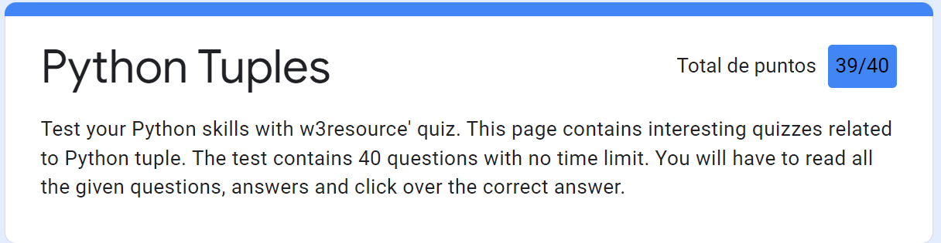

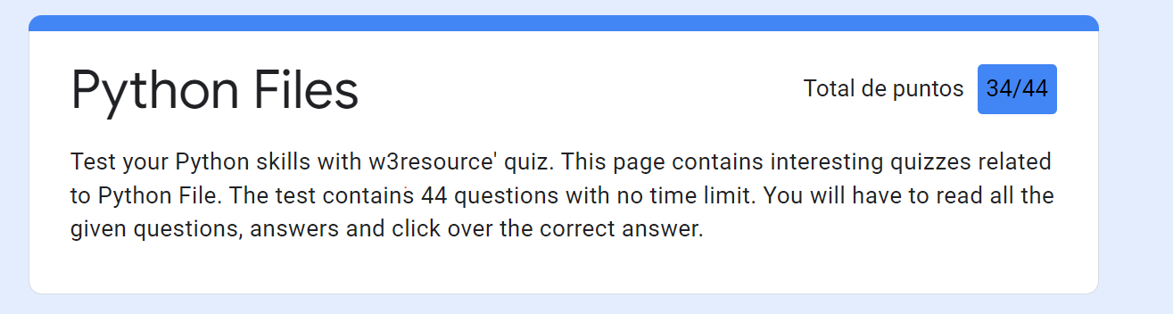**Files**

* Which one of the following is not attributes of file?
* The right answer was the mode attribute.
* Change the file position to an offset value from the starting position.
* The seek function helps you to change your position.
* Which function is used to read single line from file?
* I thought that readline() is proper for just one line, but the right answer is readlines(), because you can select the number of lines you want read.
* What is the difference between r+ and w+ modes?
* The main difference is that r+ the pointer is initially placed at the beginning of the file and the pointer is at the end for w+