Quality Assurance of Analysis of DMSA Imaging

The Data

This disc contains the DMSA scans from ten patients. Each patient has two views of the kidney, anterior and posterior in a 128x128 matrix. The data is presented in interfile version 3.3 format.

Patient No. Anterior filename Posterior filename

1 p1ant p1post
2 p2ant P2post
3 p3ant p3post
4 p4ant p4post
5 p5ant p5post
6 p6ant p6post
7 p7ant p7post
8 p8ant p8post
9 p9ant p9post
10 p10ant p10post

Each interfile image is stored in two files, one containing the header (.hdr) and one containing the image data (.img).

For example, patient 1 has four files containing the data for the two views:

p1ant.hdr header file for anterior
p1ant.img image data for anterior
p1post.hdr header file for posterior
p1post.img image data for posterior

The patient age can be determined from the header file.

Reading the Data

The data should be converted from Interfile format to that of your own computer system. Most systems should have this facility. If in doubt, ask the manufacturer of your system who should be able to show you how to transfer the data. As DICOM is fast becoming the principal medium for medical image data transfer, the audit data will be made available in this form in the near future.

To test that the process of reading the files has worked correctly, the images of patient 1 should appear as in the figure below. The total count in the anterior image should be 68757 and the total in the posterior image 87847.

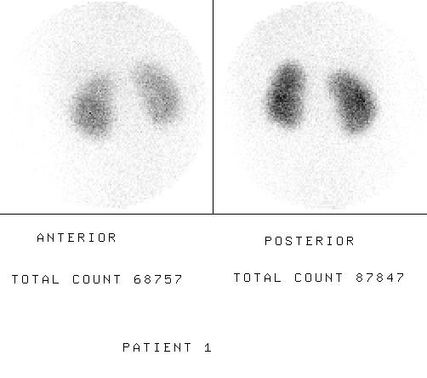

Analysis of the Data

The data enables evaluation of software for assessing the relative renal function from DMSA images. The main purpose is to allow centres to test the analysis system they use routinely. Therefore if your current process only uses the posterior image data then the anterior image should be ignored. The data should also be useful for comparing the performance of different systems particularly when changing from one system to another.

Evaluation of the Data

The results of the UK analysis of this data have been published in Nuclear Medicine Communications. The reference is:

Fleming, J.S, Cosgriff, P.S., Houston, A.S., Jarritt, P.H., Skrypniuk, J.V., Whalley, D.R., United Kingdom audit of relative renal function measurement using DMSA scintigraphy. Nuclear Medicine Communications 19, 1998, 989-997

This gives the distribution of values from centres in the UK for each of the ten sets of data. Although the correct results of these studies are not known, it is assumed for the present that the UK national mean is a reasonable estimate of truth. Therefore your results should be as close to this value as possible and certainly within the 10-90 percentile interval for each study.

If you have any questions about this audit please contact the audit organiser

Professor John S Fleming
Head of Nuclear Medicine Physics
Department of Nuclear Medicine
Southampton General Hospital
Southampton SO16 6YD

Tel 44 23 80796202
Fax 44 23 80796927
e-mail John.Fleming@suht.swest.nhs.uk
readme.doc

