INSTITUTE OF PHYSICS AND ENGINEERING IN MEDICINE

Nuclear Medicine Software Working Party

Quality Assurance of Analysis of DMSA Imaging

RESULT FORM (Please use a separate form for each operator)

Name of Site: Operator Identifier (e.g. 1,2, etc):

Computer System

Manufacturer: Make and Model of computer:

Name and version of DMSA software:

Details of analysis (Please tick appropriate box in each case)

Software used:
^{Commercial} ◻ ^{User written programme} ◻
^{User written protocol} ◻ ^{Don't know} ◻

Images used for calculation of relative function:
^{Posterior only} ◻ ^{Geometric mean} ◻

ROI: Please briefly describe method and enclose a copy of the results presented to the radiologist/nuclear medicine consultant for reporting

Is background subtraction used: Yes / No (Delete as applicable)

Operator experience (Please tick appropriate box in each case)

How long have you been routinely processing DMSA scans ?

^{< 6 months} ◻ ^{6 months - 1 year} ◻ ^{> 1 year} ◻

How many DMSA scans do you process per month ?
¹⁻¹⁰ ◻ ¹¹⁻³⁰ ◻ ^{>30} ◻

DMSA Analysis Result Form contd

If the images have been transferred correctly they should be in the conventional orientation as shown below:
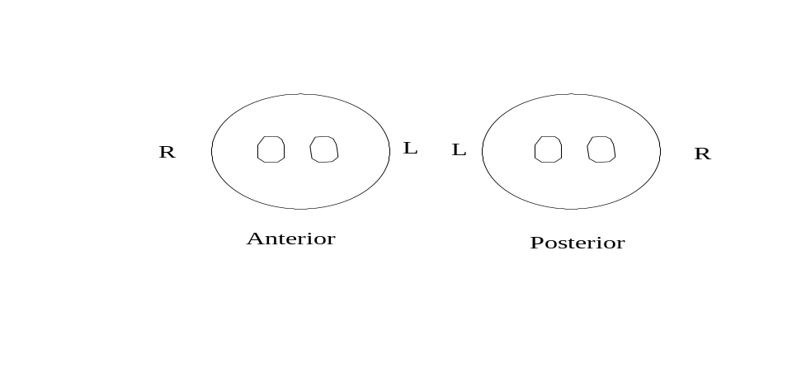

Patient No: | Percentage of Total Renal Function for Right Kidney | Comment on Analysis  (if necessary)
1
2
3
4
5
6
7
8
9
10

Please return this form to your Regional Audit Coordinator

