MSc BDS – Data Engineering and Machine Learning Operations in Business

MLOps Final Assignment:
Customer-Churn-MLOps Pipeline

Submitted by: Anzuman Ara
Student ID: 20241266

Submission Deadline: April 17, 2026

1. Introduction and Aim of the Project
Machine learning models are usually built and tested in stable environments, but their actual usefulness depends on how well they perform in real-world systems that are constantly evolving. In practice, data is constantly updated, new information keeps coming in, and system needs may also change. Therefore, models must be regularly maintained, updated, and monitored to ensure they continue to give reliable results.
This project follows core MLOps principles, with a focus not only on model development but also on deployment, monitoring, and reproducibility, as discussed by Kreuzberger et al. (2023).
This project aims to design and implement a simplified yet realistic MLOps pipeline for customer churn prediction. The project emphasizes how different components of a machine learning system interact in a production-like setting. This includes handling both historical and newly arriving data, applying consistent preprocessing, training, and storing models, exposing predictions through an API, and monitoring system behavior through logging.
Customer churn prediction is selected as a case study because it is a common business problem that involves structured data and repeated prediction tasks. The pipeline is carefully built in a modular and transparent way so that each part can be easily understood, tested, and improved separately. This aligns with real-world MLOps practices, where maintainability, reproducibility, and system reliability are often more important than achieving high model performance.
The objective of this project is to simulate a real-world production pipeline where:
- Data is continuously ingested and updated
- Preprocessing and feature engineering are applied consistently
- Models are trained and versioned
- Predictions are served through an API
- System behavior is monitored through logs
The system is designed to be modular, reproducible, and deployable, reflecting industry practices in machine learning operations (MLOps).

2. Pipeline Diagram
Historical Data + Incoming Data (SQLite Storage)
↓
Data Ingestion
↓
Preprocessing & Feature Engineering
↓
Model Training
↓
Artifact Storage (model, metrics, schema)
↓
FastAPI Prediction Service
↓
Monitoring & Logging System
↓
Dockerized Deployment
Figure 1: End-to-end MLOps pipeline for customer churn prediction

3. Technical Details of Each Pipeline Component

3.1 Data Ingestion
The system uses a batch-based ingestion strategy. Historical customer data and simulated incoming customer data are first stored in lightweight SQLite database tables. Raw CSV files are used as the initial source data, while the ingestion pipeline merges new incoming records into the historical dataset table and logs each update. The pipeline also follows data-centric AI principles, where keeping data reliable and up to date is important for building robust machine learning systems (Zha et al., 2025)
The ingestion process:
• loads historical and incoming customer data into SQLite tables
• reads incoming customer records from the database
• merges new records into the historical dataset
• logs ingestion events for monitoring
To support structured storage and improve reproducibility, SQLite was used as a lightweight relational database. Historical customer data and new incoming customer data were stored in separate database tables. The ingestion pipeline reads the new incoming data from the database and merges it into the historical customer dataset. Each ingestion step is logged to track updates over time.

3.2 Preprocessing
The preprocessing stage ensures consistency between training and inference. The preprocessing pipeline reads customer data directly from the SQLite database, then applies cleaning, encoding, and feature engineering steps.The following steps are applied:
- missing values are handled using default imputation
- numerical columns are converted to appropriate types
- categorical variables are encoded using one-hot encoding
- irrelevant identifiers (e.g., customer ID) are removed
SQLite was selected because it is lightweight, easy to integrate with Python, and suitable for small structured datasets. It provides better structured storage than flat files while maintaining simplicity for a student MLOps project. Consistent preprocessing is critical in MLOps systems to avoid training-serving skew.

3.3 Feature Engineering
A derived feature is introduced:
- average monthly value = MonthlyCharges / (tenure + 1)
This feature captures the relationship between customer lifetime and spending behavior.
Feature engineering is intentionally kept simple to emphasize pipeline design rather than model complexity.
3.4 Model Training
A Random Forest classifier is used for training due to its robustness and suitability for tabular data.
The training step:
- loads processed data
- splits features and target
- trains the model
- stores artifacts
Stored artifacts:
- trained model
- feature schema
- evaluation metrics
Random Forest is selected because it can effectively handle different types of data without requiring extensive preprocessing. It is also less sensitive to overfitting compared to many other algorithms and generally performs well with minimal parameter tuning, making it a practical and reliable choice for this project.

4. Evaluation, Monitoring, and Versioning Strategy

4.1 Evaluation

Model performance is evaluated using multiple classification metrics, including accuracy, precision, recall, and F1-score. This is especially important in customer churn prediction, where class imbalance can make accuracy alone misleading. Recall is particularly relevant because missing customers who are likely to churn may have direct business consequences. The evaluation results are stored as artifact files after each training run, which supports traceability and comparison across model versions.

In the final training run, the model achieved an accuracy of 79.7%, precision of 66.1%, recall of 48.7%, and an F1-score of 56.0%. These results were considered acceptable for this project, where the primary focus was pipeline design and operationalization rather than model optimization.

4.2 Monitoring
Monitoring is implemented at two levels. First, ingestion logs and prediction logs are stored to record system activity and support traceability. Second, a basic data drift detection step compares selected numerical features in historical and newly arriving data. If the relative difference exceeds a predefined threshold, the system records this in a drift report artifact. Although simplified, this demonstrates how monitoring can go beyond logging and help identify potential issues in data quality and model reliability.
To support automated pipeline operation, a GitHub Actions workflow was configured to initialize the SQLite database and execute the ingestion, preprocessing, and training pipeline automatically on a scheduled basis or through manual triggering. The workflow can also update logs and artifacts, simulating how production systems process regular customer data updates without manual intervention.
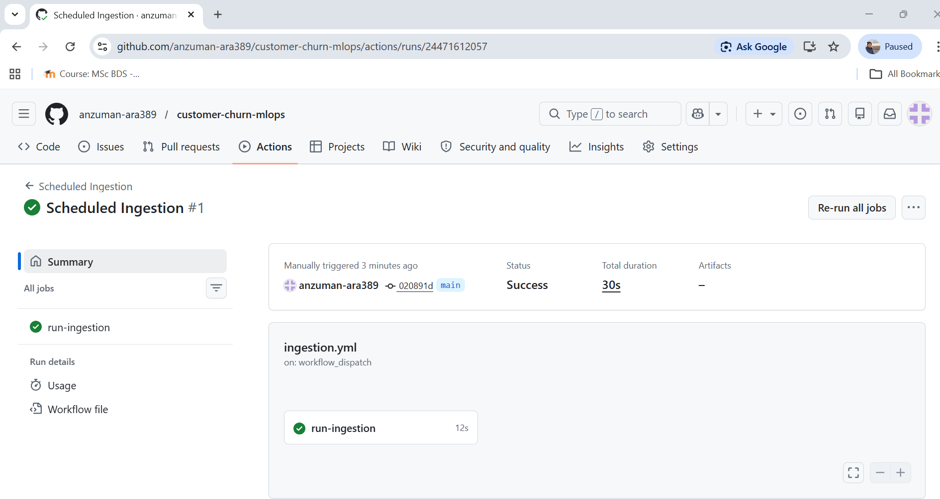
Figure 2: GitHub Actions workflow successfully executing the automated ingestion and model update pipeline.

4.3 Versioning

Artifact versioning is implemented using timestamp-based filenames. Each training run stores a versioned model file, feature schema, and evaluation metrics file. In addition, a separate latest version of the main artifacts is maintained for deployment and inference. This makes it possible to trace results back to a specific training run, compare model versions over time, and roll back if necessary.
GitHub also provides version control for source code, workflow configurations, and automated pipeline updates, improving traceability and collaboration.
Versioning supports reproducibility by making it possible to repeat the same workflow and obtain consistent results. It also allows rollback to previous versions of data or models if errors occur or if a newer version performs worse.

5. Artifact Collection and Storage
Proper artifact management improves traceability and reproducibility throughout the machine learning lifecycle. By keeping track of datasets, processed files, model versions, and logs, it becomes easier to understand how results were produced and to repeat the same workflow when needed. This is an important requirement in production systems, where reliability, consistency, and the ability to troubleshoot issues are essential. (Schlegel & Sattler, 2022)
Artifacts are stored in a structured directory and include:
- raw data (historical and incoming)
- processed data
- trained model artifacts (model_latest.pkl and timestamped model files)
- feature schema artifacts (columns_latest.pkl and timestamped schema files)
- evaluation metrics (metrics_latest.json and timestamped metrics files)
- ingestion logs
- prediction logs
- drift report artifacts
Artifact storage enables:
- reproducibility
- debugging
- auditability

6. Deployment Setup

6.1 API Deployment
The model is deployed using FastAPI, exposing a /predict endpoint.
- lightweight
- fast
- built-in documentation (Swagger)
- easy integration with ML models
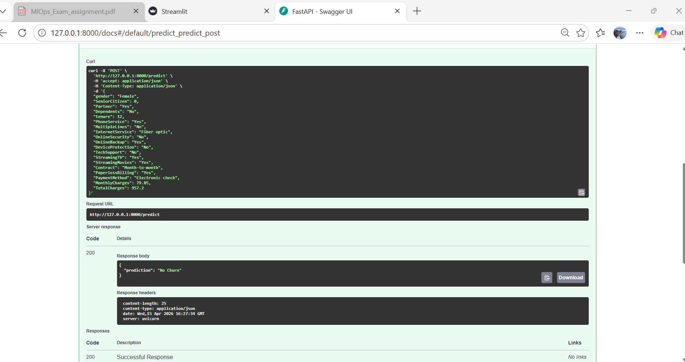
Figure 3: FastAPI Swagger UI showing successful churn prediction.

6.2 Docker Deployment
The entire system is containerized using Docker.
Steps:
- build image
- run container
- expose port 8000
Docker ensures environmental consistency, simplifies deployment, and supports reproducibility.

6.3 Execution Mode
The system supports:
- on-demand predictions through the FastAPI API
- interactive user predictions through the Streamlit frontend
- automated pipeline execution through GitHub Actions
- containerized deployment through Docker

7. Frontend
A lightweight interactive frontend was implemented using Streamlit to improve usability and demonstrate end-user interaction.
The frontend allows users to:
- enter customer details through a simple form,
- send data to the FastAPI backend,
- receive real-time churn predictions.
The frontend communicates with the deployed FastAPI API through the /predict endpoint.
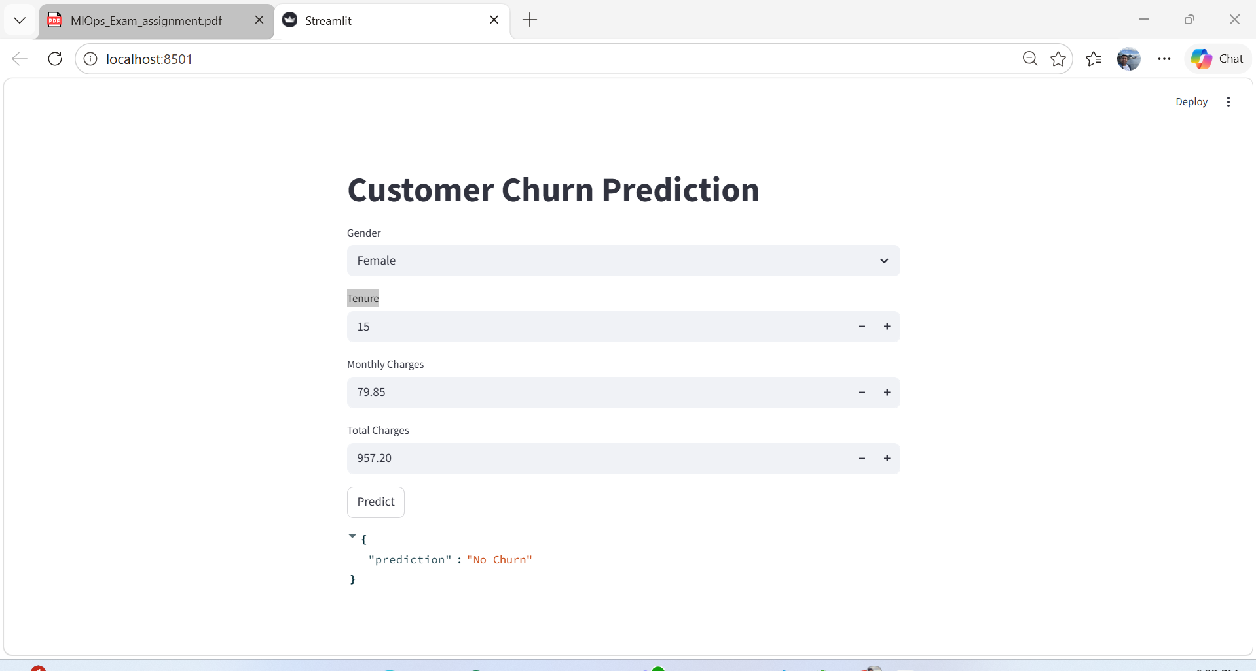
Figure 4: Streamlit frontend used for customer churn prediction.

Streamlit :
- simple and fast to develop,
- easy integration with Python APIs,
- suitable for demonstrating machine learning applications.
This frontend improves the accessibility of the system and provides a more realistic deployment scenario.

8. Conclusion
This project demonstrates a complete MLOps pipeline focusing on system design, modularity, and deployment. The pipeline successfully brings together all the main stages of the machine learning workflow, including data ingestion, preprocessing, model training, deployment, and monitoring. By connecting these components into a single system, it ensures that data can move smoothly through each stage and that the model can be updated, used, and tracked in a reliable and organized way.
The design reflects real-world machine learning systems, where reproducibility, scalability, and maintainability are more important than model accuracy alone.
The integration of SQLite for structured storage and GitHub Actions for scheduled pipeline execution further improved the realism of the system by simulating production-style live customer data updates.
The final system also includes versioned artifacts, extended evaluation metrics, and a basic drift monitoring step, which further strengthens its reproducibility and production-like behavior.

References
Kreuzberger, D., Kühl, N., & Hirschl, S. (2023). Machine Learning Operations (MLOps): Overview, Definition, and Architecture. IEEE Access, 11, 31866–31879.
Schlegel, M., & Sattler, K.-U. (2022). Management of Machine Learning Lifecycle Artifacts: A Survey. SIGMOD Record, 51(4), 18–35.
Zha, D., Bhat, Z. P., Lai, K.-H., et al. (2025). Data-centric Artificial Intelligence: A Survey. ACM Computing Surveys, 57(5), Article 129.

